Supplementary Fig. 1. Comparison of rate of AEs in SARS-CoV-2 naïve participants after receiving the third and the fourth dose (A), and the fifth dose (B) of vaccines produced by two different manufactures.
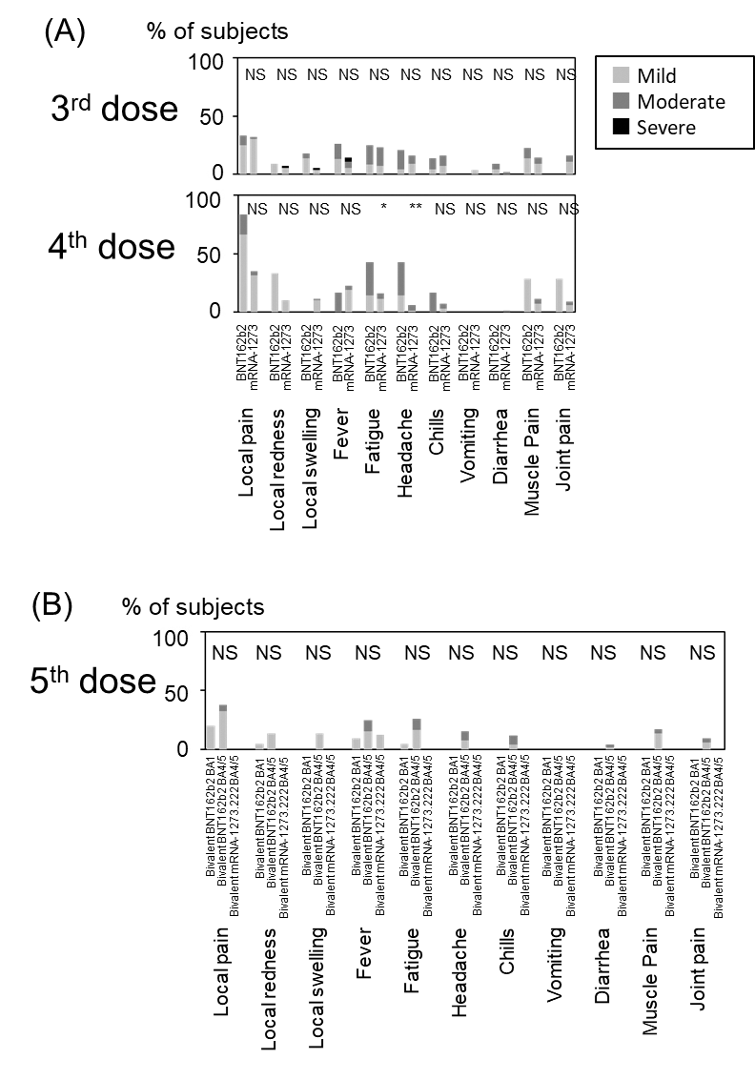
Pearson’s χ2 test, for the third dose, BNT162b2 (N=16), mRNA-1273 (N=53), for the fourth dose, BNT162b2 (N=3), mRNA-1273 (N=66), for the fifth dose, bivalent, BA.1-adapted BNT162b2 (N=21), BA.4/BA.5-adapted BNT162b2 (N=33), BA.4/BA.5-containing bivalent mRNA-1273.222 (N=15). All of SARS-CoV-2 naïve participants received five doses of the vaccine.

Supplementary Fig.2. Comparison of the cumulative AE score in SARS-CoV-2 naïve staff (A) and SARS-CoV-2 naïve residents (B) after receiving the third, the fourth dose, and the fifth dose of the vaccines produced by two different manufactures.

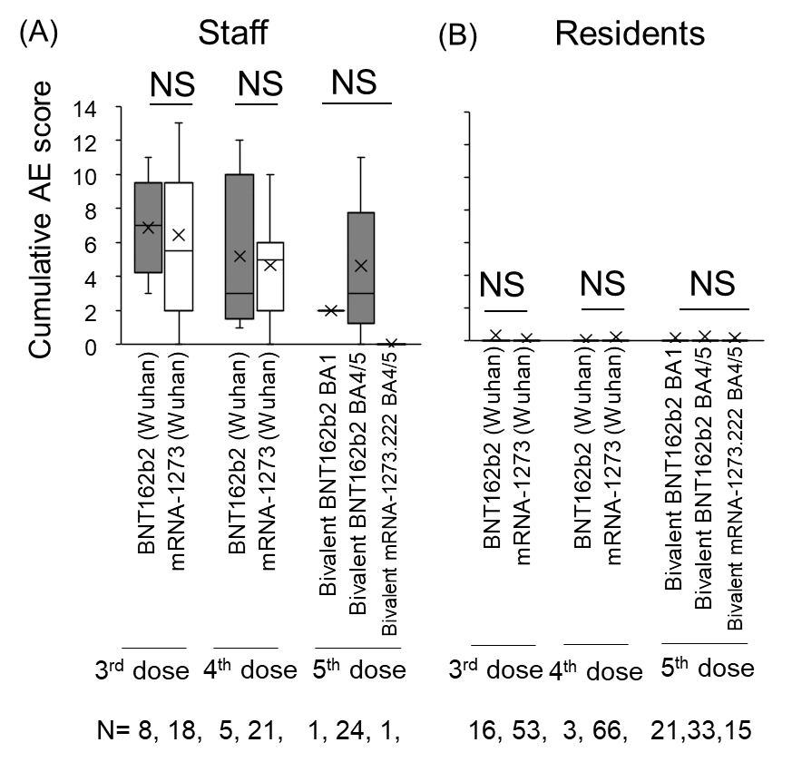
All of SARS-CoV-2 naïve participants received five doses of the vaccine. Staff, N=26; Residents, N=69. The Mann-Whitney U test. Kruskal-Wallis test, NS, not significant.

Supplementary Fig. 3. Correlation between age and cumulative AE score after COVID-19 mRNA vaccination in SARS-CoV-2 naïve staff and residents at nursing homes.
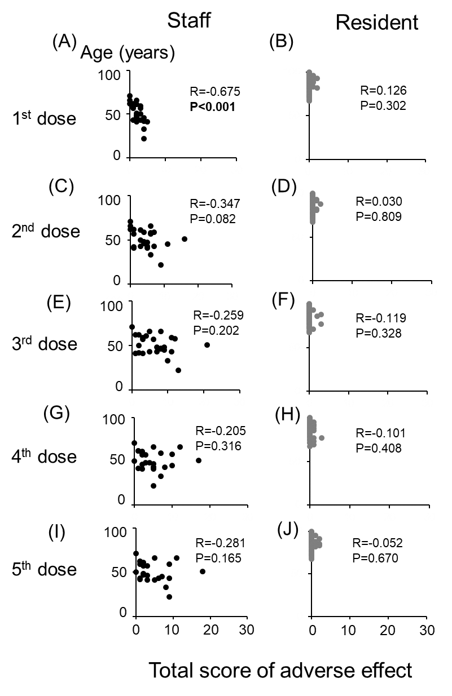
Cumulative AE score
All of SARS-CoV-2 naïve participants received five doses of the vaccine. Spearman’s correlation, staff N=26, resident N=69.

