Preparation, crystal structure, optical properties, Hirshfeld surface analysis and antimicrobial activity of 4-nitrobenzyl-4-aminopyridinium tetrachlorocuprate(II)
Yu-Ting Li¹·Lin Huang¹·Xin-Ran Li¹·Bao-Yi Hu¹·Ke-Xin Huang¹·Yan Jiang¹·Jia-Yu Yu¹·Chun-Lin Ni^{1*}

List of supporting information
Fig. SI-1 The 2D fingerprint map for smaller contributing interactions in [4NO₂Bz-Py]⁺
Fig. SI-2 The 2D fingerprint map for smaller contributing interactions in [CuCl₄]^{2–}
Fig. SI-3 The 2D fingerprint map for Cl atom contribution in [CuCl₄]^{2–}
Fig. SI-4 MIC of [4NO₂Bz-4NH₂Py]Cl, CuCl₂·2H₂O, 1, [4NO₂Bz-Py]₂[CuCl₄], and [Bz-4NH₂Py]₂[CuCl₄]

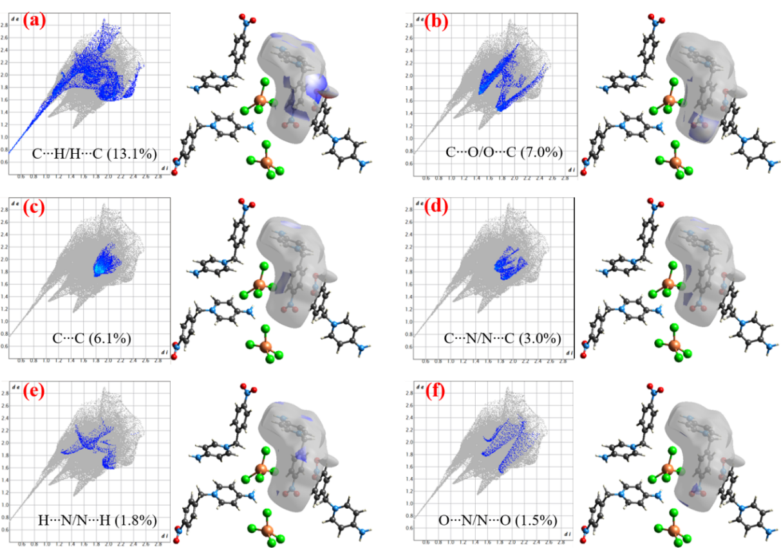
Fig. SI-1 The 2D fingerprint map for smaller contributing interactions in [4NO₂Bz-Py]⁺

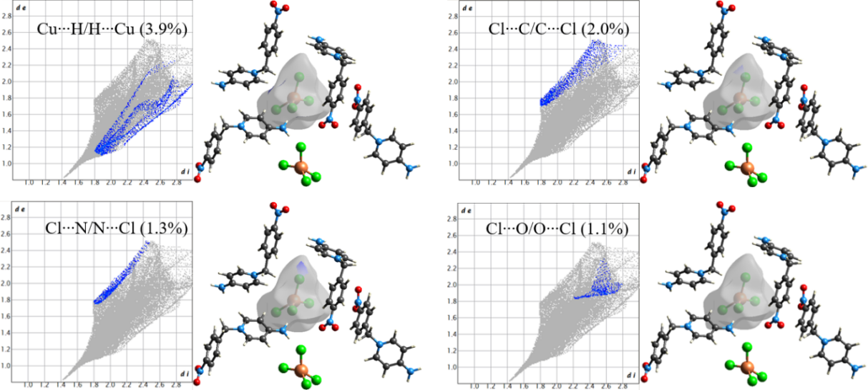
Fig. SI-2 The 2D fingerprint map for smaller contributing interactions in [CuCl₄]^{2–}

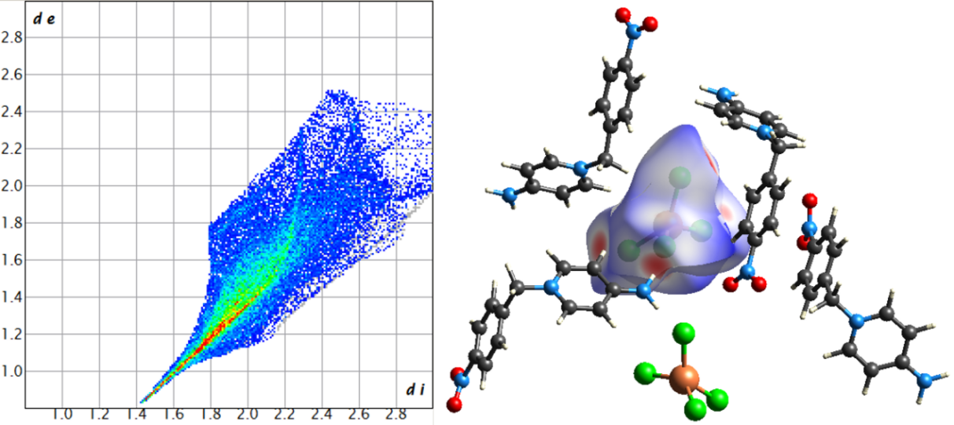
Fig. SI-3 The 2D fingerprint map for Cl atom contribution in [CuCl₄]^{2–}

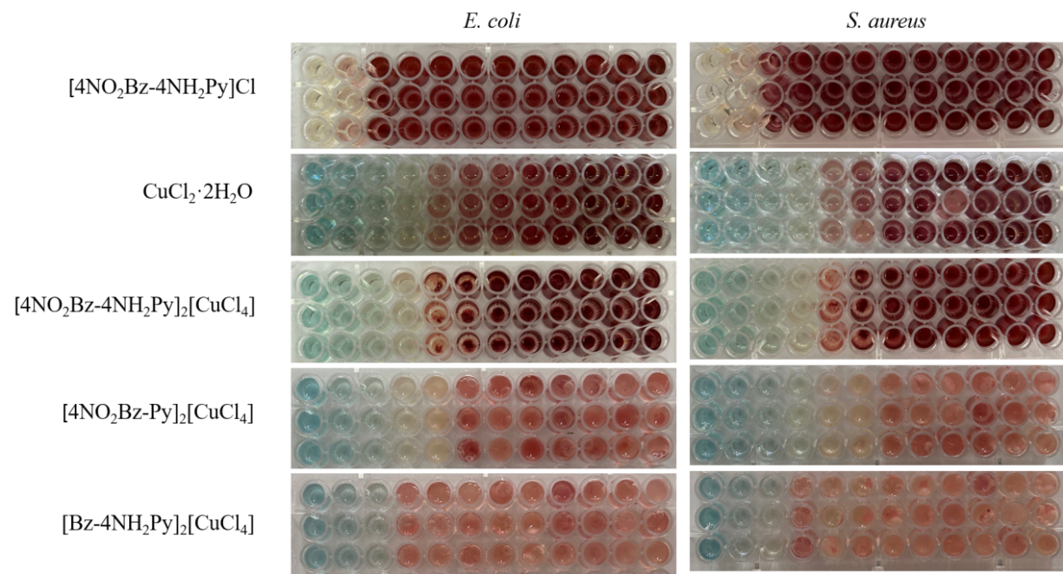
Fig. SI-4 MIC of [4NO₂Bz-4NH₂Py]Cl, CuCl₂·2H₂O, 1, [4NO₂Bz-Py]₂[CuCl₄], and [Bz-4NH₂Py]₂[CuCl₄]

