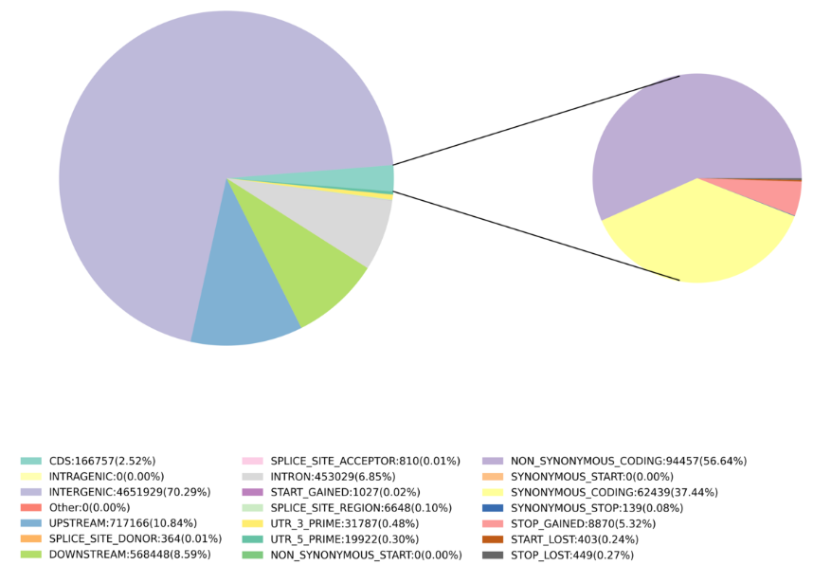
Figure S1. SNP mutation type dietribution and annotation in 418 cherry tomatoes.

Figure S2. Information of the GBTS and KASP markers used in this study.

