Supplementary Table 1. PERMANOVA testing the effect of individual shared risk factors on Euclidean distance between patients with TB.
Predictor Variable | DF | R-Squared | F | P-Value
Age (15-24) | 1 | 0.00660 | 1.0008 | 0.450
Age (25-44) | 1 | 0.00621 | 0.9420 | 0.587
Age (45-64) | 1 | 0.00712 | 1.0804 | 0.328
Sex =Male | 1 | 0.00519 | 0.7874 | 0.838
Marital Status = Single | 1 | 0.00690 | 1.0463 | 0.353
Marital Status = Married/Cohabitating | 1 | 0.00617 | 0.9363 | 0.593
HIV Status = Positive | 1 | 0.00672 | 1.0197 | 0.408
Occupation = Unskilled | 1 | 0.00977 | 1.4821 | 0.033 *
Occupation = Skilled Work | 1 | 0.00833 | 1.2635 | 0.132
Occupation = Student | 1 | 0.00489 | 0.7425 | 0.917
Past year drug use = Yes | 1 | 0.01176 | 1.7837 | 0.005 **
Past year Excess Alcohol use = Yes | 1 | 0.00598 | 0.9071 | 0.657
Past 2 months cough in close contacts | 1 | 0.01756 | 2.6641 | 0.001 ***
Past 2 years TB in households | 1 | 0.00712 | 1.0808 | 0.311
Residual | 135 | 0.88970
Total | 149 | 1.00000
Significance codes: 0 '***' 0.001 '**' 0.01 '*' 0.05 '.' 0.1'’ 1; DF – degrees of freedom; F–F statistics.

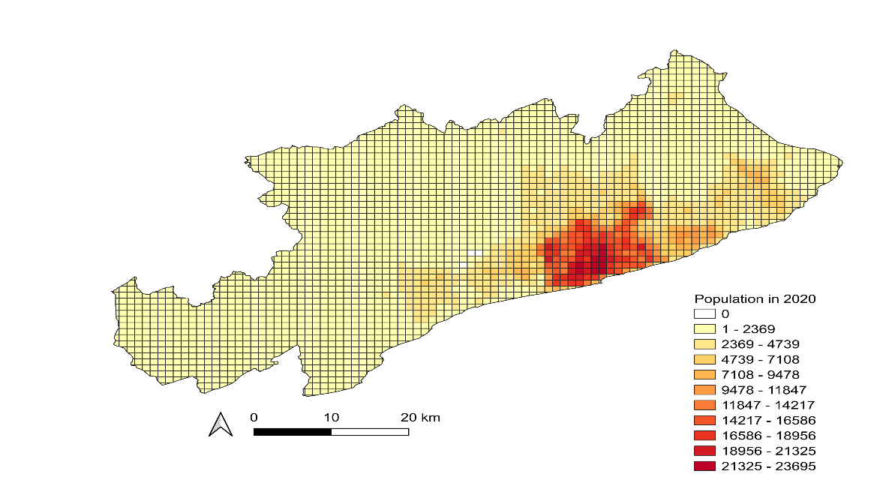
Supplementary Figure 1: Population per grid cell

