Supplementary figure:
Graphical representation of different viewing modes of Ziru, IrisVision and NuEyes.
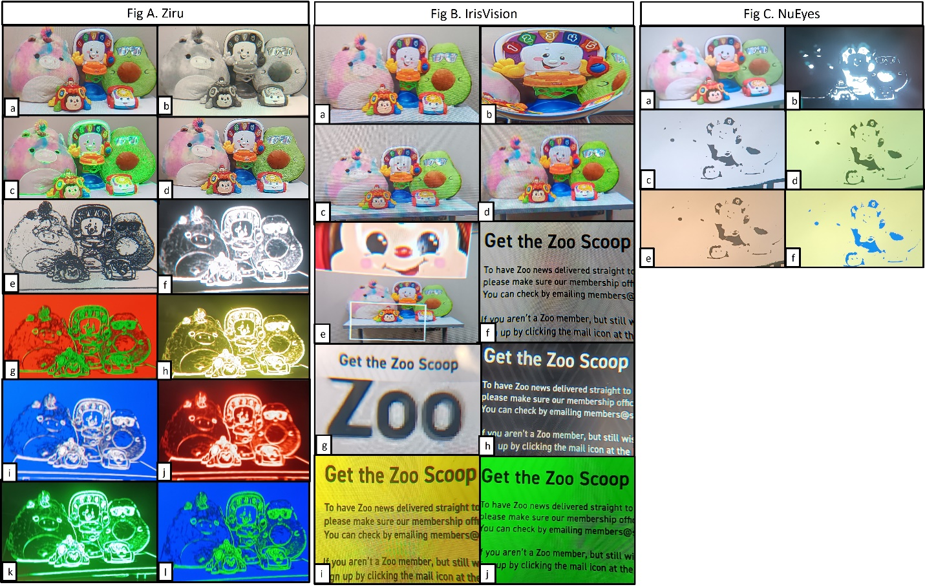 Figure A. Ziru. a. Clear, b. Gray, c. Boost, d. Cogni, e. Outline - Black Outline white background, f. White outline black background, g. Green outline red background, h. Yellow outline black background, i. White outline blue background, j. Red outline black background, k. Green outline black background, l. Green outline blue background. Figure B. IrisVision. a. Scene, b. Scene with bubble, c. RP, d. Television, e. Bioptic, f. Reading, g. Reading line, h. Reading inverted, i. Reading yellow, j. Reading green. Figure C. NuEyes. a. Regular, b. Black, c. White, d. Yellow, e. Orange, f. Blue

