Supplement Figure 1. Consort diagram
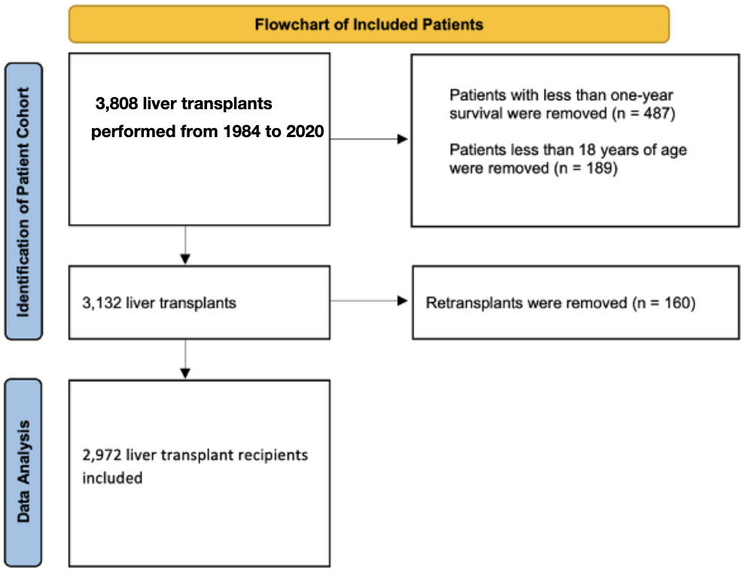

Supplementary table 1. Multivariate analysis for malignancy-related death
Parameter | Hazard  Ratio | 95% Hazard Ratio Profile  Likelihood Confidence  Limits |  | Pr > ChiSq
Transplant era |  |  |  | 0.4493
- 1984-1989 vs 2015 - 2019 | 0.157 | 0.001 | 1.132 | 0.1985
- 1990-1994 vs 2015- 2019 | 0.658 | 0.252 | 1.483 | 0.3457
- 1995- 1999 vs 2015- 2019 | 0.587 | 0.288 | 1.086 | 0.1233
- 2000 - 2004 vs 2015- 2019 | 1.062 | 0.645 | 1.708 | 0.8140
- 2005 – 2009 vs 2015- 2019 | 0.971 | 0.614 | 1.555 | 0.9030
- 2010 – 2014 vs 2015- 2019 | 0.892 | 0.568 | 1.417 | 0.6268
Recipient age |  |  |  | 0.0001
- 35-50 vs 18-34 | 1.759 | 0.694 | 5.593 | 0.2699
- 50-65 vs 18-34 | 3.575 | 1.495 | 11.039 | 0.0094
- >65 vs 18-34 | 5.119 | 1.983 | 16.496 | 0.0018
Donor age | 1.000 | . | 1.009 | 0.9659

Supplementary table 2. Multivariate analysis for infection-related death
Parameter | Hazard  Ratio | 95% Hazard Ratio Profile  Likelihood Confidence  Limits |  | Pr > ChiSq
Transplant era |  |  |  | 0.5641
- 1984-1989 vs 2015 - 2019 | 2.139 | 0.225 | 9.603 | 0.4131
- 1990-1994 vs 2015- 2019 | 0.190 | 0.001 | 1.498 | 0.2570
- 1995- 1999 vs 2015- 2019 | 0.495 | 0.095 | 1.715 | 0.3329
- 2000 - 2004 vs 2015- 2019 | 1.228 | 0.513 | 2.888 | 0.6511
- 2005 – 2009 vs 2015- 2019 | 0.764 | 0.310 | 1.825 | 0.5623
- 2010 – 2014 vs 2015- 2019 | 0.710 | 0.303 | 1.634 | 0.4385
Recipient age |  |  |  | 0.4603
- 35-50 vs 18-34 | 1.108 | 0.286 | 6.055 | 0.8884
- 50-65 vs 18-34 | 1.994 | 0.606 | 10.197 | 0.3089
- >65 vs 18-34 | 1.613 | 0.329 | 9.866 | 0.5657
Donor age | 1.018 | 1.000 | 1.036 | 0.0573

Supplementary table 3. Compairaison with Canadian Population
overall patients (tx between 1984 - 2019)
followed up from 1992 - 2020 (28 years)
Age at LFU (Female) | Our study | follow up duration | our study | our study | statscan | statscan
Age at LFU (Female) | n=1956 |  | observed death | death rate | death | population | expected death | SE | SMR | 95% CI LL | 95% CI UL | p value
20 - 45 | 110 | 1992 - 2020 | 30 | 0.2727273 | 186586 | 161656009 | 0.1269638 | 43.14006 | 236.28784 | 151.73332 | 320.84235 | <0.05
45 - 60 | 485 | 1992 - 2020 | 172 | 0.3546392 | 416996 | 96618189 | 2.0932193 | 6.2654099 | 82.17008 | 69.889877 | 94.450284 | <0.05
60 - 80 | 1286 | 1993 - 2020 | 396 | 0.3079316 | 1466358 | 69522828 | 27.123989 | 0.7336586 | 14.599623 | 13.161652 | 16.037594 | <0.05
60 - 98 | 1357 | 1993 - 2020 | 416 | 0.3065586 | 2696670 | 81331236 | 44.993552 | 0.4533111 | 9.2457693 | 8.3572795 | 10.134259 | <0.05
patients transplanted in 1984 - 1999
followed up from 1992 - 2020 (28 years)
Age at LFU (Female) | Our study | follow up duration | our study | our study | statscan | statscan
Age at LFU (Female) | n=332 |  | observed death | death rate | death | population | expected death | SE | SMR | 95% CI LL | 95% CI UL | p value
20 - 45 | 21 | 1992 - 2020 | 19 | 0.9047619 | 204423 | 173404756 | 0.0247564 | 176.07137 | 767.47733 | 422.37743 | 1112.5772 | <0.05
45 - 60 | 85 | 1992 - 2020 | 61 | 0.7176471 | 416996 | 96618189 | 0.3668529 | 21.289869 | 166.27919 | 124.55105 | 208.00734 | <0.05
60 - 80 | 185 | 1993 - 2020 | 133 | 0.7189189 | 1466358 | 69522828 | 3.9019735 | 2.9555718 | 34.085316 | 28.292396 | 39.878237 | <0.05
60 - 98 | 222 | 1993 - 2020 | 150 | 0.6756757 | 2696670 | 81331236 | 7.3607727 | 1.6638809 | 30.159877 | 26.898671 | 33.421084 | <0.05
patients transplanted in 2000 - 2009
followed up from 2005 - 2020 (15 years)
Age at LFU (Female) | Our study | follow up duration | our study | our study | statscan | statscan
Age at LFU (Female) | n=691 |  | observed death | death rate | death | population | expected death | SE | SMR | 95% CI LL | 95% CI UL | p value
20 - 45 | 17 | 2005 - 2020 | 7 | 0.4117647 | 103339 | 96695977 | 0.0181679 | 145.62779 | 385.29491 | 99.864446 | 670.72537 | <0.05
45 - 60 | 148 | 2001 - 2020 | 74 | 0.5 | 301503 | 73571475 | 0.6065183 | 14.183126 | 122.00787 | 94.208938 | 149.80679 | <0.05
60 - 80 | 493 | 2001 - 2020 | 174 | 0.3529412 | 1044985 | 54694989 | 9.4191006 | 1.4004422 | 18.473101 | 15.728235 | 21.217968 | <0.05
60 - 98 | 526 | 2003 - 2020 | 177 | 0.3365019 | 1873515 | 59849857 | 16.465685 | 0.8079916 | 10.749629 | 9.1659652 | 12.333292 | <0.05
patients transplanted in 2010 - 2019
followed up from 2011 - 2020 (9 years)

Age at LFU (Female) | Our study | follow up duration | our study | our study | statscan | statscan
Age at LFU (Female) | n=933 |  | observed death | death rate | death | population | expected death | SE | SMR | 95% CI LL | 95% CI UL | p value
20 - 45 | 72 | 2013 - 2020 | 4 | 0.3529412 | 54574 | 49700951 | 0.0243067 | 82.281759 | 164.56352 | 3.2912703 | 325.83576 | <0.05
45 - 60 | 252 | 2011 - 2020 | 37 | 0.1468254 | 152039 | 38763494 | 0.3965488 | 15.339253 | 93.305033 | 63.240097 | 123.36997 | <0.05
60 - 80 | 608 | 2012 - 2020 | 89 | 0.1463816 | 500855 | 29328671 | 4.3801417 | 2.1538073 | 20.318977 | 16.097515 | 24.540439 | <0.05
60 - 98 | 609 | 2012 - 2020 | 89 | 0.1461412 | 1025523 | 34673300 | 7.6790116 | 1.2285411 | 11.590033 | 9.1820927 | 13.997974 | <0.05

overall female patients (tx between 1986- 2020)
followed up from 1991 - 2020 (29 years of follow up)
Age at LFU (Female) | Our study | follow up duration | our study | our study | statscan | statscan
Age at LFU (Female) | n=1010 |  | observed death | death rate | death | population | expected death | SE | SMR | 95% CI LL | 95% CI UL | p value
20 - 45 | 108 | 1994-2020 | 32 | 0.2963 | 93693 | 158709485 | 0.06375702 | 88.7251967 | 501.90551 | 328.00412 | 675.8068918 | <0.05
45 - 60 | 270 | 1991-2020 | 79 | 0.29259 | 272522 | 99288719 | 0.74108057 | 11.9935603 | 106.6011 | 83.093717 | 130.1084735 | <0.05
60 - 80 | 583 | 1993-2020 | 187 | 0.32075 | 1044456 | 76858376 | 7.92259581 | 1.72604973 | 23.603375 | 20.220318 | 26.98643246 | <0.05
60 - 90 | 632 | 1993-2020 | 210 | 0.33228 | 2134644 | 93681923 | 14.400804 | 1.00628943 | 14.582519 | 12.610192 | 16.55484645 | <0.05
1st transplant era: patients transplanted in 1986 - 1999
followed up from 1991 - 2020 (29 years)
Age at LFU (Female) | Our study | follow up duration | our study | our study | statscan | statscan
Age at LFU (Female) | n=252 |  | observed death | death rate | death | population | expected death | SE | SMR | 95% CI LL | 95% CI UL | p value
20 - 45 | 12 | 1994-2014 | 12 | 1 | 72384 | 121984651 | 0.00712063 | 486.487836 | 1685.2433 | 731.72714 | 2638.759459 | <0.05
45 - 60 | 54 | 1991-2020 | 34 | 0.62963 | 272522 | 99288719 | 0.14821611 | 39.3408771 | 229.39476 | 152.28664 | 306.5028814 | <0.05
60 - 80 | 154 | 1993-2020 | 100 | 0.64935 | 1044456 | 76858376 | 2.09276116 | 4.77837615 | 47.783761 | 38.418144 | 57.14937871 | <0.05
60 -90 | 186 | 1993-2020 | 119 | 0.63978 | 2134644 | 93681923 | 4.23821129 | 2.5738953 | 28.077883 | 23.033048 | 33.12271759 | <0.05
2nd transplant era: patients transplanted in 2000 - 2009
followed up from 2002 - 2020 (18 years)
Age at LFU (Female) | Our study | follow up duration | our study | our study | statscan | statscan
Age at LFU (Female) | n=292 |  | observed death | death rate | death | population | expected death | SE | SMR | 95% CI LL | 95% CI UL | p value
20 - 45 | 29 | 2002 - 2020 | 15 | 0.51724 | 63659 | 112275335 | 0.01644271 | 235.544072 | 912.25827 | 450.59189 | 1373.92465 | <0.05
45 - 60 | 84 | 2002 - 2020 | 33 | 0.39286 | 185753 | 70910122 | 0.22004266 | 26.1065859 | 149.97092 | 98.80201 | 201.1398263 | <0.05
60 - 80 | 162 | 2004-2020 | 56 | 0.34568 | 640640 | 52590222 | 1.97344061 | 3.79201417 | 28.376836 | 20.944488 | 35.80918344 | <0.05
60 - 90 | 179 | 2004-2020 | 60 | 0.3352 | 1346670 | 64201312 | 3.75465738 | 2.0630289 | 15.980153 | 11.936617 | 20.0236898 | <0.05
3rd transplant era: patients transplanted in 2010 - 2020
followed up from 2012 - 2020 (8 years)
Age at LFU (Female) | Our study | follow up duration | our study | our study | statscan | statscan
Age at LFU (Female) | n=466 |  | observed death | death rate | death | population | expected death | SE | SMR | 95% CI LL | 95% CI UL | p value
20 - 45 | 67 | 2012-2020 | 5 | 0.34568 | 30659 | 54484530 | 1.97344061 | 1.13308096 | 2.533646 | 0.3128074 | 4.754484715 | >0.05
45 - 60 | 132 | 2012-2020 | 12 | 0.09091 | 88597 | 35060236 | 0.33356319 | 10.3851437 | 35.975193 | 15.620311 | 56.33007475 | <0.05
60 - 80 | 267 | 2011-2020 | 31 | 0.1161 | 393880 | 34373340 | 3.05952113 | 1.81981563 | 10.132305 | 6.565466 | 13.69914323 | <0.05
60 - 95 | 267 | 2011-2020 | 31 | 0.1161 | 815427 | 41551631 | 5.23972233 | 1.06260676 | 5.916344 | 3.8336348 | 7.999053284 | <0.05

