Supplementary Tables
Supplementary table 1. Clumping results with R^2 parameters in validation data.
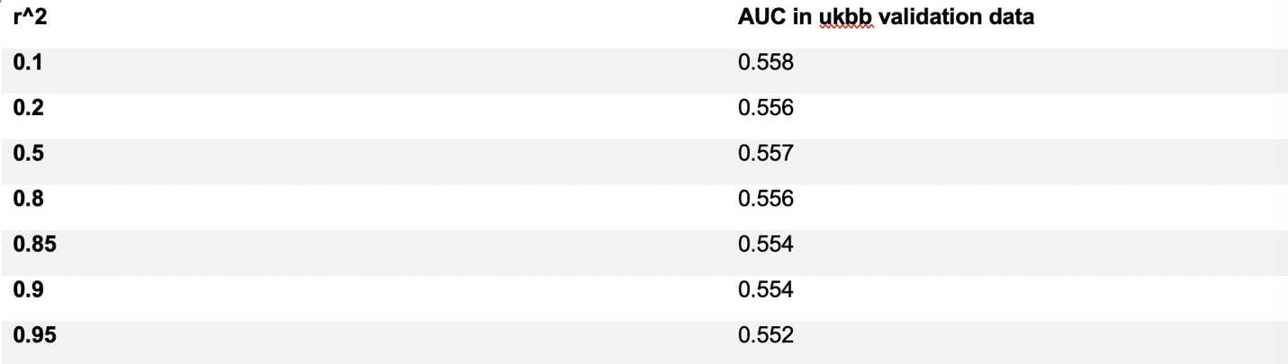
Supplementary Table 2. Prediction AUCs their confidence intervals and comparison test of PRS methods to DL-PRS.
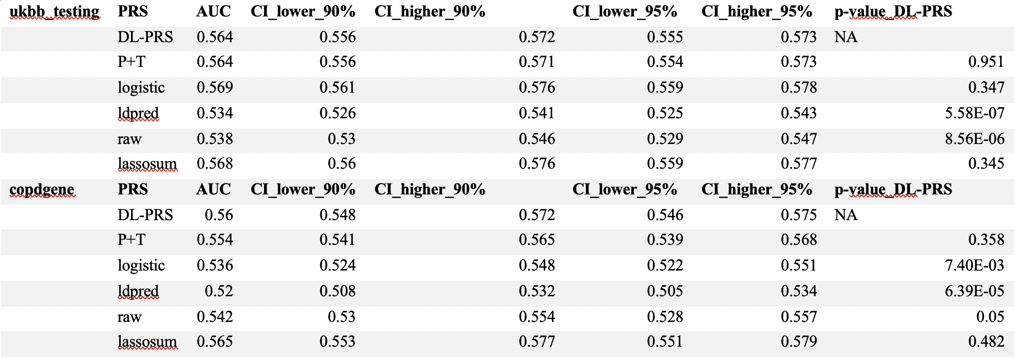
Supplementary Table 3. Linear regression comparing PRS deciles’ relationship with lung functions
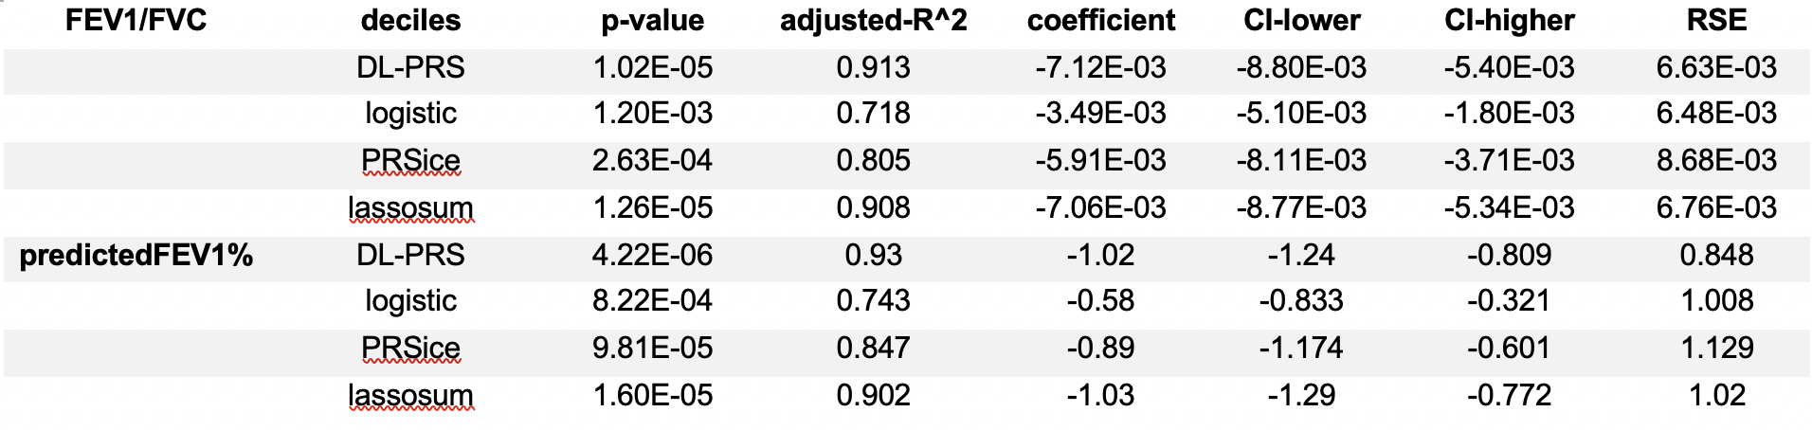

Supplementary Table 4. PRS association with GOLD stage and SGRQ stage phenotypes.

