Supplementary Figures
Supplementary Figure 1. Workflow of UK Biobank phenotype data preprocessing.
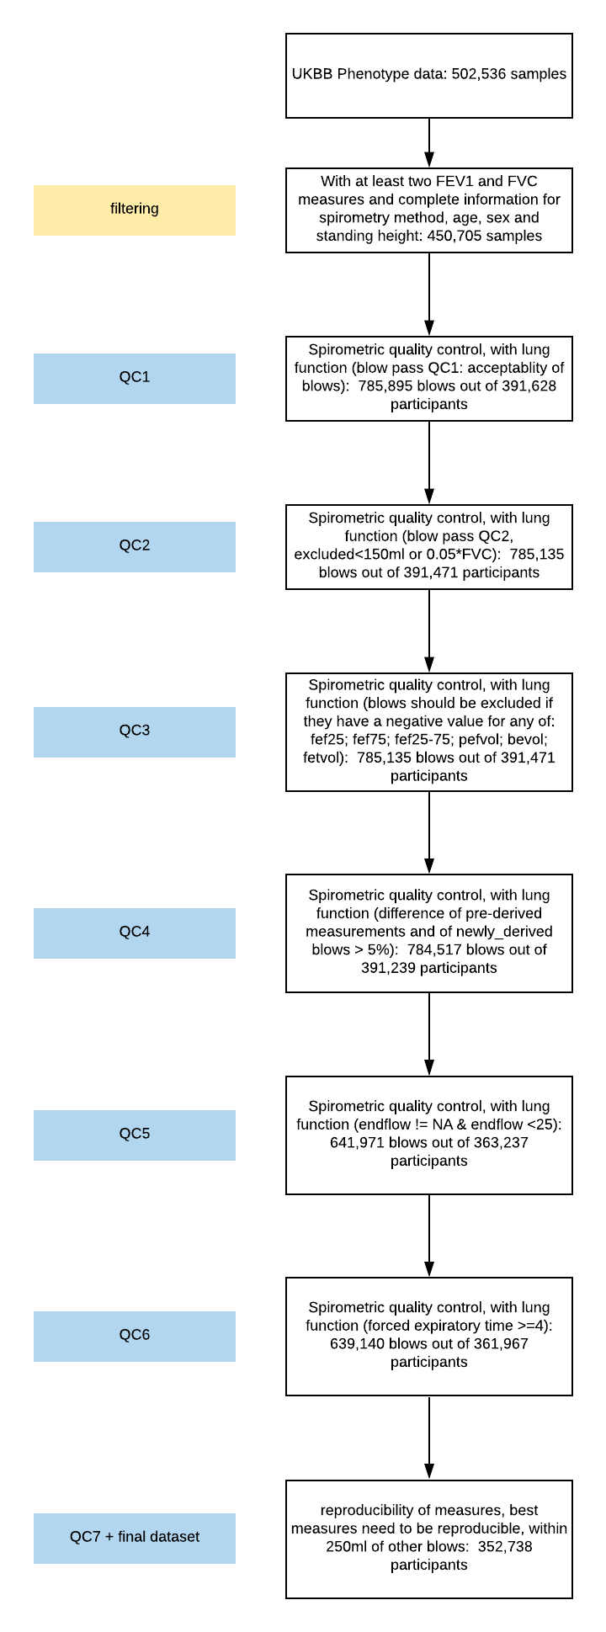
Supplementary Figure 2. Workflow of deep learning structure and derivation of DL-PRS score. The first step for DL-PRS is to generate DL-based weights for each variant using the a fully-connected Deep neural network structure from UK Biobank training data. The subject-level genotype data is the independent input variables and clinical outcome as the dependent output variable. For the prediction step, we used features (inner layer nodes) from the testing set and the weights (Wi) from the DNN model from the 1st step, DL-PRS is calculated as the sum of subject-level genotype dosages weighted by the weights of the inner layer nodes.
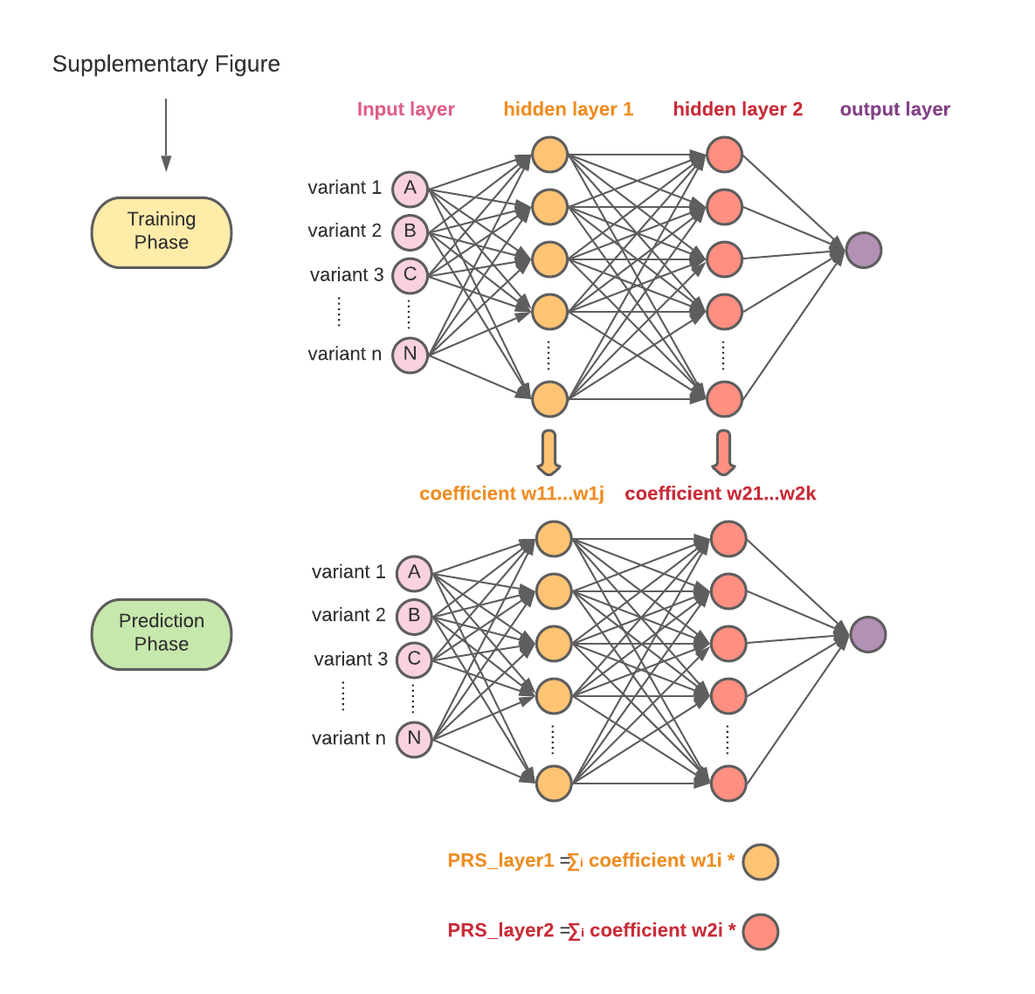
Supplementary Figure 3. Comparing neural network model without hidden layers and logistic regression on prediction of COPD phenotype. Feature selection of snps (100%, 75%, 50% and 25%) is employed before fitting into the models.
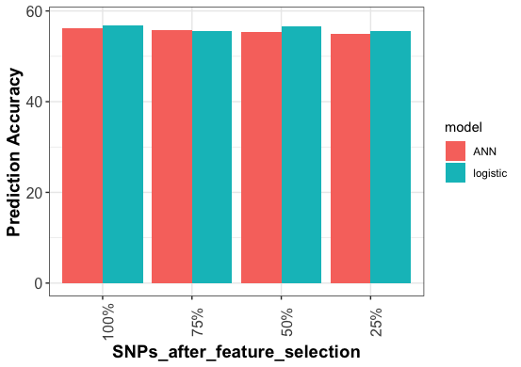
Supplementary Figure 4. Sensitivity analysis of DL-PRS. COPD phenotype prediction accuracy is measured with DL-PRS scores built with incremental snp thresholding and different inner layer nodes structure.
