Tables
Table 1. Population characteristics in UK Biobank and COPDgene cohort.
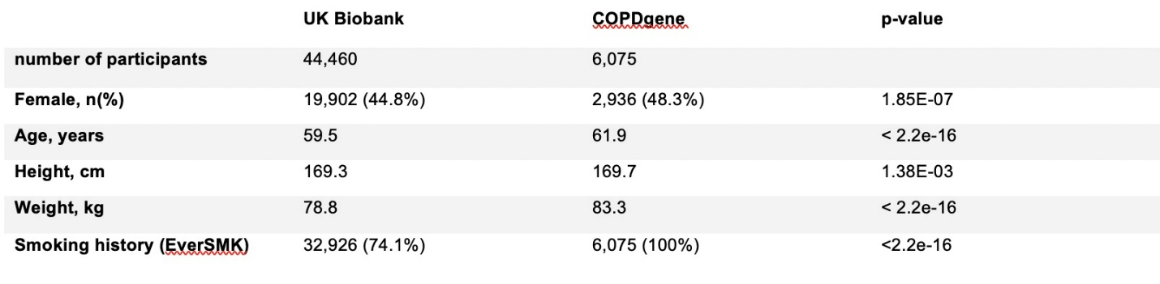
Table 2. PRS benchmark methods performance in COPD prediction. Confidence intervals of R^2 are calculated using bootstrap with 1000 replicates.
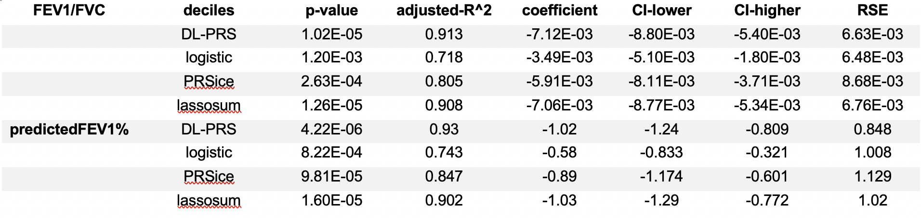
Table 3. PRS benchmark methods performance: Likelihood ratio test is used to compare model with PRS to model without PRS.
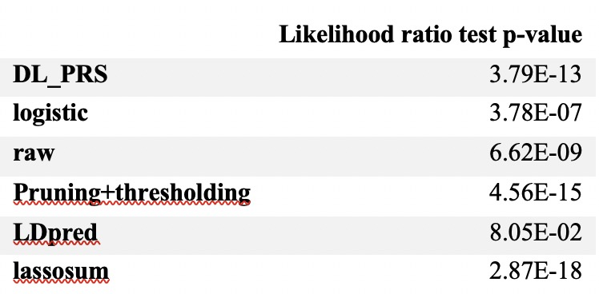
Table 4. Summary of COPD risk model comprising DL-PRS and other relevant clinical variables
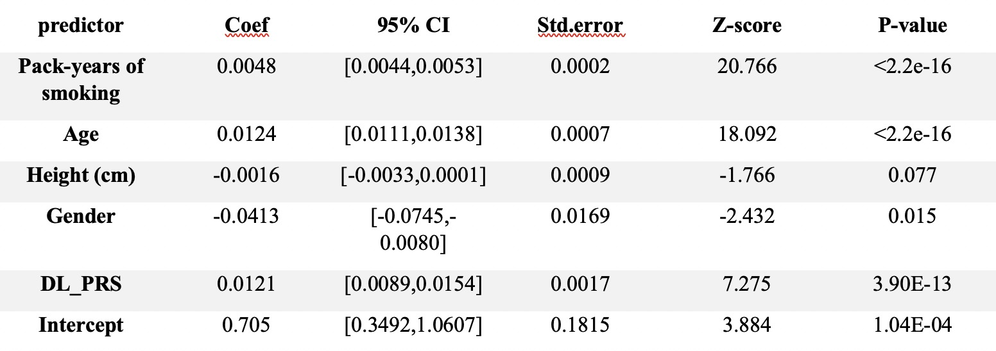
Table 5. Association test between PRS and copd-risk related phenotypes
