Fig. S1 Frequency distribution of PIC values (the X axis) of SilicoDArT markers (the Y axis).

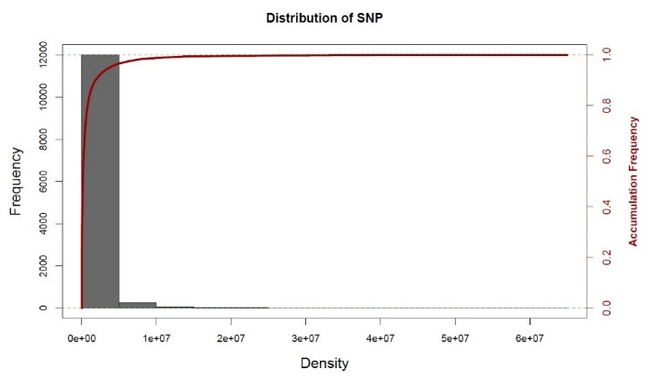
Fig. S2 Frequency distribution of PIC values (the X axis) of SNP markers (the Y axis).

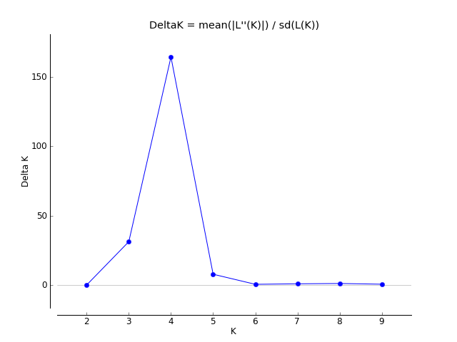

Fig.S3 Bivariate diagrams to determine the appropriate number of subpopulations in the studied genotypes (K=4).

