D-PRISM, a global study of diagnostic approaches in severe pneumonia. Supplemental section
AUTHORS: Luis Felipe Reyes, Cristian Serrano Mayorga, Zhongheng Zhang, Isabela Tsuji, Gennaro De Pascale, Valeria Enciso Prieto, Mervyn Mer, Elyce Sheehan, Prashant Nasa, Goran Zangana, Kostoula Avanti, Alexis Tabah, Gentle Shrestha, Hendrik Bracht, Arie Zainul, Khalid Abidi, Helmi bin Sulaiman, Vandana Kalwaje Eshwara, Liesbet De Bus, Yoshiro Hayashi, Pervin Korkmaz, Ali Ait Hssain, Niccolò Buetti, Qing Yuan Goh, Arthur Kwizera, Despoina Koulenti, Nathan D. Nielsen, Pedro Povoa, Otavio Ranzani, Jordi Rello, Andrew Conway Morris for the D-PRISM investigators.

D-PRISM investigators
Steering committee: Luis Felipe Reyes, Zhongheng Zhang, Mervyn Mer, Alexis Tabah, Arthur Kwizera, Despoina Koulenti, Nathan D Nielsen, Pedro Povoa, Otavio Ranzani, , Jordi Rello, Andrew Conway Morris
National/regional co-ordinators: Angola, Wilson Mphandi; Argentina, Adrian Ceccato; Australia, Alexis Tabah; Bangaldesh, Ahsina Jahan; Belgium, Liesbet De Bus; Brazil, Isabela Tsuji; China, Zhongheng Zhang; Colombia, Luis Felipe Reyes; Ecudaor, Manuel Jibaja; Egypt, Adel Alsisi; France, Antoine Roquilly; Germany, Hendrik Bracht; Greece, Kostoula Arvaniti; Guatamala, Nancy Sandoval; India, Vandana Kalwaje Eshwara; Indonesia, Arie Zainul; Iran, Faird Zand; Italy, Gennaro De Pascale; Japan, Yoshiro Hayashi; Kazakstan, Dimitry Viderman; Malaysia, Helmi bin Sulaiman; Mexico, Leonel Lagunes; Middle East, Prashant Nasa; Middle East and North Africa, Goran Zangana; Morocco, Khalid Abid; Nepal, Gentle Shrestha;, Netherlands, Jeroen Schouten; Nigeria, Dabota Buowari; Pakistan, Madiha Hashmi; Peru, Nestor Luque; Portugal, David Nora; Qatar, Ali Ait Hssain; Russia, Artem Kuzovlev; Singapore, Qing Yuan Goh; South Africa, Mervyn Mer; Spain, Jordi Rello; Sri Lanka, Rashan Hanifa; Sweden, Fredrik Sjovall; Switzerland, Niccollò Buetti; Taiwan, Tony Yeh; Turkey, Pervin Korkmaz; Uganda, Arthur Kwizera; United Kingdom, Nesreen Shaban, Islam Hamed; United States of America, Elyce Sheehan.

Tables

Table S1. Antimicrobial regimen used in CAP patients.

n=1296 | Empirical Treatment CAP
Antibiotic Regimen | Yes n=1289 (99.4%) | No n=7 (0.5%)
Monotherapy | 357 (27.7%) | 0 (0.0%)
Dual therapy with macrolide | 827 (64.1%) | 0 (0.0%)
Dual therapy with non-macrolide | 105 (8.1%) | 0 (0.0%)
N/A | 0 (0.0%) | 7 (100%)

Table S2. Treatment Duration

n=1296 | Duration of Treatment
n=1296 | CAP | HAP | VAP
<5 days | 51 (3.9%) | 25 (1.9%) | 24 (1.8%)
5-7 days | 1059 (81.7%) | 743 (57.3%) | 643 (49.6%)
>7 day | 174 (11.1%) | 515 (39.759 | 615 (47.4%)

Table S3. Antimicrobial regimen used in HAP and VAP patients.

Antibotic Regimen | HAP n = 1296 | VAP = 1296
Monotherapy for all patients | 209 (16.1%) | 163 ( 12.5%)
Monotherapy for low risk of resistant organisms | 572 (44.1%) | 511 (39.4%)
Dual therapy including coverage for resistant organisms (eg MRSA/MDR Pseudomonas) for all patients | 510 (39.3%) | 616 (47.5%)
Dual therapy for high risk of resistant organisms (eg MRSA/MDR  pseudomonas) | 572 (44.1%) | 511 (39.4%)

Table S4. Distribution between type of health care centre and income categories.

Type of Health Care Centre / Income category | Total Cohort n =1296 | High-Income n =640 | Upper-Middle Income n = 448 | Low and Lower Middle-Income n =208
Community District  Hospital | 338 (26.0%) | 188 (29.3%) | 95 (21.2%) | 55 (26.4%)
Remote and rural Hospital | 41 (3.1%) | 22 (3.4%) | 8 (1.8%) | 11 (5.2%)
Teaching Hospital | 913 (70.4%) | 428 (66.8%) | 343 (76.6%) | 208 (68.3%)
Not Answer | 4 (0.3%) | 2 (0.3%) | 2 (0.4%) | 0 (0%)

Table S5. Relation between Antibiotic Time-out and regimen.

n=1296 | VAP Antibiotic Time-Out |  |  | HAP Antibiotic Time-Out
n=1296 | Yes n= 693 (53.4%) | No n=597 (46.0%) | N/A n= 6 (0.5%) | Yes = 671 (51.7%) | No n=612 (47.2%) | N/A n=13 (1%)
Monotherapy for all patients | 100 (14.4%) | 63 (10.5%) | 0 (0%) | 116 (17.2%) | 91 (14.9%) | 2 (15.4%)
Monotherapy for low risk of resistant organisms | 247 (35.6%) | 263 (44.0%) | 1 (16.6%) | 283 (42.1%) | 285 (46.6%) | 4 (30.8%)
Dual therapy including coverage for resistant organisms (eg MRSA/MDR Pseudomonas) for all patients | 346 (49.9%) | 269 (45.0%) | 1 (16.6%) | 271 (40.3%) | 235 (38.4%) | 4 (30.8%)
Dual therapy for high risk of resistant organisms (eg MRSA/MDR  pseudomonas) | 247 (35.6%) | 263 (44.0%) | 1 (16.6%) | 283 (42.1%) | 285 (46.6%) | 4 (30.8%)
N/A | 0 (0%) | 2 (0.3%) | 4 (66.6%) | 1 (0.1%) | 1 (0.1%) | 3 (23.1%)

Table S6. Univariate and multivariate regression for factors associated with antimicrobial treatment less than 7 days in CAP.

CAP Regression for Treatment < 7 days
Factor | Univariate |  | Multivariate
Factor | p-Value | OR (95% IC) | p-Value | OR (95% IC)
Intensivist | 0.004 | 1.17 (1.20-2.43) | 0.04 | 1.47 (1.00-2.15)
Post Graduate ICU Experience
<5 years | 0.85 | 0.95 (0.67-1.36)
5- 10 years | 0.92 | 1.03 (0.70-1.51)
10 years | 1.00 | 1.00 (0.72-1.38)
Hospital Characteristics

University/Teaching Hospital | 0.18 | 1.27 (0.90-1.78) | 0.54 | 1.11 (0.78-1.59)
Community Distric Hospital | 0.40 | 0.85 (0.60-1.22)
Remote and rural Hospital | 0.47 | 0.70 (0.30-1.63)
Protocol of hospital
Antimicrobial Stewardship Program | <0.001 | 2.13 (1.50-3.02) | <0.001 | 1.93 (1.33-2.78)
Local Antimicrobial Guidelines | 0.05 | 1.45 (1.00-2.10)
Income Level
High-Income | 0.018 | 1.48 (1.07-2.05) | 0.65 | 1.08 (0.75-1.55)
Upper-middle income | 0.07 | 0.74 (0.53-1.02)
Lower-middle income | 0.49 | 0.85 (0.55-1.31)
Low Income | 0.24 | 0.38 (0.07-2.02)
Microbiological Test
Respiratory PCR Multiplex | 0.31 | 0.78 (0.51-1.19)
Diagnosis
Clinical presentation and Chest X-ray or CT scan | 0.016 | 1.20 (0.87-1.65) | 0.034 | 1.43 (1.02-2.00)
Antimicrobial

Dual Therapy with macrolide | <0.001 | 1.42 (1.01-1.99) | <0.001 | 1.78 (1.28-2.47)
Dual Therapy with non-macrolide | <0.001 | 1.75 (0.98-3.11)

Table S7. Univariate and multivariate regression for factors associated with antimicrobial treatment less than 7 days in HAP.

HAP Regression for Treatment < 7 days
 | Univariate |  | Multivariate
 | p-Value | OR (95% IC) | p-Value | OR (95% IC)
Intensivist | <0.001 | 1.79 (1.38-2.33) | 0.01 | 1.46 (1.09-1.96)
Post Graduate ICU Experience
<5 years | 0.19 | 0.84 (0.66-1.08)
5- 10 years | 0.28 | 1.16 (0.89-1.51)
10 years | 0.69 | 1.04 (0.83-1.30)
Hospital Characteristics
University/Teaching Hospital | 0.49 | 1.09 (0.86-1.39)
Community Distric Hospital | 1.00 | 0.99 (0.77-1.28)
Remote and rural Hospital | 0.19 | 0.64 (0.34-1.20)
General ICU | 0.22 | 1.17 (0.90-1.53)
Medical ICU | 0.05 | 0.71 (0.51-1.00)
Cardiac ICU | 0.72 | 0.86 (0.43-1.72)
Surgical ICU | 0.39 | 1.25 (0.76-2.05)
Neurological ICU | 1.00 | 0.96 (0.42-2.18)
Protocol Hospital
Antimicrobial Stewardship Program | <0.001 | 2.12 (1.61-2.77) | <0.001 | 1.79 (1.35-2.39)
Local Antimicrobial Guidelines | 0.006 | 1.47 (1.12-1.93)
Income Level
High-Income | <0.001 | 1.85 (1.47-2.31) | 0.004 | 1.45 (1.13-1.87)
Upper-middle income | <0.001 | 0.64 (0.51-0.81)
Lower-middle income | 0.029 | 0.71 (0.52-0.96)
Low Income | 0.128 | 0.27 (0.05-1.41) | 0.51 | 0.56 (0.10-3.16)
Microbiological Test
Respiratory PCR Multiplex | 0.27 | 1.15 (0.88-1.51)
Diagnosis
Clinical presentation and Chest X-ray or CT scan | 0.08 | 1.21 (0.97-1.52) | 0.42 | 1.10 (0.86-1.40)
Antimicrobial
Antibiotic Time-out | 0.002 | 1.42 (1.14-1.78) | 0.002 | 1.46 (1.15-1.85)
Dual Therapy MRSA,MDR, Pseudomonas | <0.001 | 0.50 (0.40-0.63) | 0.003 | 0.68 (0.53-0.87)
Dual Therapy MRSA,MDR, Pseudomonas only for High Risk Patients | 0.53 | 1.07 (0.86-1.34)
Monotherapy for all Patients | <0.001 | 3.40 (2.36-4.90) | <0.001 | 2.55 (1.72-3.77)
Monotherapy only for Low Risk Patients | 0.53 | 1.07 (0.86-1.34)

Table S8. Univariate and multivariate regression for factors associated with antimicrobial treatment less than 7 days in VAP.

VAP Regression for Treatment < 7 days
 | Univariate |  | Multivariate
 | p-Value | OR (95% IC) | p-Value | OR (95% IC)
Intensivist | <0.001 | 1.64 (1.26-2.13) | 0.07 | 1.30 (0.97-1.75)
Post Graduate ICU Experience
<5 years | 0.18 | 0.84 (0.66-1.07)
5- 10 years | 0.29 | 1.14 (0.88-1.48)
10 years | 0.65 | 1.05 (0.84-1.30)
Hospital Characteristics
University/Teaching Hospital | 0.39 | 1.11 (0.87-1.41)
Community Distric Hospital | 0.75 | 0.95 (0.74-1.22)
Remote and rural Hospital | 0.34 | 0.73 (0.39-1.36)
General ICU | 0.94 | 0.98 (0.76-1.28)
Medical ICU | 0.15 | 0.77 (0.55-1.08)
Cardiac ICU | 0.86 | 0.94 (0.47-1.86)
Surgical ICU | 0.05 | 1.65 (1.01-2.69) | 0.26 | 1.34 (0.79-2.28)
Neurological ICU | 0.54 | 1.32 (0.58-3.01)
Protocol Hospital
Antimicrobial Stewardship Program | <0.001 | 2.19 (1.66-2.89) | <0.001 | 1.74 (1.30-2.33)
Local Antimicrobial Guidelines | 0.02 | 1.36 (1.04-1.79)
Income Level
High-Income | <0.001 | 2.00 (1.60-2.49) | <0.001 | 1.62 (1.26-2.07)
Upper-middle income | <0.001 | 0.62 (0.49-0.78)
Lower-middle income | 0.003 | 0.63 (0.46-0.85)
Low Income | 0.27 | 0.37 (0.07-1.94)
Microbiological Test
Respiratory PCR Multiplex | 0.12 | 1.23 (0.94-1.59)
Diagnosis
Clinical presentation and Chest X-ray or CT scan | 0.64 | 1.05 (0.84-1.32)
Antimicrobial
Antibiotic Time-out | 0.001 | 1.43 (1.15-1.78) | <0.001 | 1.46 (1.16-1.85)
Dual Therapy MRSA,MDR, Pseudomonas | <0.001 | 0.48 (0.38-0.60) | 0.002 | 0.67 (0.52-0.86)
Dual Therapy MRSA,MDR, Pseudomonas only for High Risk Patients | 0.23 | 1.15 (0.92-1.43)
Monotherapy for all Patients | <0.001 | 4.51 (3.01-6.75) | <0.001 | 3.22 (2.09-4.97)
Monotherapy only for Low Risk Patients | 0.23 | 1.15 (0.92-1.43)

Table S9. Responses regarding conventional cultures

Response | All Cohort n=1296 | High-income n=640 | Upper-middle n= 448 | Low and Lower middle income n=208
Sputum
Don't know | 59 (4.6%) | 28 (4.4%) | 17 (3.8%) | 14 (6.7%)
N/A | 24 (1.9%) | 8 (1.3%) | 7 (1.6%) | 9 (4.3%)
Positive/Negative | 162 (12.5%) | 79 (12.3%) | 54 (12.1%) | 29 (13.9%)
Qualitative (small, moderate, heavy growth) | 336 (25.9%) | 213 (33.3%) | 76 (17%) | 47 (22.6%)
Quantitative/Semi-quantitative (Colony Forming Unit) | 696 (53.7%) | 309 (48.3%) | 287 (64.1%) | 100 (48.1%)
This technique not used in my hospital | 19 (1.5%) | 3 (0.5%) | 7 (1.6%) | 9 (4.3%)
Blind Mini BAL
Don't know | 149 (11.5%) | 69 (10.8%) | 55 (12.3%) | 25 (12%)
N/A | 63 (4.9%) | 21 (3.3%) | 19 (4.2%) | 23 (11.1%)
Positive/Negative | 114 (8.8%) | 56 (8.8%) | 35 (7.8%) | 23 (11.1%)
Qualitative (small, moderate, heavy growth) | 238 (18.4%) | 142 (22.2%) | 60 (13.4%) | 36 (17.3%)
Quantitative/Semi-quantitative (Colony Forming Unit) | 559 (43.1%) | 264 (41.3%) | 219 (48.9%) | 76 (36.5%)
This technique not used in my hospital | 173 (13.3%) | 88 (13.8%) | 60 (13.4%) | 25 (12%)
BAL
Don't know | 107 (8.3%) | 47 (7.3%) | 35 (7.8%) | 25 (12%)
N/A | 61 (4.7%) | 17 (2.7%) | 16 (3.6%) | 28 (13.5%)
Positive/Negative | 107 (8.3%) | 56 (8.8%) | 39 (8.7%) | 12 (5.8%)
Qualitative (small, moderate, heavy growth) | 246 (19%) | 146 (22.8%) | 69 (15.4%) | 31 (14.9%)
Quantitative/Semi-quantitative (Colony Forming Unit) | 737 (56.9%) | 373 (58.3%) | 276 (61.6%) | 88 (42.3%)
This technique not used in my hospital | 38 (2.9%) | 1 (0.2%) | 13 (2.9%) | 24 (11.5%)
Blood Culture
Don't know | 43 (3.3%) | 22 (3.4%) | 11 (2.5%) | 10 (4.8%)
N/A | 28 (2.2%) | 8 (1.3%) | 6 (1.3%) | 14 (6.7%)
Positive/Negative | 382 (29.5%) | 242 (37.8%) | 96 (21.4%) | 44 (21.2%)
Qualitative (small, moderate, heavy growth) | 215 (16.6%) | 113 (17.7%) | 53 (11.8%) | 49 (23.6%)
Quantitative/Semi-quantitative (Colony Forming Unit) | 619 (47.8%) | 255 (39.8%) | 282 (62.9%) | 82 (39.4%)
This technique not used in my hospital | 9 (0.7%) | 0 (0%) | 0 (0%) | 9 (4.3%)
N/A : Not Answered ; BAL: Broncho-Alveolar Lavage

Figures

Figure S1. Study Flow Chart

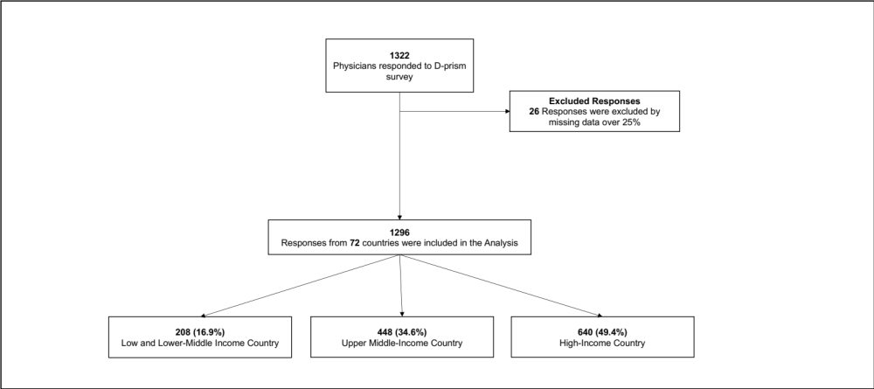

Figure S2. Number of respondents per country

Figure S3. World Bank's classification of regions.

Figure S4. Forrest Plot of Multivariate analysis for factors associated with antibiotic treatment less than 7 days in A. CAP B. HAP C. VAP

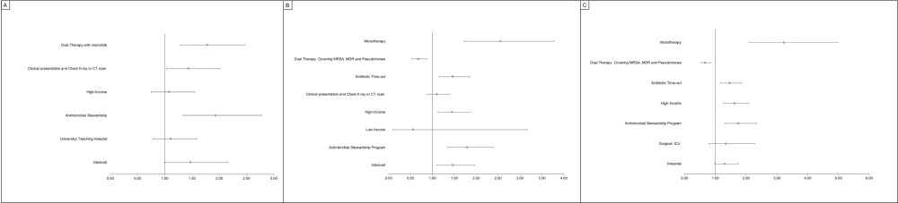

Figure S5. Multiplex tests were reported by the specialists.

