Supplementary File

(a)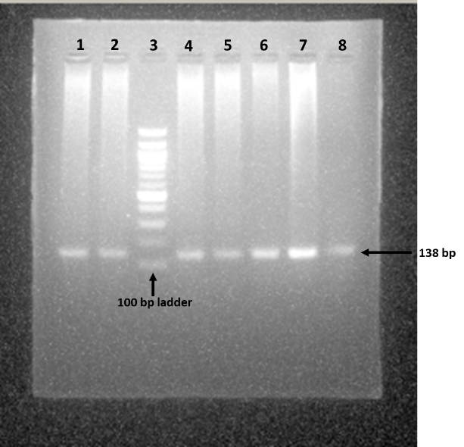 | (b)  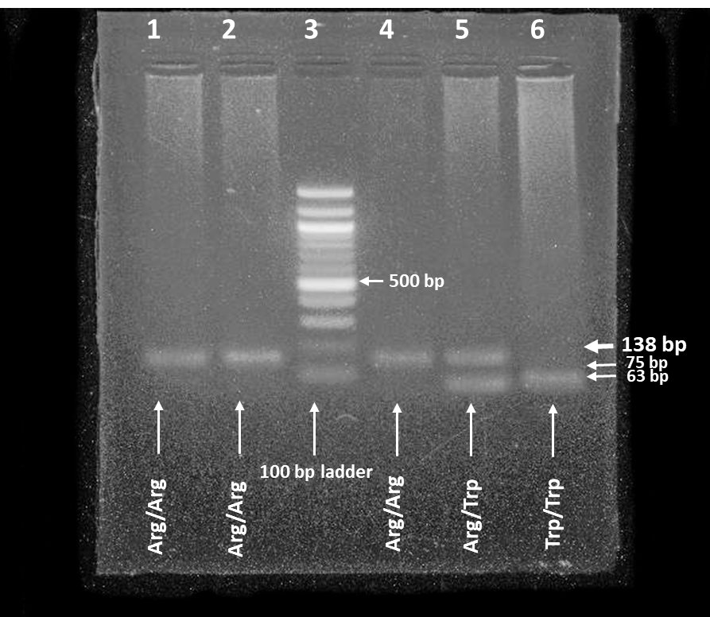
Figure S1:(a) PCR products of XRCC1 gene in 2% Agarose gel. PCR product of XRCC1 (138 bp) is in lanes 1,2, 4 to 7. Lane 3 contains a molecular ruler. (b) Restriction digestion fragments of XRCC1 (Lane 1,2, 4 to 6) resolved in 3% agarose gel. Lane 3 contains a molecular ruler. Lanes 1, 2 and 4, wild-type homozygote (138 bp); Lane 5, heterozygote (138, 75, 64 bp) and Lane 6, mutant homozygote (75, 63 bp).

(a) 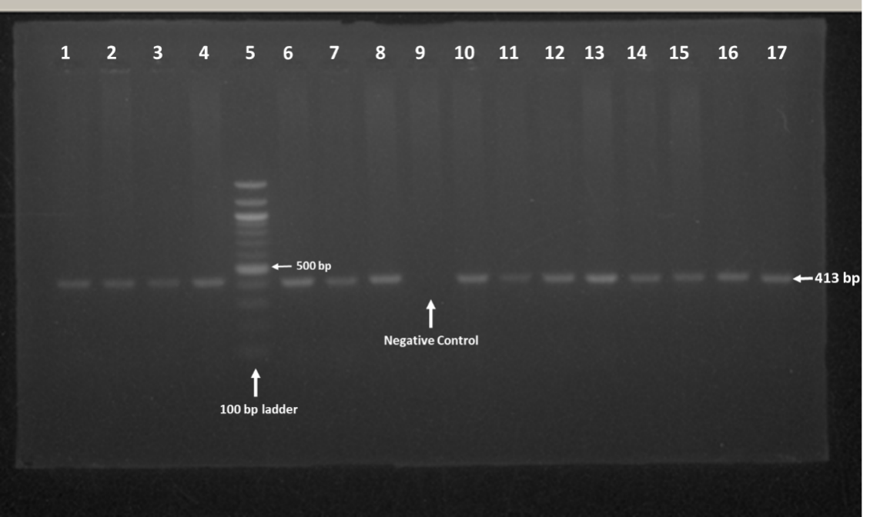
(b)
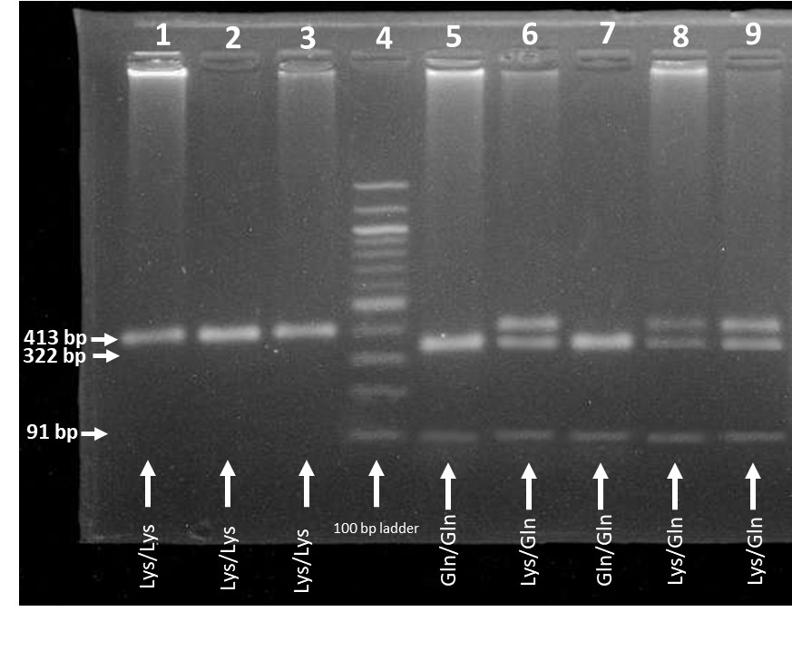
Figure S2:(a) PCR products of XPD gene in 2% Agarose gel. PCR products of XPD (413 bp) are in lanes 1 to 4, 6 to 8 and 10 to 17. Lane 5 contains a molecular ruler. Lane 9 contains negative control. (b) Restriction digestion fragments of XPD (Lanes 1 to 3, 5 to 9) resolved in 3% agarose gel. Lane 4 contains a molecular ruler. Lanes 1, 2 and 3, wild-type homozygote (413 bp); Lane 6, 8 and 9 heterozygote (413, 322 and 91 bp) and Lane 5 and 7, mutant homozygote (322 and 91 bp).

Table S1: Combined Genotypic effects of XRCC1 and XPD genotypes and PCa risk
XRCC1 | XPD | Control (n=135) n (%) | Case (n=132) n (%) | OR (95% CI) | p-value
Arg/Arg | Lys/Lys | 38 (28.15) | 32 (24.24) | 1 (Ref) | -
Arg/Arg | Lys/Gln | 29 (21.48) | 21 (15.91) | 0.83 (0.41-1.78) | 0.71
Arg/Arg | Gln/Gln | 2 (1.48) | 5 (3.79) | 2.88 (0.54-15.03) | 0.26
Arg/Arg | Any Gln | 31 (22.96) | 26 (19.70) | 0.97 (0.48-1.95) | >0.99
Arg/Trp | Lys/Lys | 29 (21.48) | 25 (18.94) | 1.02 (0.49-2.12) | >0.99
Arg/Trp | Lys/Gln | 31 (22.96) | 31 (23.48) | 1.19 (0.61-2.34) | 0.73
Arg/Trp | Gln/Gln | 4 (2.96) | 9 (6.82) | 2.59 (0.69-8.08) | 0.23
Arg/Trp | Any Gln | 35 (26.67) | 40 (30.30) | 1.36 (0.70-2.67) | 0.41
Trp/Trp | Lys/Lys | 1 (0.74) | 7 (5.30) | 8.23 (1.33-95.83) | 0.06
Trp/Trp | Lys/Gln | 1 (0.74) | 2 (1.52) | 2.28 (0.16-36.20) | 0.59
Trp/Trp | Gln/Gln | 0 (0) | 0 (0) | - | -
Trp/Trp | Any Gln | 1 (0) | 2 (1.52) | 2.38 (0.26-35.2) | 0.6
Any Trp | Lys/Lys | 30 (22.22) | 32 (24.24) | 1.27 (0.65-2.50) | 0.6
Any Trp | Lys/Gln | 32 (23.70) | 33 (25.00) | 1.19(0.62-2.29) | 0.73
Any Trp | Gln/Gln | 4 (2.96) | 9 (6.82) | 2.59 (0.69-8.08) | 0.23

