Supplementary Information

Emergence of topological bimerons in monolayer CrSBr

Baishun Yang¹, Xiufeng Han², and Silvia Picozzi¹

1. Consiglio Nazionale delle Ricerche (CNR-SPIN), Unità di Ricerca presso Terzi c/o Università “G. D’Annunzio”, 66100 Chieti, Italy
2. Beijing National Laboratory for Condensed Matter Physics, Institute of Physics, Chinese Academy of Sciences, Beijing 100190, China

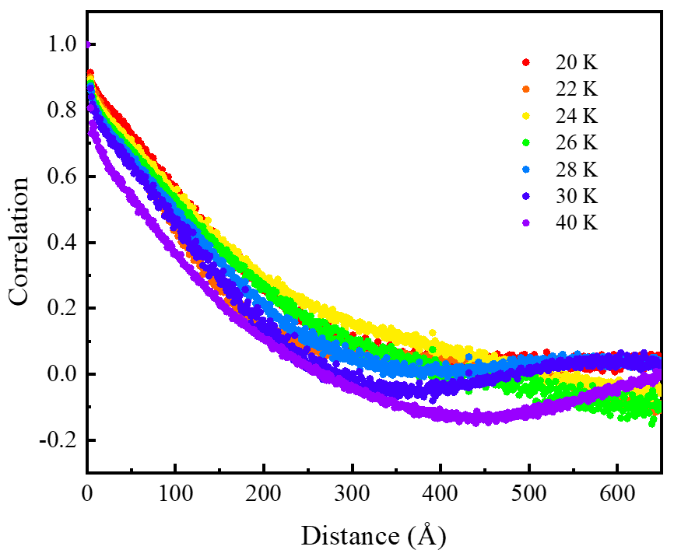

Supplementary Figure 1 | Spin-spin correlation function of 100 nm × 100 nm periodic monolayer CrSBr system in the range from T = 20 to T = 40 K (obtained with spin-dynamics). The algebraic behaviour occurs at about T < 28 K.

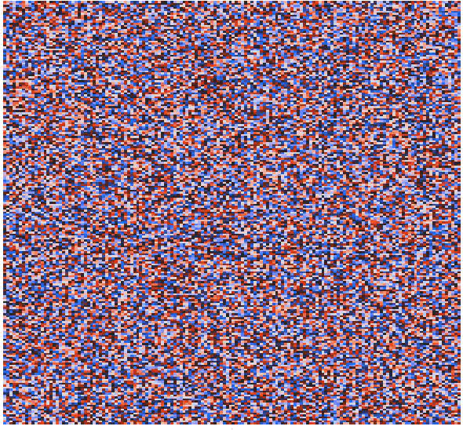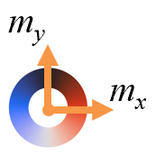

Supplementary Figure 2 | Spin texture evolution of monolayer CrSBr from 160 K to 0 K by means of spin-dynamics. Starting from a random state, it gradually changes to domains, with bimerons at the domain boundaries, domains and FM state.

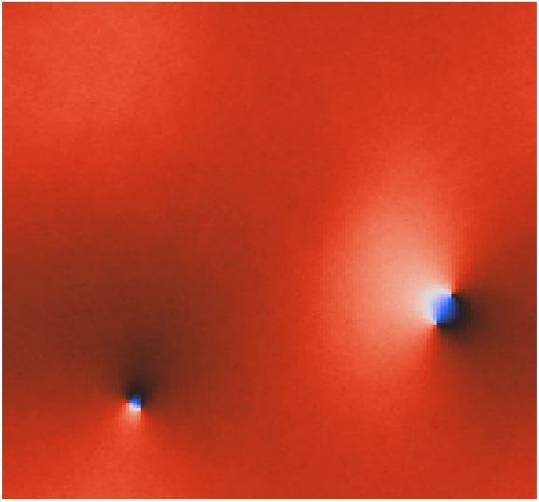

Supplementary Figure 3 | Real-space spin texture from Monte-Carlo simulation at 1K on the monolayer CrSBr real-space spin texture. The topologically non-trivial defective bimerons also occasionally emerge.

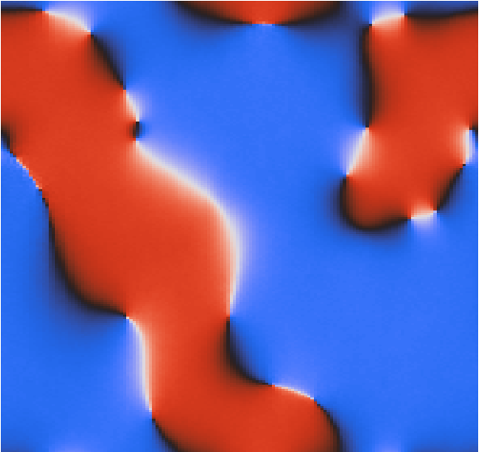

Supplementary Figure 4 | Spin texture of monolayer CrSBr when artificially setting the SIA=0 by spin-dynamics.

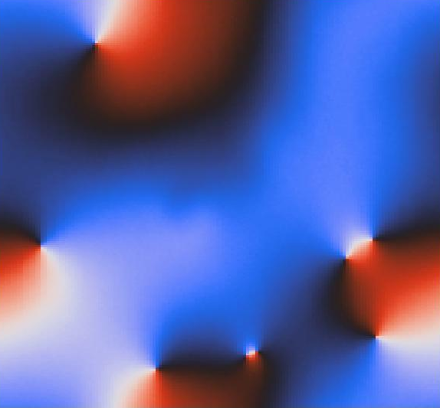

Supplementary Figure 5 | Spin texture of monolayer CrSBr when considering dipole-dipole interactions by means of spin-dynamics.

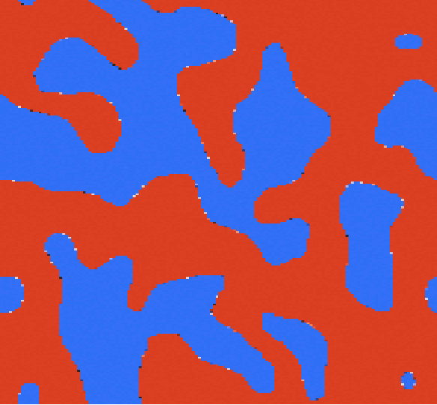

Supplementary Figure 6 | Spin texture of monolayer CrSBr when artificially setting DM=0 by means of spin-dynamics.

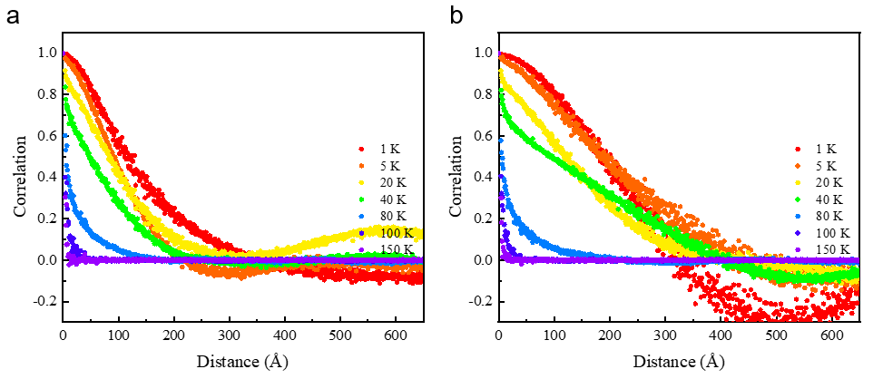
Supplementary Figure 7 | Spin-spin correlation function for monolayer CrSBr at different temperatures by spin dynamics simulations with cooling rate a two times faster (cooling time 0.05ns) and b two times slower (cooling time 0.2ns) than that in Fig. 1e (cooling time 0.1ns) in the main text.

Supplementary Note 1: Bimeron size estimation
As shown in Fig. 2 in the main text, since the bimerons are not forming lattices, they have no defined shape and no uniform size. However, they seem to be approximately circular and always distributed in the whole size of the simulation system under the spin-dynamics simulations. Therefore, we estimate the average bimeron size by
$$D_{bimeron}=\sqrt{A/N}$$
where, A and N represent the size of the simulation systems and the number of bimerons in this simulation system. For example, in Fig. 2 there are in total 7 bimerons distributed in the 100nm×100nm simulation system, thus the average bimeron size is estimated to be 37.8 nm.

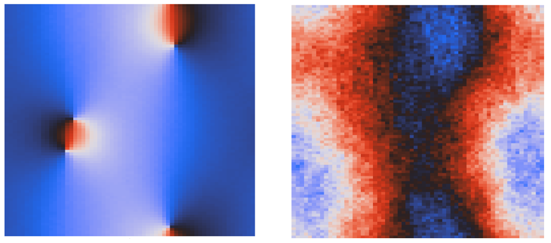

Supplementary Figure 8 | Spin textures of monolayer CrSBr with 40nm×40nm under different initial random states under cooling time 0.1ns by means of spin dynamics.

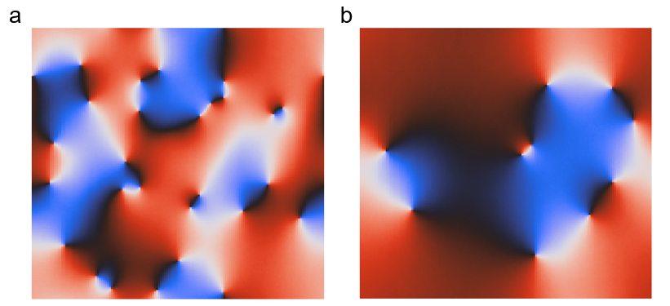
Supplementary Figure 9 | Spin textures of monolayer CrSBr with 100nm×100nm under cooling time a 0.05ns and b 0.2ns, respectively.

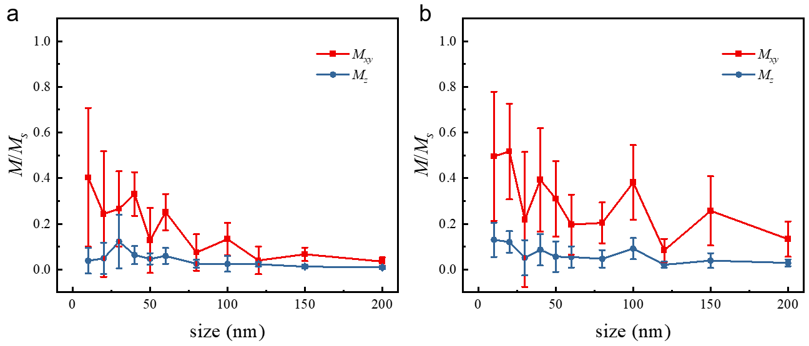

Supplementary Figure 10 | The averaged in-plane (red curve) and out-of-plane (blue curve) magnetic moment for CrSBr for different system sizes (calculated by averaging 10 times) under cooling time a 0.05ns and b 0.2ns, respectively.

Supplementary Note 2: Relation between MC and spin-dynamics results
By using MC simulations, we start from a random spin configuration at 160K and let the spins gradually evolve to intermediate configuration at T_{inter}, with 3,000,000 steps. Then we use the obtained spin configuration at T_{inter} under the MC simulation as the initial state to do the spin dynamics simulation until the temperature reaches 1K after 3,000,000 steps. The evolution of the 80nm×80nm spin textures is shown in Supplementary Fig. 11 (from left to right T_{inter}=120, 80, 50, 10 and 3K, respectively). Furthermore, the total energy of the system at 1K when the temperature cools down from T_{inter} under spin dynamics are plotted in Supplementary Fig. 12. It is clear that at higher intermediate temperatures (T_{inter}=120 and 80K), where the spins are strongly influenced by thermal fluctuations in the spin dynamics process, the system evolves to metastable bimerons at 1K (see Supplementary Fig. 11). However, when T_{inter} is lower (T_{inter}<70K, see black curve in Supplementary Fig. 12), the system evolves to magnetic states with lower energy. In this case, the fluctuation energy is probably not large enough to excite the spin texture to metastable bimerons and only near-to-ferromagnetic states are observed. A faster cooling rate will change the transition temperature to lower values in the spin dynamics simulations, as shown in Supplementary Fig. 12 (consistently with the Kibble-Zurek mechanism). Comparing the energy at 1K from Monte-Carlo simulations (gray dashed line), we can see that a slower cooling rate in the spin dynamics will lead the system energy much closer to that from the Monte-Carlo simulation. In other words, the MC simulation can be ideally thought of as a spin dynamics simulation with super-low cooling rate, in which the ground states are obtained at each temperature.

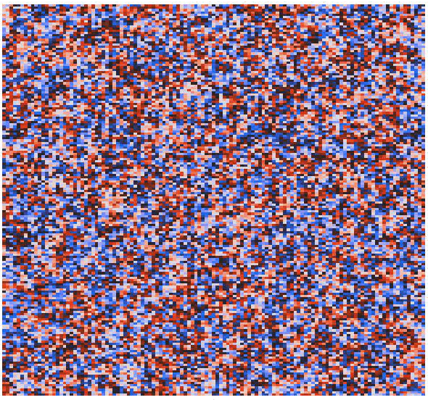
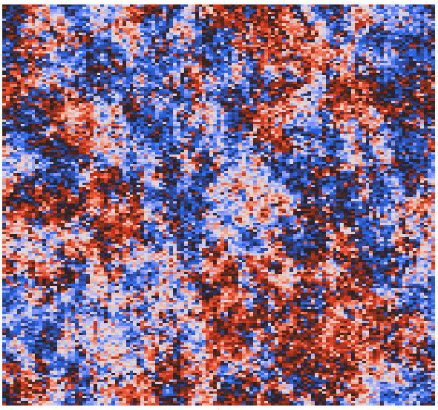
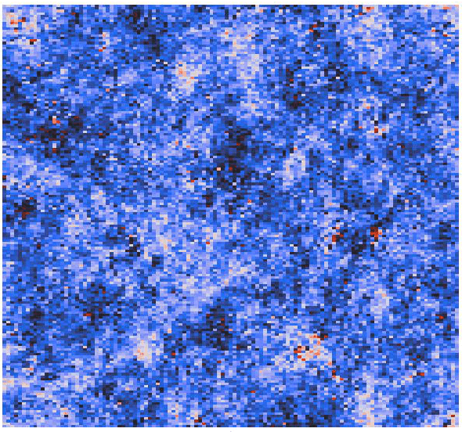
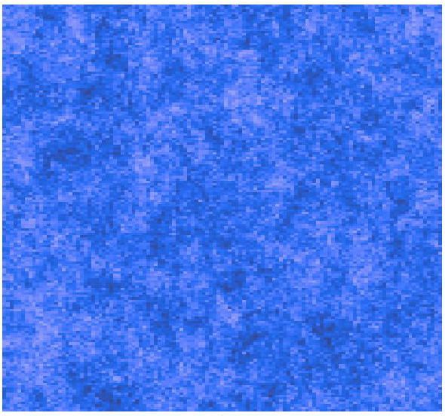
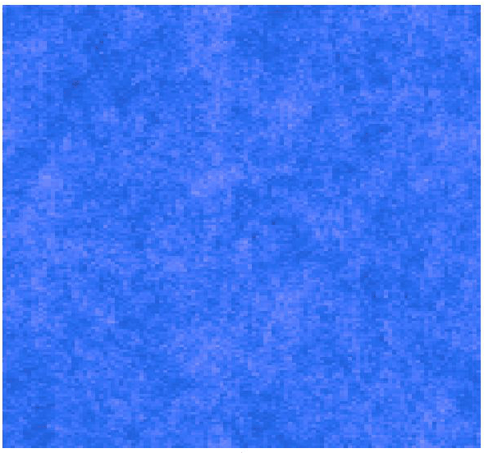

Supplementary Figure 11 | The spin evolution from an initial state at T_{inter}, which is obtained from MC calculation to 1K under spin dynamics calculations. From left to right, T_{inter}=120, 80, 50, 10 and 3K, respectively.

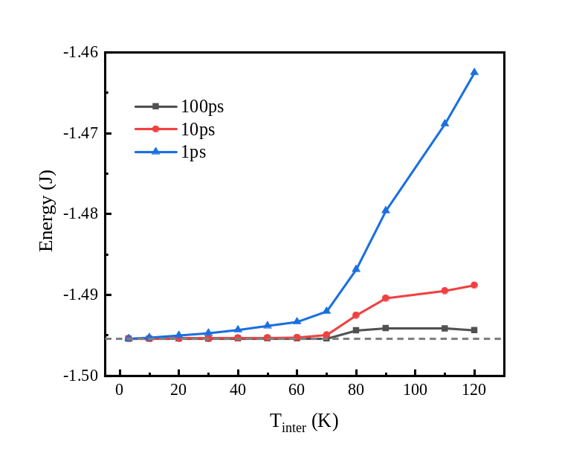
Supplementary Figure 12 | Total energy of 80nm×80nm lattice cooling down from T_{inter} state that obtained from MC simulation to 1K by means of spin dynamics simulations. Black, red, and blue curves represent lower, medium, and faster cooling rate, respectively. The gray dashed line represents the energy at 1K from MC simulations.

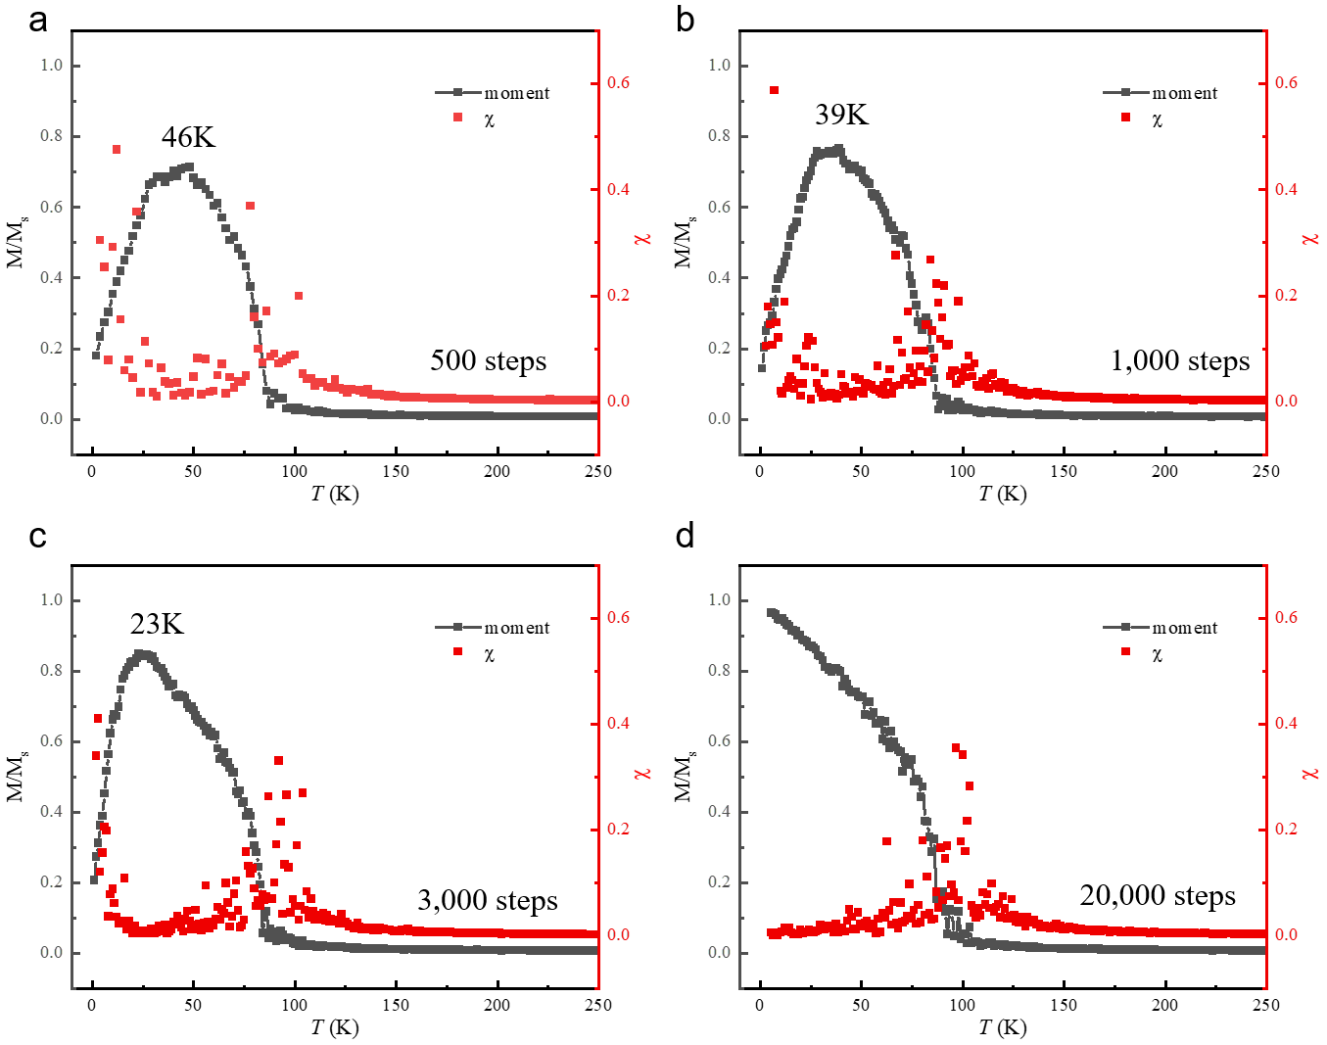
Supplementary Figure 13 | Magnetic susceptibility χ and normalized magnetic moment M/Ms as a function of temperature by MC calculation with a 500, b 1,000, c 3,000, and d 20,000 equilibration-time-steps, respectively. The corresponding T* occurs at around a 46K, b 39K, and c 23 K, respectively. No T* is observed when the equilibration-time-steps is larger than 20,000.

Supplementary Table 1 | Exchange coupling tensor J_{ij} (in meV) for 1st, 2nd, and 3rd nearest-neighbor Cr-Cr pairs, as derived from DFT simulations.
J_{ij} | J_{xx} | J_{yy} | J_{zz} | J_{xy} | J_{yz} | J_{xz} | J_{zx} | J_{zy} | J_{yx}
1st | 4.33 | 4.22 | 4.26 | 0.00 | 0.02 | -0.16 | 0.15 | -0.01 | 0.00
2nd | 5.93 | 5.98 | 5.98 | 0.01 | -0.01 | -0.01 | -0.02 | 0.00 | -0.01
3rd | 2.99 | 2.96 | 2.94 | -0.01 | -0.28 | 0.00 | 0.01 | 0.29 | 0.00

