Supplementary Table 1. Principal component (PC) 1 loadings of significant metabolites from urine (General Metabolism) following FS-CR. Positive loadings (shaded) are correlated with BAS1 and negative are correlated with BAS2. Numeric metabolites had a spectral match factor < 800.

Metabolite | PC1 (29.35%)
406846 | -2.10E-01
401047 | -2.05E-01
222303 | -1.79E-01
34083 | -1.75E-01
389988 | -1.65E-01
18305 | -1.64E-01
127665 | -1.63E-01
520639 | -1.56E-01
6376 | -1.53E-01
33401 | -1.52E-01
112261 | -1.36E-01
356986 | -1.27E-01
2,3-dihydroxybutanoic acid (tartaric acid) | -1.16E-01
arabitol | -1.16E-01
cellobiose | -1.08E-01
alanine-alanine | -9.84E-02
1981 | -9.62E-02
34015 | -9.22E-02
glycerol | -6.88E-02
pipecolinic acid | 8.18E-02
4929 | 8.28E-02
167348 | 8.28E-02
395930 | 9.19E-02
2'-deoxyguanosine | 9.29E-02
piperidone | 9.47E-02
122843 | 1.01E-01
cytosine | 1.04E-01
118995 | 1.04E-01
glycylglycine | 1.10E-01
glucose-6-phosphate | 1.18E-01
209677 | 1.20E-01
189936 | 1.23E-01
117201 | 1.37E-01
131989 | 1.40E-01
20903 | 1.42E-01
7543 | 1.43E-01
N-acetylornithine | 1.46E-01
17143 | 1.58E-01
4983 | 1.62E-01
pentadecanoic acid | 1.64E-01
118989 | 1.65E-01
209172 | 1.70E-01
105214 | 1.74E-01
404049 | 1.80E-01
uric acid | 1.88E-01
nicotinamide | 1.97E-01
379063 | 2.06E-01
210798 | 2.16E-01
Supplementary Table 2. Principal component (PC) 1 loadings of significant metabolites from stool (General Metabolism) following FS-CR. Negative loadings (shaded) are correlated with BAS1 and positive are correlated with BAS2. Numeric metabolites had a spectral match factor < 800.

Variable | PC 1 (48.59%)
cadaverine | -1.58E-01
12444 | -1.55E-01
87712 | -1.53E-01
trans-4-hydroxyproline | -1.44E-01
tryptamine | -1.43E-01
isopalmitic acid | -1.22E-01
4550 | -7.86E-02
480022 | 1.05E-01
fructose | 1.07E-01
117201 | 1.09E-01
199109 | 1.23E-01
sinigrin | 1.27E-01
sophorose | 1.39E-01
371546 | 1.47E-01
416595 | 1.56E-01
pipecolinic acid | 1.57E-01
209172 | 1.57E-01
110429 | 1.63E-01
87282 | 1.65E-01
20282 | 1.67E-01
220224 | 1.68E-01
3,6-anhydro-D-galactose | 1.68E-01
phenylacetic acid | 1.76E-01
114501 | 1.78E-01
127847 | 1.82E-01
372458 | 1.83E-01
erythrose | 1.84E-01
palmitoleic acid | 1.85E-01
N-acetyl-D-tryptophan | 1.86E-01
528624 | 1.87E-01
146226 | 1.89E-01
389988 | 1.96E-01
2-deoxyerythritol | 1.97E-01
UDP-glucuronic acid | 2.03E-01
18157 | 2.03E-01
384914 | 2.04E-01
64891 | 2.05E-01

Supplementary Table 3. Principal component (PC) 1 loadings of significant metabolites from serum (General Metabolism) following FS-CR. Positive loadings (shaded) are correlated with BAS1 and negative are correlated with BAS2. Numeric metabolites had a spectral match factor < 800.

Variable | PC1 (82.30%)
34089 | -2.97E-01
346241 | 2.99E-01
31764 | 3.06E-01
1380 | 3.09E-01
354256 | 3.13E-01
124484 | 3.23E-01
3-Amino-2-piperidone | 3.23E-01
345436 | 3.25E-01
372458 | 3.30E-01
2-picolinic acid | 3.34E-01

Supplementary Table 4. Principal component (PC) 1 loadings of significant metabolites from urine (Complex Lipids) following FS-CR. Positive loadings (shaded) are correlated with BAS1 and negative are correlated with BAS2.

Variable | PC 1 (41.83%)
0.18_172.99 | -1.89E-01
0.19_148.10 | -1.88E-01
0.19_245.15 | -1.79E-01
0.24_312.22 | -1.74E-01
0.21_305.16 | -1.72E-01
0.23_260.22 | -1.71E-01
0.21_569.31 | -1.68E-01
0.24_215.03 | -1.51E-01
0.19_212.00 | -1.46E-01
0.20_192.07 | -1.37E-01
0.20_238.02 | -1.23E-01
3.84_934.79 | 9.61E-02
0.26_152.07 | 1.18E-01
0.25_382.26 | 1.21E-01
0.23_297.00 | 1.26E-01
0.18_135.03 | 1.44E-01
1.59_568.43 | 1.46E-01
1.43_584.42 | 1.59E-01
0.20_124.01 | 1.61E-01
TG 62:14|TG 20:4_20:4_22:6 | 1.62E-01
0.20_265.15 | 1.62E-01
TG 60:13|TG 20:4_20:4_20:5 | 1.67E-01
0.20_145.13 | 1.68E-01
2.48_123.06 | 1.72E-01
0.19_218.10 | 1.72E-01
0.20_230.12 | 1.73E-01
3.54_968.77 | 1.78E-01
1.52_123.06 | 1.81E-01
0.26_141.07 | 1.81E-01
0.60_123.06 | 1.82E-01
0.24_166.09 | 1.87E-01
0.21_123.06 | 1.87E-01
3.21_538.45 | 1.90E-01
0.21_138.09 | 1.95E-01
0.21_137.07 | 2.02E-01
0.30_297.15 | 2.03E-01

Supplementary Table 5. Principal component (PC) 1 loadings of significant metabolites from stool (Complex Lipids) following FS-CR. Positive loadings (shaded) are correlated with BAS1 and negative are correlated with BAS2.

Variable | PC 1 (76.69%)
1.34_445.37 | -1.72E-01
1.33_479.32 | -1.66E-01
FA 17:0 | -1.65E-01
0.94_355.29 | -1.44E-01
0.23_324.23 | 1.30E-01
2.30_207.10 | 1.32E-01
2.30_490.43 | 1.33E-01
0.22_453.20 | 1.39E-01
FA 20:5 (eicosapentaenoic acid) | 1.40E-01
0.47_380.31 | 1.40E-01
4.13_858.79 | 1.45E-01
3.78_896.83 | 1.52E-01
TG 48:4 Isomer A | 1.55E-01
4.16_954.83 | 1.58E-01
0.22_168.07 | 1.60E-01
0.21_495.30 | 1.60E-01
0.23_496.31 | 1.63E-01
0.23_387.20 | 1.64E-01
3.87_974.82 | 1.64E-01
0.34_329.18 | 1.68E-01
4.07_822.81 | 1.74E-01
TG 46:3 Isomer A | 1.75E-01
4.06_549.49 | 1.76E-01
TG 55:6|TG 17:1_18:1_20:4 | 1.78E-01
4.07_976.83 | 1.80E-01
0.23_309.16 | 1.80E-01
TG 62:12|TG 20:3_20:4_22:5 | 1.81E-01
0.75_304.30 | 1.82E-01
TG 46:5 | 1.82E-01
0.19_162.06 | 1.83E-01
0.19_206.05 | 1.84E-01
1.55_569.43 | 1.87E-01
1.59_568.43 | 1.87E-01
2.24_552.43 | 1.87E-01
1.36_568.43 | 1.89E-01
1.39_568.48 | 1.89E-01

Supplementary Table 6. Principal component (PC) 1 loadings of significant metabolites from serum (Complex Lipids) following FS-CR. Negative loadings (shaded) are correlated with BAS1 and positive are correlated with BAS2.

Variable | PC 1 (82.63%)
PC 38:5 Isomer B | -1.92E-01
2.31_858.59 | -1.89E-01
3.21_538.45 | -1.88E-01
3.31_542.48 | -1.86E-01
2.32_860.62 | -1.85E-01
3.18_540.47 | -1.84E-01
2.23_819.61 | -1.84E-01
3.69_971.79 | -1.82E-01
2.10_766.58 | -1.82E-01
PC 40:7 Isomer B | -1.80E-01
2.39_836.67 | -1.76E-01
2.08_832.65 | -1.75E-01
1.47_569.43 | -1.71E-01
2.31_837.61 | -1.68E-01
2.50_814.68 | 1.74E-01
PC 37:4 | 1.75E-01
2.26_798.59 | 1.77E-01
PC 37:3 | 1.79E-01
2.49_813.57 | 1.80E-01
2.12_729.65 | 1.82E-01
2.33_780.59 | 1.83E-01
2.15_754.57 | 1.84E-01
2.13_1586.11 | 1.85E-01
2.47_749.59 | 1.85E-01
SM d36:2 | 1.86E-01
2.13_782.78 | 1.86E-01
PC 33:0 | 1.87E-01
2.56_774.61 | 1.87E-01
2.21_770.57 | 1.89E-01
1.98_727.58 | 1.94E-01

Supplementary Table 7. Principal component (PC) 1 loadings of significant metabolites from urine (Biogenic Amines) following FS-CR. Negative loadings (shaded) are correlated with BAS1 and positive are correlated with BAS2.

Variable | PC 1 (46.35%)
1.43_137.07 | -1.36E-01
1.43_136.65 | -1.35E-01
1.43_139.08 | -1.33E-01
1.43_94.06 | -1.32E-01
(2-oxo-2,3-dihydro-1H-indol-3-yl)acetic acid | -1.24E-01
0.41_146.06 | -1.23E-01
0.45_375.17 | -1.22E-01
0.41_174.05 | -1.21E-01
0.29_385.13 | -1.18E-01
2.23_195.05 | -1.14E-01
N-Acetylmannosamine | -1.14E-01
1.87_349.12 | -1.13E-01
1.93_278.06 | -1.08E-01
0.29_399.14 | -1.07E-01
0.30_415.13 | -1.06E-01
CMPF | -1.06E-01
His-Tyr | -1.06E-01
1.76_176.01 | -1.05E-01
0.35_106.03 | -1.05E-01
2.01_321.08 | -1.05E-01
0.74_258.07 | -1.04E-01
Ser-Arg | -1.04E-01
0.53_74.02 | -1.03E-01
0.30_431.13 | -1.02E-01
Ala-Pro | -1.01E-01
0.37_260.11 | -1.00E-01
2.39_187.94 | -9.90E-02
Threonic acid | -9.87E-02
1.03_135.03 | -9.78E-02
Nicotinamide | -9.75E-02
1.23_264.04 | -9.69E-02
0.31_415.22 | -9.64E-02
2.20_710.24 | -9.52E-02
2.18_458.05 | -9.34E-02
1.03_175.00 | -9.20E-02
N-Methylhistidine | -9.16E-02
1.91_242.09 | -8.62E-02
Dopamine | -8.30E-02
0.36_431.22 | -8.26E-02
0.47_312.97 | -8.12E-02
1.29_495.32 | -8.12E-02
Pyrrole-2-carboxylic acid | -8.07E-02
1.88_238.08 | -8.05E-02
0.31_503.28 | -7.84E-02
1.35_649.32 | -7.79E-02
1.42_438.23 | -7.77E-02
Asp-Asp | -7.60E-02
Phe-Val | 7.91E-02
0.26_241.97 | 8.56E-02
1.86_245.15 | 8.57E-02
0.29_184.07 | 8.67E-02
0.30_572.41 | 8.78E-02
1.32_243.97 | 8.81E-02
1.62_143.05 | 9.02E-02
1.50_189.16 | 9.04E-02
2.32_149.01 | 9.17E-02
1.46_60.05 | 9.20E-02
1.90_315.27 | 9.22E-02
N-Methylphenylalanine | 9.30E-02
0.62_407.11 | 9.39E-02
0.29_202.08 | 9.65E-02
1.21_306.90 | 9.84E-02
1.86_277.08 | 9.85E-02
1.48_314.18 | 9.88E-02
Phenyl glucuronide | 1.02E-01
0.54_916.55 | 1.03E-01
1.79_245.15 | 1.04E-01
0.62_291.99 | 1.05E-01
Tartaric acid | 1.05E-01
Mirtazapine | 1.06E-01
0.43_206.08 | 1.10E-01
4-Aminomethylcyclohexanecarboxylic acid | 1.11E-01
0.23_254.01 | 1.13E-01
0.29_514.36 | 1.14E-01
0.77_135.09 | 1.14E-01
1.86_184.09 | 1.17E-01
Propoxyphene | 1.17E-01
0.32_460.04 | 1.17E-01
Methacholine cation | 1.18E-01
1.87_185.10 | 1.18E-01
0.29_456.31 | 1.19E-01
1.86_125.02 | 1.20E-01
1.38_160.13 | 1.20E-01
Tyr-Phe | 1.26E-01
1.39_279.08 | 1.28E-01
1.86_200.06 | 1.28E-01
1.86_369.10 | 1.28E-01
1.60_196.03 | 1.29E-01
1.30_258.17 | 1.33E-01
1.80_205.10 | 1.34E-01

Supplementary Table 8. Principal component (PC) 1 loadings of significant metabolites from stool (Biogenic Amines) following FS-CR. Positive loadings (shaded) are correlated with BAS1 and negative are correlated with BAS2.

Variable | PC 1 (54.20%)
0.31_373.15 | -1.33E-01
Prochlorperazine | -1.28E-01
1.79_186.05 | -1.22E-01
2.09_449.17 | -1.17E-01
2.50_403.92 | -1.13E-01
0.41_164.03 | -1.10E-01
1.59_359.07 | -1.10E-01
2.12_491.17 | -1.09E-01
0.31_631.26 | -1.01E-01
0.30_572.41 | -9.95E-02
2.24_373.24 | -9.74E-02
Stachydrine | -9.60E-02
0.30_629.26 | -9.30E-02
0.26_536.38 | -8.51E-02
1.47_358.22 | -8.37E-02
1.88_278.06 | -7.82E-02
1.57_189.05 | -7.31E-02
1.39_336.23 | 6.52E-02
Temozolomide | 7.17E-02
CHEMBL1616521 | 7.88E-02
Glycerophosphocholine | 8.13E-02
2-dGMP | 8.38E-02
0.24_126.90 | 8.44E-02
0.33_73.00 | 8.66E-02
0.21_490.42 | 9.08E-02
alpha-Tocopheryl acetate | 9.10E-02
3-Pyridinemethanol | 9.73E-02
1.59_222.04 | 9.92E-02
0.90_219.01 | 1.00E-01
O-Acetylsalicylic acid | 1.02E-01
1.25_703.57 | 1.02E-01
1.00_189.98 | 1.06E-01
1.47_184.10 | 1.07E-01
0.91_142.99 | 1.07E-01
0.40_213.12 | 1.08E-01
Benzene-1,2,4-triol | 1.10E-01
0.36_509.16 | 1.15E-01
1.39_184.10 | 1.16E-01
1.43_317.13 | 1.21E-01
Caffeic acid | 1.22E-01
3,4-Dihydroxybenzoic acid | 1.24E-01
0.56_151.12 | 1.29E-01
Formononetine | 1.30E-01
Tyr-His | 1.30E-01
3-Hydroxyanthranilic acid | 1.33E-01
Cytosine | 1.37E-01
Kaempferol | 1.37E-01
2,3-Dihydroxybenzoic acid B | 1.40E-01
0.52_151.12 | 1.41E-01
1.16_577.36 | 1.42E-01
0.46_185.09 | 1.43E-01
0.54_244.08 | 1.44E-01
0.85_305.96 | 1.45E-01
1.26_539.27 | 1.45E-01
Cytarabine | 1.46E-01
0.46_165.14 | 1.47E-01
Clonidine | 1.47E-01
1.38_631.37 | 1.50E-01
1.26_533.24 | 1.50E-01
Glu-Ala | 1.51E-01
3-(1-Pyrazolyl)-alanine | 1.54E-01
1.28_110.06 | 1.55E-01
0.85_451.04 | 1.55E-01
0.85_696.05 | 1.55E-01
N-Ethyl-4-(dimethylamino)benzylamine | 1.56E-01
Acetaminophen glucuronide | 1.57E-01
3-Amino-3-(4-hydroxyphenyl)propionic acid | 1.57E-01
1.87_349.12 | 1.57E-01

Supplementary Table 9. Principal component (PC) 1 loadings of significant metabolites from serum (Biogenic Amines) following FS-CR. Negative loadings (shaded) are correlated with BAS1 and positive are correlated with BAS2.

Variable | PC 1 (69.17%)
4-Aminobenzoic acid | -2.29E-01
1.16_577.36 | -2.01E-01
1.66_160.11 | -1.98E-01
1.30_568.33 | -1.97E-01
1.26_568.34 | -1.97E-01
0.40_153.06 | -1.95E-01
0.52_151.12 | -1.94E-01
L-Histidinol | -1.93E-01
0.62_150.05 | -1.92E-01
1.68_192.04 | -1.81E-01
1.68_86.10 | -1.81E-01
0.31_234.97 | 1.80E-01
Secnidazole | 1.82E-01
1.32_510.35 | 1.82E-01
Ezetimibe | 1.84E-01
4-Hydroxybenzylcyanide | 1.85E-01
Vanillin | 1.85E-01
0.23_231.00 | 1.86E-01
0.26_230.99 | 1.89E-01
1.41_179.05 | 1.96E-01
1.32_482.32 | 1.99E-01
2.38_149.01 | 2.05E-01
Tartaric acid | 2.07E-01
0.58_207.05 | 2.08E-01
0.23_559.47 | 2.20E-01
0.23_557.45 | 2.21E-01

Supplementary Figure 1. Biplot of urine (General Metabolism) (A) before feature selection and (B) after feature selection. Red diamonds represent samples (scores), and blue triangles represent variables (loadings).

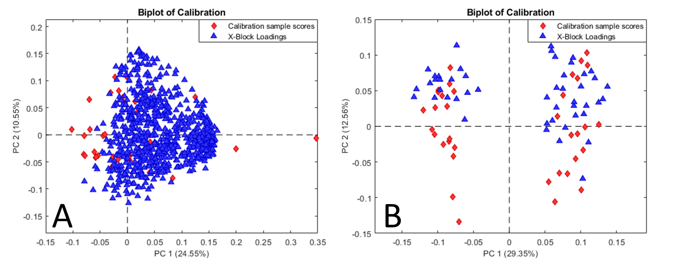

Supplementary Figure 2. Biplot of stool (General Metabolism) (A) before feature selection and (B) after feature selection. Red diamonds represent samples (scores), and blue triangles represent variables (loadings).

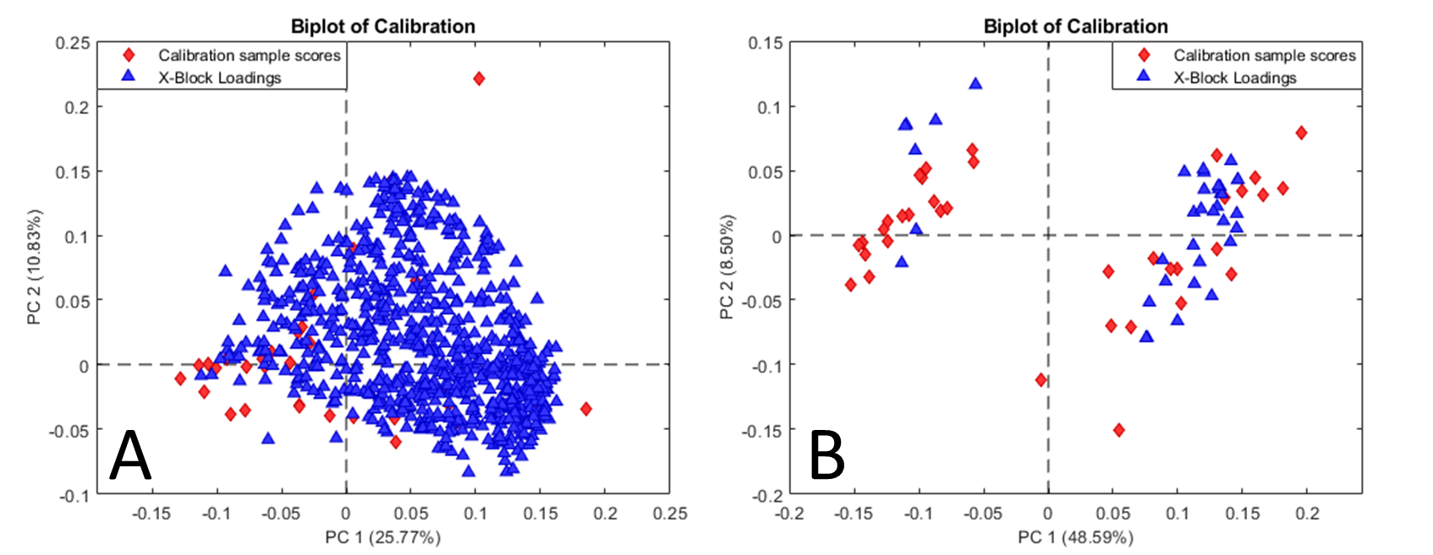

Supplementary Figure 3. Biplot of serum (General Metabolism) (A) before feature selection and (B) after feature selection. Red diamonds represent samples (scores), and blue triangles represent variables (loadings).

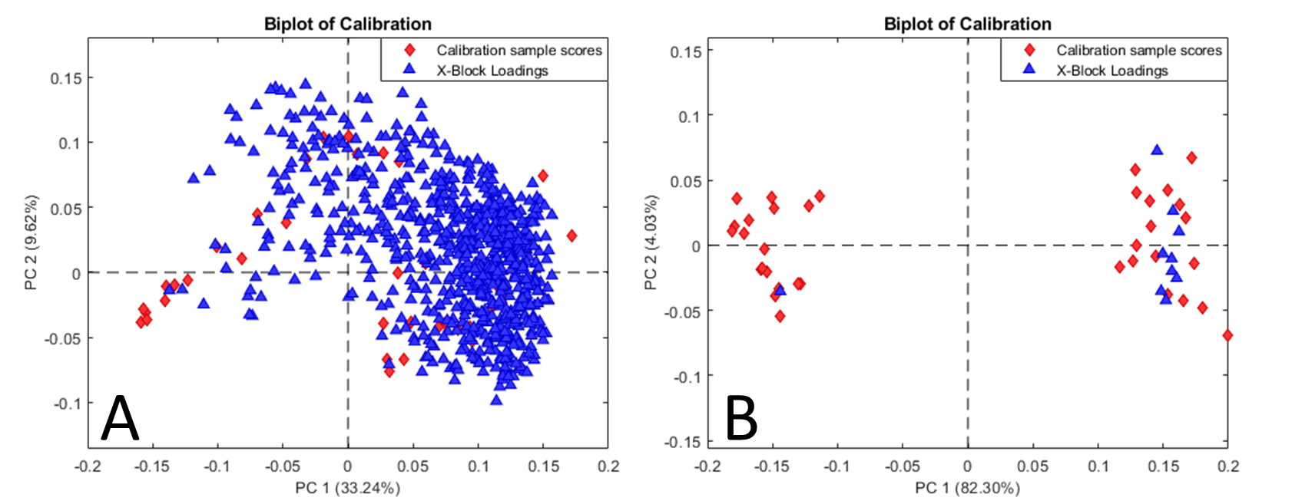

Supplementary Figure 4. Biplot of urine (Complex Lipids) (A) before feature selection and (B) after feature selection. Red diamonds represent samples (scores), and blue triangles represent variables (loadings).

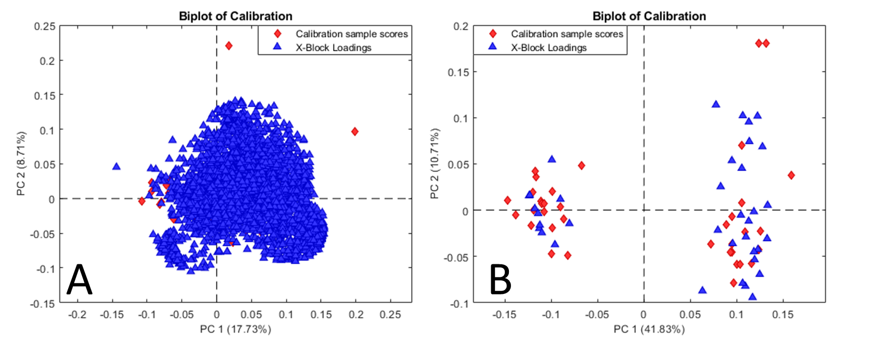

Supplementary Figure 5. Biplot of stool (Complex Lipids) (A) before feature selection and (B) after feature selection. Red diamonds represent samples (scores), and blue triangles represent variables (loadings).

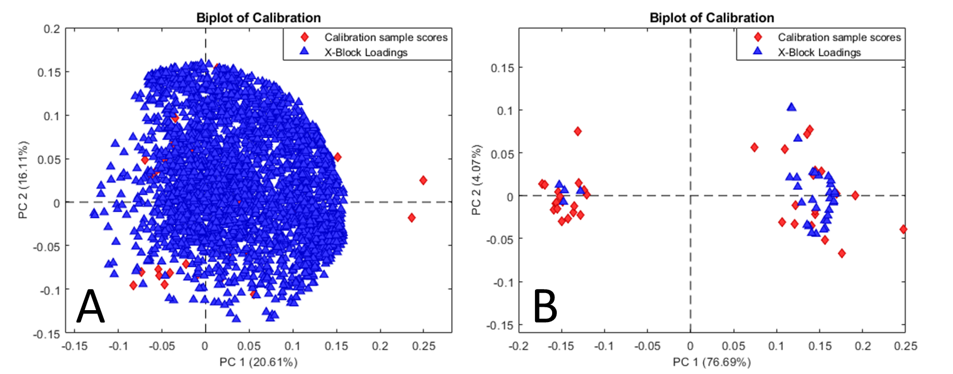

Supplementary Figure 6. Biplot of serum (Complex Lipids) (A) before feature selection and (B) after feature selection. Red diamonds represent samples (scores), and blue triangles represent variables (loadings).

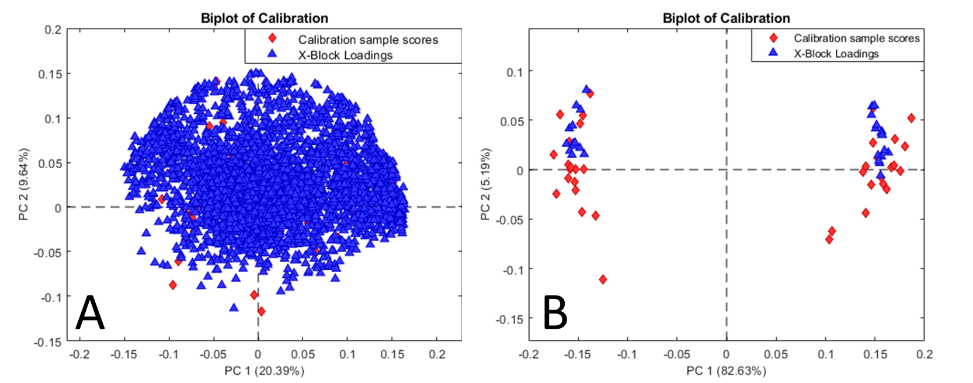

Supplementary Figure 7. Biplot of urine (Biogenic Amines) (A) before feature selection and (B) after feature selection. Red diamonds represent samples (scores), and blue triangles represent variables (loadings).

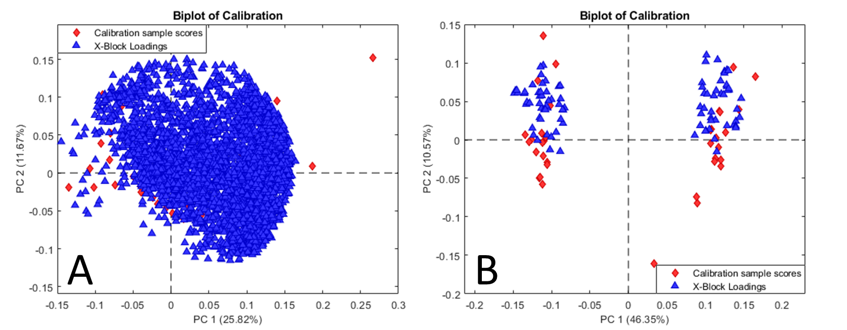

Supplementary Figure 8. Biplot of stool (Biogenic Amines) (A) before feature selection and (B) after feature selection. Red diamonds represent samples (scores), and blue triangles represent variables (loadings).

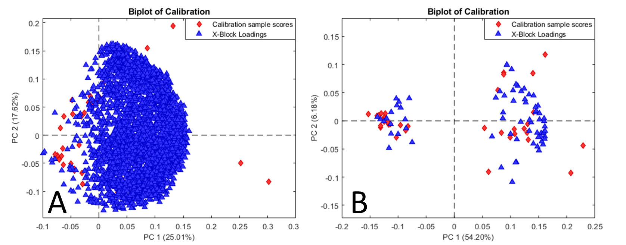

Supplementary Figure 9. Biplot of serum (Biogenic Amines) (A) before feature selection and (B) after feature selection. Red diamonds represent samples (scores), and blue triangles represent variables (loadings).

