Long read sequencing for pathogenic and novel variation discovery in patients with rare diseases

FIGURES
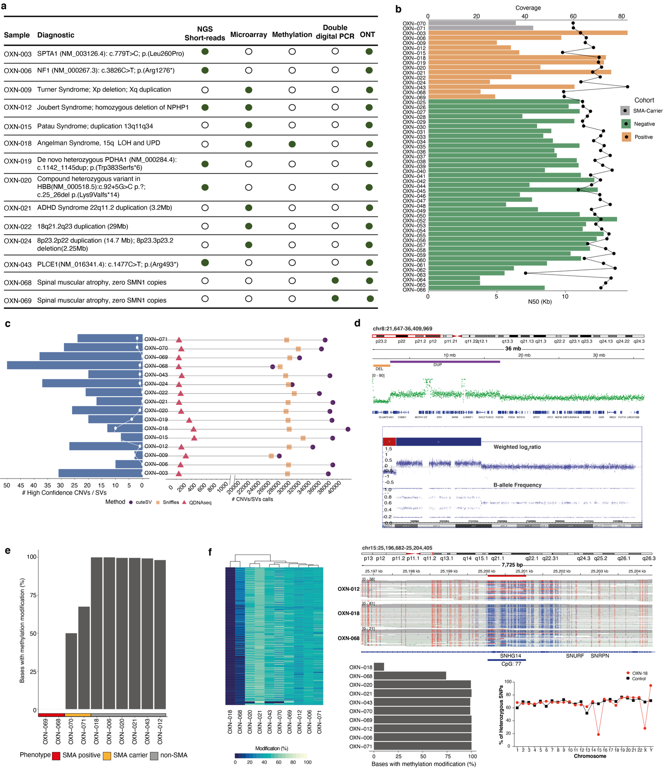
Figure 1. Positive cohort description and detected genomic variants. Shown are a) table describing the samples in the Positive cohort with the clinical assay conducted confirming the diagnosis. b) Nanopore whole genome sequencing quality showing N50 and coverage. c) Reported in the right side of the graph are the detected number of genomic variants - CNVs, SVs, and in the left side are high confidence variants, post funnel down filtering identified using LRS either from CNVs (white line graph) or SVs (blue bars). d) a complex tandem deletion and duplication event observed in OXN-024 by LRS (top panel) and confirmed by CMA (bottom panel). e) Percentage of bases in SMN1 region chr5:70239954-70249165 observed to have base modification in positive cohort. f) heatmap with % methylation across all the bases within the Angelman/Prader Willi 15q11.2 CpG 77 region (chr15:25200035-25201054, left panel) with percentage of bases modified within the region (bottom left panel). IGV methylation view is shown (top right panel) along with the percentage of heterozygous SNPs across all chromosomes (bottom right panel) of a positive control Angelman sample (OXN-018) relative to other samples. OXN-068 showed a similar profile to OXN-018 though 70% of the bases were modified at low levels, indicating that it was not positive for Angleman Syndrome, which was confirmed by MS-MLPA test.

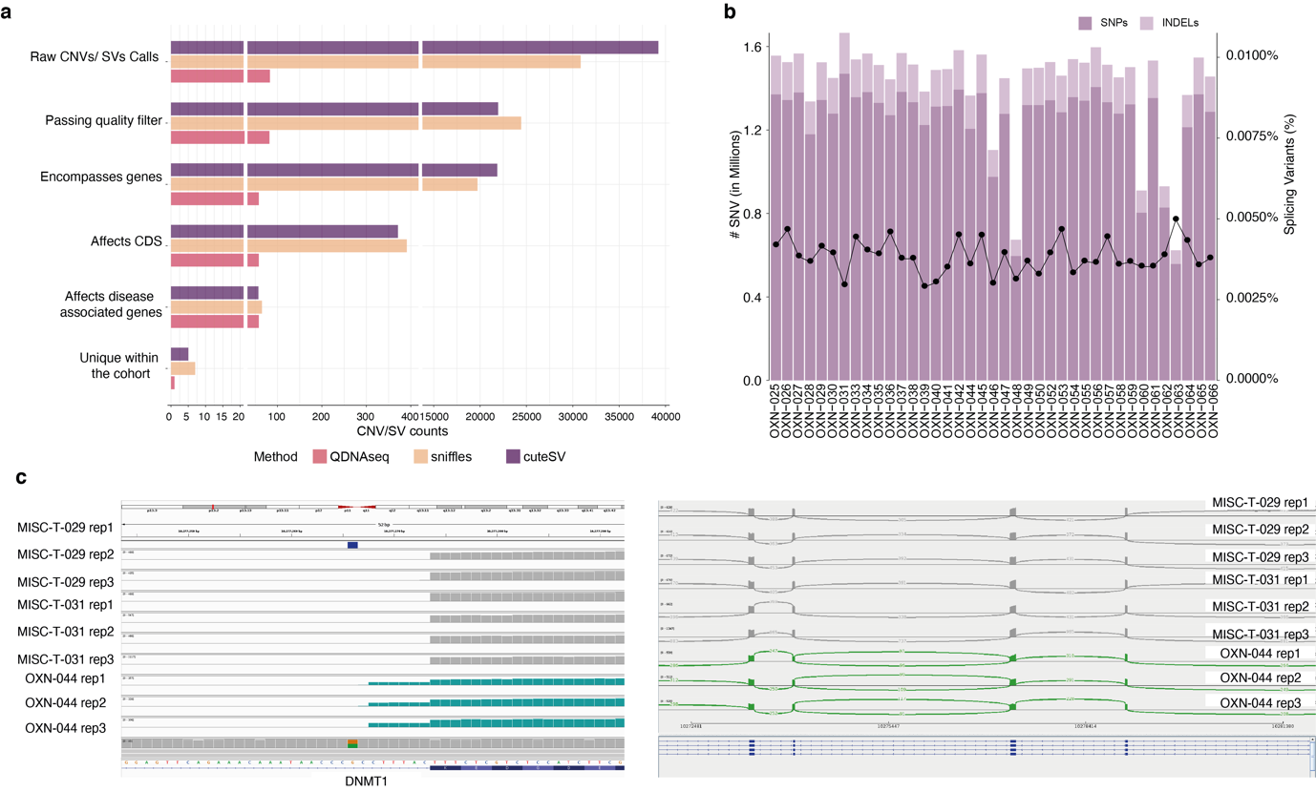
Figure 2. Variant statistics on “Funnel down” approach in genomics variants and splicing events. Shown are the a) counts of CNVs and SVs for each method in each filtering step of “funnel down” approach. b) number of splicing variants within 50bp of exon-intron boundary (bars) and the percentage of splicing variants passing filtering criteria and present in disease causing genes (black line). c) shown is the effect of a splicing variant in OXN-044 with high spliceAI prediction (>0.5), leading to altered 3’ exon with in-frame inclusion of two amino acids as shown by RNAseq data (Left, a heterozygous intronic C>A SNV in the DNMT1 gene leading to a heterozygous extension of the exon by 6 nucleotides, green bars, compared to two control replicates, MISC-T-029 and MISC-T-031. Right, Sashimi plot showing the introduction of a novel splice junction in OXN-044 (green) compared to controls samples (grey).

