Extended data figures
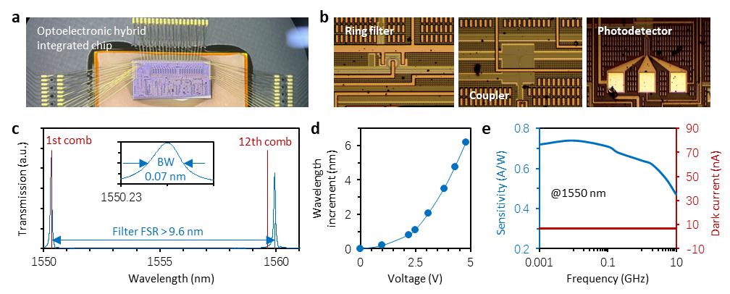
Ext. Data. Fig. 1. Characterizations and performances of the devices on chip. a, Picture of the integrated chip. b, Close ups of major components, including silicon ring filter, coupler, and Ge-photodetector. c, Transmission of a ring filter. FSR of every ring filter is > 9.6 nm, suitable for 12 comb lines whose total bandwidth < 9.3 nm. Bandwidth of the ring resonance is 0.07 nm. d, The ring filters can be thermally tuned through the application of heaters. By adjusting the heating voltage from 0 to 5 V, the central wavelength of each ring filter can be shifted over a range of 6 nm. This allows for precise filtering of each comb line. e, Sensitivity (blue curve) and dark current (bias -1 V, red curve) of a photodetector on-chip.

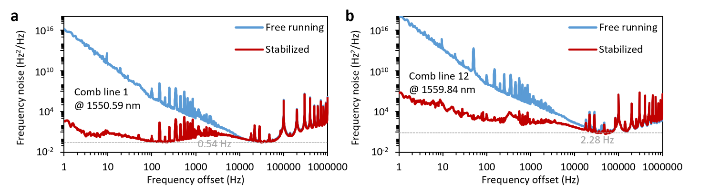
Ext. Data. Fig. 2. Frequency noises of the comb lines. a, Measured frequency noise of the first comb line (@1550.59 nm), before and after feedback stabilization. After stabilizing, minimum linewidth is 0.54 Hz when the frequency offset is 200 Hz. Meanwhile, for 1 Hz offset (slow fluctuation), linewidth of the comb line is 21 Hz. b, Measured frequency noise of the 12th comb line (@1559.84 nm), before and after feedback stabilization. After stabilizing, minimum linewidth is 2.28 Hz when the frequency offset is 71 kHz. Meanwhile, for 1 Hz offset (slow fluctuation), linewidth of the comb line is 2.38 kHz.

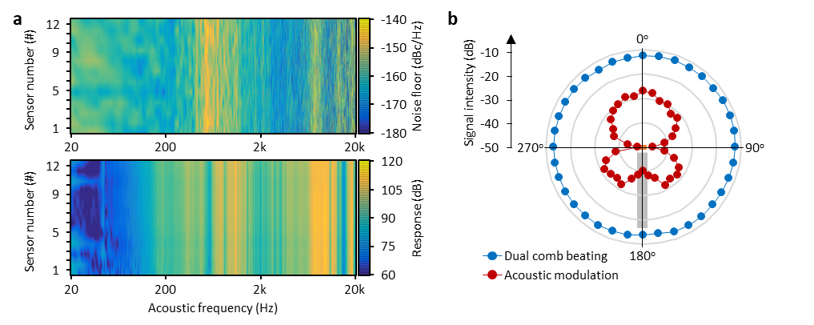
Ext. Data. Fig. 3. Response consistency and Directionality of FOMs. a, Measured noise floors and responses of 12 FOMs. In the acoustic band 20 Hz ~ 20 kHz: 1) the maximum noise floor ≈ -150 dBc/Hz @ 600 Hz, the minimum noise floor ≈ -170 dBc/Hz @ 4 kHz; 2) the maximum response is ≈ 110 dB @ 12 kHz, the minimum response is ≈ 75 dB when the acoustic frequency < 80 Hz. b, Measured acoustic directionality of a FOM, here the 0 degree marks the position directly facing the FOM. Using an acoustic wave with frequency 2 kHz, the blue dots show the dual-comb beating intensity, while the red dots show the acoustic modulation intensity at 2 kHz away.

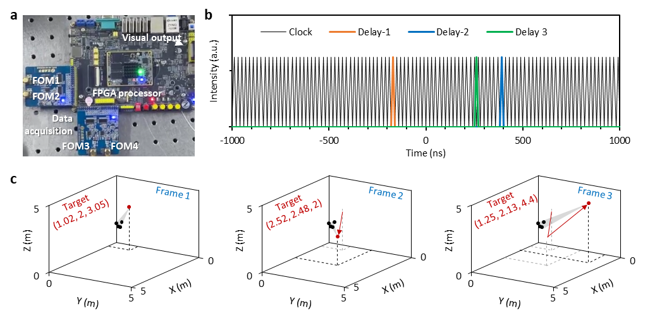
Ext. Data. Fig. 4. Real-time demodulation of target’s spatial position using FPGA. a, Picture of the FPGA processor for demodulating the coordinates of acoustic targets. b, In digital processing, we use a clock (100 MHz) to localize the arrival coherences between the target and sensors. Here we show an example: orange, blue and green curve respectively shows the cross-delay of <target-FOM1, target-FOM2>, <target-FOM1, target-FOM3>, and <target-FOM2, target-FOM3>. c, 3D interface displays the dynamic spatial position of an acoustic target. Here black dots show the FOMs, red dots show the target. Arrow: target movement.

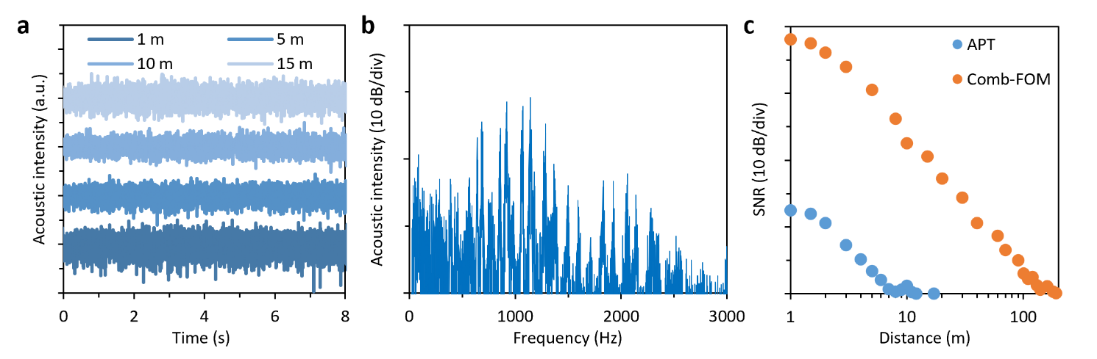
Ext. Data. Fig. 5. Acoustic characteristics of the UAV. a, Temporal traces, measured by using an electronic microphone (APT), at 1, 5, 10, 15 m away. b, Acoustic spectrum of the UAV, measured by using an electronic microphone (APT), at 1 m away. c, SNR versus distance. Blue dots show the results got from an electronic microphone (APT), orange dots show measured data from a comb-driven FOM.

