Supplementary information of
On-chip dual-microcomb based fiber-optic acoustic mapper

Xin-Yue He^{1,#}, Teng Tan^{1,2#}, Bing Chang^{1,#}, Jin-Long Xiang³, Zi-Yi Yang¹, Shang-Ce Wang¹, Ze-Ping Wang^{1,4}, Yu-Pei Liang¹, Heng Zhou^{1,2}, Yong-Jun Huang⁵, Ying-Zhan Yan⁶, Yi-Kai Su³, Yun-Jiang Rao¹, Yu Wu¹, Xu-Han Guo³, Bai-Cheng Yao^{1,2}*

¹ Key Laboratory of Optical Fiber Sensing and Communications (Education Ministry of China), University of Electronic Science and Technology of China, Chengdu 611731, China.
² Engineering Center of Integrated Optoelectronic & Radio Meta-chips, University of Electronic Science and Technology, Chengdu, China.
³ State Key Laboratory of Advanced Optical Communication Systems and Networks, Shanghai Jiao Tong University, Shanghai, China.
⁴ Glasgow College, University of Electronic Science and Technology, Chengdu, China.
⁵ Engineering Research Center of Communication Technology for Intelligent IoT, University of Electronic Science and Technology of China, Chengdu, 611731, China.
⁶ Information Science Research Institute, China Electronics Technology Group Corporation, Beijing 10086, China.
These authors contributed equally: Xin-Yue He, Teng Tan, Bing Chang
Corresponding authors: yaobaicheng@uestc.edu.cn

The supplementary information includes:
Supplementary Note S1-S2.
Supplementary Figure S1-S10.

Note S1. Supplementary theoretical analysis and simulations.

S1.1. Soliton generation in an on-chip micro-ring.
Two silicon-nitride (Si₃N₄) microring cavities with a width-height cross-section of 1600$×$800 nm² and a diameter of 446 μm are utilized for Kerr soliton dual-microcomb generation. According to the design parameters of the microring, the transverse electrical mode field distribution and longitudinal mode fields of the microring cavity are simulated by COMSOL Multiphysics, as shown in Fig. S1a and Fig. S1b, respectively. The longitudinal mode interval obtained by our simulation is 0.8 nm (≈ 100 GHz). Fig. S1c demonstrates the simulated intracavity electric field distribution (longitude modes) of the fundamental mode (transverse mode) satisfying the resonant condition near 1549.6 nm. The Si₃N₄ microring parameters obtained by simulation and experiment are summarized in Table S1.
Table S1. Parameters used in analytical calculations for soliton microcomb
Parameters | Value
n_{eff} | 2.14
L | 1.4 mm
D₁ | 100 GHz
γ | 1.0 w⁻¹∙m⁻¹
β₂ | -80×10⁻²⁷ s² m⁻¹
Q | 4×10⁶
α | 0.003
θ | 0.0015

Based on the parameters shown in the table, and using the Lugiato-Lefever equation (LLE) model, we numerically calculate the generation process of soliton microcomb in the microring. The LLE can be expressed as follows [¹]:
(S1)
Here, t_{R} represents roundtrip time of the Si₃N₄ microring, t and τ are denote the slow time at the scale of the cavity photon lifetime and the fast time defined in a reference frame moving at the light group velocity in the cavity, respectively, which are used to describe the evolution of the intracavity comb field E (t, τ). On the right side of the equation, κ is total intracavity power loss, δω₀ is phase-detuning, which can be expressed as δω₀ = δω × t_{R}, where detuning δω = ω₀ – ω_{p}, ω₀ and ω_{p} are angular frequencies of pumping resonance and pump, respectively. L is cavity length, β₂ is GVD, while higher-order dispersion is neglected. γ is nonlinear coefficient, θ represents coupling power loss, equal to half of κ when critical coupling is considered, E_{in} is the complex field of pump intracavity, neff is the effective refractive index in fiber, and α is the cavity decay per roundtrip.
Fig. S1d-f illustrate the calculated evolution of intracavity power. Optical field in time domain and optical field in frequency domain change with the pump wavelength red-detuning, respectively. These three figures demonstrate the typical time-frequency characteristics of a soliton frequency comb [²]. During this simulation, a soliton state can be clearly observed. Single soliton appears after the states including primary comb, chaotic state and multi-soliton state. Here, we ignore the effect of thermal on soliton formation. In practical experiments, an important problem affecting the formation of soliton combs is thermal balance, which limits the stability and robustness of soliton combs in applications. In the experiment, we can obtain deterministic single soliton production in two microrings using an auxiliary laser heating scheme [³], a strategy that makes our dual-comb source reliable and applicable as an out-of-lab tool.
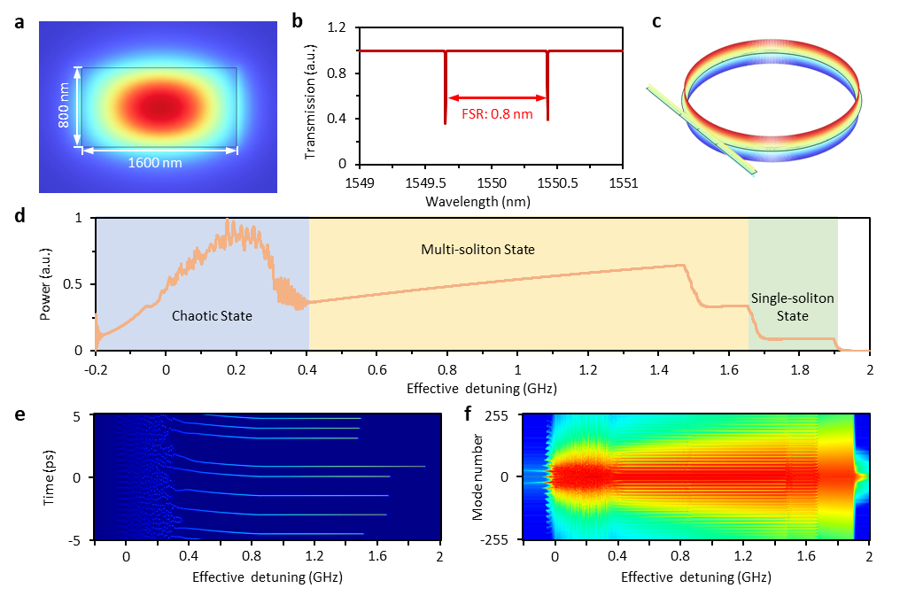
Fig S1. Numerical simulations of an integrated Kerr soliton frequency comb. a, Transverse mode field distribution of microring resonator. b, Longitudinal resonances of the microring, FSR ≈ 0.8 nm. c, Intracavity electric field distribution of the resonant mode near 1549.6 nm. d-f, The evolution of intracavity power, optical field in time domain and optical field in frequency domain with the pump wavelength red-detuning.

S1.2. Fabry-Perot cavity and its acoustic sensing properties.
We use optical fiber Fabry-Perot (F-P) microcavities as opto-acoustic sensors. For enhancing acoustic response, these microcavities are incorporated by metal film fabricated via micro electromechanical system (MEMS). Fig S2a shows the model of our F-P acoustic sensor. When external sound pressure acts on the propagation film, the deformation of the MEMS film will cause changes in the optical fiber F-P cavity. This leads to a spectral shift of the optical resonance inside [⁴]. In our experiment, we use one frequency comb line to detect the resonance shift of every F-P cavity. The intensity alteration of the reflected light refers to the acoustic magnitude. Specifically, the cavity length L of an F-P cavity can be detected in the following equation:
(S2)
Here, λ₁and λ₂ are the two central wavelengths of adjacent resonance peaks in the Fabry-Perot cavity interference spectrum. They can be directly measured from the interference spectrum; n = 1 is the refractive index of the medium in the F-P cavity, as the F-P cavity is filled with air.
In sensing application, the two reflective end faces of the fiber F-P cavity (MEMS film and single-mode fiber end face) are weakly reflective surfaces (< 5%), we can approximately equate it in double-beam interference model [⁵]. Accordingly, the total reflected intensity of the fiber F-P cavity at a wavelength λ can be expressed as:
(S3)
Here, I_{Fiber}(λ) is the reflected intensity of the single-mode fiber (SMF) facet, I_{MEMS}(λ) is the reflected intensity from the MEMS diaphragm, λ ≈ λ₁≈ λ₂ when the free spectral range (FSR) of the F-P resonator (sub-THz level) is much smaller than the optical frequency (200 THz level). In dual comb demodulation, cos(4πL/λ) mainly demonstrates acoustic modulation.
When an external sound pressure P is applied to the MEMS diaphragm, the deformation of the diaphragm will change the F-P cavity length (ΔL), as Fig. S2b illustrates. Within the dynamic range of the MEMS diaphragm, such a change of cavity length ΔL caused by the sound pressure is linear:
(S4)
In this equation, α is a constant. Therefore, it can modulate the reflection intensity ΔI(λ) by shaping in ΔL. When changing the ΔL, I(λ) become:
(S5)
The intensity modulation writes:
(S6)
For getting the highest sensitivity, we choose a λ satisfying cos(4πL/λ) = 0, so that:
(S7)
Such an effect is schematically shown in Fig. S2c. This optical modulation can be detected by a photodetector (PD) and demonstrated in electronics. Therefore, the sensitivity of the MEMS diaphragm-based fiber optic F-P acoustic wave sensor is mainly affected by the following two factors: 1) the displacement of the elastic diaphragm at the center of the diaphragm under unit sound pressure; 2) the reflected optical intensity. We can check the response via measuring the modulation depth D = |ΔI/I(λ)|, it equals to:
(S8)
When assuming I_{Fiber}(λ) = I_{MEMS}(λ), D can be further simplified as |sin(4πΔL/λ)|. When ΔL is far smaller than λ, the response is approximately linear, ≈ 4πΔL/λ. For a circular elastic diaphragm with a fixed periphery, its acoustic response sensitivity (S) can be expressed as the maximum diaphragm displacement caused by unit sound pressure change L, written in the following equation [⁶]:
(S9)
The cut-off frequency of forced vibration is:
(S10)
In these equations, r is the effective radius of the film, that is, the inner radius of the glass sleeve of the fiber optic F-P acoustic sensor, h is the thickness of the film, μ is the Poisson's ratio of the film, and Y is the Young’s modulus of the film, ρ = 3.17 g/cm³ is the material density. When the external sound pressure of the film is constant, a larger radius of the film or a smaller thickness of the film can enable a higher sensitivity. Besides, a smaller Young’s modulus can also promote sensitivity. In practice, the above parameters which determine the sensitivity of the diaphragm cannot be freely designed. For instance, in fabrication, due to the thermal preparation, a diaphragm will suffer initial stress. As a result, h cannot be infinitely small. In this work, we use a thin film with a designed micro-structure instead of a pure flat film. The schematic design is shown in Fig. S2d. This structure can reduce rigid resistance and residual stress by using the annular corrugated geometry, e.g. 5 concentric rings. This can increase the μ and decrease the Y. In our device, r = 0.9 mm, h = 400 nm. Specifically, μ of a flat silicon nitride film (made via PECVD) is 0.2, Y of a flat silicon nitride film is 280 GPa [⁷]. In Table S2, we compare the parameters of a flat silicon nitride film and a structured silicon nitride film.
Table S2. Parametric comparisons between pristine and micro-structured SiN diaphragm.
 | Y (GPa) | μ | S (μm/Pa) | f_{Cut} (GHz)
Flat diaphragm | 280 | 0.2 | 6.59 | 83.1
Micro-structured diaphragm | 100 | 0.1 | 19.02 | 12.4

In acoustic sensing applications, sensitivity and frequency response bandwidth are the two most important indicators. We use the commercial software ANSYS to establish a simulation model of the MEMS diaphragm, as Fig. S2e shows. The simulation area is π×(0.9)² mm² on the x-z plane. The diaphragm has 5 concentric corrugated rings, and its thickness h = 400nm. In this simulation, the diaphragm material is silicon nitride. Fig. S2f shows the simulated displacement of the diaphragm when we set the pressure P = 2 mPa. Specifically, when the pressure is temporal constant (f_{P} = 0 Hz), the maximum ΔL is 38 nm. when the pressure changes fast (f_{P} = 1 MHz), the maximum ΔL is 38 nm as well. When in our work, typical FSR of the F-P cavity is 1.5 THz and L is 100 μm in approximation. Using this parameter, we set λ = 1550.4 nm. In Fig. S2g we calculate the optical modulation depth (D) versus the frequency of pressure (f_{P}). We see that the silicon nitride MEMS film can well detect a fast vibration higher than 10 MHz, which is sufficient for acoustic sensing.
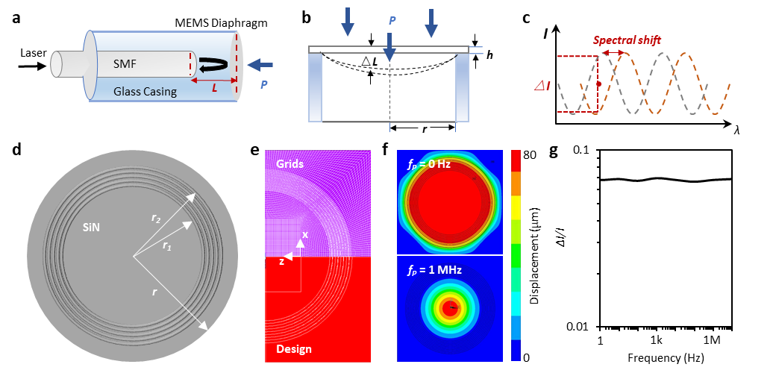
Fig.S2. Acoustic sensing using a MEMS diagram-based F-P cavity. a, Schematic diagram of an F-P cavity, which is sensitive to external pressure, SMF: single mode fiber. b, Principle of the response, external pressure changes the shape of the MEMS film, and tunes the cavity length of the F-P resonator. c, Alteration of the cavity length changes the optical resonance, which leads to reflected intensity modulation at a specific wavelength. d, Top view of our MEMS diaphragm. e-f, Simulated displacements of the MEMS film, when adding pressure on it. g, Calculated response bandwidth of the MEMS diaphragm.

S1.3. Influences from the laser instability.
In schematics, Fig. S3a shows the model in which we use a fixed laser line (e.g. a comb line) to detect the resonance shift. Since the reflectivity of the fiber/air facet and the air/MEMS film is pretty small (<5%), such an F-P resonator has a very low finesse (≈ 1). The resonant spectrum of our FOM could be approximately written in:
(S11)
Here f is the optical frequency, r is the resonant magnitude, c = 3×10⁸ m/s is the light velocity, ΔL ≈ 10⁻⁴ mm is the cavity length. Free-spectral-range (FSR) of every FOM is on 1.475 THz level around 1550 nm. On the other hand, power spectrum of the laser can be simplified as:
(S12)
Full width at half maximum (FWHM) of L(f) is 1.76M. The reflected laser power is ∫L(f)R(f)df. Here l is the laser’s peak power density, f₀ is the central frequency of the laser, and M determines the linewidth of the laser. For a fixed L(f), when the reflection curve changes from R(f) to R’(f), the reflected laser power alters, as the red area shows in schematics. In qualitative simplification, we can approximately assume f₀ = 0 and linearly simplify L(f), R(f) and R’(f) in a narrow band:
(S13)
Here a and b are reflectivity at f = 0, before and after applying an acoustic pressure, n is a parameter relying on the laser linewidth (δ), δ = l/n. Fig. S3b shows this simplification. The acoustic pressure induced reflected power alteration is:
(S14)
Now we consider that there exists power fluctuation Δl and frequency drift Δf in the laser between two measurements, i.e. the L(f) writes:
(S15)
Therefore, the acoustic pressure induced reflected power alteration in this case is:
(S16)
The noise-induced reflected power uncertainty is N_{P} = ΔP’ – ΔP, and the final SNR is ΔP/N_{P}. Typically, the FSR of the FOM (> 1 THz) is much larger than the linewidth of the laser (<< 1 GHz), we can linearly approximate the resonance curve and obtain a relation:
(S17)
We summarize the relation as SNR ≈ ζ₁/[ζ₂RIN+mΔf]. Here ζ₁ and ζ₂ are constants determined by the FOM. Specifically, ζ₁ ∝ a-b, ζ₂ ∝ m. In practice, RIN and Δf can be directly measured by using noise analyzers. In Fig. S3c, by fixing ζ₁ = 10⁻⁶, ζ₂ = 10⁻¹, we map the SNR varying with Δf and RIN. In sum, using a laser line with higher RIN and lower frequency drift is a key point to improve the accuracy of acoustic detection based on FOMs. In our experiment, when using a stabilized comb line, the frequency drifting is at 10² level, while its total RIN is at -90 dB level, meeting the expectation that SNR > 90 dB.
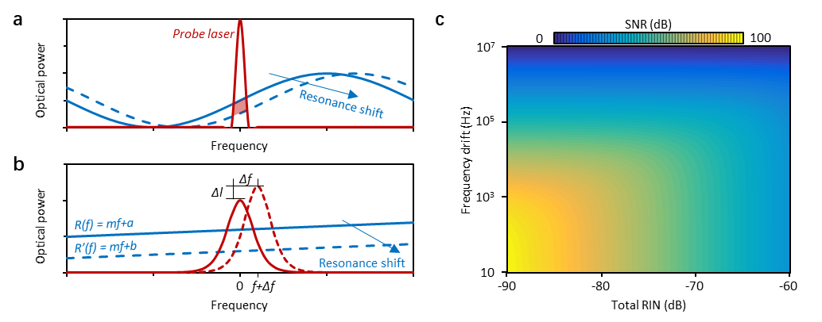
Fig. S3. Stabilization of the laser line plays a role in improving the SNR for acoustic detection. a, Schematic principle. b, Uncertainties from the laser line, including power fluctuation Δl and frequency drift Δf. c, Calculated SNR when fixing ζ₁ = 10⁻⁶, ζ₂ = 10⁻¹.

S1.4 Acoustic positioning algorithm.
The 3-dimensional acoustic positioning relies on solving the propagation paths of sound waves. Leveraging multiplexed sensors, the times when the sound waves reach different sensors are distinct. Related to beam synthesis [⁸], this method is simple, cheap, easy to transport, and convenient to set up on-site. Moreover, it can offer high resolution when the arrival time analysis is accurate [⁹]. In our design, fiber optic microphones (FOMs) are placed at varied locations, the minimum distance (L_{m}) between them determines the sampling rate of sound localization. Typically, we use a L_{m} = 40 cm in the experiment, suggesting that the maximum sampling rate for acoustic waves is 850 Hz.
When using this sensor array system to measure the three-dimensional coordinates of an acoustic target in the open air, we introduce our positioning method based on the time difference of arrival (TDOA). Each FOM has an independent coordinate Mi (x_{i}, y_{i}, z_{i}), here i = 1, 2, 3 or 4, speed of sound is v_{A} = 340 m/s, t_{Mi,Mj} signifies arrival time difference between Mi and Mj (i ≠ j). Considering we have N acoustic sensors, we can solve N(N-1)/2 acoustic paths. For example, when N = 4 and the sensors’ coordinates are M1(x₁, y₁, z₁), M2(x₂, y₂, z₂), M3(x₃, y₃, z₃), M4(x₄, y₄, z₄), and the coordinate of the target is Target (x, y, z), the sound arrival time difference between every two array elements is t_{M2,M1}, t_{M3,M1,} t_{M4,M1,} t_{M3,M2,} t_{M4,M2}, t_{M4,M3}, the following positioning equation can be obtained:
(S18)
Based on numerical optimization methods, iterative algorithms are usually used to approximate the roots of the above equations. First, we provide an initial guess point. These nonlinear equations return a function, whose value is a vector, representing the residual of the system. This function would be called at each iteration step and calculate the residual of the system of equations based on the current guess point. Then, the optimization algorithm iteratively updates the current guess point. In each iteration step, it calculates the gradient (or approximate gradient) of the objective function and the Hessian matrix. With decreasing the residuals, the algorithm terminates when the solutions meet the convergence criterion.
Estimate the time delay between the arrival of the sound wave signal of the sound source and the four array elements, and then combine the positional relationship of the array elements based on obtaining the time delay to obtain the relative coordinates of the sound source relative to the origin of the array. Although the principle is simple and the cost is low, compared with manual methods, the efficiency is much higher, but there are still certain errors.
As mentioned, such a localization method is automatic, but relies on estimating the errors. The distance between the target and an acoustic sensor is written d=v_{A}×t_{Mi,Mj}. When the sound path changes due to unknown external interference (e.g. noise, echo, wind noise, and other influences), a new tiny delay variable τ is introduced, and the distance calculated by the TDOA method becomes d’=v_{A}× (t_{Mi,Mj} +τ). Here, we simulate a scenario, in which we add random noises. Here four sensors with coordinates N₁(-$\frac{1}{2}$L_{m}, -$\frac{1}{2\sqrt{3}}$L_{m}, 0), N₂($\frac{1}{2}$L_{m}, -$\frac{1}{2\sqrt{3}}$L_{m}, 0), N₃(0, $\frac{1}{\sqrt{3}}$L_{m}, 0), N₄(0,$0$, $\frac{\sqrt{2}}{\sqrt{3}}$L_{m}) are used, L_{m} = 0.4 m, and the target’s coordinate Target (x, y, z) is arbitrarily set. Assuming four cases, SNR = 3 dB, 5 dB, 10 dB and 15 dB, Fig. S4 shows the simulated results. Through 1000 calculations, we confirm that the error of localization becomes smaller when the SNR is higher. Fig. S4a shows the measured Δd, where Δd = [(x-x_{m})²+(y-y_{m})²+(z-z_{m})²]^{1/2}. Here Target_{m} (x_{m}, y_{m}, z_{m}) is the measured coordinate of the target. According to statistics, Fig. S4b shows the distribution intervals of the measurement error, while Fig. S4c shows when we want an error < 2 cm, how many times we need to measure.
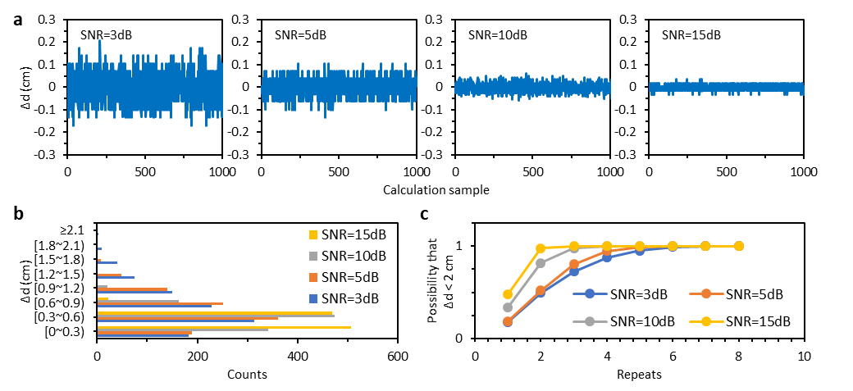
Fig.S4. Simulated accuracy when using the TDOA. a, 1000 measured Δd numbers when the SNR is 3 dB, 5 dB, 10 dB, and 15 dB. b, Statistical histogram of TDOA error. c, Probability to reach an error < cm after repeated measurements.

Note S2. Supplementary experimental details.

S2.1. Preparation of micro-structured MEMS films.
The manufacturing process flow of periodic annular corrugated MEMS film is shown in Fig. S5. The fabrication steps can be summarized as follows (Fig. S5a): First, we cover a layer of evenly coated photoresist on the silicon wafer substrate (i). Then a photolithography mask with a periodic annular corrugation pattern is prepared (ii). After photoresist lithography, the pattern on the photoresist mask is transferred to the photoresist coating on the silicon wafer surface (iii). After the annular corrugation pattern is successfully transferred, the silicon wafer with the shape of the photoresist coating is etched using the reactive ion etching (RIE) method [¹⁰], see step (iv). Afterwards, the photoresist coating on the surface of the silicon wafer is immersed in pure acetone and washed away via ultrasonic vibration cleaning. Then, an annular corrugated silicon nitride film was deposited on the surface of the silicon substrate by plasma-enhanced chemical vapor deposition (PECVD), as step (v) shows. Finally, the silicon substrate is etched away to obtain the silicon nitride film with a thickness of several hundred nanometers (vi). In Fig. S5b, we show the samples of the fabricated MEMS silicon nitride films, verifying that this component can be prepared on a large scale, with high consistency. The size of every sample is 1.9×1.9mm². In Fig. S5c, we show the scanning electron microscopic pictures of a single film. The width of each ring's channel is 25 μm. The innermost concentric ring has a diameter of 1.15 mm, and the outer concentric ring has a diameter of 1.6 mm. The thickness of the film is 400 nm.
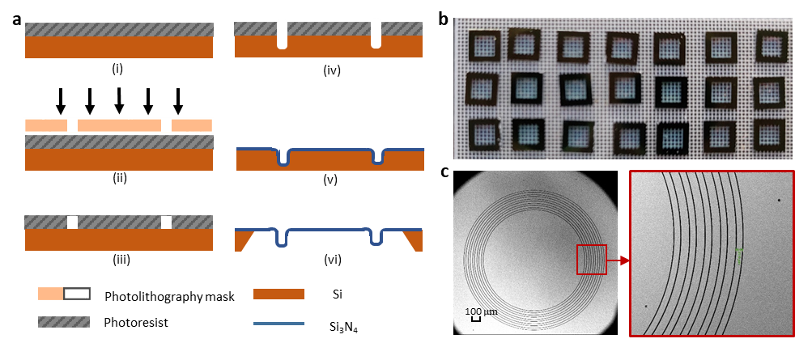
Fig.S5. Preparation and characterization of the micro-structured MEMS films. a, Manufacturing process flow of the MEMS diaphragms. (i) Photoresist coating; (ii) Photolithography mask; (iii) Photolithography treatment; (iv) Reactive ion etching; (v) Depositing an annular corrugated silicon nitride film on the surface of the silicon wafer via PECVD; (vi) Removing the silicon substrate. b, Picture of MEMS film samples. c, SEM picture of a MEMS silicon nitride film.

S2.2 Fabrication and characterization of fiber optical microphones.
The specific manufacturing process of fiber optic acoustic wave sensors is shown in Fig. S6a. First, we prepare a capillary glass tube (i), whose inner diameter is d₀ = 0.127±0.001 mm (suitable for fixing and calibrating a single mode fiber, or SMF). Its outer diameter is d₁ = 1.8±0.01 mm. Then we put an SMF with a flat-cut end-face into the capillary glass tube, and fix its position in depth using glue (ii). The distance between the fiber end and the capillary glass tube end is L₁. Afterwards, we use a large-diameter glass sleeve to attach the MEMS sensing film. This forms another reflective surface of the F-P cavity (iii). The distance between the sleeve end and the end of the capillary glass tube is L₂. The inner diameter of the glass sleeve is d₂ = 2.8±0.01mm, and its outer diameter is 4.0±0.01 mm. Then, we put the MEMS film on the sleeve (iv), and optimize the total cavity length (L = L₁ + L₂). All the structures are finally fixed by using UV glue. Fig. S6b shows the picture of the FOM device, during fabrication. Its spatial parameters are precisely controlled by using a displacement table. The final product is packaged with an outer diameter of 4 mm. Optimizing the number L = L₁ + L₂ is significant to achieve a higher extinction ratio (ER). Specifically, reflections of light from the end face of a single-mode fiber can be equivalent to the Fresnel reflection under normal incidence. Typically, the reflection coefficient of the single-mode fiber end face is R_{Fiber} = 3.6%. To get a maximum ER, the interfering light intensities of the two reflected light beams should be equal. According to the light intensity loss theory of an optical fiber F-P cavity, the loss coefficient ε of the Faber-Perot cavity can be expressed as the following:
(S19)
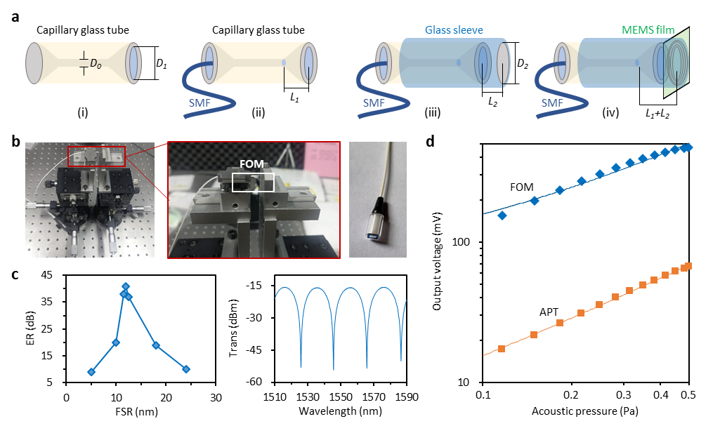
Fig.S6. Fabrication and characterization of FOM microcavity. a, Manufacturing process flow of the FOM device. b, Experimental picture shows how we calibrate the fiber in an F-P microresonator. c, Measured extinction ratios for distinct cavity length, and a spectrum showing interference fringes when the FSR is 12 nm. d, Sensitivity of an FOM and a commercial electric microphone (APT).

Here λ is the wavelength of the incident light, L is the length of the F-P cavity, N₀ is the refractive index of the F-P cavity medium, and ω₀ is the beam mode field radius. Here, for single-mode fiber, N₀=1, ω₀ = 4.9 μm, λ = 1550 nm, L =100.2μm. The surface reflection coefficient of the MEMS film is approximately R_{MEMS} = 18.237%. Since the reflectivity of the MEMS film is greater than that of the single-mode fiber end face, we need to optimize the L to obtain a proper ε, for meeting εR_{MEMS} = R_{Fiber}. As Fig. S6c shows, when the FSR of the cavity is 12 nm, we obtain the highest ER (about 40 dB). Here we also demonstrate the interference fringes. In Fig. S6d, we discuss the performance of our FOM. This FOM is much more sensitive than commercial electronic microphones. Typically, the sensitivity of an electronic condenser microphone (APT-15A) is 47.3 mV/Pa, with a response linearity of 99.88%. On the other hand, the acoustic pressure sensitivity of our FOM is estimated to be 313 mV/Pa, with a response linearity of 97.18%.
Fig. S7a shows the experimental setup measuring the response of an FOM. We use the comb device to drive FOMs, the circulator (CIR) is used to collect the reflected light, and the PD is used to filter out the optical frequency (≈ 193 THz) while detecting the acoustic wave (with frequency < 20 kHz). In comparison, we also use an electrical microphone (APT) as the reference. A frequency tunable speaker provides an acoustic signal in the band 10 Hz ~ 20 kHz. The speaker, FOM and APT are fixed in a silent chamber to cancel environment noises. Here we also show the picture in the silent chamber. Fig. S7b shows the measured responses of several FOM samples and an APT. Here we present the results of 3 F-P cavity based FOMs (solid curves) and the response of the APT (red dashed curve). In the band lower than 60 Hz, the response of an FOM is 50 dB in approximation, similar to the APT. But in the band higher than 60 Hz, the F-P cavity based FOM shows a 30 dB higher response. In the band 200 Hz to 20 kHz, the response of the FOMs is very flat, typically equal to 110 dB. The response dips at 600 Hz and 15 kHz majorly induced by the spatial resonance attenuation in the silent chamber. In Fig. S7c, we demonstrate the signal-to-noise ratio (SNR) of our FOM and the APT. Here we use a single-frequency acoustic wave (20 kHz) to excite their responses. SNR of the APT is about 50 dB, while SNR of the microcomb driven FOM is about 92 dB.
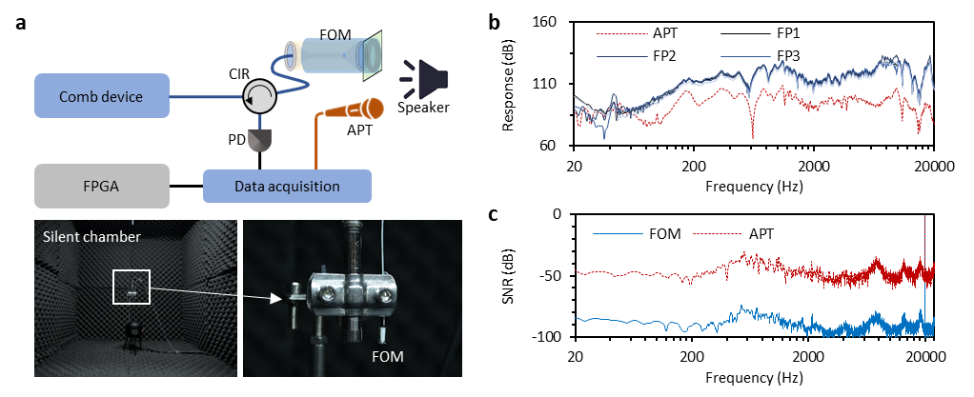
Fig.S7. Response and SNR of our FOMs. a, Setup to measure the response and SNR of an acoustic sensor. b, Measured response of F-P cavity based FOMs (solid curves) and an APT (red dashed curve). c, Measured SNR of an F-P cavity based FOMs (blue solid curve) and an APT (red dashed curve).

S2.3. Formation and stabilization of our on-chip dual microcombs.
Fig. S8a shows our experimental setup for the generation and stabilization of dual Kerr soliton microcomb. Two external cavity laser diodes are used as the optical pumps. These two lasers drive two separate silicon nitride microrings on chip. The two microrings have slightly different repetition rates. Their difference in repetition frequencies (Δf_{rep}) is 11.5 MHz. Thanks to the high Q factor (4×10⁶), soliton threshold of each microring is below 50 mW [¹¹]. Therefore, we don’t need a fiber amplifier before sending the optical energy into the microresonators. To drive two microcomb resonators, we directly use the pump#1 to drive the comb#1, while we use the pump#2 to drive comb#2. We fully stabilize the dual comb outputs to an optical reference (Menlo system FC1500-ULNnova-ORS). Repetition of the reference is 250 MHz, with an optical band (3dB) > 26 nm. Stability is better than 7×10⁻¹⁶ @ 1 s. Four on-chip photodetectors (PDs) are used to collect the beat notes of pump#1-ref (PD1), pump#2-ref (PD2), comb#1-ref (PD3) and comb#2-ref (PD4). For clearly monitoring the repetition drifts of the microrings, we use two optical filters on-chip to select the first comb line of comb#1 and the second comb line of comb#2. The beat notes are collected by integrated data acquisition card and sent into the FPGA. In the FPGA, low-pass filters are used to cancel the high frequency noises and then the beating signals are processed in proportional–integral–derivative (PID) controllers. These PIDs provide feedback to the pump lasers for stabilizing the f_{ceo} and the temperature electrical coolers (TECs) for stabilizing the FSRs. Here the FLs mean feedback loops.
Fig. S8b illustrates the spectrum encompassing the optical reference, the pump laser, and the filtered comb lines. The wavelengths (frequencies) for pump#1, pump#2, the first comb line (comb#1), and the second comb line (comb#2) are specified as 1549.64 nm (193.593 THz), 1549.64 nm (193.593 THz), 1550.49 nm (193.487 THz), and 1551.34 nm (193.382 THz), respectively. Corresponding selected wavelengths in the reference are 1549.64 nm, 1549.64 nm, 1550.49 nm, and 1551.34 nm. Fig. S8c details the individual beat notes, specifically identifying the beat notes between pump#1 and the reference (PD1), pump#2 and the reference (PD2), the first comb line and the reference (PD3), and the second comb line and the reference (PD4) with frequencies of 28.714 MHz, 195.214 MHz, 22.286 MHz, and 63.213 MHz, respectively. Notably, all these frequencies fall within the bandwidth of our integrated PIDs. Fig. S8d presents the temporal traces of the frequency shifts, showcasing their behavior before and after stabilization. The panels, from left to right, exhibit typical frequency drifts for the beat notes between the pump and reference and between the comb line and reference. The observed drifts signify the stability of the carrier frequency and the FSR stability, respectively. Over a 15-second period, the frequency drift of an operational pump laser is noted at 23 Hz, which, following feedback stabilization, is reduced to less than 2 Hz. Similarly, the frequency drift of a typical FSR decreases from 45 Hz to under 2 Hz subsequent to locking.
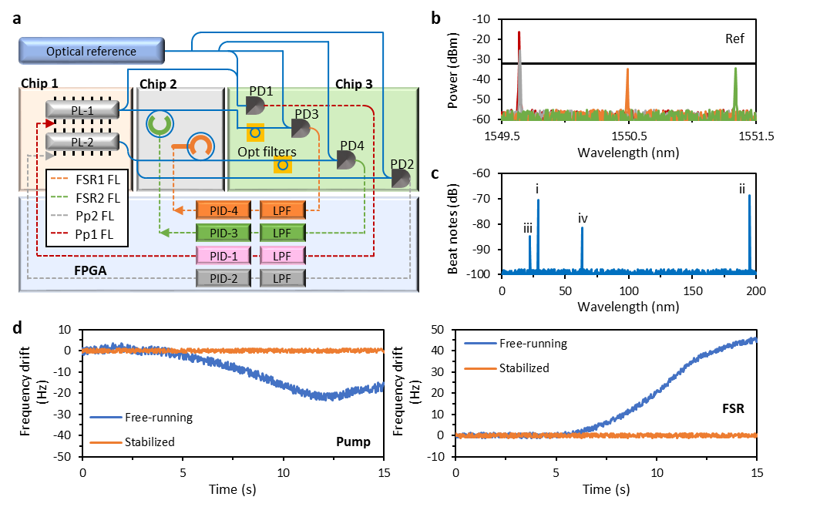
Fig.S8. Stabilization of the microcomb devices. a, Setup for generating and stabilizing the dual comb device, it includes an optical reference, an FPGA processor and 3 connected chips. b, Measured spectrum showing that we use an optical reference to mix the selected optical lines. Red, grey, green and orange curves show the optical frequencies detected in PD1 to PD4. c, Measured beat notes in radio frequency domain, here i, ii, iii, iv illustrates beats from pump#1-ref, pump#2-ref, comb#1-ref, comb#2-ref, respectively. d, Temporal traces show the stabilization effect for suppressing the frequency drift of pumping frequency (left) and FSR (right).

S2.4. Extended data in acoustic localization experiment.
In Fig. S9, we show more detailed data related to the maintext Fig. 3. Here we show the cross-correlations of Mi-Mj pairs one by one. In detail, blue, red, orange, green, yellow, grey and purple curves illustrate the cross-correlated traces between M1~Mj (j = 2 to 8), M2~Mj (j = 3 to 8), M3~Mj (j = 4 to 8), M4~Mj (j = 5 to 8), M5~Mj (j = 6 to 8), M6~Mj (j = 7 to 8), and M7~M8. Totally, there are 28 correlations. Typically, when we use N sensors, the total number of measurable cross-correlated traces is N(N-1)/2. For localizing a target in 3D space, there is data redundancy when using 8 sensors in the simultaneous measurement. But this also offers a capability to improve the accuracy.
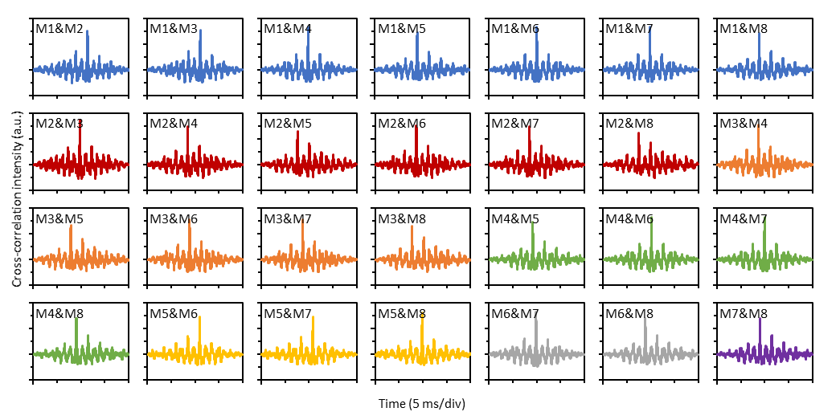
Fig.S9. Temporal cross-correlations when using 8 FOMs to measure the coordinate of a static indoor target. 28 traces are demonstrated, here blue, red, orange, green, yellow, grey, and purple curves illustrate the cross-correlated traces between Mi-Mj (i ≠ j).

In Fig. S10, we show more detailed data related to the maintext Fig. 4. In out-field measurements for localizing a UAV, we use four FOM sensors. Therefore, we demodulate 6 cross-correlations about arrival time differences. Originally, spatial coordinate of the UAV is at position 1 (-8.7 m, 2.1 m, 13.4 m), while the terminal is at position 2 (12.5 m, 10.1 m, 2.1 m). Here we illustrate the temporal correlations for these two positions. In this measurement, temporal sampling rate is 20 kHz. Specifically, at position 1, the measured correlation delays (Mi-Mj, i ≠ j) are 0.6345 ms, 0.1858 ms, -0.5265 ms, -0.4488 ms, -1.1611 ms and -0.7123 ms; at position 2, the corresponding numbers are -0.9033 ms, -1.0843 ms, -0.7805 ms, -0.1810 ms, 0.1228 ms and 0.3039 ms.
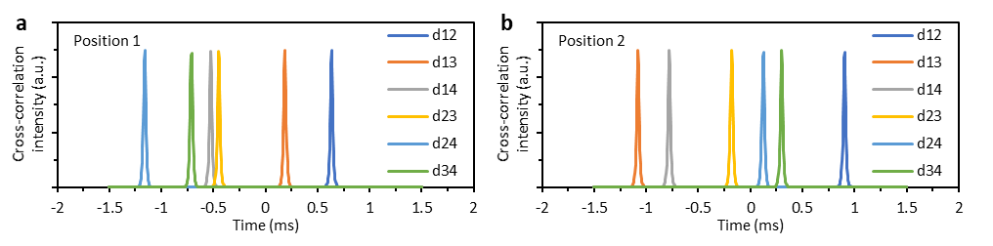
Fig.S10. Temporal cross-correlations when using 4 FOMs to measure a UAV. a, at position 1. b, at position 2. In each panel, there are 6 traces, suggesting distinct acoustic propagation delay differences from the target to sensors, Mi-Mj (i ≠ j).

Supplementary references
1. Obrzud, E., Lecomte, S. & Herr, T. Temporal solitons in microresonators driven by optical pulses. Nat. Photonics 11, 600–607 (2017).
2. Zhang, H. et al. Soliton Microcombs Multiplexing Using Intracavity-Stimulated Brillouin Lasers. Phys. Rev. Lett. 130, 153802 (2023).
3. Zhou, H. et al. Soliton bursts and deterministic dissipative Kerr soliton generation in auxiliary-assisted microcavities. Light Sci. Appl. 8, 50 (2019).
4. Lu, X., Wu, Y., Gong, Y. & Rao, Y. A Miniature Fiber-Optic Microphone Based on an Annular Corrugated MEMS Diaphragm. J. Light. Technol. 36, 5224–5229 (2018).
5. Rao, Y.-J. Recent progress in fiber-optic extrinsic Fabry–Perot interferometric sensors. Opt. Fiber Technol. 12, 227–237 (2006).
6. Wu, Y. et al. A Highly Sensitive Fiber-Optic Microphone Based on Graphene Oxide Membrane. J. Light. Technol. 35, 4344–4349 (2017).
7. Khan, A., Philip, J. & Hess, P. Young’s modulus of silicon nitride used in scanning force microscope cantilevers. J. Appl. Phys. 95, 1667–1672 (2004).
8. Zhang, P. et al. Generation of acoustic self-bending and bottle beams by phase engineering. Nat. Commun. 5, 4316 (2014).
9. Cao, S., Chen, X., Zhang, X. & Chen, X. Effective Audio Signal Arrival Time Detection Algorithm for Realization of Robust Acoustic Indoor Positioning. IEEE Trans. Instrum. Meas. 69, 7341–7352 (2020).
10. Jansen, H., Gardeniers, H., Boer, M. de, Elwenspoek, M. & Fluitman, J. A survey on the reactive ion etching of silicon in microtechnology. J. Micromechanics Microengineering 6, 14 (1996).
11. Yi, X., Yang, Q.-F., Yang, K. Y., Suh, M.-G. & Vahala, K. Soliton frequency comb at microwave rates in a high-Q silica microresonator. Optica 2, 1078–1085 (2015).

