Supplementary Material for

Biomimetics Through Bioconjugation of 16-Methylheptadecanoic Acid to Damaged Hair for Hair Barrier Recovery

Sang-Hun Song*, Hyun Sub Park, Byung Tack Lim, and Seong Kil Son
LG Household & Health Care, Gangseo-gu, Seoul, 07795, Republic of Korea;
* Correspondence: sanghun@uw.edu; Tel.: +82-2-6980-1221

Supplementary Figure 1. Chromatogram of the samples in Figure 1(c). (a) Standard materials. (b) Hair sample. Peak: 1. Myristic acid; 2. o-Terphenyl; 3. Palmitic acid; 4. Stearic acid; 5. Oleic acid.
Selected ion monitoring (SIM) was carried out by monitoring m/z 228 for myristic acid, m/z 256 for palmitic acid, m/z 69 for oleic acid, m/z 284 for stearic acid, and m/z 386 for cholesterol. A reference stock solution of each lipid was dissolved in 2:1 chloroform:methanol at a concentration of 10000 mg/L. 1 mL of each standard solution was aliquoted into a 10 mL volumetric flask and used as a mixed standard solution according to the indicated line. The concentration of the mixed standard solution was 1000 mg/L.
Peak identification was conducted by comparing retention times and mass spectral fragmentation patterns with standards. An internal standard of m/z 230 for o-Terphenyl was added into the lipid solution, with 10μL of o-Terphenyl (2000 mg/L) being added to 1 mL of the extracted lipids. 100 mg of each reference substance (fatty acids) was dissolved in 10 mL of a 2:1 mixture of chloroform and methanol.
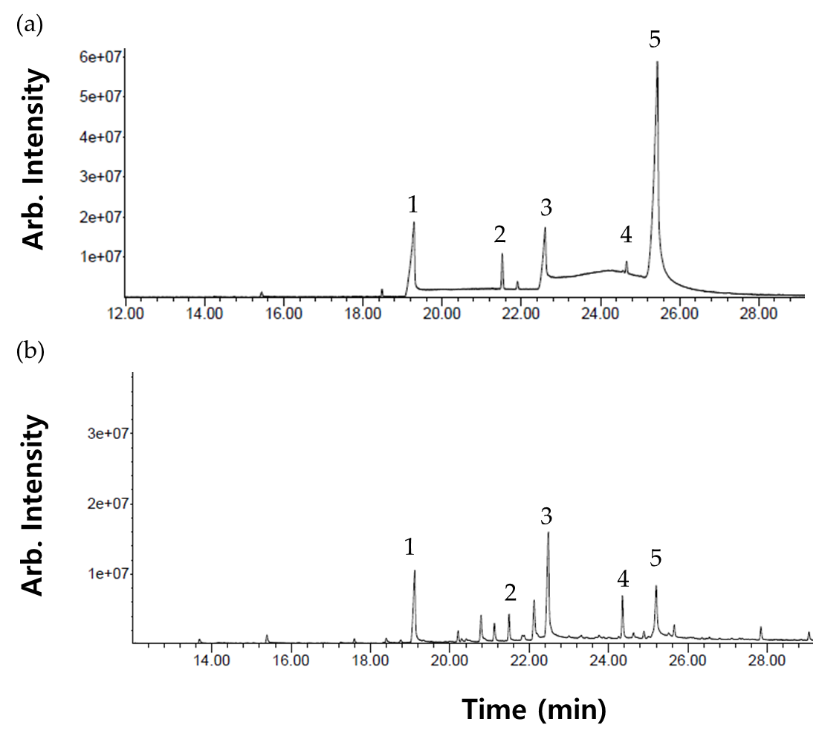
Supplementary Figure 2. Mass spectrum of the chromatogram at 30.2 min in Figure 2. Peaks of the 16-MHA fragment were detected, with a molecular weight of 284 indicating 16-MHA.
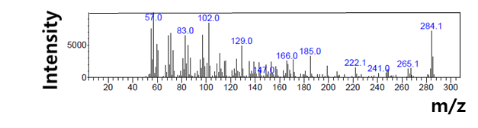
Supplementary Figure 3. PTIS dissolved in n-butanol. Tert-butanol reaches its melting point at room temperature, making it difficult to handle, so n-butanol, which has a low melting point, was used. 16-MHA was not observed in n-butanol; instead, butyloctadecanoate was generated at 32.5 min. This reaction was observed up to pH 4, and no further.
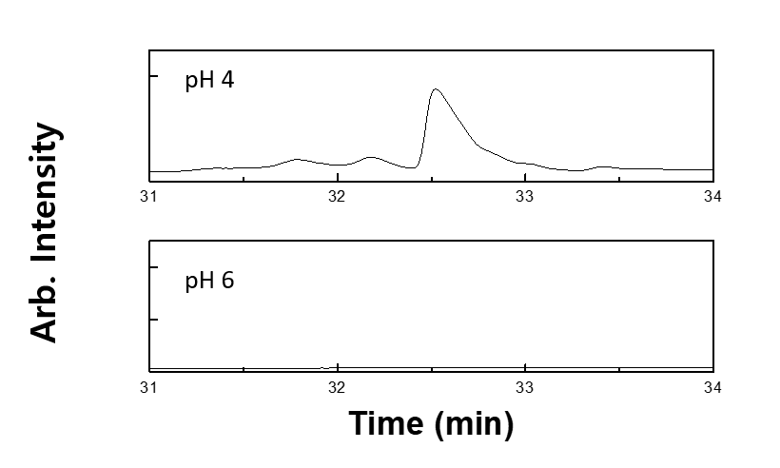

Supplementary Figure 4. PCI concentration dependence of Young’s modulus (a) and tensile strength (b). The lines above the bar graph denote a significant difference (n = 20) calculated using Student’s t-test. **P < 0.01.
The hair swatch was washed with a 10% SLES solution and transferred to a 200 mL beaker filled with water for cross-linking. Cross-linking was performed in water based on the carbodiimide chemistry.¹ Hair was immersed in the first agent and then transferred to the second liquid agent, an aqueous solution of 5% polycarbodiimide (PCI). The appropriate concentration of PCI where bioconjugation occurs was evaluated using Arginine/Lysine Polypeptide (Peptiskin, 111632, active 40%). Young’s modulus and tensile strength curves were obtained using Dia-stron MTT 175 (UK) at room temperature and 45% RH. One side of the fiber placed in fiber holder was pulled straight in 20 mm/min with converted energy from rotation of motor inside. The pulling force is measured and monitored in graphs with load cell located on the other side of the fiber holder.
The 3-Aminopropyltrimethoxysilane (APTES) in a sol-gel system has been reported to react between the hydroxyl groups of hair and the silanol moiety of APTES.² Interactions within the hair affect tensile strength and Young's modulus.³
The PCI concentration at which bioconjugation occurs was observed. When the PCI concentration was less than 0.4%, there was no peptide fixation effect and there was no change in Young's modulus and tensile strength. Statistically significant changes in Young's modulus was observed above 0.4% PCI concentration.
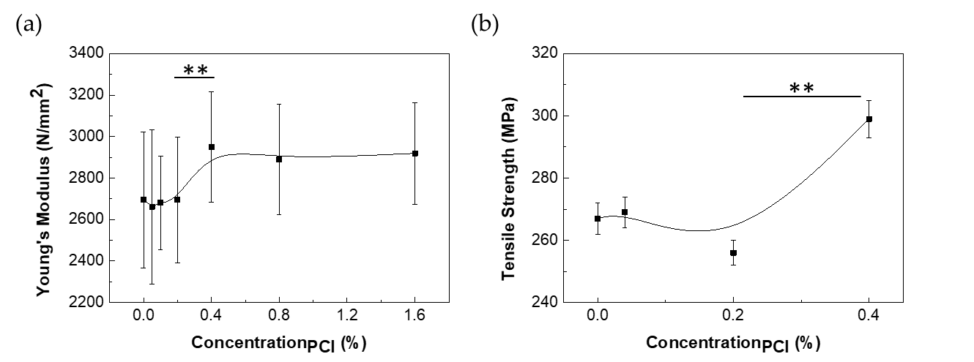
References
1 Song, S.-H. et al. Prevention of lipid loss from hair by surface and internal modification. Scientific Reports 9, 9834, doi:10.1038/s41598-019-46370-x (2019).
2 Hallegot, P. et al. Discovery of a sol–gel reinforcing the strength of hair structure: mechanisms of action and macroscopic effects on the hair. J. Sol-Gel Sci. Technol. 79, 359-364, doi:https://doi.org/10.1007/s10971-016-3961-z (2016).
3 Gray, J. & Thomas, J. Textbook of cosmetic dermatology 4th edn. edn, 225-227 (CRC Press, 2010).

