Supplementary Figure
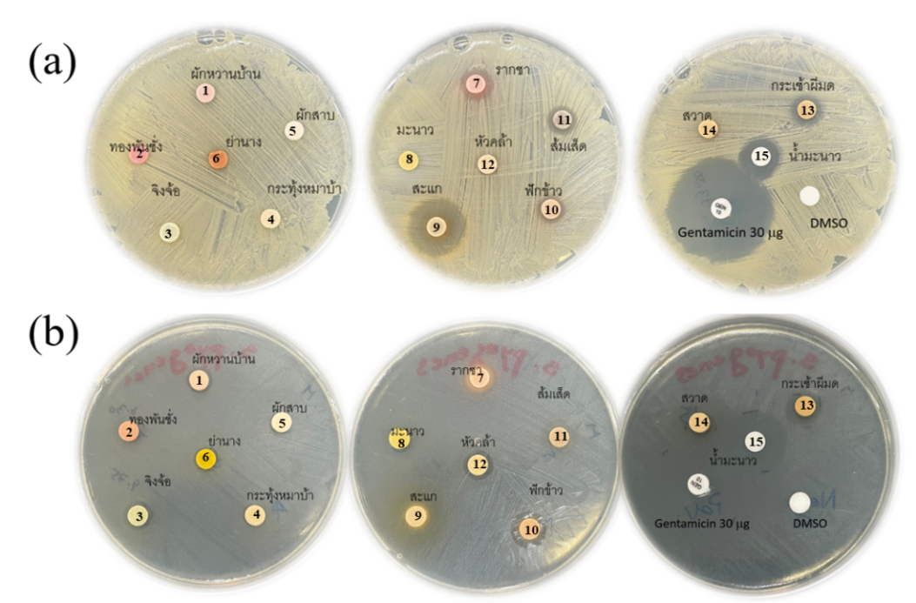
Figure S1: The inhibition zone of MYK extract, methanolic extract of the crude drug and lime juice at concentration of 100 mg/ml on Streptococcus species (a) S. sorbinus (b) S. pyogenes. The negative control and positive control were DMSO and Gentamicin, respectively.1, S. androgynu;,2, R. nasutus; 3, M. vitifolia; 4, D. volubilis; 5, A. viridiflora; 6, T. triandra; 7, C. sinensis; 8, C. aurantifolia; 9, C. quadrangulare; 10, M. cochinchinensis; 11, G. zeylanicum; 12, S. dichotomus; 13, H. formicarum; 14, C. bonduc and 15, lime juice.
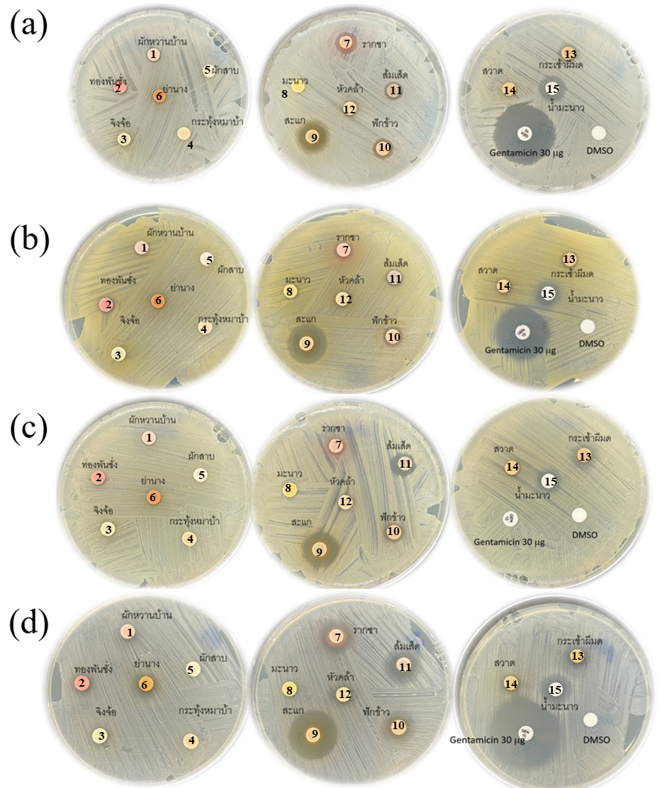
Figure S2: The inhibition zone of MYK extract, methanolic extract of the crude drug and lime juice at concentration of 100 mg/ml on Staphylococcus species; (a) S. aureus; (b) S. aureus; (c) methicillin-resistant S. aureus (MRSA); and (d) S. epidermidis. The negative control and positive control were DMSO and Gentamicin, respectively.1; S. androgynus, B. androgyna,2; R. nasutus, 3; M. vitifolia, 4; D. volubilis, 5; A. viridiflora, 6; T. triandra, 7; C. sinensis, 8; C. aurantifolia, 9; C. quadrangulare, 10; M. cochinchinensis, 11; G. zeylanicum, 12; S. dichotomus/ S. benthamianus, 13; H. formicarum, 14; C. bonduc and 15; lime juice.
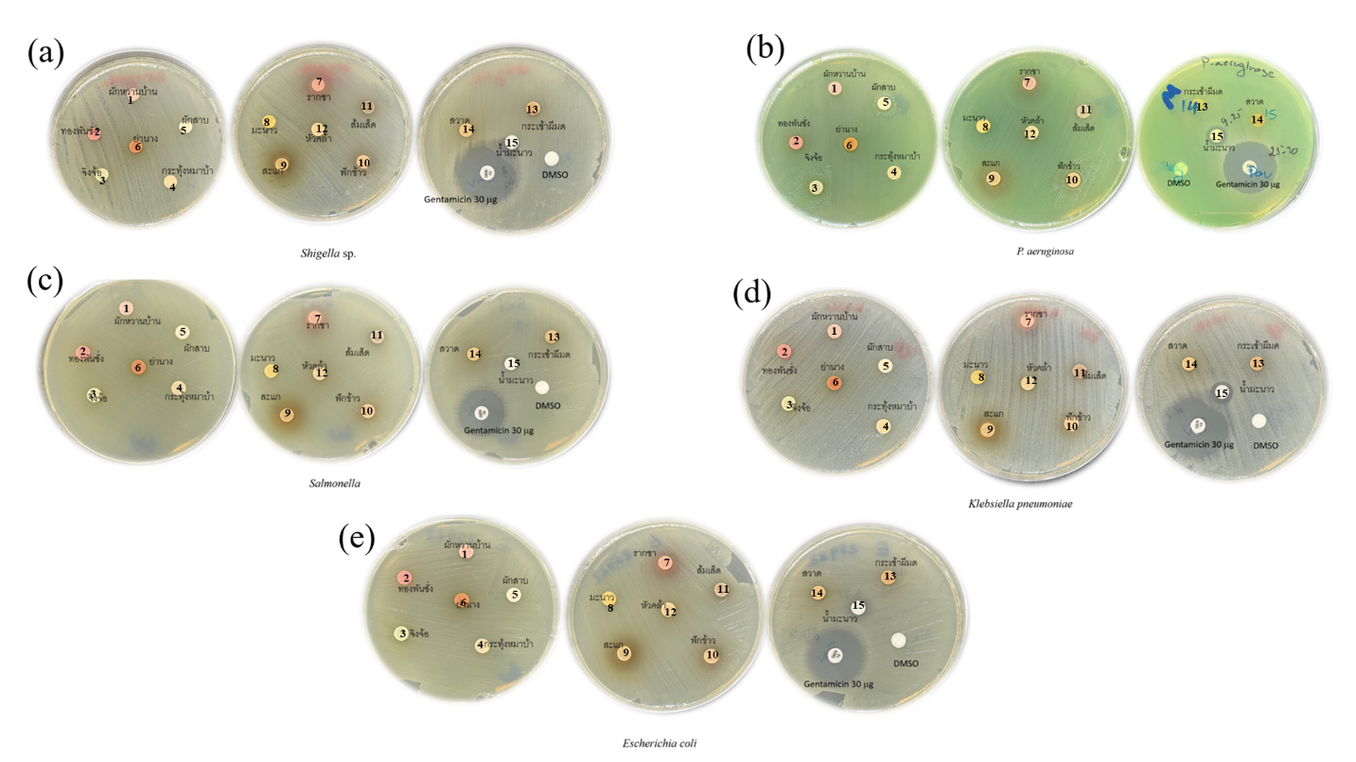
Figure S3: The inhibition zone of MYK formula, methanolic crude drug extract, and lime juice with concentration at 100 mg/ml on Gram negative bacteria strains; (a) Shigella sp. (b) P. aeruginosa (c) Salmonella sp. (d) K.pneumoniae and (e) E.coli. The negative control and positive control were DMSO and Gentamicin, respectively.1; S. androgynus, B. androgyna,2; R. nasutus, 3; M. vitifolia, 4; D. volubilis, 5; A. viridiflora, 6; T. triandra, 7; C. sinensis, 8; C. aurantifolia, 9; C. quadrangulare, 10; M. cochinchinensis, 11; G. zeylanicum, 12; S. dichotomus/ S. benthamianus, 13; H. formicarum, 14; C. bonduc and 15; lime juice.

