Supplementary Material for Microbial Cell Factories

SIRT2-mediated deacetylation of Glutathione transferase alleviates oxidative damage and increases heat tolerance of Pleurotus ostreatus
Qianqian Chai¹ ·Huihui Li¹ ·Yuandong Liu² ·Qing Wen ¹· Qing Liu¹·Yuancheng Qi¹ ·Fengqin Wang ¹· Jinwen Shen¹ ·Yanru Hu¹*

Affiliations: 1. Key Laboratory of Agricultural Microbial Enzyme Engineering, Ministry of Agriculture, Rural Department, College of Life Sciences, Henan Agricultural University, Henan, Zhengzhou 450002, People’s Republic of China.
2. Zhoukou Academy of Agricultural Sciences, Henan, Zhoukou 466000, People’s Republic of China.
Running title: Important role of acetylation modification in Pleurotus ostreatus under high temperature stress
*Corresponding author. Mailing address: College of Life Sciences, Henan Agricultural University, 95 Wenhua Road, Zhengzhou 450002, People’s Republic of China. Telephone and Fax: 0371-63555790. E-mail: huyanru12@163.com

Supplementary Material

Table. S1 Primers used in this study
Target gene | primer
SIRT2 | F-SIRT2：cagcaaatgggtcgcggatccATGTTCAAGTTCAAGCGAGGGA
 | R-SIRT2：gtggtggtggtggtgctcgagTTATGATGTTAGTACGGTTGATGATGC
 | F-RT-sirt2: TCGCTCCTCCATACTTG
 | R-RT-sirt2: GCATTTGGGCACCTTAC
GST1 | F-GST1：CGCGGATCCATGAGTCTCCCCGACGAA
 | R-GST1：CGAGCTCTCATGGAATAACCCGACCT
GST2 | F-GST2：CGCGGATCCATGGCAGACACCGGAAAGC
 | R-GST2：CCCAAGCTTTTAGGGGAGCCCGCGAC
GST1 K66R | F-GST1 K66R：CGTACAAGAAGGAAAGGCACTTTCTGGCGATC
 | R-GST1 K66R: GATCGCCAGAAAGTGCCTTTCCTTCTTGTACG
GST2 K206R | F-GST2 K206R：GACCAGTGTCTTGAGACATTACCGAGGCTTC
 | R-GST2 K206R：GAAGCCTCGGTAATGTCTCAAGACACTGGTC
GST2 K233R | F-GST2 K233R：GCAGGTGGCTCTGAAGGACGGGTGGTTGAA
 | F-GST2 K233R：TTCAACCACCCGTCCTTCAGAGCCACCTGC
HAT(PLEOSDRAFT_32249) | F-RT-32249: AACCAATCTGGGACACTTC
 | R-RT-32249: AACTCATCAGGGCTCACC
NAT(PLEOSDRAFT_1061978) | F-RT-1061978: TGACTGATGTGGAGACTATTT
 | R-RT-1061978: CCGAGACTGCCAGAAGA
NAT(PLEOSDRAFT_1073431) | F-RT-1073431: TGGGCTACATTCTTGGC
 | R-RT-1073431: CTATGGGACATCGTGGG
NAT(PLEOSDRAFT_28905) | F-RT-28905: CGCTAACATCAAACAACC
 | R-RT-28905: AGTATCCAGGCATCGTG

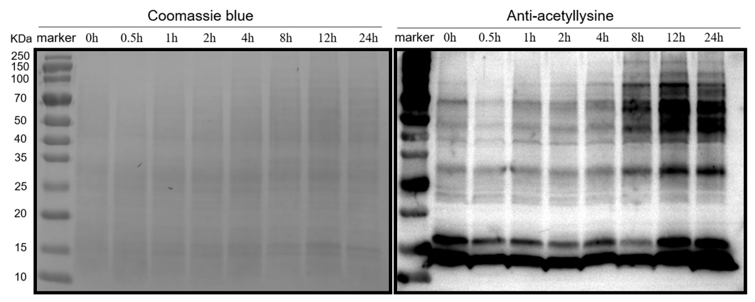
Fig. S1 The acetylation level of total protein in Pleurotus ostreatus
at different heat stress times
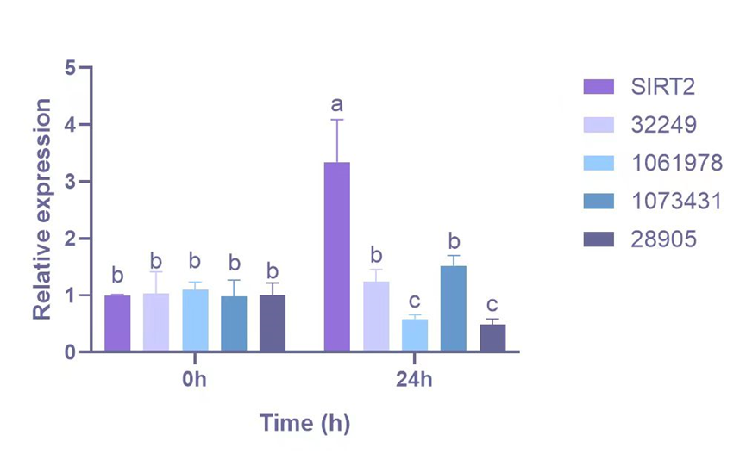
Fig. S2 Relative expressions of acetylation modifies related proteins under heat stress in Pleurotus ostreatus. SIRT2 is one kind of deacetylase. HAT(PLEOSDRAFT_32249), NAT(PLEOSDRAFT_1061978), NAT(PLEOSDRAFT_1073431) and NAT(PLEOSDRAFT_28905) belongs to acetyltransferase family. The error bars indicate the standard deviation from the mean of the triplicates. The differences at P <0.05 were considered significant ac-cording to Turkey’s test and were marked with different letters.

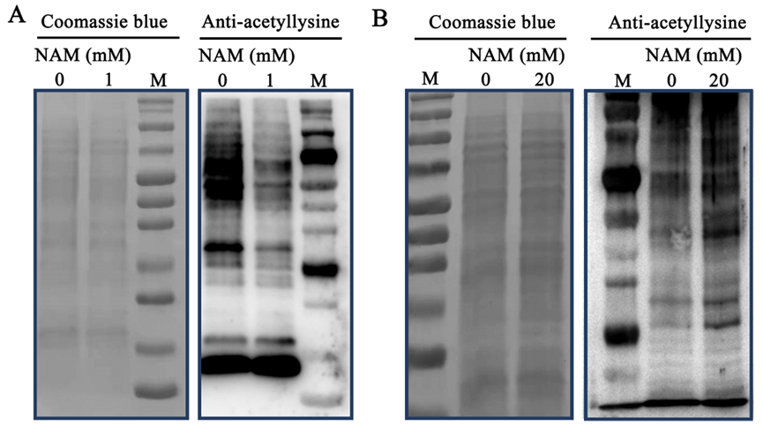
Fig. S3 Effects of low and high concentration of nicotinamide (NAM) on the acetylation level of total protein in Pleurotus ostreatus. A Effect of 1 mM NAM on the acetylation level of total protein in Pleurotus ostreatus. B Effect of 20 mM NAM on the acetylation level of total protein in Pleurotus ostreatus.
Fig. S4 Effect of 1 mM NAM on mycelium growth rate of bag-grown Pleurotus ostreatus. A Effect of 1 mM NAM on the mycelium growth rate of bag-grown Pleurotus ostreatus under normal condition. B Effect of 1 mM NAM on the mycelium recovery growth rate of bag-grown Pleurotus ostreatus after heat stress treatment. The error bars indicate the standard deviation from the mean of the triplicates. The differences at P <0.05 were considered significant ac-cording to Turkey’s test and were marked with different letters.

Fig. S5 Both total proteins and purified GSTs and SIRT2 protein were analysed by SDS-PAGE. M, protein marker; 1, negative control; 2, total proteins; 3, the purified recombinat protein.

