Supporting Information
Zn-Co needle-grass shape nanostructure in-situ grown on porous Nickle foam as an electrocatalyst for efficient HER
Linfeng Xiao^{1#}, Jing Han^{1#}, Runhua Liao¹*, Boyu Liang¹, Wenqiang Deng¹, Yan Hong¹, Jie Du¹, Lichun Fu²*, Zhixiang Xie³

1. School of Materials Science and Engineering, Jingdezhen Ceramic University, Jingdezhen 333403, China
2. School of Iron and Steel, Soochow University, Suzhou 215000, PR China; School of the Environment, Nanjing University, Nanjing, 210023, China
3.School of Chemistry, Biology Engineering, Suzhou University of Science and Technology, Suzhou 215009, China

#Linfeng Xiao and Jing Han are contributed equally to the article
*Corresponding author E-mail: 001072@jcu.edu.cn (Rh. L.); lcfu@suda.edu.cn (Lc. F.)

Fig. S1
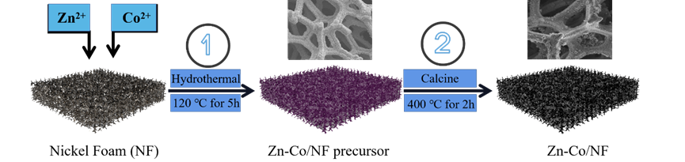
Fig. S1 The synthesized process of Zn-Co/NF.

Fig. S2
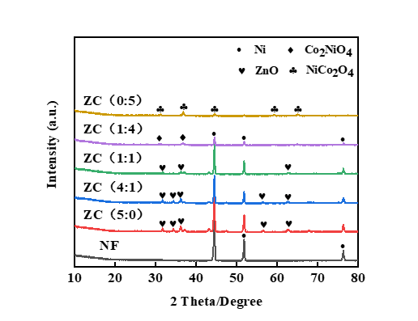
Fig. S2 XRD pattern of Zn-Co/NF samples and pure NF.

