APPENDIX 1: Structured Interview Guide

Script and instructions:

Thank you for participating in this study. You have Attended at least one “Empathy, Humanism & Comics” session this academic year. The purpose of this session is to reflect on the curriculum and consider how they affect your interactions with patients.

In this interview, I will be asking you a series of open-ended questions. To help me with gathering and analyzing the results, I will be recording your responses. There won’t be any identifying information on these recordings. Any identifying information will also be removed in the transcription process. They will be kept for 5 years and then the files will be destroyed. The transcribed answers will be secured in a safe place without any identifying information on them.

This focus will last around 30-45 minutes.
At the end, you will fill out a final survey, which should take less than 5 minutes.
Do you have any questions before we begin?

Impact of the Curriculum:

The curriculum consisted of 6 sessions over the year (refer to sheet). During each session, you viewed a comic, discussed what was going on, what went well and what could be done better in that comic. Then there was a discussion point around humanism and your role as physician, teacher, person. This was followed by a reflective exercise done in between sessions that was debriefed at the next session.

- What impact, if any, did this curriculum have on you? (potential cues: How did the curriculum affect your patients throughout the year and in the future? What was its impact on you as a physician? What was its impact on you as a teacher? What was its impact on you as a person? Have you had any previous empathy and communications training? How does this complement your previous empathy and communications training?)
  - If no effect on approach: how could the curriculum be revised to be most useful?

- Now let’s talk about specific components of the curriculum – comic and debrief, humanism discussion, reflective exercise and debrief. What aspects of the curriculum did you find most valuable and why? What aspects were less useful and why?
(potential cues: comics themselves, comic debrief, humanism discussion, reflective exercise, reflective exercise debrief; how do you think students can use the comics most effectively – viewing it on their own or discussing it in a group? What are some other reflective activities you’ve done in residency, if any? What is the role, impact, or value of these reflective activities? How was the format of the reflective exercises conducive to the content of the exercises Is there a role of additional reflective exercises?)

- We are now going to discuss any effect on your approach to patients and empathy:
  - How do you feel your level of empathy has changed since you started your medical training?
  - What were the key issues that stood out for you when you reflect back on the curriculum? What was your awareness of the issue before and how did it change?
    - What was your attitude towards patient with diabetes? How did it change?
    - What was your knowledge of the patient’s perspective (views, feelings, fears) on living with diabetes? How did it change?
    - What differences exist between patient and physician perspectives? How did your knowledge of this difference change?
  - What is the impact of this curriculum on your level of empathy or your empathic approach to patients?
    - If no impact: how could the curriculum be revised to be most useful?

- We are now going to discuss the potential educational value of this curriculum, and comics, if any.
  - What have you learned so far in medical residency about chronic disease and communication skills?
  - How does this curriculum compare or add to what you’ve learned so far?
  - What do you think of comics as a medium for learning?
  - How do comics compare as a learning medium to other formats, like text, movies or video clips?
  - How do you think the comics can be best integrated into the current curriculum?
  - How do you think students can use the comics most effectively – viewing it on their own or discussing it in a group?

What other suggestions do you have for improving the curriculum and comics?

- Any other final comments?

APPENDIX 2: Framework Development

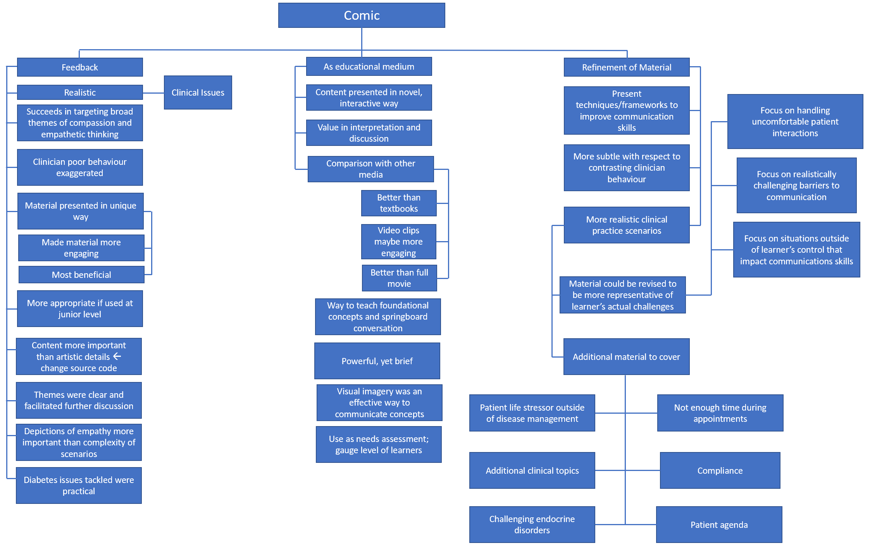
Appendix 2: Representative example of framework development. Transcribed data was coded independently by the three authors. Independently generated codes were discussed and refined with subsequent data analysis. After final data analysis, codes were consolidated and representative quotations presented as shown in Table1. As an example, pictured above is an early coding schematic highlighting participant feedback on the comics. The authors examined and discussed these proto-codes to identify relevant and concise themes as elaborated on in Theme 3.

