Supplementary Materials
The following Supplementary figures and table accompany Sero-epidemiology of Highly Pathogenic Avian Influenza viruses among wild birds in subarctic intercontinental transition zones, by Gass, et al.
Supplementary figure 1. Map of the pCMV-ORF Influenza A H5N8 (A/duck/Jiangsu/k1203/2010) Hemagglutinin / HA Gene ORF cDNA clone expression plasmid used for HPAI H5 psuedovirus transfection and production. Obtained from SinoBiological, Chesterbrook, PA, USA.
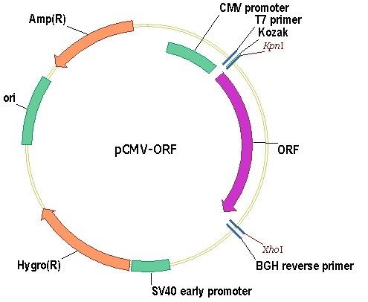

Supplementary figure 2. Map of the pCMV3-H5N2-AC-07-HA A/American green-winged teal/California/HKWF609/2007(H5N2) cDNA expression plasmid used for LPAI H5 pseudovirus transfection and production. Obtained from SinoBiological, Chesterbrook, PA, USA.
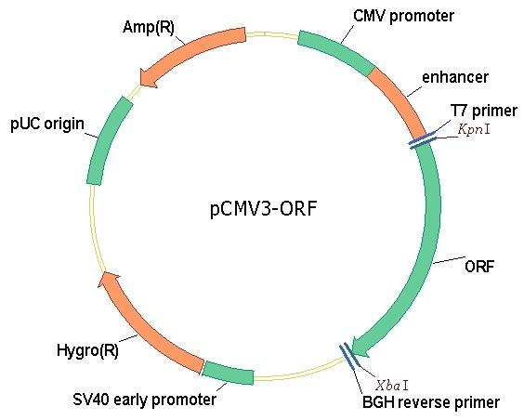
Supplementary figure 3. Map of the pMET7-GAG-EGFP vector used for pseudovirus transfection and production.
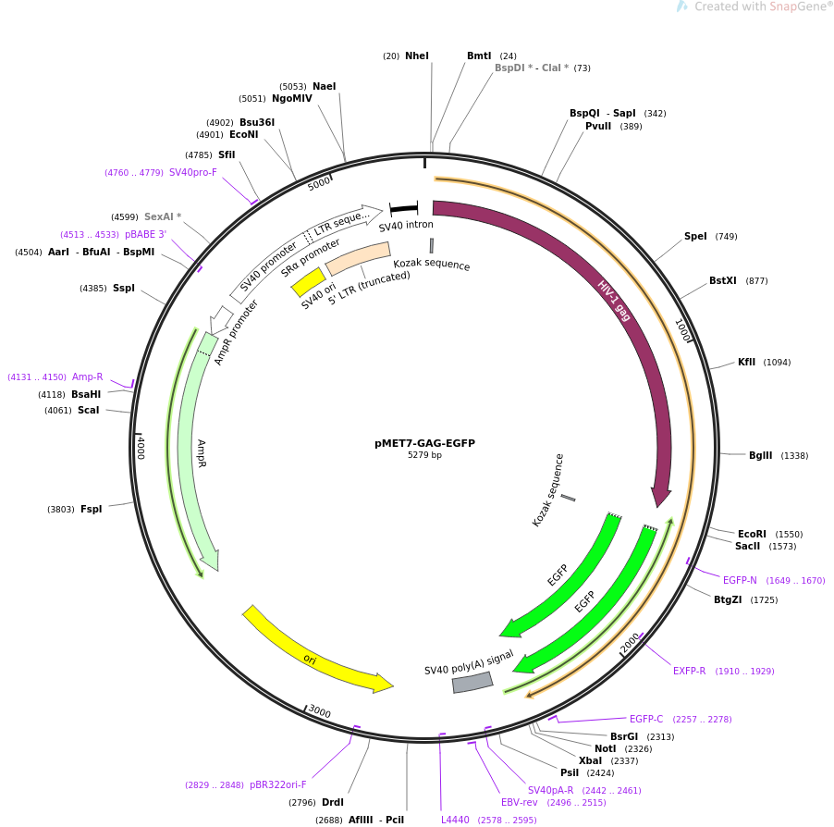

Supplementary figure 4. Diagnostic restriction digest to confirm identity of transformed plasmids. Plasmids are digested with restriction enzymes which cleave the plasmid DNA at known sequences (restriction sites). Left: pCMV-ORF Influenza A H5N8 (A/duck/Jiangsu/k1203/2010) Hemagglutinin / HA Gene ORF cDNA clone expression plasmid using restriction enzymes Kpn1 and Xho1 in NEBuffer 1.1. Uncut DNA measures 7361bp. Digested fragments measure 5657bp and 1704bp. Right: pCMV3-H5N2-AC-07-HA A/American green-winged teal/California/HKWF609/2007(H5N2) cDNA expression plasmid using restriction enzymes Kpn1 and Xba1 in NEBuffer 2.1. Uncut DNA measures 7981bp. Digested fragments measure 6223bp and 1695bp. (New England Biolabs, Ipswich, MA).
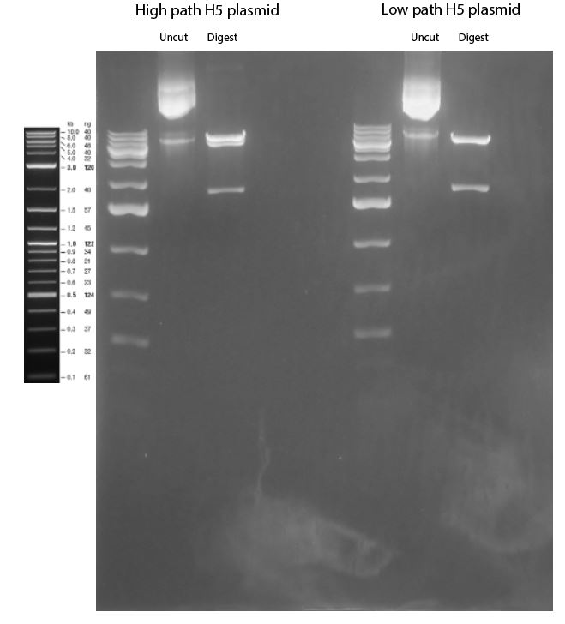

Supplementary figure 5. Green fluorescent protein (GFP) expression in 293-T cells via fluorescent microscopy at 48 hours post transfection with A) pCMV3-H5N2-AC-07-HA A/American green-winged teal/California/HKWF609/2007(H5N2) cDNA expression plasmid used for LPAI H5 pseudovirus transfection and production (Image date: 08/18/2021), and B) pCMV-ORF Influenza A H5N8 (A/duck/Jiangsu/k1203/2010) Hemagglutinin / HA Gene ORF cDNA clone expression plasmid used for HPAI H5 pseudovirus transfection and production (Images date: 08/05/2021).
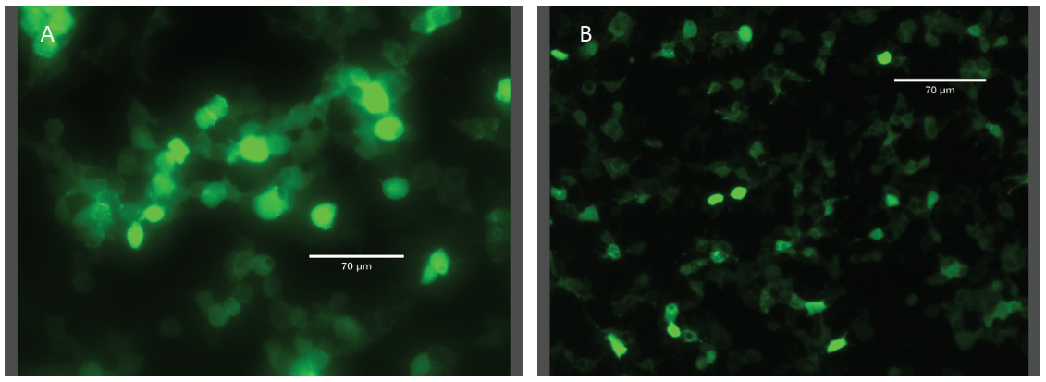

Supplementary table 1. Emperor Goose serum samples from Ramey, 2020 et al. which were previously tested for antibody reactivity to North American lineage (rgBWTE/TX) H5 and clade 2.3.4.4 goose Guangdong lineage (GsGD) highly pathogenic (HP) H5 (GYRF/WA) influenza A viruses using hemagglutinin inhibition (HI) assays. Each sample was tested separately using HI with LPAIpsv and HPAIpsv as antigens, in duplicate as positive control to differentiate induced antibody reactivity of pseudoviruses. Titers are expressed as the inverse of the dilution at which a serologic response was detected.
Capture year | Emperor Goose serum sample ID | LPAI rgBWTE/TX antibody titer | HPAI GYRF/WA antibody titer | LPAIpsv HI antibody titer | HPAIpsv HI antibody titer
2015 | 26983 | 64 | <16 | 32 | 0
2015 | 78882 | <16 | 32 | 0 | 32
2015 | 79348 | 32 | <16 | 64 | 0
2016 | 79102 | <16 | 32 | 0 | 64

Supplementary table 2. Results of analyses of ecological traits between immunologically naïve and exposed birds between Iceland and Alaska.

Exposure status | Iceland | Alaska
Immunonaive | 564 | 260
Exposed | 203 | 501

Odds Ratio 95% CI LL 95% CI UL P-value
5.35 4.29 6.67 <0.0001

Supplementary table 3. Results of analyses of ecological traits between immunologically naïve and exposed birds, by Season. Undetermined categories and Procellariiformes not included in analyses of age, sex, or Order.

Exposure status | Autumn | Winter | Spring | Summer
Immunonaive | 244 | 0 | 448 | 132
Exposed | 164 | 27 | 212 | 301

Chi sq (Pearson) P-value
184.75 <0.0001

Supplementary table 4. Results of analyses of ecological traits between immunologically naïve and exposed birds, by Year. Undetermined categories and Procellariiformes not included in analyses of age, sex, or Order.

Exposure status | 2010 | 2011 | 2012 | 2013 | 2014 | 2015 | 2016 | 2017 | 2018 | 2019
Immunonaive | 171 | 11 | 123 | 73 | 112 | 115 | 134 | 79 | 3 | 3
Exposed | 187 | 24 | 30 | 14 | 50 | 195 | 84 | 70 | 17 | 33

Chi sq (Pearson) P-value
184.9 <0.0001

Supplementary table 5. Results of analyses of ecological traits between immunologically naïve and exposed birds, by hatch year. Undetermined categories not included.

Exposure status | 1CY | 2CY+
Immunonaive | 127 | 644
Exposed | 154 | 541

Odds ratio 95% CI LL 95% CI UL P-value
1.44 1.11 1.87 0.0057

Supplementary table 6. Results of analyses of ecological traits between immunologically naïve and exposed birds, by Sex. Undetermined categories not included.

Exposure status | Female | Male
Immunonaive | 186 | 163
Exposed | 204 | 206

Odds ratio 95% CI LL 95% CI UL P-value
0.87 0.65 1,15 0.3309

Supplementary table 7. Multiple logistic regression model

Study site  Iceland  Alaska | Odds ratio  4.97  0.20 | P-value  <0.0001  <0.0001 | 95% CI LL  3.17  0.13 | 95% CI UL  7.78  0.31
Season  Spring  Autumn | Odds ratio  1.4  0.71 | P-value  0.0458  0.0458 | 95% CI LL  1.01  0.51 | 95% CI UL  1.95  0.99

