Supplementary Table 1. Included SNPs that are significantly associated with Refractive error
SNP | Chromosome | EA | OA | EAF | Refractive error |  |  | F statistic | R²
 |  |  |  |  | beta | SE | P | F statistic | R²
rs10182376 | NA | C | T | 0.980756 | -0.072236 | 0.013502 | 8.80E-08 | 28.62273774 | 0.000196967
rs1029278 | NA | A | G | 0.333989 | -0.0286414 | 0.00392195 | 2.80E-13 | 53.33157136 | 0.000364949
rs10740465 | NA | T | G | 0.597054 | 0.032344 | 0.00377081 | 9.70E-18 | 73.5729477 | 0.000503359
rs10790167 | NA | T | C | 0.34001 | -0.0191481 | 0.00390405 | 9.40E-07 | 24.05584582 | 0.000164555
rs10955977 | NA | G | A | 0.376859 | -0.0277141 | 0.00385723 | 6.70E-13 | 51.62386158 | 0.000360742
rs11030403 | NA | G | A | 0.634271 | 0.0196832 | 0.00385239 | 3.20E-07 | 26.10543396 | 0.000179745
rs11043221 | NA | A | C | 0.701604 | 0.0229828 | 0.00407111 | 1.60E-08 | 31.86986336 | 0.000221167
rs1107592 | NA | A | G | 0.590074 | -0.0209287 | 0.00375089 | 2.40E-08 | 31.1326328 | 0.000211898
rs113130019 | NA | C | T | 0.774416 | -0.0253781 | 0.00449678 | 1.70E-08 | 31.85040267 | 0.000225025
rs117180150 | NA | G | A | 0.972909 | 0.0609507 | 0.0115429 | 1.30E-07 | 27.88223152 | 0.000195832
rs117855045 | NA | C | T | 0.956066 | -0.045226 | 0.00903779 | 5.60E-07 | 25.04101134 | 0.000171828
rs11898437 | NA | C | T | 0.483385 | -0.0202585 | 0.0036954 | 4.20E-08 | 30.05326512 | 0.000204977
rs11940147 | NA | G | T | 0.750889 | -0.0215246 | 0.00427615 | 4.80E-07 | 25.33753239 | 0.000173328
rs12033783 | NA | A | G | 0.612752 | 0.0217383 | 0.0037983 | 1.00E-08 | 32.75462479 | 0.000224262
rs12193446 | NA | A | G | 0.904482 | -0.128686 | 0.00627413 | 1.70E-93 | 420.6835958 | 0.002861395
rs12350420 | NA | C | T | 0.4724 | 0.0197409 | 0.00371917 | 1.10E-07 | 28.17356709 | 0.000194258
rs12492279 | NA | T | C | 0.538768 | 0.0324718 | 0.00371136 | 2.10E-18 | 76.55024083 | 0.000524039
rs12568187 | NA | T | C | 0.55159 | 0.032507 | 0.00372434 | 2.60E-18 | 76.18248584 | 0.000522728
rs12601919 | NA | A | G | 0.81016 | -0.0253529 | 0.00472657 | 8.10E-08 | 28.77153937 | 0.000197717
rs12692387 | NA | T | C | 0.325427 | -0.0214326 | 0.00398126 | 7.30E-08 | 28.98068433 | 0.00020168
rs12790243 | NA | G | A | 0.49492 | 0.0182728 | 0.00370574 | 8.20E-07 | 24.31421826 | 0.00016693
rs12898755 | NA | G | A | 0.793415 | -0.0269018 | 0.00455984 | 3.60E-09 | 34.80674979 | 0.000237242
rs1291602 | NA | T | C | 0.159266 | -0.0276854 | 0.00505074 | 4.20E-08 | 30.04634018 | 0.000205264
rs12941198 | NA | A | C | 0.218217 | -0.0224661 | 0.00451766 | 6.60E-07 | 24.73023765 | 0.000172211
rs13067032 | NA | A | G | 0.655341 | -0.0293818 | 0.00388833 | 4.10E-14 | 57.09927109 | 0.000389981
rs13089830 | NA | G | A | 0.28969 | -0.0262062 | 0.00408575 | 1.40E-10 | 41.14002237 | 0.000282631
rs13336069 | NA | T | G | 0.587602 | 0.0227757 | 0.00375842 | 1.40E-09 | 36.72255132 | 0.000251405
rs13380109 | NA | G | A | 0.580195 | 0.0392677 | 0.00374545 | 1.00E-25 | 109.9165076 | 0.000751143
rs139571700 | NA | G | A | 0.967046 | -0.0571417 | 0.0106139 | 7.30E-08 | 28.98386715 | 0.000208109
rs1550870 | NA | C | T | 0.528655 | -0.0267979 | 0.00369703 | 4.20E-13 | 52.54066616 | 0.000357884
rs16890057 | NA | G | A | 0.794405 | -0.0640926 | 0.00457501 | 1.40E-44 | 196.25995 | 0.001341839
rs17011031 | NA | T | C | 0.777811 | 0.0220415 | 0.0044396 | 6.90E-07 | 24.64873339 | 0.000167923
rs17125093 | NA | G | A | 0.801329 | 0.0265316 | 0.00463248 | 1.00E-08 | 32.8019586 | 0.000224131
rs17228803 | NA | G | A | 0.606576 | -0.0185936 | 0.0037837 | 8.90E-07 | 24.14869007 | 0.000165007
rs1765139 | NA | T | C | 0.771738 | -0.029777 | 0.00439806 | 1.30E-11 | 45.83946942 | 0.000312389
rs189759618 | NA | C | T | 0.816915 | -0.0246257 | 0.00478888 | 2.70E-07 | 26.44291078 | 0.0001814
rs1924623 | NA | C | A | 0.0670895 | 0.0366364 | 0.00748731 | 9.90E-07 | 23.9427458 | 0.000168016
rs1963456 | NA | T | C | 0.363078 | 0.0223426 | 0.00384929 | 6.50E-09 | 33.69039927 | 0.000230879
rs2046144 | NA | A | G | 0.26963 | -0.0263742 | 0.00417182 | 2.60E-10 | 39.96754446 | 0.000273968
rs2122549 | NA | G | A | 0.206322 | -0.0271234 | 0.00457959 | 3.20E-09 | 35.07801914 | 0.00024094
rs2151002 | NA | T | C | 0.413279 | 0.01888 | 0.00375653 | 5.00E-07 | 25.25982032 | 0.000172866
rs2434281 | NA | C | T | 0.632478 | 0.0223346 | 0.00382875 | 5.40E-09 | 34.02846338 | 0.000231908
rs2630762 | NA | G | A | 0.453889 | -0.0205141 | 0.00381 | 7.30E-08 | 28.9904519 | 0.000208625
rs273956 | NA | A | G | 0.416933 | -0.0217488 | 0.00375079 | 6.70E-09 | 33.62212049 | 0.000229977
rs2745939 | NA | C | A | 0.361613 | -0.0211836 | 0.00386701 | 4.30E-08 | 30.00882177 | 0.000207185
rs28513111 | NA | A | C | 0.727906 | -0.0306236 | 0.0041607 | 1.80E-13 | 54.17260015 | 0.000371481
rs3138142 | NA | C | T | 0.759693 | -0.0645661 | 0.00430265 | 6.70E-51 | 225.1837615 | 0.001522102
rs34512536 | NA | G | A | 0.805332 | 0.0304757 | 0.00467192 | 6.90E-11 | 42.55166758 | 0.00029121
rs35399547 | NA | A | C | 0.852401 | -0.0294511 | 0.00526537 | 2.20E-08 | 31.28565496 | 0.000218253
rs3741878 | NA | T | C | 0.604311 | -0.0184896 | 0.00377795 | 9.90E-07 | 23.95204616 | 0.000163493
rs3781197 | NA | G | T | 0.780725 | -0.0277773 | 0.00447149 | 5.20E-10 | 38.59006685 | 0.000264178
rs3906617 | NA | C | T | 0.728306 | 0.0395858 | 0.00415668 | 1.70E-21 | 90.69548521 | 0.000620159
rs4239639 | NA | G | A | 0.1674 | -0.0325358 | 0.00496028 | 5.40E-11 | 43.02398116 | 0.000295083
rs4358800 | NA | C | T | 0.334484 | -0.0221054 | 0.00402385 | 3.90E-08 | 30.17957991 | 0.000217551
rs442439 | NA | G | A | 0.651222 | 0.0337639 | 0.00387781 | 3.10E-18 | 75.81098827 | 0.000517861
rs4757432 | NA | T | C | 0.174281 | -0.0240346 | 0.00486732 | 7.90E-07 | 24.38338511 | 0.000166259
rs4764038 | NA | T | G | 0.267343 | -0.029506 | 0.00420599 | 2.30E-12 | 49.21349456 | 0.000341052
rs4781852 | NA | C | A | 0.725048 | -0.0242464 | 0.00467965 | 2.20E-07 | 26.8452706 | 0.000234395
rs4804033 | NA | A | G | 0.564579 | -0.0192225 | 0.00373708 | 2.70E-07 | 26.45787433 | 0.00018167
rs500959 | NA | A | G | 0.84699 | 0.0321369 | 0.00557072 | 8.00E-09 | 33.2801521 | 0.000267692
rs524373 | NA | A | G | 0.741005 | -0.0377043 | 0.00422086 | 4.20E-19 | 79.79576997 | 0.000545663
rs55634267 | NA | C | T | 0.688424 | -0.0235657 | 0.00399899 | 3.80E-09 | 34.72642316 | 0.000238238
rs55871839 | NA | T | C | 0.580238 | 0.0207452 | 0.00376764 | 3.70E-08 | 30.31771417 | 0.00020964
rs560683 | NA | C | T | 0.506227 | -0.0283437 | 0.0036934 | 1.70E-14 | 58.89255491 | 0.00040162
rs56087297 | NA | A | G | 0.71899 | 0.023399 | 0.00410406 | 1.20E-08 | 32.50627402 | 0.000221243
rs5758188 | NA | T | C | 0.762771 | 0.0290642 | 0.00435638 | 2.50E-11 | 44.51078316 | 0.000305709
rs62059826 | NA | C | T | 0.82302 | -0.0245761 | 0.00484407 | 3.90E-07 | 25.73979657 | 0.000175951
rs62073229 | NA | C | T | 0.794517 | -0.0247388 | 0.00476266 | 2.10E-07 | 26.98100369 | 0.000199833
rs62218223 | NA | G | A | 0.780309 | 0.0279671 | 0.00446139 | 3.60E-10 | 39.29655615 | 0.000268166
rs62567097 | NA | C | T | 0.795276 | 0.0319763 | 0.00459645 | 3.50E-12 | 48.3962085 | 0.000332945
rs634990 | NA | T | C | 0.509266 | 0.0589863 | 0.00369769 | 2.80E-57 | 254.4727675 | 0.001739094
rs6874218 | NA | T | G | 0.659932 | 0.022635 | 0.00390157 | 6.60E-09 | 33.6575261 | 0.000229962
rs6897861 | NA | A | G | 0.584087 | -0.0200605 | 0.00375709 | 9.30E-08 | 28.50889009 | 0.000195521
rs7076442 | NA | A | C | 0.461098 | 0.0254813 | 0.00370752 | 6.30E-12 | 47.23633098 | 0.000322683
rs7077561 | NA | T | C | 0.501782 | 0.0187401 | 0.00375984 | 6.20E-07 | 24.84305954 | 0.000175593
rs7117841 | NA | T | G | 0.463144 | -0.022716 | 0.00372248 | 1.00E-09 | 37.23908264 | 0.000256606
rs7143338 | NA | A | C | 0.67825 | -0.019449 | 0.00395899 | 9.00E-07 | 24.13380188 | 0.000165095
rs7198283 | NA | C | A | 0.127887 | 0.034186 | 0.00554215 | 6.90E-10 | 38.04871768 | 0.000260691
rs72755233 | NA | G | A | 0.88674 | -0.0297638 | 0.00583001 | 3.30E-07 | 26.06382529 | 0.000177942
rs73175083 | NA | C | T | 0.683524 | 0.0259562 | 0.00398647 | 7.50E-11 | 42.39408082 | 0.000291479
rs75120018 | NA | G | A | 0.927792 | 0.0357282 | 0.00719374 | 6.80E-07 | 24.66679924 | 0.000171036
rs7521615 | NA | G | A | 0.761718 | -0.0229835 | 0.00435129 | 1.30E-07 | 27.89949055 | 0.000191755
rs770769 | NA | C | A | 0.467084 | 0.021802 | 0.00372257 | 4.70E-09 | 34.30101129 | 0.000236634
rs77410616 | NA | T | G | 0.921116 | -0.0353036 | 0.00685648 | 2.60E-07 | 26.51157692 | 0.000181122
rs7744813 | NA | C | A | 0.413584 | 0.0560587 | 0.00377474 | 6.90E-50 | 220.5524863 | 0.001524353
rs77853220 | NA | G | A | 0.899363 | -0.0377313 | 0.0061521 | 8.60E-10 | 37.61462748 | 0.000257707
rs7834466 | NA | G | T | 0.390521 | 0.0257433 | 0.00379169 | 1.10E-11 | 46.09595205 | 0.000315473
rs7839755 | NA | A | G | 0.925441 | -0.0394199 | 0.00703334 | 2.10E-08 | 31.4128841 | 0.000214442
rs8010533 | NA | G | A | 0.867237 | -0.0367402 | 0.00546651 | 1.80E-11 | 45.17131549 | 0.000310834
rs8029715 | NA | C | T | 0.237129 | 0.0234556 | 0.00436604 | 7.80E-08 | 28.86141856 | 0.000199048
rs8136485 | NA | C | T | 0.786623 | 0.025129 | 0.00451911 | 2.70E-08 | 30.92036325 | 0.00021198
rs826222 | NA | C | T | 0.381038 | -0.0291187 | 0.00385512 | 4.20E-14 | 57.05164379 | 0.00039995
rs893363 | NA | G | A | 0.387962 | 0.0237179 | 0.00378794 | 3.80E-10 | 39.20543571 | 0.000267147
rs9291547 | NA | A | G | 0.517926 | 0.0198816 | 0.00370017 | 7.70E-08 | 28.87083259 | 0.000197385
rs9457476 | NA | G | A | 0.367979 | 0.0192771 | 0.00382307 | 4.60E-07 | 25.42487934 | 0.000172849
rs949146 | NA | T | C | 0.62049 | -0.0234512 | 0.00390931 | 2.00E-09 | 35.98569711 | 0.000259011
rs9547035 | NA | T | G | 0.73337 | 0.0310654 | 0.00418468 | 1.10E-13 | 55.10987085 | 0.000377412
rs9824877 | NA | G | A | 0.777475 | 0.0252134 | 0.00464492 | 5.70E-08 | 29.46499356 | 0.000219967
EA, effect allele; EAF, effect allele frequency; OA, other allele; SE, standard error; SNP, single nucleotide polymorphism.

Supplementary Table 2.Included SNPs that are significantly associated with Alzheimer's disease
SNP | Chromosome | EA | OA | EAF | Alzheimer's disease |  |  | F statistic | R²
 |  |  |  |  | beta | SE | P | F statistic | R²
rs138929227 | 6 | A | G | 0.026982 | 0.001487 | 0.000294142 | 4.40E-07 | 25.55688125 | 1.16104E-07
rs519288 | 11 | T | C | 0.470255 | 0.000523441 | 9.27E-05 | 1.60E-08 | 31.88423531 | 1.3651E-07
rs429358 | 19 | C | T | 0.154139 | 0.0036216 | 0.000128239 | 2.80E-175 | 797.5551385 | 3.42013E-06
EA, effect allele; EAF, effect allele frequency; OA, other allele; SE, standard error; SNP, single nucleotide polymorphism.

Supplementary Table 3. Heterogeneity and pleiotropy testing between self-reported sleep phenotypes and cognitive impairment
Exposure | Outcome | Heterogeneity |  |  | Pleiotropy
 |  | Cochran’Q | DF | P value | Egger intercept | SE | P value
Refractive error | Alzheimer's disease | 279899.9 | 97 | 0 | -0.0003142379 | 0.003159504 | 0.920982
Alzheimer's disease | Refractive error | 2.406202 | 2 | 0.3002616 | 0.005016356 | 0.004474506 | 0.4636937

(A) (B)
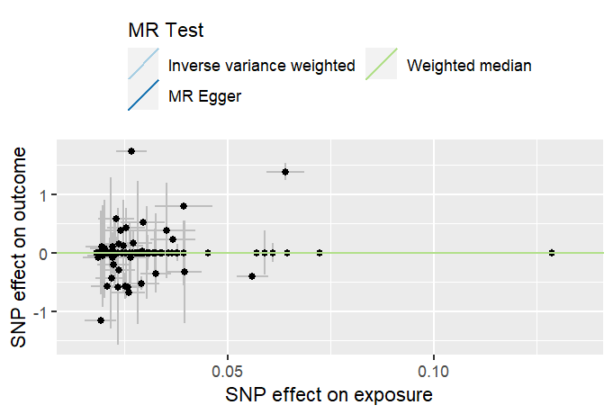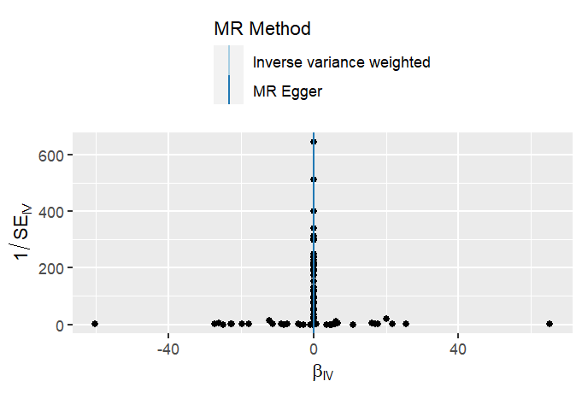
(C)
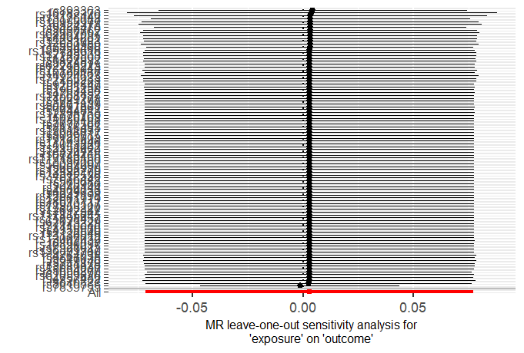
Supplementary Fig1 The forward MR analyses:Casual effect of refractive error on Alzheimer's disease. (A) The scatter plot for the effect of Refractive error on the risk of Alzheimer's disease. (B) Funnel plot of causation between Refractive error and Alzheimer's disease. (C) MR leave-one-out sensitivity analysis for Refractive error on Alzheimer's disease.
(A) (B)
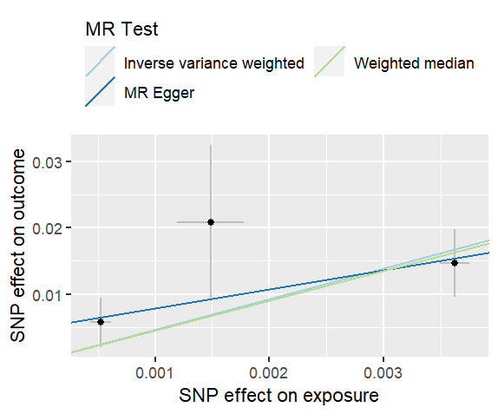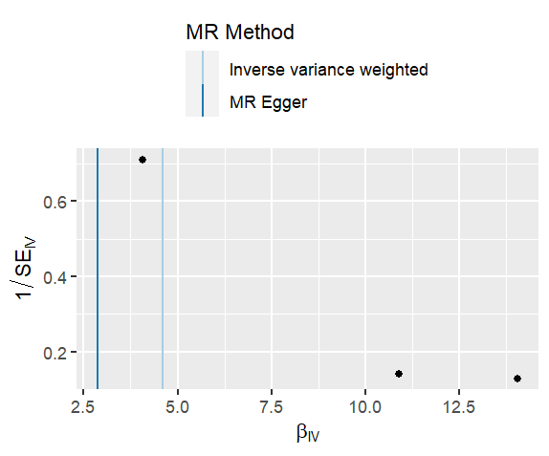
(C)
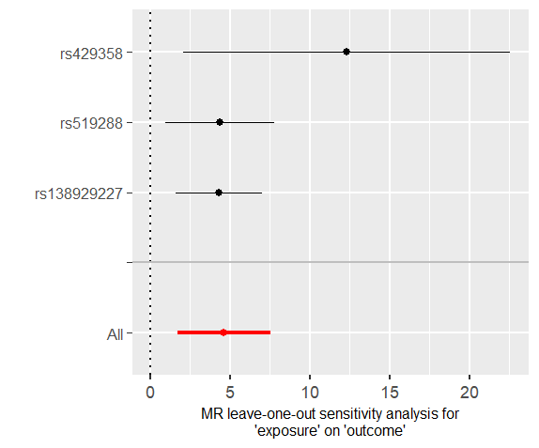
Supplementary Fig2 The reverse MR analyses:Casual effect of Alzheimer's disease on refractive error

- The scatter plot for the effect of Alzheimer's disease on the risk of Refractive error. (B) Funnel plot of causation between Alzheimer's disease and Refractive erro. (C) MR leave-one-out sensitivity analysis for Alzheimer's disease on Refractive error

