Table S1 Genome sequence features of strains FZY0004^{T} and YYF002^{T} as well as of the closely related species belonging to the genera Thalassospira and Winogradskyella.

Type species | Size (Mb) | DNA G+C content (mol%) | Genes | Assembly accession  number
FZY0004^{T} | 5.0 | 54.5 | 4,573 | GCA_029624155.1
T. profundimaris WP0211^{T} | 4.4 | 55.2 | 4,089 | GCA_000300275.1
T. xianhensis MCCC 1A02616^{T} | 5.2 | 54.5 | 4,582 | GCA_003326475.1
T. xiamenensis M-5^{T} | 4.8 | 54.5 | 4,424 | GCA_000300235.2
T. povalilytica Zumi 95^{T} | 4.4 | 55.1 | 4,055 | GCA_002844235.1
T. australica NP 3b2^{T} | 4.3 | 53.6 | 3,928 | GCA_000763295.1
T. indica PB8B^{T} | 4.7 | 54.9 | 4,433 | GCA_003403095.1
T. tepidiphila 1-1B^{T} | 4.4 | 54.9 | 3,879 | GCA_001662875.1
YYF002^{T} | 3.5 | 33.5 | 3166 | GCA_029624125.1
W. poriferorum JCM12885^{T} | 3.6 | 33.5 | 3284 | GCA_036553625.1
W. algicola IMCC33238^{T} | 3.4 | 33.9 | 3050 | GCA_005869935.1
W. tangerina M1309^{T} | 3.5 | 36.0 | 3203 | GCA_003260205.1
W. flava KCTC 52348^{T} | 3.9 | 35.0 | 3453 | GCA_014243395.1
W. luteola WHY3^{T} | 3.5 | 34.5 | 3276 | GCA_019203985.1
W. ouciana ZXX205^{T} | 3.6 | 35.5 | 3309 | GCA_009709615.1
Data for reference strains retrieved from NCBI.

Table S2 Numbers of genes associated with the KEGG functional pathways in strain FZY0004^{T} and the reference type strains T. profundimaris WP0211^{T} and T. xianhensis MCCC 1A02616^{T}.

KEGG functional pathways | FZY0004^{T} | T. profundimaris WP0211^{T} | T. xianhensis MCCC 1A02616^{T}
Amino acid metabolism | 247 | 255 | 253
Biosynthesis of other secondary metabolites | 33 | 36 | 38
Carbohydrate metabolism | 282 | 273 | 267
Cell growth and death | 29 | 30 | 31
Cell motility | 48 | 46 | 47
Energy metabolism | 151 | 156 | 143
Folding, sorting and degradation | 39 | 40 | 39
Glycan biosynthesis and metabolism | 49 | 52 | 49
Lipid metabolism | 52 | 49 | 45
Membrane transport | 138 | 124 | 138
Metabolism of cofactors and vitamins | 164 | 162 | 167
Metabolism of other amino acids | 66 | 66 | 64
Metabolism of terpenoids and polyketides | 22 | 23 | 27
Nucleotide metabolism | 90 | 86 | 87
Replication and repair | 65 | 65 | 68
Signal transduction | 80 | 78 | 86
Signaling molecules and interaction | 0 | 1 | 1
Transcription | 4 | 4 | 4
Translation | 76 | 79 | 79
Transport and catabolism | 9 | 9 | 11
Xenobiotics biodegradation and metabolism | 77 | 65 | 62

Table S3 Numbers of genes associated with the KEGG functional pathways in strain YYF002^{T} and the closely related strain W. poriferorum JCM12885^{T}, W. algicola IMCC33238^{T} and W. tangerina M1309^{T}.

KEGG functional pathways | YYF002^{T} | W. poriferorum JCM12885^{T} | W. algicola IMCC33238^{T} | W. tangerina M1309^{T}
Amino acid metabolism | 172 | 178 | 154 | 177
Biosynthesis of other secondary metabolites | 36 | 35 | 35 | 34
Carbohydrate metabolism | 183 | 202 | 158 | 178
Cell growth and death | 20 | 21 | 20 | 18
Cell motility | 4 | 4 | 4 | 4
Energy metabolism | 91 | 98 | 96 | 89
Folding, sorting and degradation | 27 | 28 | 28 | 27
Glycan biosynthesis and metabolism | 55 | 55 | 49 | 55
Lipid metabolism | 37 | 38 | 38 | 36
Membrane transport | 29 | 29 | 27 | 27
Metabolism of cofactors and vitamins | 97 | 97 | 95 | 103
Metabolism of other amino acids | 31 | 32 | 33 | 32
Metabolism of terpenoids and polyketides | 24 | 24 | 24 | 23
Nucleotide metabolism | 58 | 59 | 59 | 60
Replication and repair | 59 | 63 | 63 | 63
Signal transduction | 37 | 36 | 36 | 32
Signaling molecules and interaction | 1 | 1 | 1 | 1
Transcription | 3 | 3 | 3 | 3
Translation | 76 | 77 | 77 | 77
Transport and catabolism | 10 | 8 | 8 | 11
Xenobiotics biodegradation and metabolism | 30 | 33 | 27 | 31

Table S4 Results of strain FZY0004^{T} and the reference type strains T. profundimaris MCCC 1A00207^{T} and T. xianhensis CGMCC 1.6849^{T} in BiOLOG GEN III microtest.
According to the BiOLOG GEN III microtest, all strains show positive results for bromo-succinic acid, D-arabitol, D-cellobiose, D-fructose, D-galactose, D-malic acid, D-mannitol, D-mannose, formic acid, glycerol, L-histidine, L-malic acid, L-pyroglutamic acid, methyl pyruvate, propionic acidα-D-glucose, lincomycin, lithium chloride and 1% sodium lactate, and negative results for citric acid, p-hydroxy-phenylacetic acid, D-serine, fusidic acid, minocycline and troleandomycin.
Strains | Positive results | Negative results
FZY0004^{T} | acetic acid, acetoacetic acid, D-gluconic acid, D-saccharic acid, glycyl-L-proline, inosine, L-alanine, L-aspartic acid, L-fucose, L-glutamic acid, L-lactic acid, L-rhamnose, L-serine, mucic acid, myo-inositol, N-acetyl-D-glucosamine, quinic acid, α-hydroxy-butyric acid, α-keto-butyric acid, α-keto-glutaric acid, β-hydroxy-D, L butyric acid, γ-amino-butryric acid, aztreonam, potassium tellurite, rifamycin SV and vancomycin | D-fucose, D-maltose, D-melibiose, D-raffinose, D-salicin, D-sorbitol, D-trehalose, L-arginine, N-acetyl neuraminic acid, pectin, sucrose, α-D-lactose, β-methyl-D-glucoside, 3-methyl glucose, sodium bromate, sodium butyrate, tetrazolium blue and tetrazolium violet
T. profundimaris MCCC 1A00207^{T} | D-galacturonic acid, D-gluconic acid, D-glucuronic acid, glycyl-L-proline, L-alanine, L-galactonic acid lactone, L-glutamic acid, L-lactic acid, L-serine, α-keto-butyric acid, α-keto-glutaric acid, β-hydroxy-D, L butyric acid, γ-amino-butryric acid, nalidixic acid, potassium tellurite, rifamycin SV and vancomycin | acetic acid, acetoacetic acid, D-maltose, D-raffinose, D-serine, D-sorbitol, D-trehalose, gelatin, L-arginine, L-rhamnose, mucic acid, pectin, stachyose, sucrose, guanidine HCl, sodium bromate and sodium butyrate
T. xianhensis CGMCC 1.6849^{T} | acetic acid, D-fructose-6-PO_{4,} D-maltose, D-saccharic acid, D-trehalose, D-turanose, inosine, myo-inositol, N-acetyl-D-glucosamine, N-acetyl-β-D-mannosamine, sucrose, α-hydroxy-butyric acid, aztreonam and rifamycin SV | D-serine, gelatin, L-alanine, L-aspartic acid, L-serine, pectin and α-keto-glutaric acid, potassium tellurite, tetrazolium blue and tetrazolium violet
Data from and this study. Results of strain YYF002^{T} in BiOLOG GEN III microtest weren’t shown, as the positive test failed.

Table S5 Cellular fatty acid compositions of strain FZY0004^{T} and related type strains within the genus Thalassospira
Strains: 1. FZY0004^{T}; 2, T. profundimaris MCCC 1A00207^{T}; 3, T. xianhensis CGMCC 1.6849^{T}. Strains were all incubated on TSA containing 2.5% (w/v) NaCl at 28°C for 2 days prior to fatty acid analysis and data from this study. Values are percentages of total fatty acids. Fatty acids amounting to <1% of the total fatty acids in strains FZY0004^{T}, T. profundimaris MCCC 1A00207^{T} and T. xianhensis CGMCC 1.6849^{T} are not shown. Major components (>10.0%) are highlighted in bold type; tr, traces (<1%); −, not detected.

Fatty acid | 1 | 2 | 3
Straight-chain
C_{12:0} | 3.4 | 3.2 | 1.7
C_{14:0} | 7.3 | 5.5 | 4.7
C_{16:0} | 22.2 | 26.7 | 21.3
C_{17:0} | tr | tr | 1.1
C_{18:0} | 4 | 2.5 | 3.9
Hydroxy
C_{16:0} 3-OH | 4.8 | 4.2 | 2.9
C_{18:0} 3-OH | − | − | tr
C_{18:1} 2-OH | − | − | tr
Unsaturated
iso-C_{17:1} ω5c | − | 2.6 | 2.4
C_{15:1} ω5c | 1.9 | 1.5 | 1.6
C_{20:4} ω6/9/12/15c | 3.5 | 2.1 | −
anteiso-C_{14:0} | − | 3.1 | 2.9
cyclo-C_{17:0} | 5.5 | 19.2 | 10.0
cyclo-C_{19:0} ω8c | tr | 10.6 | 2.8
Summed features
2 | 2.8 | 1.5 | 1.2
3 | 14.5 | 1.9 | 8.3
8 | 24.2 | 12.1 | 29.7
Summed features represent groups of two or three fatty acids that cannot be separated by using the Microbial Identification System. Summed feature 2 comprised C_{14:0} 3-OH and/or iso-C_{16:1} I; summed feature 3 comprised C_{16:1} ω7c and/or C_{16:1} ω6c; summed feature 8 consists of C_{18:1} ω7c and/or C_{18:1} ω6c.

Table S6 Cellular fatty acid compositions of strain YYF002^{T} and related type strains within the genus Winogradskyella
Strains: 1. YYF002^{T}; 2, W. poriferorum JCM12885^{T}. Strains were both incubated on TSA containing 2.5% (w/v) NaCl at 28°C for 2 days prior to fatty acid analysis and data from this study. Values are percentages of total fatty acids. Fatty acids amounting to <1% of the total fatty acids in strains YYF002^{T} and W. poriferorum JCM12885^{T} are not shown. Major components (>10.0%) are highlighted in bold type; tr, traces (<1%); −, not detected.

Fatty acid | 1 | 2
Straight-chain
C_{12:0} | 2.0 | 3.8
C_{16:0} | 3.7 | 5.9
C_{18:0} | 1.8 | 3.6
Hydroxy
C_{15:0} 2-OH | tr | tr
C_{16:0} 3-OH | − | 1.2
C_{17:0} 2-OH | − | 1.1
Branched
iso-C_{14:0} | tr | −
iso-C_{15:0} | 33.1 | 37.5
iso-C_{15:1} G | 29.3 | 9.2
iso-C_{16:0} | tr | tr
iso-C_{16:1} G | tr | −
iso-C_{15:0} 3-OH | 12.0 | 10.1
iso-C_{16:0} 3-OH | − | 2.5
iso-C_{17:0} 3-OH | − | 14.3
Unsaturated
iso-C_{17:1} ω5c | 2.4 | −
C_{15:1} ω5c | 1.7 | 1.6
anteiso-C_{15:0} | 3.1 | 1.6
anteiso-C_{15:1} A | 1.2 | −
Summed features
3 | 3.6 | 1.6
Summed features represent groups of two or three fatty acids that cannot be separated by using the Microbial Identification System. Summed feature 3 comprised C_{16:1} ω7c and/or C_{16:1} ω6

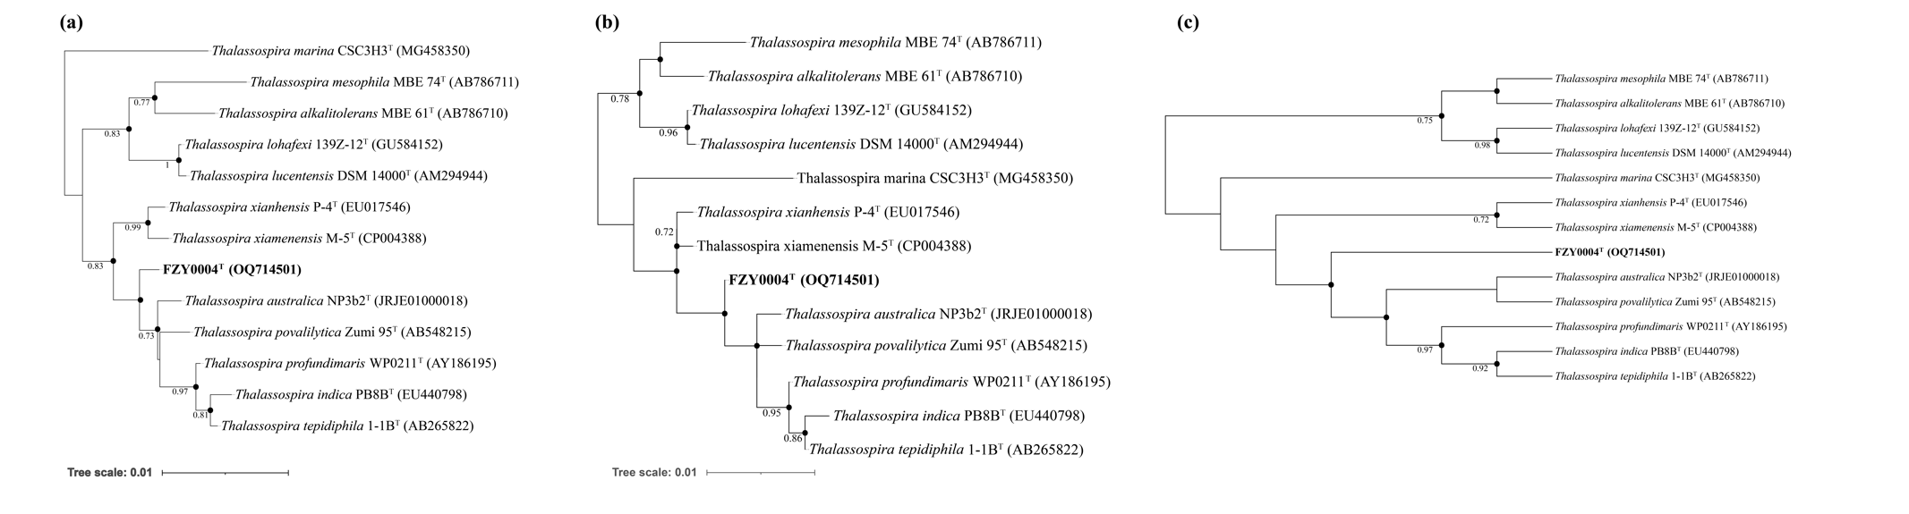
Fig. S1 Neighbour­joining phylogenetic tree (a), Maximum-likelihood tree (b) and Maximum-parsimony (c) based on 16S rRNA gene sequences showing the phylogenetic relationship of strain FZY0004^{T} and their closely relaxed species of the genus Thalassospira. Dots indicate that the corresponding nodes were recovered in the trees generated with the maximum-likelihood and maximum-parsimony algorithms; bootstrap values >70 % are shown based on a neighbour-joining analysis of 1000 resampled datasets. Azorhizobium caulinodans ORS 571^{T} (D11342) was used as an outgroup organism and not shown. Bar, 0.01 substitutions per nucleotide position.

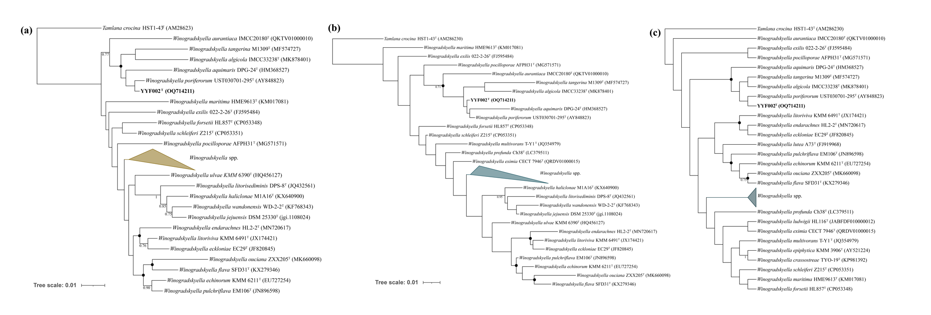
Fig. S2 Neighbour­joining phylogenetic tree (a), Maximum-likelihood tree (b) and Maximum-parsimony (c) based on 16S rRNA gene sequences showing the phylogenetic relationship of strain YYF002^{T} and their closely relaxed species of the genus Winogradskyella. Dots indicate that the corresponding nodes were recovered in the trees generated with the maximum-likelihood and maximum-parsimony algorithms; bootstrap values >70 % are shown based on a neighbour-joining analysis of 1000 resampled datasets. Tamlana crocina HST1-43^{T} (AM286230) was used as an outgroup organism and hidden in the tree. Bar, 0.01 substitutions per nucleotide position.

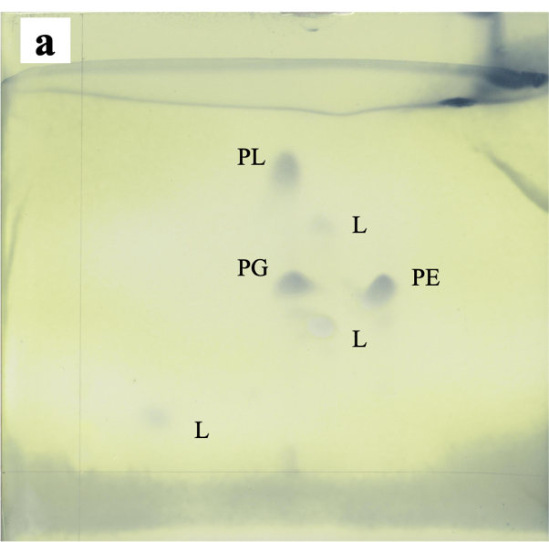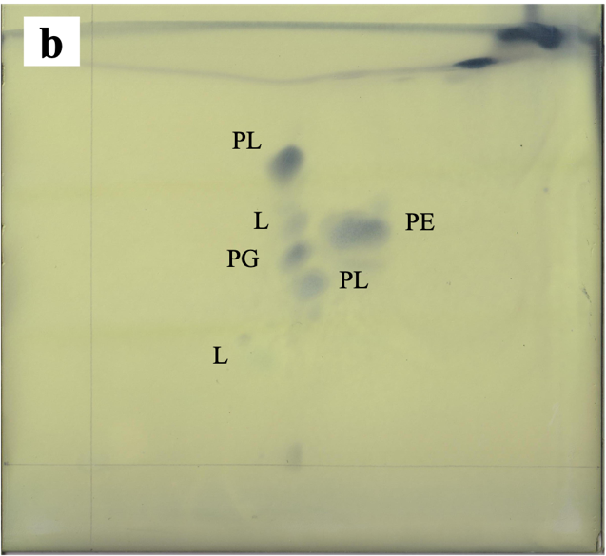
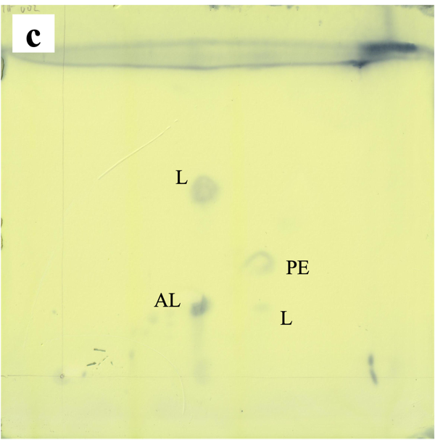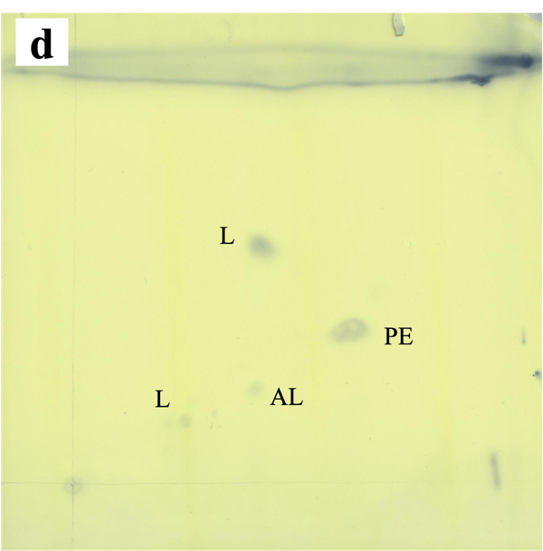
Fig. S3 Two-dimensional thin-layer chromatogram of polar lipid profile of strains: a, FZY0004^{T}; b, T. xianhensis CGMCC 1.6849^{T} ; c, YYF002^{T}; d, W. poriferorum JCM 12885^{T}.
AL, aminolipid; PE, phosphatidylethanolamine; PG, phosphatidylglycerol; PL, unidentified phospholipid; L, unidentified polar lipid.

