Supporting Information
A resilient type-III broken gap Ga₂O₃/SiC van der Waals heterogeneous bilayer with band-to-band tunneling effect and tunable electronic property
Naim Ferdous¹, Md. Sherajul Islam^{1,2}*, & Jeongwon Park^{1,3}
¹Department of Electrical & Biomedical Engineering, University of Nevada, Reno, NV 89557, USA.
²Department of Electrical and Electronic Engineering, Khulna University of Engineering & Technology, Khulna 9203, Bangladesh.
³School of Electrical Engineering and Computer Science, University of Ottawa, Ottawa, ON K1N6N5, Canada.
*Corresponding author. Email: sheraj_kuet@eee.kuet.ac.bd

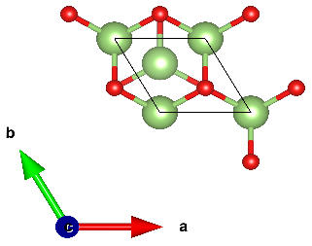
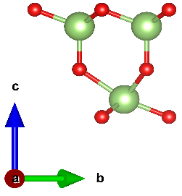
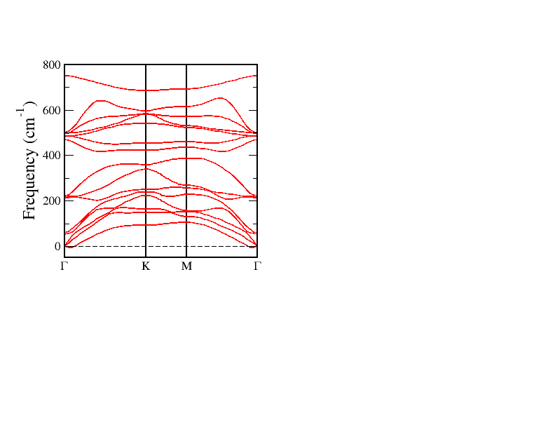
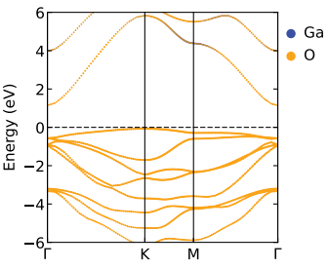
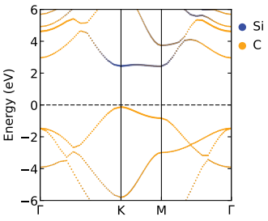
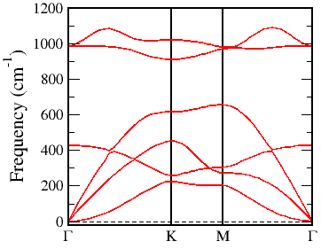
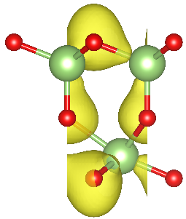
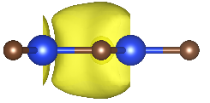
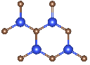
(a) (b) (c)
(d) (e) (f)

(g)

Figure S1. (a) Top view and side view of the unit cell of the Ga₂O₃ monolayer. (b) Projected band structure of the Ga₂O₃ monolayer. The contributions from the Ga and O atom are represented by the navy blue and cyber-yellow colors, respectively. (c) Phonon dispersion relations of the Ga₂O₃ monolayer. (d) Electronic band structure of the SiC monolayer. The contributions from the Si and C atom are represented by the navy blue and cyber-yellow colors, respectively. The inset shows the top view of the SiC monolayer. Electron localization function of the (f) Ga₂O₃ monolayer, and (g) SiC monolayer. Yellow overlayers represent the localization of the electrons.

The geometry-optimized structure of the Ga₂O₃ mono-layer is shown in Figure S1(a). We obtained a lattice constant of 3.09 Å for the geometry-optimized structure of 2D Ga₂O₃, consistent with the work of Liao et al¹. Three O-layers and two Ga-layers alternate in the structure of the FE-Ga₂O₃ layer while the movement of the internal O-layer determines the structure’s polarization inversion. The electronic band diagram of the layered Ga₂O₃ is illustrated in Figure S1(b). Layered Ga₂O₃ is a semiconductor with an indirect band gap of 1.202 eV. The valence band maximum (VBM) is located at the K point while the conduction band minimum is located at the $Γ$ point. In order to verify the dynamic stability of the layered Ga₂O₃, the phonon dispersion spectrum of the Ga₂O₃ layer is calculated. As Figure S1(c) suggests, soft-frequency phonon mode is absent in the dispersion relation, indicating that monolayer Ga₂O₃ is dynamically stable. Figure S1(d) presents the band structure of 2D SiC while the inset shows the top view of the unit cell of 2D SiC. As our calculation yields, the optimized lattice constant of the 2D SiC is 3.095 Å, which agrees well with the earlier studies^{2–4}. 2D SiC is semiconductor with an indirect band gap of 2.54 eV, VBM located at the K-point while CBM located at the $Γ$ point. The phonon dispersion spectrum of the monolayer 2D SiC (Figure S1(e)) indicates that there is no negative frequency phonon mode, confirming the dynamic stability of the monolayer SiC. Figure S1(f) and (g) depict the electron localization function (ELF) of the layered Ga₂O₃ and SiC, respectively, where form the covalent bonding characteristic between the Si and C atoms as well as Ga and O atoms can be observed.

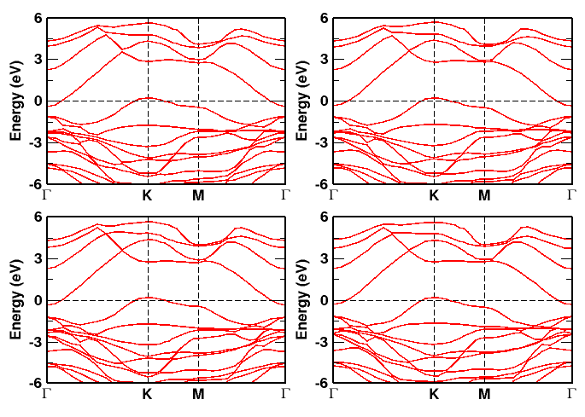
(a) (b)
(c) (d)
Figure S2. Electronic band diagram of the four configurations of the Ga₂O₃/SiC vdW bilayer heterostructure. (a) X₁, (b) X₂, (c) X₃, (d) X₄ configuration.

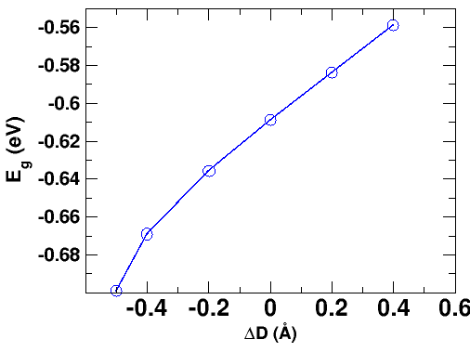
Figure S3. The variation of the band gap (E_{g}) as a function of vertical strain applied to the Ga₂O₃/SiC vdW bilayer heterostructure.

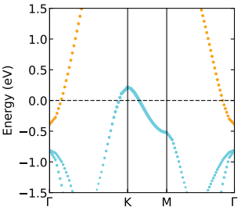
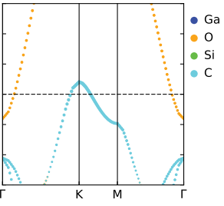
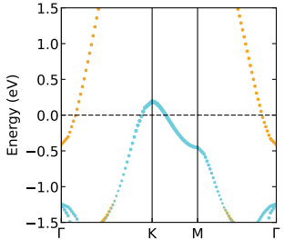
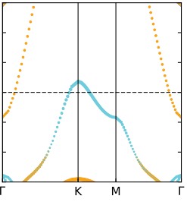
-6% -2%
+2% +6%

Figure S4. (Projected) Electronic band diagram of the Ga₂O₃/SiC vdW bilayer heterostructure under various biaxial strains applied to it.

Table S1. Binding energy, optimized interlayer distance and type of band alignment of the four configurations of the Ga₂O₃/SiC vdW bilayer heterostructure.
Stacking Configuration | Binding energy (meV$/Å$²) | Optimized interlayer distance ($Å)$ | Band Alignment
X₁ | -28.15 | 3.025 | Type-III
X₂ | -25.05 | 3.183 | Type-III
X₃ | -20.51 | 3.294 | Type-III
X4 | -20.48 | 3.546 | Type-III

References
1. Liao, Y., Zhang, Z., Gao, Z., Qian, Q. & Hua, M. Tunable Properties of Novel Ga2O3Monolayer for Electronic and Optoelectronic Applications. ACS Appl Mater Interfaces 12, 30659–30669 (2020).
2. Bekaroglu, E., Topsakal, M., Cahangirov, S. & Ciraci, S. First-principles study of defects and adatoms in silicon carbide honeycomb structures. Phys Rev B Condens Matter Mater Phys 81, 1–9 (2010).
3. Şahin, H. et al. Monolayer honeycomb structures of group-IV elements and III-V binary compounds: First-principles calculations. Phys Rev B Condens Matter Mater Phys 80, (2009).
4. Ferdous, N., Islam, M. S., Biney, J., Stampfl, C. & Park, J. Two-dimensional SiC/AlN based type-II van der Waals heterobilayer as a promising photocatalyst for overall water disassociation. Sci Rep 12, 1–13 (2022).

