Supplementary information
Results
Additional DaTSCAN results
As a descriptive analysis, the PASADENA delayed- and early-start groups showed a mean progression after 4 years of 0.63 (80% CI: 0.6 to 0.65) and 0.63 (80% CI: 0.61 to 0.65) points, respectively, while the PPMI cohort showed a mean progression of 0.55 (80% CI: 0.53 to 0.56) points in the putamen. In the caudate, the PASADENA delayed- and early-start groups showed a mean progression after 4 years of 1.18 (80% CI: 1.13 to 1.23) and 1.19 (80% CI: 1.15 to 1.23) points, respectively, while the PPMI cohort showed a mean progression of 1.45 (80% CI: 1.45 to 1.49) points.

The annual decline in putamen at year 1, 2 and 4 in PASADENA was -6.66, -10.55 and -9.02 (delayed-start) and -10.33, -8.90 and -8.41 (early-start) percent, while for the PPMI cohort, it was -16.70, -6.45 and -6.53 percent. The annual decline in caudate at year 1, 2 and 4 in PASADENA was -6.42, -9.37 and -8.85 (delayed-start) and -8.84, -8.75 and -8.53 (early-start) percent, while for the PPMI cohort, it was 10.11 -7.63, and -5.07 percent.

Rigidity subscore
The PASADENA delayed- and early-start groups both showed lower MDS-UPDRS Part III rigidity subscore progression in OFF-state in comparison with the PPMI cohort after 4 years, with -39% relative difference (mean [80% CI], -0.77 [-1.25 to -0.29] points) for the delayed-start group and -71% relative difference (mean [80% CI], -1.38 [-1.77 to -0.98] points) for the early-start group (Supplementary Figure S6A).

Resting tremor subscore
The PASADENA delayed- and early-start groups both showed lower MDS-UPDRS Part III resting tremor subscore progression in OFF-state in comparison with the PPMI cohort after 4 years, with -34% relative difference (mean [80% CI], -0.47 [-0.89 to -0.06] points) for the delayed-start group and -50% relative difference (mean [80% CI], -0.69 [-1.03 to -0.35] points) for the early-start group (Supplementary Figure S6B).

Bradykinesia subscore
The PASADENA delayed- and early-start groups both showed lower MDS-UPDRS Part III bradykinesia subscore progression in OFF-state in comparison with the PPMI cohort after 4 years, with -62% relative difference (mean [80% CI], -3.67 [-4.70 to -2.65] points) for the delayed-start group and -67% relative difference (mean [80% CI], -3.98 [-4.83 to -3.13] points) for the early-start group (Supplementary Figure S6C).

Axial signs subscore
Axial symptoms comprise MDS-UPDRS Part III items 10, 11 and 12. The PASADENA delayed- and early-start groups both showed lower MDS-UPDRS Part III axial signs subscore progression in OFF-state in comparison with the PPMI cohort after 4 years, with -67% relative difference (mean [80% Cl], -0.47 [-0.71 to -0.23] points) for the delayed-start group and -64% relative difference (mean [80% CI], -0.45 [-0.65 to -0.25] points) for the early-start group (Supplementary Figure S6D).

Tremor motor severity subscore – ON-state
The tremor motor severity subscore includes item 10 from MDS-UPDRS Part II and items 15, 16, 17 and 18 from MDS-UPDRS Part III. The PASADENA delayed- and early-start groups both showed lower MDS-UPDRS Part III tremor subscore progression in ON-state in comparison with the PPMI cohort after 4 years, with -19% relative difference (mean [80% CI], 0.3 [-0.26 to 0.86] points) for the delayed-start group and -35% relative difference (mean [80% CI], 0.55 [0.1 to 1.01] points) for the early-start group (Supplementary Figure S6E).

Tremor motor severity subscore – OFF-state
The PASADENA delayed- and early-start groups both showed lower MDS-UPDRS Part III tremor subscore progression in OFF-state in comparison with the PPMI cohort after 4 years, with 400% relative difference (mean [80% CI], 0.64 [-0.02 to 1.29] points) for the delayed-start group and 288% relative difference (mean [80% CI], 0.46 [-0.06 to 0.98] points) for the early-start group (Supplementary Figure S6F).

Non-tremor subscale – ON-state
The non-tremor motor severity subscore includes items 1‒9 and 11‒13 from MDS-UPDRS Part II, and items 1‒14 from MDS UPDRS Part III. The PASADENA delayed- and early-start groups both showed lower MDS-UPDRS Part III non-tremor subscore progression in ON-state in comparison with the PPMI cohort after 4 years, with -53% relative difference (mean [80% CI], -2.97 [-4.97 to -0.98] points) for the delayed-start group and -66% relative difference (mean [80% CI], -3.75 [-5.38 to -2.12] points) for the early-start group (Supplementary Figure S6G).

Non-tremor subscale – OFF-state The PASADENA delayed- and early-start groups both showed lower MDS-UPDRS Part III non-tremor subscore progression in OFF-state in comparison with the PPMI cohort after 4 years, with 9% relative difference (mean [80% CI], 0.47 [-1.78 to 2.73] points) for the delayed-start group and -2% relative difference (mean [80% CI], -0.08 [-1.9 to 1.74] points) for the early-start group (Supplementary Figure S6H).

Supplementary Table S1. MDS UPDRS Part IV and start of levodopa descriptive summary statistics
Assessment | Visit | PASADENA delayed-start(N=94) | PASADENA early-start (N=177) | PPMI (N=303)
MDS-UPDRS Part IV: N  Mean (SD) change from baseline  Median [Range] | Year 1 | 62  0.92 (2.21)  0 [0-10] | 113  0.58 (1.77)  0 [0-10] | 174  0.43 (1.35)  0 [0-9]
 | Year 2 | 75  1.4 (2.05)  0 [0-7] | 134  1.07 (1.96)  0 [0-9] | 231  0.71 (1.79)  0 [0-11]
 | Year 3 | 82  1.55 (2.39)  0 [0-11] | 149  1.48 (2.25)  0 [0-12] | 245  0.86 (1.82)  0 [0-11]
 | Year 4 | 84  1.99 (2.64)  0 [0-11] | 159  1.93 (2.65)  0 [0-13] | 239  1.53 (2.58)  0 [0-12]
Levodopa started, n (%) | Baseline | 0 (0) | (0) | 4 (1)
Levodopa started, n (%) | Year 1 | 25 (27) | 50 (28) | 81 (27)
Levodopa started, n (%) | Year 2 | 54 (57) | 94 (53) | 143 (49)
Levodopa started, n (%) | Year 3 | 70 (74) | 125 (71) | 187 (66)
Levodopa started, n (%) | Year 4 | 76 (84) | 142 (82) | 209 (77)
MDS-UPDRS Part IV with score 0,  n (%) | Year 1 | 53 (53.2) | 99 (55.9) | 152 (51.2)
MDS-UPDRS Part IV with score 0,  n (%) | Year 2 | 47 (50.0) | 95 (53.7) | 187 (64.5)
MDS-UPDRS Part IV with score 0,  n (%) | Year 3 | 50 (53.2) | 89 (50.6) | 184 (64.6)
MDS-UPDRS Part IV with score 0,  n (%) | Year 4 | 44 (48.4) | 85 (49.1) | 159 (58.2)
MDS-UPDRS Part IV with score 1,  n (%) | Year 1 | 0 (0) | 0 (0) | 5 (1.7)
MDS-UPDRS Part IV with score 1,  n (%) | Year 2 | 1 (1.1) | 4 (2.3) | 7 (2.4)
MDS-UPDRS Part IV with score 1,  n (%) | Year 3 | 4 (4.3) | 6 (3.4) | 14 (4.9)
MDS-UPDRS Part IV with score 1,  n (%) | Year 4 | 5 (5.5) | 8 (4.6) | 6 (2.2)
MDS-UPDRS Part IV with score ≥2,  n (%) | Year 1 | 12 (12.8) | 14 (7.9) | 17 (5.7)
MDS-UPDRS Part IV with score ≥2,  n (%) | Year 2 | 27 (28.7) | 35 (19.8) | 37 (12.8)
MDS-UPDRS Part IV with score ≥2,  n (%) | Year 3 | 28 (29.8) | 53 (30.1) | 47 (16.5)
MDS-UPDRS Part IV with score ≥2,  n (%) | Year 4 | 35 (38.5) | 65 (37.6) | 74 (27.1)
MDS-UPDRS Part IV missing,  n (%) | Year 1 | 32 (34.0) | 64 (36.2) | 123 (41.4)
MDS-UPDRS Part IV missing,  n (%) | Year 2 | 19 (20.2) | 43 (24.3) | 59 (20.3)
MDS-UPDRS Part IV missing,  n (%) | Year 3 | 12 (12.8) | 28 (15.9) | 40 (14)
MDS-UPDRS Part IV missing,  n (%) | Year 4 | 7 (7.7) | 15 (8.7) | 34 (12.5)
MDS-UPDRS Part IV item 4.1  missing or 0 vs ≥1 (%) | Year 1 | 96.8 vs 3.2 | 99.4 vs 0.6 | 99.0 vs 1.0
MDS-UPDRS Part IV item 4.1  missing or 0 vs ≥1 (%) | Year 2 | 94.7 vs 5.3 | 96.0 vs 4.0 | 95.2 vs 4.8
MDS-UPDRS Part IV item 4.1  missing or 0 vs ≥1 (%) | Year 3 | 91.5 vs 8.5 | 90.9 vs 9.1 | 91.6 vs 8.4
MDS-UPDRS Part IV item 4.1  missing or 0 vs ≥1 (%) | Year 4 | 83.5 vs 16.5 | 84.4 vs 15.6 | 89.0 vs 11.0
MDS-UPDRS Part IV item 4.3  missing or 0 vs ≥1 (%) | Year 1 | 87.2 vs 12.8 | 92.7 vs 7.3 | 94.3 vs 5.7
MDS-UPDRS Part IV item 4.3  missing or 0 vs ≥1 (%) | Year 2 | 73.4 vs 26.6 | 79.7 vs 20.3 | 87.9 vs 12.1
MDS-UPDRS Part IV item 4.3  missing or 0 vs ≥1 (%) | Year 3 | 69.1 vs 30.9 | 68.8 vs 31.2 | 74.9 vs 15.1
MDS-UPDRS Part IV item 4.3  missing or 0 vs ≥1 (%) | Year 4 | 59.3 vs 40.7 | 61.8 vs 38.2 | 72.6 vs 27.5
MDS-UPDRS, Movement Disorder Society-sponsored revision of the Unified Parkinson's Disease Rating Scale; SD, standard deviation; PPMI, Parkinson's Progression Markers Initiative.

Supplementary Figure S1. Adjusted logistic model Hoehn & Yahr ≥3 at year 4. PPMI, Parkinson's Progression Markers Initiative.
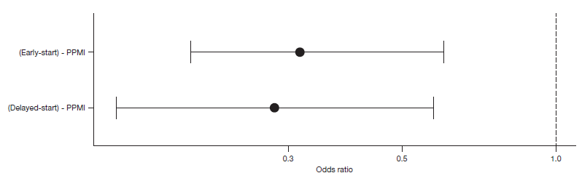

Supplementary Figure S2. LEDD plot of mean and standard deviation over time (A) and LEDD MMRM change from baseline (B). LEDD, levodopa equivalent daily dose; MMRM, Mixed Models for Repeated Measures; PPMI, Parkinson's Progression Markers Initiative.

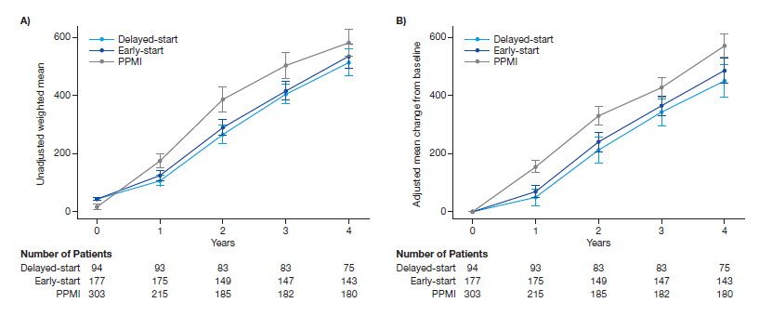

Supplementary Figure S3. Change from baseline for MDS-UPDRS Part I of PASADENA (early and delayed start) against PPMI. MDS-UPDRS, Movement Disorder Society-sponsored revision of the Unified Parkinson's Disease Rating Scale; PPMI, Parkinson's Progression Markers Initiative.

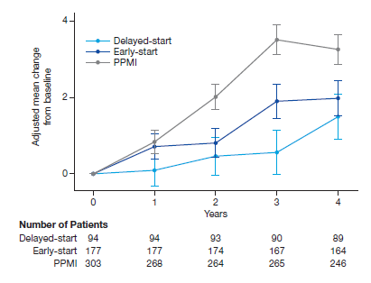

Supplementary Figure S4. Attrition of PPMI sample. H&Y, Hoehn and Yahr; PD, Parkinson’s disease; PPMI, Parkinson's Progression Markers Initiative.
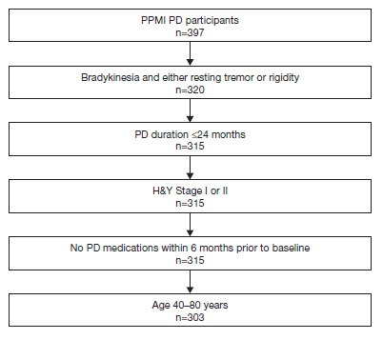

Supplementary Figure S5. Evaluation of the PPMI-based disease progression models with PASADENA data from the placebo group for (A) MDS-UPDRS Part III OFF; (B) MDS-UPDRS Part III ON and (C) MDS-UPDRS Part II; and comparison of PPMI-based disease model prediction and PASADENA data when merging the two treatment groups (early- and delayed-start) for (D) MDS-UPDRS Part III OFF and OLE; (E) MDS-UPDRS Part III ON and OLE, and (F) MDS-UPDRS Part II and OLE. Over that year, 46% and 48% of the PASADENA data fall within the predicted PPMI median for MDS-UPDRS Part III OFF and Part II, respectively. For MDS-UPDRS Part III ON, 42% of the PASADENA data fall within the PPMI median, which was considered too low to keep the model for further comparison. Note that the figures for MDS-UPDRS Part III ON are only shown for transparency and to illustrate the challenges of successfully reproducing placebo data. MDS-UPDRS, Movement Disorder Society-sponsored revision of the Unified Parkinson's Disease Rating Scale; OLE, open-label extension; PPMI, Parkinson's Progression Markers Initiative.
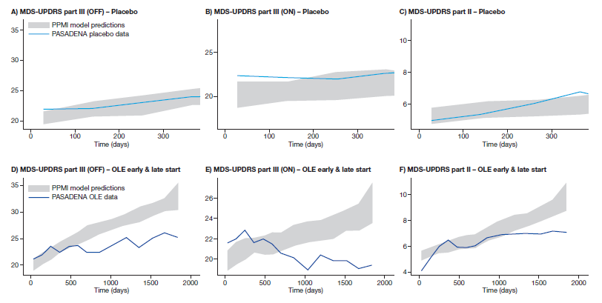

Supplementary Figure S6. Adjusted mean change from baseline in MDR-UPDRS Part III motor subscores (all in OFF state), and in combination with Part II for tremor and non-tremor. MDS-UPDRS, Movement Disorder Society-sponsored revision of the Unified Parkinson's Disease Rating Scale; PPMI, Parkinson's Progression Markers Initiative.
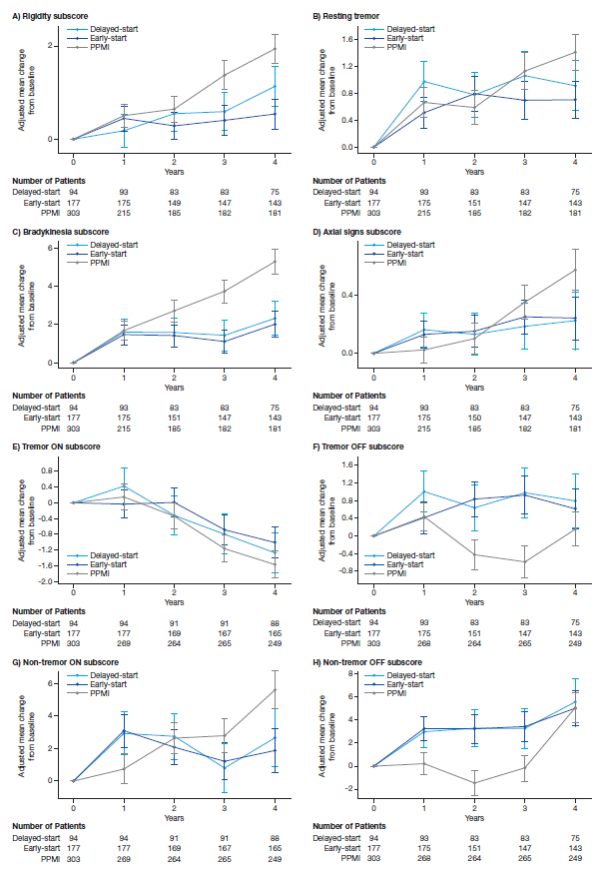

A full list of the members of the PASADENA Investigators and Prasinezumab Study Group
PASADENA Investigators
Claudia Altendorf¹, Chareyna Anandan², Giulia Andrews³, Solène Ansquer⁴, Raphaele Arrouasse⁵, Sana Aslam³, Jean-Philippe Azula⁶, Jeanette Baker⁷, Ernest Balaguer Martinez⁸, Shadi Barbu³, Kara Bardram⁹, Danny Bega¹⁰, Helena Bejr-Kasem Marco¹¹, Isabelle Benatru⁴, Eve Benchetrit⁶, Felix Bernhard¹², Amit Besharat¹³, Sagari Bette¹⁴, Amelie Bichon¹⁵, Andrew Billnitzer², Sophie Blondeau⁴, Thomas Boraud¹⁶, Freiderike Borngräber¹, James Boyd⁷, Kathrin Brockmann¹⁷, Matthew Brodsky¹⁸, Ethan Brown¹⁹, Christof Bruecke¹, Fabienne Calvas²⁰, Monica Canelo²¹, Federico Carbone²², Claire Carroll²³, Laura Casado Fernandez²⁴, Catherine Casse-Parrot⁶, Anna Castrioto¹⁵, Helene Catala²⁰, Justine Chan³, Samia Cheriet²⁰, Anthony Ciabarra²⁵, Joseph Classen²⁶, Juliana Coleman²⁷, Robert Coleman²⁷, Yaroslau Compta²⁸, Jean-Christophe Corvol²⁹, Mariana Cosgaya²⁸, Nabila Dahodwala³⁰, Philippe Damier³¹, Elodie David³², Thomas Davis³³, Marissa Dean³⁴, Berengere Debilly³⁵, Janell DeGiorgio³⁶, Andres Deik³⁰, Laure Delaby³⁵, Marie-Helene Delfini⁶, Pascal Derkinderen³¹, Philipp Derost³⁵, Maria de Toledo²⁴, Lisa Deuel⁷, Ann Marie DiazHernandez¹⁴, Cameron Dietiker¹⁹, Karina Dimenshteyn³⁷, Julio Dotor²⁴, Franck Durif³⁵, Jens Ebentheuer²¹, Karla Maria Eggert³⁸, Sara Eichau Madueño³⁹, Claudia Eickoff³⁷, Aaron Ellenbogen⁹, Philipp Ellmerer²², Ines Esparragosa Vazquez⁴⁰, Alexandre Eusebio⁶, Siobhan Ewert¹, John Fang³³, Danielle Feigenbaum¹³, Frederique Fluchere⁶, Alexandra Foubert-Samier¹⁶, Marie Fournier¹⁵, Anne Fradet⁴, Valerie Fraix¹⁵, Samuel Frank⁴¹, Franka Fries¹⁷, Monique Gailitzky²⁰, Anne Gaille Corbille³¹, Marisol Gallardó Pérez⁴², Jose Manuel Garcia Morena³⁹, Carmen Gasca⁴³, Thomas Gasser¹⁷, Joyce Gibbons⁴⁴, Caroline Giordana³², Alicia Gonzalez Martinez²⁴, Ira Goodman²³, Arantza Gorospe⁴⁰, Marie Goubeaud²⁰, David Grabli²⁹, Mangone Graziella²⁹, Stephan Grimaldi⁶, Jeffrey Gross⁴⁵, Raquel Guimaraes-Costa²⁹, Andreas Hartmann²⁹, Christian Hartmann³⁷, Travis Hassell³³, Robert Hauser⁴⁶, Antonio Hernandez⁸, Jorge Hernandez-Vara⁴⁷, Günter Höglinger⁴⁸, Christian Homedes⁸, Andrea Horta¹¹, Jean-Luc Houeto⁴, Julius Huebl¹, Jennifer Hui¹³, Stuart Isaacson¹⁴, Joseph Jankovic², Annette Janzen³⁸, Jocelyne Jiao¹⁸, Maria Jose Marti Domenech⁴⁹, Xavier Joseph⁵, Srinath Kadimi⁴⁵, Pat Kaminski⁵⁰, Silja Kannenberg³⁷, R. Jan Kassubek⁵¹, Maya Katz¹⁹, Kevin Klos⁵², Shannon Klos⁵², Christopher Kobet²⁷, Jennifer Koebert⁴⁶, Patricia Krause¹, Andrea Kuhn¹, Jaime Kulisevsky Bojarsky⁵³, Rajeev Kumar³⁶, Martin Kunz⁵², Lille Kurvits¹, Kimberly Kwei⁵⁴, Simon Laganiere⁴¹, Brice Laurens¹⁶, Johannes Levin⁴⁸, Oren Levy⁵⁵, Peter Le Witt⁵¹, Gurutz Linazasoro Cristobal¹¹, Irene Litvan⁵⁵, Karlo Lizarraga⁵⁶, Katherine Longardner⁵⁷, Rocio Lopez³⁹, Lydia Lopez Manzanares²⁴, Sara Lucas del Pozo⁴⁷, Maria Rosario Luquin Puido⁴⁰, Nijee Luthra¹⁹, Kelly Lyons⁵⁷, Sylvia Maass⁴⁸, Gerrit Machetanz¹⁷, Yolanda Macias⁴³, David Maltete⁵⁸, Jorge Uriel Manez Miro⁴³, Louis-Laure Mariani²⁹, Juan Marin¹¹, Kathrin Marini²², Ana Marques³⁵, Gloria Marti⁴⁰, Saul Martinez¹¹, Wassilios Meissner¹⁶, Sara Meoni¹⁵, Brit Mollenhauer²¹, Dunia Mon Martinez⁸, Johnson Moon²⁵, Elena Moro¹⁵, Peter Morrison⁵⁶, Christoph Muehlberg²⁶, Manpreet Multani²⁵, Christine Murphy²³, Anthony Nicholas³⁴, Rajesh Pahwa⁵⁷, Antonio Palasis⁴⁷, Heidi Pape³⁸, Neepa Patel⁵⁰, Prity Patel²³, Marina Peball²², Elizabeth Peckham⁵⁹, Terry Peery⁵⁹, Jesus Perez¹¹, Rafael Perez Alisa Petit³⁹, Elmar Pinkhardt⁵¹, Werner Poewe²², Elsa Pomies²⁰, Cecile Preterre³¹, Joseph Quinn¹⁸, Olivier Rascol²⁰, Philippe Remy⁵, Emily Reuther²⁷, Irene Richard⁵⁶, Benjamin Roeben¹⁷, Jost-Julian Rumpf²⁶, David Russell⁴⁴, Hayet Salhi⁵, Daniela Samaniego⁴⁷, Alexandra Samier-Foubert¹⁶, Alvaro Sanchez-Ferro⁴³, Emmanuelle Schmitt¹⁵, Alfons Schnitzler³⁷, Oliver Schorr²², Julie Schwartzbard⁶⁰, Kerstin Schweyer⁴⁸, Klaus Seppi²², Victoria Sergo³⁶, Holly Shill³, Andrew Siderowf³⁰, Tanya Simuni¹⁰, Umberto Spampinato¹⁶, Ashok Sriram²⁷, Natividad Stover³⁴, Caroline Tanner¹⁹, Arjun Tarakad², Carolyn Taylor¹⁰, Claire Thalamus²⁰, Thomas Toothaker⁴⁵, Nadege Van Blercom¹¹, Nora Vanegas-Arrogave⁵⁴, Lydia Vela⁴³, Sylvian Vergnet¹⁶, Tiphaine Vidal³⁵, Jonathan Vöglein⁴⁸, Ryan Walsh³, Cheryl Waters⁵⁴, Mirko Wegschneider²⁶, Endy Weidinger²⁶, Caroline Weill⁵, Gregor Wenzel¹, Tatiana Witjas⁶, Isabel Wurster¹⁷, Brenton Wright⁵⁵, Milan Zimmermann¹⁷, Rafael Zuzuarregui¹⁹

1. Berlin Medical University, Neurology Clinic, Campus Charité Mitte, Berlin, Germany;
2. Baylor College of Medicine, Houston, TX, USA;
3. Barrow Neurological Institute, Phoenix, AZ, USA;
4. Poitiers University Hospital, Poitiers, France;
5. Henri-Mondor University Hospital, Créteil, France;
6. Marseille University Hospital Timone, Marseille, France;
7. University of Vermont, Larner College of Medicine, Burlington, VT, USA;
8. General University Hospital of Catalonia, Barcelona, Spain;
9. Quest Research Institute, Farmington Hills, MI, USA;
10. Northwestern University, Evanston, IL, USA;
11. Policlinica Gipuzkoa Servicio De Neurologia, Gipuzkoa, Spain;
12. Philipps University of Marburg, Neurology Clinic, Marburg, Germany;
13. University of Southern California, Keck Medical Center, Los Angeles, CA, USA;
14. Parkinson's Disease and Movement Disorders Center of Boca Raton, Boca Raton, FL, USA;
15. Grenoble Alpes University Michallon Hospital, La Tronche, France;
16. Hospital Pellegrin Bordeaux, Bordeaux, France;
17. Tubingen University Hospital, Tubingen, Germany;
18. Oregon Health & Science University, Portland, OR, USA;
19. University of California, San Francisco, CA, USA;
20. Toulouse University, Clinical Research Center, Purpan Hospital, Toulouse, France;
21. Goettingen University Medical Center, Paracelsus Elena Klinik Kassel, Goettingen, Germany;
22. Medical University of Innsbruck, Neuroradiology Clinic, Innsbruck, Austria;
23. Compass Research LLC, Orlando, FL, USA;
24. De La Princessa University Hospital, Madrid, Spain;
25. Neurology Center of North Orange County, Fullerton, CA, USA;
26. Leipzig University, Neurology Clinic and Polyclinic, Leipzig, Germany;
27. Spectrum Health Medical Group, USA;
28. Hospital Clinic Barcelona, Barcelona, Spain;
29. Sorbonne University, Pitié-Salpêtrière University Hospital, Paris, France;
30. University of Pennsylvania, Philadelphia, PA, USA;
31. Nantes University, North Laennec University Hospital, Saint-Herblain, France;
32. Nice University, Hospital Pasteur, Nice, France;
33. Vanderbilt University Medical Center, Nashville, TN, USA;
34. University of Alabama, UAB Medicine, Birmingham, AL, USA;
35. Clermont-Ferrand University Hospital Center, Site Gabriel-Montpied, Clermont-Ferrand, France;
36. Rocky Mountain Movement Disorders Center, Englewood, CO, USA;
37. Heinrich Heine University Düsseldorf, University Hospital Düsseldorf, Germany;
38. Philips University of Marburg, Marburg, Germany;
39. University of Sevilla, Virgin Macarena University Hospital, Sevilla, Spain;
40. University of Navarra, Navarra University Hospital, Department of Neurology, Navarre, Spain;
41. Beth Israel Deaconess Medical Center, Boston, MA, USA;
42. University of Barcelona, The Provincial Clinic Hospital, Barcelona, Spain;
43. University of Madrid, The Alcorcón Foundation University Hospital, Madrid, Spain;
44. Invicro, New Haven, CT, USA;
45. Associated Neurologists of Southern Connecticut, P.C., Milford, CT, USA;
46. University of South Florida, Parkinson’s Disease and Movement Disorders, Tampa, FL, USA;
47. Vall d'Hebron Barcelona University Hospital, Department of Neurology, Barcelona, Spain;
48. Technical University of Munich, The Rechts der Isar Hospital, Munich, Germany;
49. Neurosciences Clinic Institute of the Barcelona Hospital Clinic, Parkinson Disease and Movement Disorders Unit, Barcelona, Spain;
50. Henry Ford Health System. Clarkston, MI, USA;
51. University of Ulm, Ulm University Hospital, Clinic for Neurology, Ulm, Germany;
52. The Movement Disorder Clinic of Oklahoma, Tulsa, OK, USA;
53. Autonomous University of Barcelona, Hospital de la Santa Creu i Sant Pau, Autoimmune Neurology Unit – Neurology Service, Barcelona, Spain;
54. Columbia University, New York, CU, USA;
55. University of California San Diego Altman Clinical and Translational Research Institute, La Jolla, CA, USA;
56. University of Rochester Medical Center, Rochester, NY, USA;
57. University of Kansas Medical Center, Kansas City, KS, USA;
58. University of Rouen Normandy Hospital, Charles Nicolle Parkinson’s Disease Center, Rouen, France;
59. Central Texas Neurology Consultants, Round Rock, TX, USA;
60. Aventura Neurologic Associates, Aventura, FL, USA;

Prasinezumab Study Group
Markus Abt,¹ Atieh Bamdadian,¹ Teresa Barata,¹ Nicholas Barbet,¹ Sara Belli,¹ Frank Boess,¹ Azad Bonni,¹ Edilio Borroni,¹ Anne Boulay,¹ Markus Britschgi,¹ Valerie Cosson,¹ Christian Czech,¹ Evan Davies,¹ Dennis Deptula,¹ Cheikh Diack,¹ Rachelle Doody,¹ Juergen Dukart,¹ Giulia D’Urso,¹ Sebastian Dziadek,¹ Chris Edgar,¹ Laurent Essioux,¹ Morgan Farell,¹ Rebecca Finch,¹ Paulo Fontoura,¹ Waltraud Gruenbauer,¹ Andrea Hahn,¹ Stefan Holiga,¹ Michael Honer,¹ Shirin Jadidi,¹ Timothy Kilchenmann,¹ Thomas Kremer,¹ Thomas Kustermann,¹ Claire Landsdall,¹ Michael Lindemann,¹ Florian Lipsmeier,¹ Cecile Luzy,¹ Marianne Manchester,¹ Maddalena Marchesi,¹ Ferenc Martenyi,² Meret Martin-Facklam,¹ Katerina Mironova,¹ Emma Moore,¹ Annabelle Monnet,¹ Markus Niggli,¹ Tania Nikolcheva,² Susanne Ostrowitzki,¹ Gennaro Pagano,¹ Benedicte Passemard,¹ Agnes Poirier,¹ Anke Post,¹ Megana Prasad,¹ Nathalie Pross,¹ Benedicte Ricci,¹ Ellen Rose,² Daria Rukina,¹ Christoph Sarry,¹ Marzia A. Scelsi,¹ Christine Schubert,¹ Jeff Sevigny,¹ Kaycee Sink,¹ Nima Shariati,¹ Alexander Strasak,¹ Hannah Staunton,¹ Hanno Svoboda,¹ Kirsten I. Taylor,¹ Dylan Trundell,¹ Daniel Umbricht,¹ Lynne Verselis,¹ Annamarie Vogt,¹ Ekaterina Volkova-Volkmar,¹ Cornelia Weber,¹ Silke Weber,¹ Stefano Zanigni¹

1. F. Hoffmann-La Roche Ltd, Basel, Switzerland;
2. Prothena Corporation plc, Dublin, Ireland

