Supplementary Materials
Haoran Xue^{1,2}, Yunchen Gong^{1,3}, Stephen I. Wright^{1,3*}, and Spencer C.H. Barrett^{1*}
* These authors contributed equally to the work
1. Department of Ecology and Evolutionary Biology, University of Toronto, Toronto, Ontario M5S 3B2, Canada
2. Institute for Biochemistry and Biology, University of Potsdam, 14476 Potsdam-Golm, Germany
3. Centre for Analysis of Genome Evolution and Function, University of Toronto, Toronto, Ontario M5S 3B2, Canada
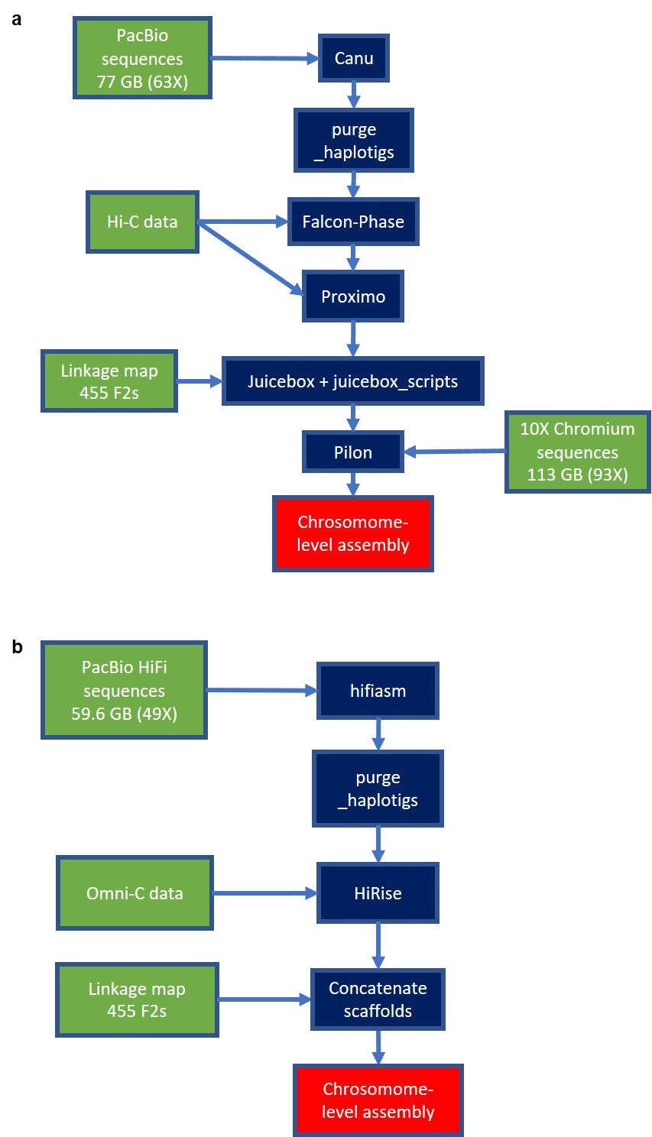
Figure S1 | Schematics of assembly workflow. a. SsMm assembly. b. ssmm assembly for Eichhornia paniculata

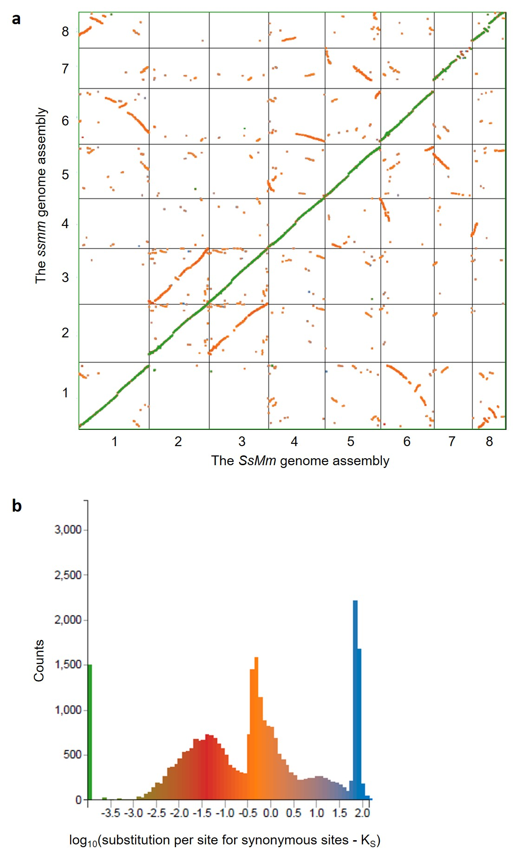
Figure S2 | a. Syntenic comparison between the SsMm (x-axis) and ssmm (y-axis) assemblies of Eichhornia paniculata. Colours represent synonymous substitution rates of homologous genes shown in b. b. Distribution of synonymous substitutions between homologous genes.

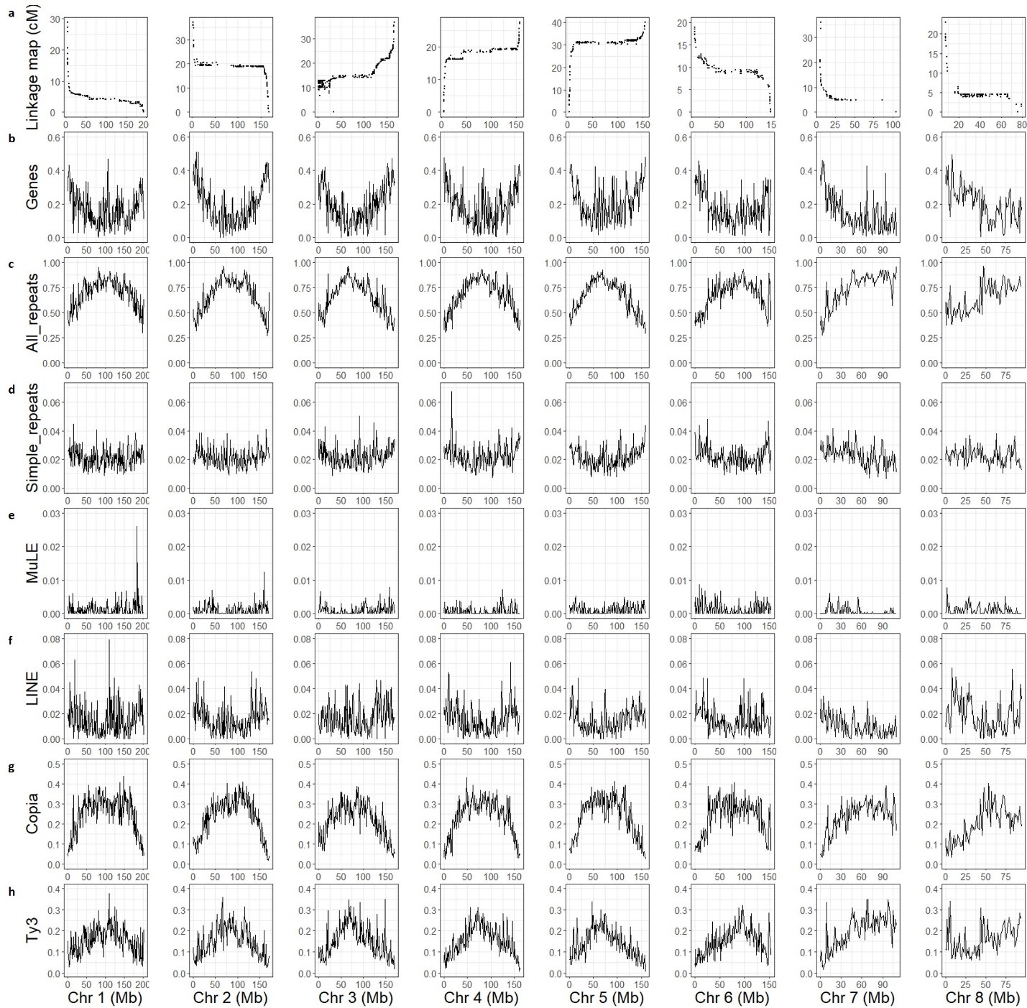
Figure S3 | The recombination landscape and genome content across the chromosomes of Eichhornia paniculata. a. Marey maps plotting the position on the linkage map (cM) against the position on the physical map (Mb). b-h, Densities of genes (b), all repetitive elements (c), simple repeats (d), Mutator-Like Element (MuLE) (e), Long Interspersed Nuclear Element (LINE) (f), Copia elements (g), and Ty3 elements (h), all measured as proportions of 1-Mb windows.

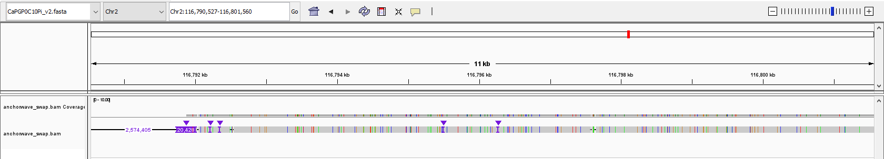
Figure S4 | Anchorwave alignment supports divergence between the S and s alleles in Eichhornia paniculata.

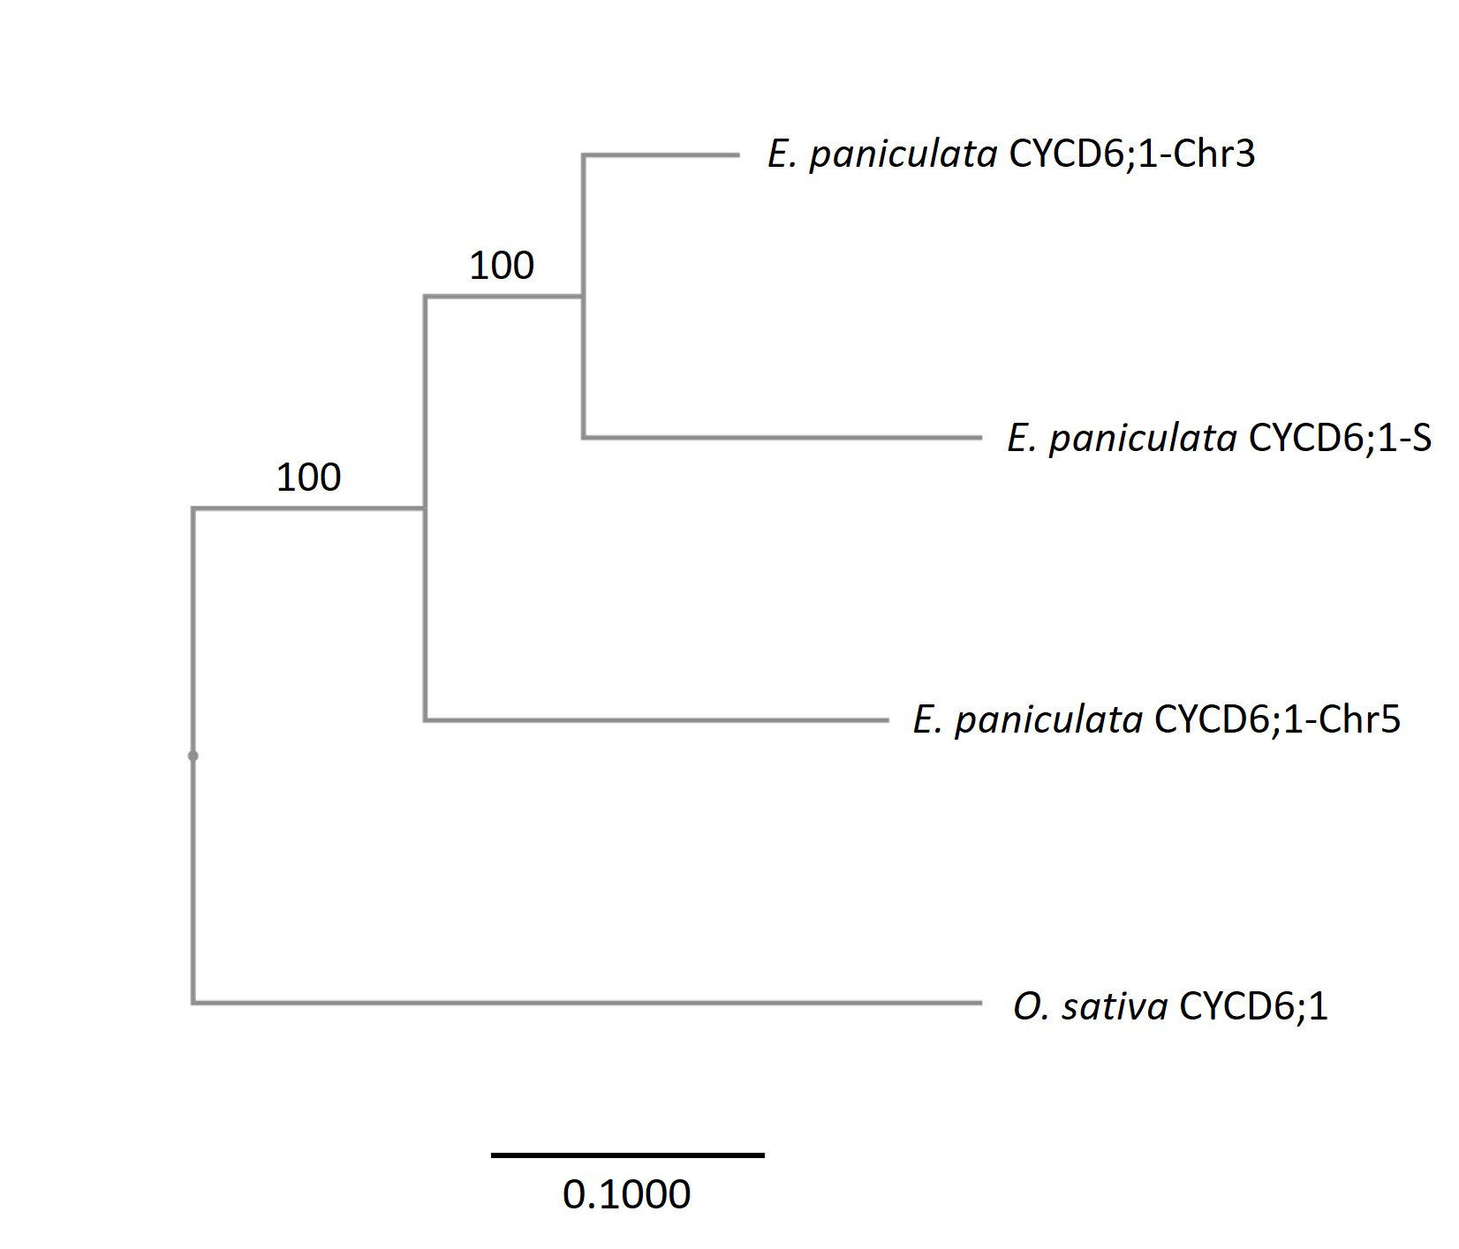
Figure S5 | Neighbor joining tree of CYCD6;1 genes in Oryza sativa and Eichhornia paniculata. Branch length represents substitutions per site. Numbers on branches are bootstrap values.

Table S1 | Number of differentially expressed genes in each comparison between the morphs of Eichhornia paniculata
Comparison |  |  | LFC > 2 | LFC < -2
Morph | Tissue | Development stage | LFC > 2 | LFC < -2
S vs. non-S | Style | Early | 450 | 586
S vs. non-S | Style | Late | 854 | 609
S vs. non-S | Stamen | Early | 413 | 406
S vs. non-S | Stamen | Late | 485 | 418
M vs. L | Style | Early | 704 | 775
M vs. L | Style | Late | 353 | 292
M vs. L | Stamen | Early | 781 | 374
M vs. L | Stamen | Late | 219 | 138

Genes that were significantly (adjusted p < 0.05) upregulated (LFC > 2) or downregulated (LFC < -2) in S-morph plants (compared to non-S-morph plants) or M-morph plants (compared to L-morph plants) in styles or stamens at early (bud size = 3-5 mm) or late (bud size = 5-8 mm) development stages.

Table S2 | Comparisons with significant enrichments in Mercator4 BIN enrichment analysis
Upregulated in S-morph styles (compared with non-S-morph styles), early developmental stage
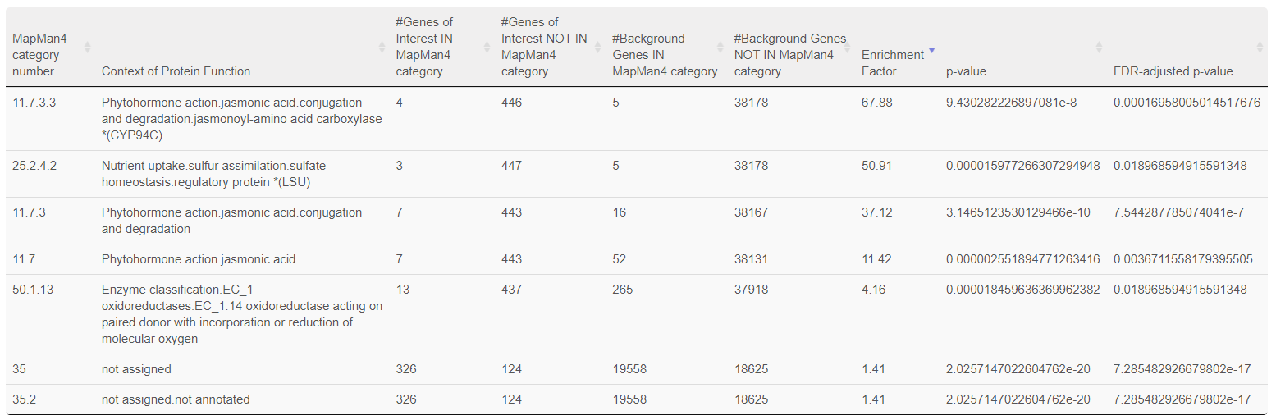
Upregulated in S-morph styles (compared with non-S-morph styles), late developmental stage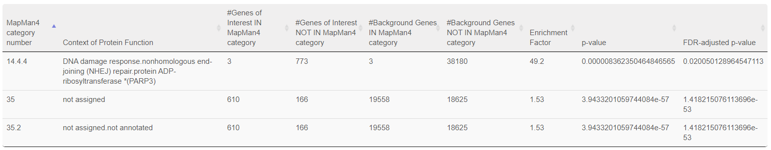
Upregulated in M-morph styles (compared with L-morph styles), late developmental stage
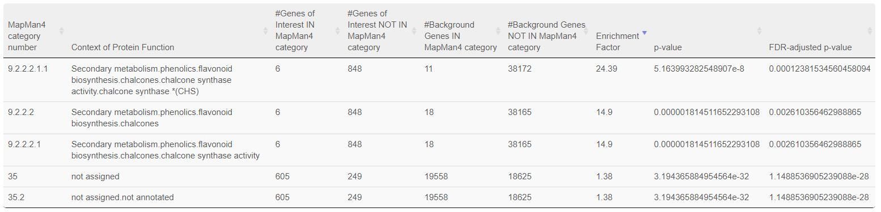

*Comparisons for which only “35, not assigned” and “35.2, not assigned.not annotated” were significantly enriched are not shown.

Table S3 | Floral morphs of individuals in the selfed progeny of the S-morph plant (SsMm) used for genome assembly
Floral morph | Number of individuals | Percentage
L-morph | 117 | 21.6%
M-morph | 9 | 1.7%
S-morph | 415 | 76.7%
Total | 541

Table S4 | Information on the locations of Eichhornia paniculata plants used in this study
Individual or population | Location | Population size | Note
Maternal parent of the SsMm individual | Yara, Granma, Cuba
Paternal parent of the SsMm individual | Igaci, Alagoas, Brazil
The ssmm individual | San Mateo del Mar, Oaxaca, Mexico
Pop 1 | Quixadá-2, Ceará, Brazil. Roadside small lake | 200 | Bulk from 30 plants
Pop 2 | Quixadá-1, Ceará, Brazil. Roadside marsh | 250 | Bulk from 30 plants

Table S5 | Statistics for the two genome assemblies of Eichhornia paniculata
Genotype of the individual | SsMm | ssmm
Sequencing technology and depth | PacBio CLR, 77 Gb (63X) | PacBio CCS (HiFi), 60 Gb (49X)
Assemblers | Canu + purge_haplotigs | hifiasm + purge_haplotigs
Contig N50 | 3.81 Mb | 96.8 Mb
Proximity ligation method | Hi-C + falcon_phase + Proximo | Omni-C + HiRise
Number of scaffolds (pseudomolecules) | 8 | 8
Unscaffolded contigs | 417 | 11
Total length | 1,273,901,216 bp | 1,189,336,515 bp
BUSCO scores (dataset: embryophyta_odb10) | C:98.1%[S:70.4%, D:27.7%], F:1.0%, M:0.9%, n:1614 | C:98.6%[S:85.8%, D:12.8%], F:0.4%, M:1.0%, n:1614

Table S6 | Number of the individuals N(indiv) and floral buds N(bud) used for each RNA-Seq sample
Morph | Tissue | Development stage | Biological replicate 1  (from Pop 1) |  | Biological replicate 2  (from Pop 1) |  | Biological replicate 3  (from Pop 1) |  | Biological replicate 4  (from Pop 2)
Morph | Tissue | Development stage | N(indiv) | N(bud) | N(indiv) | N(bud) | N(indiv) | N(bud) | N(indiv) | N(bud)
L | Style | Early | 14 | 14 | 14 | 14 | 14 | 14 | 17 | 17
L | Style | Late | 14 | 14 | 14 | 14 | 13 | 14 | 17 | 17
L | Stamen | Early | 14 | 14 | 14 | 14 | 14 | 14 | 17 | 17
L | Stamen | Late | 14 | 14 | 14 | 14 | 13 | 14 | 17 | 17
M | Style | Early | 13 | 13 | 13 | 13 | 9 | 9 | 11 | 22
M | Style | Late | 13 | 13 | 13 | 13 | 13 | 13 | 11 | 11
M | Stamen | Early | 13 | 13 | 13 | 13 | 9 | 9 | 11 | 11
M | Stamen | Late | 13 | 13 | 13 | 13 | 13 | 13 | 11 | 11
S | Style | Early | 7 | 21 | 7 | 14 | 7 | 21 | 5 | 20
S | Style | Late | 7 | 21 | 7 | 14 | 7 | 13 | 7 | 13
S | Stamen | Early | 7 | 7 | 7 | 7 | 7 | 7 | 5 | 5
S | Stamen | Late | 7 | 7 | 7 | 7 | 7 | 14 | 7 | 13
*Early: bud size = 3-5 mm. Late: bud size = 5-8 mm

