Extended data Figure legends
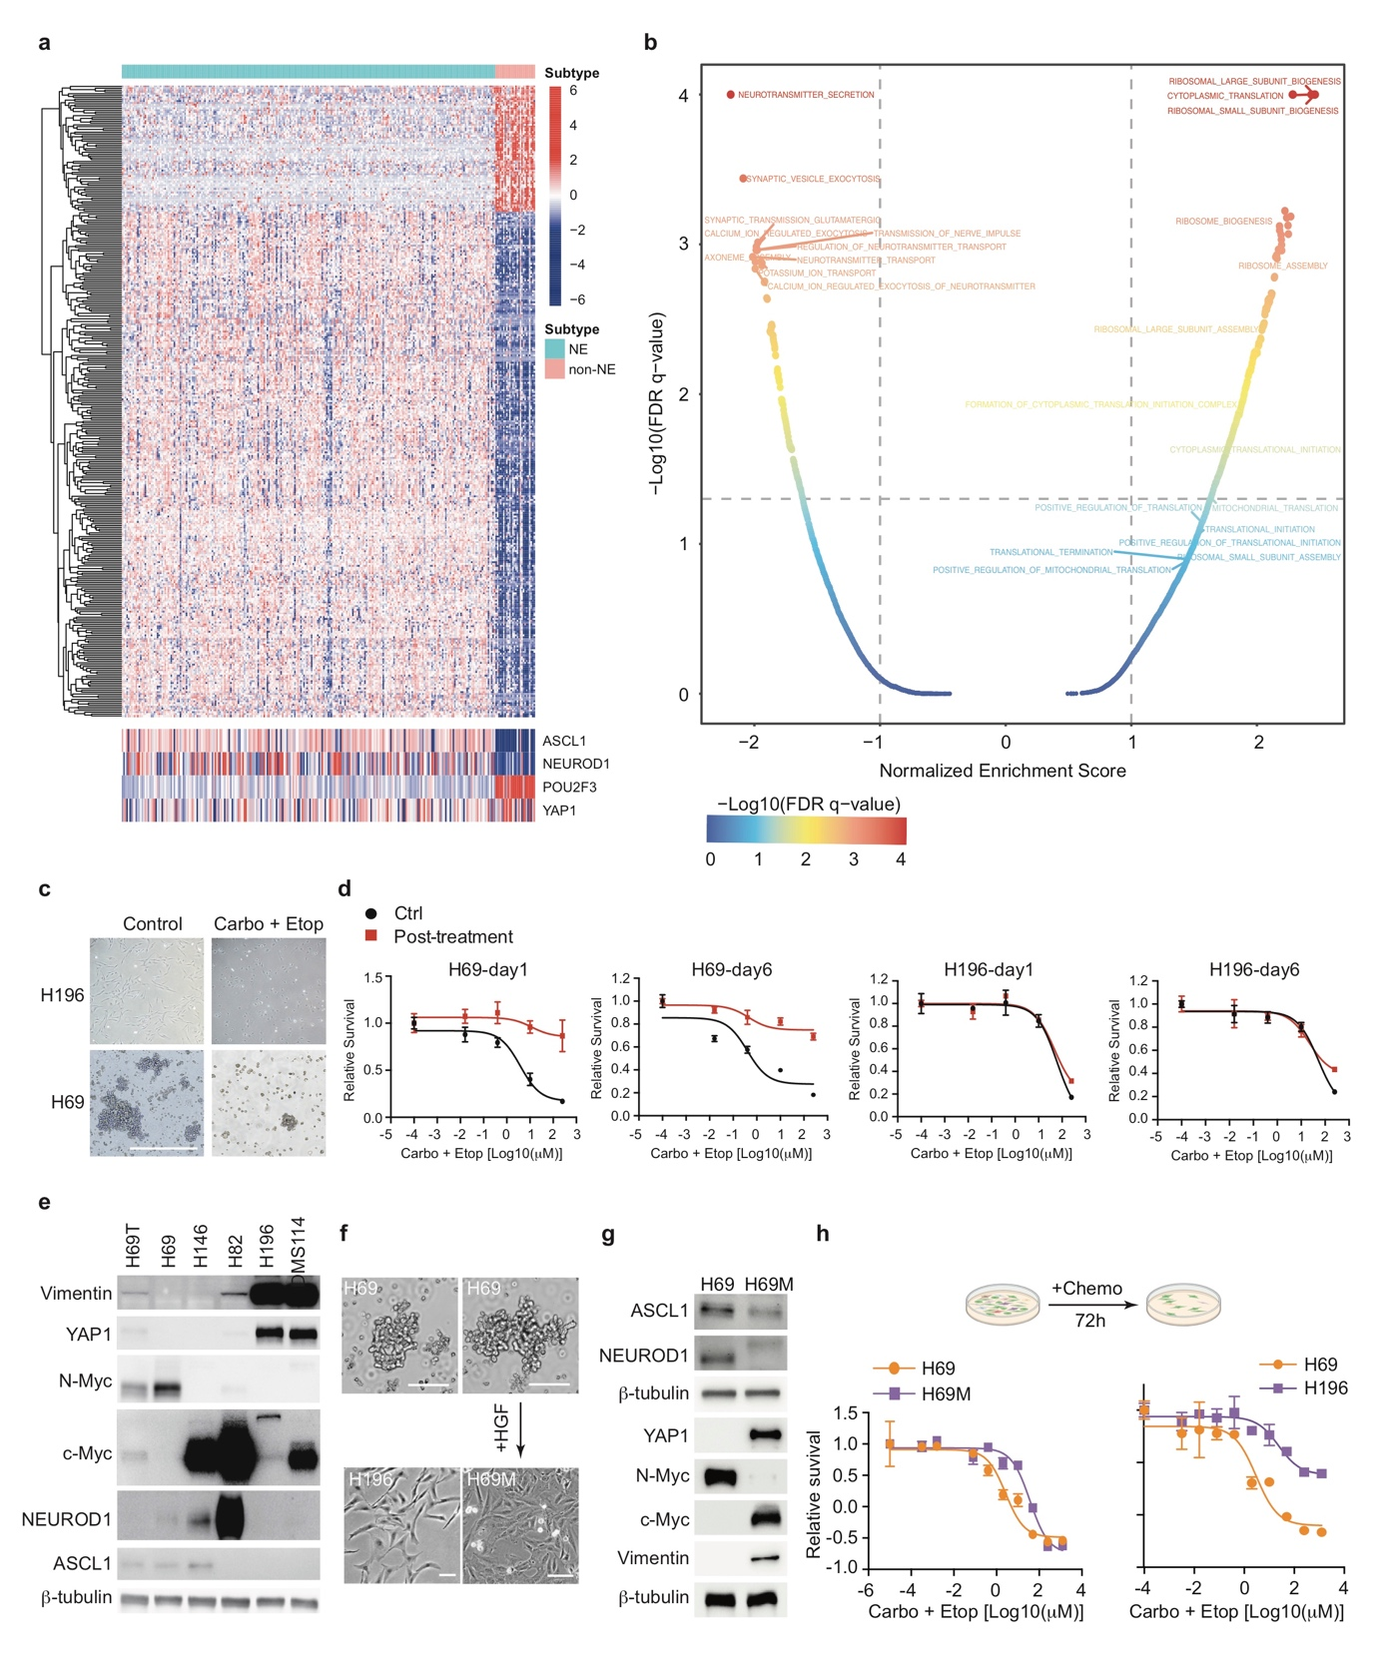
Extended Data Figure 1. Chemoresistance associates with non-NE transdifferentiation and translational regulation in SCLC.
a. NMF clustering of ASCL1, NEUROD1, POU2F3, YAP1 from RNA-seq dataset of IMPower 133 human SCLC cohort.
b. Volcano plot of differentially expressed genes in relapsed tumors after chemotherapy (n=18) vs. treatment naive tumors (n=81) from human SCLC RNA-seq dataset.
c. Bright field images of H69 and H196 cell lines treated with or without carboplatin and etoposide for 72 h.
d. Cell viability assay of parental or persistent H69 and H196 cells on day 1 or day 6 post 72 h of chemotherapy treatment (50 μM carboplatin and 10 μM etoposide) rechallenged with increasing concentration of chemotherapy for 72 h.
e. Immunoblot analysis of indicated SCLC cell lines, β-tubulin as loading control (H69T, H69 cells induced with 40 ng ml⁻¹ HGF for 14 days).
f. Bright field images of H69, H196 and H69M cell lines. H69M cell line was induced by HGF from H69 cell line.
g. Immunoblot showing different molecular patterns of H69M versus H69 cell line.
h. Drug response test of H69 versus H69M cells and H69 versus H196 cells after 72 h of treatment with increasing concentration of chemotherapy as indicated.
For d and h, n=3 biological replicates. Data are represented as mean ± SEM. Scale bars, 50 μm.

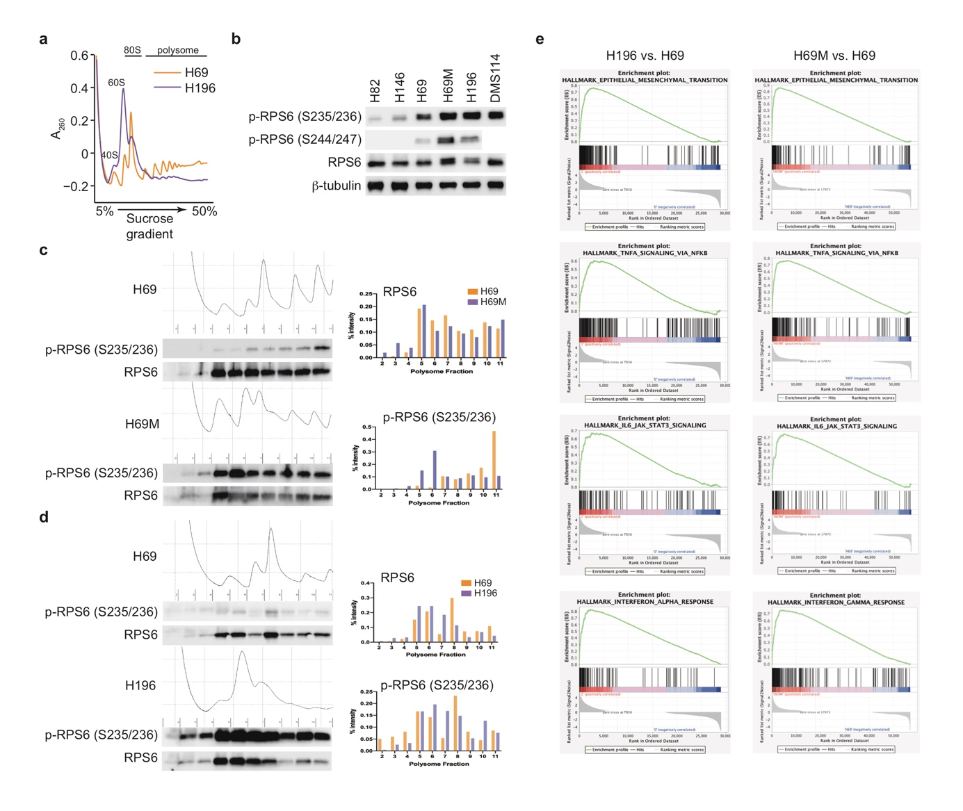
Extended Data Figure 2. Transdifferentiation in SCLC remodelling translational regulation and gene expression.
a. Comparison of polysome profiling between H69 and H196 cells.
b. Immunoblot of indicated SCLC cell lines, β-tubulin as loading control.
c.d. Immunoblot and quantification of protein expression for RPS6 and phospho-RPS6 (Ser 235/236) in each polysome fraction of H69 versus H69M (c) or H69 versus H196 cells (d).
e. GSEA of RNA-seq data from H69M vs. H69 or H196 vs. H69 using hallmark gene set of epithelial mesenchymal transition, TNF-α signaling via NFκB, IL-6-JAK-STAT3 signaling or interferon-α response.

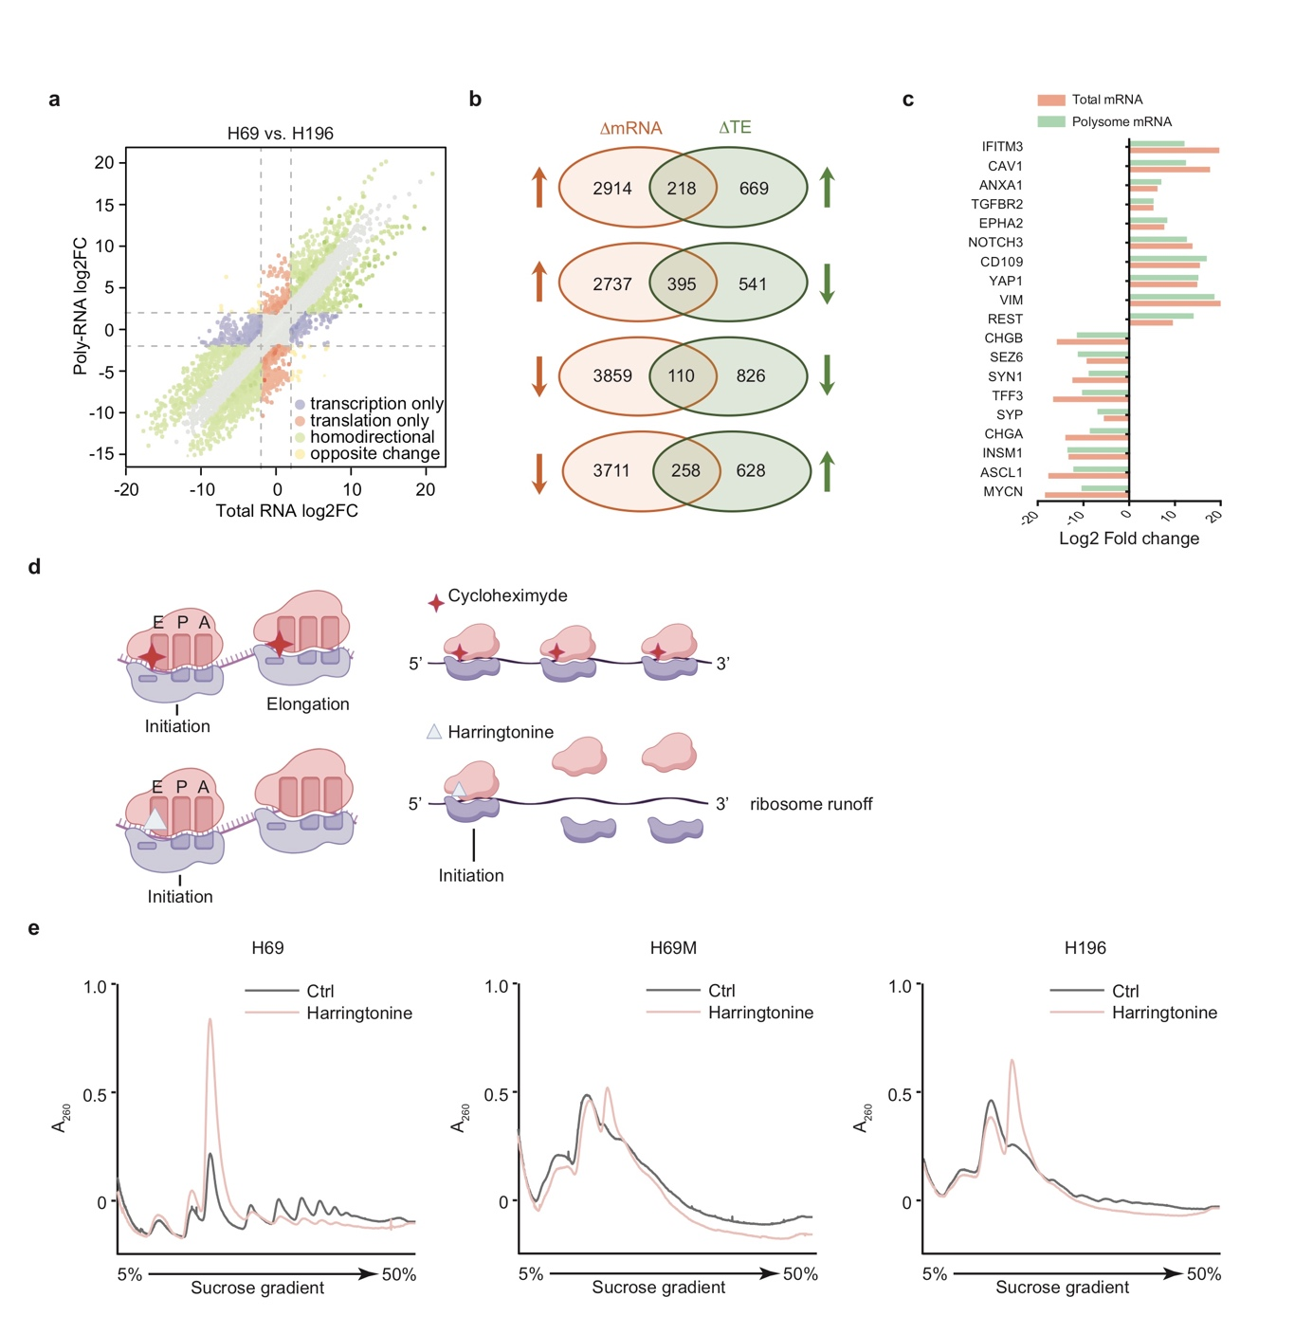
Extended Data Figure 3. Translational landscape and potential regulatory mechanism in NE and non-NE SCLC.
a. Scatterplot depicting gene expression differentiation between H196 and H69 cells on translational and transcriptional levels.
b. Venn diagrams depicting differentially transcripted (𝚫 mRNA, log2 fold change >1) or differentially translated (𝚫 translation efficiency [TE]) genes in H196 cells compared with H69 cells.
c. Expression of non-NE (neuroendocrine) or NE related transcripts from both RNA-seq and polysome RNA-seq data in H196 relative to H69 cells.
d. Schematic view of harringtonin run-off assay. Cycloheximide would bind with all ribosomes on mRNA and inhibit their dissociation. However, Harringtonine only blocks the 80S ribosome at the initiation codon, leading to run-off (dissociation) of other ribosomes binding to the mRNA 3 minutes after adding harringtonine. Therefore, more 80S monosome and fewer polysomes would appear on polysome profiling after harringtonine treatment. Otherwise, ribosomes stalling on mRNA should be suspected.
e. Polysome profiling in H69, H69M or H196 cells treated with harringtonine compared to vehicle illustrating no ribosomes stalling on mRNA in these cells.

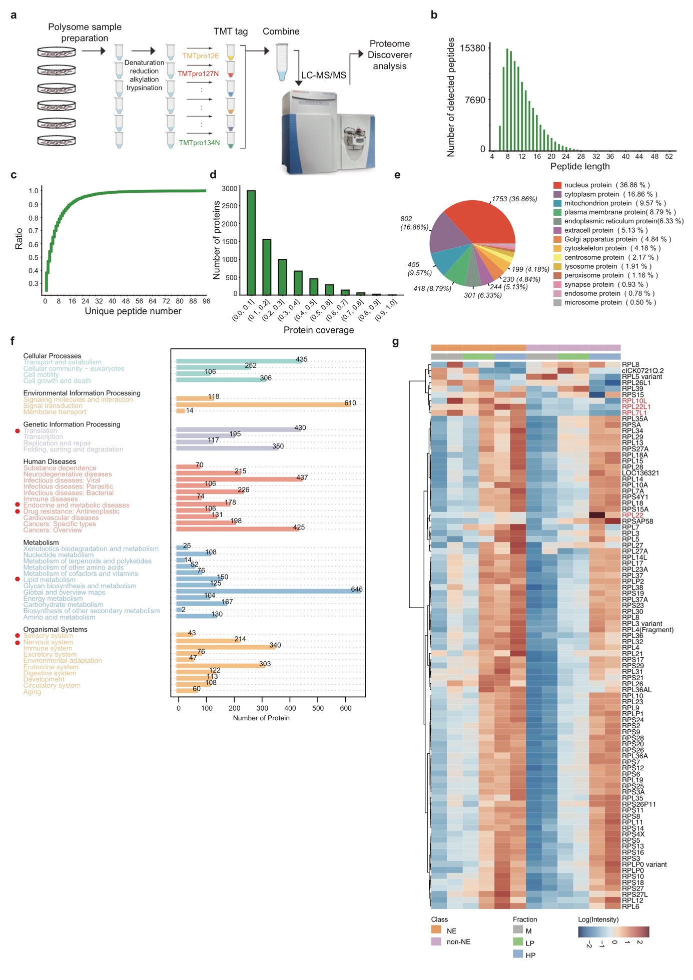
Extended Data Figure 4. Ribosome protein composition is invariant between NE and non-NE cells analyzed by quantitative TMT mass spectrometry.
a. Model. Extracts from H69 and H69M were fractioned by sucrose gradient sedimentation and protein from monosome, light polysome and heavy polysome were extracted separately for the following TMT based LC-MS/MS analysis.
b. Bar chart showing number of detected peptides across various peptide length.
c. Distribution of the number of unique peptide showing the cumulative proportion of proteins containing unique peptide in the total protein approaches 100% as the number of unique peptide increases.
d. Bar chart presenting protein number in various protein coverage (detected peptides length/protein length).
e. Subcellular localization of all detected protein.
f. KEGG pathway annotation of all detected protein.
g. Heatmap indicating the expression of ribosome protein in H69 vs. H69M cells among monosome (M), light polysome (LP), and heavy polysome (HP).

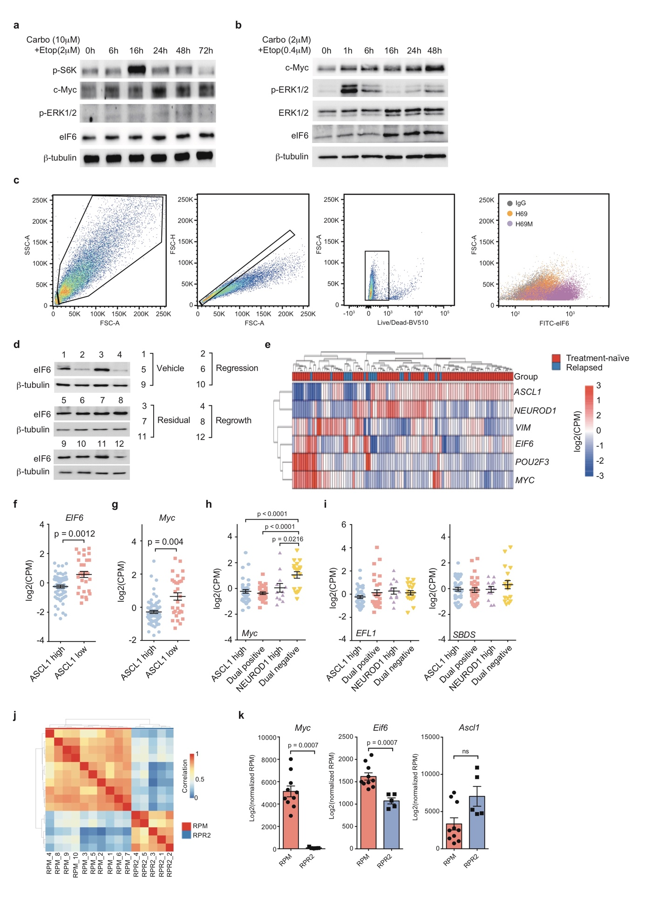
Extended Data Figure 5. Upregulation of eIF6 in chemo drug persisters and non-NE SCLC.
a.b. Immunoblot showing upregulation of indicated proteins after chemotherapy treatment for different durations in H69 cells (a) and RPM derived mouse cells (b).
c. Representative flowcytometry plots depicting the sequential gating strategy used for comparing eIF6 expression in H69 and H69M cells.
d. Immunoblot of eIF6 in tumors from different groups of H69 cell line xenograft as indicated in Figure 2c, β-tubulin as loading control.
e. Heatmap of indicated gene copy number in relapsed (n=18) relative to treatment naïve (n=81) tumors with publicly available human SCLC RNA-seq dataset.
f-i. Comparison of gene expression for eIF6 (f), MYC (g.h), EFL1, and SBDS (i) between ASCL1^{high} (n=) and ASCL1^{low} (n=) human SCLC tumors or across ASCL1^{high}(n=), NEUROD1^{high}(n=), dual-positive (ASCL1^{high}NEUROD1^{high}) (n=) and dual-negative (ASCL1^{low}NEUROD1^{low}) (n=) subtypes from RNA seq data of George et al SCLC cohort.
j. Heatmap depicting different transcript patterns between SCLC tumors from RPM and RPR2 (Rb1^{-/-}, P53^{-/-}, Rbl2^{-/-}) GEMM.
j. Gene expression of Myc, Eif6, and Ascl1 in tumors from RPM (n=10 tumors) v.s. RPR2 (n=5 tumors) GEMM.
Two tailed unpaired Student’s t test. Data are represented as mean ± SEM.

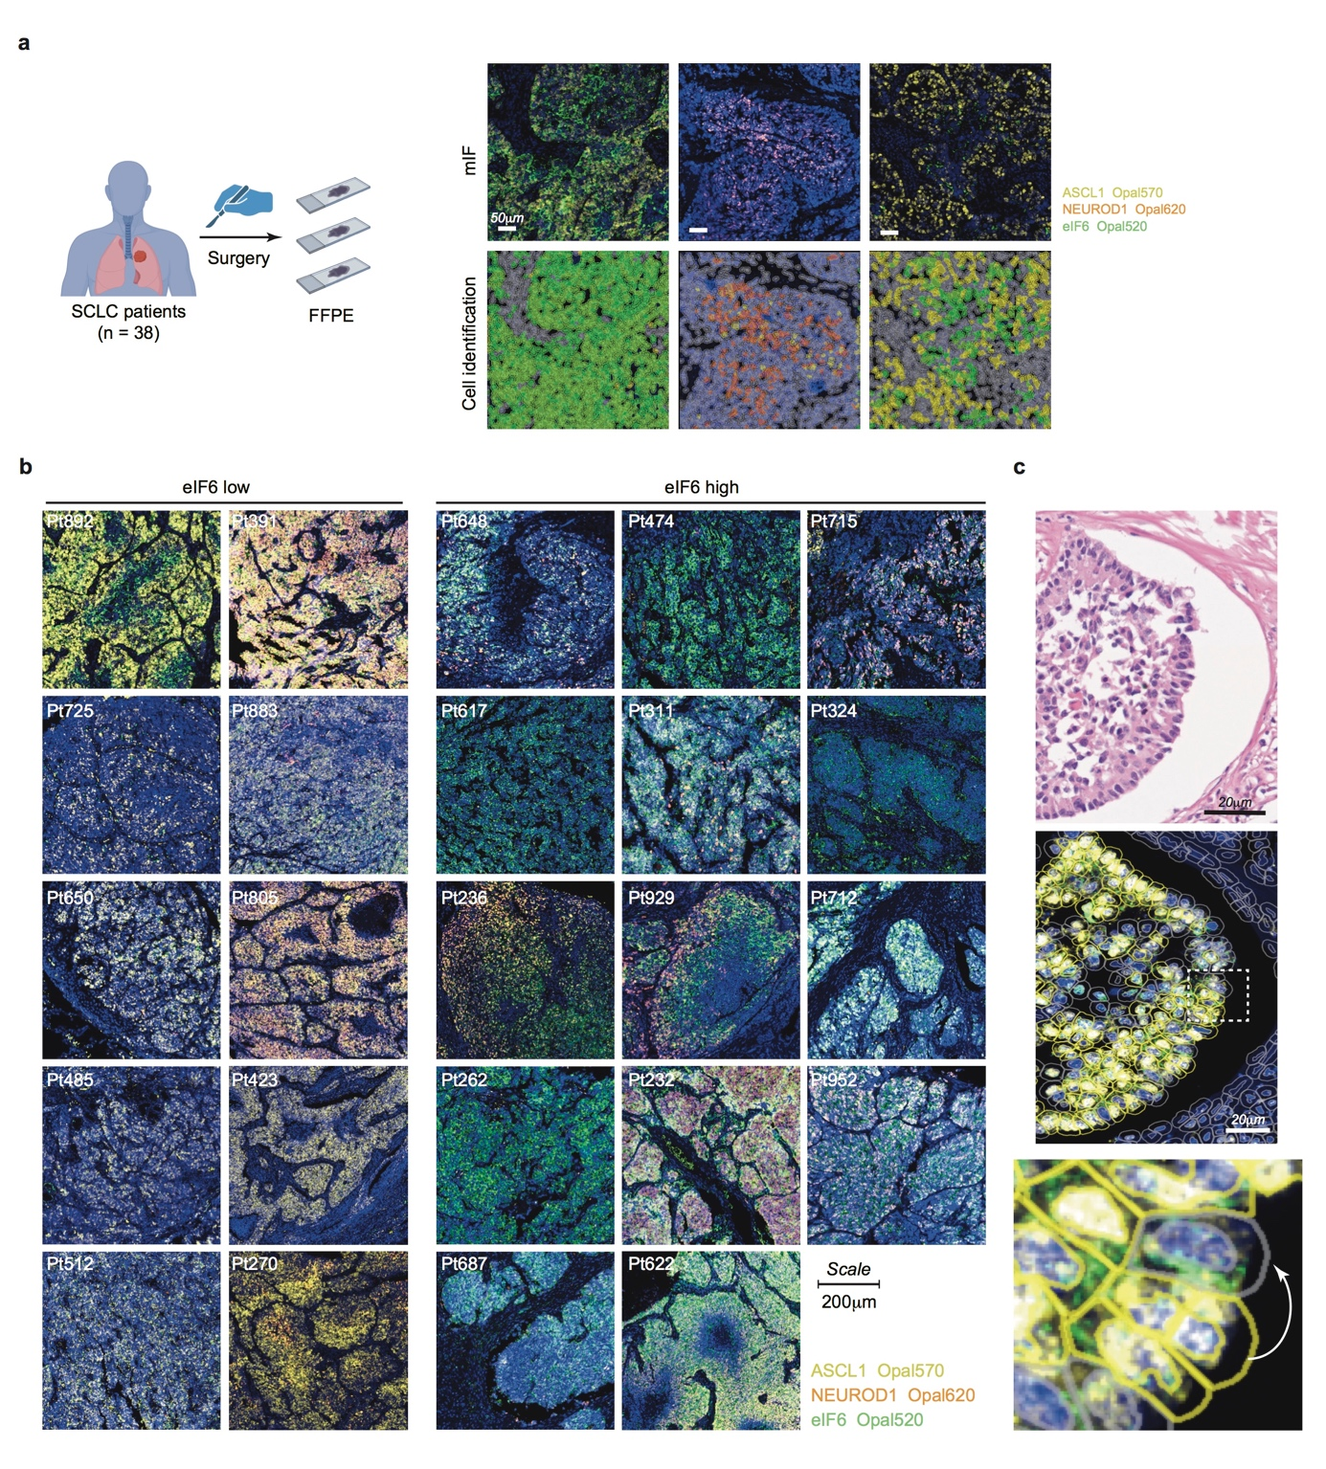
Extended Data Figure 6. Anti-correlation between eIF6 and ASCL1 in SCLC patient tumors.
a. Human SCLC tumors (n=38 tumors) were surgically resected for formalin-fixed paraffin-embedded (FFPE). Representative of multiplex IF staining showing identification of ASCL1⁺, NEUROD1⁺ or eIF6⁺ and dual or triple positive cells with automatic cell detection analysis by using Qupath (Scale bars, 50 μm).
b. Representative of mIF staining for ASCL1, NEUROD1 or eIF6 in eIF6 high and low tumors (n=38 tumors) (Scale bars, 200 μm).
c. H&E staining and mIF staining on consecutive slides of the same tumor showing the heterogeneity of ASCL1 and eIF6 expression on single cell level (Scale bars, 50 μm).

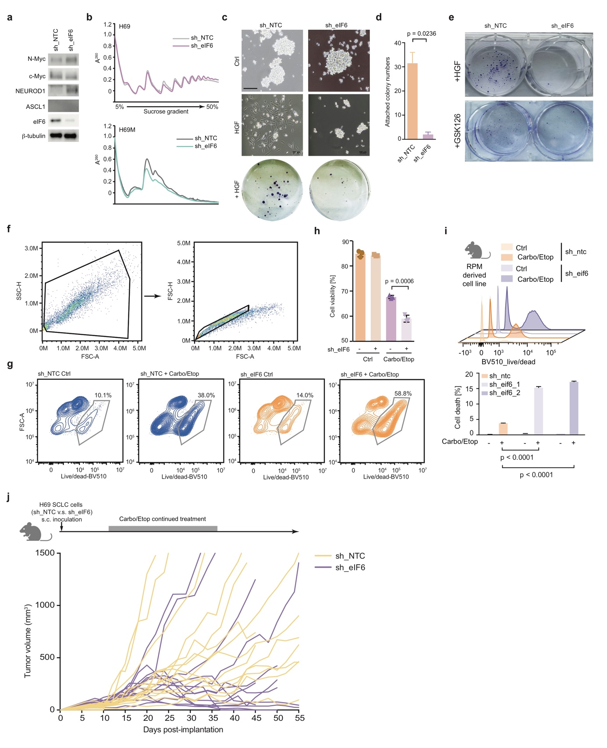
Extended Data Figure 7. eIF6 mitigates non-NE transdifferentiation and chemoresistance.
a. Immunoblot of indicated genes in sh_eIF6 and sh_NTC H69M cells.
b. Polysome profiling of H69M and H69 cells with eIF6 knockdown.
c.d. Representative bright field images from sh_NTC and sh_eIF6 H69 cells plated on six-well plates with or without 2 weeks HGF induction (c). Attached colonies were then stained with crystal violet (c) and calculated for analysis (d). (n=2 biological replicates)
e. Representative crystal violet staining of transdifferentiated sh_NTC vs. sh_eIF6 H69 cells (from suspension to adhesion growth) after 14 days treatment with 40 nM HGF or 5 μM GSK126 (n=2 biological replicates).
f.g. Representative flowcytometry plots of H69M sh_NTC or sh_eIF6 cells depicting the sequential gating strategy used for enriching for dead cells after treatment with chemotherapy or vehicle for 72 h.
h.i. Quantification of live/dead cell percentage in sh_NTC versus sh_eIF6 H69M cells (h) or sh_NTC versus sh_eIF6 mouse SCLC cells (i) treated with or without CE (10 μM carboplatin and 2 μM etoposide for H69M cells and 2 μM carboplatin and 0.4 μM etoposide for mouse SCLC cells) for 72 h through flow cytometry.
j. Tumor growth curve of sh_NTC and sh_eIF6 H69 cell line xenografts (n=13 tumors per group) treated with CE (carboplatin and etoposide) for 3 weeks.
For figure f-i, n=3 biological replicates. Two-tailed unpaired Student’s t test. Data are represented as mean ± SEM. Scale bars, 200 μm.

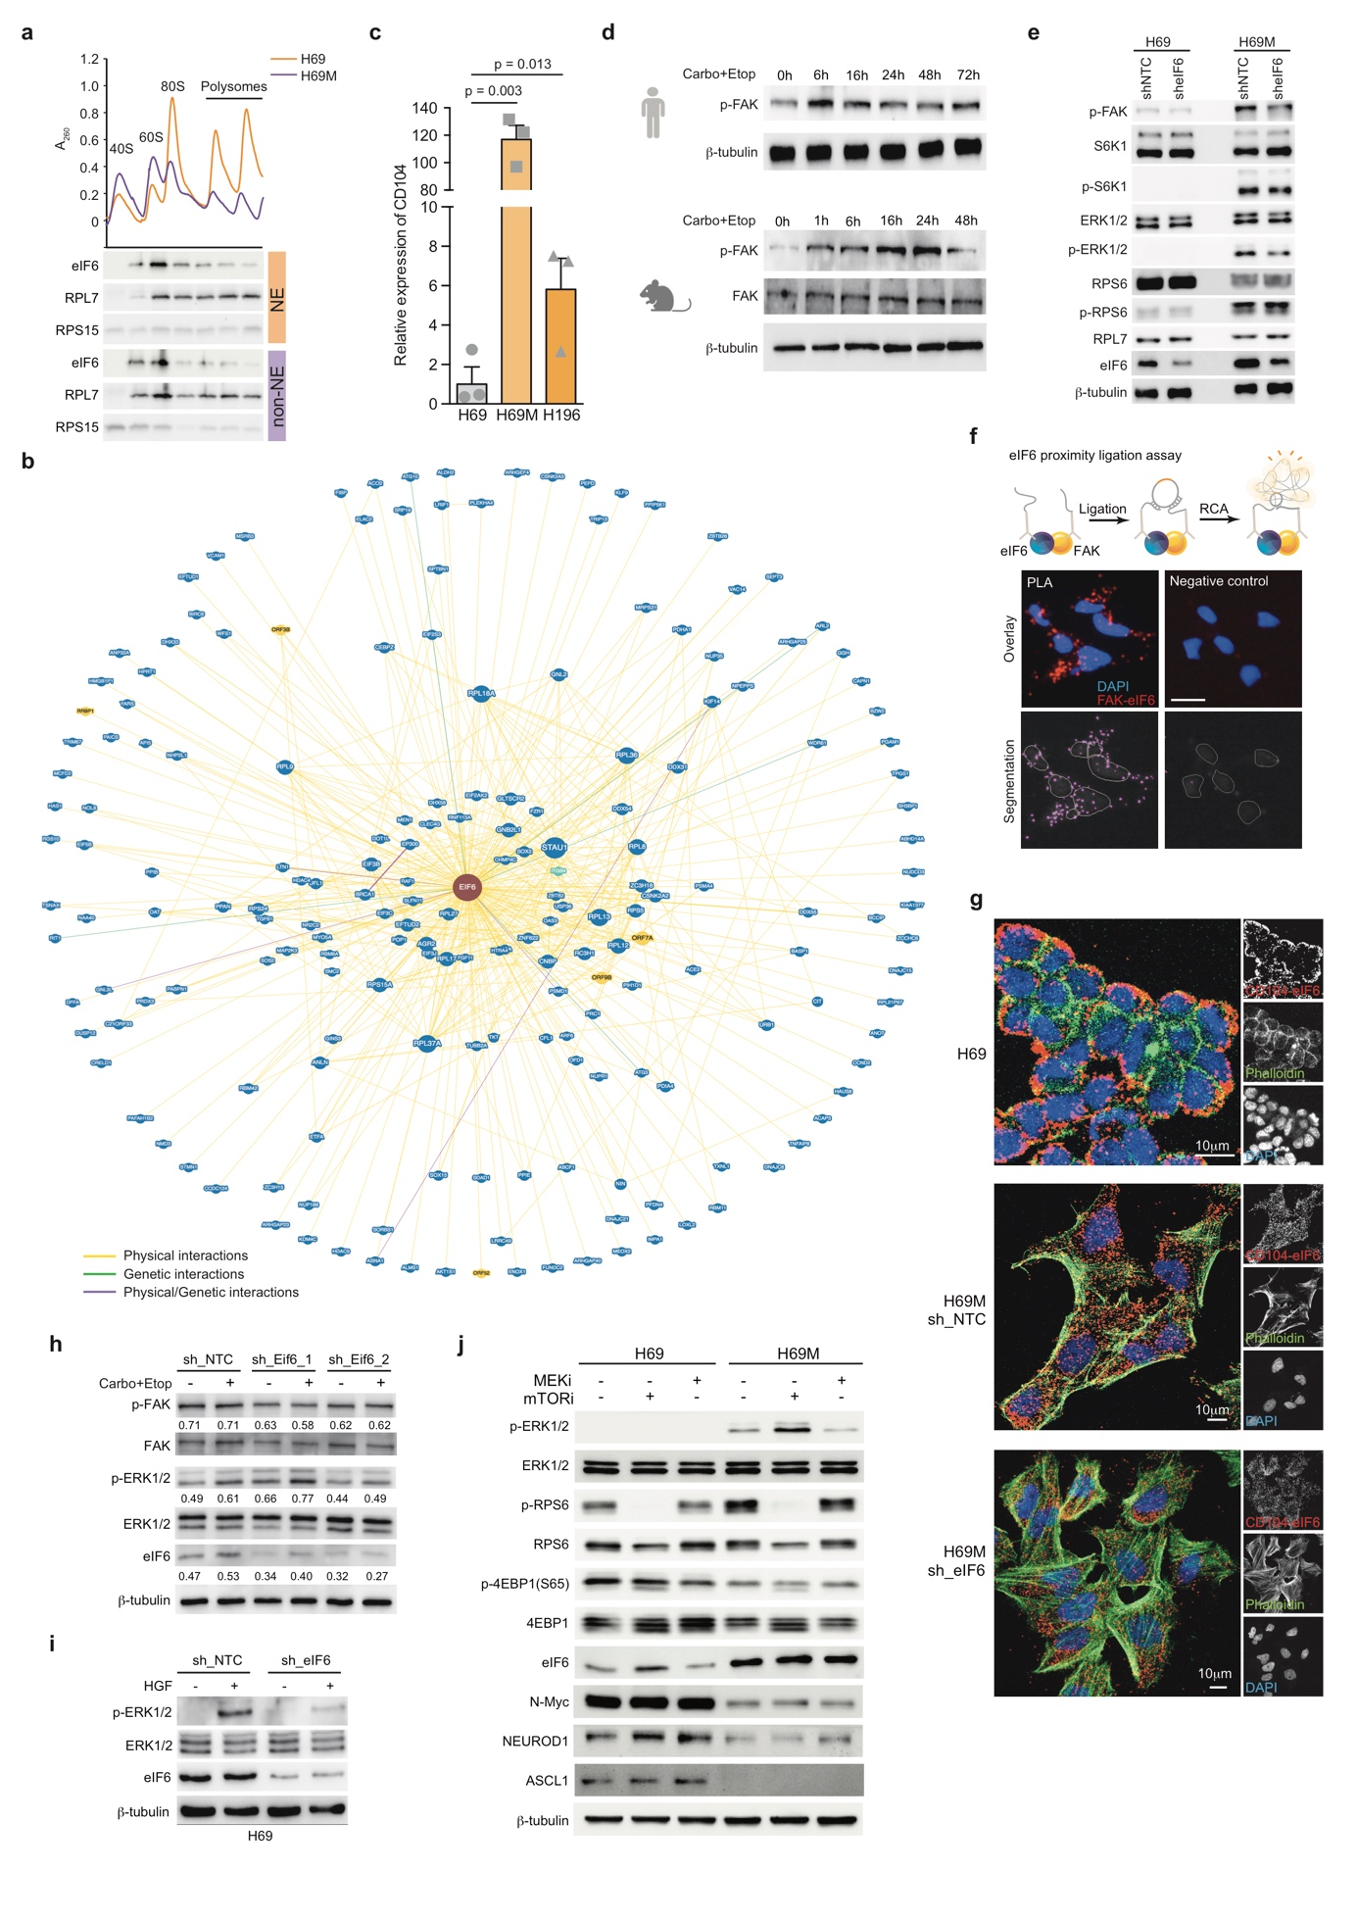
Extended Data Figure 8. eIF6 regulates MAPK pathway through CD104/FAK signaling axis.
a. Immunoblot analysis for eIF6 distribution in different fractions of H69 and H69M cells. RPL7 and RPS15 as fraction indicator.
b. Candidate factors interacting with eIF6 physically, genetically, or both analyzed by BioGrid database.
c. qPCR analysis for CD104 gene expression in H69, H69M and H196 cells (n=3 biological replicates).
d. Immunoblot showing upregulation of phospho-FAK (Tyr397) following CE (10 μM carboplatin and 2 μM etoposide) treatment for different durations in H69 cells and mouse SCLC cells (2 μM carboplatin and 0.4 μM etoposide).
e. Immunoblot of indicated protein in H69 and H69M cells upon eIF6 knockdown or not.
f. Model and representative far-red immunofluorescence images demonstrating interaction between eIF6 and FAK/CD104 can be detected and quantified by using proximity ligation assay (PLA).
g. Representative images of CD104-eIF6 PLA complexes in H69 cells and sh_NTC and sh_eIF6 H69M cells.
h. Immunoblot analysis of RPM mouse-derived SCLC cell line upon 24 h chemotherapy (2 μM carboplatin and 0.4 μM etoposide) in the presence or absence of eIF6 shRNA (quantified and normalized by β-tubulin), β-tubulin as loading control.
i. Immunoblot analysis of sh_NTC and sh_eIF6 H69 cells treated with 40 ng/ml HGF or vehicle for 14 days.
j. Immunoblot of H69 and H69M cells treated with vehicle, MEK inhibitor (100 nM cobimetinib) or mTOR inhibitor (100 nM rapamycin) for 72 h.
Two-tailed unpaired Student’s t test. Data are represented as mean ± SEM. Scale bars, 50 μm.

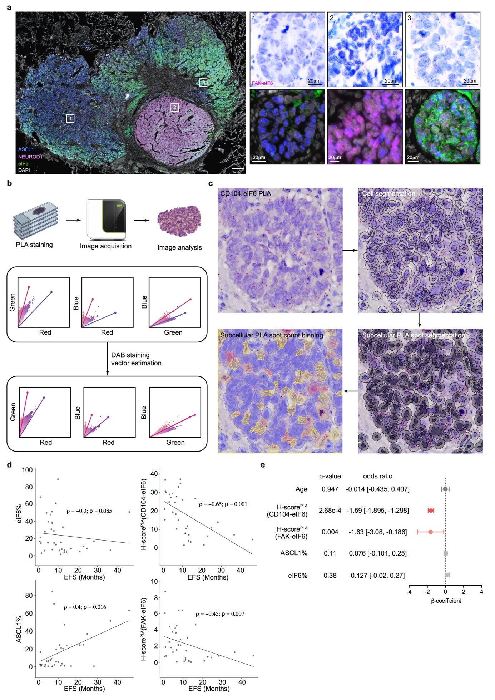
Extended Data Figure 9. CD104-eIF6 complex is a strong biomarker for SCLC patients’ prognosis.
a. Representatives images of mIF staining and CD104-eIF6 PLA complex within the same tumor. Scale bars, 20 μm.
b.c. Model and representative images of CD104-eIF6 PLA complex demonstrating the image-based analysis pipeline for quantification of PLA spot at single cell level through QuPath.
d. Pearson correlation between EFS and the percentage of eIF6 or ASCL1 positive cells, H-score^{PLA} of CD104-eIF6 or FAK-eIF6 (n=38 tumors).
e. Multivariable Cox regression analysis for relationship between EFS and indicated variables (n=38 patients).

Supplementary Information

EIF6 conditions drug-tolerant persister-like transdifferentiation in small cell lung carcinoma

Haoning Peng^{1,2,#}, Zhile Wang^{1,2,#}, Mengyao Wang^{1,#}, Xinpu Tang^{1,#}, Kaixiu Li¹, Xuejiao Yu³, Siyang Song³, Yuqing Wang¹, Tianjian Lu^{1,2}, Bo Dong^{1,2}, Youyu Wang², Minqi Chen^{1,2}, Dongjian Ceng¹, Yulan Deng¹, Liang Xia², Chenglin Guo², Qiang Pu², Lu Li⁴, Michael Cerezo^{5,6}, Weiya Wang³, Lunxu Liu^{2,*}, Shensi Shen^{1,2,*}

Supplementary Table 1. Transcriptome and translatome analysis of NE vs non-NE cell state.
Supplementary Table 2. TMT mass spectrometry-detected proteins in H69 and H69M polysome fractions.
Supplementary Table 3. GESA analysis of transcriptome in non-NE vs NE cells.
Supplementary Table 4. WCH SCLC cohort clinical data.
Supplementary Figure 1. Raw data of western blot.

