Appendix 1. Expanded methods
Biotic resistance of native communities and propagule pressure are consistent predictors of invasion success during grassland establishment
Sandra Rojas-Botero^{1*} (sandra.rojas-botero@tum.de), Johannes Kollmann^{1,2}, Leonardo H. Teixeira¹
¹Restoration Ecology, Department of Ecology and Ecosystem Management, Technical University of Munich. Emil-Ramann-Str. 6, 85354 Freising, Germany
²Norwegian Institute of Bioeconomy Research (NIBIO), P.O. Box 115, 1431 Ås, Norway
*Corresponding author

Establishment of resident communities based on trait hierarchies
The two grassland types were designed based on the relative abundances of the native grasses composing both communities. In community ARR50, the species with the highest competitive ability were more abundant (dominated by the grass Arrhenatherus elatius), whereas, in community ARR5, species with a lower competitive ability were more abundant (dominated by the grass Festuca ovina). The effective density of the seeds needed for ARR5 and ARR50 was based on seed mass, adjusted considering the a priori germination rates tested for each species (Table S1). To establish each native community type, a mixture of sterilized sand and the seeds of the selected species in the appropriate proportions were sown manually in each tray.

Table S1 Mean seed weights, germination rates, and adjusted mass of seeds used for establishing the native communities according to the two competitive hierarchies. ARR50, community with dominance of highly competitive species, and ARR5, community with dominance of low competitive species
Species | Mean seed weight (g) | Germination rate (%) | ARR50 | ARR5
Species | Mean seed weight (g) | Germination rate (%) | Seed mass (g) | Seed mass (g)
Arrhenaterum elatius | 0.0024 | 69 | 0.1526 | 0.0153
Holcus lanatus | 0.0003 | 62 | 0.0852 | 0.0273
Dactylis glomerata | 0.0006 | 20 | 0.1260 | 0.1260
Festuca rubra | 0.0008 | 84 | 0.0200 | 0.0625
Festuca ovina | 0.0003 | 34 | 0.0305 | 0.3052

Experimental design expanded
For testing the effects of trait-hierarchy, sowing-pattern, and N-fertilization on the invasion success of Solidago gigantea, a greenhouse experiment was conducted for 16 weeks. The resident grassland communities ARR5 and ARR50 were sown in the experimental units considering the two tested patterns (Figures S1.1 and S1.2). S. gigantea was simultaneously sown also following either a clumped or a random pattern. For the clumped pattern, we used a piece of a plastic pipe with a diameter of 10 cm, resulting in circular clumps of synthetic communities. To simulate the effect of resource fluctuation (N-enrichment), fertilization occurred in two different levels within a limited time during the establishment of the plants (four times in total). Half of the experimental units received a basic amount of NPK (Peters Excel Grower 15/5/15, 100g/100 liter). The other half received additional nitrogen (Novatec 18 Fluid, 85g/100 liter). We applied the fertilizer once a week by watering 1 l of dissolved solution. The basic fertilization consisted of 0.6 g nitrogen together with phosphate and potassium, while the N-enriched level received 0.6 g N extra, to simulate rich soil conditions.
The schematic experimental design of each of the three experiments conducted is presented below.

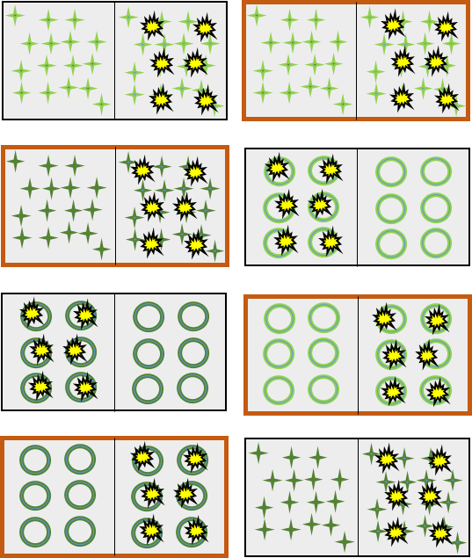
Fig. S1.1 Experimental design of the experiment testing the effect of trait hierarchy, sowing density, and N-fertilization on invasion success. Each rectangle depicts an experimental unit (tray), light and dark green symbols represent communities ARR5 and ARR50, respectively. Star shapes refer to random sowing pattern and rings to the clumped sowing pattern of the communities. Yellow symbols depict Solidago gigantea added to each half-tray (1 g m⁻²) simultaneously with the sowing of the native communities. Trays framed by brown color were subjected to extra nitrogen addition. In total, five blocks with randomized split-plots were used

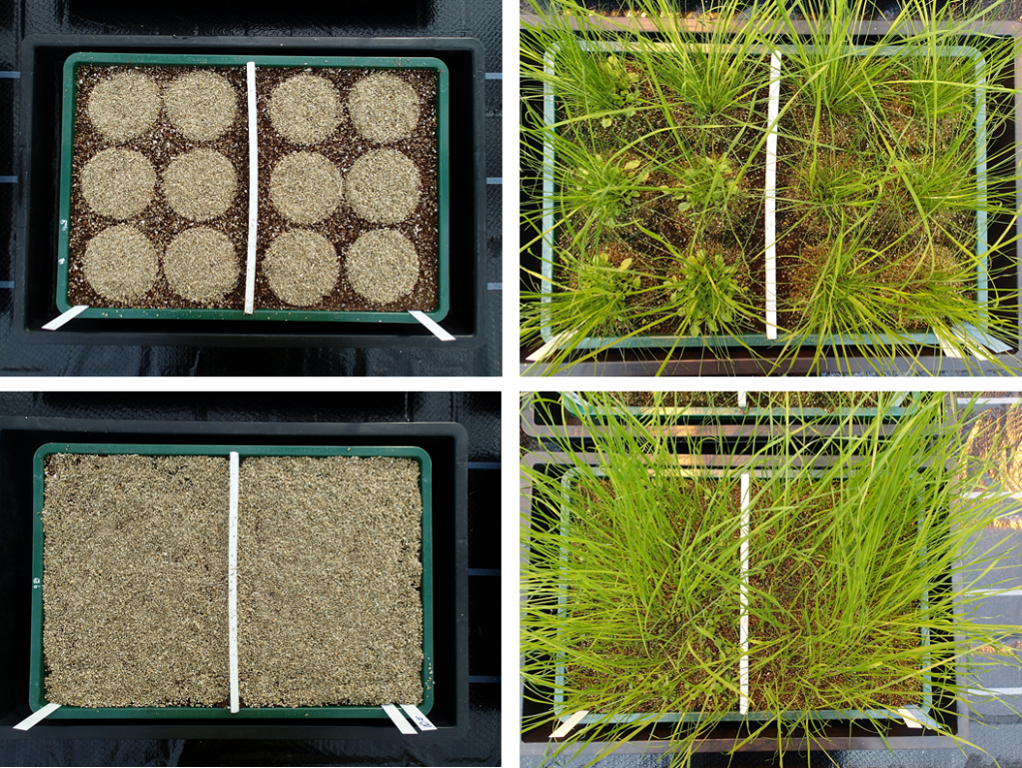
Fig. S1.2 Appearance of exemplary experimental units for testing the effects of trait-hierarchy, sowing-pattern, and N-fertilization on invasion success. The pictures from the left side depict the distribution of the sowing area for the clumped (above) and the random (below) sowing pattern. Right-side pictures show the development of the synthetic communities a few weeks after sowing. Note that for each tray, half of the area contained an invaded community and the other half a non-invaded community (Photos by Andrea Frank and Johannes Prifling)

For testing the effects of trait-hierarchy and heat-flood pulses on the invasion success of Solidago gigantea, an experiment was conducted for 14 weeks in two walk-in climate chambers (Figure S1.3). The resident grassland communities ARR5 and ARR50 were sown in the experimental units in a density of 3 g m⁻² (Figures S1.4 and S1.5). Again, S. gigantea was simultaneously sown. To assess the effect of heat and flood pulses, the experimental communities were subjected to interspersed simulated temperature increases and flood events. For this, the air temperature of one of the chambers was increased and kept to 35 °C for 48 h every second week. To simulate the flood events, two tables per chamber were randomly selected and watered with 50 l of tap water and maintained flooded for 48 h every two weeks.

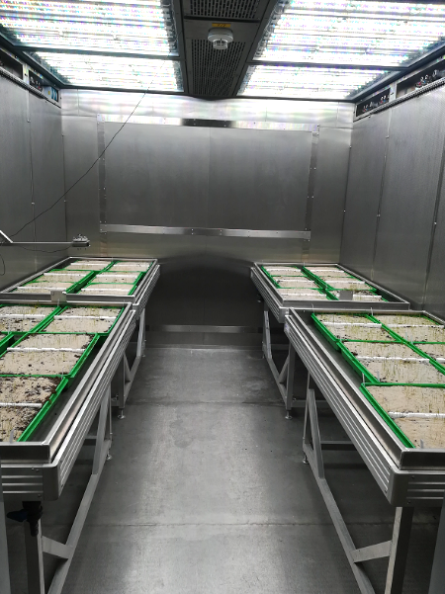
Fig. S1.3 Walk-in climate chamber with the experimental setup for the experiments involving heat and flood pulses (Photo by the authors)

Fig. S1.4 Experimental design for testing the effect of trait hierarchy, heat and flood pulses on invasion success of Solidago gigantea. Two walk-in climate chambers were used; each chamber (2.4 x 3.2 x 2.2 m³; area 7.7 m²) received four floodable tables with six experimental trays each. Light and dark green rectangles represent trays containing communities ARR5 and ARR50, respectively. Tables framed by blue color were subjected to flooding simulations during 48 h every two weeks. In the yellow chamber, an increase of 10 °C in air temperature was simulated during 48 h every two weeks and interspersed with the flooding events. Bright yellow symbols depict S. gigantea added to each half-tray (1 g m⁻²) simultaneously with the sowing of the native communities

The assessment of the effect of trait-hierarchy, propagule pressure, and heat and flood pulses on invasion success of Solidago gigantea was conducted in four walk-in climate chambers (Figures S1.5 and S1.6). The communities ARR5 and ARR50 described above were subjected to temperature increases and floodings after three weeks of sowing. For each community, propagule pressure of S. gigantea was manipulated in the following levels: (i) A single introduction event of seeds with a density of 1 g m⁻² occurring simultaneously with the sowing of the native seeds; (ii) A single introduction event of seeds with a density of 3 g m⁻² occurring simultaneously with the sowing of the native seeds; (iii) Three biweekly introduction events of seeds, starting simultaneously with the sowing of native seeds, each of them with a density of 1 g m⁻². By using the split-plot approach of the trays, each treatment replication had a corresponding control at the side, i.e. without sowing of S. gigantea. To test environmental fluctuations in the form of pulses, two of the chambers were randomly selected to simulate six heating events, by increasing air temperatures from 25 °C to 35 °C for 72 h every second week. To simulate six flood pulses, two tables per chamber (corresponding to two different treatment combinations) were randomly selected and watered with 50 l of tap water and maintained flooded for 72 h every two weeks. During the experiment, water was supplied to the plants every second day, by pouring 10 l of tap water directly into the table, so it could be absorbed by the roots of the plants.

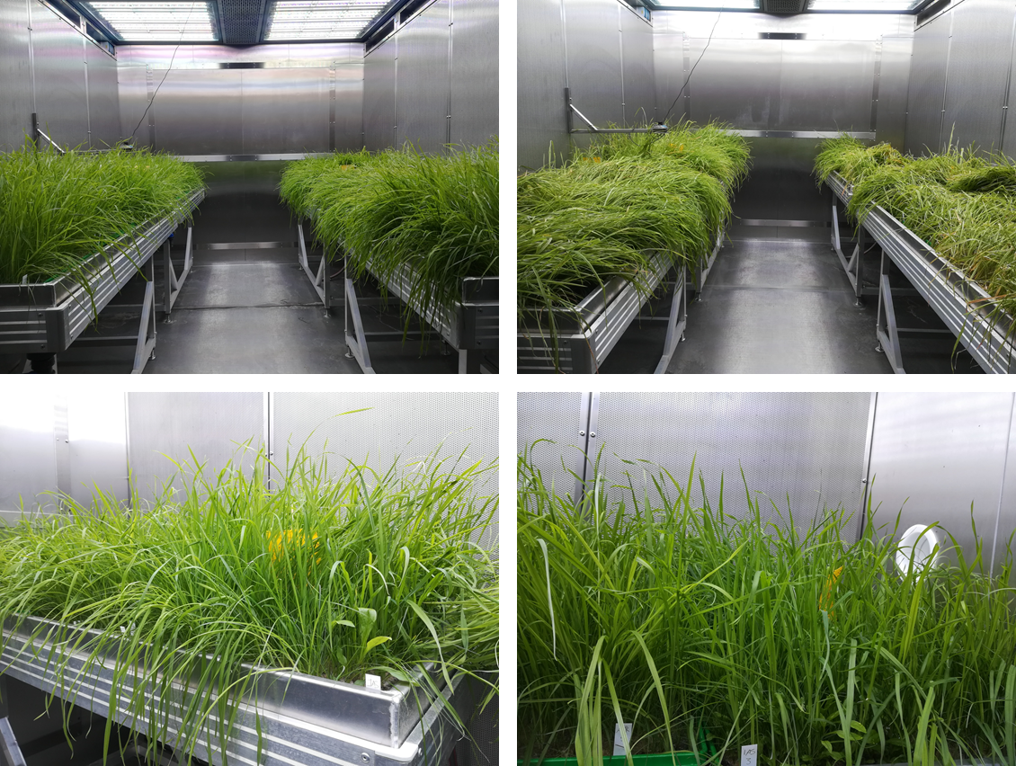
Fig. S1.5 Experimental grassland communities after three weeks of establishment in the walk-in climate chambers of TUMmesa (Photos by the authors)
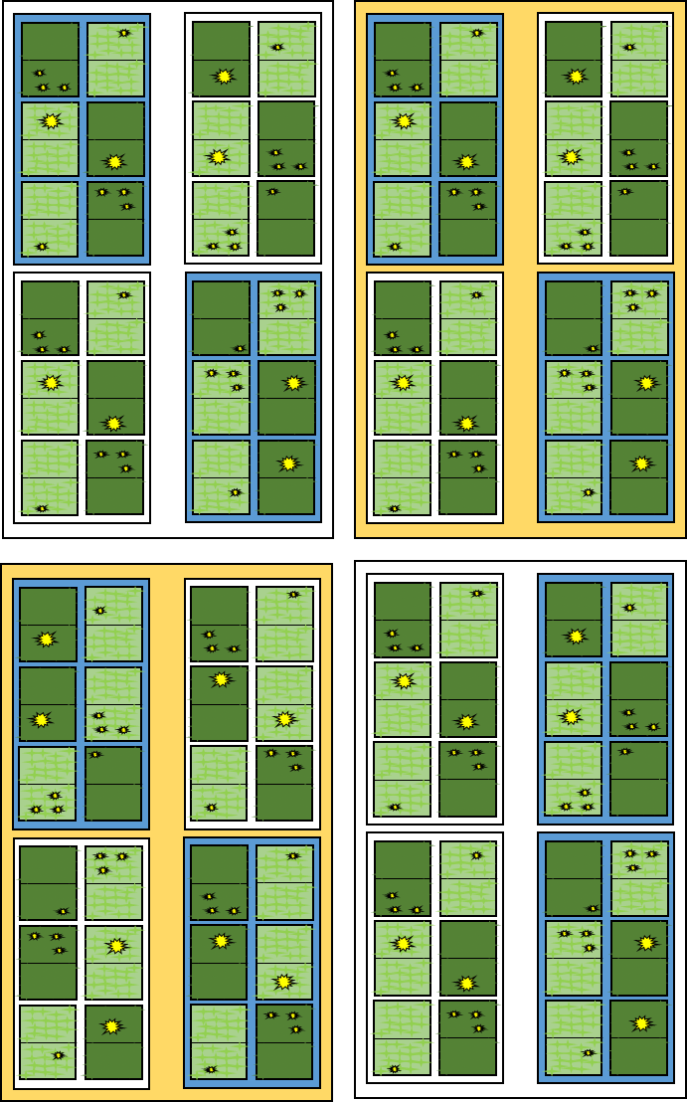
Fig. S1.6 Experimental design testing the effect of trait hierarchy, invasive propagule pressure, and heat and flood pulses on invasion success of Solidago gigantea. Four climate chambers were used in this experiment. Two chambers were subjected to six heat events for 72 h every two weeks (yellow-colored chambers). Each chamber had four floodable tables containing the native communities in two competitive hierarchies. Light and dark green represent tables containing hierarchies ARR5 and ARR50, respectively. Tables framed by blue color were subjected to six flooding events lasting 72 h and occurring every two weeks. Three propagule pressure levels of S. gigantea were tested (levels depicted with yellow symbols in the experimental units): 1. One single event of seed arrival with a density of 1 g m⁻² (single small yellow symbol); 2. Three biweekly events of seed arrival, each of them with a density of 1 g m⁻² (three small yellow symbols); and 3. One single event of seed arrival with a density of 3 g m⁻² (single large yellow symbol). No yellow symbol represents the adjacent control without S. gigantea. Each table contained six experimental trays divided in half, representing two subsamples per propagule pressure (i.e. levels 1, 2, and 3) which were split in two for containing the control with no S. gigantea
Appendix 2. Expanded results

Biotic resistance of native communities and propagule pressure are consistent predictors of invasion success during grassland establishment

Sandra Rojas-Botero^{1*} (sandra.rojas-botero@tum.de), Johannes Kollmann^{1,2}, Leonardo H. Teixeira¹
¹Restoration Ecology, Department of Ecology and Ecosystem Management, Technical University of Munich. Emil-Ramann-Str. 6, 85354 Freising, Germany
²Norwegian Institute of Bioeconomy Research (NIBIO), P.O. Box 115, 1431 Ås, Norway
*Corresponding author

Fig. S2.1 Total community biomass for the first experiment, which tested the effects of trait hierarchy, sowing density, and N-fertilization on S. gigantea invasion success. Higher community biomass was observed in nitrogen-enriched communities in combination with a clumped sowing pattern, indicating high competition effects. See Table S3 for details on significant differences

Fig. S2.2 Total community biomass for the second experiment, which tested the effects of trait hierarchy, and environmental fluctuations (heat and flood pulses) on invasion success of S. gigantea. Flooded, heated, and invaded communities displayed higher community productivity. See Table S3 for details on significant differences

Fig. S2.3 Total community biomass for the third experiment, which tested the effects of trait hierarchy, invasive propagule pressure, and environmental fluctuations (heat and flood pulses) on S. gigantea invasion success. Only invaded communities were significantly more productive. See Table S3 for details on significant differences

Table S2 Results of the linear mixed-effects model for total community biomass in each one of the experiments performed, testing for the effects of biotic resistance, invasive propagule pressure, and environmental fluctuations, on the invasion success of Solidago gigantea. The table presents estimates, standard errors (SE), degrees of freedom (df), p-values, and significance codes. Marginal and conditional R² of each model are also presented
Experiment | Pedictor variable | Estimate | SE | df | Crit. value | p-values | Std. Estimate | Significance codes | Marginal R² | Conditional R²
1 Trait hierarchy - sowing density - N-fertilization experiment | S. gigantea presence = yes | -0.76 | 1.08 | 71 | -0.704 | 0.484 | -0.039 |  | 0.76 | 0.76
 | Community = ARR 50 | -0.19 | 1.08 | 71 | -0.173 | 0.864 | -0.010 |  | 0.76 | 0.76
 | Nitrogen added = yes | 16.05 | 1.08 | 71 | 14.846 | 0.000 | 0.827 | *** | 0.76 | 0.76
 | Sowing pattern = clumped | 5.48 | 1.08 | 71 | 5.074 | 0.000 | 0.283 | *** | 0.76 | 0.76
2 Trait hierarchy - heat-flood-pulses experiment | S. gigantea presence = yes | 3.29 | 0.75 | 84 | 4.357 | 0.000 | 0.268 | *** | 0.66 | 0.66
2 Trait hierarchy - heat-flood-pulses experiment | Community = ARR 50 | -2.18 | 0.75 | 84 | -2.890 | 0.005 | -0.178 | ** | 0.66 | 0.66
2 Trait hierarchy - heat-flood-pulses experiment | Flooding = yes | 7.23 | 0.76 | 84 | 9.569 | 0.000 | 0.589 | *** | 0.66 | 0.66
2 Trait hierarchy - heat-flood-pulses experiment | Heating = yes | 5.49 | 0.75 | 84 | 7.282 | 0.000 | 0.448 | *** | 0.66 | 0.66
3 Trait hierarchy - propagule pressure - heat-flood-pulses experiment | S. gigantea presence = yes | 2.03 | 0.72 | 173 | 2.809 | 0.006 | 0.161 | ** | 0.11 | 0.40
 | Community = ARR 50 | 0.32 | 2.01 | 12 | 0.161 | 0.875 | 0.026 |  | 0.11 | 0.40
 | Propagule pressure = 1+1+1 gm⁻² | 0.29 | 0.89 | 173 | 0.326 | 0.745 | 0.037 |  | 0.11 | 0.40
 | Propagule pressure = 3 gm⁻² | -0.62 | 0.89 | 173 | -0.701 | 0.484 | -0.049 |  | 0.11 | 0.40
 | Flooding = yes | -0.93 | 2.01 | 12 | -0.463 | 0.652 | -0.074 |  | 0.11 | 0.40
 | Heating = yes | 3.72 | 2.01 | 12 | 1.851 | 0.089 | 0.296 |  | 0.11 | 0.40
Significance levels: (*) p < 0.1, *p < 0.05, **p < 0.01, ***p < 0.001
Marginal (only fixed-effects) and conditional (marginal and random effects) R² of each evaluated model.
Codes for invasive propagule pressure levels evaluated in the third experiment: 1: One single event of seed arrival with a density of 1 g m⁻²; 1+1+1: Three biweekly events of seed arrival, each of them with a density of 1 g m⁻²; 3: One single event of seed arrival with a density of 3 g m⁻²

Table S3 Results of piecewise structural equation models (piecewise SEM) combining two individual models for each experiment testing direct and indirect effects of biotic and abiotic drivers on invasion success of S. gigantea in experimental grasslands. The table presents the standardized path coefficients (Estimate), standard errors (SE), p-values, and significance codes. Marginal and conditional R² of the models are also shown
Experiment | Response variable | Pedictor variable | Std. Estimate | SE | p-value | Significance code | Marginal R² | Conditional R²
1 Trait hierarchy - sowing density - N-fertilization experiment | Native Biomass | Community = ARR 50 | 0.06 | 1.630 | 0.473 |  | 0.74 | 0.75
 | Native Biomass | Nitrogen added = yes | 0.80 | 1.630 | 0.000 | *** | 0.74 | 0.75
 | Native Biomass | Sowing pattern = clumped | 0.32 | 1.630 | 0.000 | *** | 0.74 | 0.75
 | Invasive biomass⁺ | Native biomass | -0.59 | 0.025 | 0.039 | * | 0.33 | 0.33
 | Invasive biomass⁺ | Community = ARR 50 | -0.44 | 0.249 | 0.003 | ** | 0.33 | 0.33
 | Invasive biomass⁺ | Nitrogen added = yes | 0.35 | 0.471 | 0.186 |  | 0.33 | 0.33
 | Invasive biomass⁺ | Sowing pattern = clumped | 0.04 | 0.295 | 0.792 |  | 0.33 | 0.33
2 Trait hierarchy - heat-flood-pulses experiment | Native Biomass | Community = ARR 50 | 0.27 | 0.783 | 0.004 | ** | 0.62 | 0.66
2 Trait hierarchy - heat-flood-pulses experiment | Native Biomass | Flooded = yes | 0.51 | 0.786 | 0.000 | *** | 0.62 | 0.66
2 Trait hierarchy - heat-flood-pulses experiment | Native Biomass | Heated = yes | 0.55 | 0.785 | 0.000 | *** | 0.62 | 0.66
2 Trait hierarchy - heat-flood-pulses experiment | Invasive Biomass | Native biomass | -0.18 | 0.176 | 0.302 |  | 0.54 | 0.54
2 Trait hierarchy - heat-flood-pulses experiment | Invasive Biomass | Community = ARR 50 | -0.46 | 1.016 | 3.00E-04 | *** | 0.54 | 0.54
2 Trait hierarchy - heat-flood-pulses experiment | Invasive Biomass | Flooded = yes | 0.58 | 1.215 | 1.00E-04 | *** | 0.54 | 0.54
2 Trait hierarchy - heat-flood-pulses experiment | Invasive Biomass | Heated = yes | -0.13 | 1.276 | 0.357 |  | 0.54 | 0.54
3 Trait hierarchy - propagule pressure - heat-flood-pulses experiment | Native Biomass | Community = ARR 50 | 0.13 | 2.434 | 0.487 |  | 0.19 | 0.65
 | Native Biomass | Flooded = yes | 0.34 | 2.434 | 0.095 |  | 0.19 | 0.65
 | Native Biomass | Heated = yes | -0.06 | 2.618 | 0.782 |  | 0.19 | 0.65
 | Native Biomass | Propagule pressure = 1+1+1 | 0.09 | 1.214 | 0.552 |  | 0.19 | 0.65
 | Native Biomass | Propagule pressure = 3 | -0.20 | 1.296 | 0.050 | * | 0.19 | 0.65
 | Invasive Biomass | Native biomass | 0.04 | 0.010 | 0.122 |  | 0.88 | 0.91
 | Invasive Biomass | Community = ARR 50 | -0.12 | 0.143 | 0.004 | ** | 0.88 | 0.91
 | Invasive Biomass | Flooded = yes | 0.03 | 0.147 | 0.455 |  | 0.88 | 0.91
 | Invasive Biomass | Heated = yes | 0.08 | 0.142 | 0.126 |  | 0.88 | 0.91
 | Invasive Biomass | Propagule pressure = 1+1+1 | -0.01 | 0.104 | 0.694 |  | 0.88 | 0.91
 | Invasive Biomass | Propagule pressure = 3 | 7.58 | 0.542 | 0.000 | *** | 0.88 | 0.91
Significance levels: (*) p < 0.1, *p < 0.05, **p < 0.01, ***p < 0.001
+ Invasive biomass in Experiment 1 was log-transformed.
Marginal (only fixed effects) and conditional (marginal and random effects) R² of each evaluated model.
Codes for invasive propagule pressure levels evaluated in the third experiment: 1: One single event of seed arrival with a density of 1 g m⁻²; 1+1+1: Three biweekly events of seed arrival, each of them with a density of 1 g m⁻²; 3: One single event of seed arrival with a density of 3 g m⁻²

