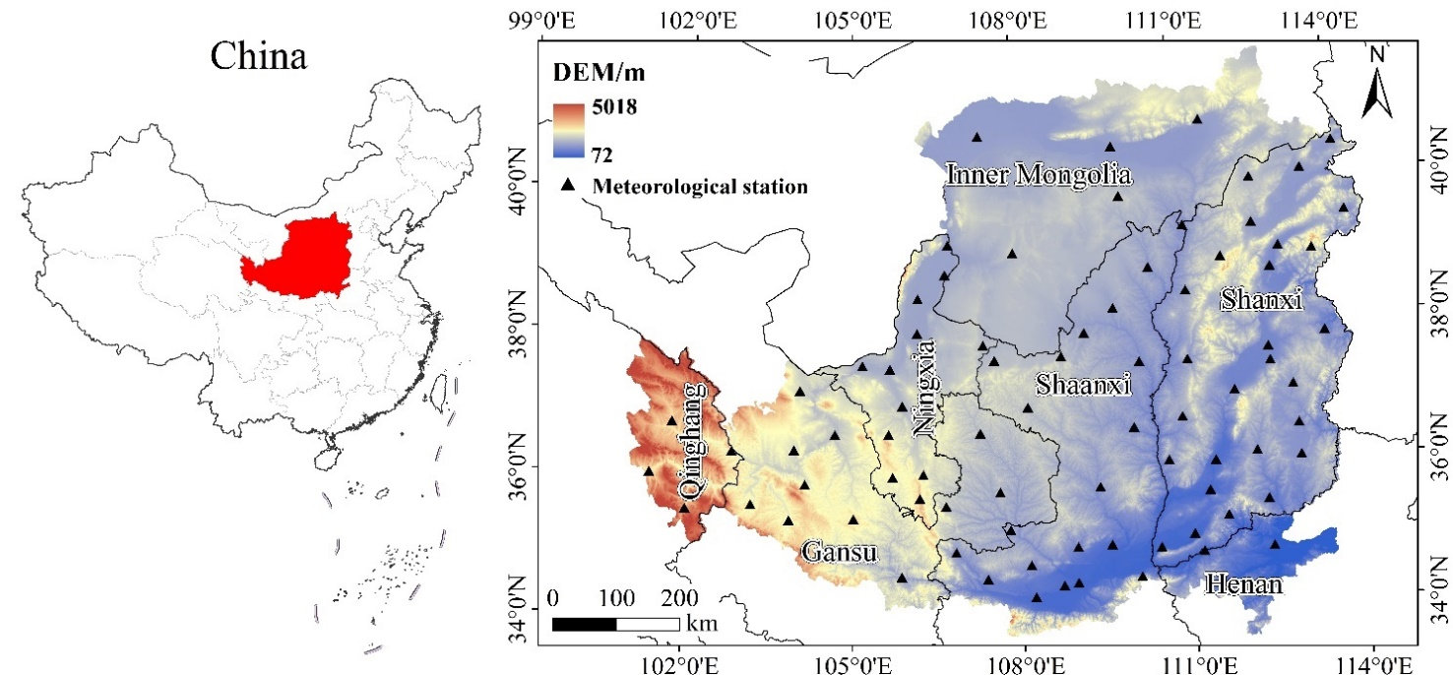
Figure 1. Location map of the Loess Plateau and distribution of meteorological stations
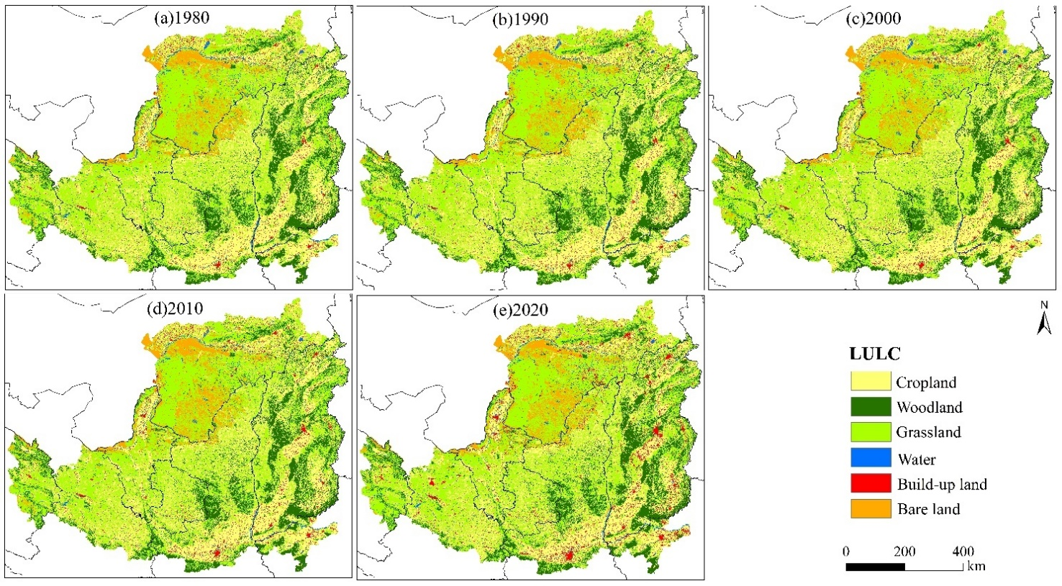
Figure 2. Spatiotemporal distribution of LULC on the Loess Plateau, 1980-2020

Figure 3. Trends in area changes of different LULC types on the Loess Plateau, 1980-2020

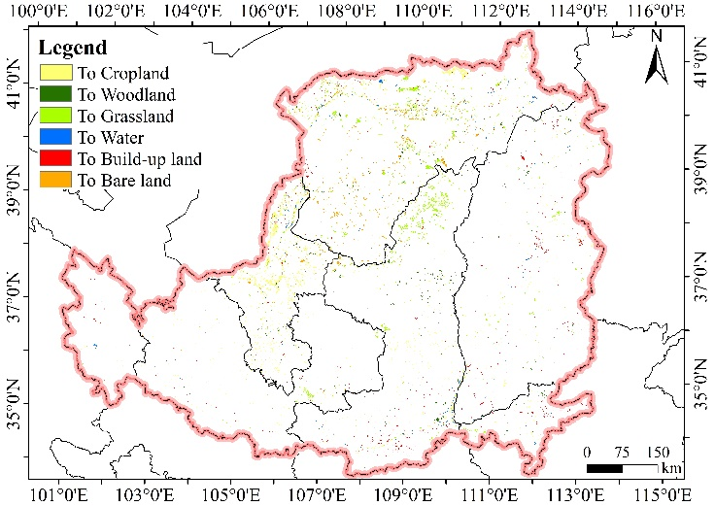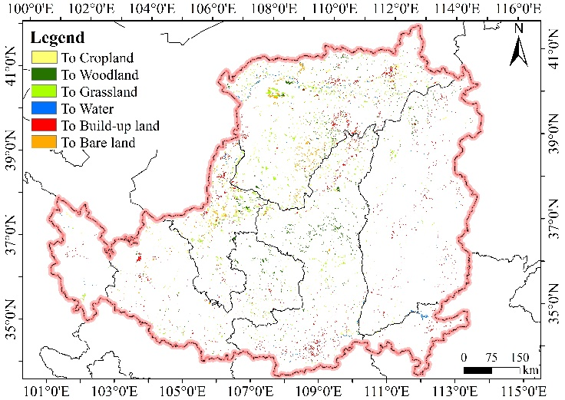
(a)1980-2000 (b)2000-2020
Figure 4. Map of LULC type changes on the Loess Plateau, 1980-2000 and 2000-2020
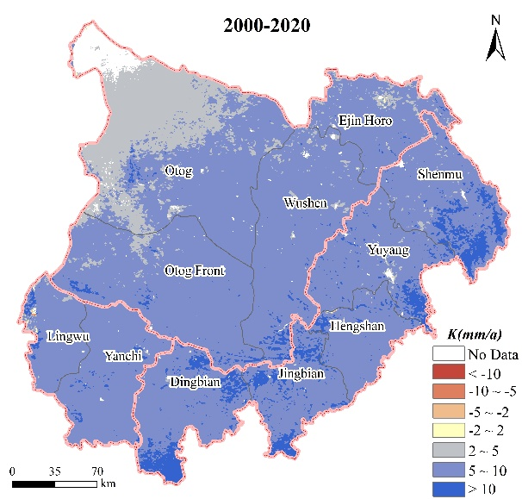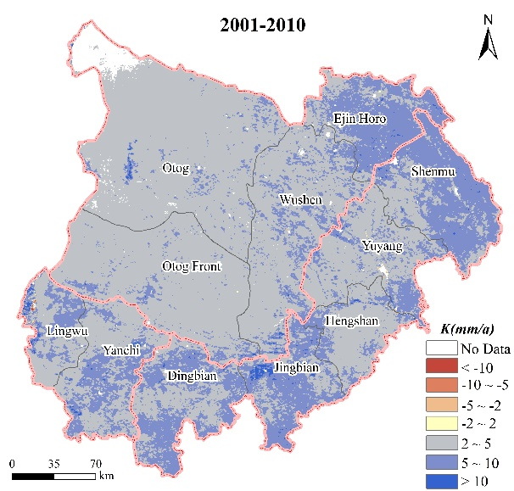

Figure 5. Land use dynamicity of different LULC types on the Loess Plateau, 1980-2000 and 2000-2020

Figure 6. The annual (a) average temperature and (b) precipitation change on the Loess Plateau, 1980-2020
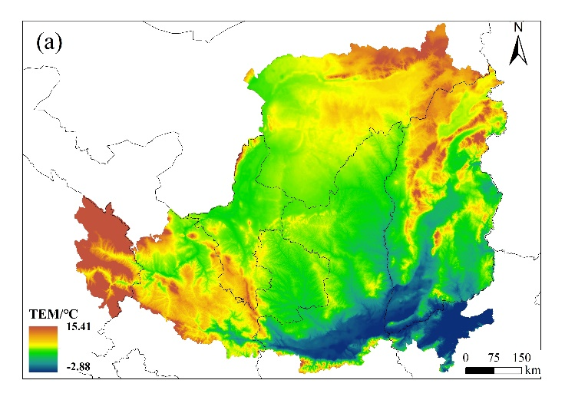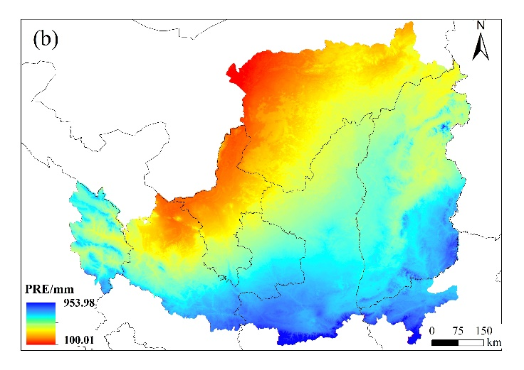
Figure 7. Spatial distribution of (a) annual average temperature and (b) annual precipitation on the Loess Plateau, 1980-2020

