Investigating the carcinogenic and non-carcinogenic health hazards of heavy metal ions in Spinacia oleracea grown in agricultural soil treated with biochar and humic acid
Farzad Moradi-Choghamarani and Farshid Ghorbani
Department of Environmental Sciences, Faculty of Natural Resources, University of Kurdistan, Sanandaj, Iran.

Table S1
Some physical and chemical properties as well as total concentrations of HMs in untreated soil.
Properties | Value | Properties | Value | Properties | Value
Sand (%) | 58.86 | CEC (${cmol}_{c}{kg}^{-1}$) | 11.31 | Cu ($mg {kg}^{-1}$) | 161.55
Silt (%) | 24.54 | Total nitrogen (%) | 0.14 | Mn ($mg {kg}^{-1}$) | 1200.44
Clay (%) | 16.6 | NH₄OAc-K ($mg {kg}^{-1}$) | 505 | Cr ($mg {kg}^{-1}$) | 35.98
USDA texture class | Sandy loam | NaHCO₃ -P ($mg {kg}^{-1}$) | 15 | Cd ($mg {kg}^{-1}$) | 11.06
OC (%) | 0.72 | SSA ($m^{2} g^{-1}$) | 44.71 | Pb ($mg {kg}^{-1}$) | 27.54
EC ($dS m^{-1}$) | 0.24 | Zn ($mg {kg}^{-1}$) | 150.11 | Ni ($mg {kg}^{-1}$) | 125.75
pH (-) | 7.05 | Fe ($mg {kg}^{-1}$) | 4819.55
Note: USDA, united states department of agriculture; EC, electrical conductivity; CEC, cation exchange capacity; NH₄OAc-K, ammonium acetate-extractable potassium; NaHCO₃, sodium bicarbonate-extractable phosphorus; SSA, specific surface area; Zn, zinc; Fe, iron; Cu, cooper; Mn, manganese; Cr, chromium; Cd, cadmium; Pb, lead; Ni, nickel.

Table S2
Experimental design in terms of coded factors.
 |  | Independent variables
 |  | Real values |  |  | Coded values
Run numbers | Categorical  factor levels | Application rate (%) | Humic acid (mg/L) | Biomass/Biochar type | Application rate (%) | Humic acid (mg/L) | Biomass/Biochar type
 |  | A | B | C | A | B | C
1 | factorial points | 0.75 | 500.00 | SBP | -1 | -1 | 1
2 | factorial points | 4.35 | 500.00 | SBP | 1 | -1 | 1
3 | factorial points | 0.75 | 2000.00 | SBP | -1 | 1 | 1
4 | factorial points | 4.35 | 2000.00 | SBP | 1 | 1 | 1
5 | axial points | 0.00 | 1250.00 | SBP | -α | 0 | 1
6 | axial points | 5.10 | 1250.00 | SBP | +α | 0 | 1
7 | axial points | 2.55 | 189.34 | SBP | 0 | -α | 1
8 | axial points | 2.55 | 2310.66 | SBP | 0 | +α | 1
9 | central points | 2.55 | 1250.00 | SBP | 0 | 0 | 1
10 | central points | 2.55 | 1250.00 | SBP | 0 | 0 | 1
11 | central points | 2.55 | 1250.00 | SBP | 0 | 0 | 1
12 | central points | 2.55 | 1250.00 | SBP | 0 | 0 | 1
13 | central points | 2.55 | 1250.00 | SBP | 0 | 0 | 1
14 | factorial points | 0.75 | 500.00 | RH | -1 | -1 | 2
15 | factorial points | 4.35 | 500.00 | RH | 1 | -1 | 2
16 | factorial points | 0.75 | 2000.00 | RH | -1 | 1 | 2
17 | factorial points | 4.35 | 2000.00 | RH | 1 | 1 | 2
18 | axial points | 0.00 | 1250.00 | RH | -α | 0 | 2
19 | axial points | 5.10 | 1250.00 | RH | +α | 0 | 2
20 | axial points | 2.55 | 189.34 | RH | 0 | -α | 2
21 | axial points | 2.55 | 2310.66 | RH | 0 | +α | 2
22 | central points | 2.55 | 1250.00 | RH | 0 | 0 | 2
23 | central points | 2.55 | 1250.00 | RH | 0 | 0 | 2
24 | central points | 2.55 | 1250.00 | RH | 0 | 0 | 2
25 | central points | 2.55 | 1250.00 | RH | 0 | 0 | 2
26 | central points | 2.55 | 1250.00 | RH | 0 | 0 | 2
27 | factorial points | 0.75 | 500.00 | SBP300 | -1 | -1 | 3
28 | factorial points | 4.35 | 500.00 | SBP300 | 1 | -1 | 3
29 | factorial points | 0.75 | 2000.00 | SBP300 | -1 | 1 | 3
30 | factorial points | 4.35 | 2000.00 | SBP300 | 1 | 1 | 3
31 | axial points | 0.00 | 1250.00 | SBP300 | -α | 0 | 3
32 | axial points | 5.10 | 1250.00 | SBP300 | +α | 0 | 3
33 | axial points | 2.55 | 189.34 | SBP300 | 0 | -α | 3
34 | axial points | 2.55 | 2310.66 | SBP300 | 0 | +α | 3
35 | central points | 2.55 | 1250.00 | SBP300 | 0 | 0 | 3
36 | central points | 2.55 | 1250.00 | SBP300 | 0 | 0 | 3
37 | central points | 2.55 | 1250.00 | SBP300 | 0 | 0 | 3
38 | central points | 2.55 | 1250.00 | SBP300 | 0 | 0 | 3
39 | central points | 2.55 | 1250.00 | SBP300 | 0 | 0 | 3
40 | factorial points | 0.75 | 500.00 | SBP600 | -1 | -1 | 4
41 | factorial points | 4.35 | 500.00 | SBP600 | 1 | -1 | 4
42 | factorial points | 0.75 | 2000.00 | SBP600 | -1 | 1 | 4
43 | factorial points | 4.35 | 2000.00 | SBP600 | 1 | 1 | 4
44 | axial points | 0.00 | 1250.00 | SBP600 | -α | 0 | 4
45 | axial points | 5.10 | 1250.00 | SBP600 | +α | 0 | 4
46 | axial points | 2.55 | 189.34 | SBP600 | 0 | -α | 4
47 | axial points | 2.55 | 2310.66 | SBP600 | 0 | +α | 4
8 | central points | 2.55 | 1250.00 | SBP600 | 0 | 0 | 4
49 | central points | 2.55 | 1250.00 | SBP600 | 0 | 0 | 4
50 | central points | 2.55 | 1250.00 | SBP600 | 0 | 0 | 4
51 | central points | 2.55 | 1250.00 | SBP600 | 0 | 0 | 4
52 | central points | 2.55 | 1250.00 | SBP600 | 0 | 0 | 4
53 | factorial points | 0.75 | 500.00 | RH300 | -1 | -1 | 5
54 | factorial points | 4.35 | 500.00 | RH300 | 1 | -1 | 5
55 | factorial points | 0.75 | 2000.00 | RH300 | -1 | 1 | 5
56 | factorial points | 4.35 | 2000.00 | RH300 | 1 | 1 | 5
57 | axial points | 0.00 | 1250.00 | RH300 | -α | 0 | 5
58 | axial points | 5.10 | 1250.00 | RH300 | +α | 0 | 5
59 | axial points | 2.55 | 189.34 | RH300 | 0 | -α | 5
60 | axial points | 2.55 | 2310.66 | RH300 | 0 | +α | 5
61 | central points | 2.55 | 1250.00 | RH300 | 0 | 0 | 5
62 | central points | 2.55 | 1250.00 | RH300 | 0 | 0 | 5
63 | central points | 2.55 | 1250.00 | RH300 | 0 | 0 | 5
64 | central points | 2.55 | 1250.00 | RH300 | 0 | 0 | 5
65 | central points | 2.55 | 1250.00 | RH300 | 0 | 0 | 5
66 | factorial points | 0.75 | 500.00 | RH600 | -1 | -1 | 6
67 | factorial points | 4.35 | 500.00 | RH600 | 1 | -1 | 6
68 | factorial points | 0.75 | 2000.00 | RH600 | -1 | 1 | 6
69 | factorial points | 4.35 | 2000.00 | RH600 | 1 | 1 | 6
70 | axial points | 0.00 | 1250.00 | RH600 | -α | 0 | 6
71 | axial points | 5.10 | 1250.00 | RH600 | +α | 0 | 6
72 | axial points | 2.55 | 189.34 | RH600 | 0 | -α | 6
73 | axial points | 2.55 | 2310.66 | RH600 | 0 | +α | 6
74 | central points | 2.55 | 1250.00 | RH600 | 0 | 0 | 6
75 | central points | 2.55 | 1250.00 | RH600 | 0 | 0 | 6
76 | central points | 2.55 | 1250.00 | RH600 | 0 | 0 | 6
77 | central points | 2.55 | 1250.00 | RH600 | 0 | 0 | 6
78 | central points | 2.55 | 1250.00 | RH600 | 0 | 0 | 6

Table S3
The phyto-availability of HMs in feedstocks and their biochars based on DTPA method.
 | Zn | Fe | Cu | Mn | Cr | Cd | Pb | Ni
 | $$mg {kg}^{-1}$$
RH | 13.09 | 31.91 | 4.98 | 131.70 | 2.02 | 0.15 | 0.82 | 3.34
RH300 | 10.35 | 27.48 | 4.27 | 91.68 | 2.64 | 0.17 | 0.62 | 2.37
RH600 | 6.11 | 25.05 | 4.03 | 77.12 | 3.02 | 0.21 | 0.59 | 1.82
SBP | 9.83 | 69.79 | 11.66 | 41.29 | 1.49 | 0.12 | 0.67 | 6.74
SBP300 | 2.12 | 34.62 | 6.30 | 14.89 | 2.02 | 0.19 | 0.66 | 5.11
SBP600 | 1.28 | 16.44 | 4.04 | 3.36 | 2.73 | 0.38 | 0.60 | 4.22
Soil | 0.38 | 15.75 | 1.67 | 88.17 | 1.37 | 0.16 | 0.75 | 0.85
SNC * | >3 | >20 | >1.8 | >30
* Soil nutrient class based on Yang et al. (2014). The figures given in this row are class 1 of Yang's classification, which indicates the abundance.
Note: RH, rice husk; RH300, rice husk biochar at 300 ºC; RH600, rice husk biochar at 600 ºC; SBP, sugar beet pulp; SBP300, sugar beet pulp biochar at 300 ºC; SBP600, sugar beet pulp biochar at 600 ºC.

Equations S1-S22. The respective multiple regression models in terms of coded factors for EDI-HMs, HQ-HMs, HI, CR-HMs, and TCR taking into consideration linear (A, B, C), quadratic ($A^{2}$, $B^{2}, C^{2})$ and interactive (AB, AC, BC,) effects of all variables. (Only significant models at 95% of probability level are written.)
$$EDI-Mn=0.020-2.69×{10}^{-3}AB+3.11×{10}^{-3}\left(BC1\right)+4.97×{10}^{-3}\left(BC2\right)-2.50×{10}^{-4}\left(BC3\right)+1.66×{10}^{-3}\left(BC4\right)-6.38×{10}^{-3}(BC5)$$ | (S1)
$$EDI-Cd=9.46×{10}^{-4}+1.78×{10}^{-4}\left(B\right)-3.68×{10}^{-5}\left(C1\right)+1.33×{10}^{-4}\left(C2\right)-7.15×{10}^{-5}\left(C3\right)-3.85×{10}^{-5}\left(C4\right)+1.74×{10}^{-4}\left(C5\right)$$ | (S2)
$$EDI-Pb=4.44×{10}^{-3}-9.52×{10}^{-4}\left(C1\right)-3.60×{10}^{-5}\left(C2\right)-3.20×{10}^{-4}\left(C3\right)+2.16×{10}^{-4}\left(C4\right)-3.25×{10}^{-4}\left(C5\right)$$ | (S3)
$$HQ-Zn=0.11+0.013B$$ | (S4)
$$HQ-Mn=0.14-0.019AB+0.022\left(BC1\right)+0.036\left(BC2\right)-1.79×{10}^{-3}\left(BC3\right)+0.012\left(BC4\right)-0.046(BC5)$$ | (S5)
$$HQ-Cd=0.95+0.18B-0.037\left(C1\right)+0.13\left(C2\right)-0.072\left(C3\right)-0.039\left(C4\right)+0.17(C5)$$ | (S6)
$$HQ-Pb=1.27-0.27\left(C1\right)-0.01\left(C2\right)-0.091\left(C3\right)+0.062\left(C4\right)-0.093(C5)$$ | (S7)
$$HI=3.50+0.38(B)$$ | (S8)
$$CR-Cr=3.59×{10}^{-4}+6.76×{10}^{-5}B$$ | (S9)
$$CR-Pb=3.77×{10}^{-5}-8.09×{10}^{-6}\left(C1\right)-3.06×{10}^{-7}\left(C2\right)-2.72×{10}^{-6}\left(C3\right)+1.84×{10}^{-6}\left(C4\right)-2.76×{10}^{-6}(C5)$$ | (S10)

Table S4
Regression analysis using response surface linear model for CCI response.
Source | Sum of squares | df | Mean square | F value | p-value
Model | 72.80 | 7 | 10.40 | 3.25 | 0.0048
A: Application rate | 0.1721 | 1 | 0.1721 | 0.0537 | 0.8174
B: Humic acid | 2.49 | 1 | 2.49 | 0.7787 | 0.3806
C: Biomass/Biochar type | 70.13 | 5 | 14.03 | 4.38 | 0.0016
Residual | 224.25 | 70 | 3.20
Lack of fit | 133.48 | 46 | 2.90 | 0.7673 | 0.7838
Pure error | 90.77 | 24 | 3.78
Cor total | 297.05 | 77
R-squared | 0.245
Adj R-squared | 0.170
Pred R-squared | 0.069
Adeq precision | 6.63

Table S5
Regression analysis using response surface linear model for Zn-bioaccumulation response.
Source | Sum of squares | df | Mean square | F value | p-value
Model | 23602.34 | 7 | 3371.76 | 3.67 | 0.0020
A: Application rate | 0.66 | 1 | 0.66 | 0.00 | 0.9788
B: Humic acid | 8601.87 | 1 | 8601.87 | 9.36 | 0.0031
C: Biomass/Biochar type | 14999.82 | 5 | 2999.96 | 3.26 | 0.0105
Residual | 64320.22 | 70 | 918.86
Lack of fit | 60056.72 | 46 | 1305.58 | 7.35 | < 0.0001
Pure error | 4263.49 | 24 | 177.65
Cor total | 87922.56 | 77
R-squared | 0.268
Adj R-squared | 0.195
Pred R-squared | 0.072
Adeq precision | 8.25

Table S6
Regression analysis using response surface quadratic model for Fe-bioaccumulation response.
Source | Sum of squares | df | Mean square | F value | p-value
Model | 2463836.10 | 20 | 123191.80 | 3.40 | 0.0001
A: Application rate | 22023.82 | 1 | 22023.82 | 0.61 | 0.4385
B: Humic acid | 330702.10 | 1 | 330702.10 | 9.14 | 0.0037
C: Biomass/Biochar type | 503157.57 | 5 | 100631.51 | 2.78 | 0.0257
AB | 90.68 | 1 | 90.68 | 0.00 | 0.9603
AC | 809904.25 | 5 | 161980.85 | 4.48 | 0.0016
BC | 497201.70 | 5 | 99440.34 | 2.75 | 0.0272
A^2 | 87128.25 | 1 | 87128.25 | 2.41 | 0.1263
B^2 | 176189.32 | 1 | 176189.32 | 4.87 | 0.0314
Residual | 2062614.87 | 57 | 36186.23
Lack of fit | 1828833.67 | 33 | 55419.20 | 5.69 | < 0.0001
Pure error | 233781.20 | 24 | 9740.88
Cor total | 4526450.97 | 77
R-squared | 0.544
Adj R-squared | 0.384
Pred R-squared | -0.058
Adeq precision | 9.85

Table S7
Regression analysis using response surface linear model for Cu-bioaccumulation response.
Source | Sum of squares | df | Mean square | F value | p-value
Model | 722.36 | 7 | 103.19 | 5.58 | < 0.0001
A: Application rate | 9.46 | 1 | 9.46 | 0.51 | 0.4771
B: Humic acid | 119.44 | 1 | 119.44 | 6.45 | 0.0133
C: Biomass/Biochar type | 593.46 | 5 | 118.69 | 6.41 | < 0.0001
Residual | 1295.30 | 70 | 18.50
Lack of fit | 1201.71 | 46 | 26.12 | 6.70 | < 0.0001
Pure error | 93.60 | 24 | 3.90
Cor total | 2017.66 | 77
R-squared | 0.358
Adj R-squared | 0.294
Pred R-squared | 0.187
Adeq precision | 9.18

Table S8
Regression analysis using response surface 2FI model for Mn-bioaccumulation response.
Source | Sum of squares | df | Mean square | F value | p-value
Model | 17946.16 | 18 | 997.01 | 3.00 | 0.0008
A: Application rate | 135.21 | 1 | 135.21 | 0.41 | 0.5262
B: Humic acid | 88.57 | 1 | 88.57 | 0.27 | 0.6078
C: Biomass/Biochar type | 3734.46 | 5 | 746.89 | 2.25 | 0.0615
AB | 2126.28 | 1 | 2126.28 | 6.39 | 0.0142
AC | 3282.99 | 5 | 656.60 | 1.97 | 0.0958
BC | 8578.65 | 5 | 1715.73 | 5.16 | 0.0005
Residual | 19626.42 | 59 | 332.65
Lack of Fit | 18361.89 | 35 | 524.63 | 9.96 | < 0.0001
Pure Error | 1264.54 | 24 | 52.69
Cor Total | 37572.58 | 77
R-squared | 0.478
Adj R-squared | 0.318
Pred R-squared | -0.112
Adeq precision | 7.62

Table S9
Regression analysis using response surface quadratic model for Cr-bioaccumulation response.
Source | Sum of squares | df | Mean square | F value | p-value
Model | 81.88 | 20 | 4.09 | 1.61 | 0.0810
A: Application rate | 0.37 | 1 | 0.37 | 0.15 | 0.7037
B: Humic acid | 12.62 | 1 | 12.62 | 4.97 | 0.0297
C: Biomass/Biochar type | 23.68 | 5 | 4.74 | 1.87 | 0.1145
AB | 0.52 | 1 | 0.52 | 0.20 | 0.6531
AC | 7.55 | 5 | 1.51 | 0.60 | 0.7033
BC | 19.51 | 5 | 3.90 | 1.54 | 0.1925
A^2 | 12.68 | 1 | 12.68 | 5.00 | 0.0293
B^2 | 7.14 | 1 | 7.14 | 2.82 | 0.0989
Residual | 144.57 | 57 | 2.54
Lack of Fit | 139.70 | 33 | 4.23 | 20.88 | < 0.0001
Pure Error | 4.87 | 24 | 0.20
Cor Total | 226.45 | 77
R-squared | 0.362
Adj R-squared | 0.138
Pred R-squared | -0.531
Adeq precision | 5.04

Table S10
Regression analysis using response surface quadratic model for Cd-bioaccumulation response.
Source | Sum of squares | df | Mean square | F value | p-value
Model | 51.13 | 20 | 2.56 | 2.45 | 0.0043
A: Application rate | 0.05 | 1 | 0.05 | 0.05 | 0.8243
B: Humic acid | 18.58 | 1 | 18.58 | 17.83 | < 0.0001
C: Biomass/Biochar type | 13.91 | 5 | 2.78 | 2.67 | 0.0309
AB | 0.38 | 1 | 0.38 | 0.36 | 0.5509
AC | 1.91 | 5 | 0.38 | 0.37 | 0.8688
BC | 7.33 | 5 | 1.47 | 1.41 | 0.2356
A^2 | 2.49 | 1 | 2.49 | 2.39 | 0.1275
B^2 | 7.45 | 1 | 7.45 | 7.15 | 0.0098
Residual | 59.39 | 57 | 1.04
Lack of Fit | 49.16 | 33 | 1.49 | 3.50 | 0.0011
Pure Error | 10.23 | 24 | 0.43
Cor Total | 110.51 | 77
R-squared | 0.463
Adj R-squared | 0.274
Pred R-squared | 0.164
Adeq precision | 7.61

Table S11
Regression analysis using response surface quadratic model for Pb-bioaccumulation response.
Source | Sum of squares | df | Mean square | F value | p-value
Model | 1268.09 | 20 | 63.40 | 2.81 | 0.0012
A: Application rate | 62.29 | 1 | 62.29 | 2.76 | 0.1022
B: Humic acid | 45.21 | 1 | 45.21 | 2.00 | 0.1625
C: Biomass/Biochar type | 531.06 | 5 | 106.21 | 4.70 | 0.0012
AB | 14.18 | 1 | 14.18 | 0.63 | 0.4313
AC | 94.19 | 5 | 18.84 | 0.83 | 0.5308
BC | 313.98 | 5 | 62.80 | 2.78 | 0.0257
A^2 | 123.84 | 1 | 123.84 | 5.48 | 0.0227
B^2 | 110.31 | 1 | 110.31 | 4.89 | 0.0311
Residual | 1287.02 | 57 | 22.58
Lack of Fit | 1219.58 | 33 | 36.96 | 13.15 | < 0.0001
Pure Error | 67.44 | 24 | 2.81
Cor Total | 2555.11 | 77
R-squared | 0.496
Adj R-squared | 0.320
Pred R-squared | -0.183
Adeq precision | 7.03

Table S12
Regression analysis using response surface quadratic model for Ni-bioaccumulation response.
Source | Sum of squares | df | Mean square | F value | p-value
Model | 564.90 | 20 | 28.24 | 1.97 | 0.0239
A: Application rate | 58.34 | 1 | 58.34 | 4.07 | 0.0484
B: Humic acid | 74.79 | 1 | 74.79 | 5.22 | 0.0261
C: Biomass/Biochar type | 180.84 | 5 | 36.17 | 2.52 | 0.0393
AB | 1.69 | 1 | 1.69 | 0.12 | 0.7323
AC | 52.95 | 5 | 10.59 | 0.74 | 0.5975
BC | 33.60 | 5 | 6.72 | 0.47 | 0.7980
A^2 | 151.21 | 1 | 151.21 | 10.55 | 0.0020
B^2 | 3.08 | 1 | 3.08 | 0.21 | 0.6447
Residual | 817.10 | 57 | 14.34
Lack of Fit | 624.91 | 33 | 18.94 | 2.36 | 0.0158
Pure Error | 192.19 | 24 | 8.01
Cor Total | 1382.00 | 77
R-squared | 0.409
Adj R-squared | 0.201
Pred R-squared | -0.232
Adeq precision | 6.21

Table S13
Regression analysis using response surface linear model for EDI-Zn response.
Source | Sum of squares | df | Mean square | F value | p value
Model | $$3.35×{10}^{-3}$$ | 20 | $$1.68×{10}^{-4}$$ | 1.42 | 0.1501
A: Application rate | $$3.36×{10}^{-8}$$ | 1 | $$5.36×{10}^{-8}$$ | $$4.55×{10}^{-4}$$ | 0.9831
B: Humic acid | $$7.04×{10}^{-4}$$ | 1 | $$7.04×{10}^{-4}$$ | 5.97 | 0.0177
C: Biomass/Biochar type | $$1.26×{10}^{-3}$$ | 5 | $$2.51×{10}^{-4}$$ | 2.13 | 0.0747
AB | $$7.08×{10}^{-5}$$ | 1 | $$7.08×{10}^{-5}$$ | 0.60 | 0.4414
AC | $$7.87×{10}^{-4}$$ | 5 | $$1.57×{10}^{-4}$$ | 1.34 | 0.2624
BC | $$4.34×{10}^{-4}$$ | 5 | $$8.67×{10}^{-5}$$ | 0.74 | 0.5996
A² | $$2.56×{10}^{-5}$$ | 1 | $$2.56×{10}^{-5}$$ | 0.22 | 0.6431
B² | $$8.64×{10}^{-5}$$ | 1 | $$8.64×{10}^{-5}$$ | 0.73 | 0.3954
Residual | $$6.72×{10}^{-3}$$ | 57 | $$1.18×{10}^{-4}$$
Lack of fit | $$3.50×{10}^{-3}$$ | 33 | $$1.06×{10}^{-4}$$ | 0.79 | 0.7366
Pure error | $$3.22×{10}^{-3}$$ | 24 | $$1.34×{10}^{-4}$$
Cor total | 0.01 | 77
R-squared | 0.333
Adj R-squared | 0.099
Pred R-squared | -0.228
Adeq precision | 5.37

Table S14
Regression analysis using response surface linear model for EDI-Fe response.
Source | Sum of squares | df | Mean square | F value | p value
Model | 0.20 | 20 | 0.01 | 1.53 | 0.1079
A: Application rate | $$1.80×{10}^{-3}$$ | 1 | $$1.80×{10}^{-3}$$ | 0.27 | 0.6035
B: Humic acid | 0.027 | 1 | 0.027 | 4.10 | 0.0477
C: Biomass/Biochar type | 0.042 | 5 | $$8.31×{10}^{-3}$$ | 1.26 | 0.2945
AB | $$7.42×{10}^{-6}$$ | 1 | $$7.42×{10}^{-6}$$ | $$1.12×{10}^{-3}$$ | 0.9734
AC | 0.066 | 5 | 0.013 | 2.01 | 0.0915
BC | 0.041 | 5 | $$8.13×{10}^{-3}$$ | 1.23 | 0.3064
A² | $$8.21×{10}^{-3}$$ | 1 | $$8.21×{10}^{-3}$$ | 1.24 | 0.2697
B² | 0.013 | 1 | 0.013 | 1.96 | 0.1665
Residual | 0.38 | 57 | $$6.61×{10}^{-3}$$
Lack of fit | 0.15 | 33 | $$4.51×{10}^{-3}$$ | 0.47 | 0.9763
Pure error | 0.23 | 24 | $$9.49×{10}^{-3}$$
Cor total | 0.58 | 77
R-squared | 0.345
Adj R-squared | 0.1203
Pred R-squared | -0.1177
Adeq precision | 6.63

Table S15
Regression analysis using response surface linear model for EDI-Cu response.
Source | Sum of squares | df | Mean square | F value | p value
Model | $$5.86×{10}^{-5}$$ | 7 | $$8.38×{10}^{-6}$$ | 2.11 | 0.5437
A: Application rate | $$7.74×{10}^{-7}$$ | 1 | $$7.74×{10}^{-7}$$ | 0.19 | 0.6603
B: Humic acid | $$9.77×{10}^{-6}$$ | 1 | $$9.77×{10}^{-6}$$ | 2.46 | 0.1213
C: Biomass/Biochar type | $$4.81×{10}^{-5}$$ | 5 | $$9.62×{10}^{-6}$$ | 2.42 | 0.0440
Residual | $$2.78×{10}^{-4}$$ | 70 | $$3.97×{10}^{-6}$$
Lack of fit | $$9.95×{10}^{-5}$$ | 46 | $$2.16×{10}^{-6}$$ | 0.29 | 0.9998
Pure error | $$1.78×{10}^{-4}$$ | 24 | $$2.44×{10}^{-6}$$
Cor total | $$3.37×{10}^{-4}$$ | 77
R-squared | 0.1742
Adj R-squared | 0.0916
Pred R-squared | 0.0016
Adeq precision | 5.63

Table S16
Regression analysis using response surface linear model for EDI-Mn response.
Source | Sum of squares | df | Mean square | F value | p value
Model | $$1.47×{10}^{-3}$$ | 18 | $$8.16×{10}^{-5}$$ | 1.98 | 0.0259
A: Application rate | $$1.11×{10}^{-5}$$ | 1 | $$1.11×{10}^{-5}$$ | 0.27 | 0.6066
B: Humic acid | $$7.25×{10}^{-6}$$ | 1 | $$7.25×{10}^{-6}$$ | 0.18 | 0.6767
C: Biomass/Biochar type | $$3.07×{10}^{-4}$$ | 5 | $$6.14×{10}^{-5}$$ | 1.49 | 0.2078
AB | $$1.74×{10}^{-4}$$ | 1 | $$1.74×{10}^{-4}$$ | 4.21 | 0.0445
AC | $$2.69×{10}^{-4}$$ | 5 | $$5.37×{10}^{-5}$$ | 1.30 | 0.2757
BC | $$7.02×{10}^{-4}$$ | 5 | $$1.40×{10}^{-4}$$ | 3.40 | 0.0091
Residual | $$2.43×{10}^{-5}$$ | 59 | $$4.13×{10}^{-5}$$
Lack of fit | $$1.45×{10}^{-3}$$ | 35 | $$4.15×{10}^{-5}$$ | 1.02 | 0.4926
Pure error | $$9.81×{10}^{-4}$$ | 24 | $$9.09×{10}^{-5}$$
Cor total | $$3.90×{10}^{-3}$$ | 77
R-squared | 0.3764
Adj R-squared | 0.1861
Pred R-squared | -0.1189
Adeq precision | 6.24

Table S17
Regression analysis using response surface linear model for EDI-Cr response.
Source | Sum of squares | df | Mean square | F value | p value
Model | $$7.91×{10}^{-6}$$ | 20 | $$3.96×{10}^{-7}$$ | 1.43 | 0.1475
A: Application rate | $$3.03×{10}^{-8}$$ | 1 | $$3.03×{10}^{-8}$$ | 0.11 | 0.7421
B: Humic acid | $$1.03×{10}^{-6}$$ | 1 | $$1.03×{10}^{-6}$$ | 3.72 | 0.0586
C: Biomass/Biochar type | $$2.55×{10}^{-6}$$ | 5 | $$5.11×{10}^{-7}$$ | 1.84 | 0.1191
AB | $$4.24×{10}^{-8}$$ | 1 | $$4.24×{10}^{-8}$$ | 0.15 | 0.6973
AC | $$6.18×{10}^{-7}$$ | 5 | $$1.24×{10}^{-7}$$ | 0.45 | 0.8144
BC | $$1.60×{10}^{-6}$$ | 5 | $$3.19×{10}^{-7}$$ | 1.15 | 0.3441
A² | $$1.42×{10}^{-6}$$ | 1 | $$1.42×{10}^{-6}$$ | 5.12 | 0.0274
B² | $$8.79×{10}^{-7}$$ | 1 | $$8.79×{10}^{-7}$$ | 3.17 | 0.0802
Residual | $$1.58×{10}^{-5}$$ | 57 | $$2.77×{10}^{-7}$$
Lack of fit | $$1.11×{10}^{-5}$$ | 33 | $$3.38×{10}^{-7}$$ | 1.74 | 0.0804
Pure error | $$4.65×{10}^{-6}$$ | 24 | $$1.94×{10}^{-7}$$
Cor total | $$2.37×{10}^{-5}$$ | 77
R-squared | 0.3338
Adj R-squared | 0.1000
Pred R-squared | -0.3940
Adeq precision | 4.50

Table S18
Regression analysis using response surface linear model for EDI-Cd response.
Source | Sum of squares | df | Mean square | F value | p value
Model | $$5.59×{10}^{-6}$$ | 7 | $$3.70×{10}^{-7}$$ | 3.49 | 0.0029
A: Application rate | $$4.24×{10}^{-9}$$ | 1 | $$4.24×{10}^{-9}$$ | 0.04 | 0.8421
B: Humic acid | $$1.52×{10}^{-6}$$ | 1 | $$1.52×{10}^{-6}$$ | 14.34 | 0.0003
C: Biomass/Biochar type | $$1.06×{10}^{-6}$$ | 5 | $$2.13×{10}^{-7}$$ | 2.01 | 0.0481
Residual | $$7.42×{10}^{-6}$$ | 70 | $$1.06×{10}^{-7}$$
Lack of fit | $$5.37×{10}^{-6}$$ | 46 | $$1.17×{10}^{-7}$$ | 1.37 | 0.2047
Pure error | $$2.05×{10}^{-6}$$ | 24 | $$8.53×{10}^{-8}$$
Cor total | $$1.00×{10}^{-5}$$ | 77
R-squared | 0.2586
Adj R-squared | 0.1844
Pred R-squared | 0.0796
Adeq precision | 8.04

Table S19
Regression analysis using response surface linear model for EDI-Pb response.
Source | Sum of squares | df | Mean square | F value | p value
Model | $$1.02×{10}^{-4}$$ | 20 | $$5.09×{10}^{-6}$$ | 1.81 | 0.0422
A: Application rate | $$5.10×{10}^{-6}$$ | 1 | $$5.10×{10}^{-6}$$ | 1.81 | 0.1841
B: Humic acid | $$3.70×{10}^{-6}$$ | 1 | $$3.70×{10}^{-6}$$ | 1.31 | 0.2568
C: Biomass/Biochar type | $$4.12×{10}^{-5}$$ | 5 | $$8.23×{10}^{-6}$$ | 2.92 | 0.0204
AB | $$1.16×{10}^{-6}$$ | 1 | $$1.16×{10}^{-6}$$ | 0.41 | 0.5237
AC | $$7.71×{10}^{-6}$$ | 5 | $$1.54×{10}^{-6}$$ | 0.55 | 0.7401
BC | $$2.60×{10}^{-5}$$ | 5 | $$5.14×{10}^{-6}$$ | 1.82 | 0.1229
A² | $$1.04×{10}^{-5}$$ | 1 | $$1.04×{10}^{-5}$$ | 3.68 | 0.0602
B² | $$9.24×{10}^{-6}$$ | 1 | $$9.24×{10}^{-6}$$ | 3.28 | 0.0755
Residual | $$1.61×{10}^{-4}$$ | 57 | $$2.82×{10}^{-6}$$
Lack of fit | $$9.74×{10}^{-5}$$ | 33 | $$2.95×{10}^{-6}$$ | 1.12 | 0.3918
Pure error | $$6.33×{10}^{-5}$$ | 24 | $$2.64×{10}^{-6}$$
Cor total | $$2.63×{10}^{-4}$$ | 77
R-squared | 0.3880
Adj R-squared | 0.1733
Pred R-squared | -0.1959
Adeq precision | 5.53

Table S20
Regression analysis using response surface linear model for EDI-Ni response.
Source | Sum of squares | df | Mean square | F value | p value
Model | $$2.63×{10}^{-5}$$ | 7 | $$3.75×{10}^{-6}$$ | 1.67 | 0.1308
A: Application rate | $$4.77×{10}^{-6}$$ | 1 | $$4.77×{10}^{-6}$$ | 2.12 | 0.1495
B: Humic acid | $$6.12×{10}^{-6}$$ | 1 | $$6.12×{10}^{-6}$$ | 2.72 | 0.1035
C: Biomass/Biochar type | $$1.54×{10}^{-5}$$ | 5 | $$3.07×{10}^{-6}$$ | 1.37 | 0.2468
Residual | $$1.57×{10}^{-4}$$ | 70 | $$2.25×{10}^{-6}$$
Lack of fit | $$7.10×{10}^{-5}$$ | 46 | $$1.54×{10}^{-6}$$ | 0.43 | 0.9932
Pure error | $$8.63×{10}^{-5}$$ | 24 | $$3.60×{10}^{-6}$$
Cor total | $$1.84×{10}^{-4}$$ | 77
R-squared | 0.1431
Adj R-squared | 0.0574
Pred R-squared | -0.0431
Adeq precision | 5.68

Table S21
Regression analysis using response surface linear model for HQ-Zn response.
Source | Sum of squares | df | Mean square | F value | p value
Model | 0.022 | 7 | $$3.11×{10}^{-3}$$ | 2.42 | 0.0283
A: Application rate | $$5.96×{10}^{-7}$$ | 1 | $$5.96×{10}^{-7}$$ | $$4.63×{10}^{-4}$$ | 0.9829
B: Humic acid | $$7.82×{10}^{-3}$$ | 1 | $$7.82×{10}^{-3}$$ | 6.07 | 0.0162
C: Biomass/Biochar type | 0.014 | 5 | $$2.79×{10}^{-3}$$ | 2.17 | 0.0675
Residual | 0.090 | 70 | $$1.29×{10}^{-3}$$
Lack of fit | 0.054 | 46 | $$1.18×{10}^{-3}$$ | 0.79 | 0.7540
Pure error | 0.036 | 24 | $$1.49×{10}^{-3}$$
Cor total | 0.11 | 77
R-squared | 0.1946
Adj R-squared | 0.1140
Pred R-squared | 0.0051
Adeq precision | 6.76

Table S22
Regression analysis using response surface linear model for HQ-Fe response.
Source | Sum of squares | df | Mean square | F value | p value
Model | 0.41 | 20 | 0.021 | 1.53 | 0.1079
A: Application rate | $$3.68×{10}^{-3}$$ | 1 | $$3.68×{10}^{-3}$$ | 0.27 | 0.6035
B: Humic acid | 0.055 | 1 | 0.055 | 4.10 | 0.0477
C: Biomass/Biochar type | 0.085 | 5 | 0.017 | 1.26 | 0.2945
AB | $$1.51×{10}^{-5}$$ | 1 | $$1.51×{10}^{-5}$$ | $$1.12×{10}^{-3}$$ | 0.9734
AC | 0.14 | 5 | 0.027 | 2.01 | 0.0915
BC | 0.083 | 5 | 0.017 | 1.23 | 0.3064
A² | 0.017 | 1 | 0.017 | 1.24 | 0.2697
B² | 0.026 | 1 | 0.026 | 1.96 | 0.1665
Residual | 0.77 | 57 | 0.013
Lack of fit | 0.30 | 33 | $$9.19×{10}^{-3}$$ | 0.47 | 0.9763
Pure error | 0.46 | 24 | 0.019
Cor total | 1.18 | 77
R-squared | 0.3488
Adj R-squared | 0.1203
Pred R-squared | -0.1177
Adeq precision | 6.63

Table S23
Regression analysis using response surface linear model for HQ-Cu response.
Source | Sum of squares | df | Mean square | F value | p value
Model | 0.037 | 7 | $$5.24×{10}^{-3}$$ | 2.11 | 0.0537
A: Application rate | $$4.83×{10}^{-4}$$ | 1 | $$4.83×{10}^{-4}$$ | 0.19 | 0.6603
B: Humic acid | $$6.11×{10}^{-3}$$ | 1 | $$6.11×{10}^{-3}$$ | 2.46 | 0.1213
C: Biomass/Biochar type | 0.030 | 5 | $$6.01×{10}^{-3}$$ | 2.42 | 0.0440
Residual | 0.17 | 70 | $$2.48×{10}^{-3}$$
Lack of fit | 0.062 | 46 | $$1.35×{10}^{-3}$$ | 0.29 | 0.9998
Pure error | 0.11 | 24 | $$4.65×{10}^{-3}$$
Cor total | 0.21 | 77
R-squared | 0.1746
Adj R-squared | 0.0916
Pred R-squared | 0.0016
Adeq precision | 5.63

Table S24
Regression analysis using response surface linear model for HQ-Mn response.
Source | Sum of squares | df | Mean square | F value | p value
Model | 0.075 | 18 | $$4.16×{10}^{-3}$$ | 1.98 | 0.0259
A: Application rate | $$5.64×{10}^{-4}$$ | 1 | $$5.64×{10}^{-4}$$ | 0.27 | 0.6066
B: Humic acid | $$3.70×{10}^{-4}$$ | 1 | $$3.70×{10}^{-4}$$ | 0.18 | 0.6767
C: Biomass/Biochar type | 0.016 | 5 | $$3.13×{10}^{-3}$$ | 1.49 | 0.2078
AB | $$8.87×{10}^{-3}$$ | 1 | $$8.87×{10}^{-3}$$ | 4.21 | 0.0445
AC | 0.014 | 5 | $$2.74×{10}^{-3}$$ | 1.30 | 0.2757
BC | 0.036 | 5 | $$7.16×{10}^{-3}$$ | 3.40 | 0.0091
Residual | 0.12 | 59 | $$2.11×{10}^{-3}$$
Lack of fit | 0.074 | 35 | $$2.12×{10}^{-3}$$ | 1.02 | 0.4926
Pure error | 0.050 | 24 | $$2.09×{10}^{-3}$$
Cor total | 0.20 | 77
R-squared | 0.3764
Adj R-squared | 0.1861
Pred R-squared | -0.1189
Adeq precision | 6.24

Table S25
Regression analysis using response surface linear model for HQ-Cr response.
Source | Sum of squares | df | Mean square | F value | p value
Model | 0.88 | 20 | 0.044 | 1.43 | 0.1475
A: Application rate | $$3.37×{10}^{-3}$$ | 1 | $$3.37×{10}^{-3}$$ | 0.11 | 0.7421
B: Humic acid | 0.11 | 1 | 0.11 | 3.72 | 0.0586
C: Biomass/Biochar type | 0.28 | 5 | 0.057 | 1.84 | 0.1191
AB | $$4.71×{10}^{-3}$$ | 1 | $$4.71×{10}^{-3}$$ | 0.15 | 0.6973
AC | 0.069 | 5 | 0.014 | 0.45 | 0.8144
BC | 0.18 | 5 | 0.035 | 1.15 | 0.3441
A² | 0.16 | 1 | 0.16 | 5.12 | 0.0274
B² | 0.098 | 1 | 0.098 | 3.17 | 0.0802
Residual | 1.76 | 57 | 0.031
Lack of fit | 1.24 | 33 | 0.038 | 1.74 | 0.0804
Pure error | 0.52 | 24 | 0.022
Cor total | 2.63 | 77
R-squared | 0.3338
Adj R-squared | 0.1000
Pred R-squared | -0.3940
Adeq precision | 4.50

Table S26
Regression analysis using response surface linear model for HQ-Cd response.
Source | Sum of squares | df | Mean square | F value | p value
Model | 2.59 | 7 | 0.37 | 3.49 | 0.0029
A: Application rate | $$4.24×{10}^{-3}$$ | 1 | $$4.24×{10}^{-3}$$ | 0.04 | 0.8421
B: Humic acid | 1.52 | 1 | 1.52 | 14.34 | 0.0003
C: Biomass/Biochar type | 1.06 | 5 | 0.21 | 2.01 | 0.0481
Residual | 7.42 | 70 | 0.11
Lack of fit | 5.38 | 46 | 0.12 | 1.37 | 0.2047
Pure error | 2.05 | 24 | 0.085
Cor total | 10.01 | 77
R-squared | 0.2586
Adj R-squared | 0.1844
Pred R-squared | 0.0796
Adeq precision | 8.04

Table S27
Regression analysis using response surface linear model for HQ-Pb response.
Source | Sum of squares | df | Mean square | F value | p value
Model | 8.32 | 20 | 0.42 | 1.81 | 0.0422
A: Application rate | 0.42 | 1 | 0.42 | 1.81 | 0.1841
B: Humic acid | 0.30 | 1 | 0.30 | 1.31 | 0.2568
C: Biomass/Biochar type | 3.36 | 5 | 0.67 | 2.92 | 0.0204
AB | 0.095 | 1 | 0.095 | 0.41 | 0.5237
AC | 0.63 | 5 | 0.13 | 0.55 | 0.7401
BC | 2.10 | 5 | 0.42 | 1.82 | 0.1229
A² | 0.85 | 1 | 0.85 | 3.68 | 0.0602
B² | 0.75 | 1 | 0.75 | 3.28 | 0.0755
Residual | 13.12 | 57 | 0.23
Lack of fit | 7.95 | 33 | 0.24 | 1.12 | 0.3918
Pure error | 5.16 | 24 | 0.22
Cor total | 21.43 | 77
R-squared | 0.3880
Adj R-squared | 0.1733
Pred R-squared | -0.1959
Adeq precision | 5.53

Table S28
Regression analysis using response surface linear model for HQ-Ni response.
Source | Sum of squares | df | Mean square | F value | p value
Model | 0.11 | 20 | $$5.69×{10}^{-3}$$ | 0.94 | 0.5436
A: Application rate | 0.012 | 1 | 0.012 | 1.97 | 0.1659
B: Humic acid | 0.015 | 1 | 0.015 | 2.53 | 0.1176
C: Biomass/Biochar type | 0.038 | 5 | $$7.69×{10}^{-3}$$ | 1.27 | 0.2898
AB | $$3.46×{10}^{-4}$$ | 1 | $$3.46×{10}^{-4}$$ | 0.057 | 0.8119
AC | 0.011 | 5 | $$2.17×{10}^{-3}$$ | 0.36 | 0.8752
BC | $$6.87×{10}^{-3}$$ | 5 | $$1.37×{10}^{-3}$$ | 0.23 | 0.9494
A² | 0.026 | 1 | 0.026 | 4.37 | 0.0411
B² | $$1.47×{10}^{-3}$$ | 1 | $$1.47×{10}^{-3}$$ | 0.24 | 0.6243
Residual | 0.35 | 57 | $$6.06×{10}^{-3}$$
Lack of fit | 0.13 | 33 | $$3.92×{10}^{-3}$$ | 0.44 | 0.9862
Pure error | 0.22 | 24 | $$8.99×{10}^{-3}$$
Cor total | 0.46 | 77
R-squared | 0.2479
Adj R-squared | -0.0161
Pred R-squared | -0.2370
Adeq precision | 4.29

Table S29
Regression analysis using response surface linear model for HI response.
Source | Sum of squares | df | Mean square | F value | p value
Model | 10.86 | 7 | 1.55 | 4.26 | 0.0006
A: Application rate | 0.65 | 1 | 0.65 | 1.79 | 0.1847
B: Humic acid | 7.10 | 1 | 7.10 | 19.49 | < 0.0001
C: Biomass/Biochar type | 3.10 | 5 | 0.62 | 1.70 | 0.1458
Residual | 25.52 | 70 | 0.36
Lack of fit | 17.46 | 46 | 0.38 | 1.13 | 0.3815
Pure error | 8.06 | 24 | 0.34
Cor total | 36.38 | 77
R-squared | 0.2985
Adj R-squared | 0.2284
Pred R-squared | 0.1269
Adeq precision | 8.85

Table S30
Regression analysis using response surface linear model for CR-Cr response.
Source | Sum of squares | df | Mean square | F value | p value
Model | $$1.98×{10}^{-6}$$ | 20 | $$9.89×{10}^{-8}$$ | 1.43 | 0.1475
A: Application rate | $$7.58×{10}^{-9}$$ | 1 | $$7.58×{10}^{-9}$$ | 0.11 | 0.7421
B: Humic acid | $$2.58×{10}^{-7}$$ | 1 | $$2.58×{10}^{-7}$$ | 3.72 | 0.0586
C: Biomass/Biochar type | $$6.38×{10}^{-7}$$ | 5 | $$1.28×{10}^{-7}$$ | 1.84 | 0.1191
AB | $$1.06×{10}^{-8}$$ | 1 | $$1.06×{10}^{-8}$$ | 0.15 | 0.6973
AC | $$1.55×{10}^{-7}$$ | 5 | $$3.09×{10}^{-8}$$ | 0.45 | 0.8144
BC | $$3.99×{10}^{-7}$$ | 5 | $$7.99×{10}^{-8}$$ | 1.15 | 0.3441
A² | $$3.55×{10}^{-7}$$ | 1 | $$3.55×{10}^{-7}$$ | 5.12 | 0.0274
B² | $$2.20×{10}^{-7}$$ | 1 | $$2.20×{10}^{-7}$$ | 3.17 | 0.0802
Residual | $$3.95×{10}^{-6}$$ | 57 | $$6.93×{10}^{-8}$$
Lack of fit | $$2.79×{10}^{-6}$$ | 33 | $$8.44×{10}^{-8}$$ | 1.74 | 0.0804
Pure error | $$1.16×{10}^{-6}$$ | 24 | $$4.84×{10}^{-8}$$
Cor total | $$5.93×{10}^{-6}$$ | 77
R-squared | 0.3338
Adj R-squared | 0.1000
Pred R-squared | -0.3940
Adeq precision | 4.50

Table S31
Regression analysis using response surface linear model for CR-Cd response.
Source | Sum of squares | df | Mean square | F value | p value
Model | $$3.74×{10}^{-7}$$ | 7 | $$5.34×{10}^{-8}$$ | 3.49 | 0.0029
A: Application rate | $$6.12×{10}^{-10}$$ | 1 | $$6.12×{10}^{-10}$$ | 0.04 | 0.8421
B: Humic acid | $$2.19×{10}^{-7}$$ | 1 | $$2.19×{10}^{-7}$$ | 14.34 | 0.0003
C: Biomass/Biochar type | $$1.54×{10}^{-7}$$ | 5 | $$3.07×{10}^{-8}$$ | 2.01 | 0.0481
Residual | $$1.07×{10}^{-6}$$ | 70 | $$1.53×{10}^{-8}$$
Lack of fit | $$7.76×{10}^{-7}$$ | 46 | $$1.69×{10}^{-8}$$ | 1.37 | 0.2047
Pure error | $$2.96×{10}^{-7}$$ | 24 | $$1.23×{10}^{-8}$$
Cor total | $$1.45×{10}^{-6}$$ | 77
R-squared | 0.2586
Adj R-squared | 0.1844
Pred R-squared | 0.0796
Adeq precision | 8.04

Table S32
Regression analysis using response surface linear model for CR-Pb response.
Source | Sum of squares | df | Mean square | F value | p value
Model | $$7.36×{10}^{-9}$$ | 20 | $$3.68×{10}^{-10}$$ | 1.81 | 0.0422
A: Application rate | $$3.68×{10}^{-10}$$ | 1 | $$3.68×{10}^{-10}$$ | 1.81 | 0.1841
B: Humic acid | $$2.67×{10}^{-10}$$ | 1 | $$2.67×{10}^{-10}$$ | 1.31 | 0.2568
C: Biomass/Biochar type | $$2.97×{10}^{-9}$$ | 5 | $$5.95×{10}^{-10}$$ | 2.92 | 0.0204
AB | $$8.38×{10}^{-11}$$ | 1 | $$8.38×{10}^{-11}$$ | 0.41 | 0.5237
AC | $$5.57×{10}^{-10}$$ | 5 | $$1.11×{10}^{-10}$$ | 0.55 | 0.7401
BC | $$1.86×{10}^{-9}$$ | 5 | $$3.71×{10}^{-10}$$ | 1.82 | 0.1229
A² | $$7.49×{10}^{-10}$$ | 1 | $$7.49×{10}^{-10}$$ | 3.68 | 0.0602
B² | $$6.68×{10}^{-10}$$ | 1 | $$6.68×{10}^{-10}$$ | 3.28 | 0.0755
Residual | $$1.16×{10}^{-8}$$ | 57 | $$2.04×{10}^{-10}$$
Lack of fit | $$7.04×{10}^{-9}$$ | 33 | $$2.13×{10}^{-10}$$ | 1.12 | 0.3918
Pure error | $$4.57×{10}^{-9}$$ | 24 | $$1.91×{10}^{-10}$$
Cor total | $$1.90×{10}^{-8}$$ | 77
R-squared | 0.3880
Adj R-squared | 0.1733
Pred R-squared | -0.1959
Adeq precision | 5.53

Table S33
Regression analysis using response surface linear model for CR-Ni response.
Source | Sum of squares | df | Mean square | F value | p value
Model | $$1.31×{10}^{-4}$$ | 20 | $$6.58×{10}^{-6}$$ | 0.94 | 0.5436
A: Application rate | $$1.38×{10}^{-5}$$ | 1 | $$1.38×{10}^{-5}$$ | 1.97 | 0.1659
B: Humic acid | $$1.77×{10}^{-5}$$ | 1 | $$1.77×{10}^{-5}$$ | 2.53 | 0.1176
C: Biomass/Biochar type | $$4.44×{10}^{-5}$$ | 5 | $$8.89×{10}^{-6}$$ | 1.27 | 0.2898
AB | $$4.00×{10}^{-7}$$ | 1 | $$4.00×{10}^{-7}$$ | 0.057 | 0.8119
AC | $$1.25×{10}^{-5}$$ | 5 | $$2.50×{10}^{-6}$$ | 0.36 | 0.8752
BC | $$7.94×{10}^{-6}$$ | 5 | $$1.59×{10}^{-6}$$ | 0.23 | 0.9494
A² | $$3.06×{10}^{-5}$$ | 1 | $$3.06×{10}^{-5}$$ | 4.37 | 0.0411
B² | $$1.70×{10}^{-6}$$ | 1 | $$1.70×{10}^{-6}$$ | 0.24 | 0.6243
Residual | $$3.99×{10}^{-4}$$ | 57 | $$7.00×{10}^{-6}$$
Lack of fit | $$1.50×{10}^{-4}$$ | 33 | $$4.54×{10}^{-6}$$ | 0.44 | 0.9862
Pure error | $$2.49×{10}^{-4}$$ | 24 | $$1.04×{10}^{-5}$$
Cor total | $$5.31×{10}^{-4}$$ | 77
R-squared | 0.2479
Adj R-squared | -0.0161
Pred R-squared | -0.2370
Adeq precision | 4.29

Table S34
Regression analysis using response surface linear model for TCR response.
Source | Sum of squares | df | Mean square | F value | p value
Model | $$1.35×{10}^{-4}$$ | 20 | $$6.73×{10}^{-6}$$ | 0.92 | 0.5620
A: Application rate | $$1.44×{10}^{-5}$$ | 1 | $$1.44×{10}^{-5}$$ | 1.98 | 0.1652
B: Humic acid | $$2.70×{10}^{-5}$$ | 1 | $$2.70×{10}^{-5}$$ | 3.71 | 0.0592
C: Biomass/Biochar type | $$4.27×{10}^{-5}$$ | 5 | $$8.54×{10}^{-6}$$ | 1.17 | 0.3346
AB | $$6.58×{10}^{-7}$$ | 1 | $$6.58×{10}^{-7}$$ | 0.090 | 0.7647
AC | $$1.18×{10}^{-5}$$ | 5 | $$2.35×{10}^{-6}$$ | 0.32 | 0.8971
BC | $$7.57×{10}^{-6}$$ | 5 | $$1.51×{10}^{-6}$$ | 0.21 | 0.9580
A² | $$2.56×{10}^{-5}$$ | 1 | $$2.56×{10}^{-5}$$ | 3.51 | 0.0660
B² | $$2.31×{10}^{-6}$$ | 1 | $$2.31×{10}^{-6}$$ | 0.32 | 0.5760
Residual | $$4.15×{10}^{-4}$$ | 57 | $$7.29×{10}^{-6}$$
Lack of fit | $$1.66×{10}^{-4}$$ | 33 | $$5.02×{10}^{-6}$$ | 0.48 | 0.9739
Pure error | $$2.50×{10}^{-4}$$ | 24 | $$1.04×{10}^{-5}$$
Cor total | $$5.50×{10}^{-4}$$ | 77
R-squared | 0.2446
Adj R-squared | -0.0204
Pred R-squared | -0.2678
Adeq precision | 4.47

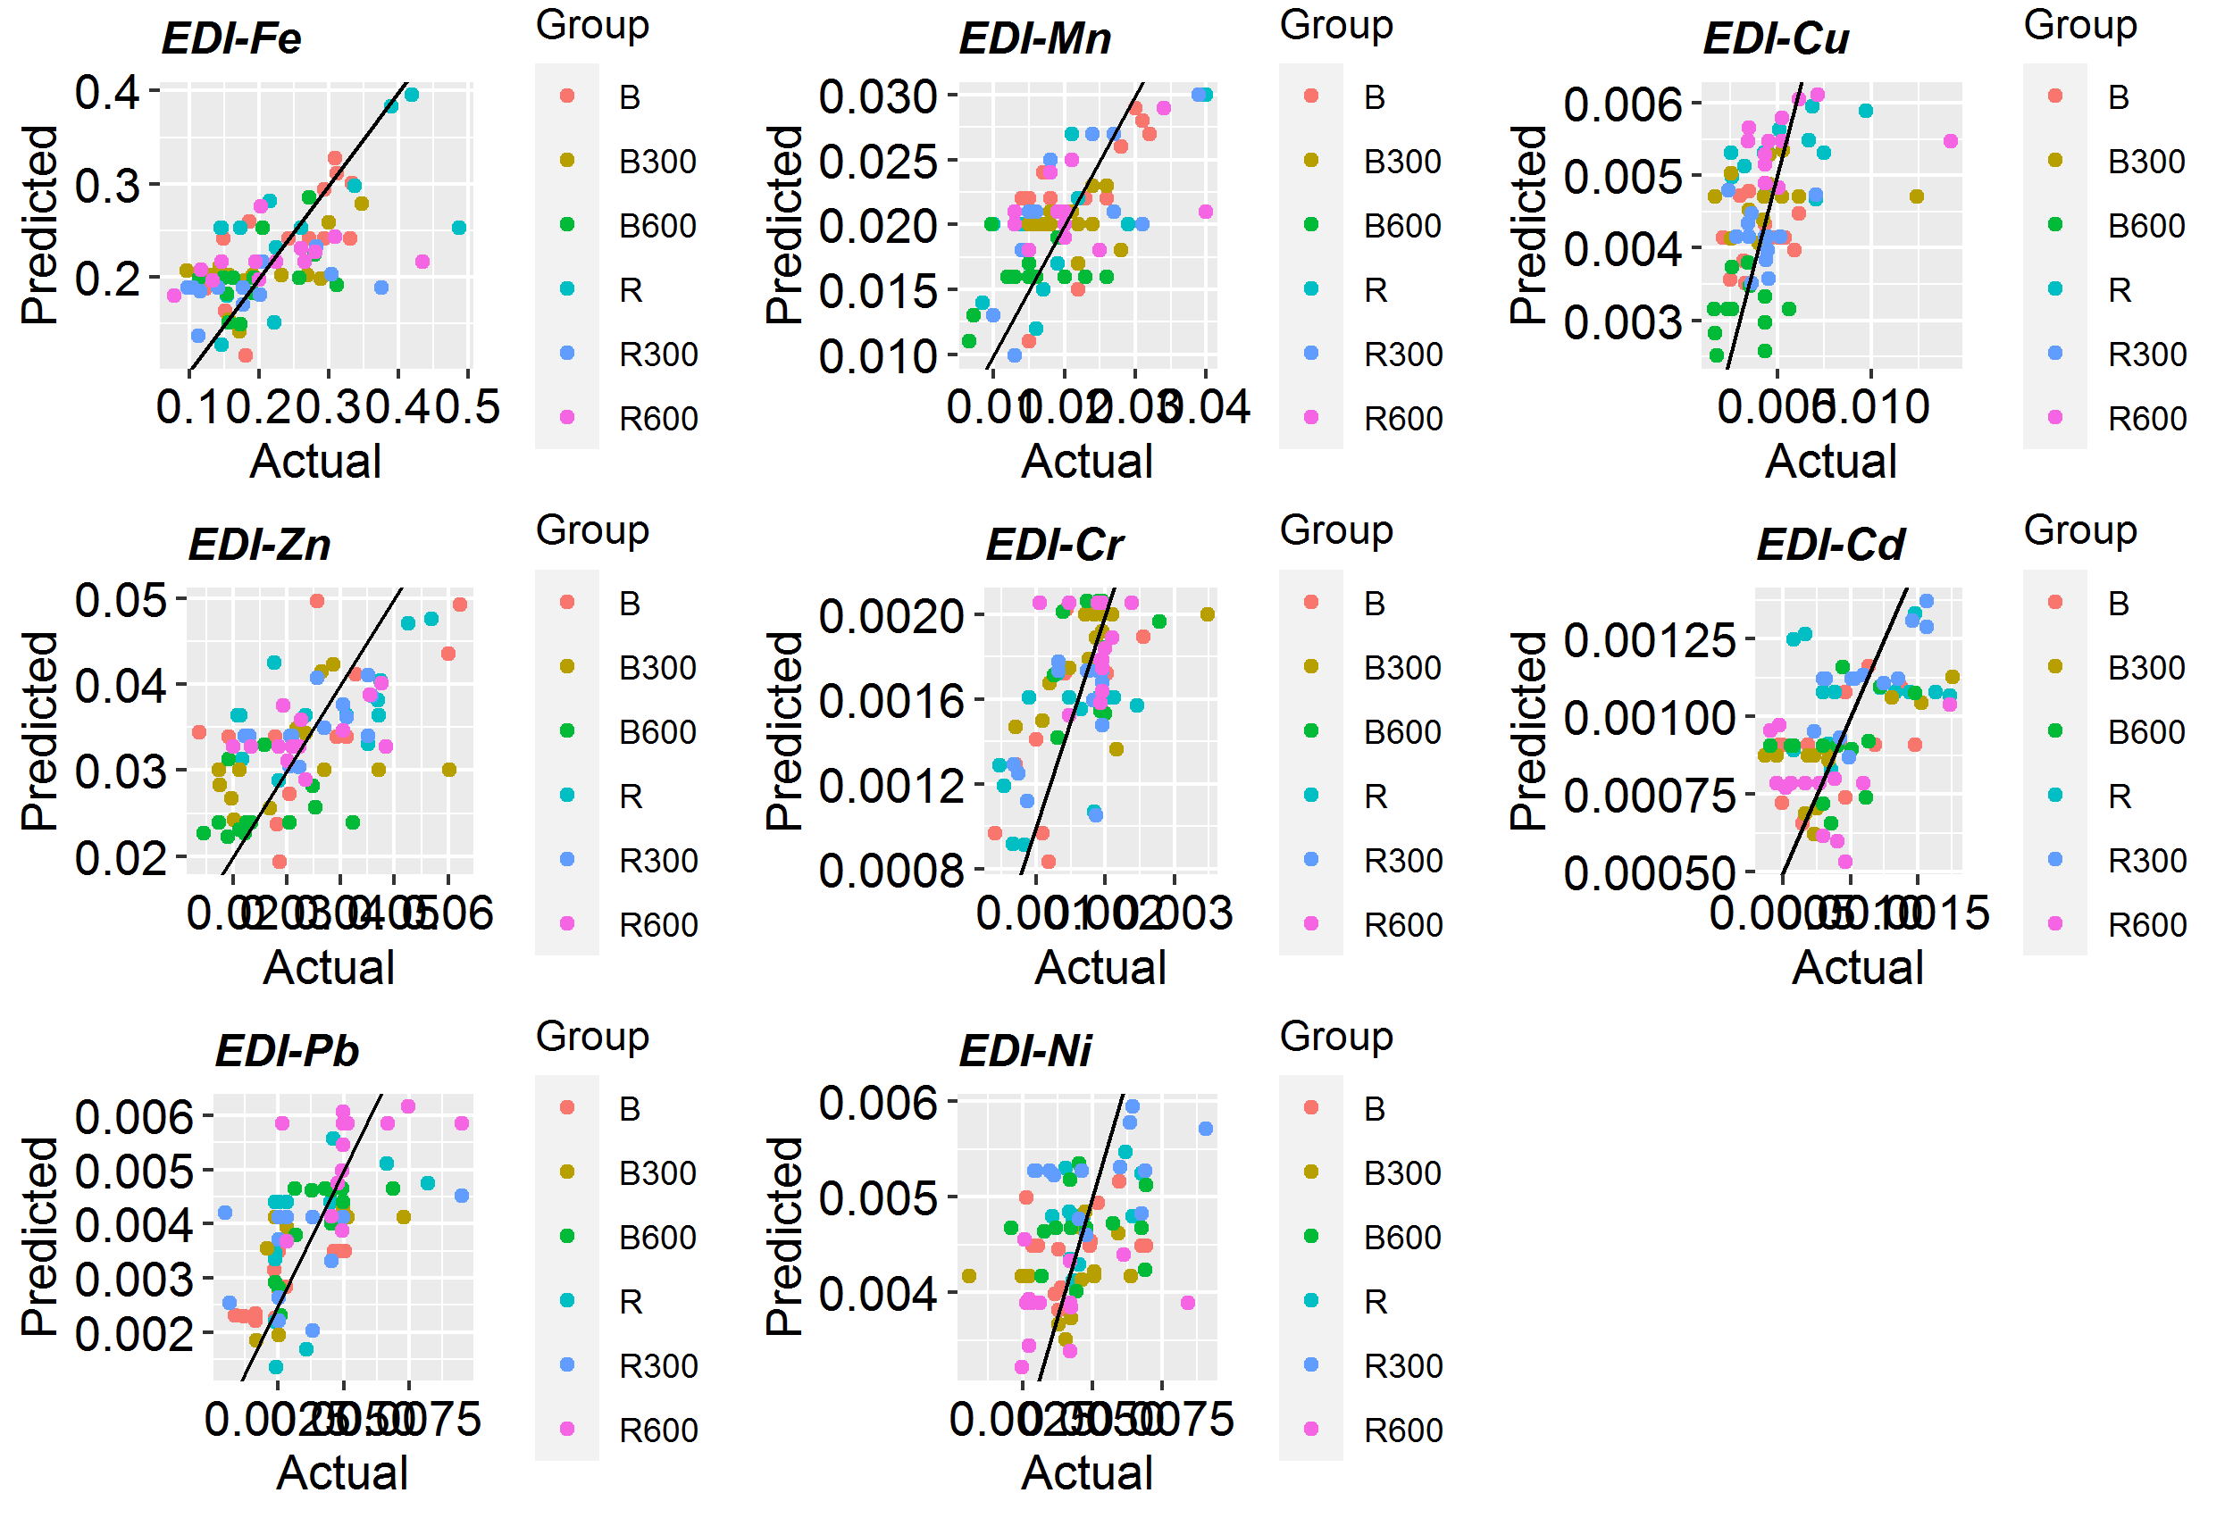Fig. S1. Predicted vs. observed regression scatter plots along with 1:1 corresponding lines for EDI-HMs.

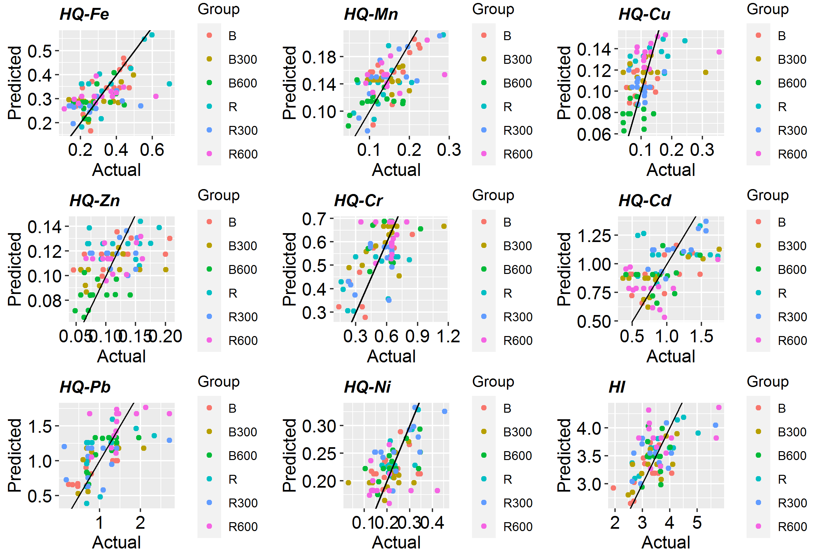Fig. S2. Predicted vs. observed regression scatter plots along with 1:1 corresponding lines for HQ-HMs and HI.

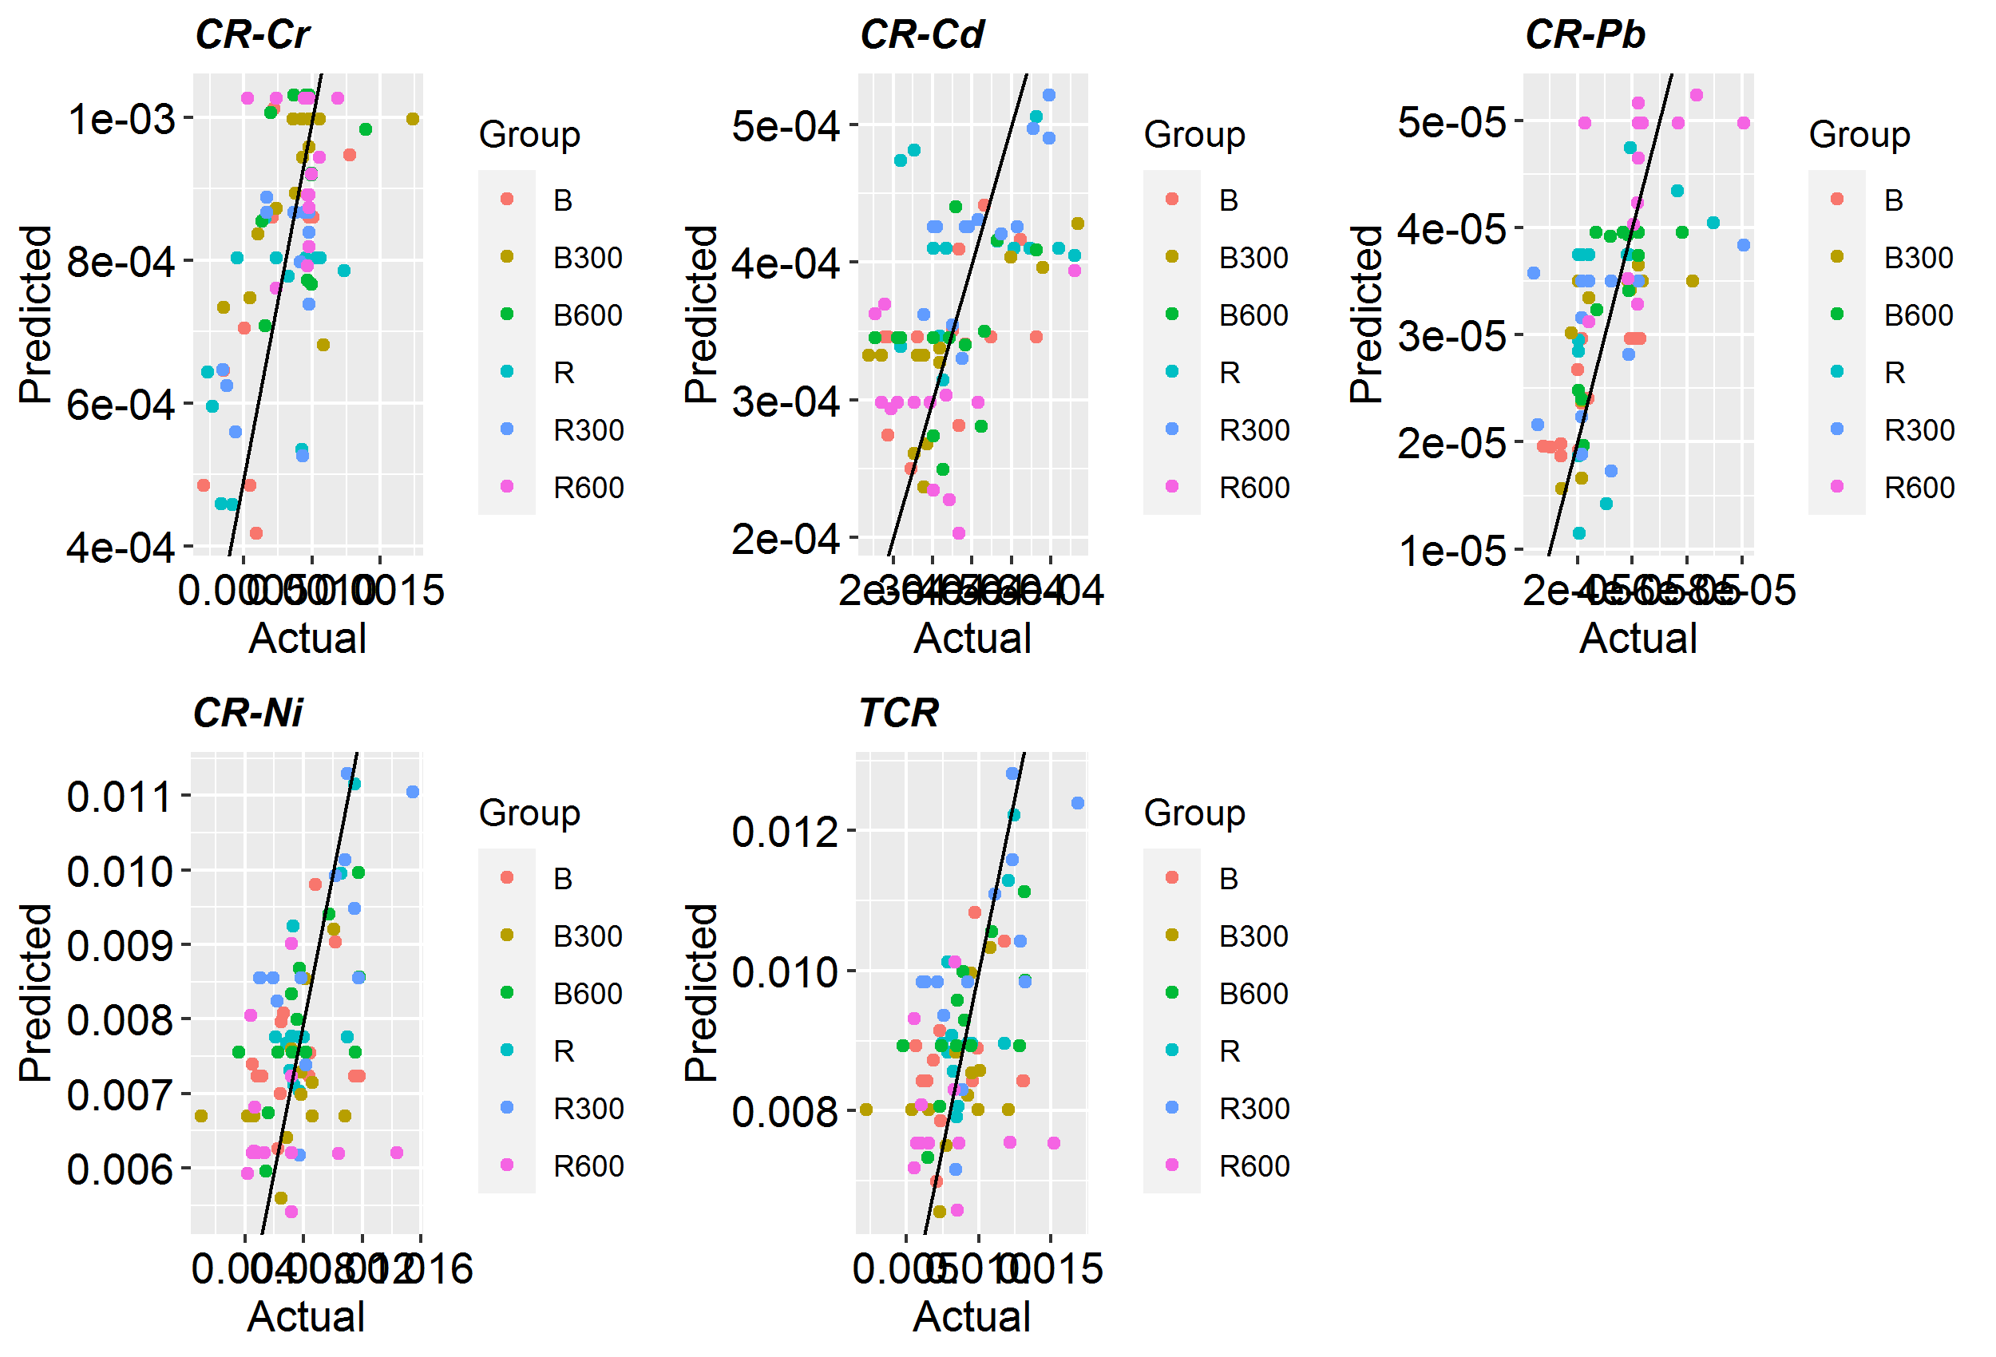Fig. S3. Predicted vs. observed regression scatter plots along with 1:1 corresponding lines for CR-HMs and TCR.

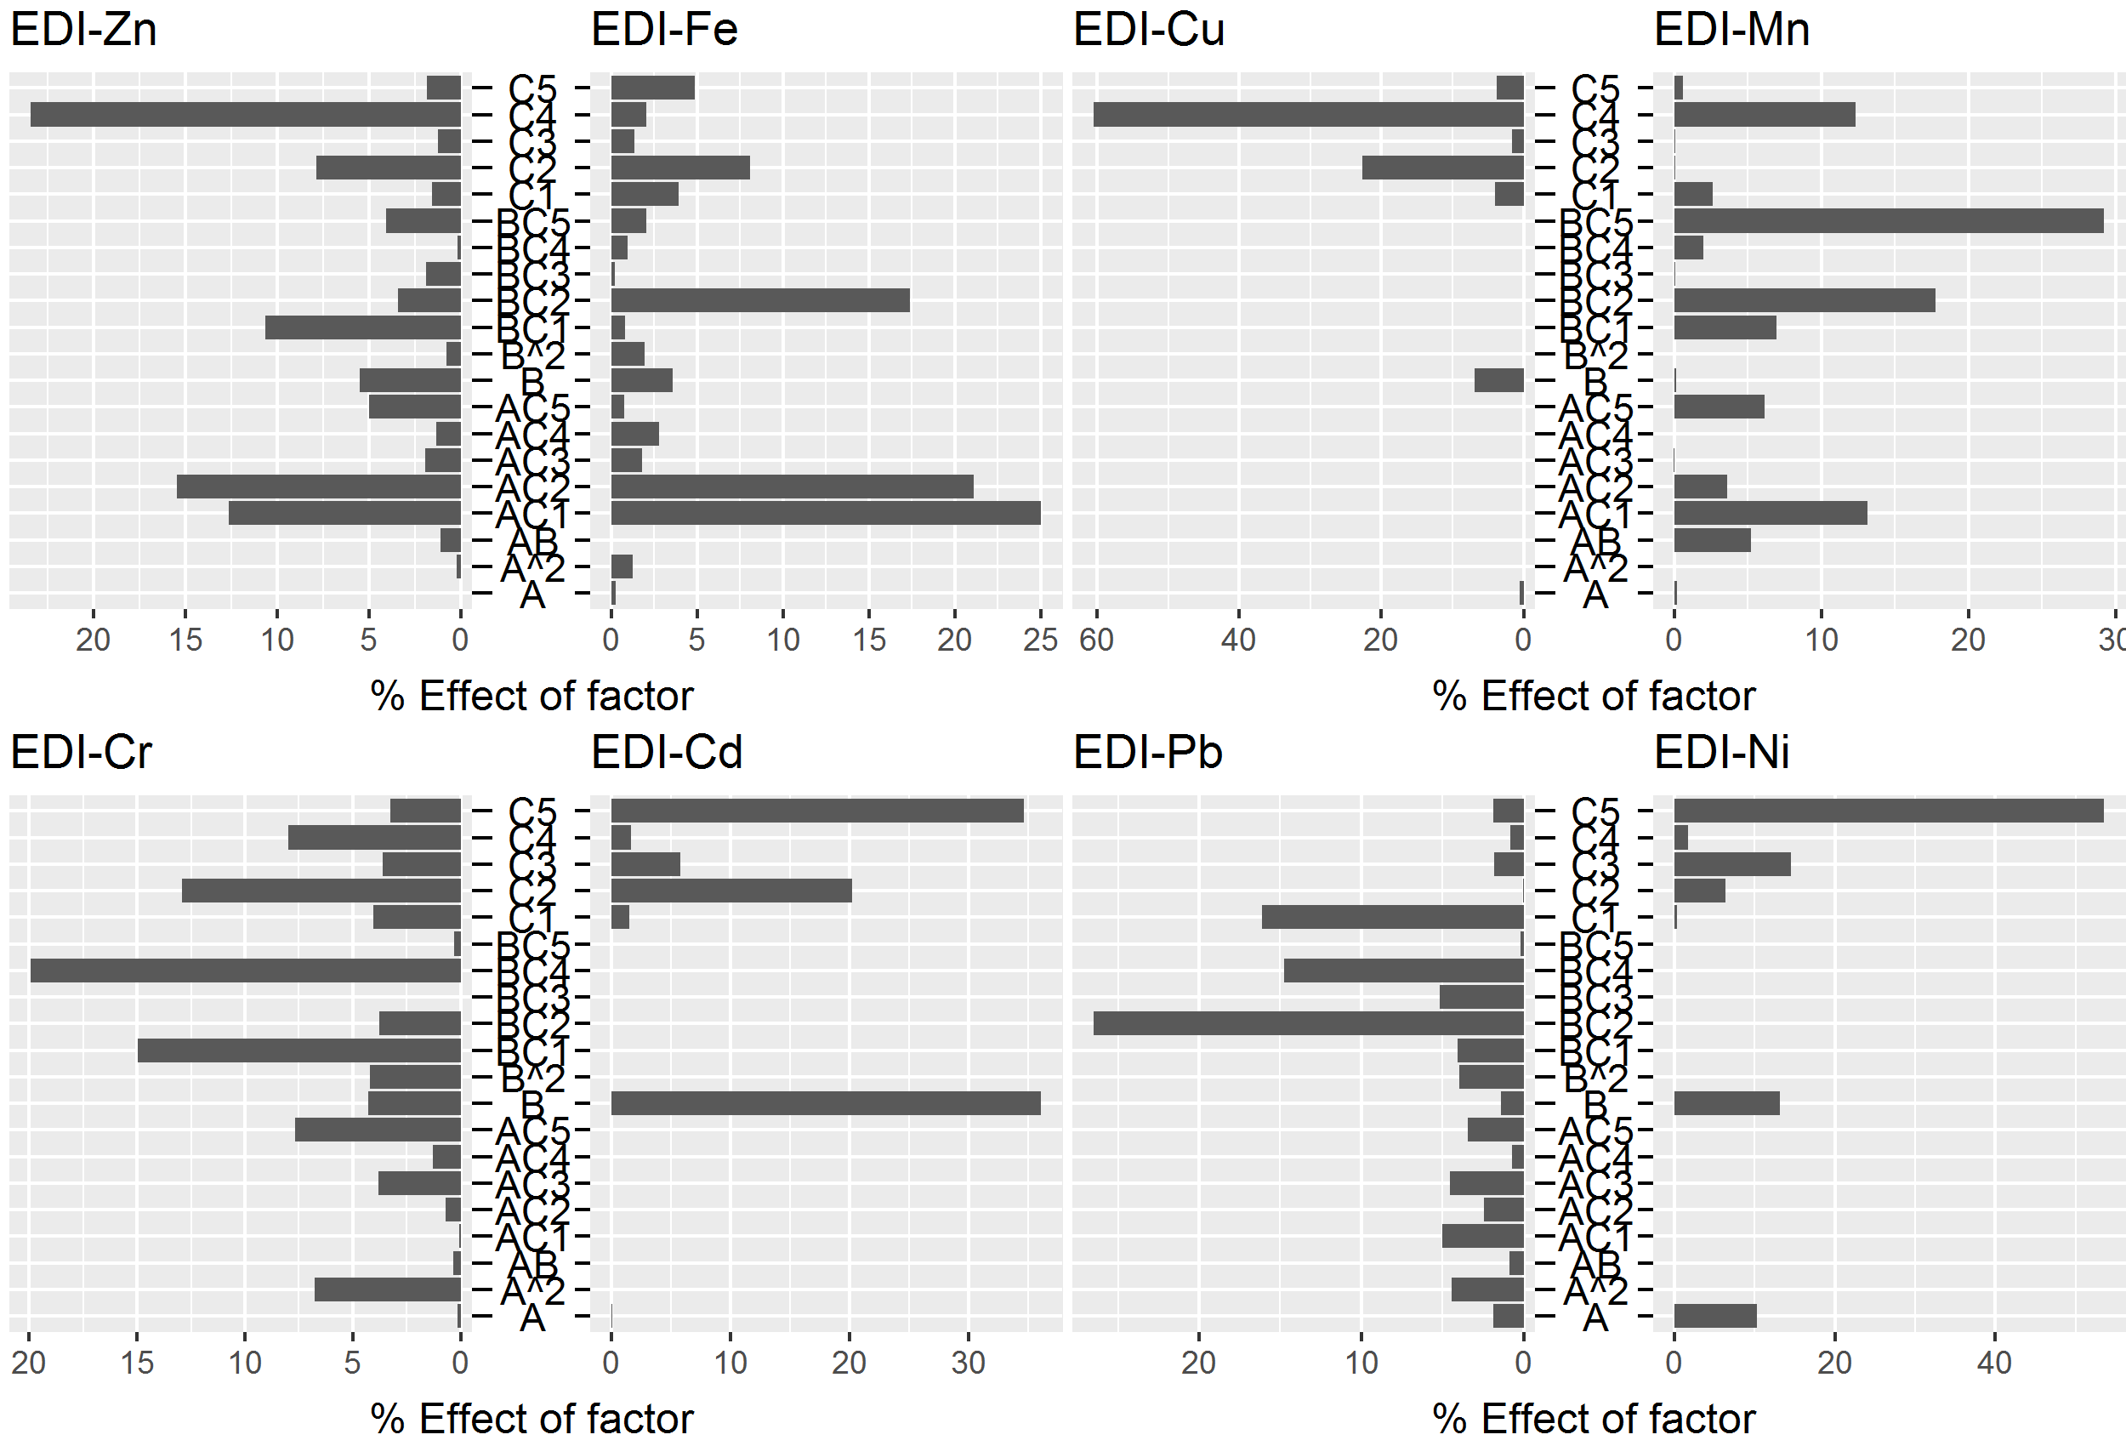
Fig. S4. Pareto chart presenting percent contribution of application rate (A), humic acid concentration (B), and biomass/biochar type (C) to percent EDI-HMs.

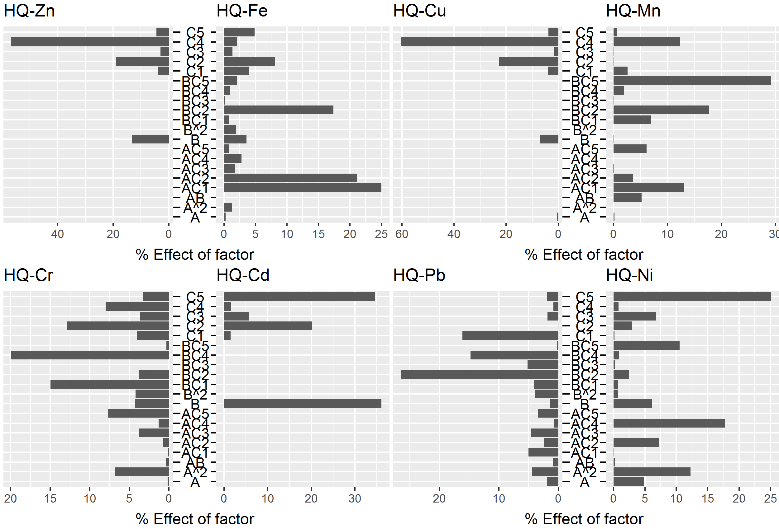
Fig. S5. Pareto chart presenting percent contribution of application rate (A), humic acid concentration (B), and biomass/biochar type (C) to percent HQ-HMs.

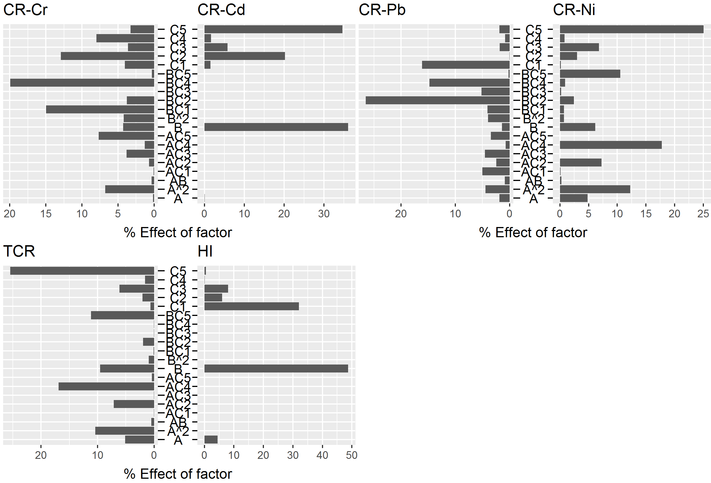
Fig. S6. Pareto chart presenting percent contribution of application rate (A), humic acid concentration (B), and biomass/biochar type (C) to percent CR-HMs, TCR and HI.

(a) | (b)
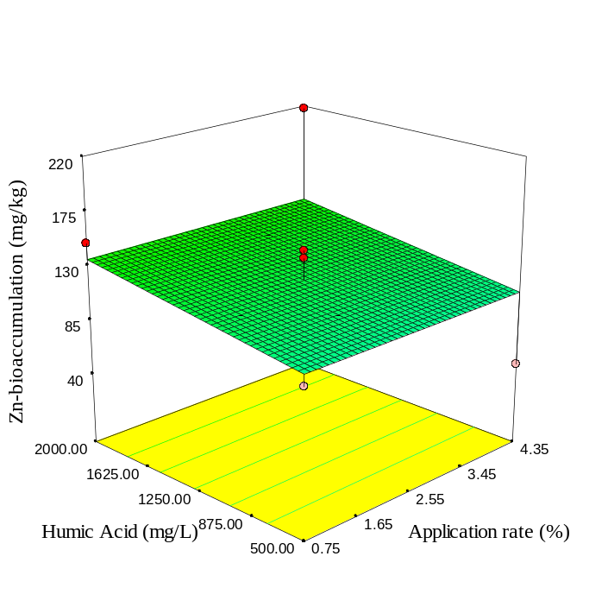 | 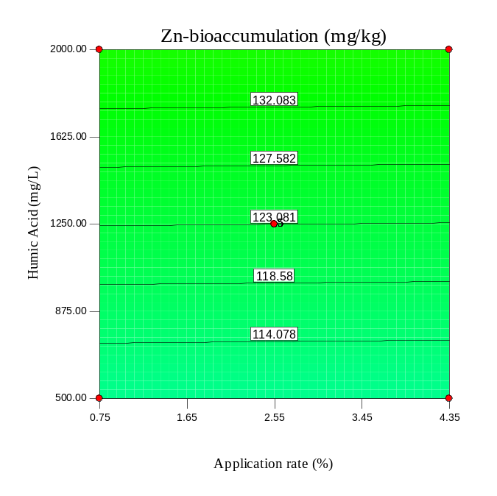
(c) | (d)
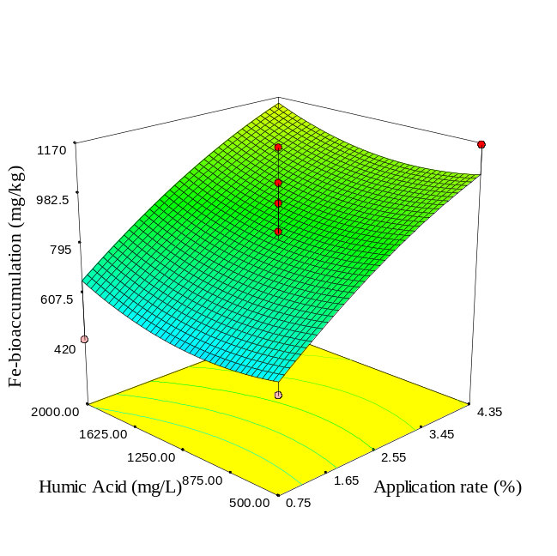 | 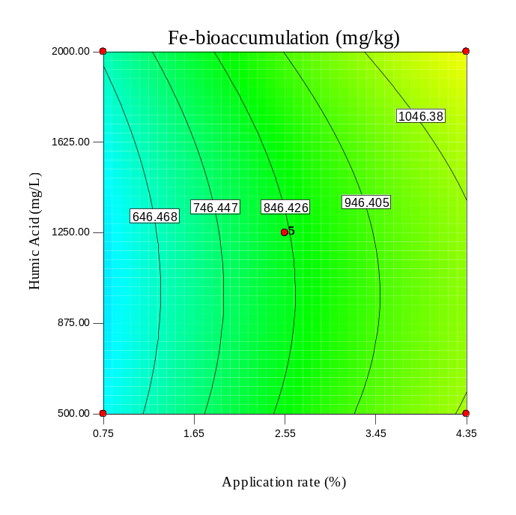
Fig. S7. 3D surface and contour plots of Zn- and Fe-bioaccumulation in spinach leaves affected by humic acid concentration and SBB application rate.

(a) | (b)
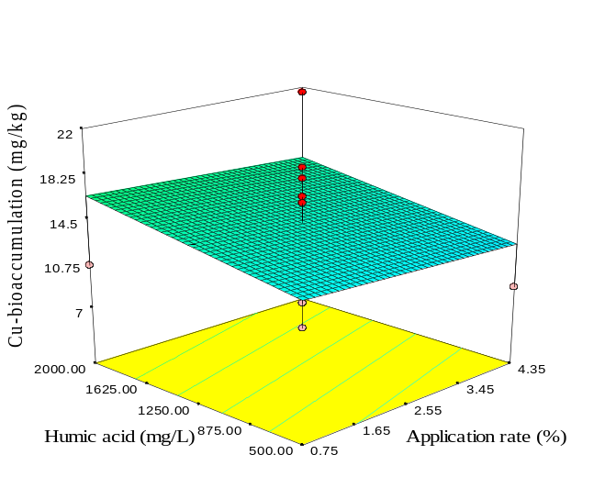 | 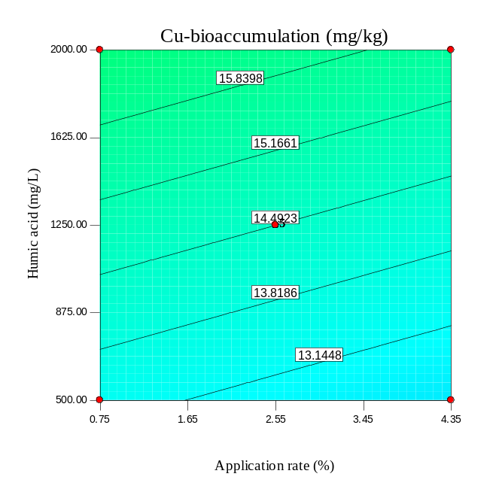
(c) | (d)
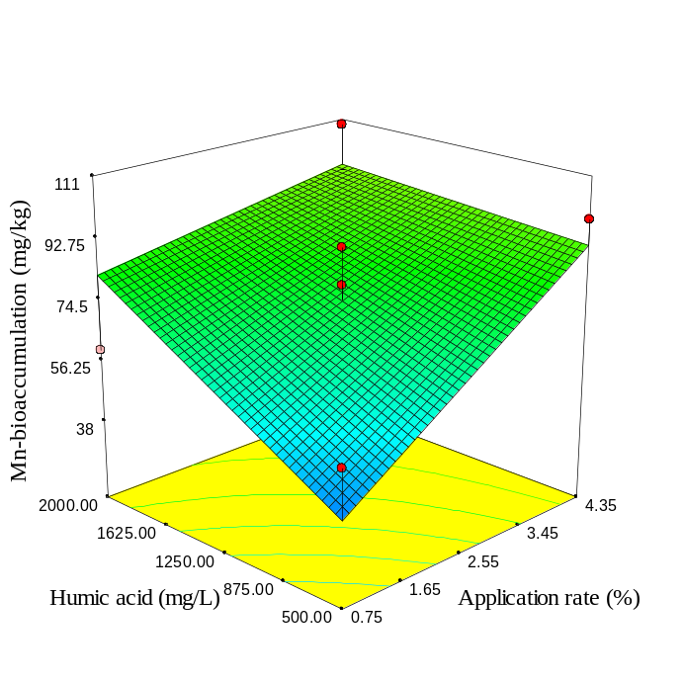 | 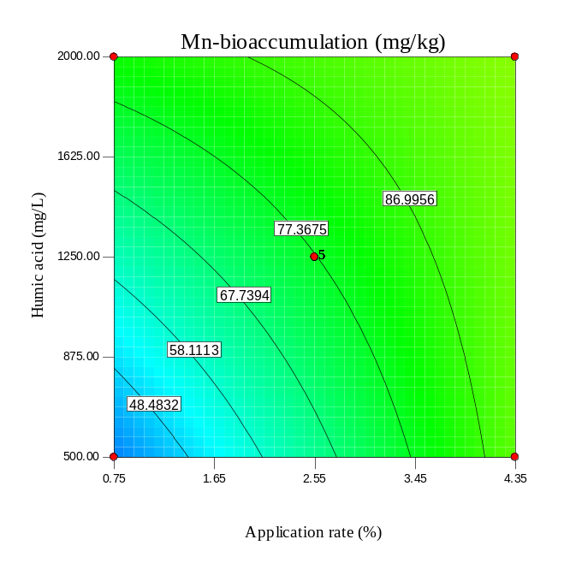
Fig. S8. 3D surface and contour plots of Cu- and Mn-bioaccumulation in spinach leaves affected by humic acid concentration and SBB application rate.

(a) | (b)
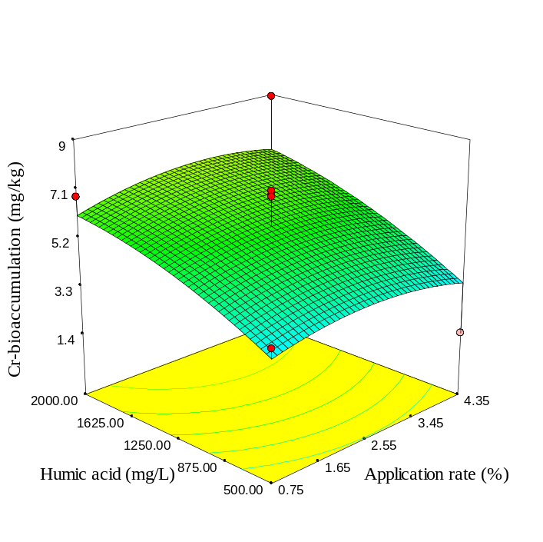 | 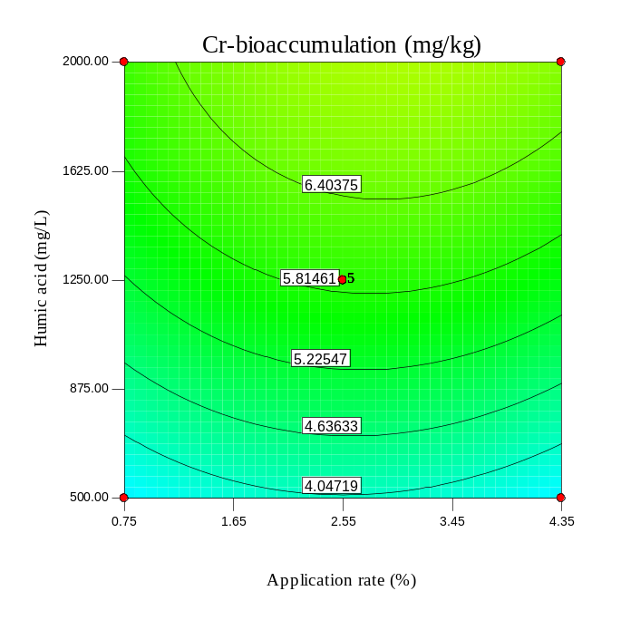
(c) | (d)
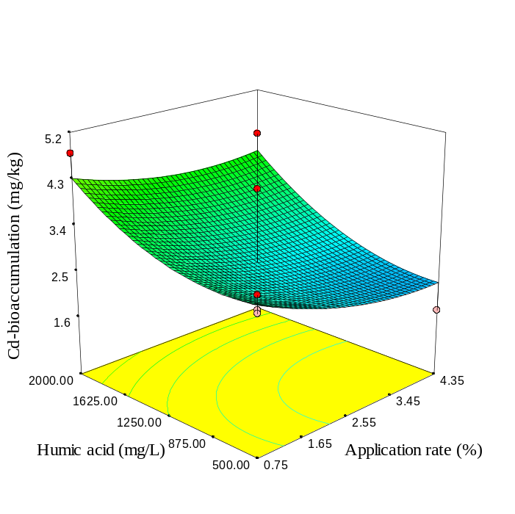 | 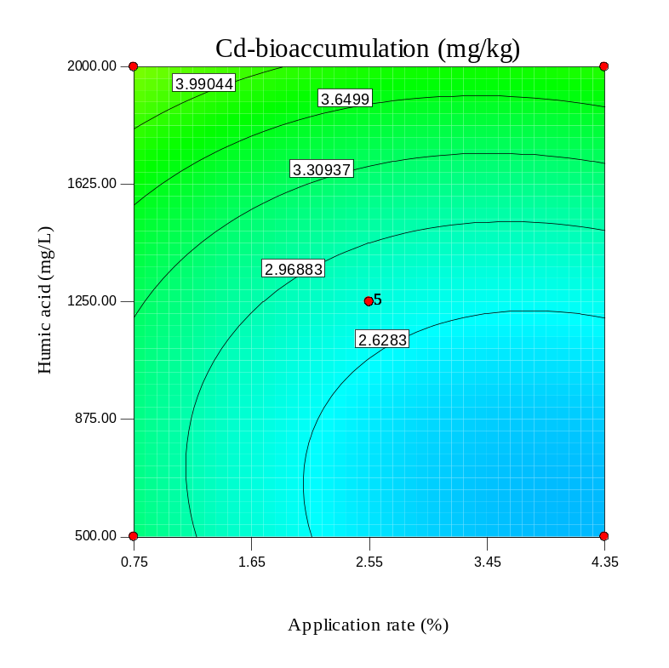
Fig. S9. 3D surface and contour plots of Cr- and Cd-bioaccumulation in spinach leaves affected by humic acid concentration and SBB application rate.

(a) | (b)
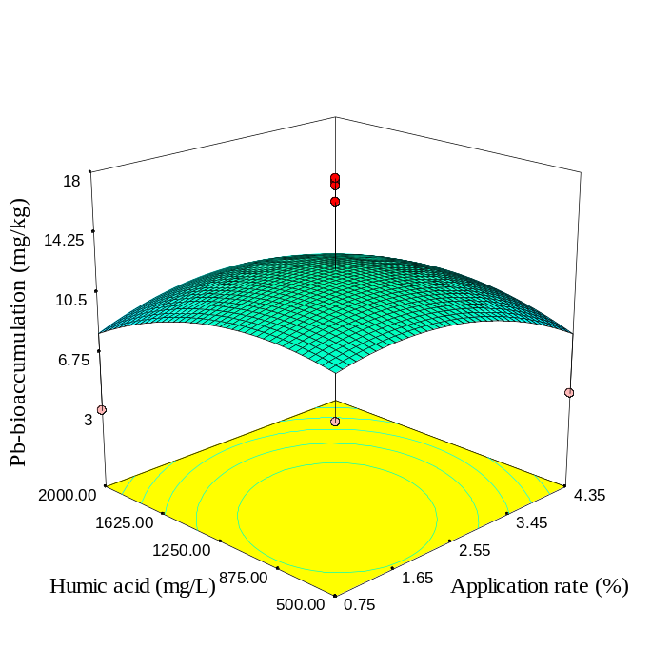 | 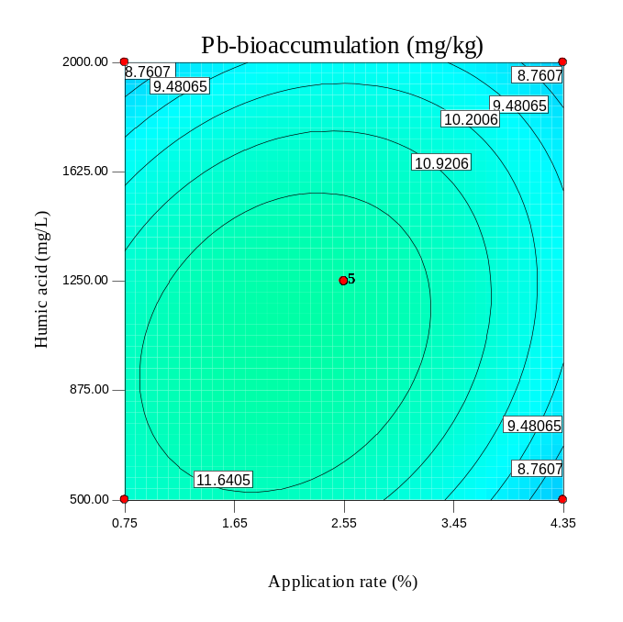
(c) | (d)
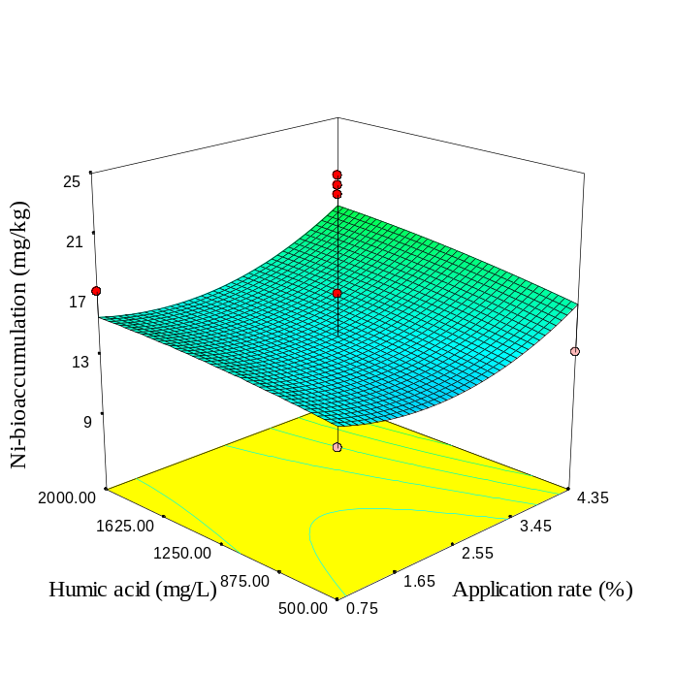 | 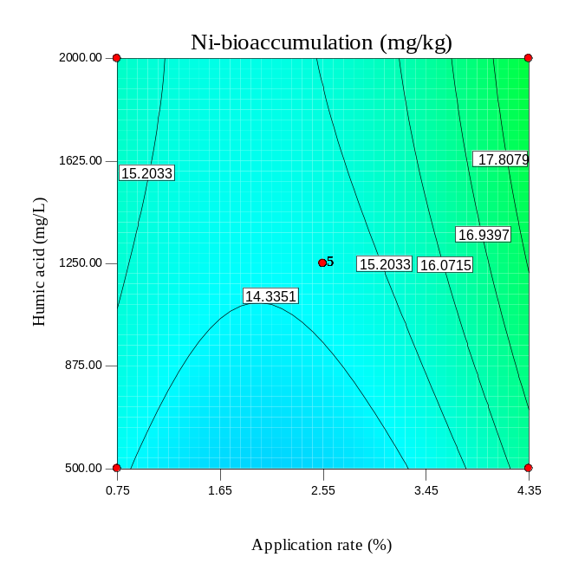
Fig. S10. 3D surface and contour plots of Pb- and Ni-bioaccumulation in spinach leaves affected by humic acid concentration and SBB application rate.

(a) | (b)
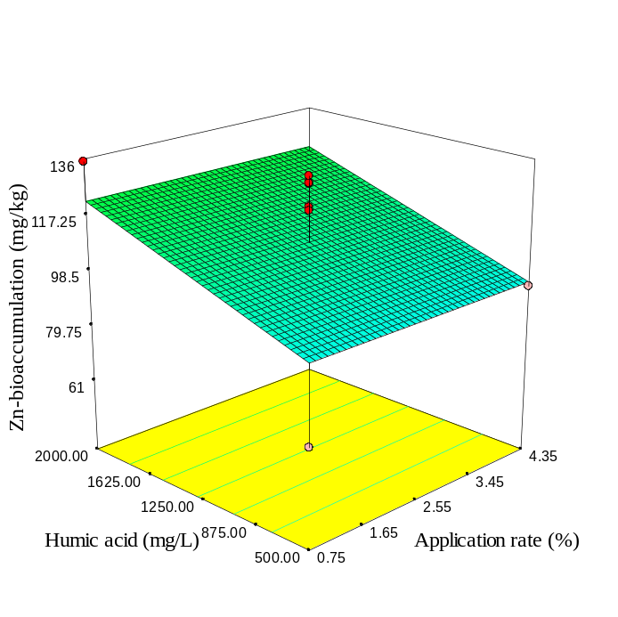 | 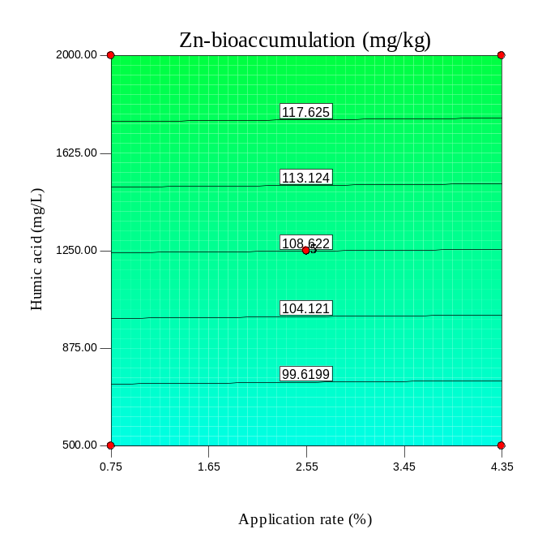
(c) | (d)
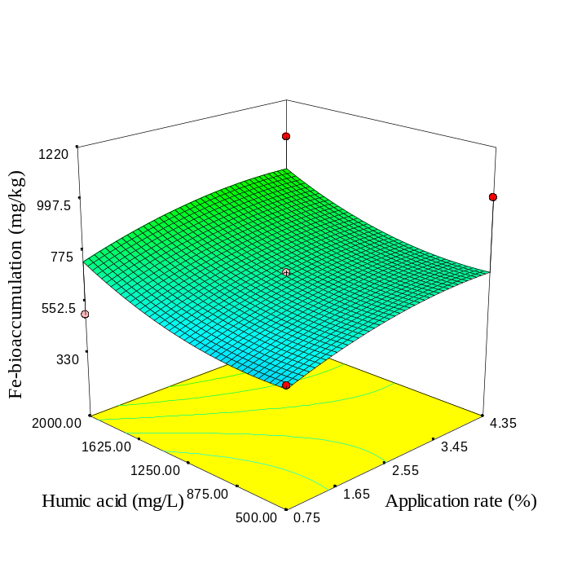 | 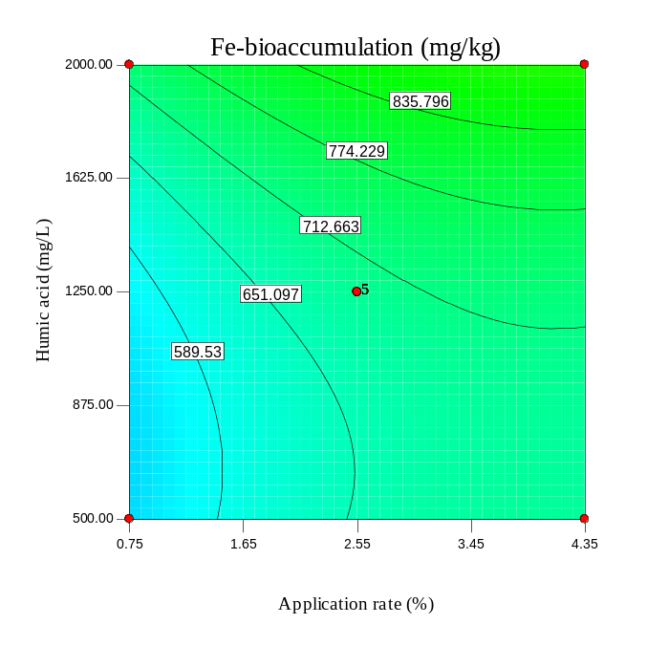
Fig. S11. As Fig. S7 but for SBP-300.

(a) | (b)
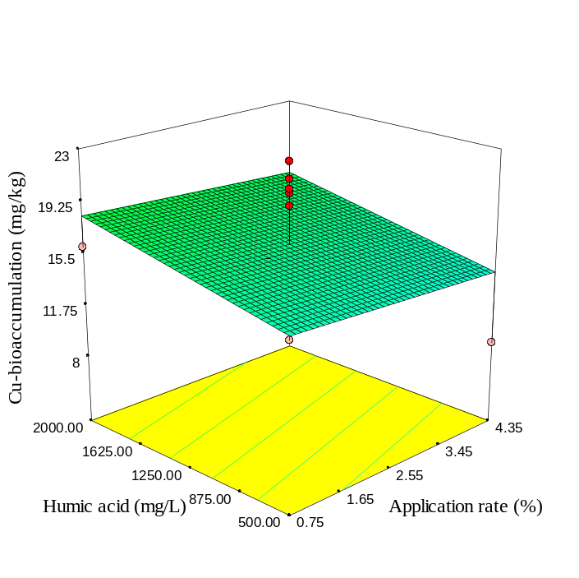 | 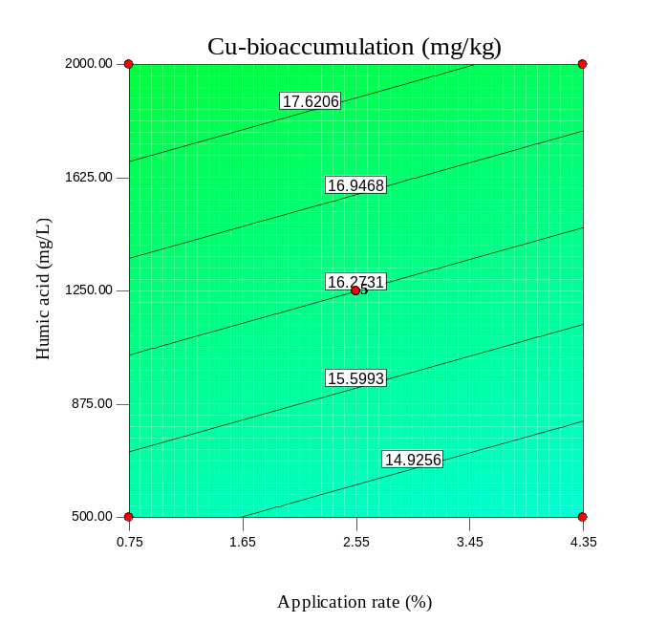
(c) | (d)
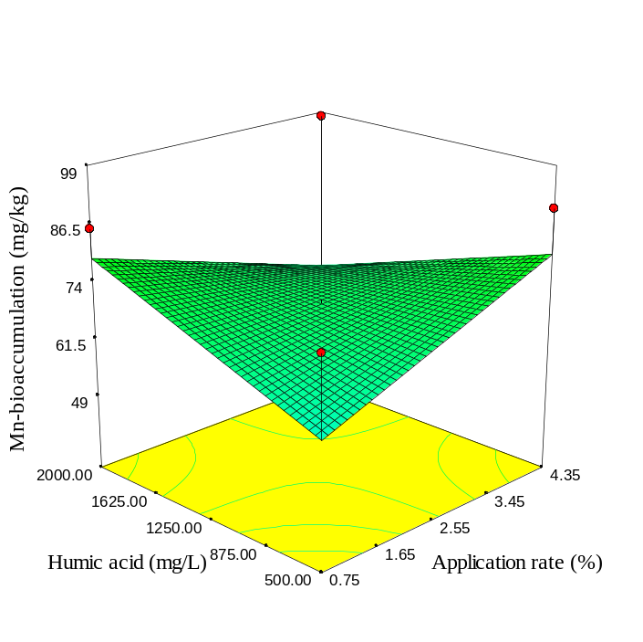 | 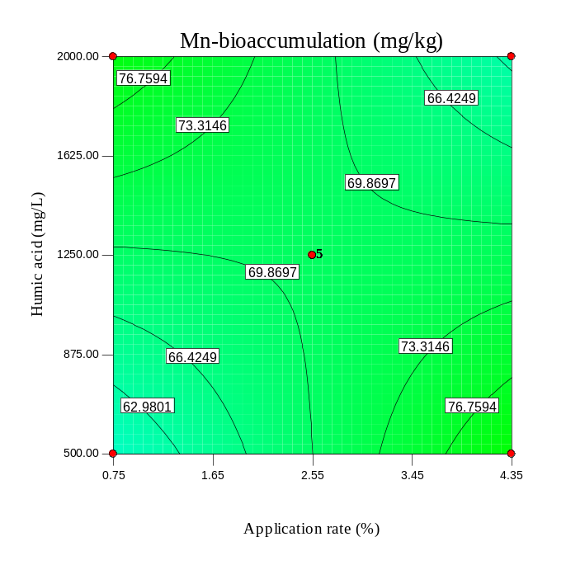
Fig. S12. As Fig. S8 but for SBP-300.

(a) | (b)
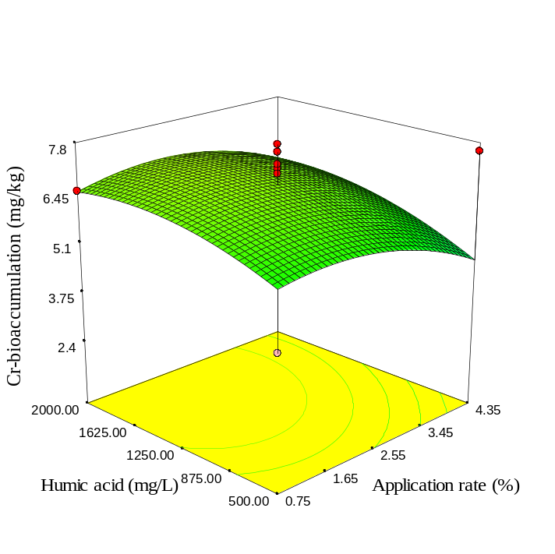 | 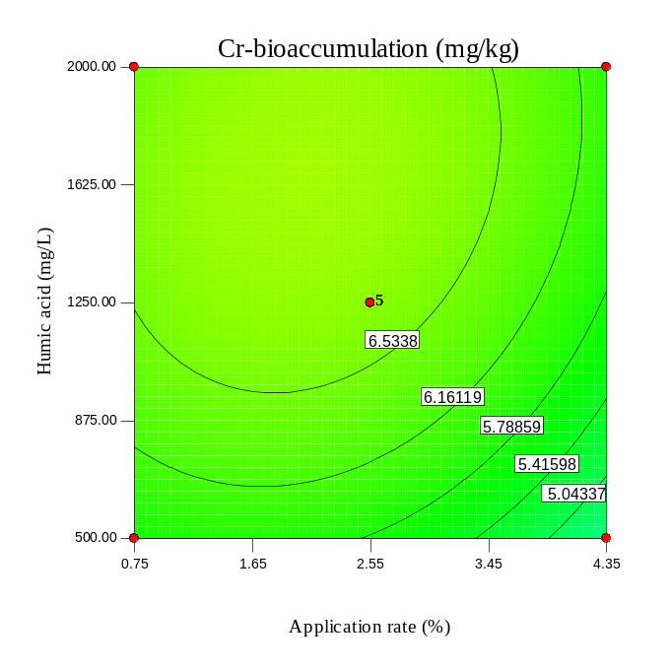
(c) | (d)
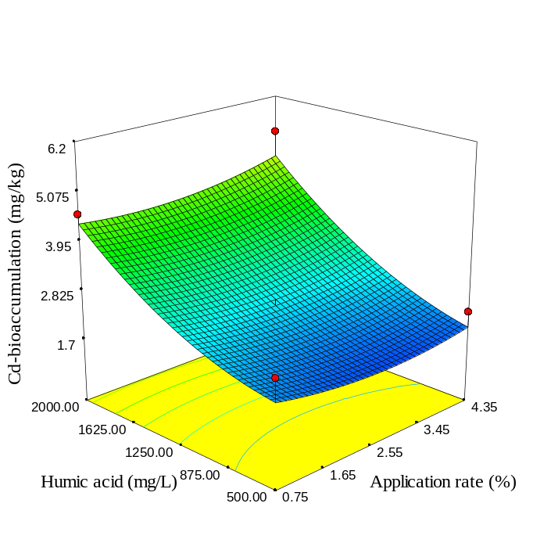 | 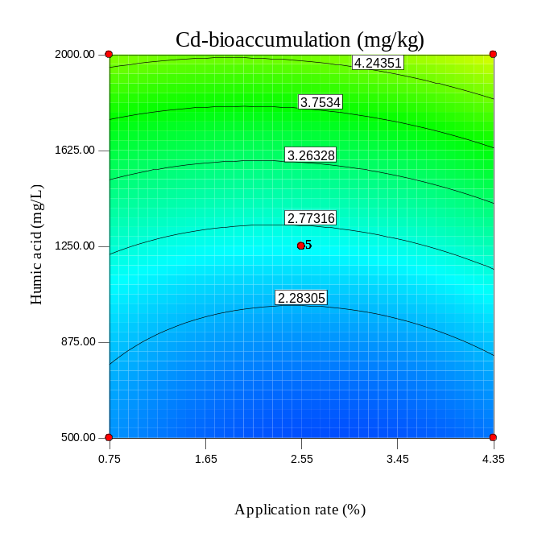
Fig. S13. As Fig. S9 but for SBP-300.

(a) | (b)
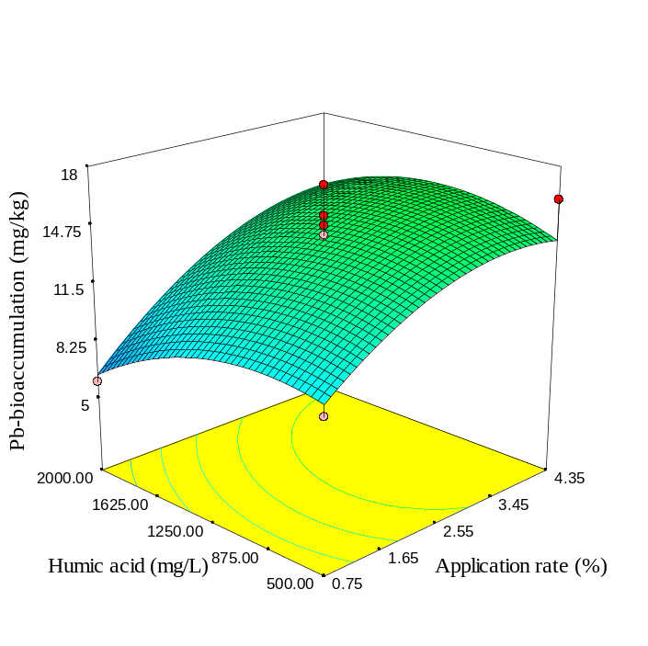 | 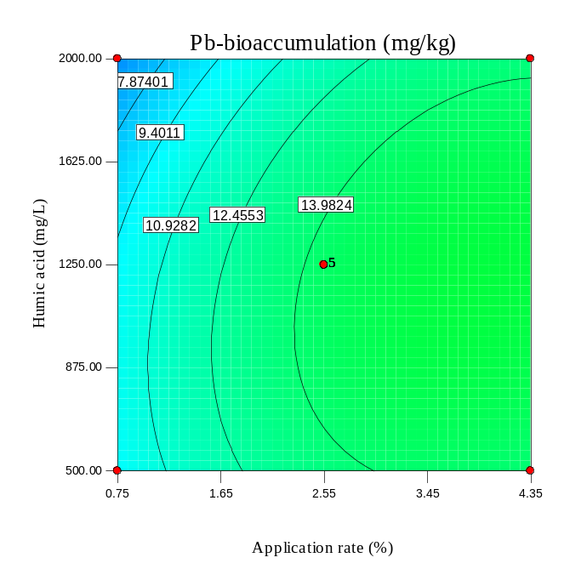
(c) | (d)
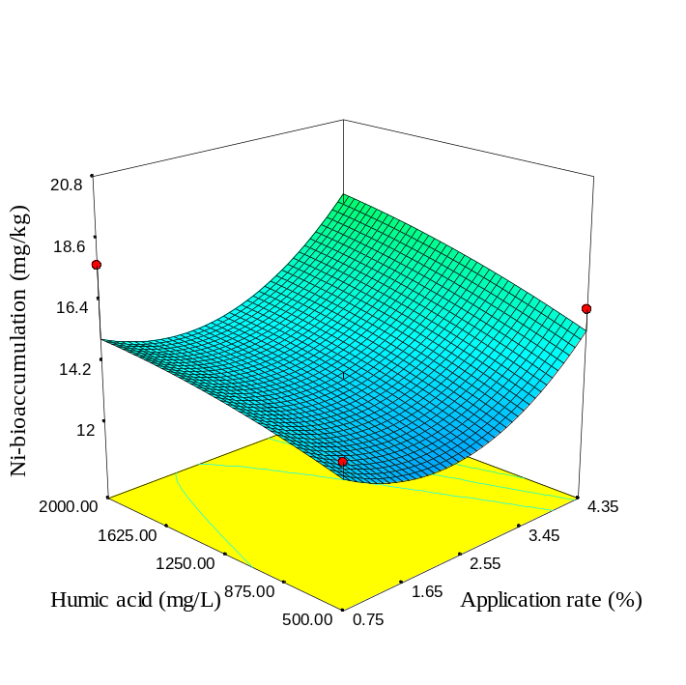 | 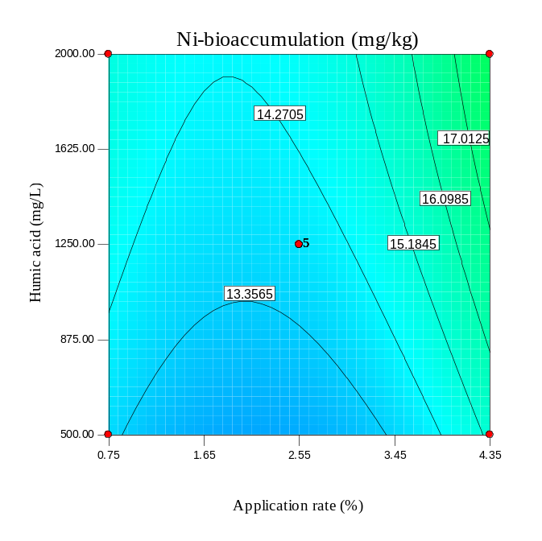
Fig. S14. As Fig. S10 but for SBP-300.

(a) | (b)
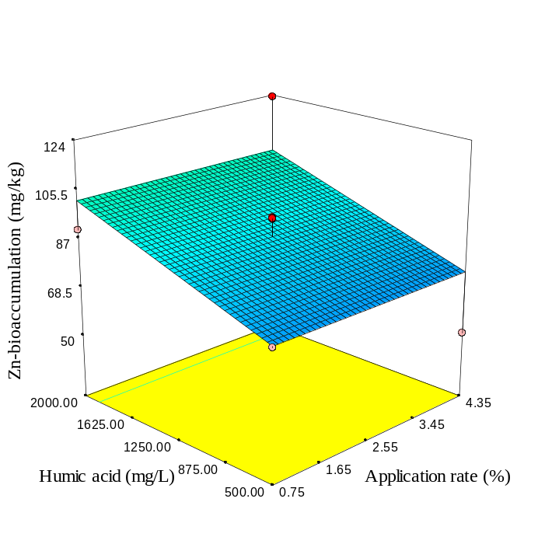 | 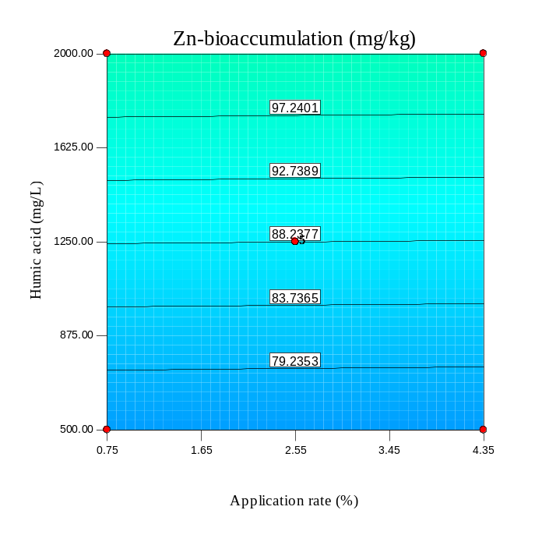
(c) | (d)
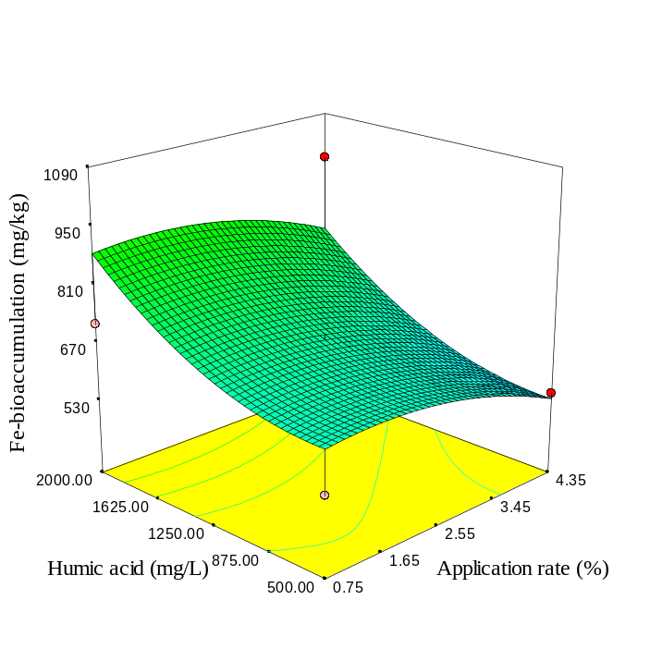 | 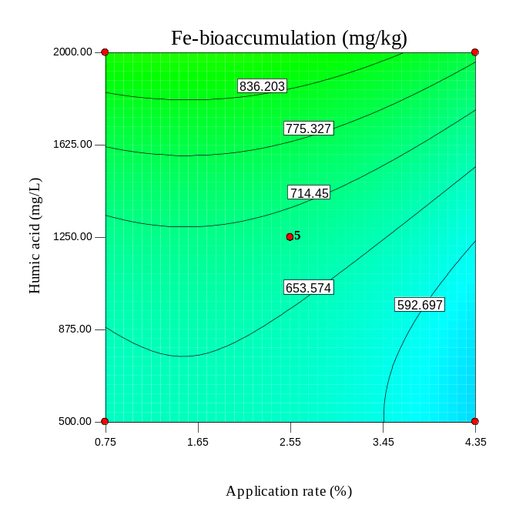
Fig. S14. As Fig. S7 but for SBP-600.

(a) | (b)
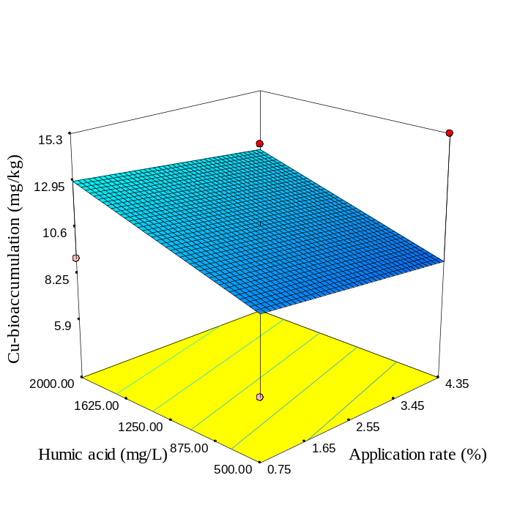 | 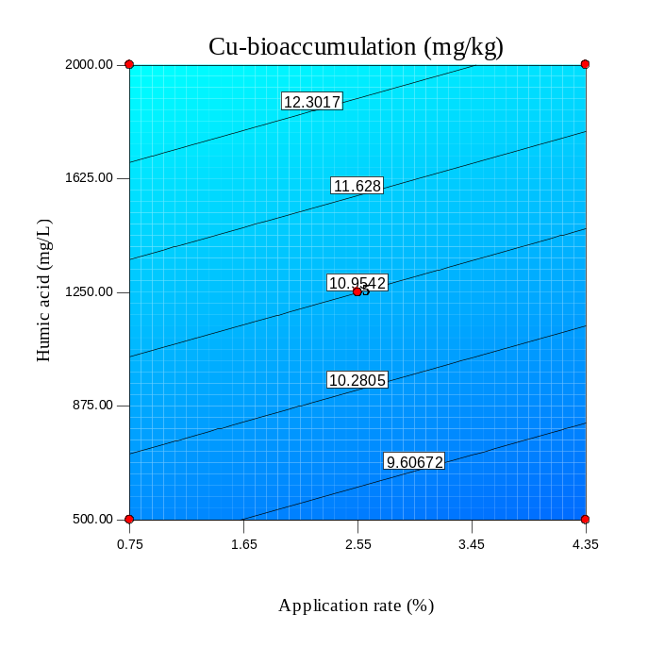
(c) | (d)
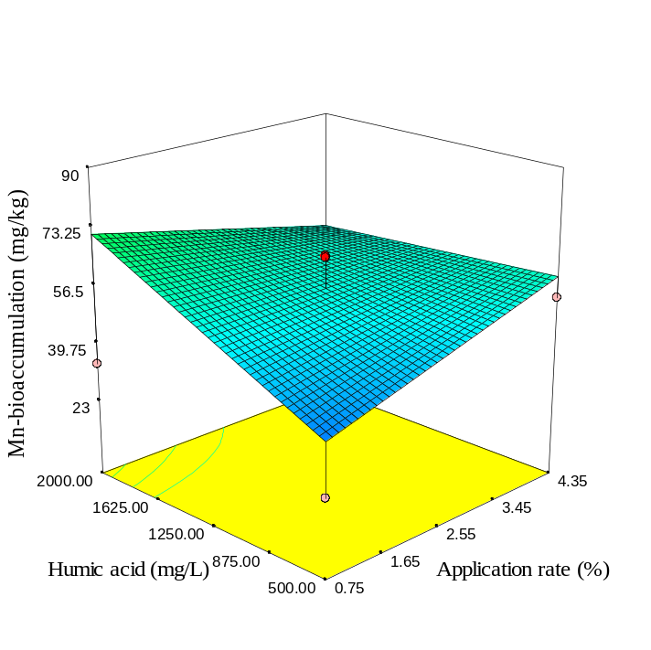 | 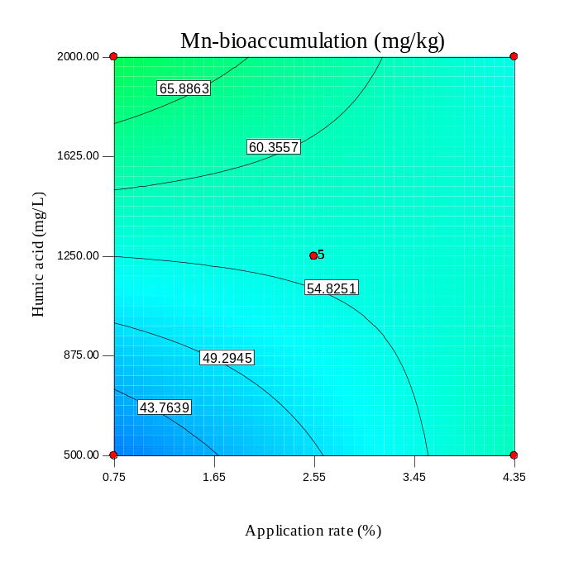
Fig. S15. As Fig. S8 but for SBP-600.

(a) | (b)
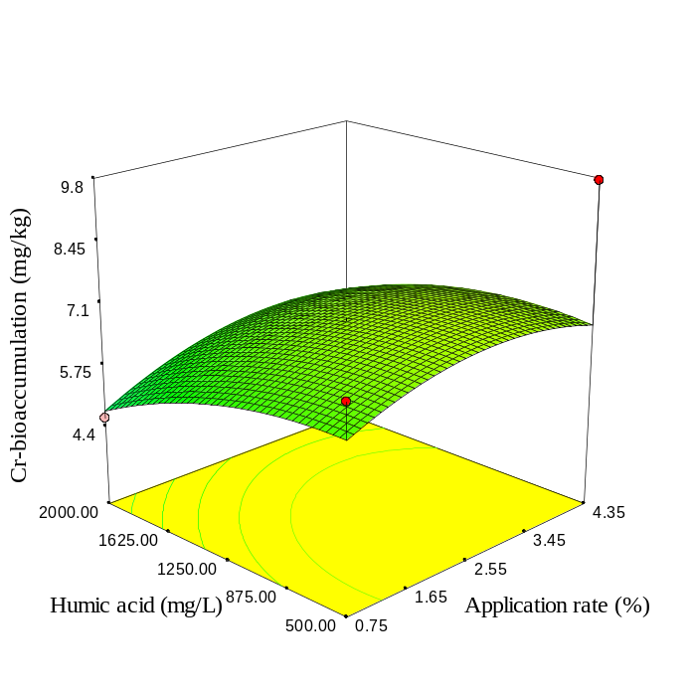 | 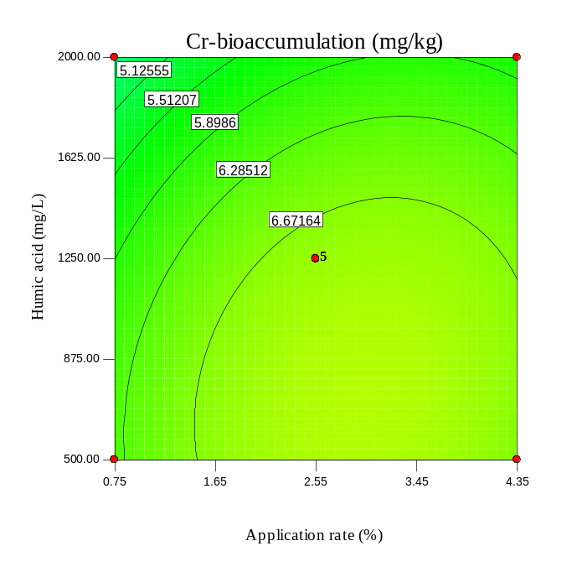
(c) | (d)
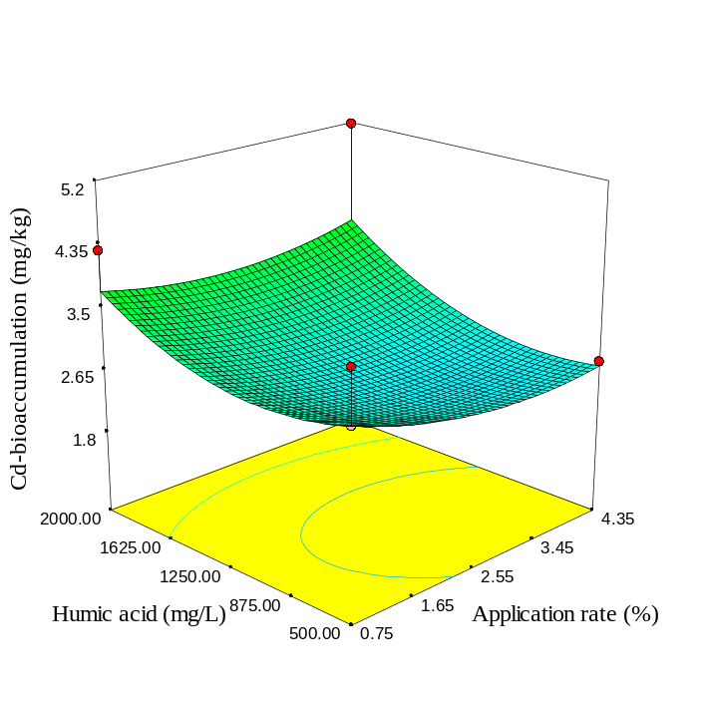 | 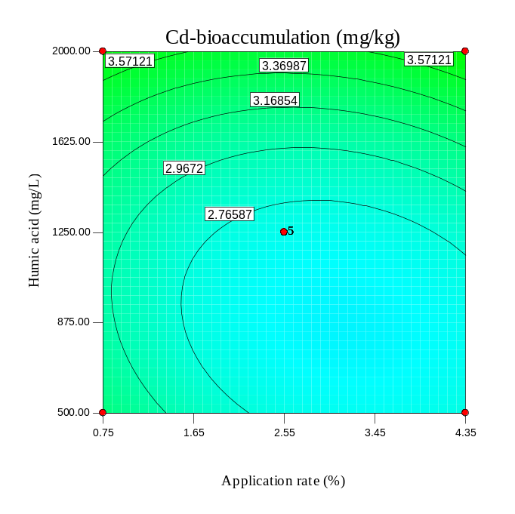
Fig. S16. As Fig. S9 but for SBP-600.

(a) | (b)
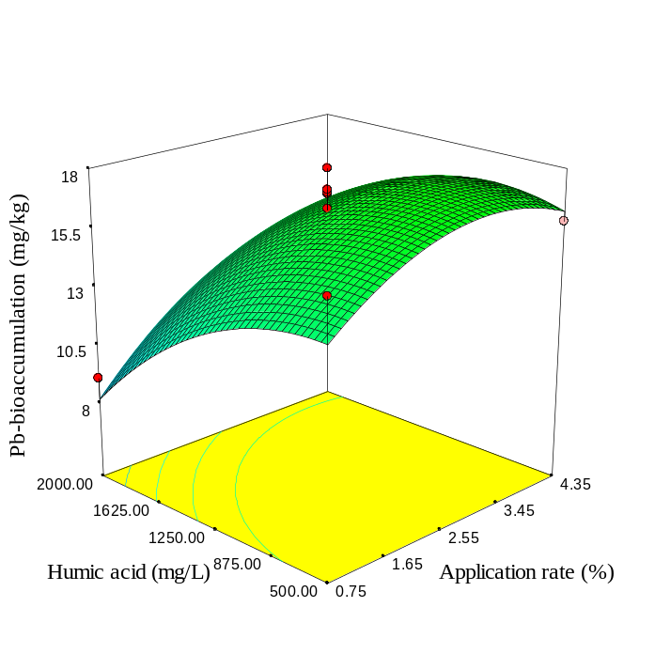 | 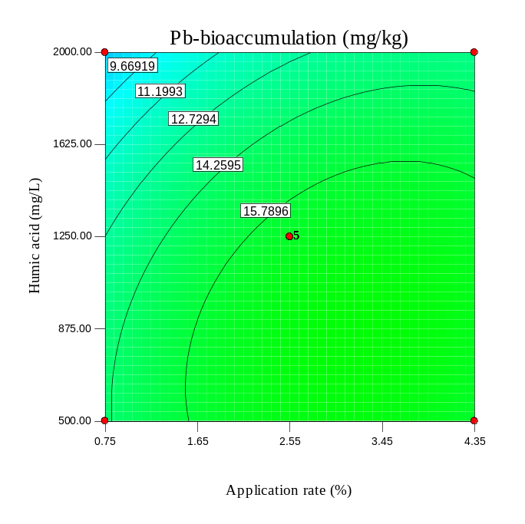
(c) | (d)
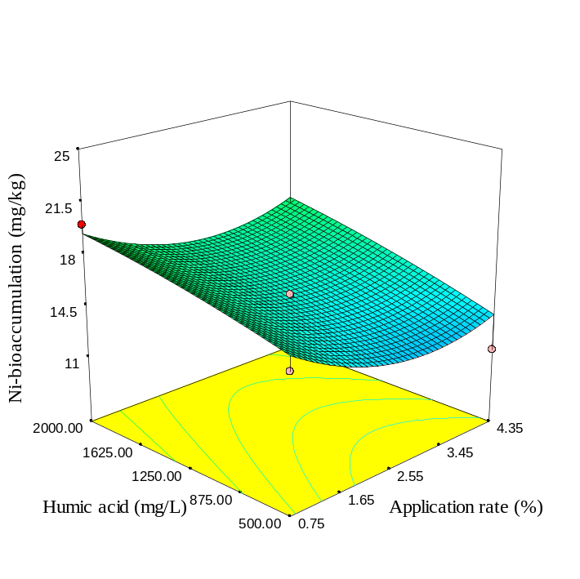 | 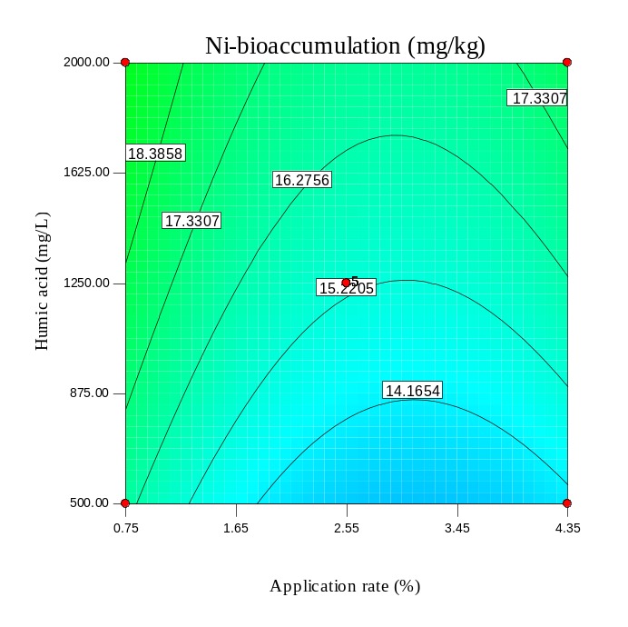
Fig. S17. As Fig. S10 but for SBP-600.

(a) | (b)
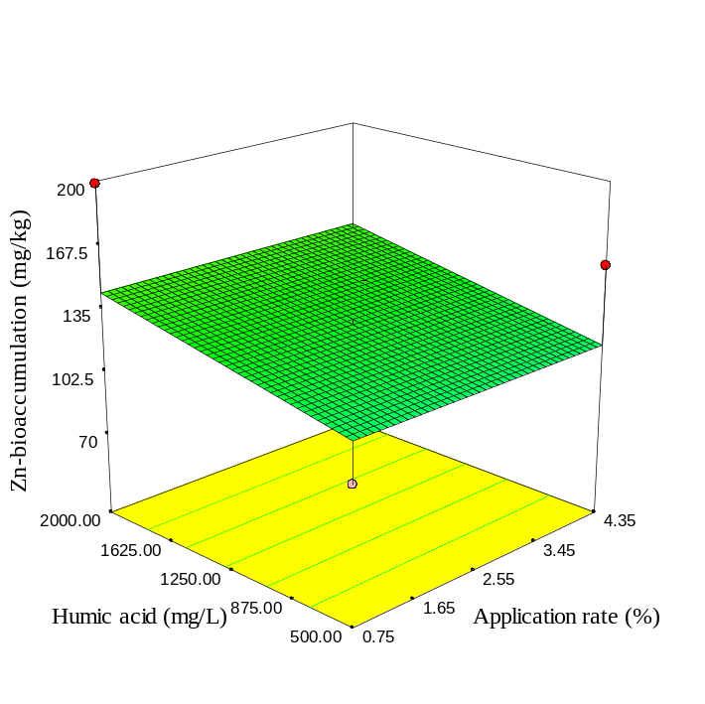 | 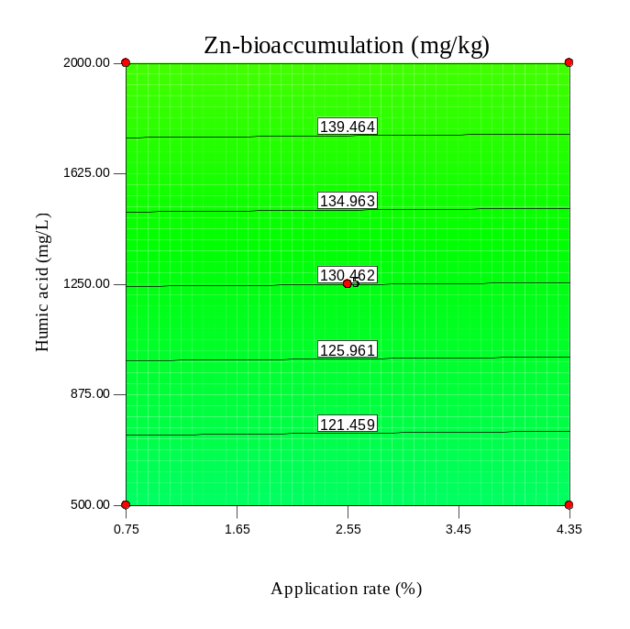
(c) | (d)
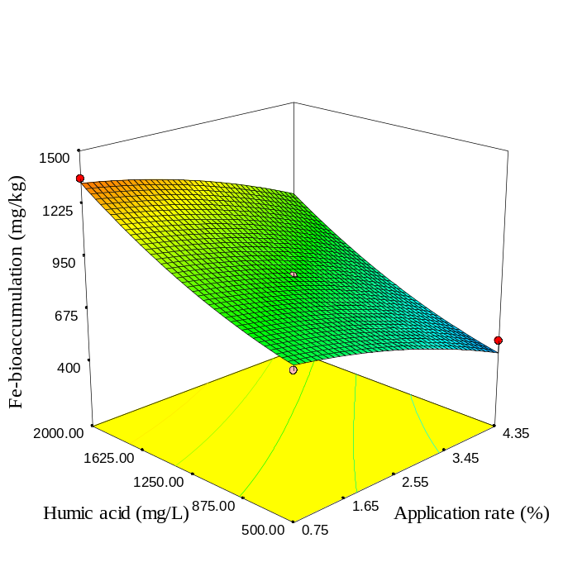 | 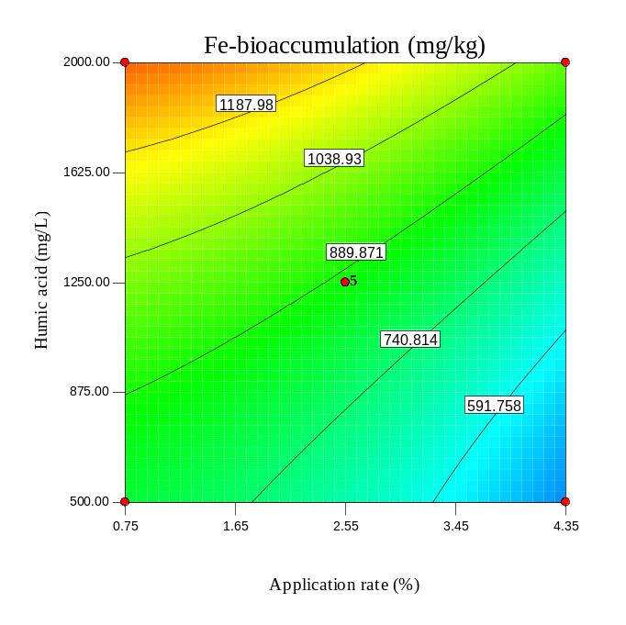
Fig. S18. As Fig. S7 but for RH.

(a) | (b)
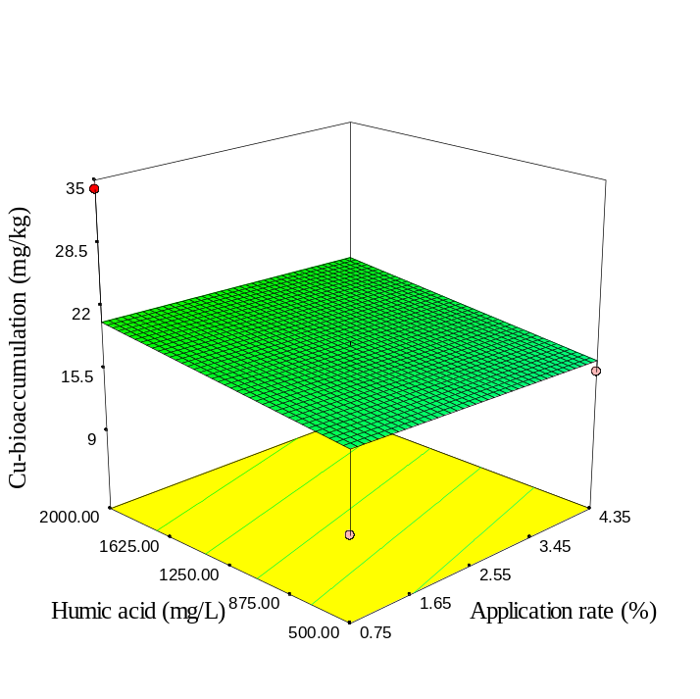 | 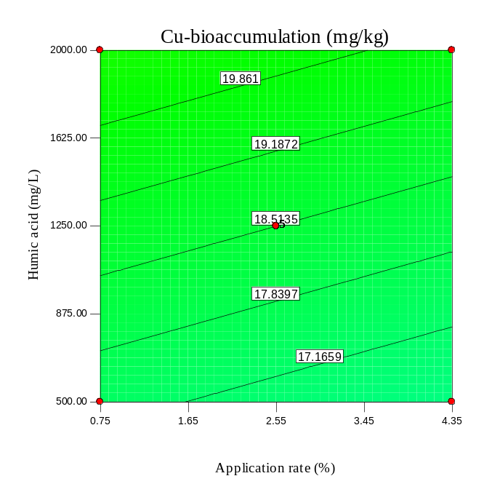
(c) | (d)
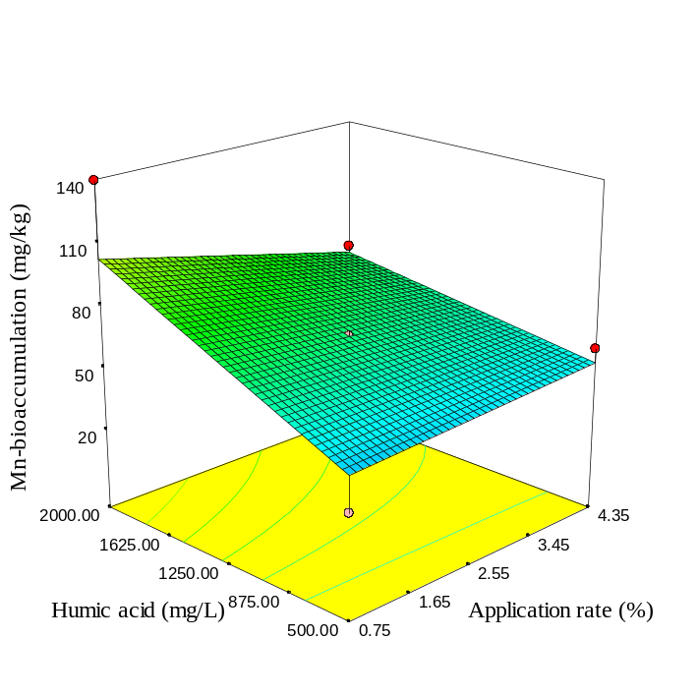 | 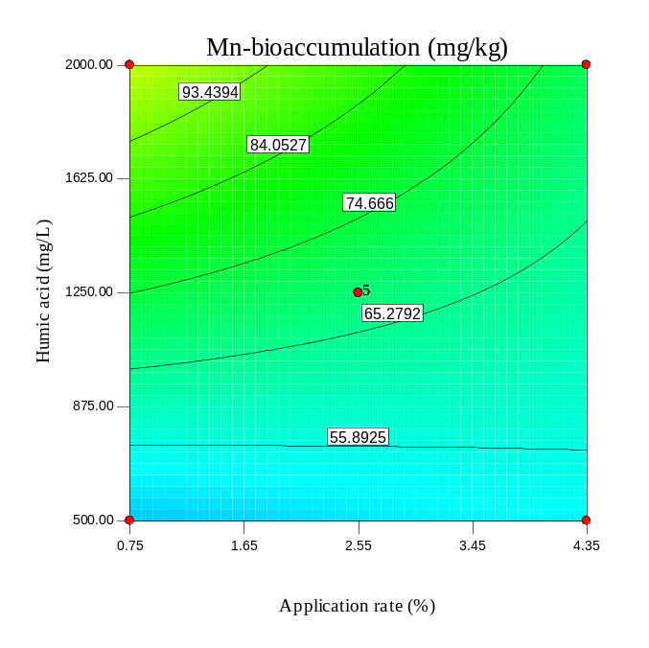
Fig. S19. As Fig. S8 but for RH.

(a) | (b)
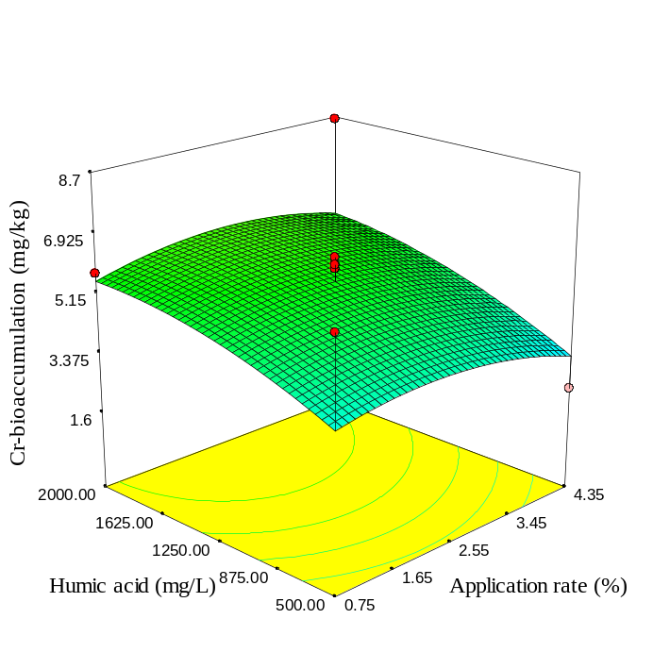 | 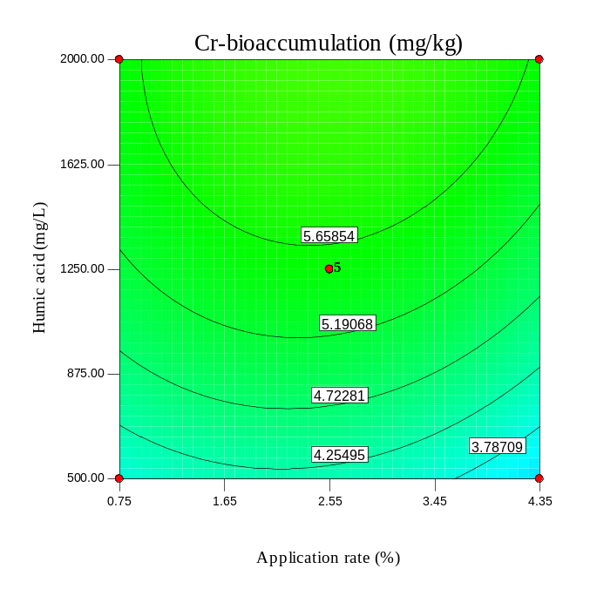
(c) | (d)
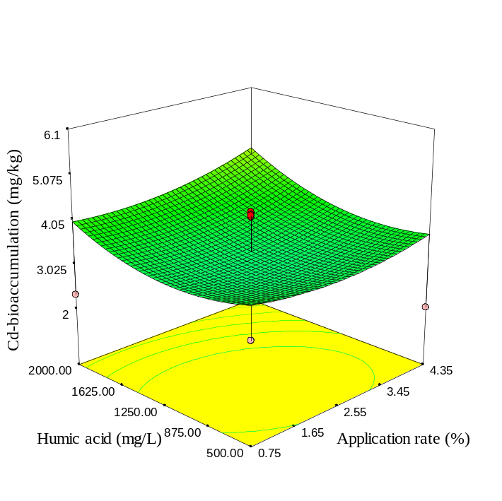 | 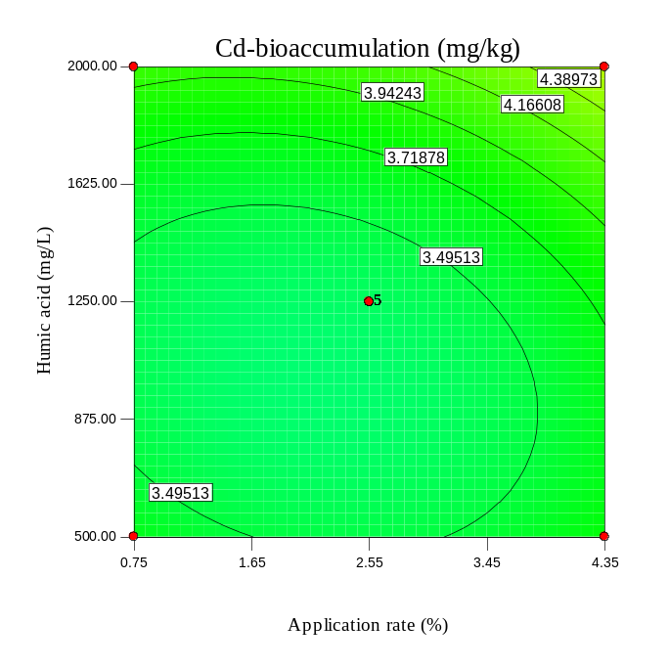
Fig. S20. As Fig. S9 but for RH.

(a) | (b)
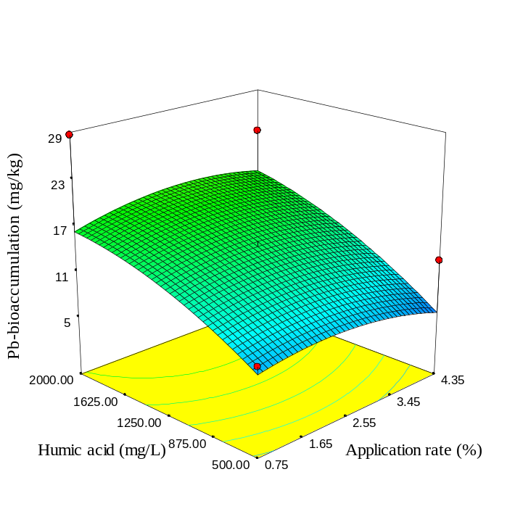 | 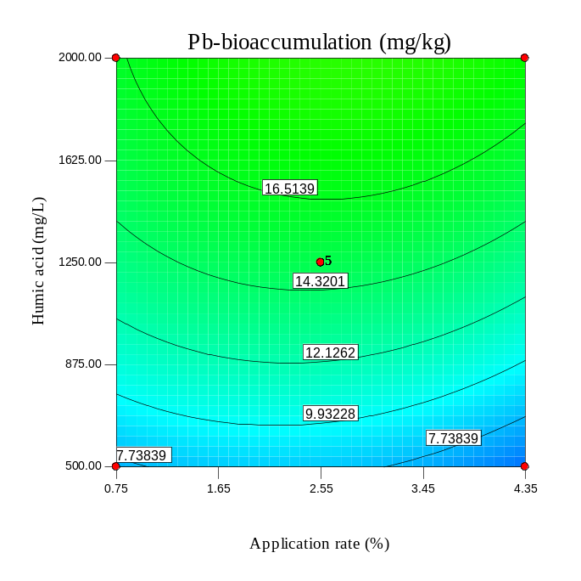
(c) | (d)
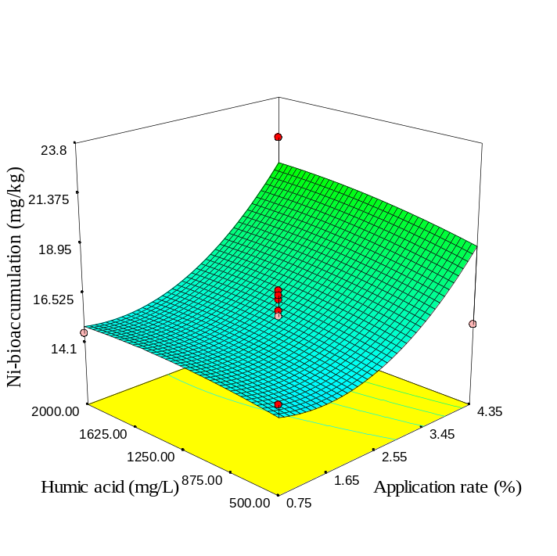 | 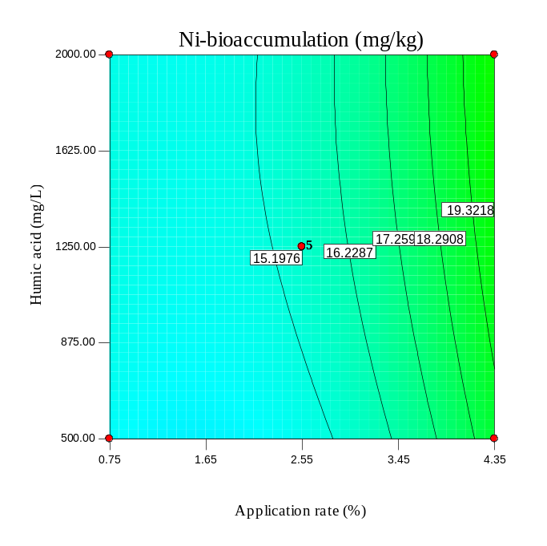
Fig. S21. As Fig. S10 but for RH.

(a) | (b)
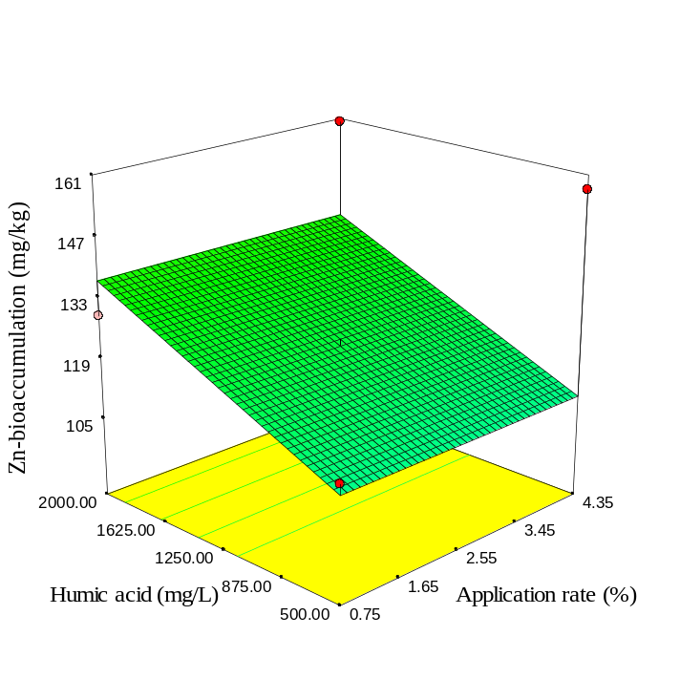 | 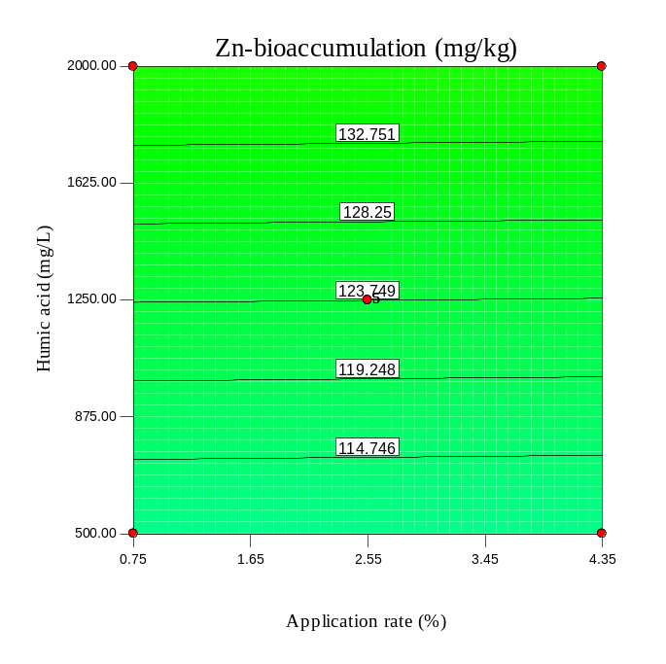
(c) | (d)
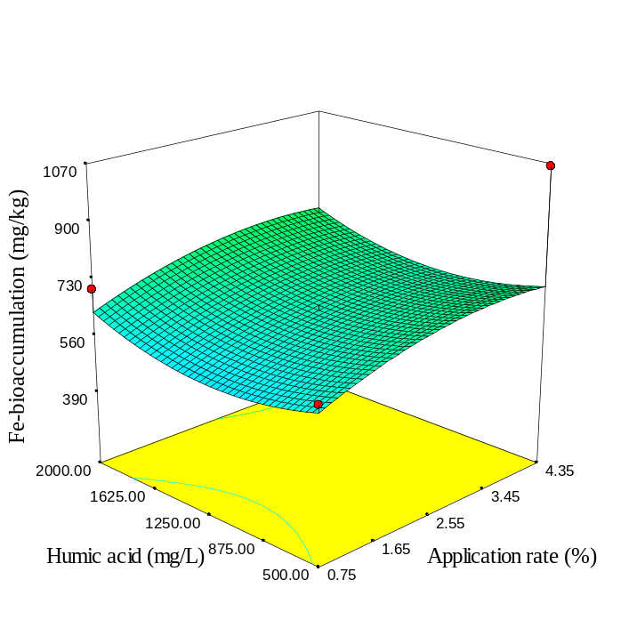 | 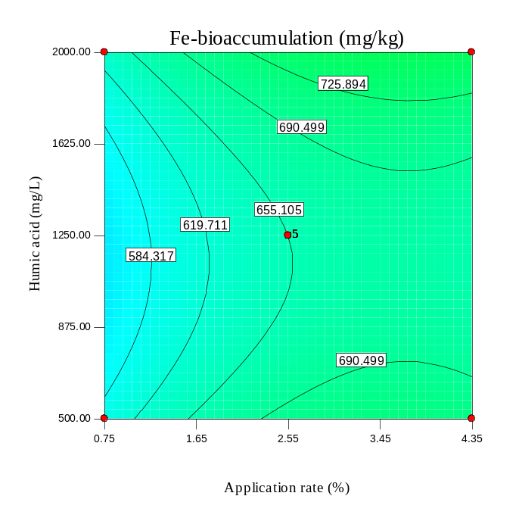
Fig. S22. As Fig. S7 but for RH-300.

(a) | (b)
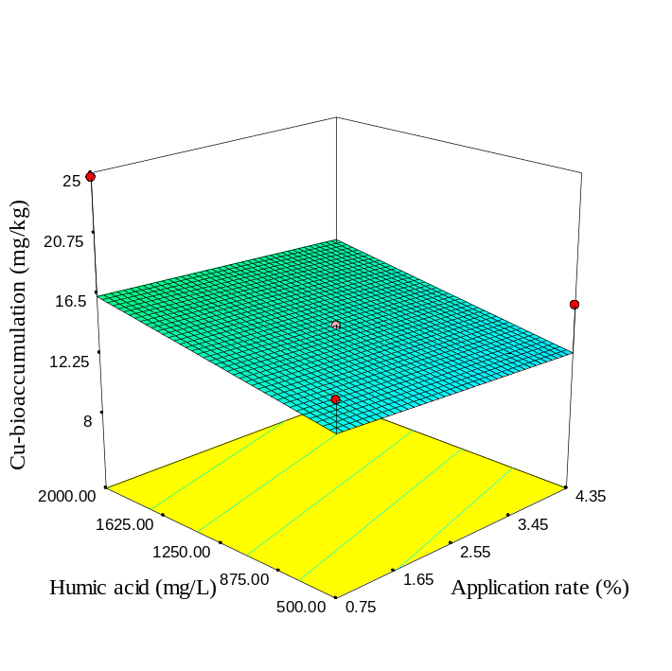 | 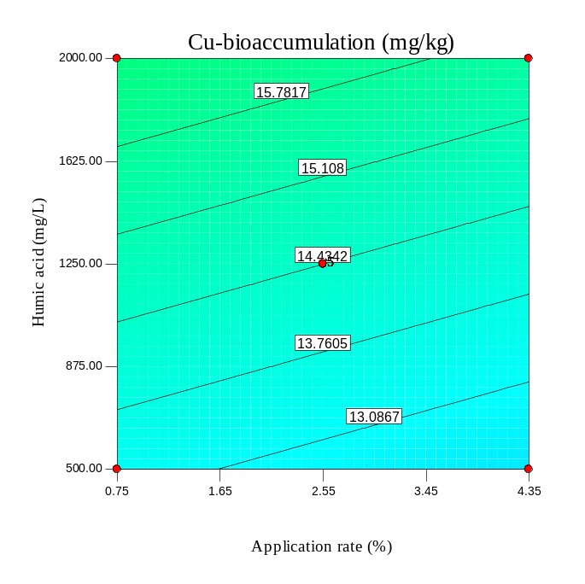
(c) | (d)
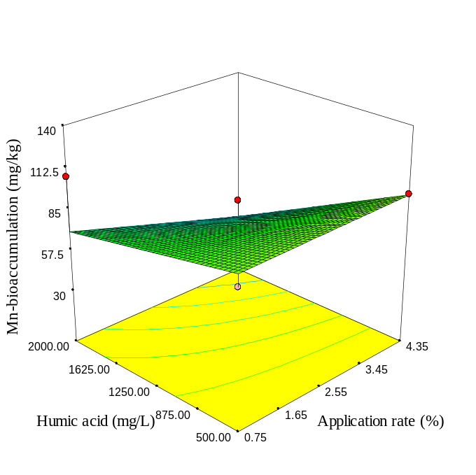 | 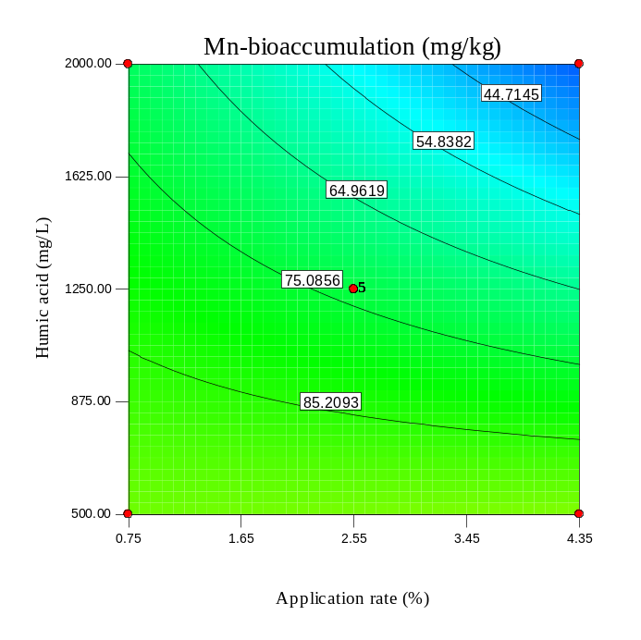
Fig. S23. As Fig. S8 but for RH-300.

(a) | (b)
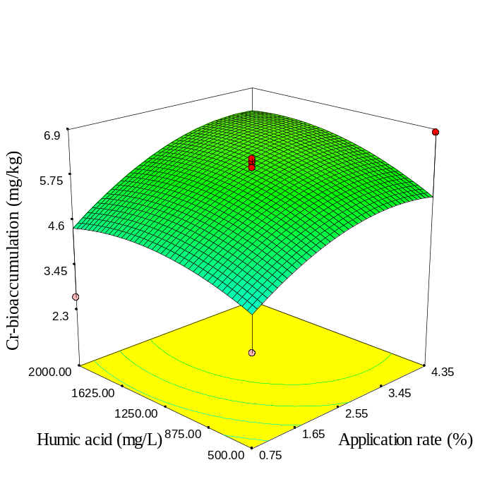 | 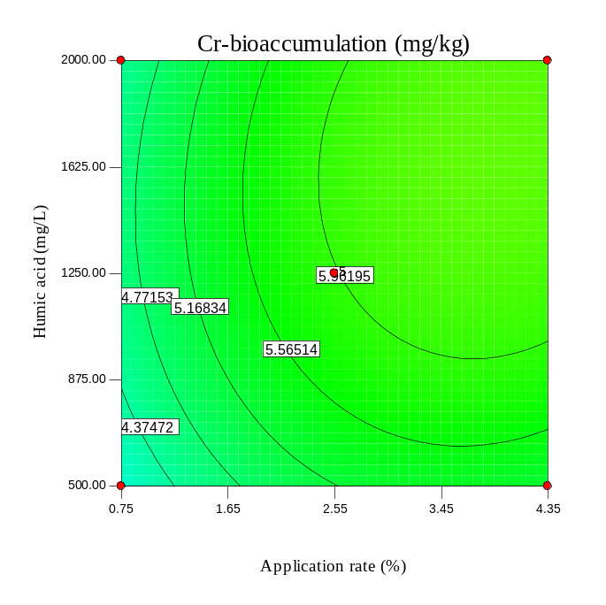
(c) | (d)
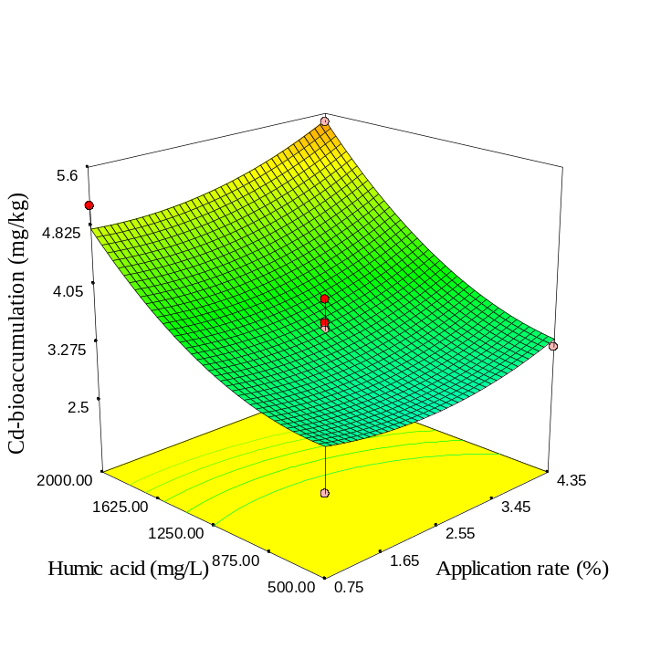 | 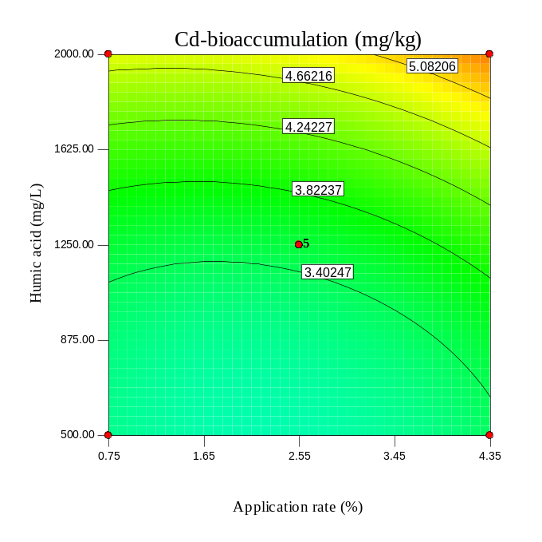
Fig. S24. As Fig. S9 but for RH-300.

(a) | (b)
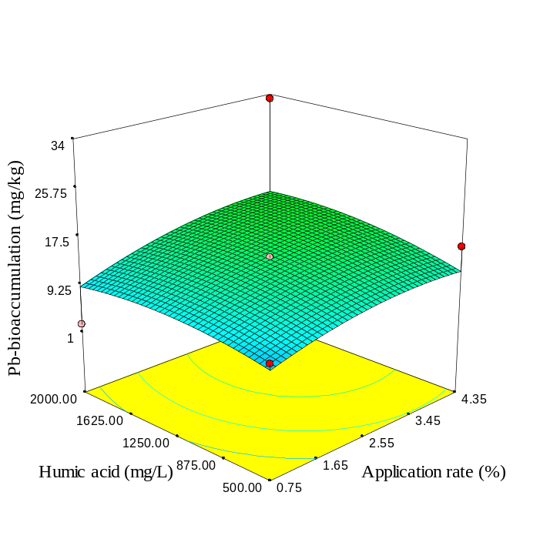 | 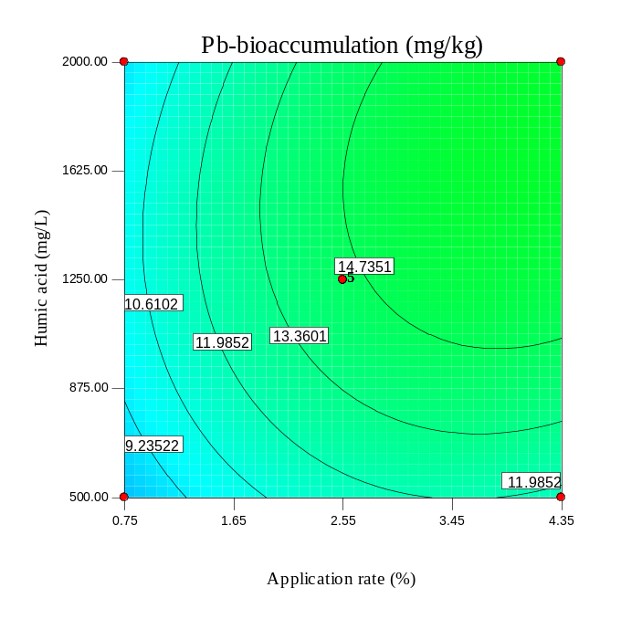
(c) | (d)
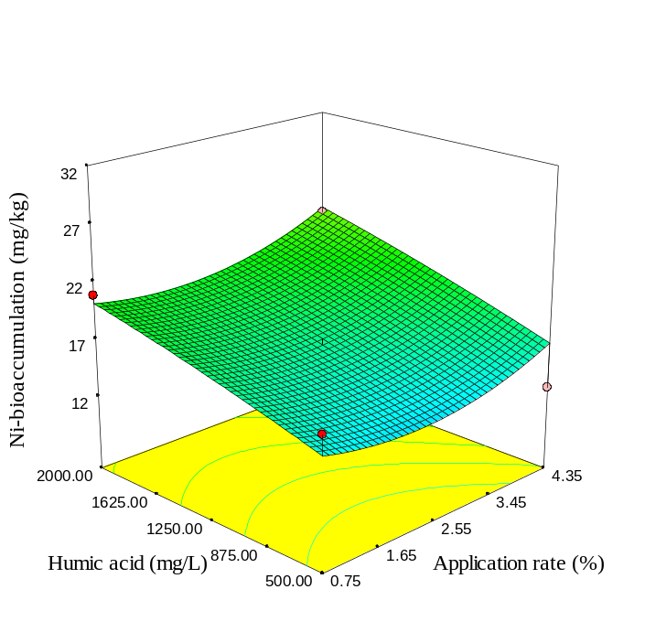 | 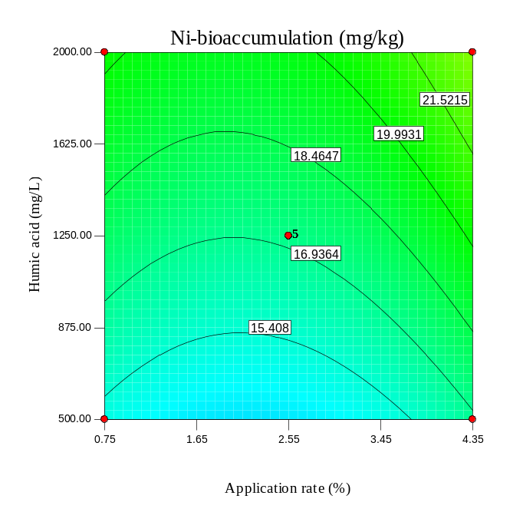
Fig. S25. As Fig. S10 but for RH-300.

(a) | (b)
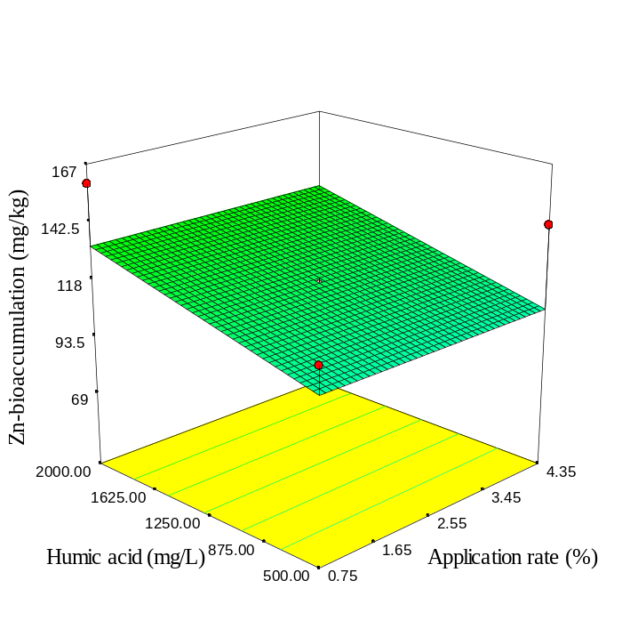 | 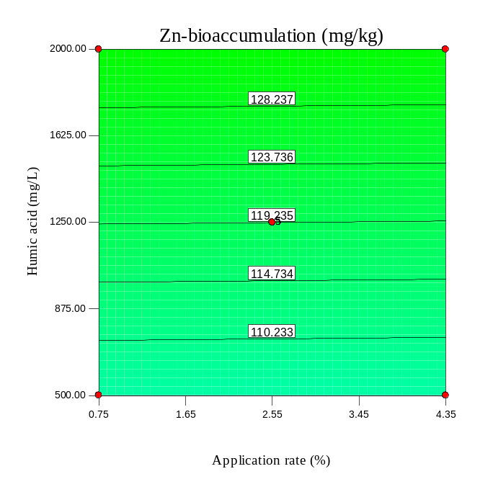
(c) | (d)
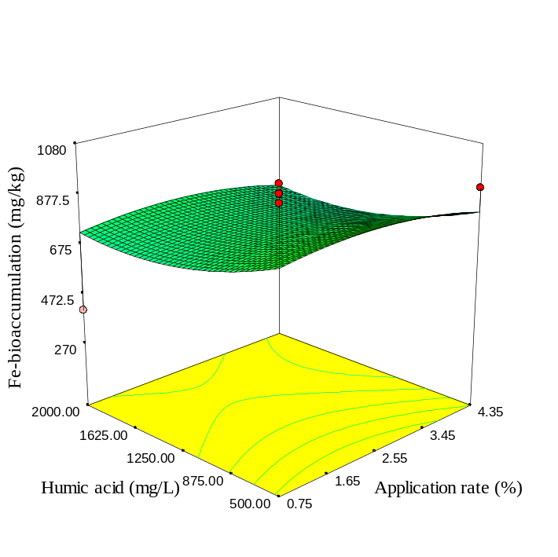 | 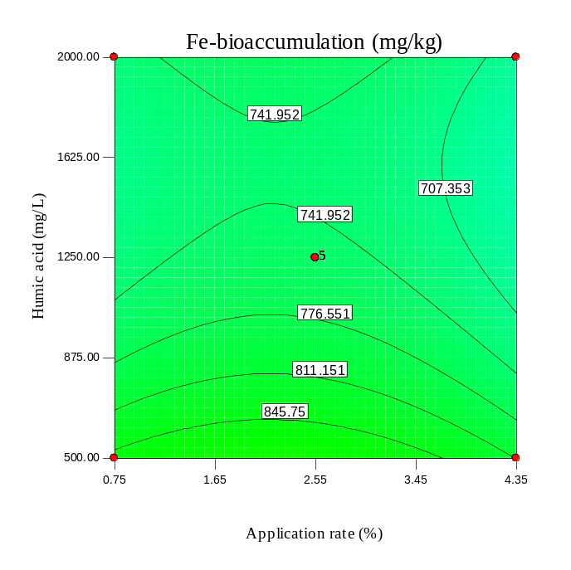
Fig. S26. As Fig. S7 but for RH-600.

(a) | (b)
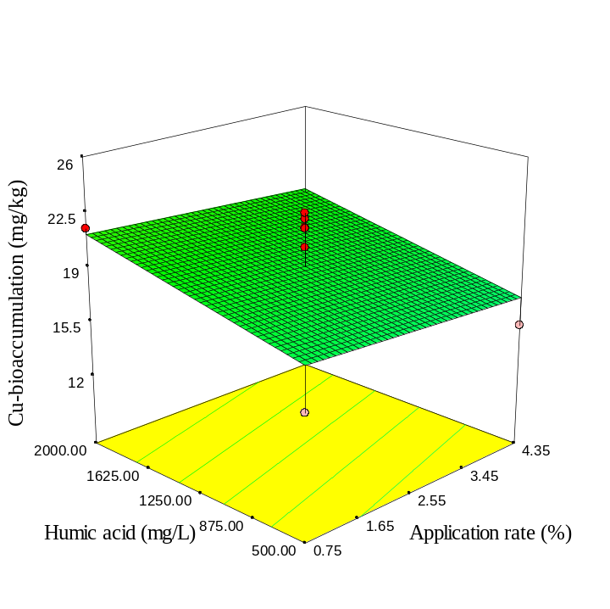 | 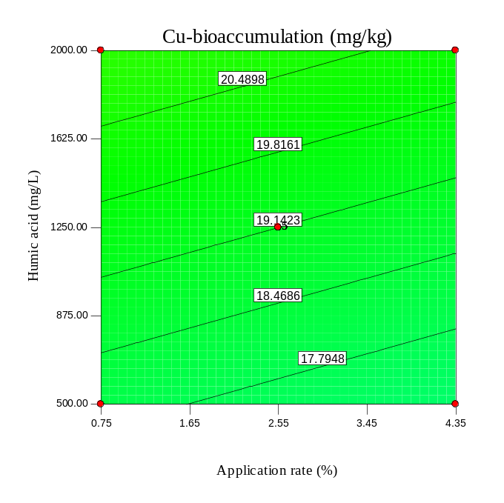
(c) | (d)
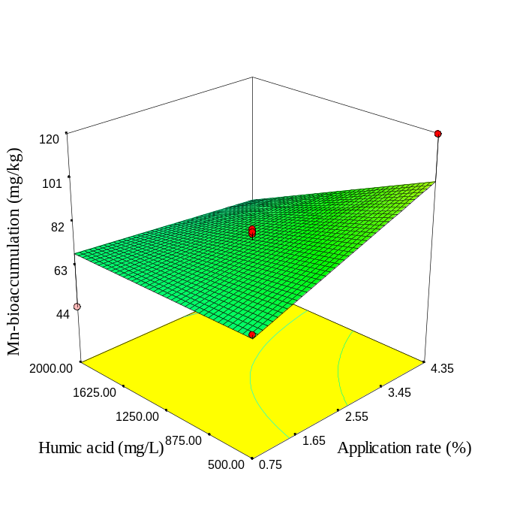 | 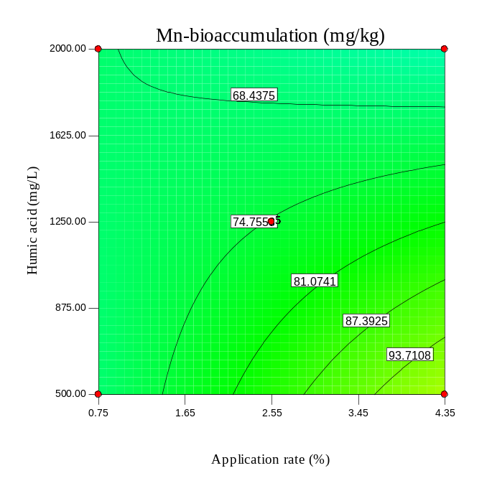
Fig. S27. As Fig. S8 but for RH-600.

(a) | (b)
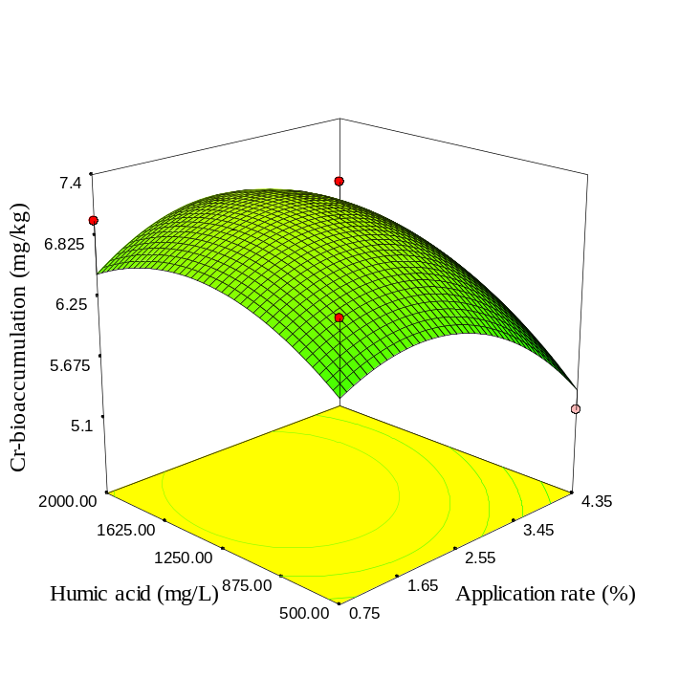 | 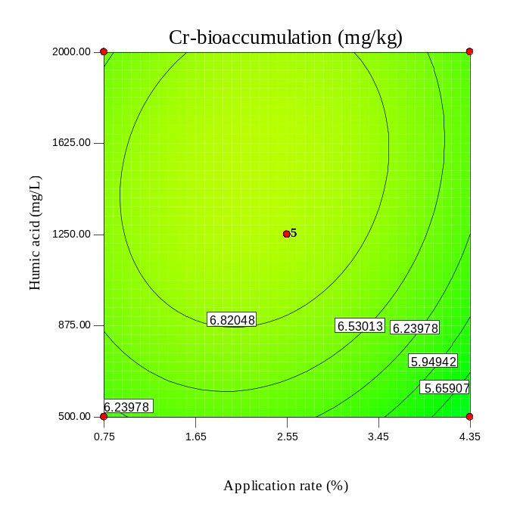
(c) | (d)
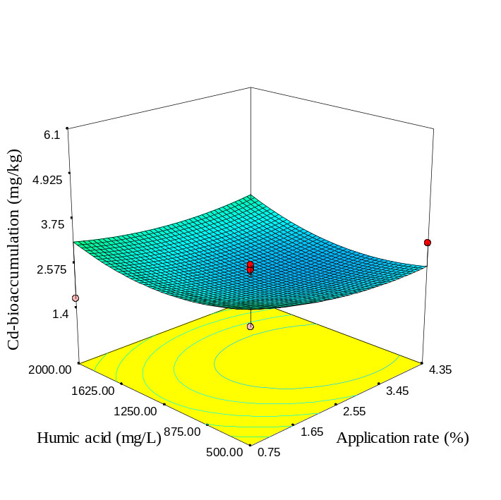 | 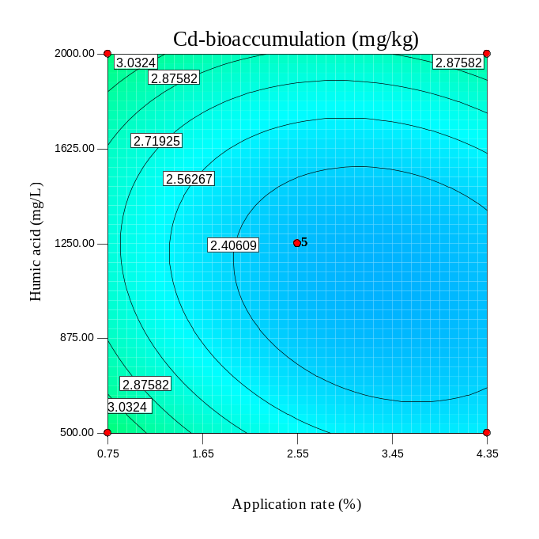
Fig. S28. As Fig. S9 but for RH-600.

(a) | (b)
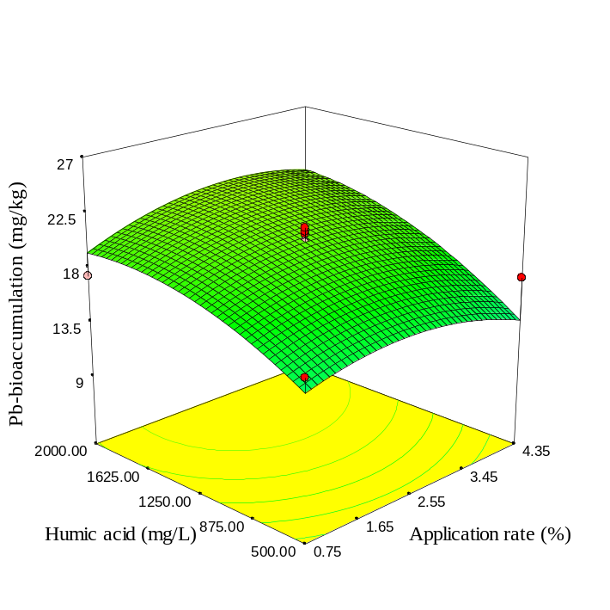 | 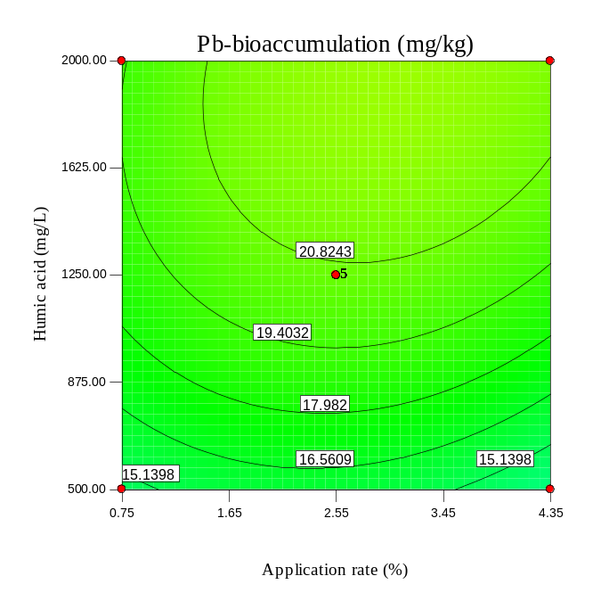
(c) | (d)
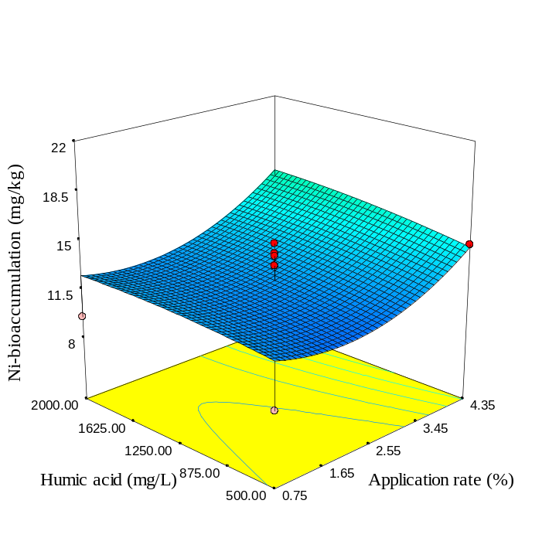 | 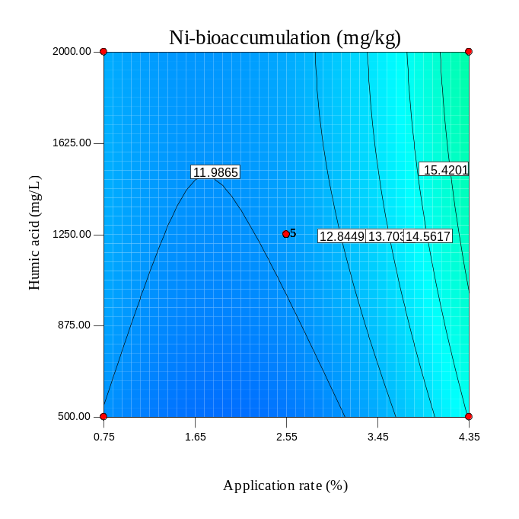
Fig. S29. As Fig. S10 but for RH-600.

(a) SBP | (b) SBP
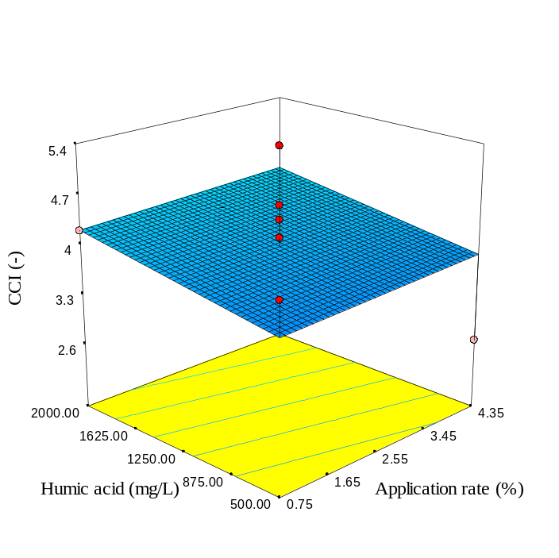 | 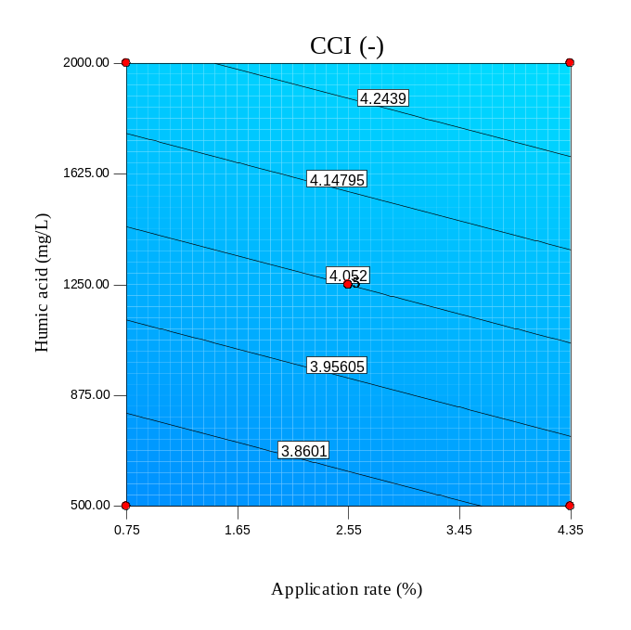
(c) SBP300 | (d) SBP300
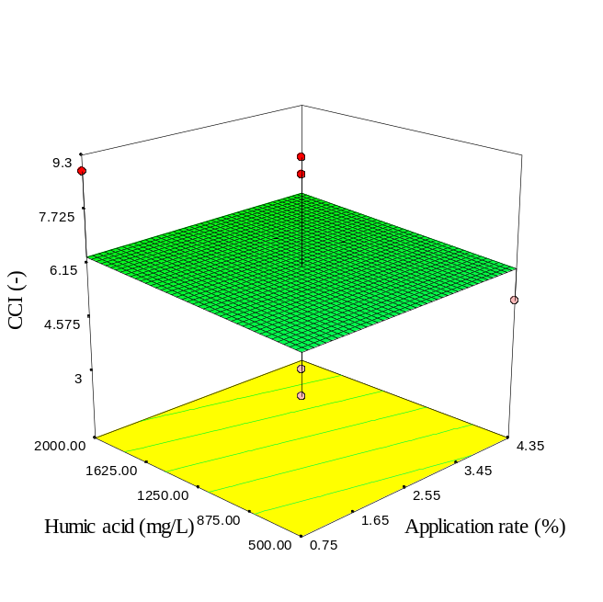 | 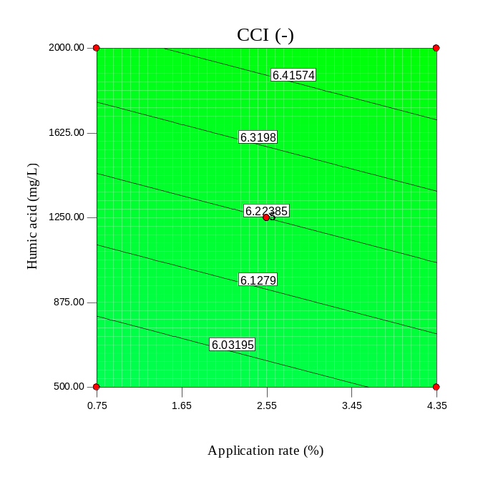
Fig. S30. 3D surface and contour plots of CCI in spinach leaves affected by humic acid concentration and biomass/biochar application rate.

(a) SBP600 | (b) SBP600
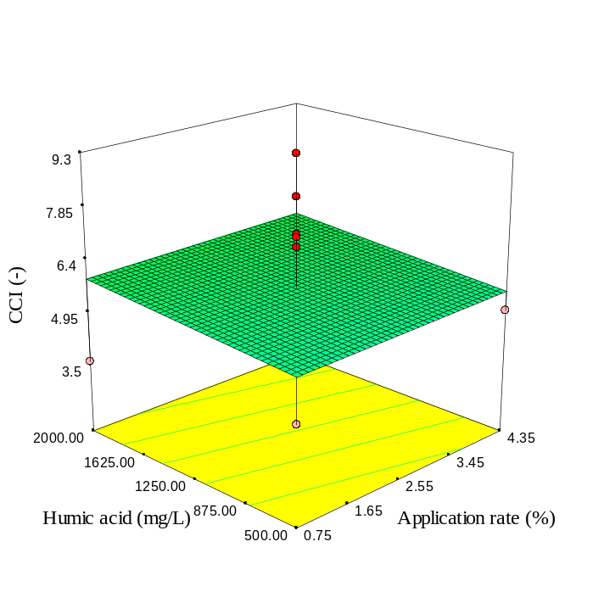 | 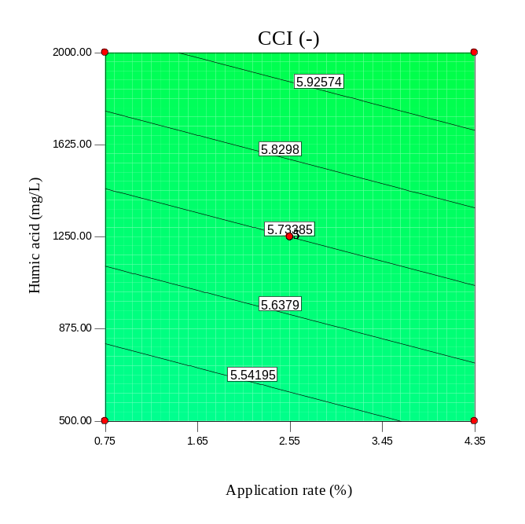
(c) RH | (d) RH
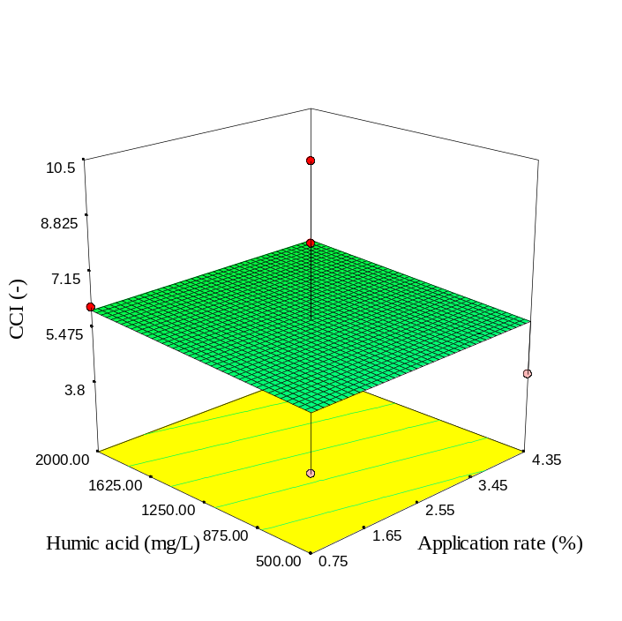 | 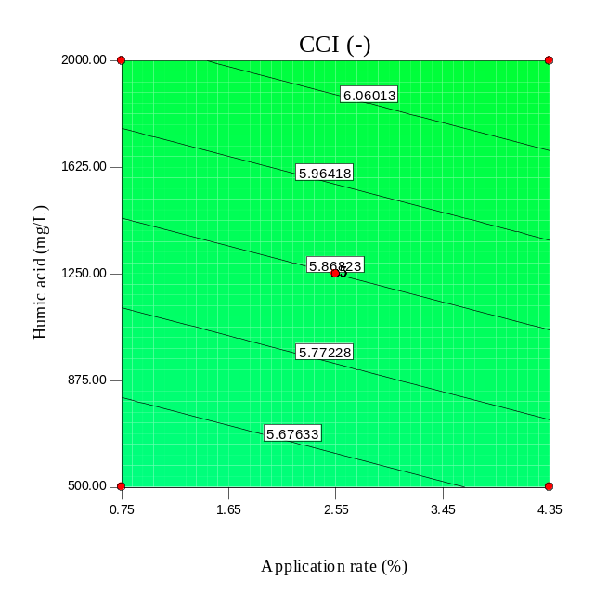
Fig. S31. 3D surface and contour plots of CCI in spinach leaves affected by humic acid concentration and biomass/biochar application rate.

(a) RH300 | (b) RH300
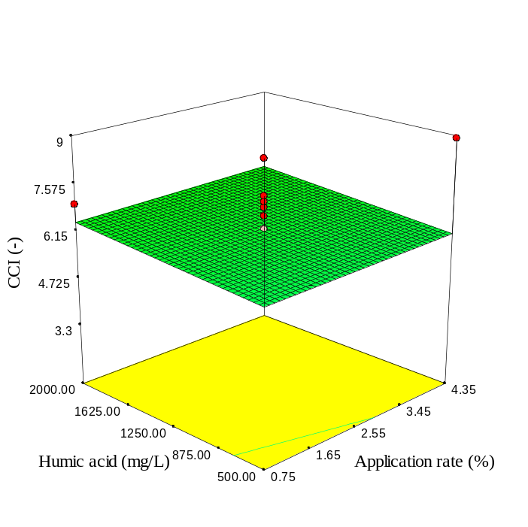 | 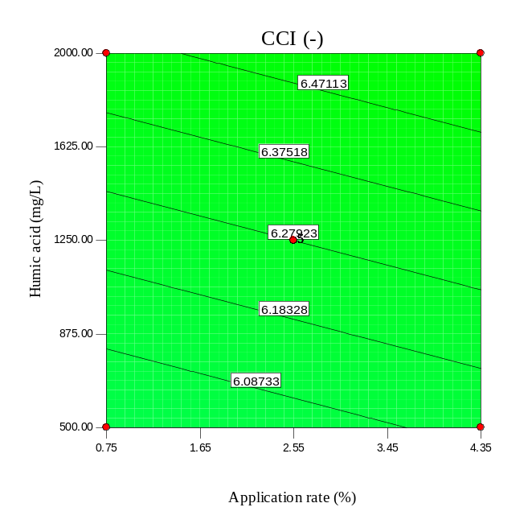
(c) RH600 | (d) RH600
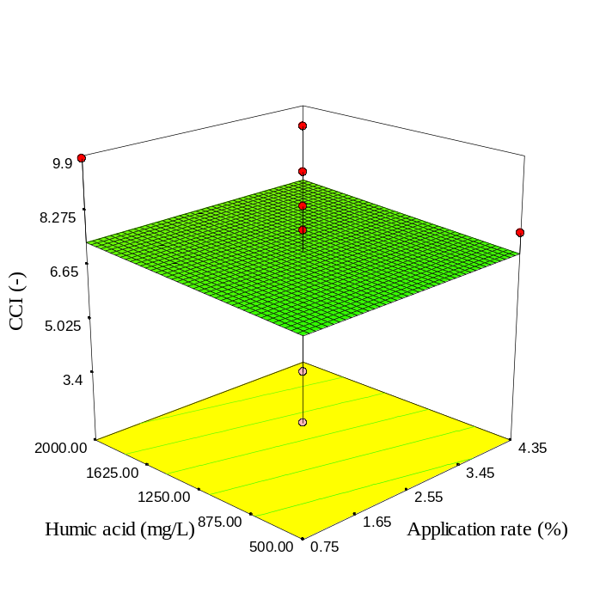 | 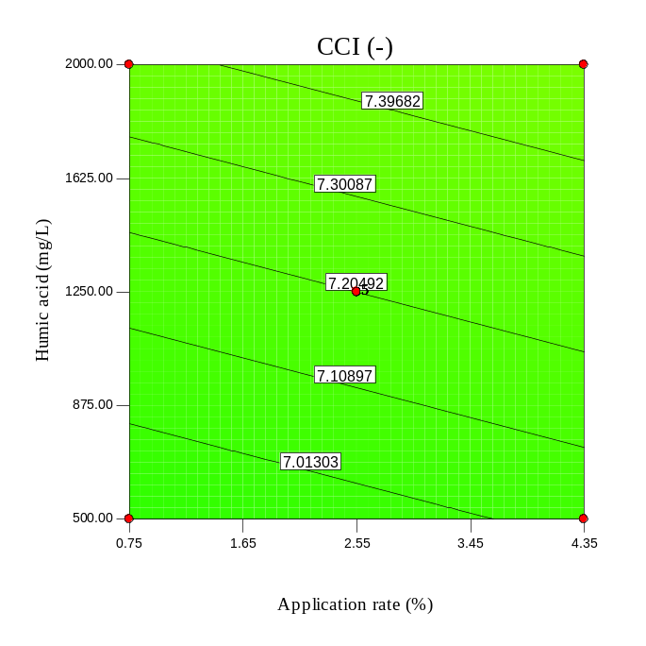
Fig. S32. 3D surface and contour plots of CCI in spinach leaves affected by humic acid concentration and biomass/biochar application rate.

(a) | (b)
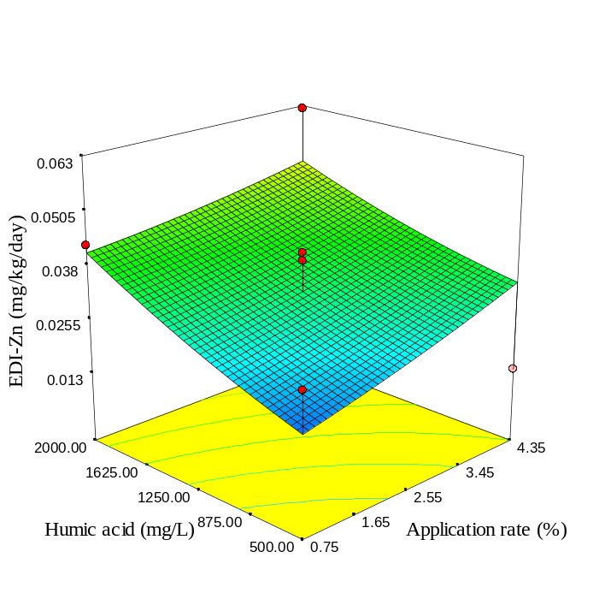 | 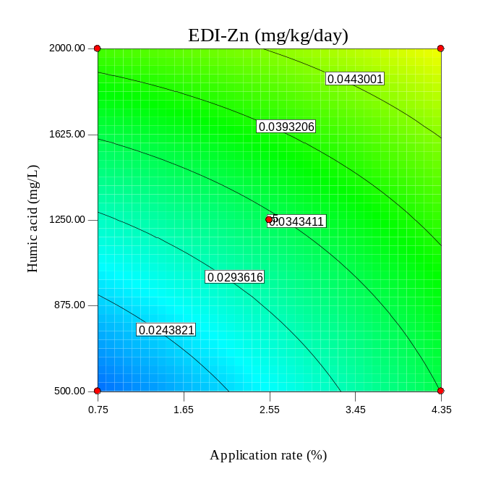
(c) | (d)
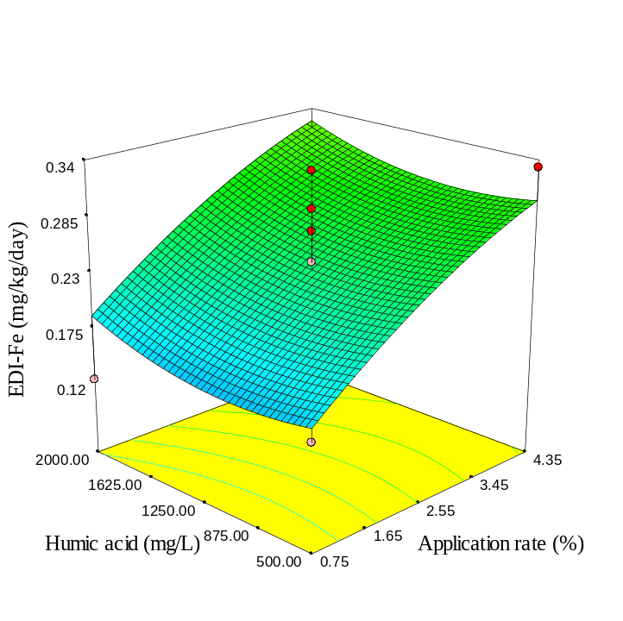 | 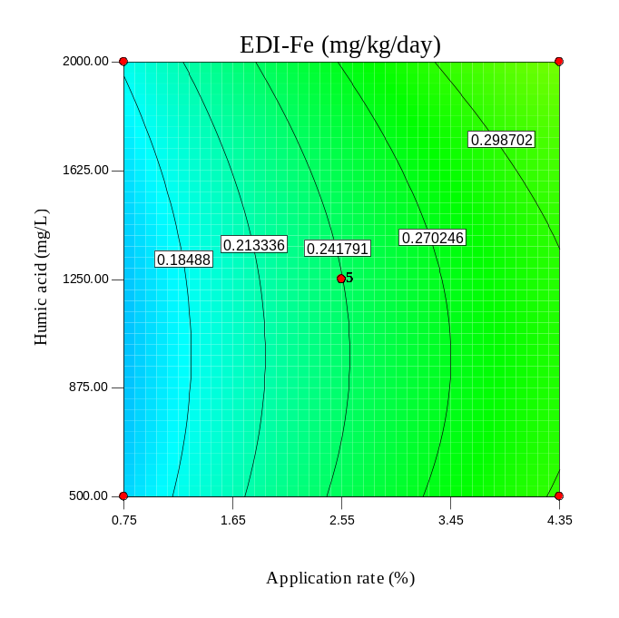
Fig. S33. 3D surface and contour plots of EDI-Zn and EDI-Fe due to ingestion of spinach leaves affected by humic acid concentration and SBP application rate.

(a) | (b)
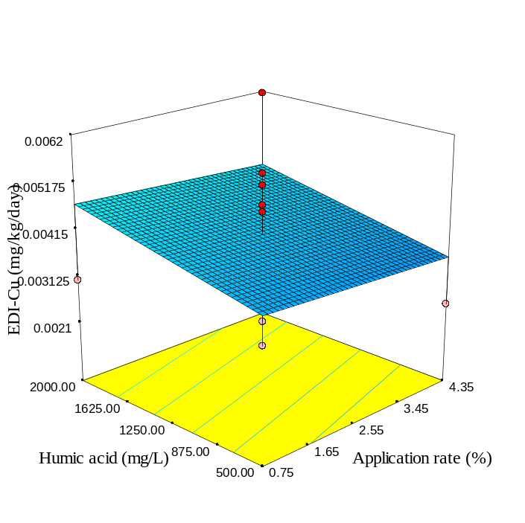 | 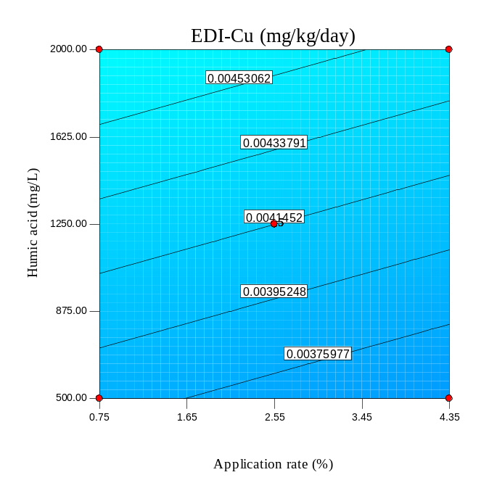
(c) | (d)
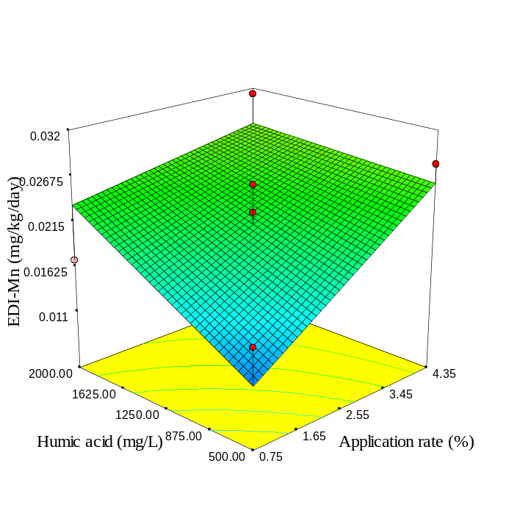 | 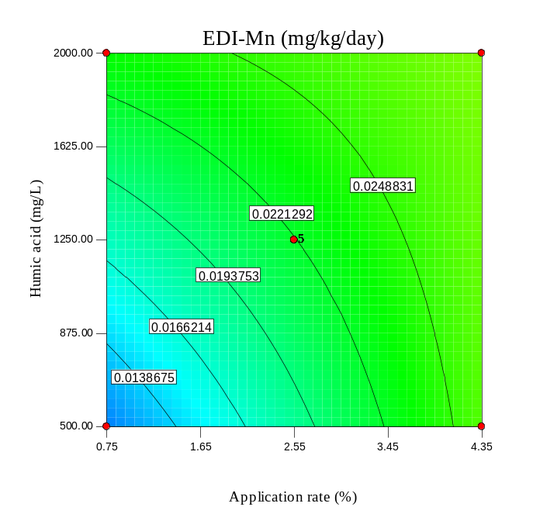
Fig. S34. 3D surface and contour plots of EDI-Cu and EDI-Mn due to ingestion of spinach leaves affected by humic acid concentration and SBP application rate.

(a) | (b)
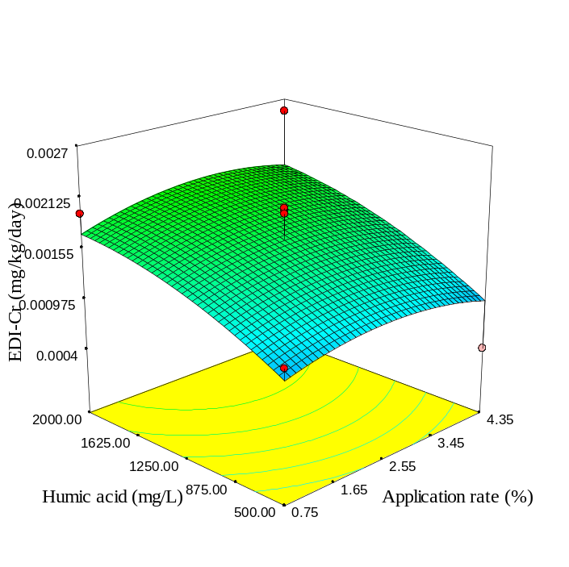 | 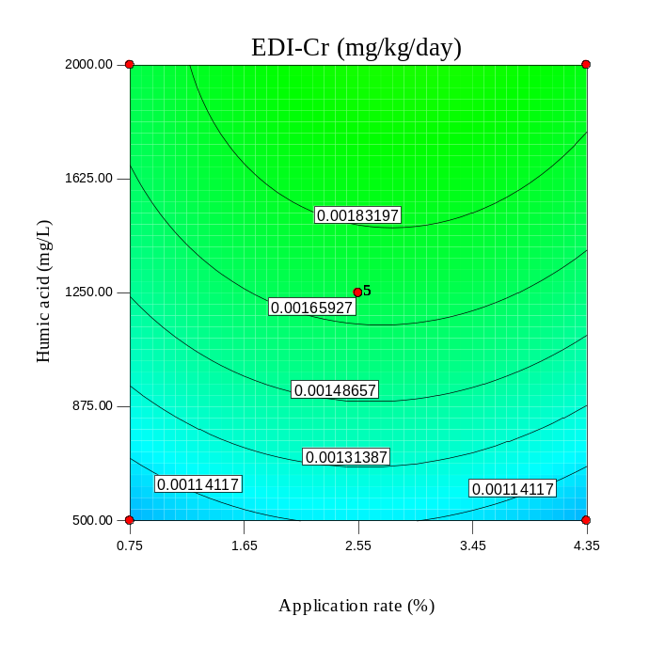
(c) | (d)
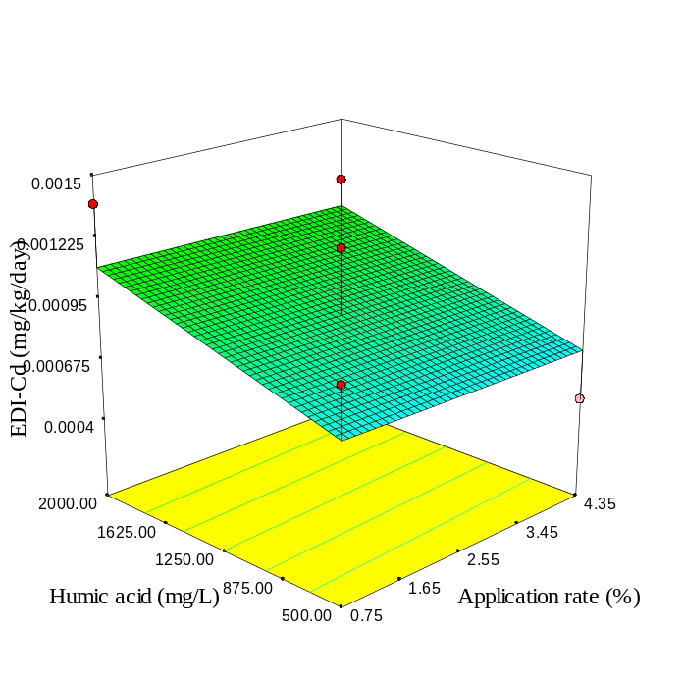 | 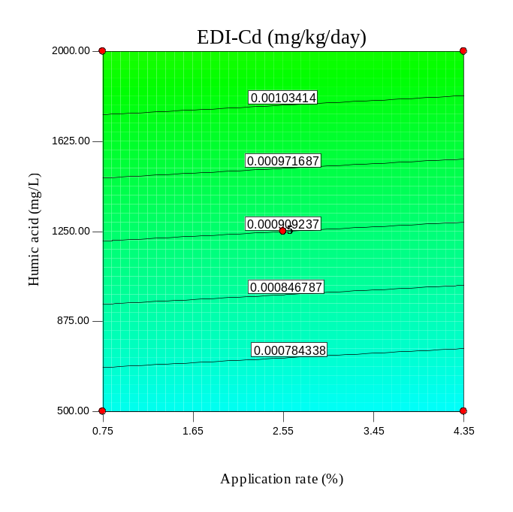
Fig. S35. 3D surface and contour plots of EDI-Cr and EDI-Cd due to ingestion of spinach leaves affected by humic acid concentration and SBP application rate.

(a) | (b)
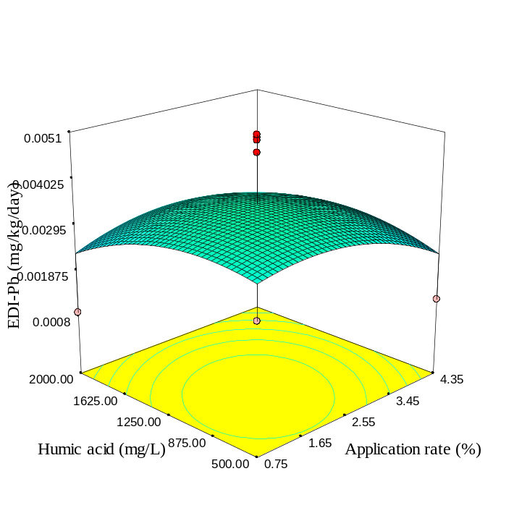 | 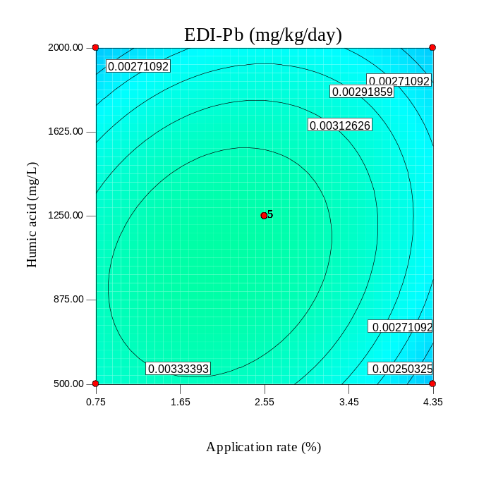
(c) | (d)
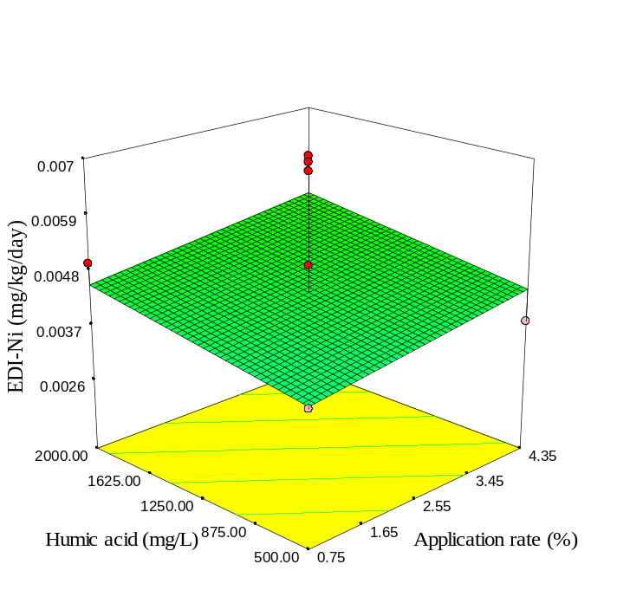 | 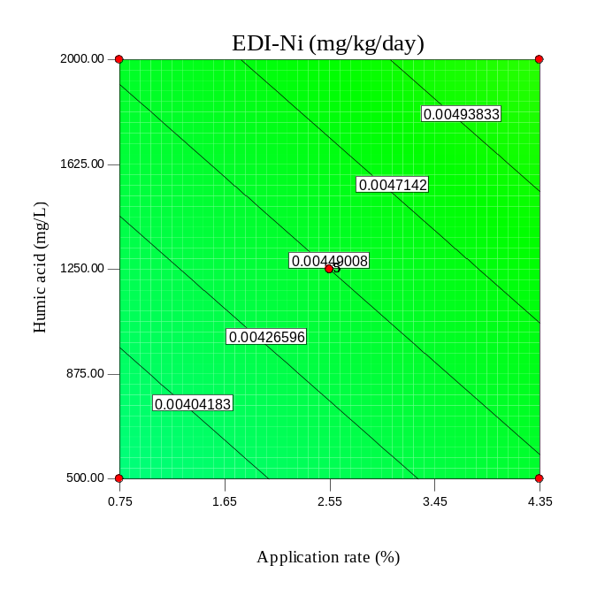
Fig. S36. 3D surface and contour plots of EDI-Pb and EDI-Ni due to ingestion of spinach leaves affected by humic acid concentration and SBP application rate.

(a) | (b)
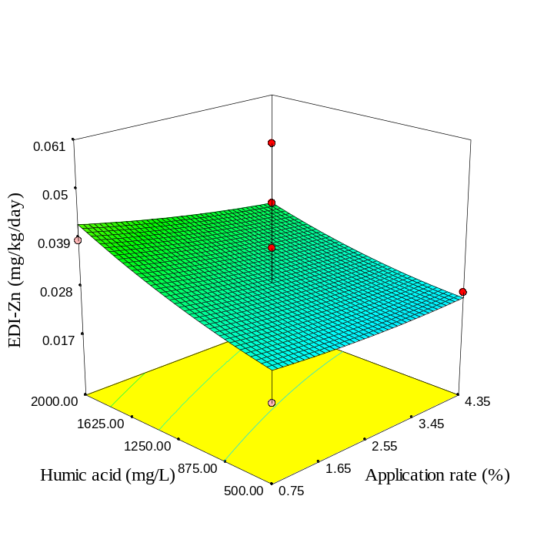 | 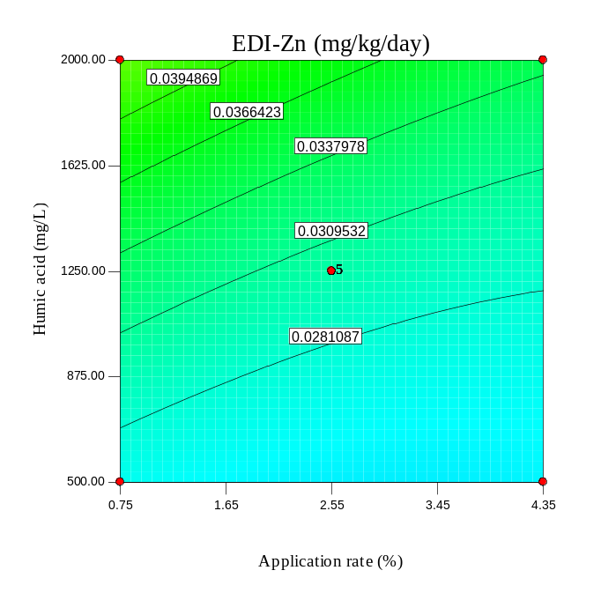
(c) | (d)
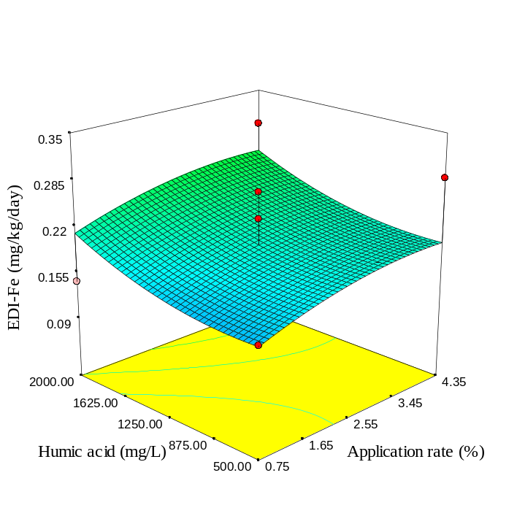 | 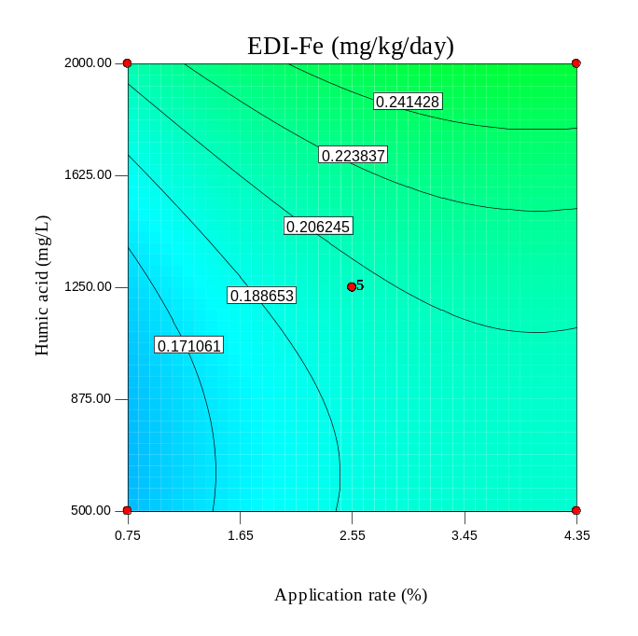
Fig. S37. As Fig. S33, but for SBP300.

(a) | (b)
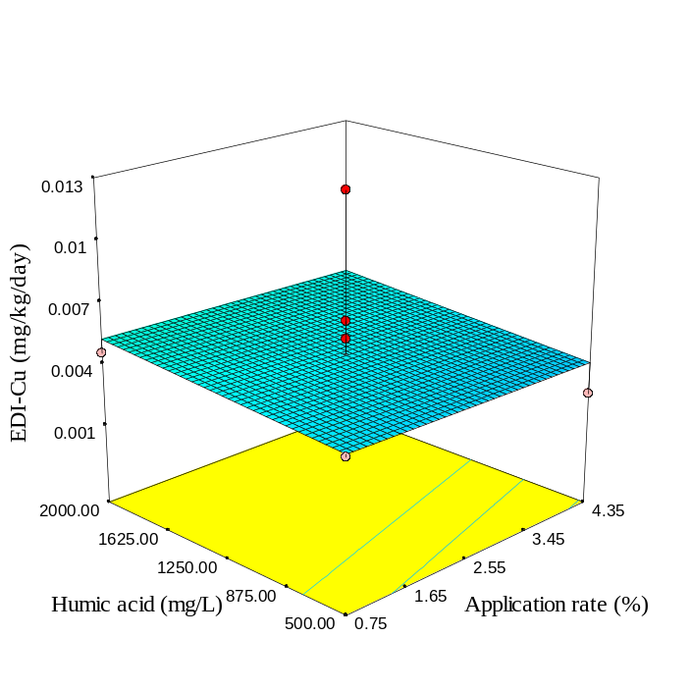 | 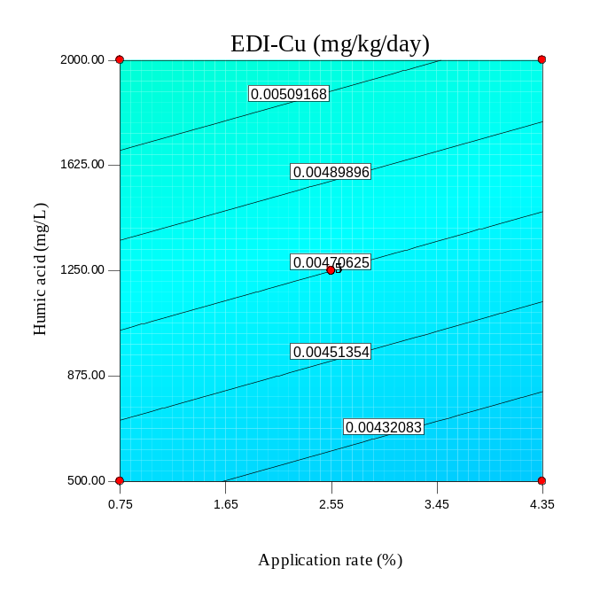
(c) | (d)
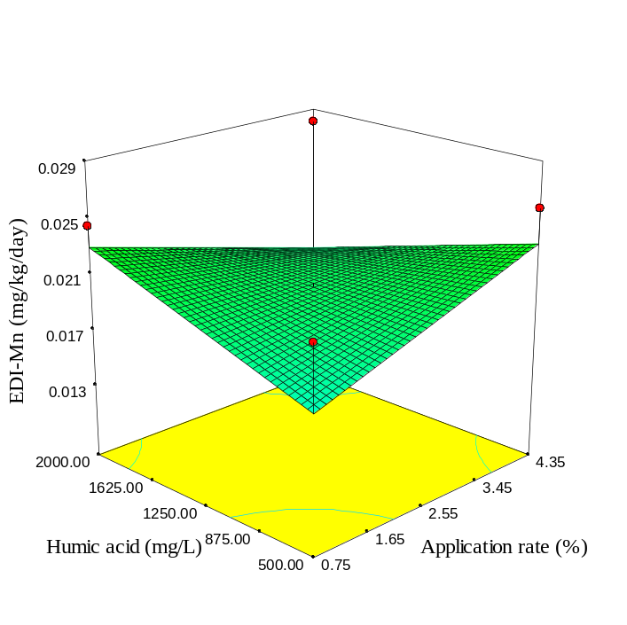 | 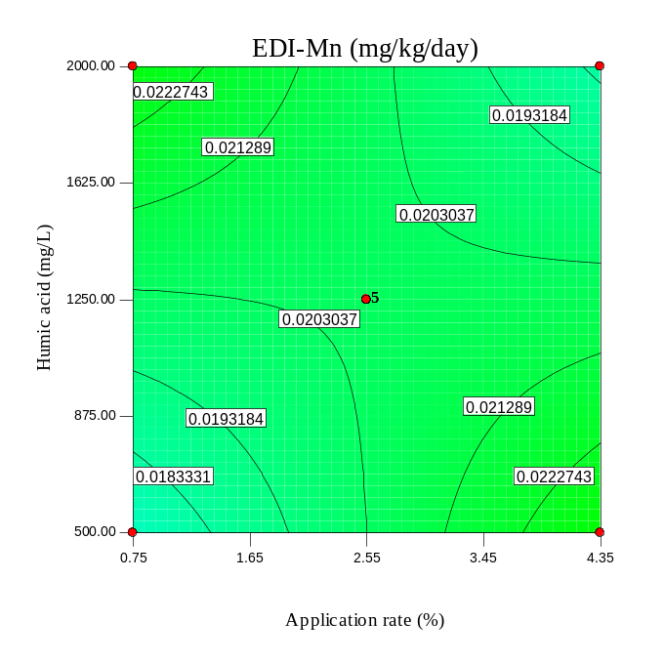
Fig. S38. As Fig S34, but for SBP300.

(a) | (b)
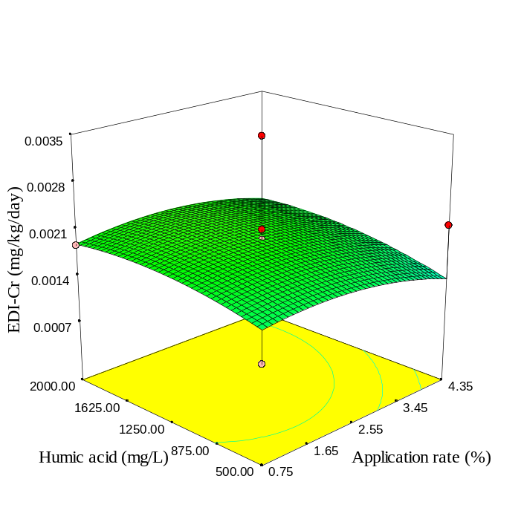 | 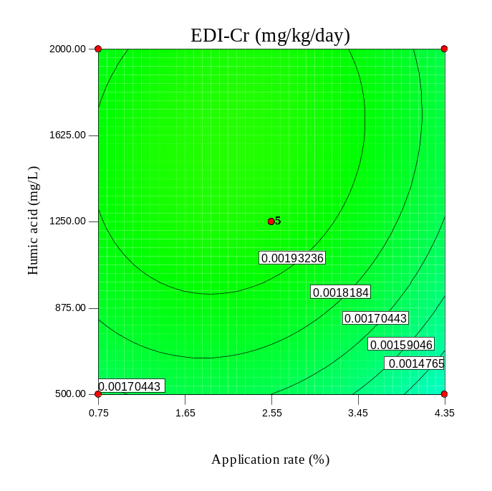
(c) | (d)
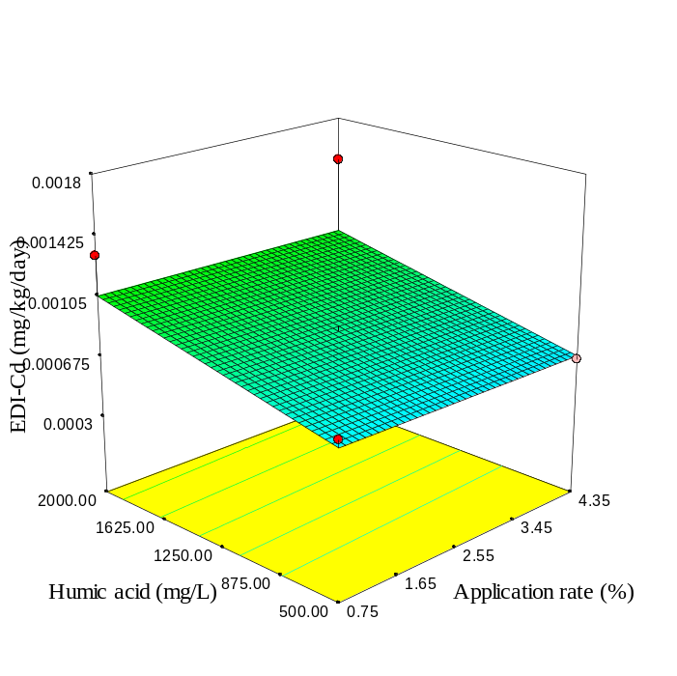 | 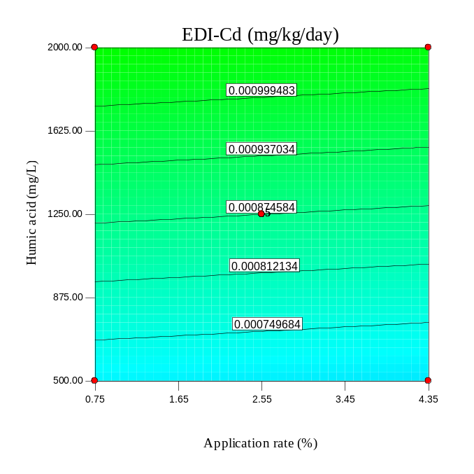
Fig. S39. As S35, but for SBP300.

(a) | (b)
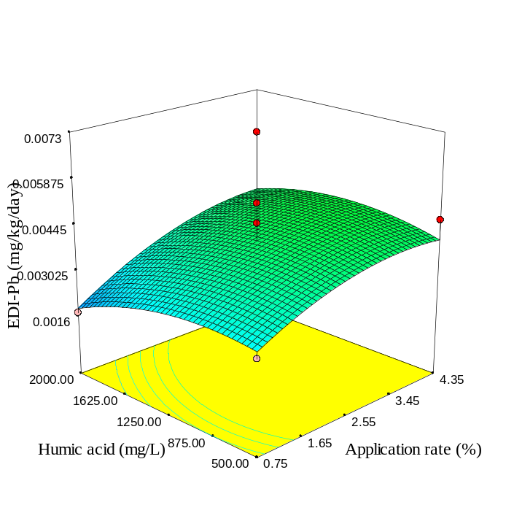 | 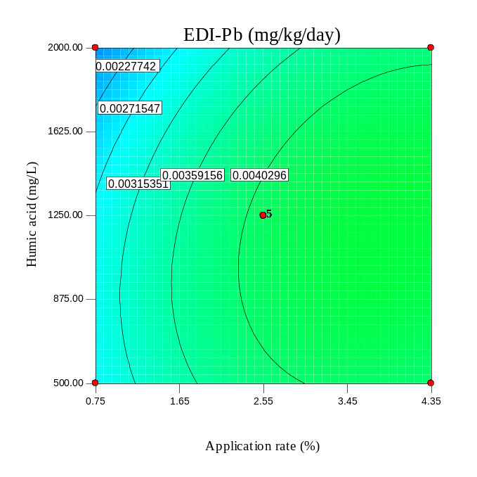
(c) | (d)
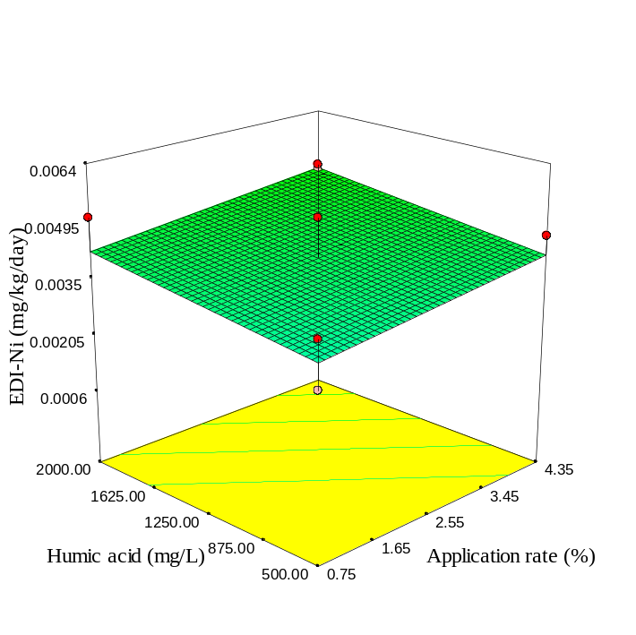 | 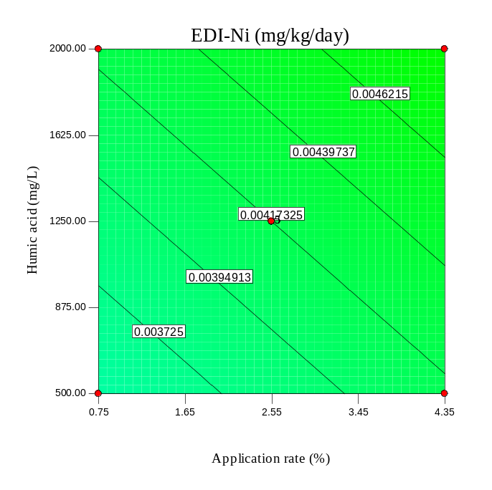
Fig.40. As Fig S36, but for SBP300.

(a) | (b)
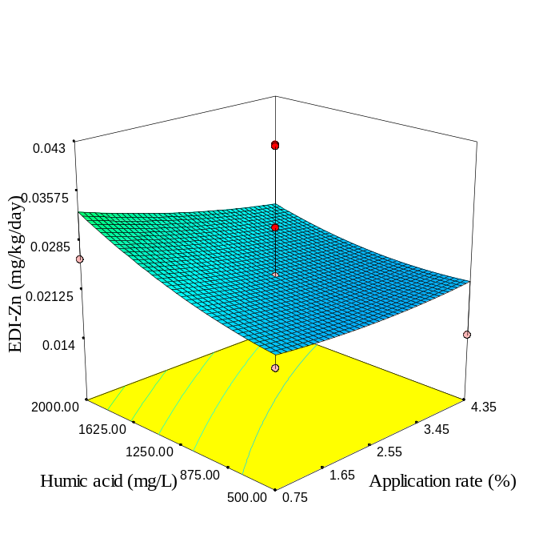 | 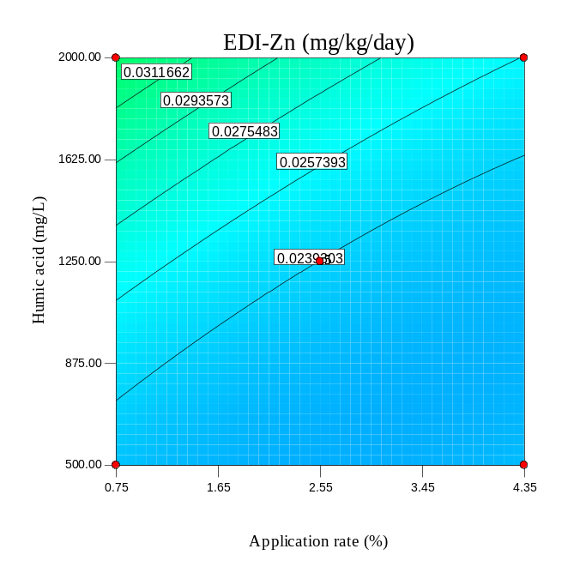
(c) | (d)
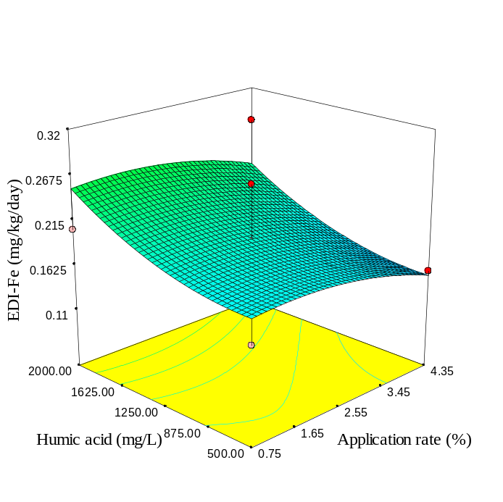 | 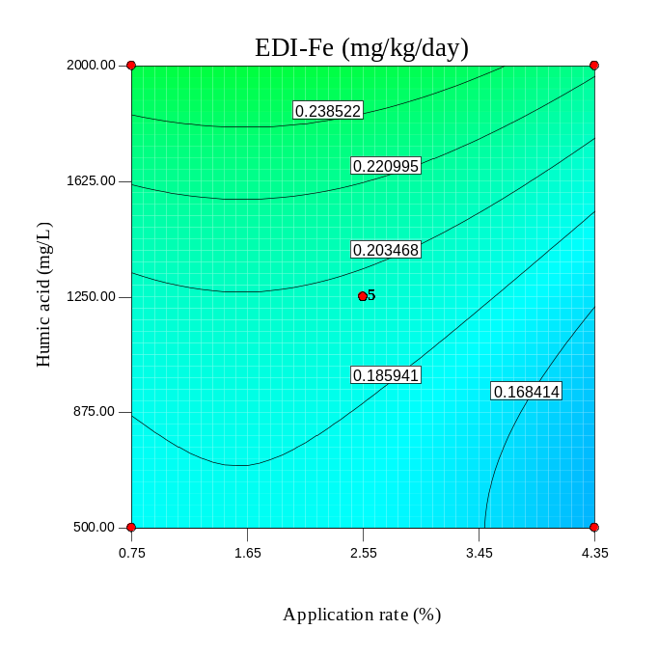
Fig. S41. As Fig S33, but for SBP600.

(a) | (b)
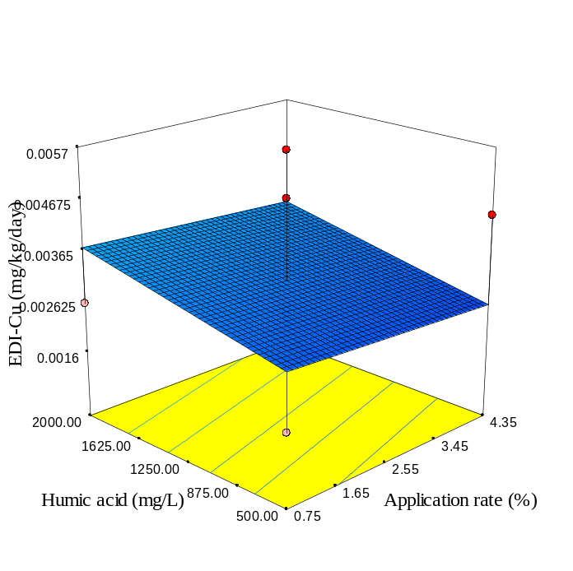 | 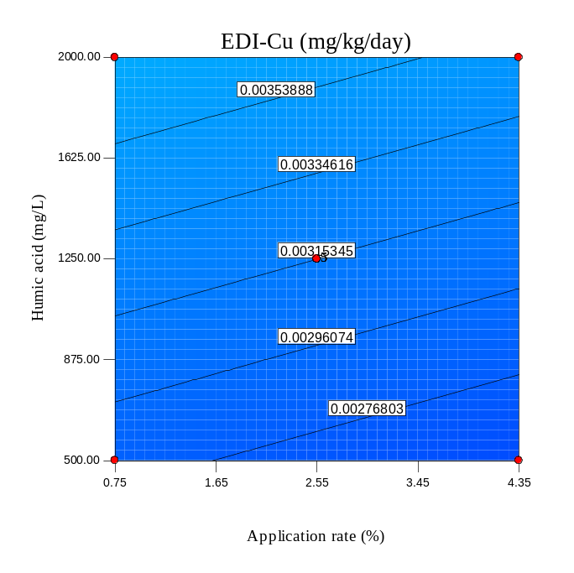
(c) | (d)
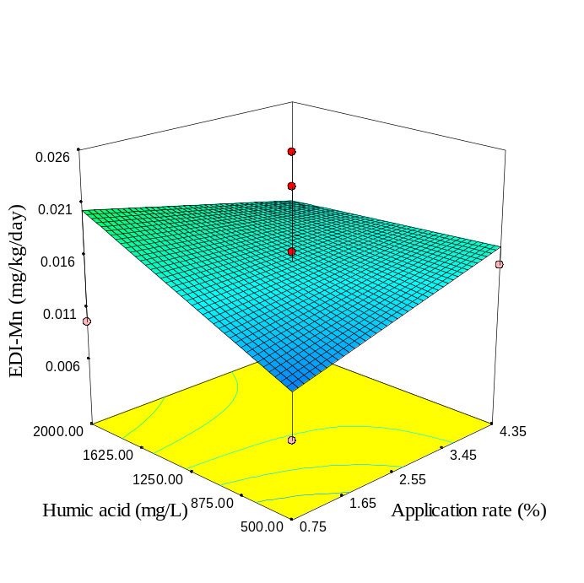 | 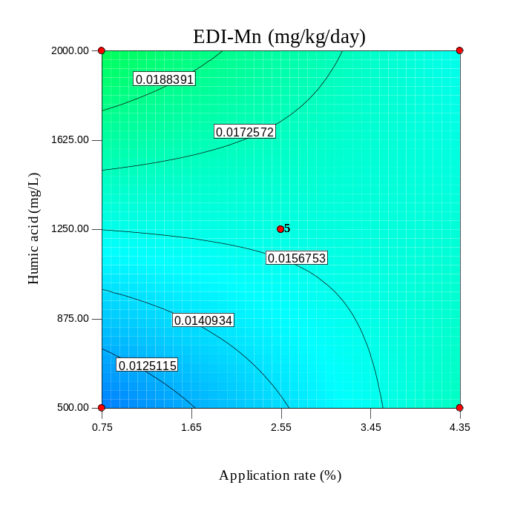
Fig. S42. As Fig S34, but for SBP600.

(a) | (b)
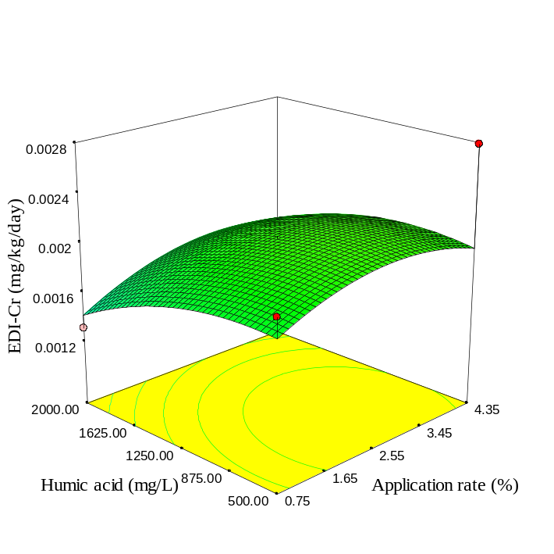 | 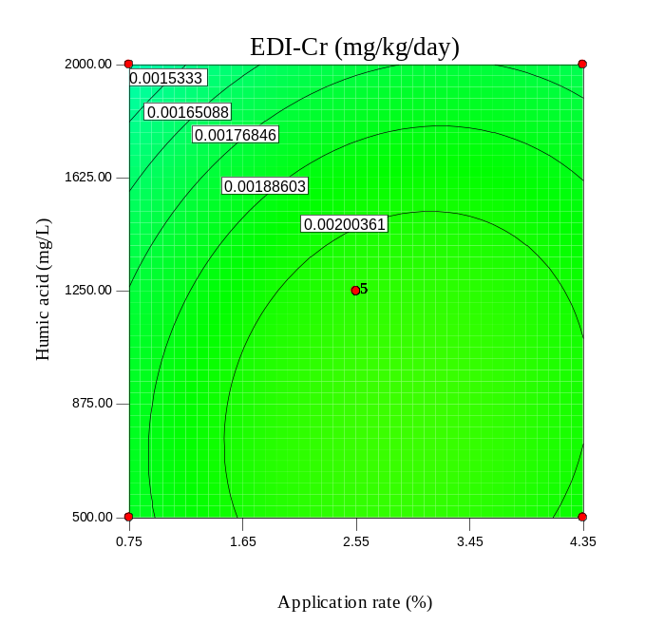
(c) | (d)
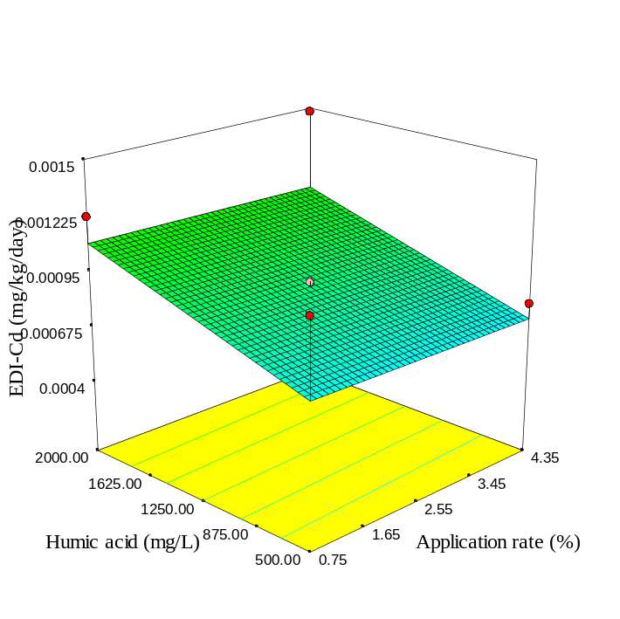 | 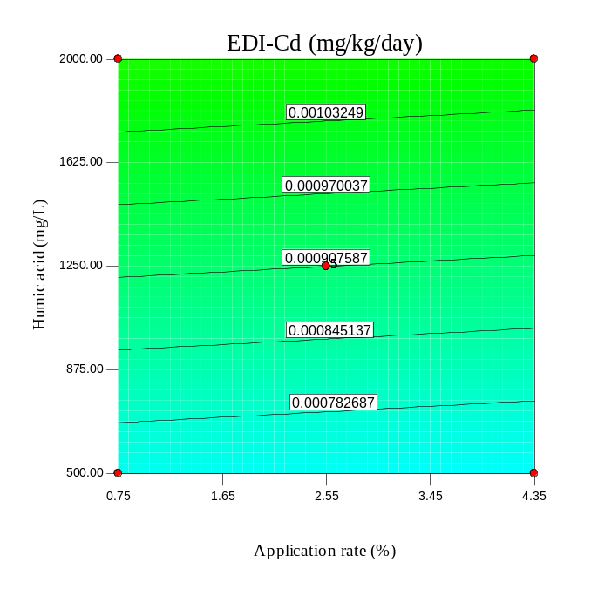
Fig. S43. As Fig S35, but for SBP600.

(a) | (b)
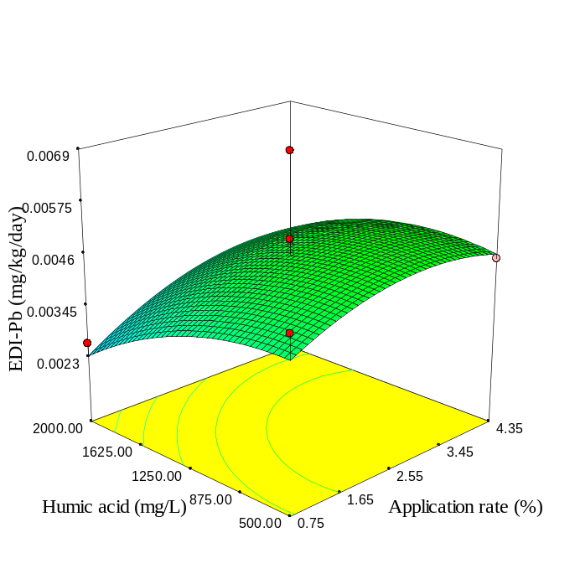 | 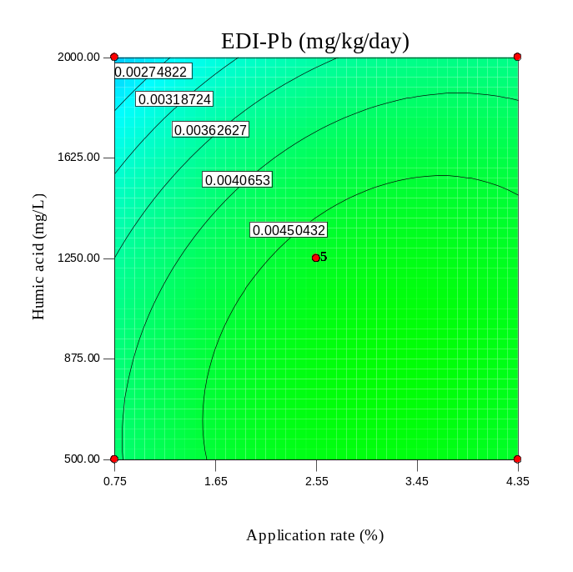
(c) | (d)
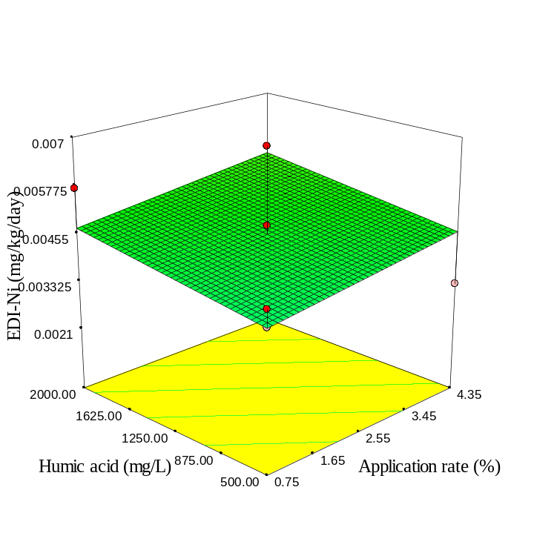 | 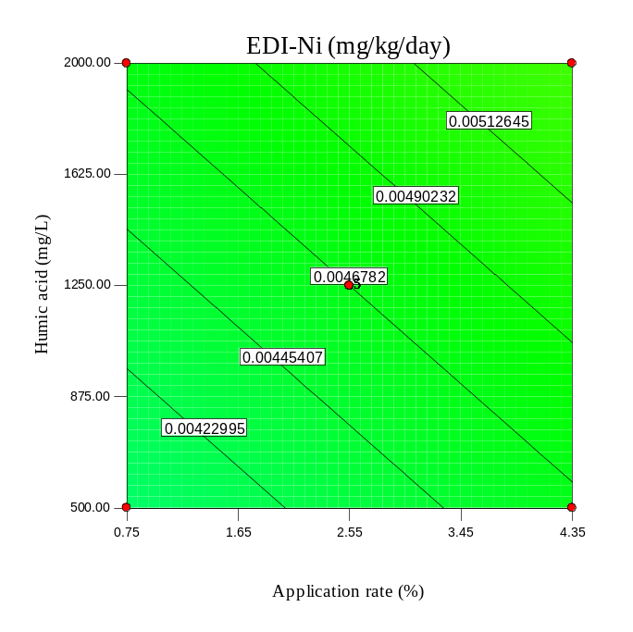
Fig. S44. As Fig S36, but for SBP600.

(a) | (b)
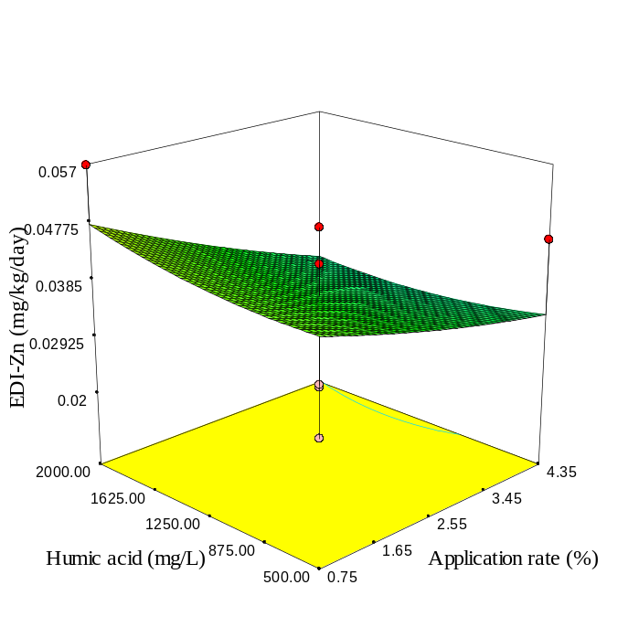 | 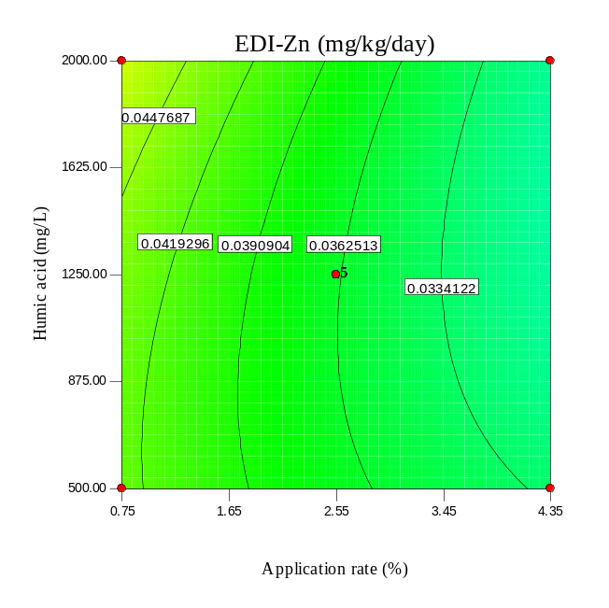
(c) | (d)
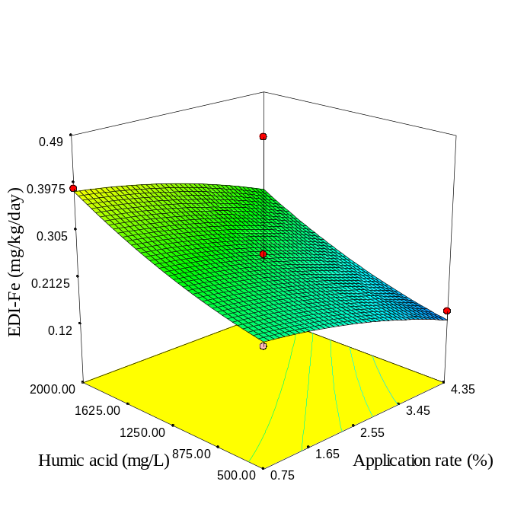 | 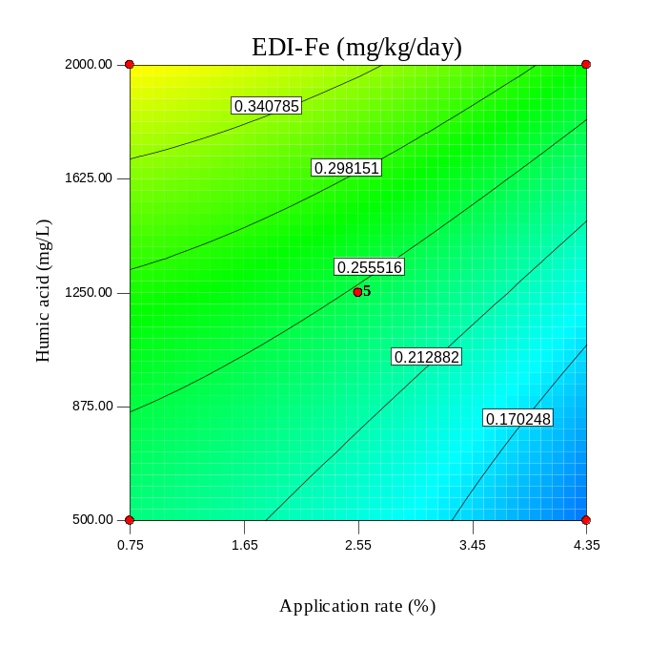
Fig. S45. As Fig S33, but for RH.

(a) | (b)
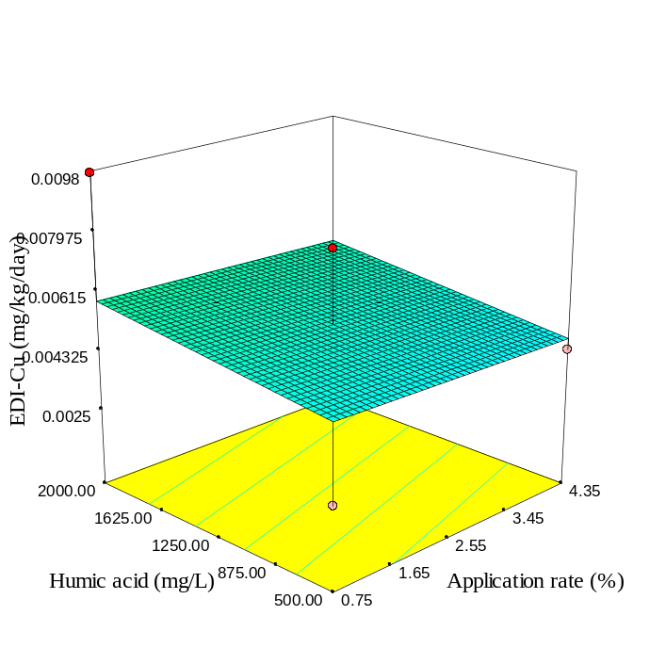 | 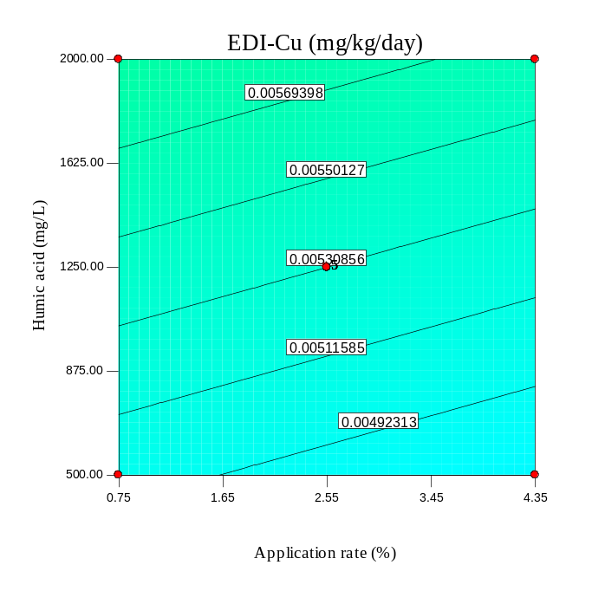
(c) | (d)
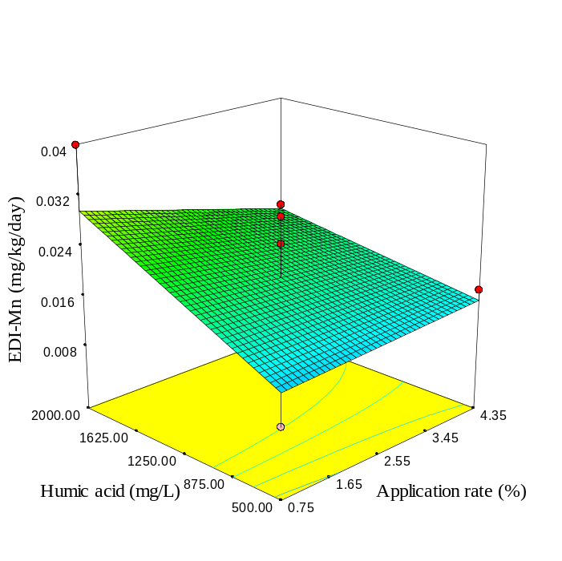 | 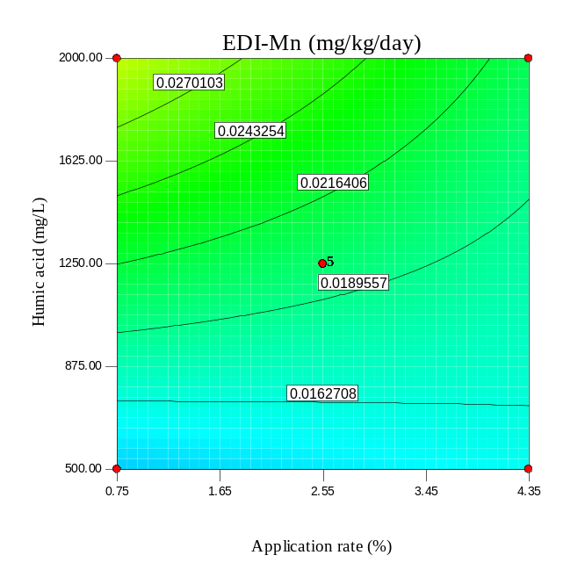
Fig. S46. As Fig S34, but for RH.

(a) | (b)
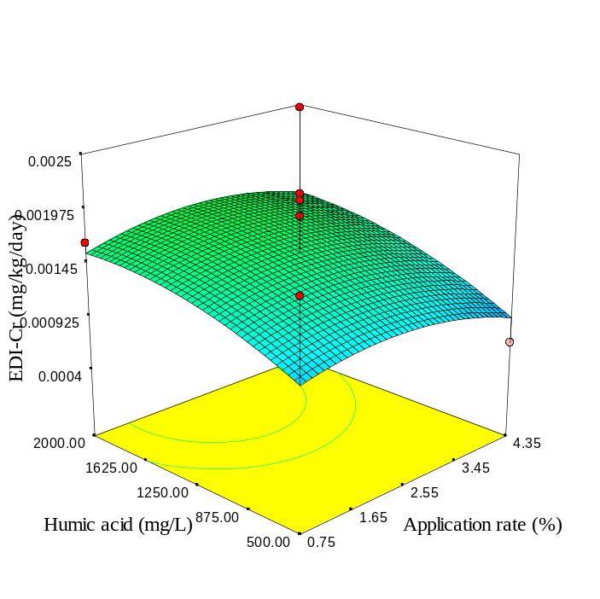 | 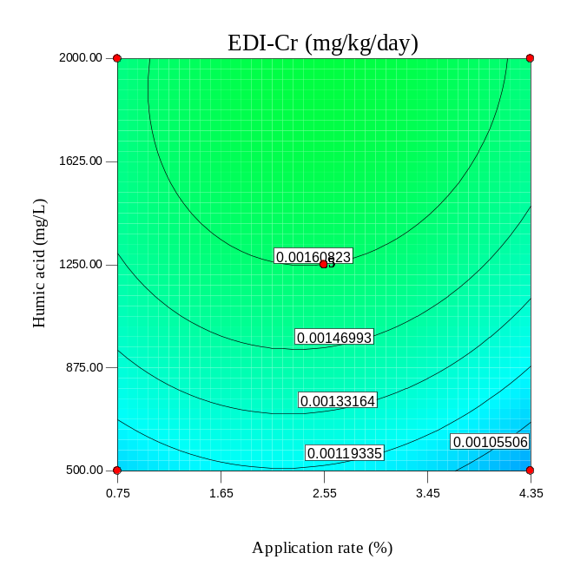
(c) | (d)
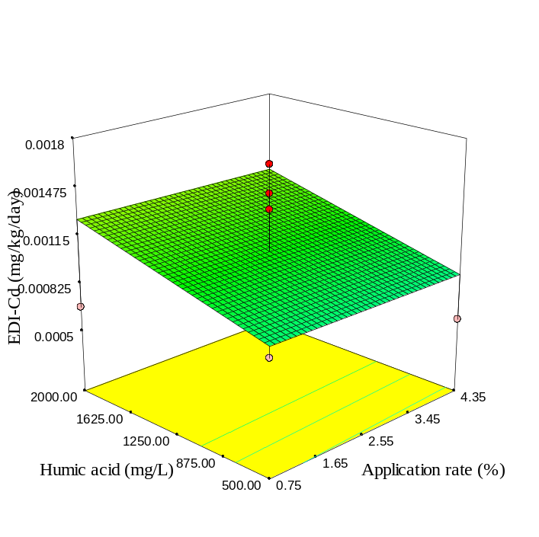 | 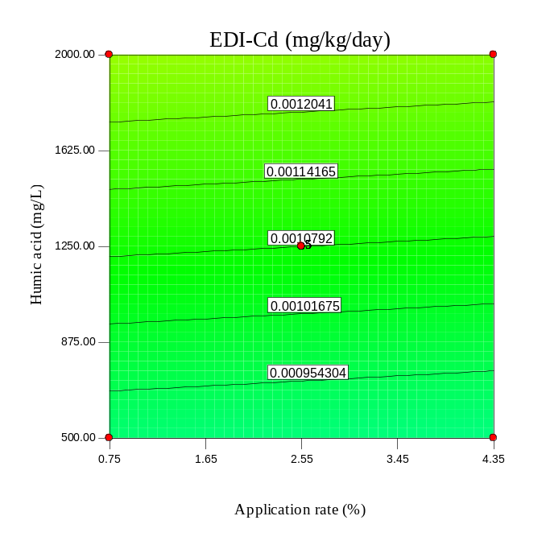
Fig. S47. As Fig S35, but for RH.

(a) | (b)
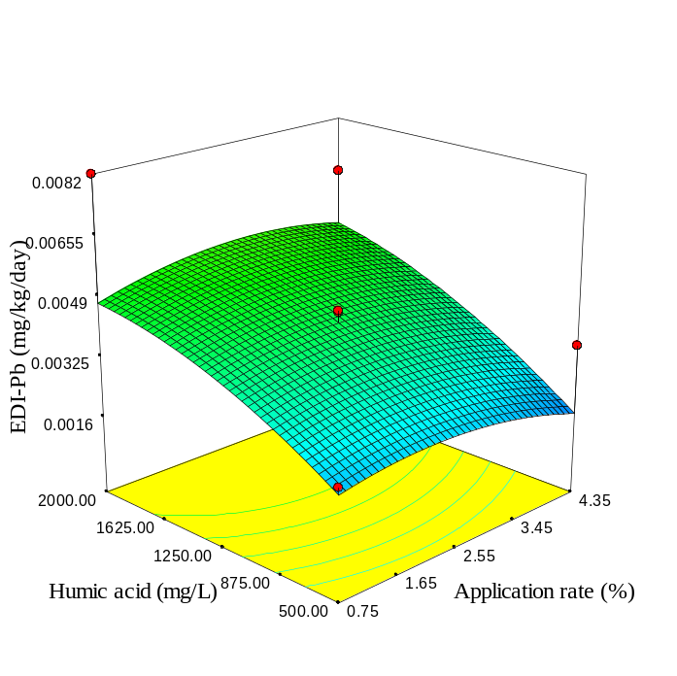 | 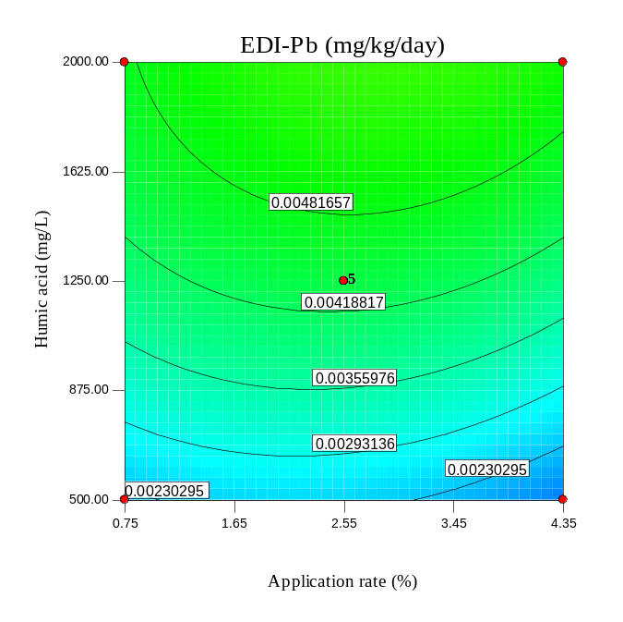
(c) | (d)
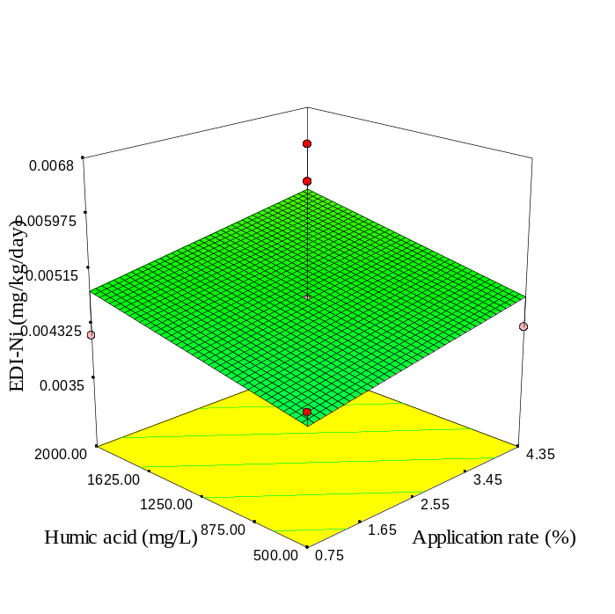 | 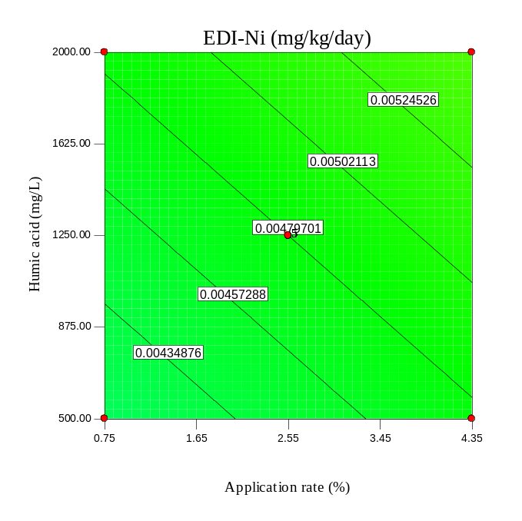
Fig. S48. As Fig S36, but for RH.

(a) | (b)
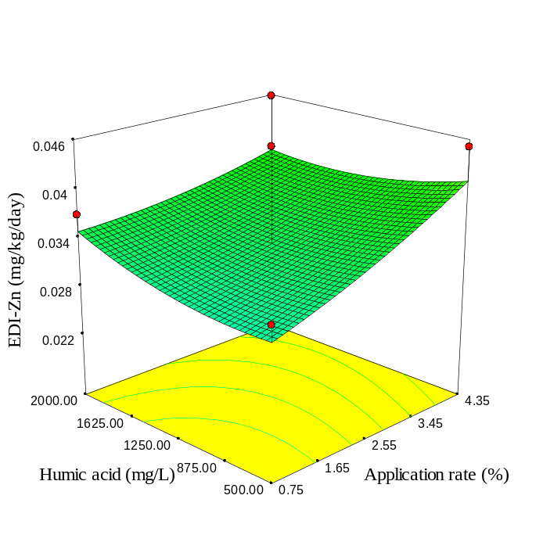 | 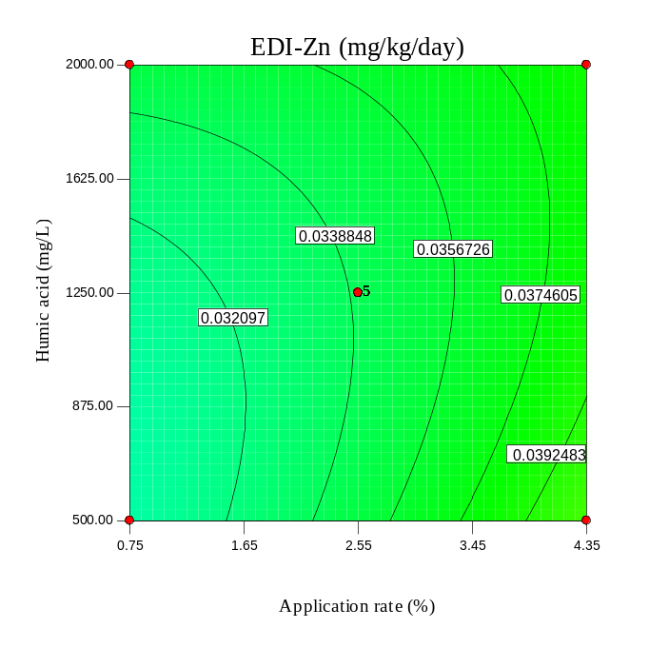
(c) | (d)
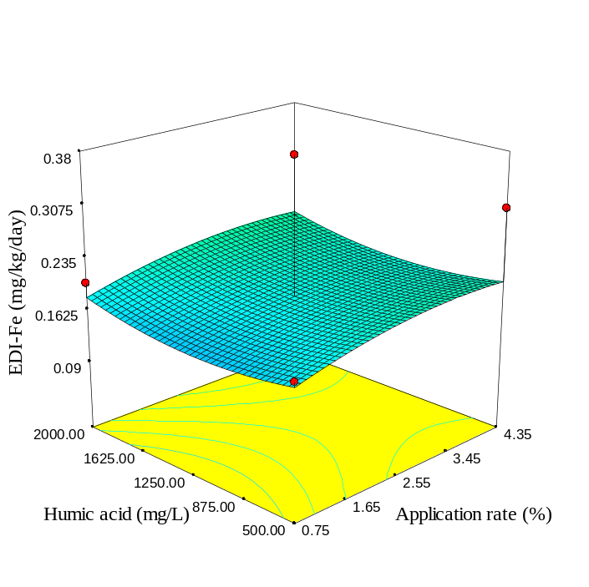 | 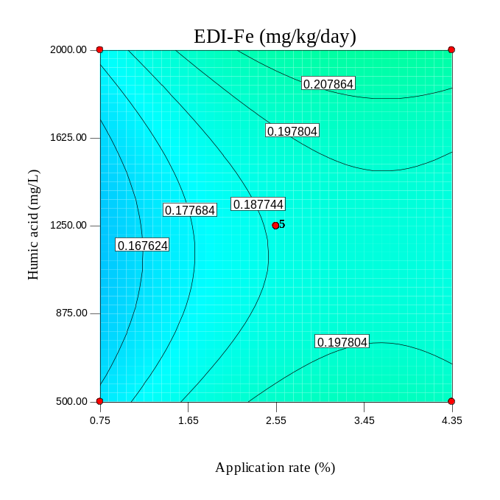
Fig. S49. As Fig S33, but for RH300.

(a) | (b)
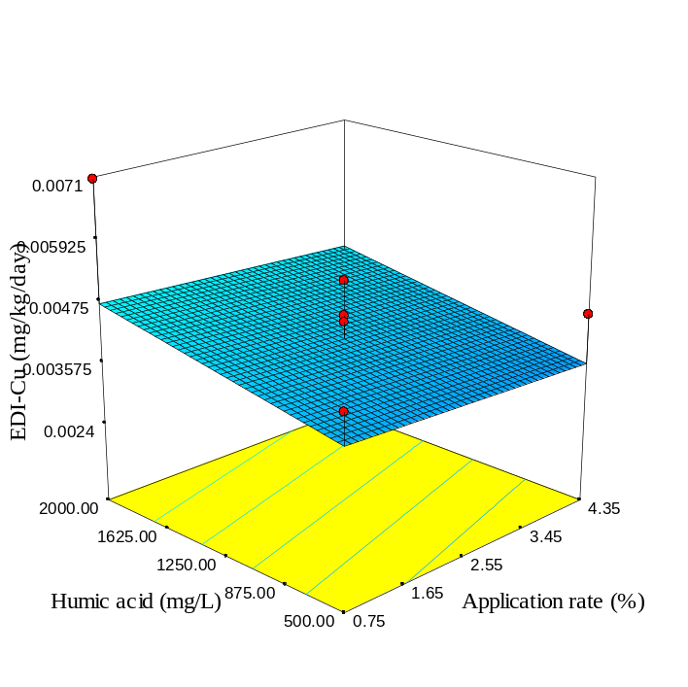 | 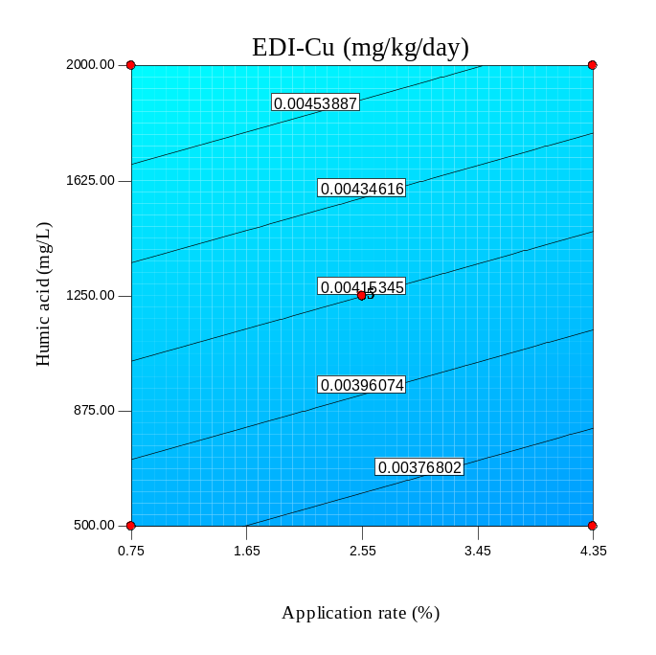
(c) | (d)
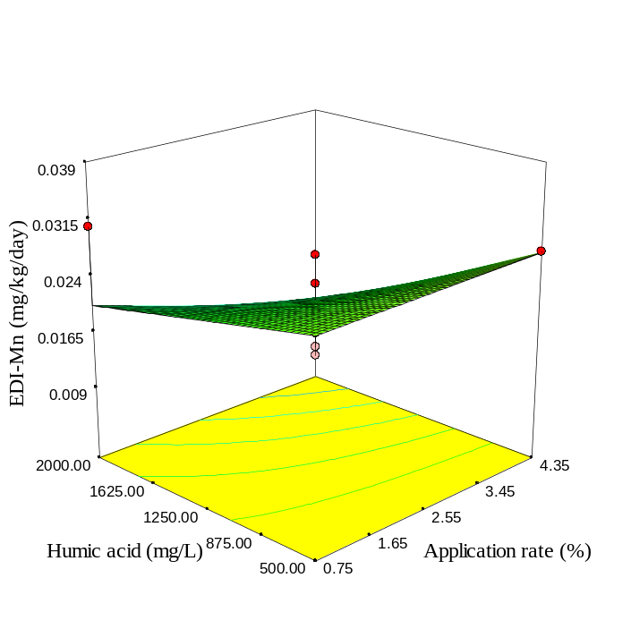 | 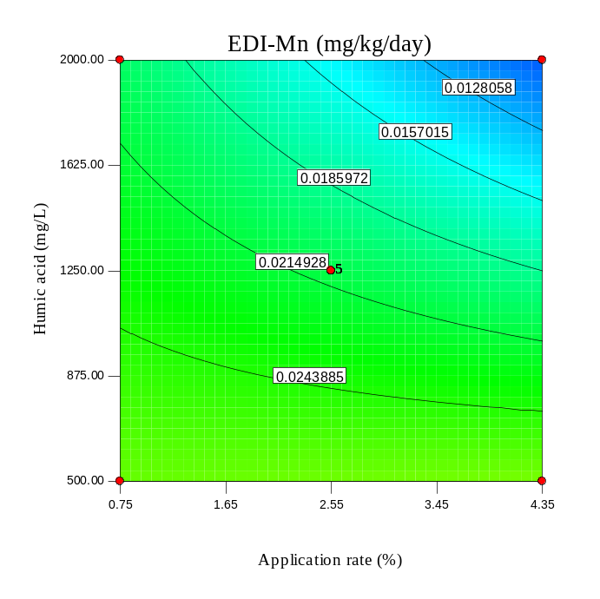
Fig. S50. As Fig S34, but for RH300.

(a) | (b)
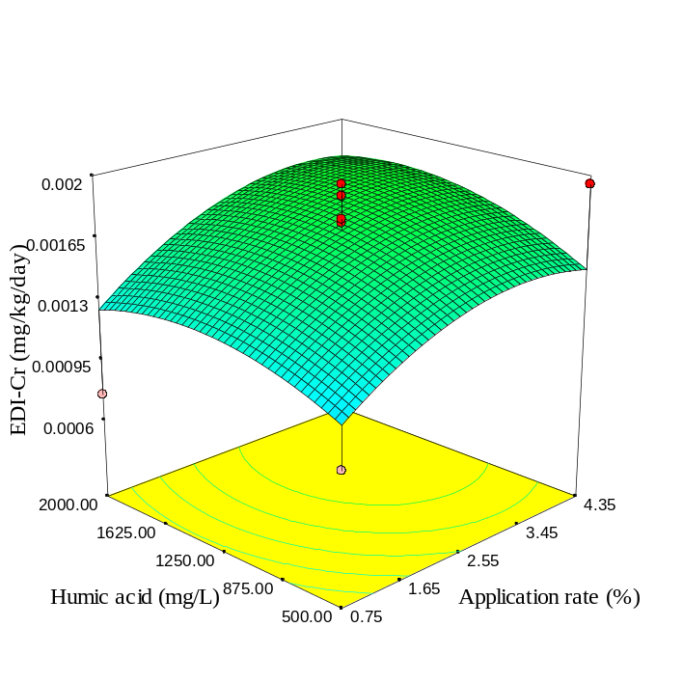 | 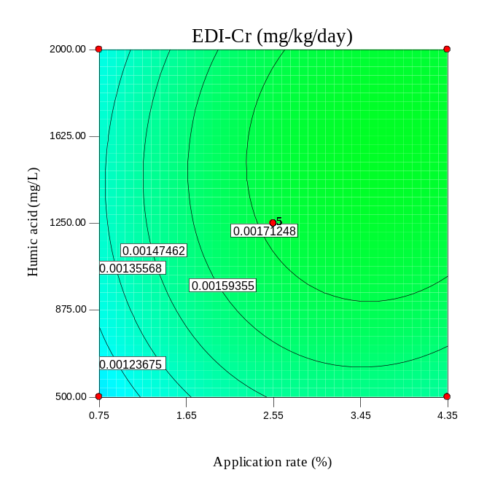
(c) | (d)
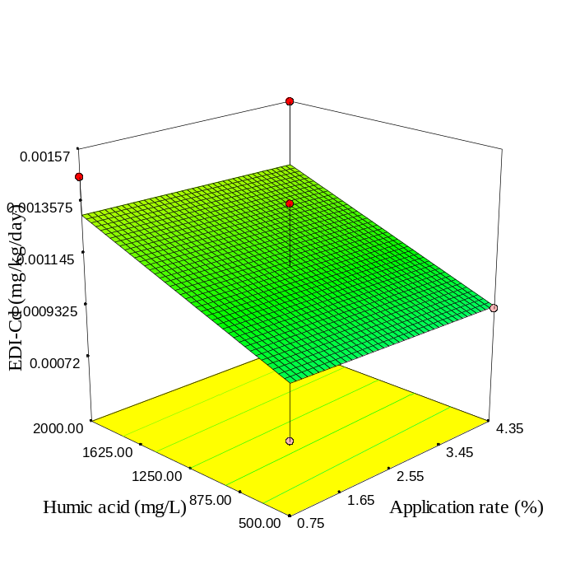 | 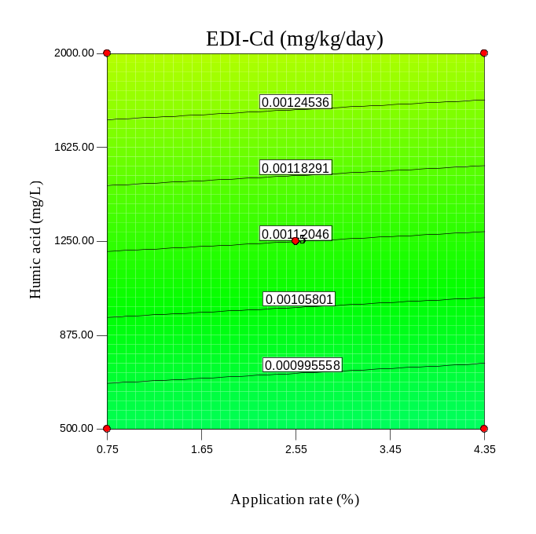
Fig. S51. As Fig S35, but for RH300.

(a) | (b)
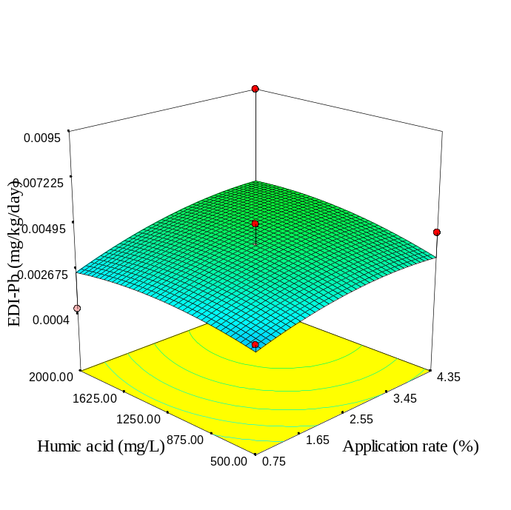 | 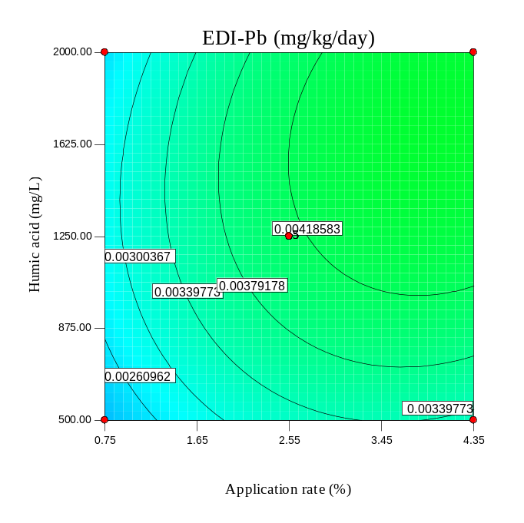
(c) | (d)
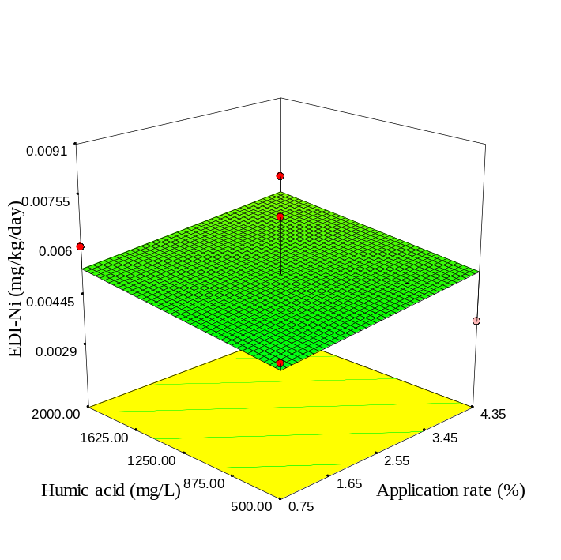 | 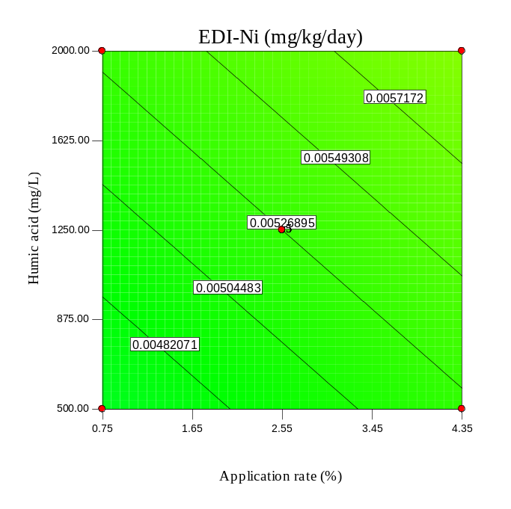
Fig. S52. As Fig S36, but for RH300.

(a) | (b)
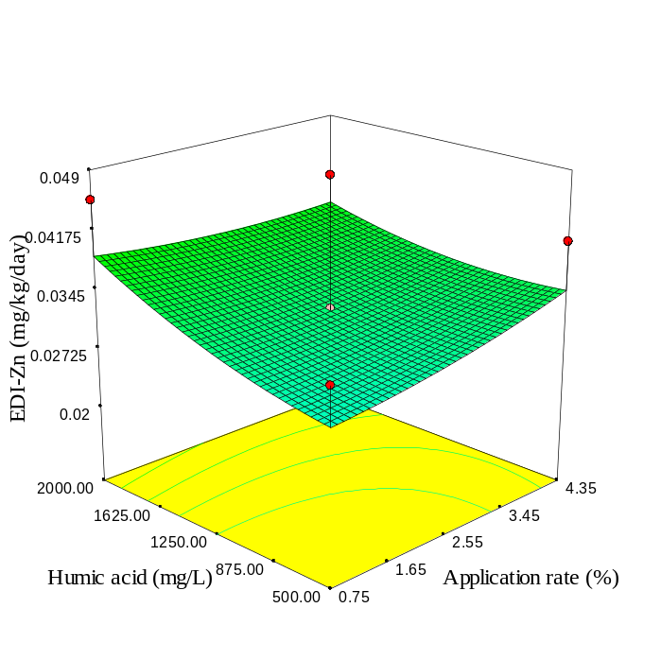 | 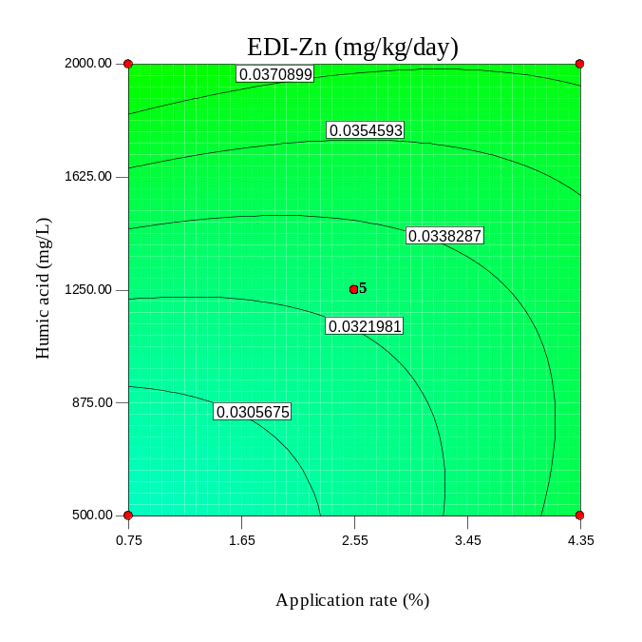
(c) | (d)
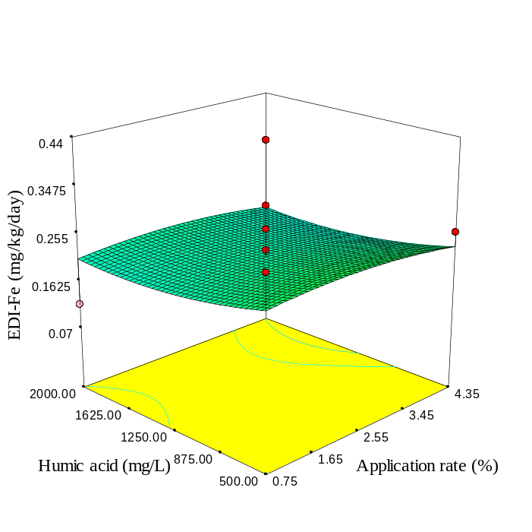 | 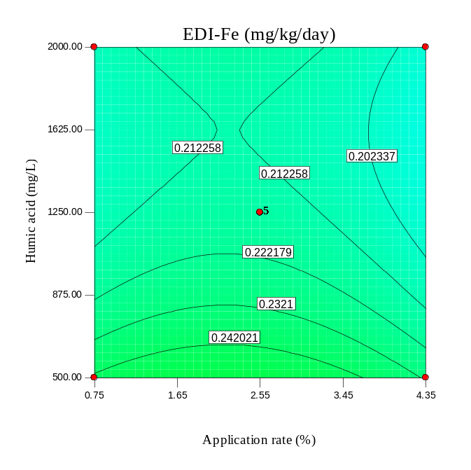
Fig. S53. As Fig S33, but for RH600.

(a) | (b)
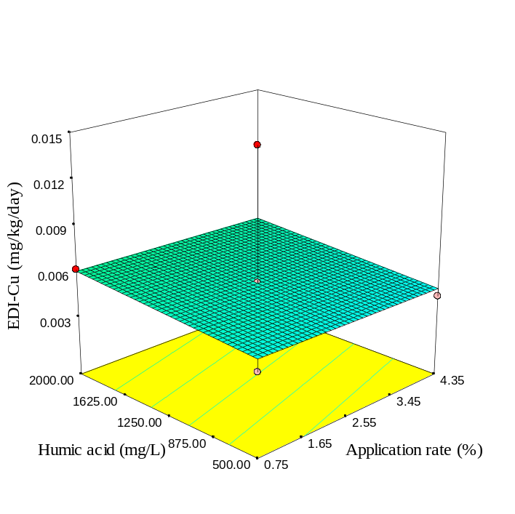 | 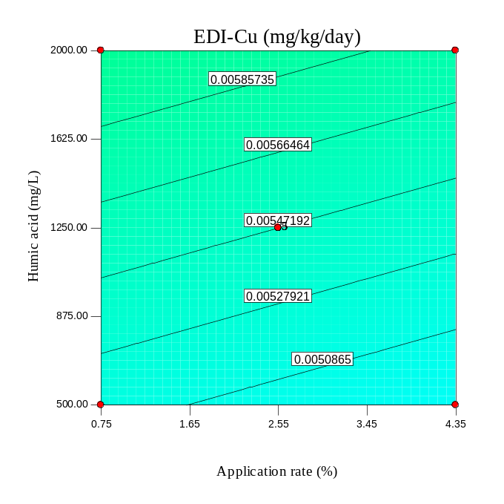
(c) | (d)
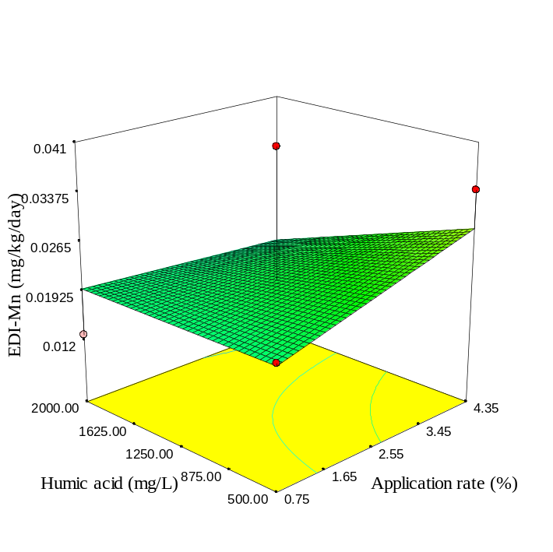 | 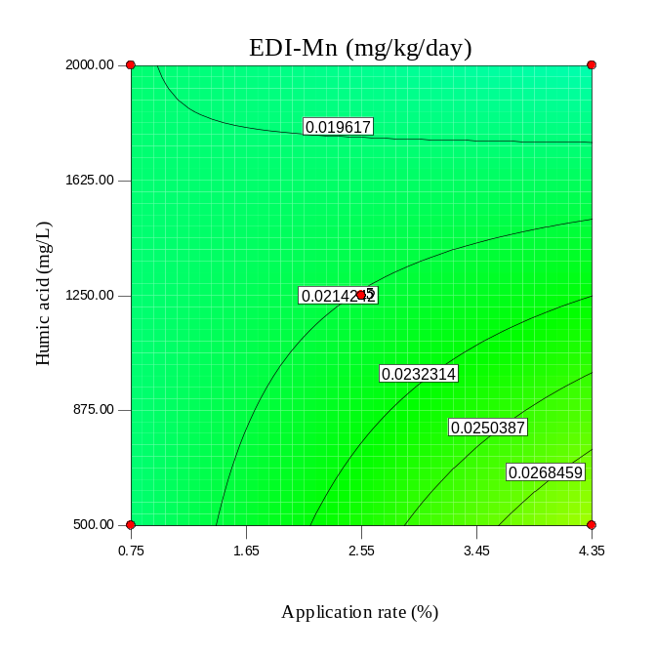
Fig. S54. As Fig S34, but for RH600.

(a) | (b)
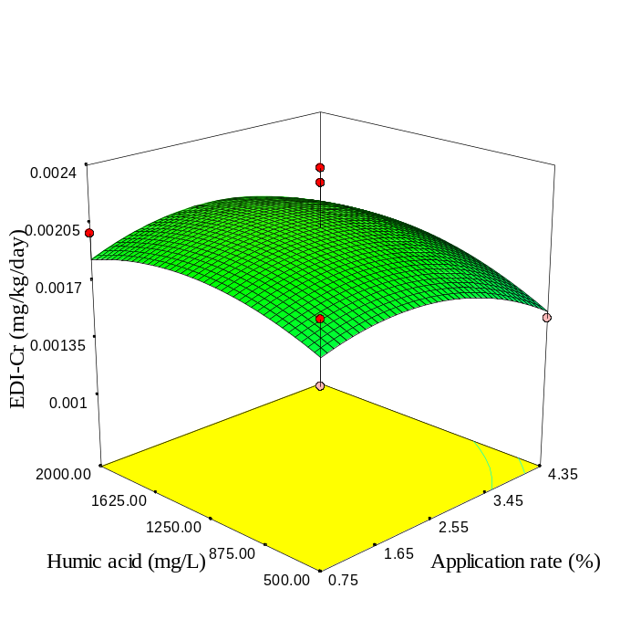 | 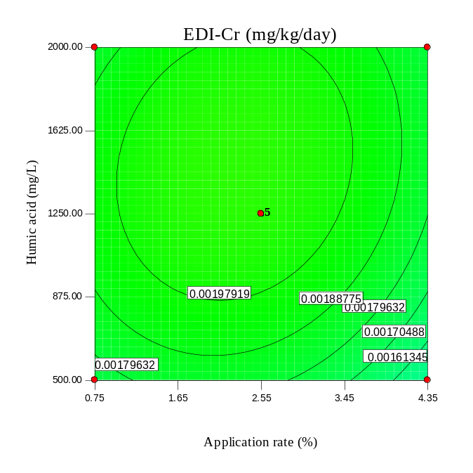
(c) | (d)
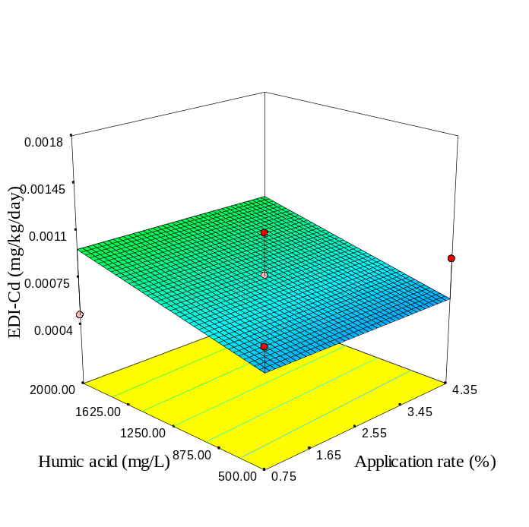 | 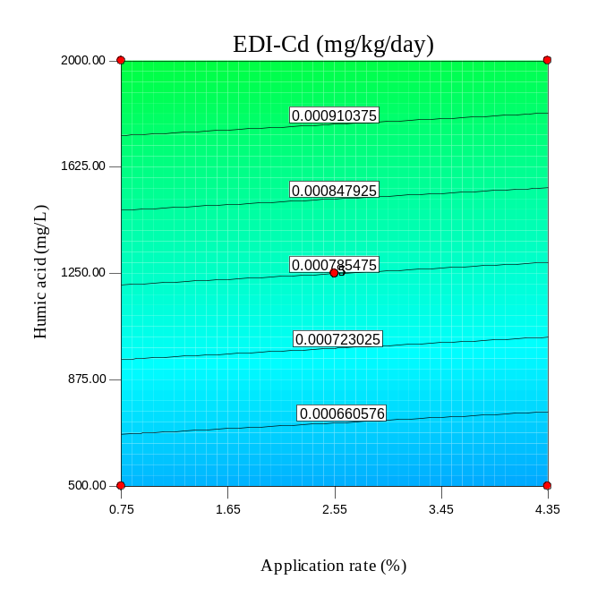
Fig. S55. As Fig S35, but for RH600.

(a) | (b)
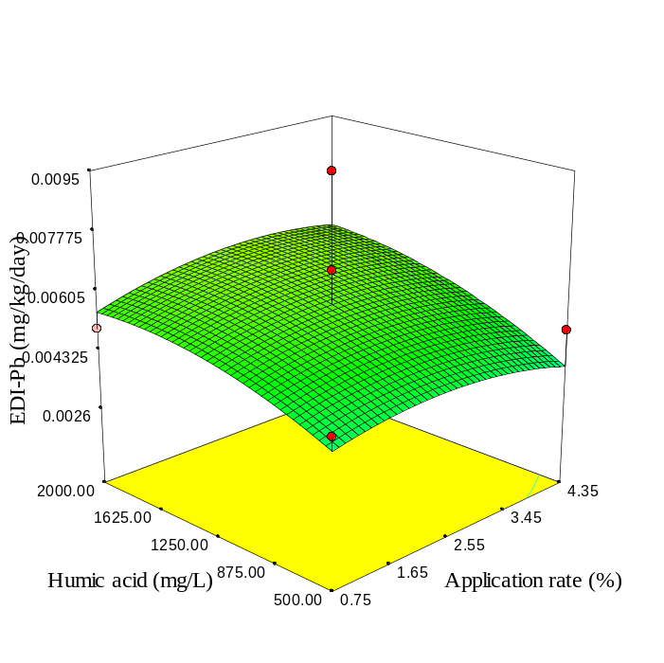 | 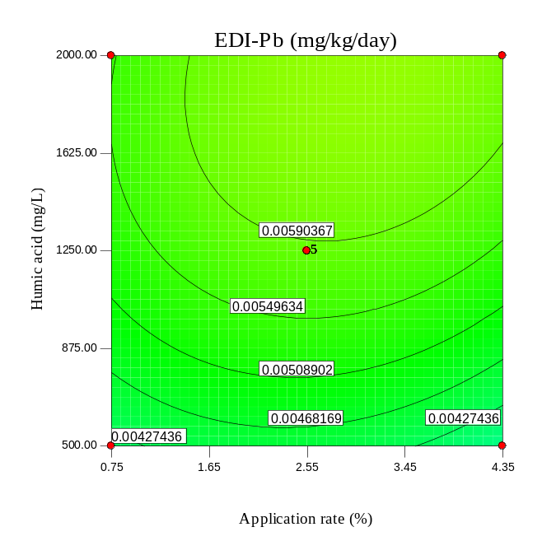
(c) | (d)
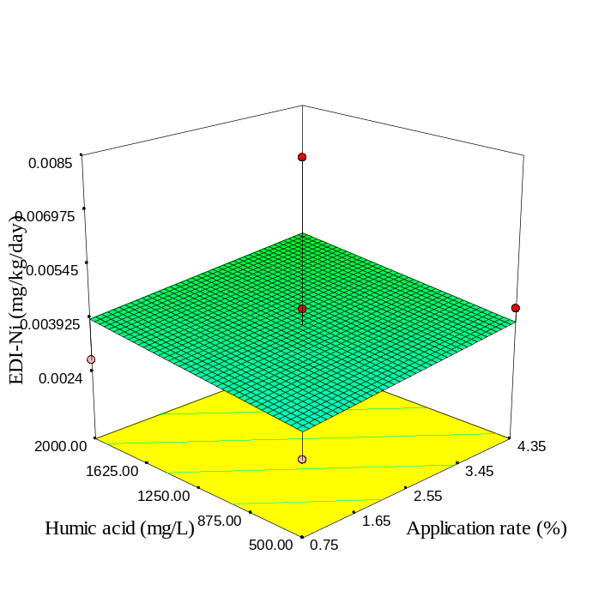 | 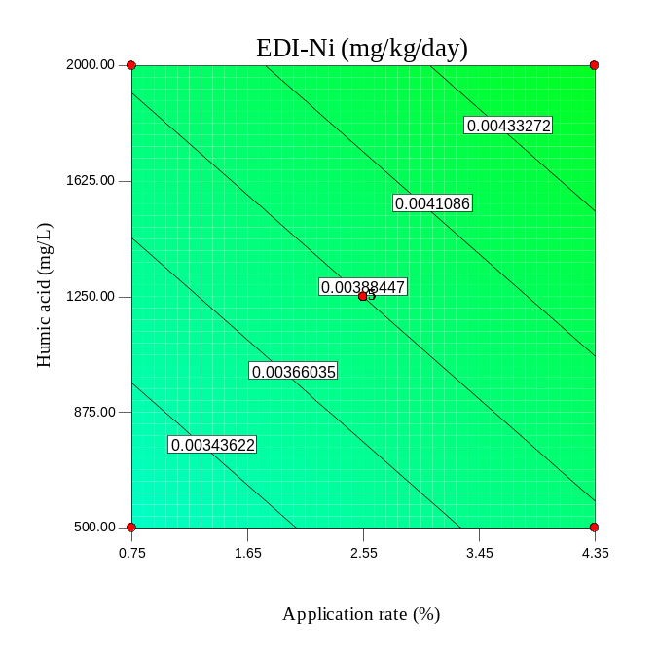
Fig. S56. As Fig S36, but for RH600.

(a) | (b)
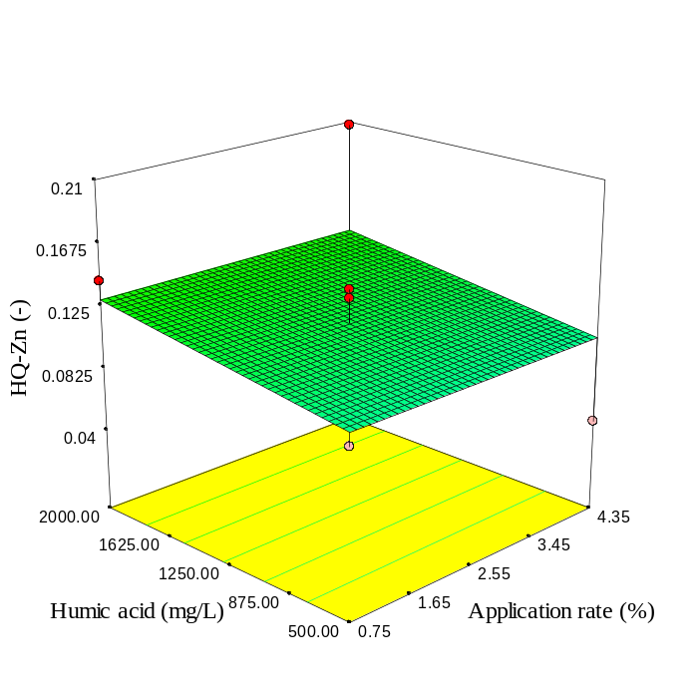 | 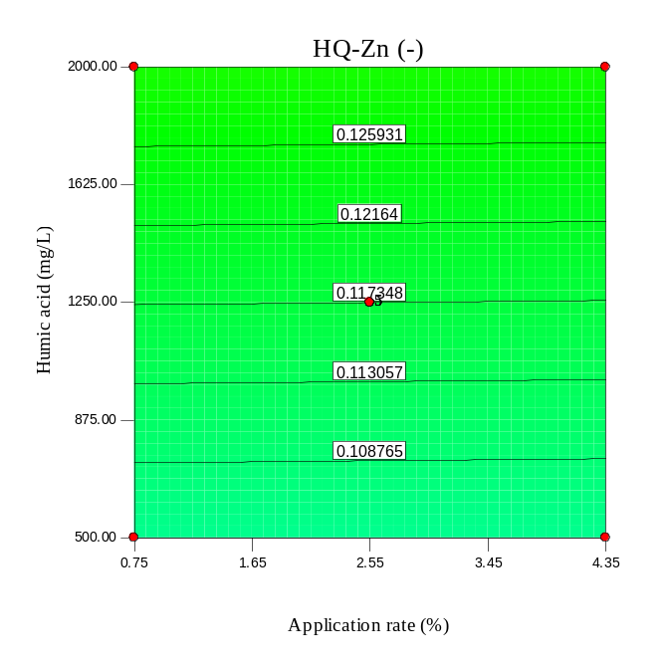
(c) | (d)
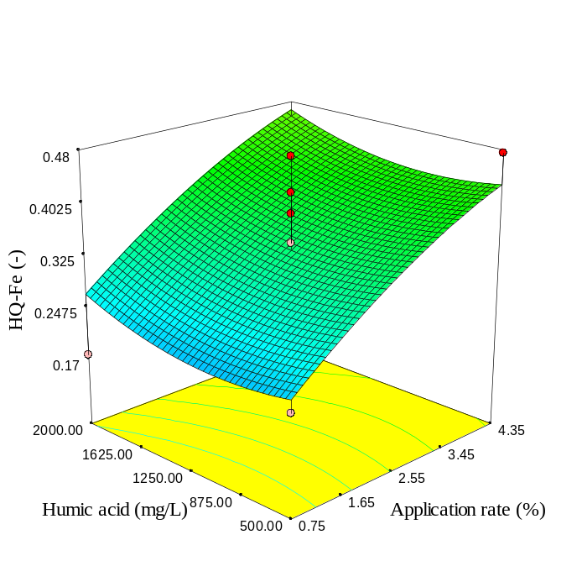 | 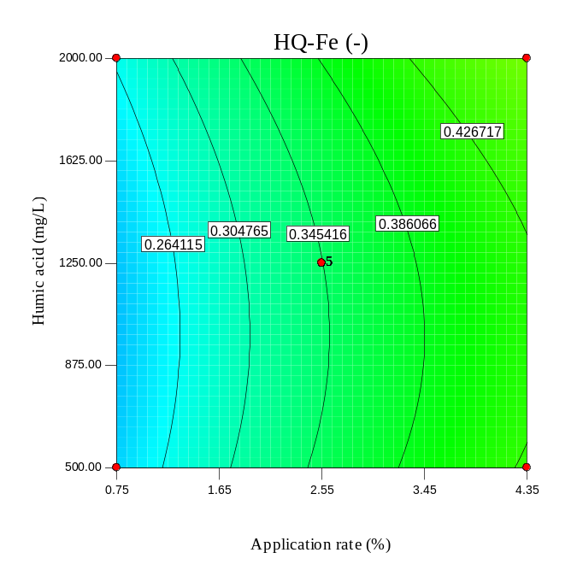
Fig. S57. 3D surface and contour plots of HQ-Zn and HQ-Fe due to ingestion of spinach leaves affected by humic acid concentration and SBP application rate.

(a) | (b)
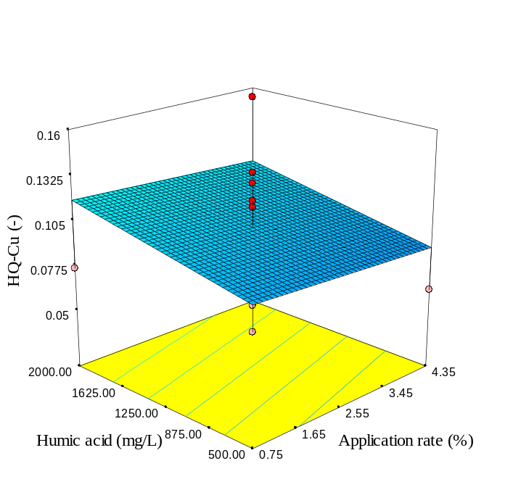 | 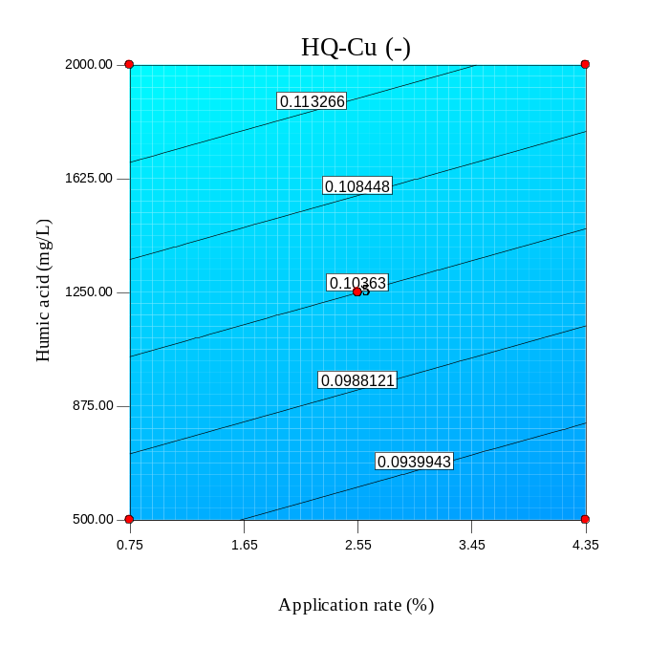
(c) | (d)
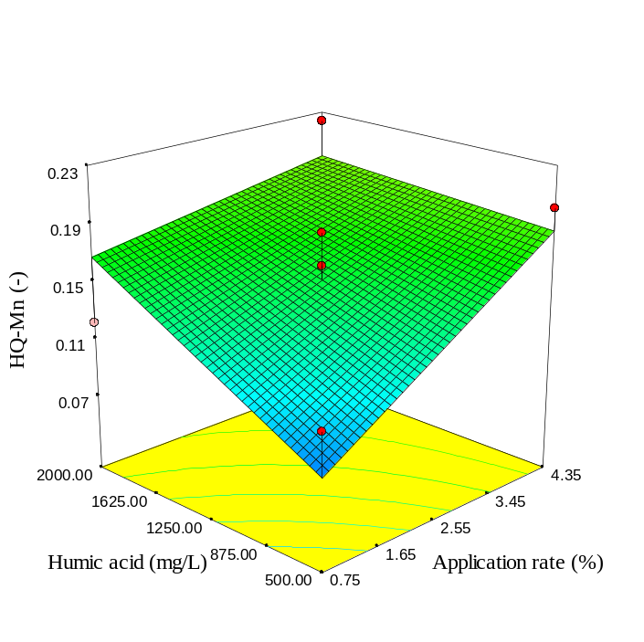 | 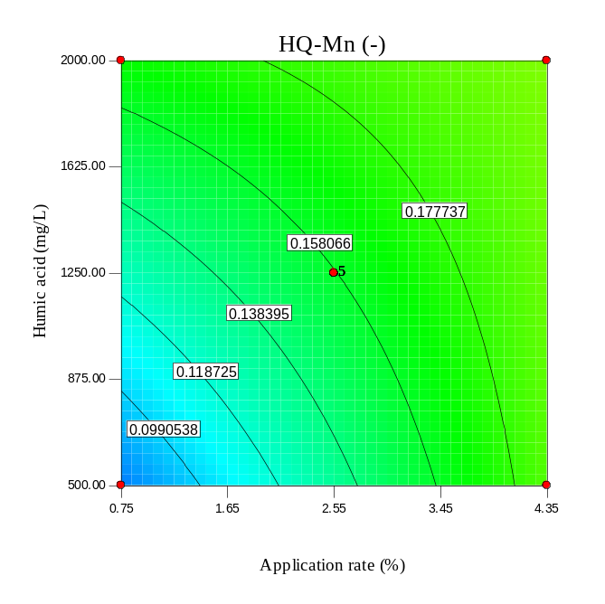
Fig. S58. 3D surface and contour plots of HQ-Cu and HQ-Mn due to ingestion of spinach leaves affected by humic acid concentration and SBP application rate.

(a) | (b)
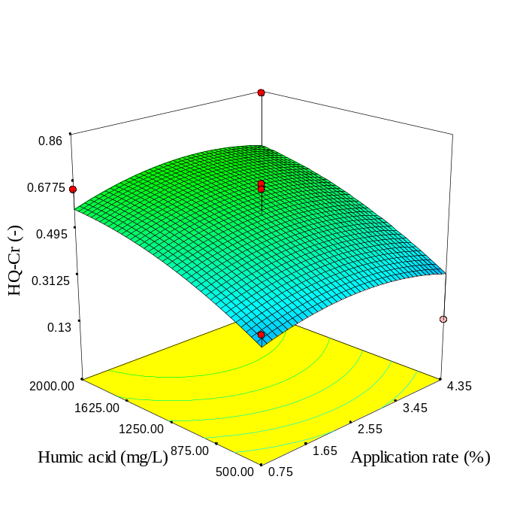 | 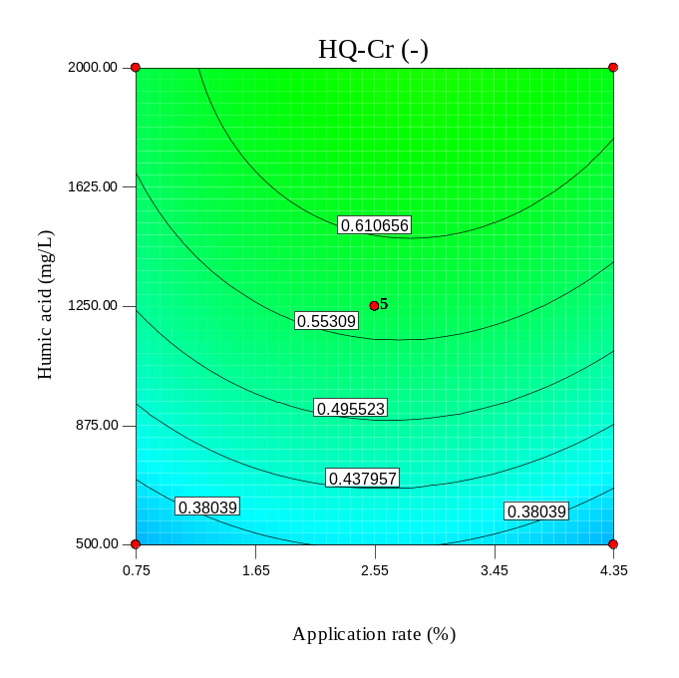
(c) | (d)
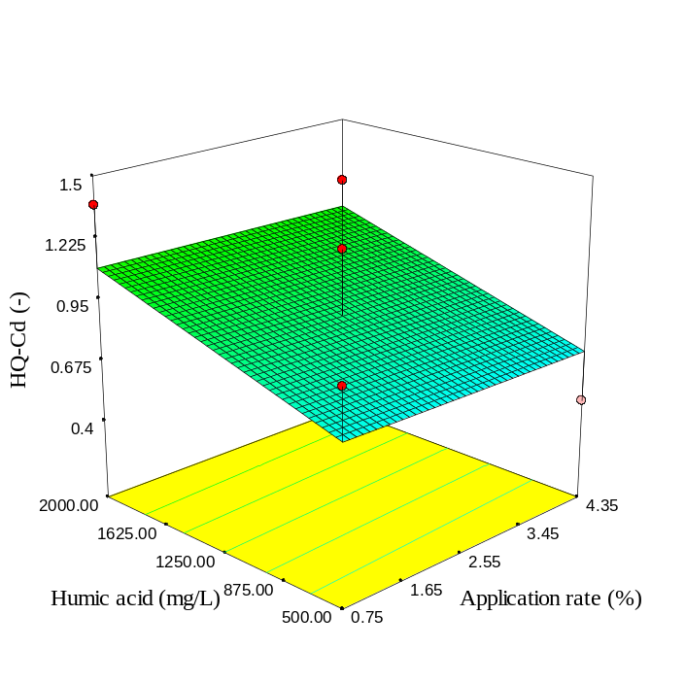 | 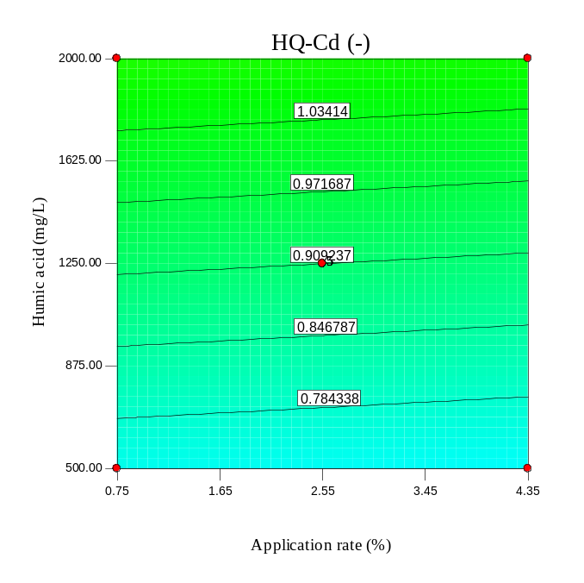
Fig. S59. 3D surface and contour plots of HQ-Cr and HQ-Cd due to ingestion of spinach leaves affected by humic acid concentration and SBP application rate.

(a) | (b)
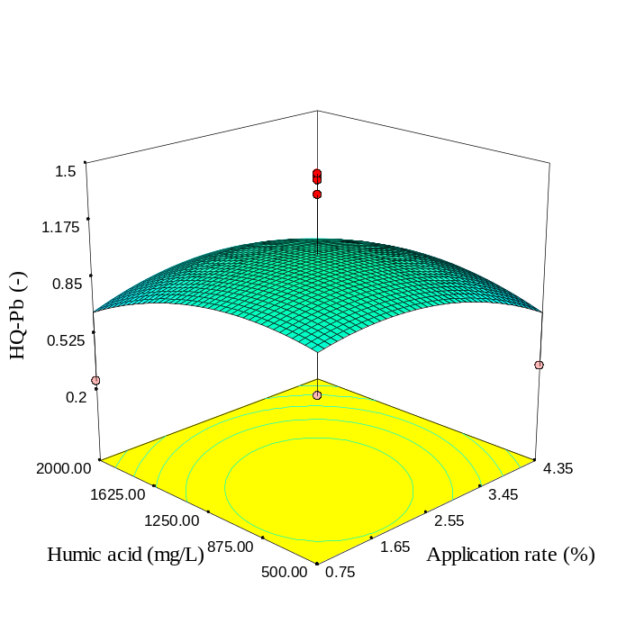 | 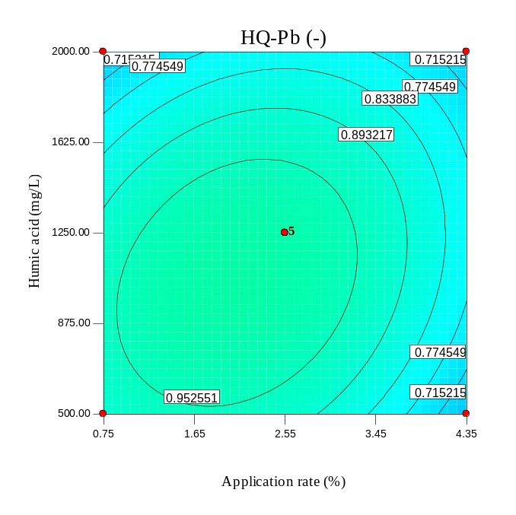
(c) | (d)
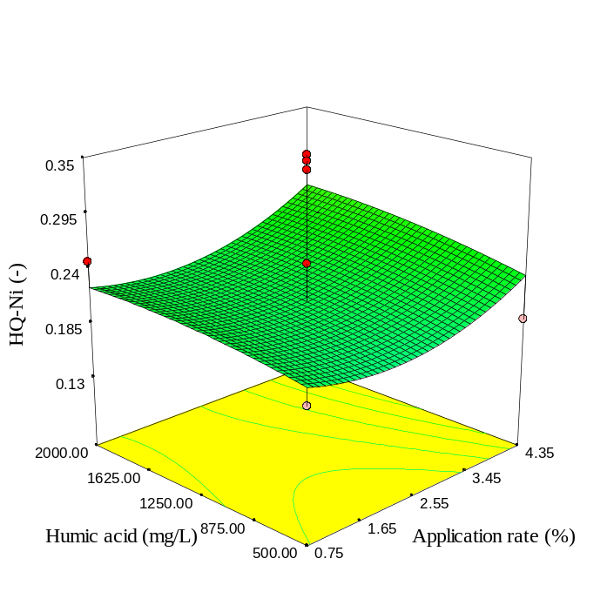 | 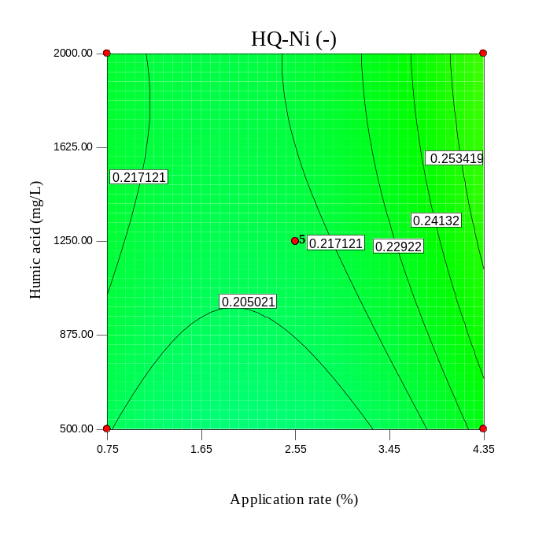
Fig. S60. 3D surface and contour plots of HQ-Pb and HQ-Ni due to ingestion of spinach leaves affected by humic acid concentration and SBP application rate.

(a) | (b)
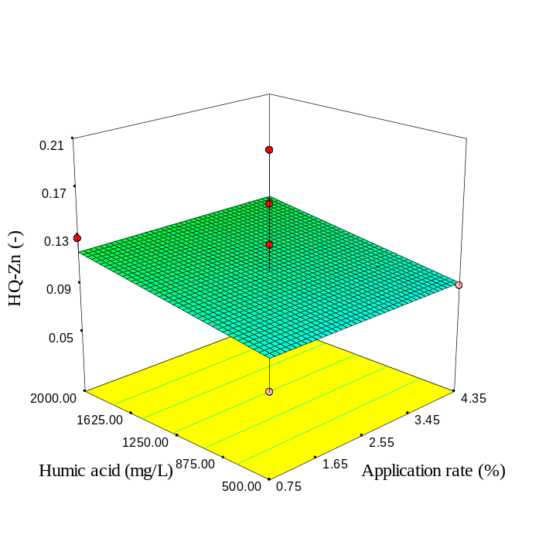 | 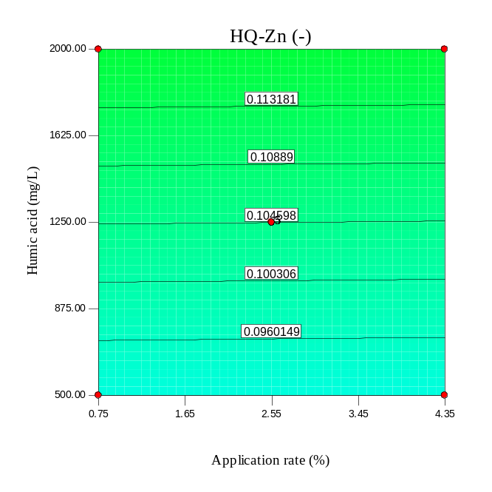
(c) | (d)
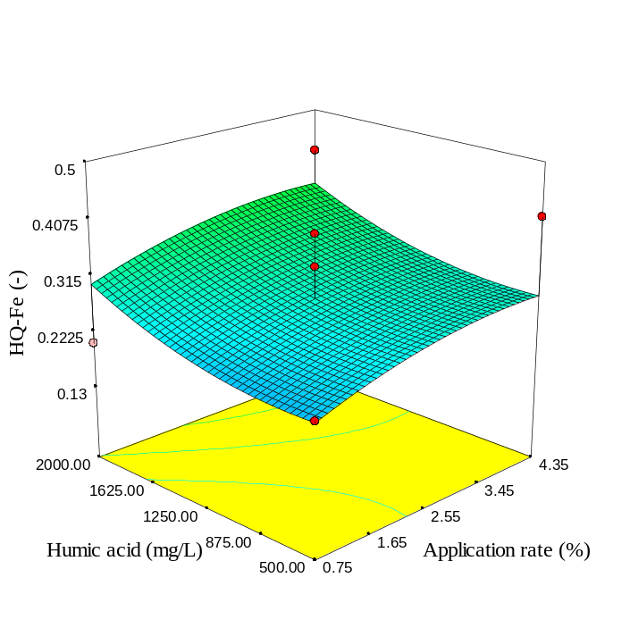 | 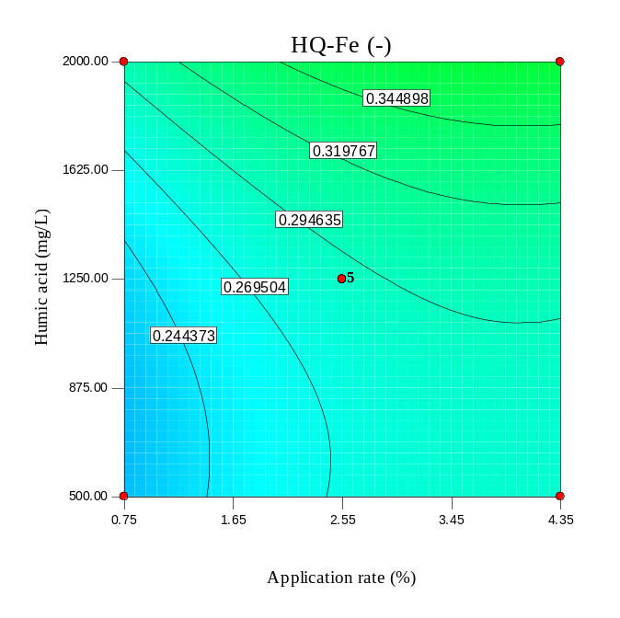
Fig. S61. As Fig S57, but for SBP300.

(a) | (b)
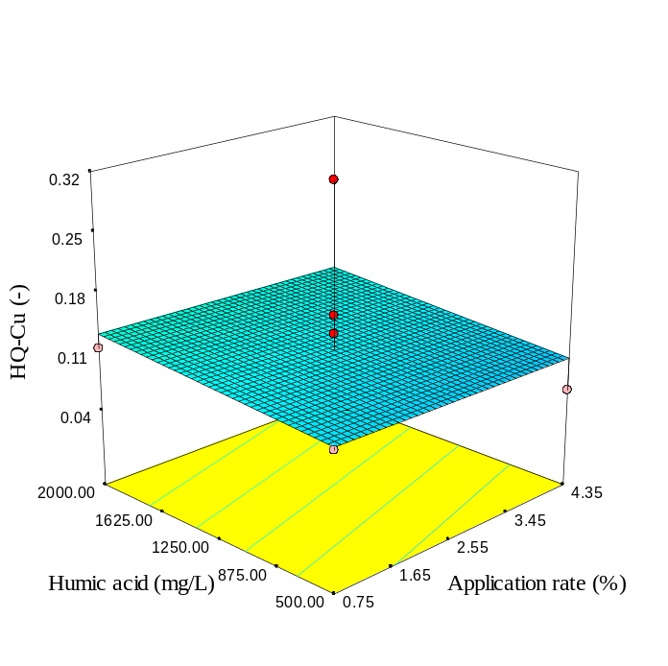 | 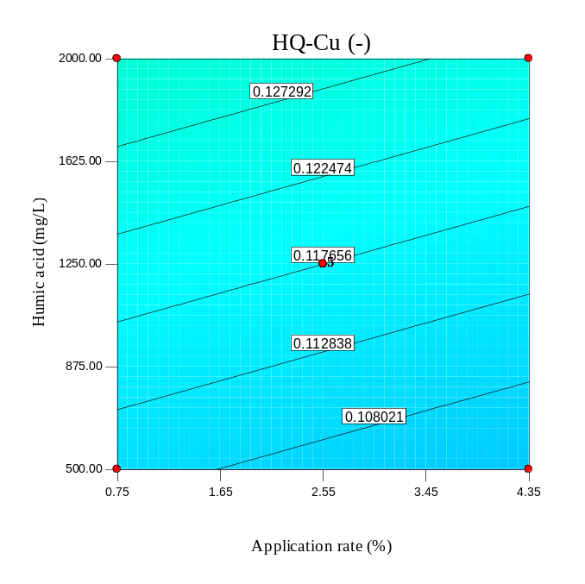
(c) | (d)
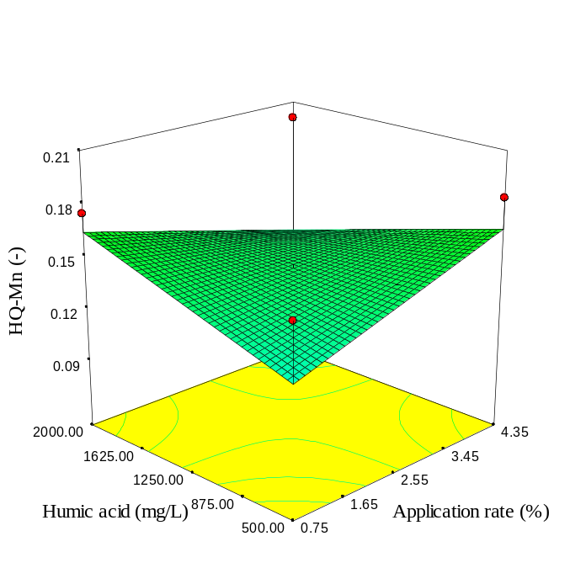 | 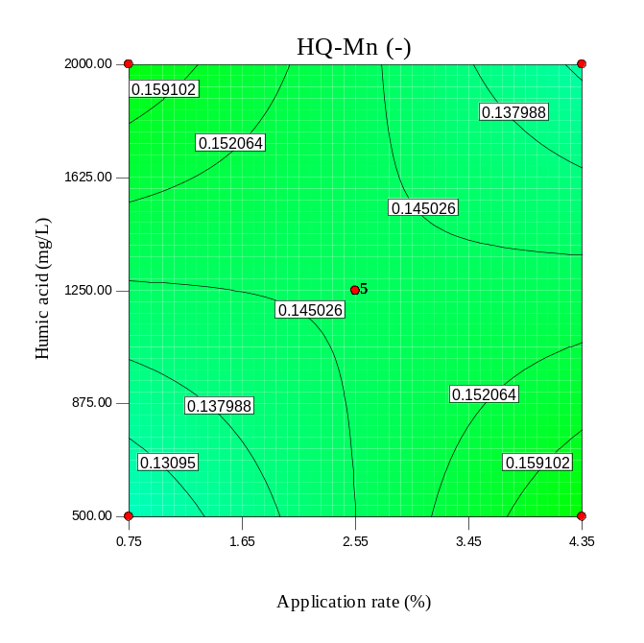
Fig. S62. As Fig S58, but for SBP300.

(a) | (b)
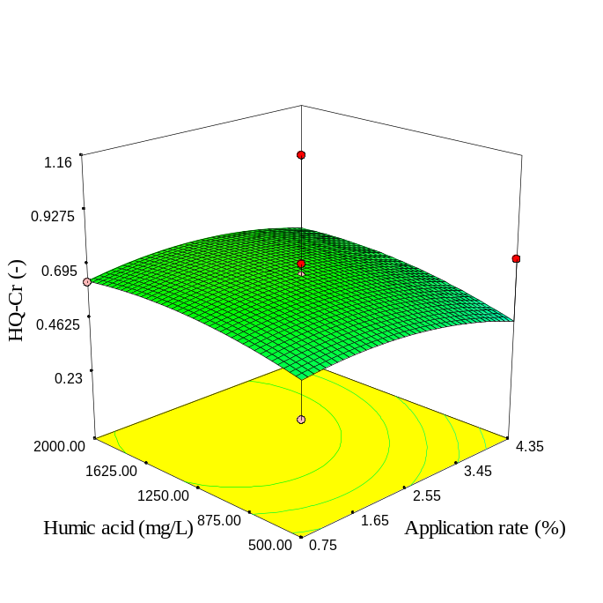 | 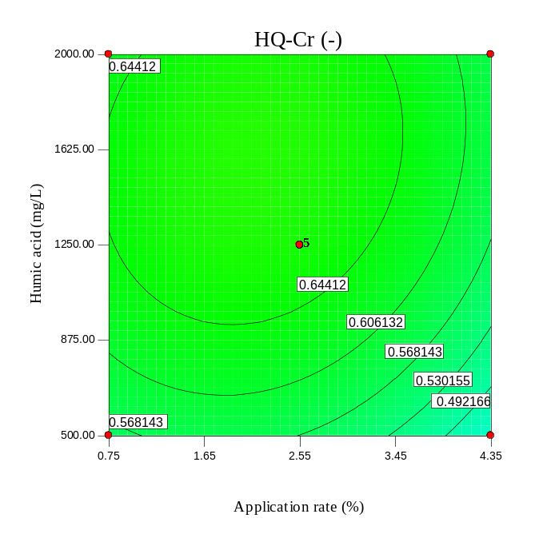
(c) | (d)
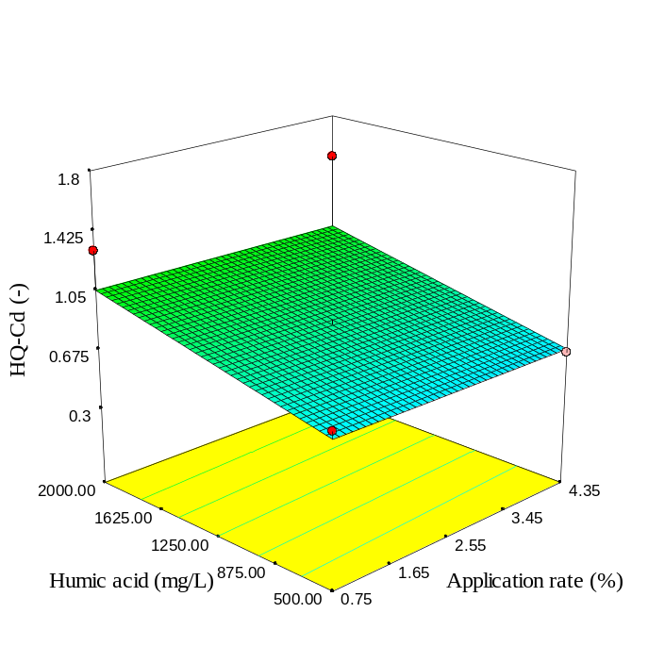 | 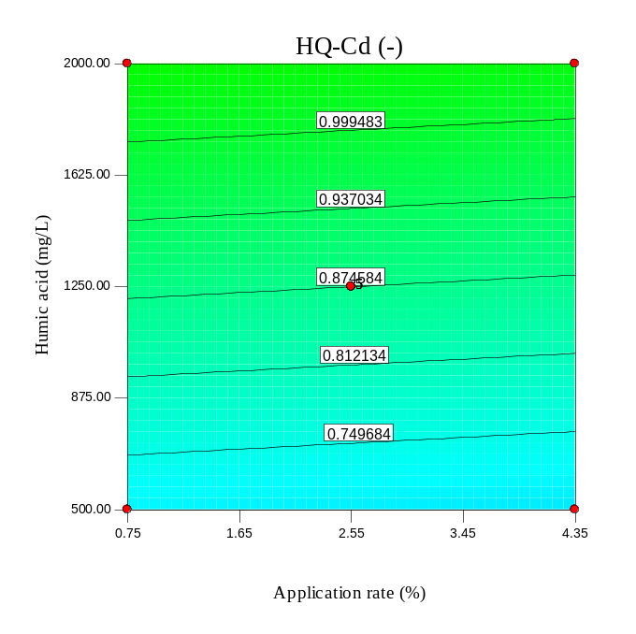
Fig. S63. As Fig S59, but for SBP300.

(a) | (b)
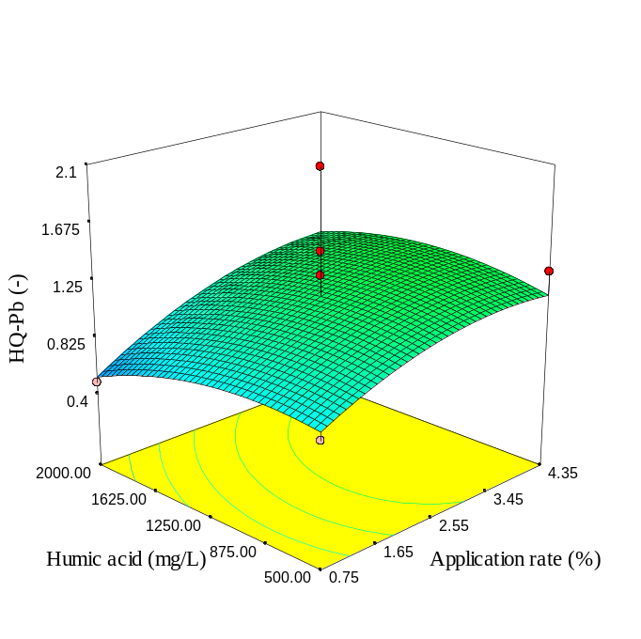 | 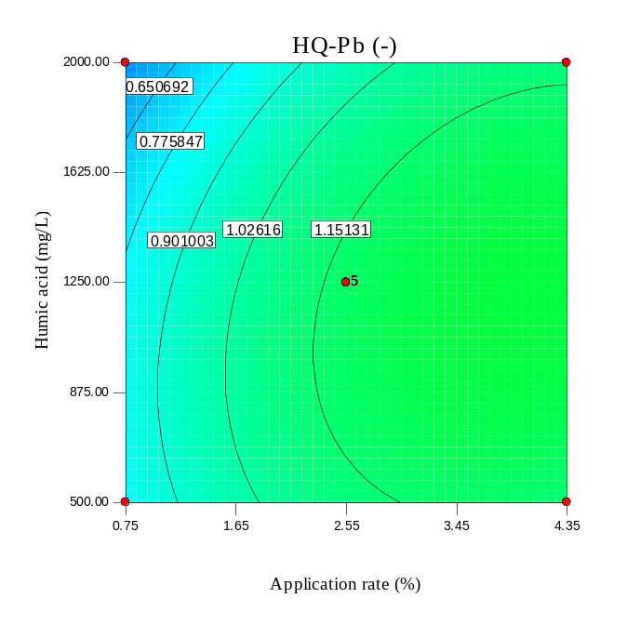
(c) | (d)
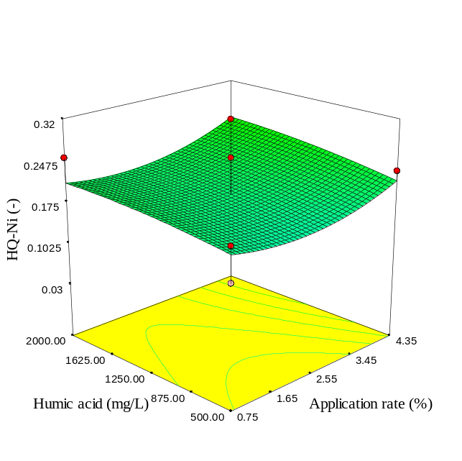 | 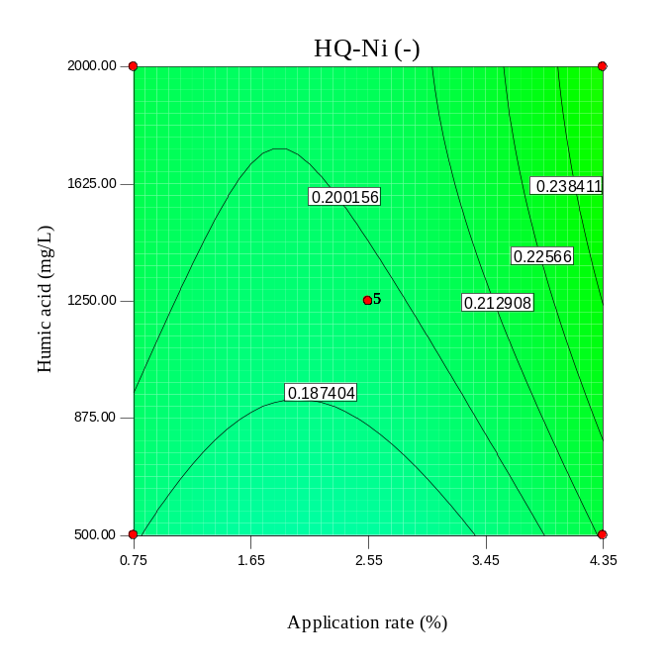
Fig. S64. As Fig S60, but for SBP300.

(a) | (b)
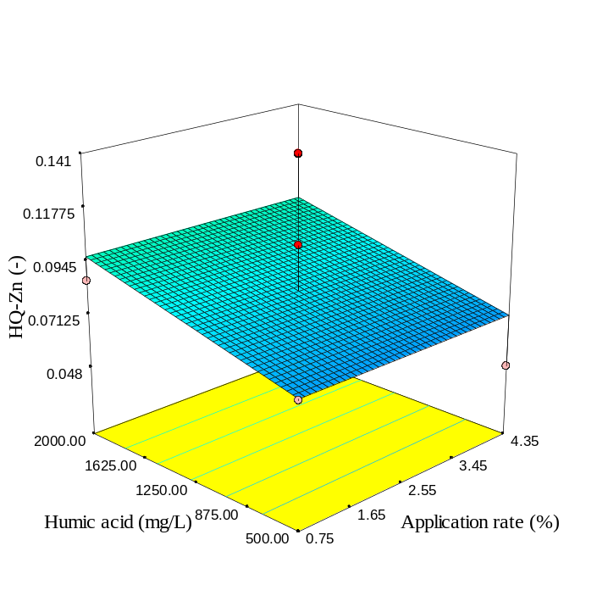 | 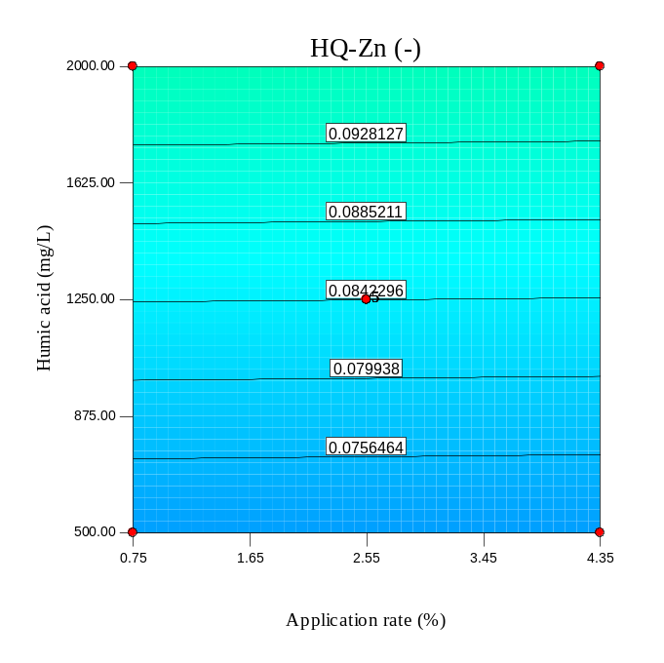
(c) | (d)
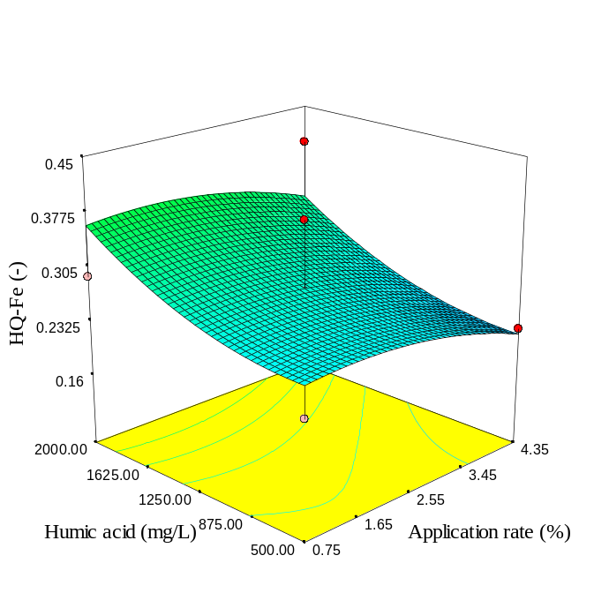 | 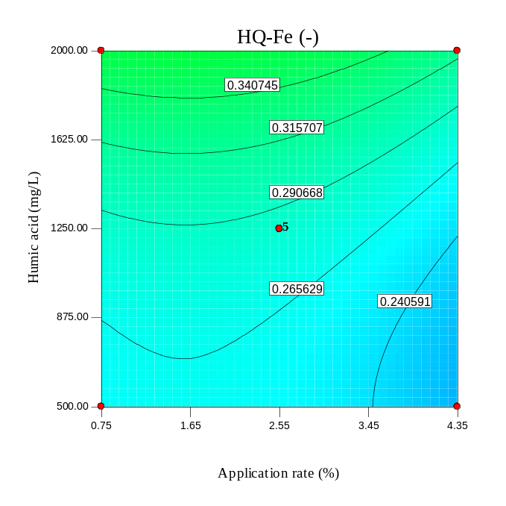
Fig. S65. As Fig S57, but for SBP600.

(a) | (b)
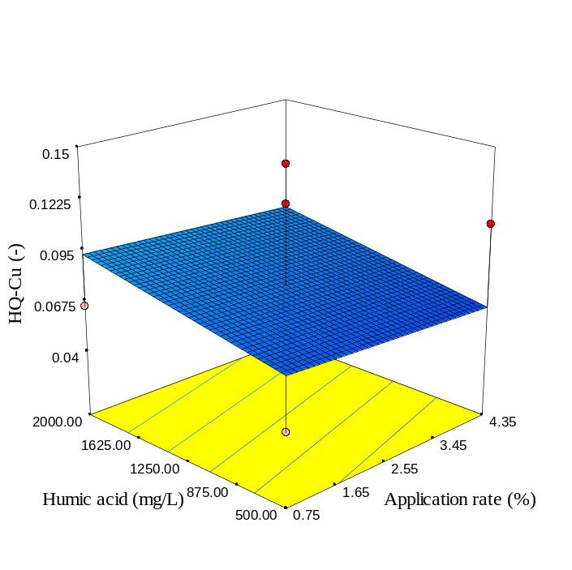 | 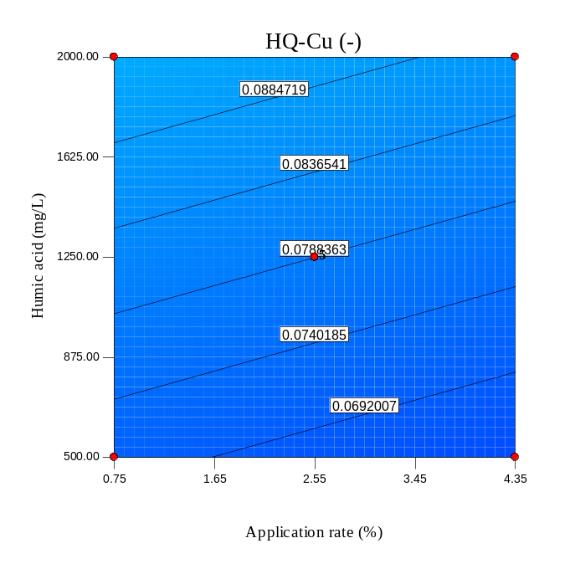
(c) | (d)
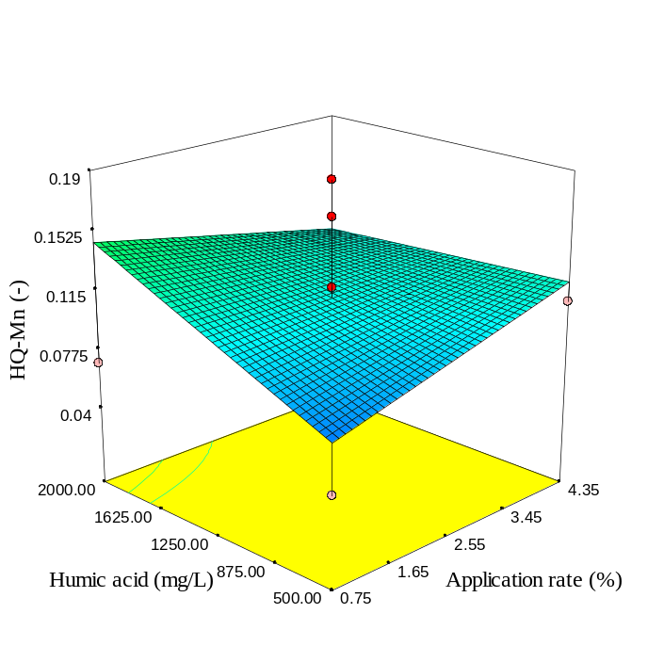 | 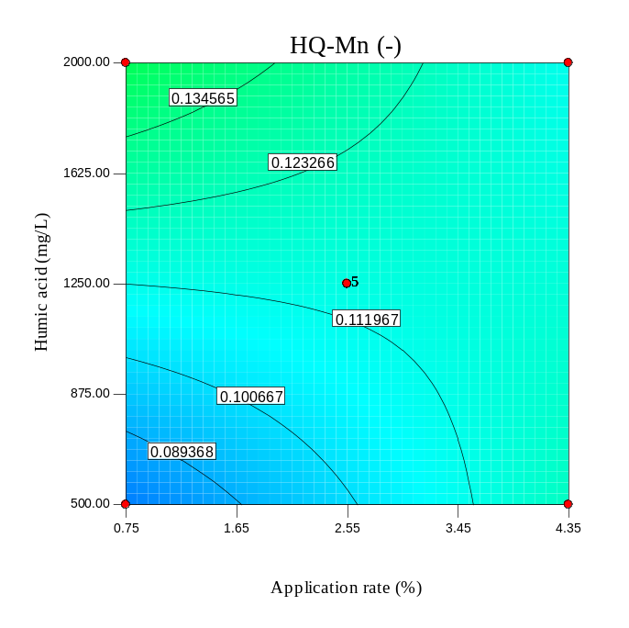
Fig. S66. As Fig S58, but for SBP600.

(a) | (b)
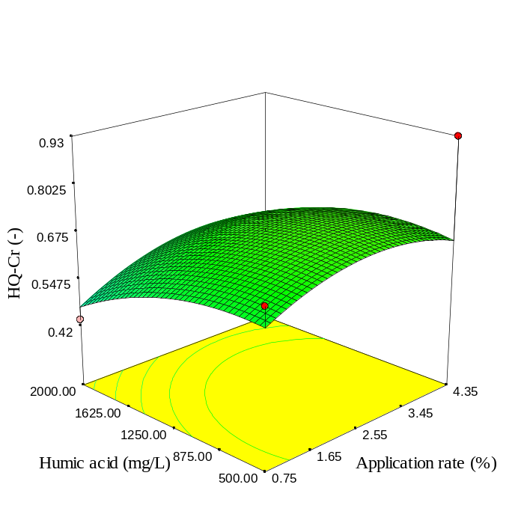 | 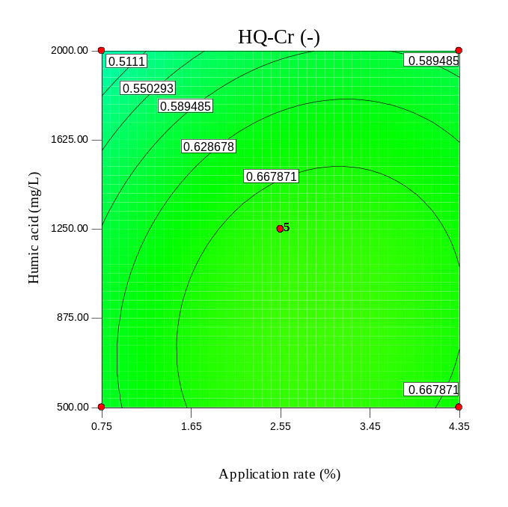
(c) | (d)
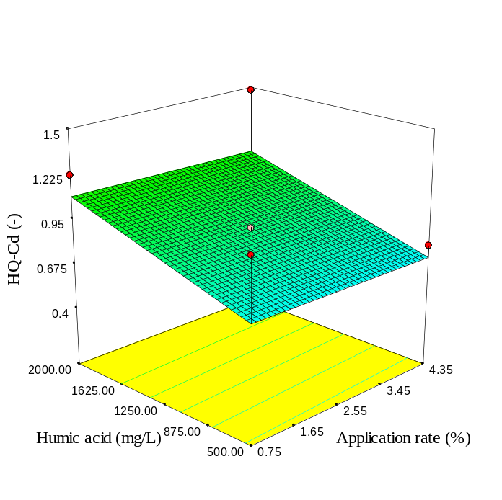 | 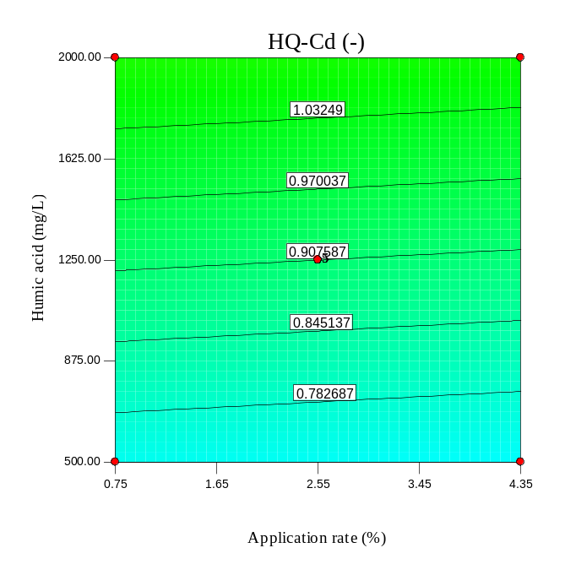
Fig. S67. As Fig S59, but for SBP600.

(a) | (b)
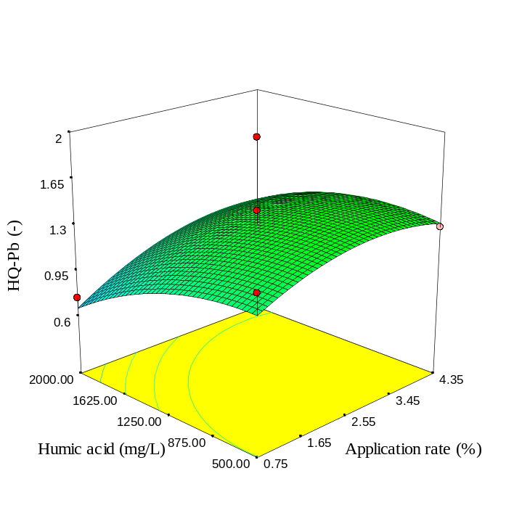 | 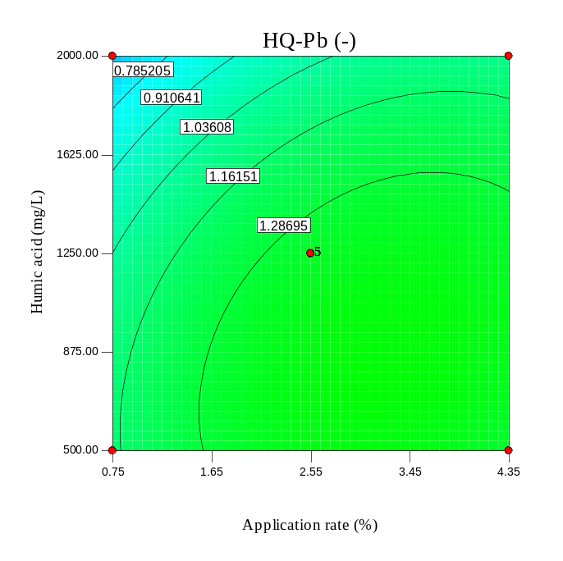
(c) | (d)
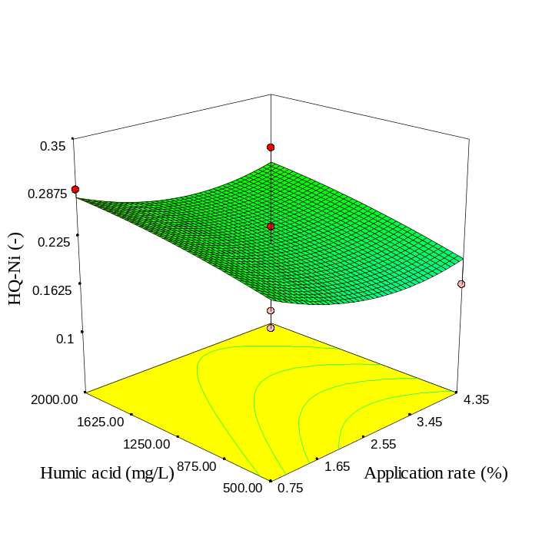 | 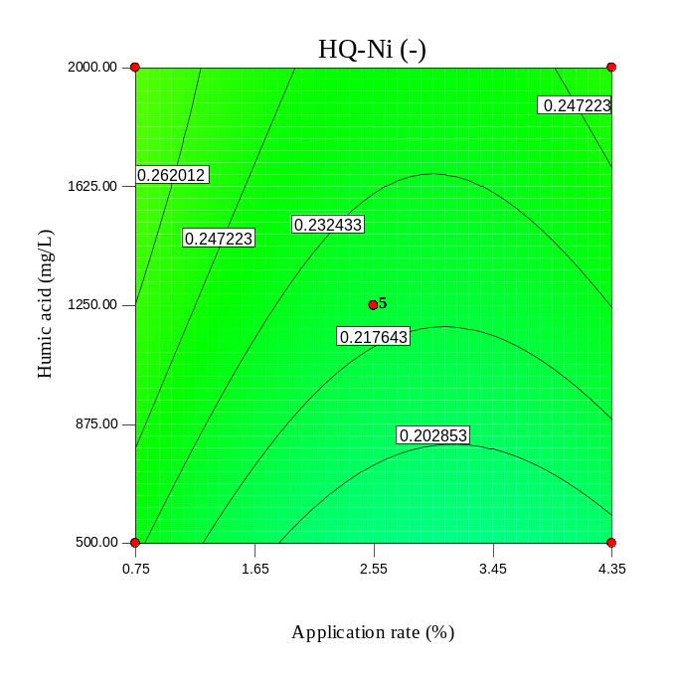
Fig. S68. As Fig S60, but for SBP600.

(a) | (b)
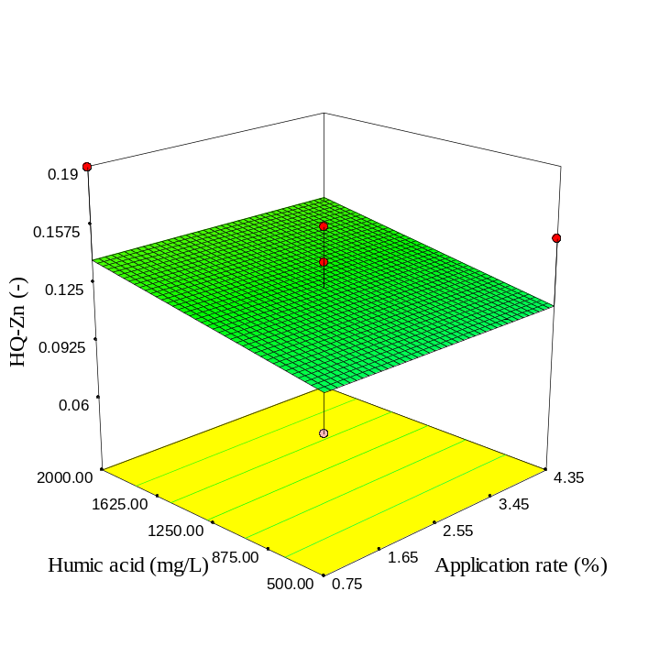 | 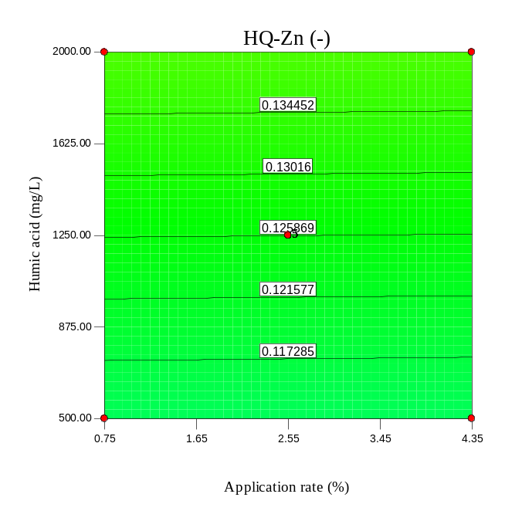
(c) | (d)
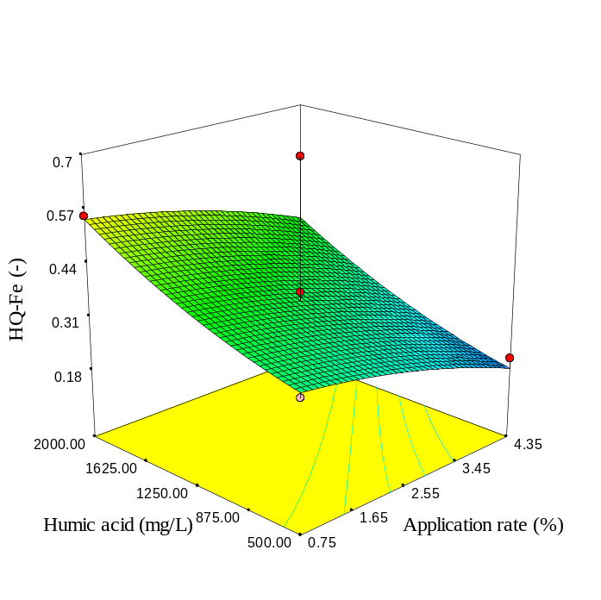 | 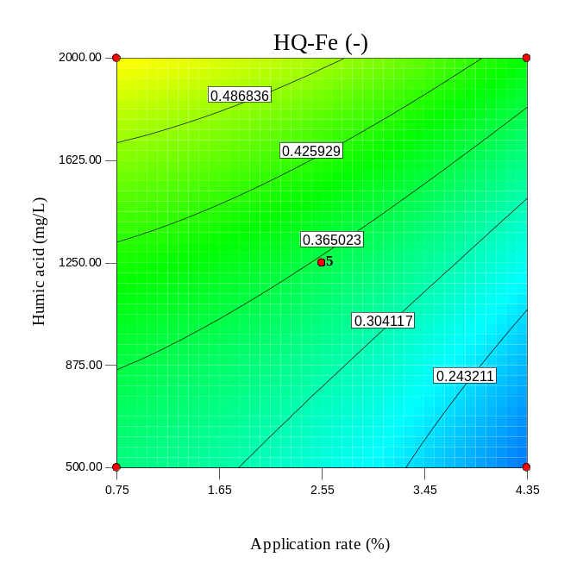
Fig. S69. As Fig S57, but for RH.

(a) | (b)
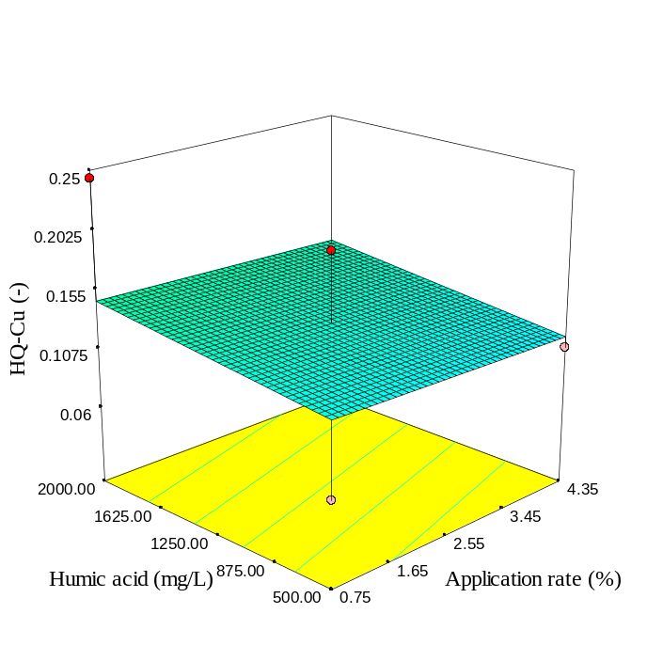 | 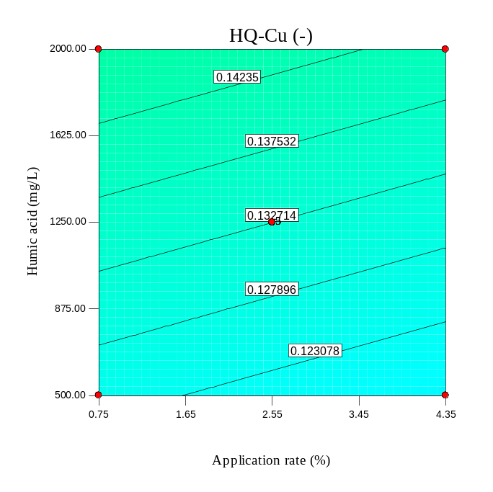
(c) | (d)
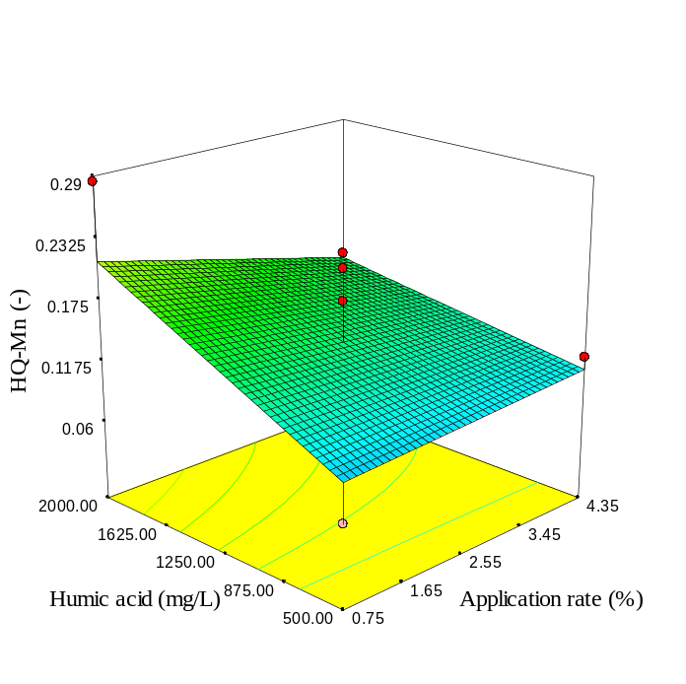 | 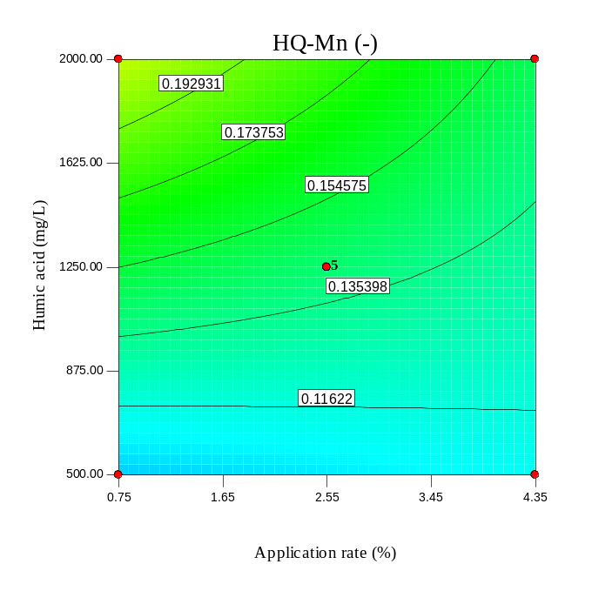
Fig. S70. As Fig S58, but for RH.

(a) | (b)
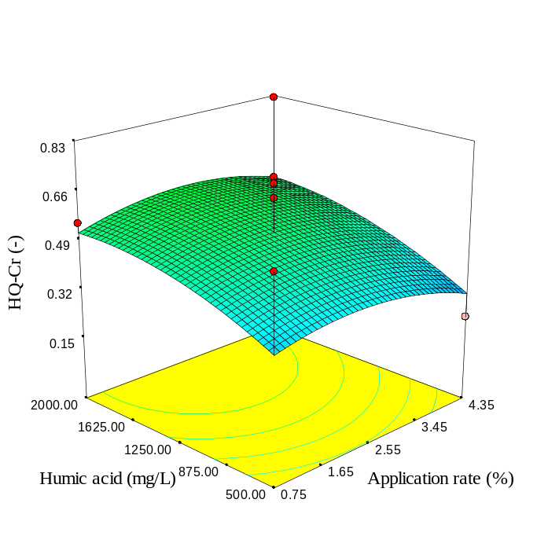 | 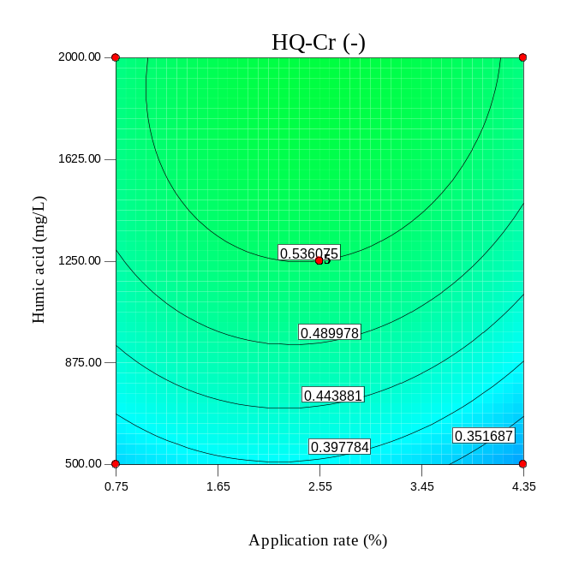
(c) | (d)
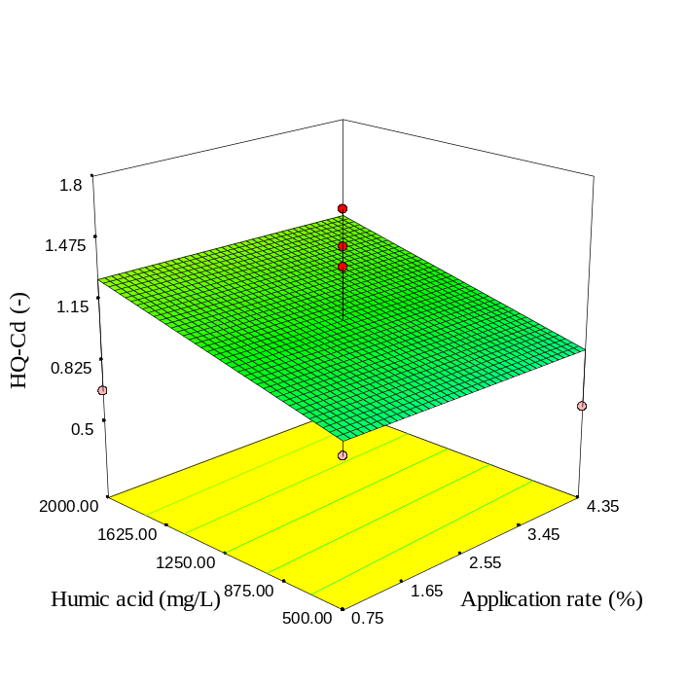 | 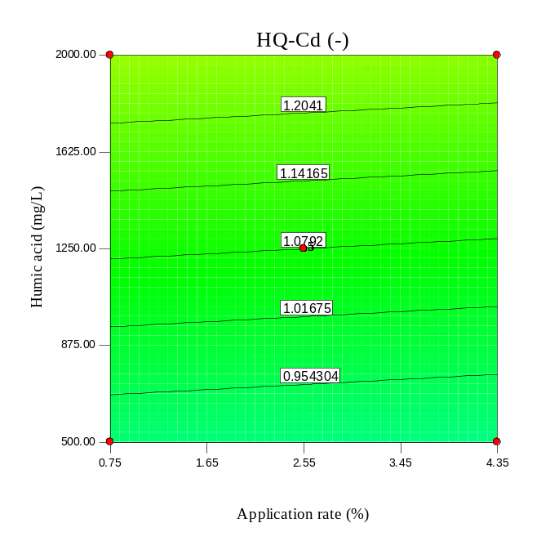
Fig. S71. As Fig S59, but for RH.

(a) | (b)
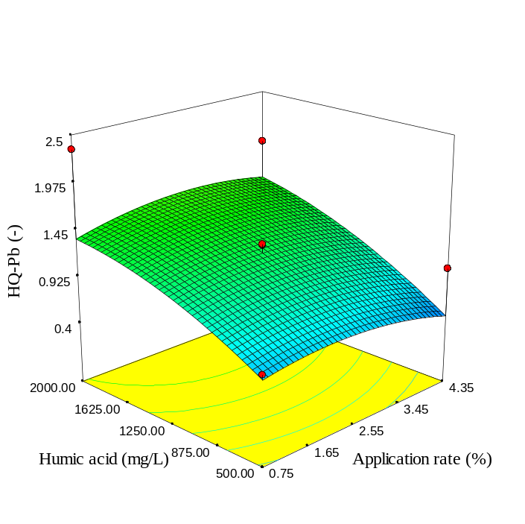 | 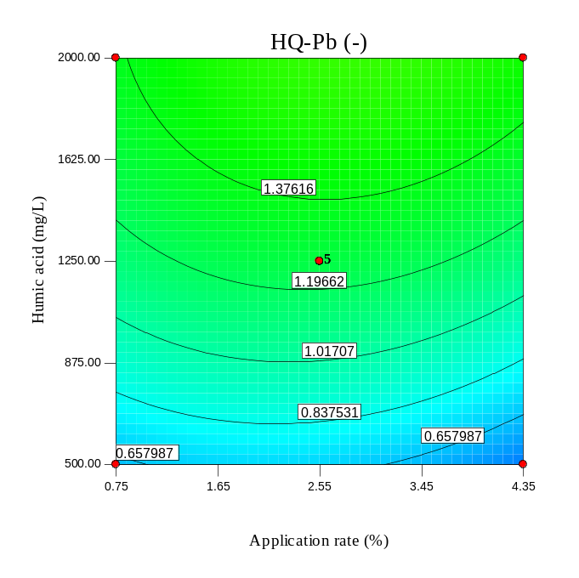
(c) | (d)
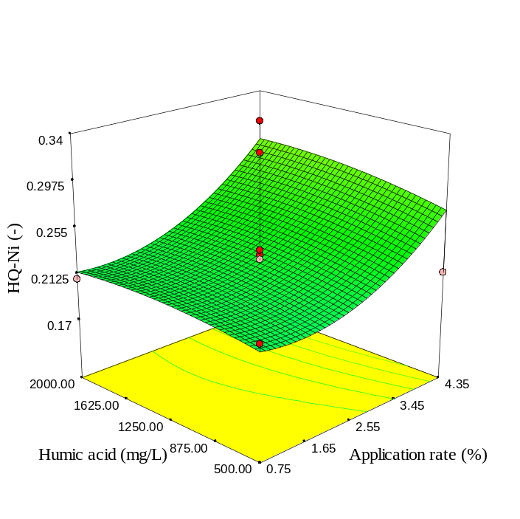 | 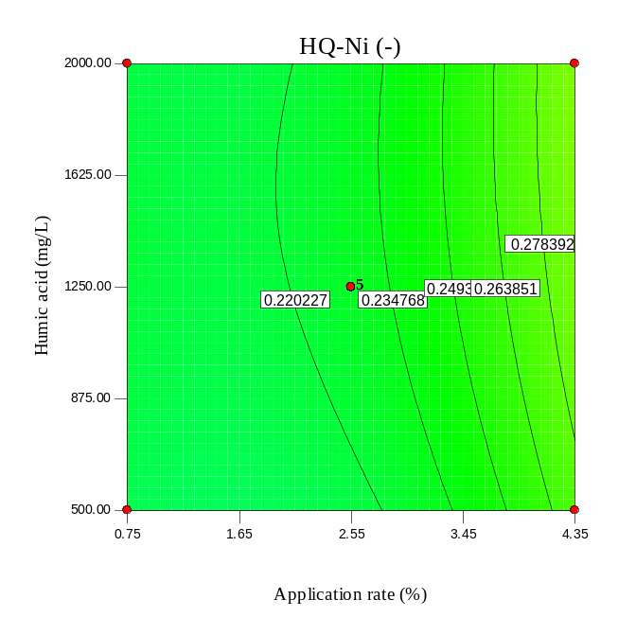
Fig. S72. As Fig S60, but for RH.

(a) | (b)
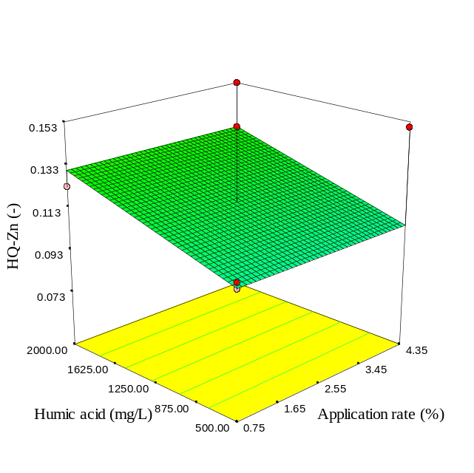 | 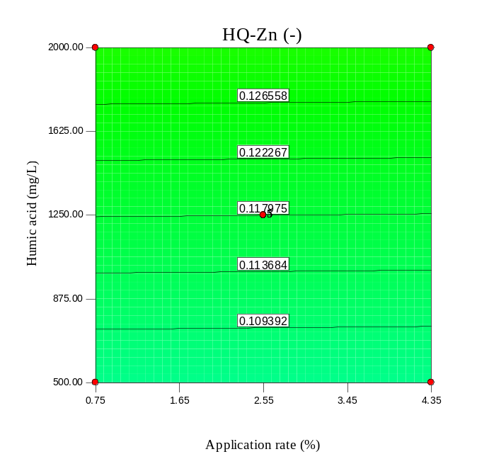
(c) | (d)
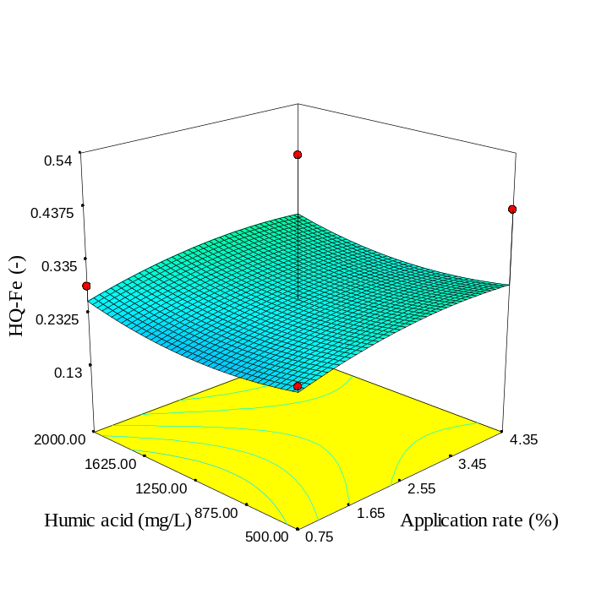 | 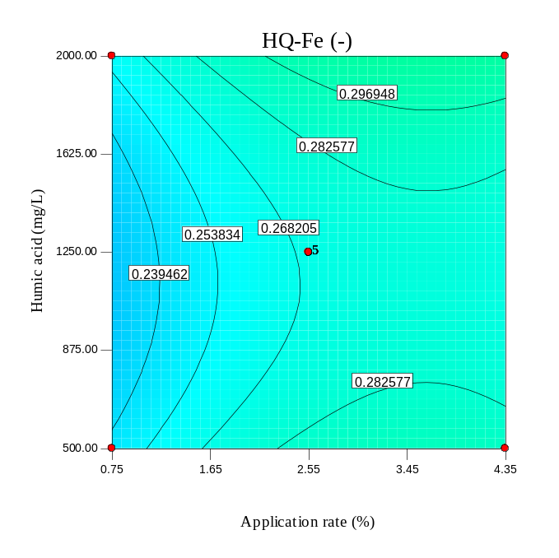
Fig. S73. As Fig S57, but for RH300.

(a) | (b)
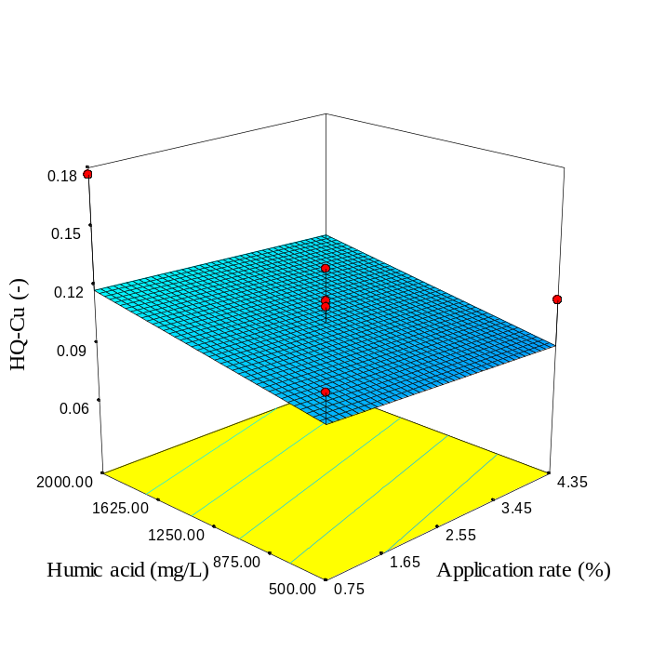 | 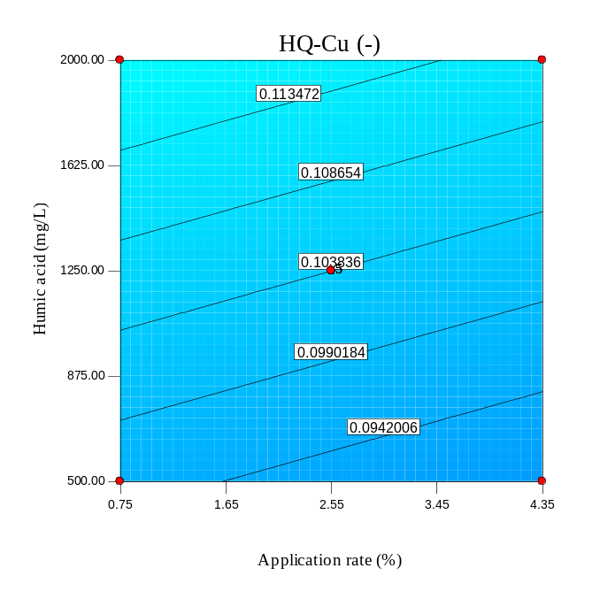
(c) | (d)
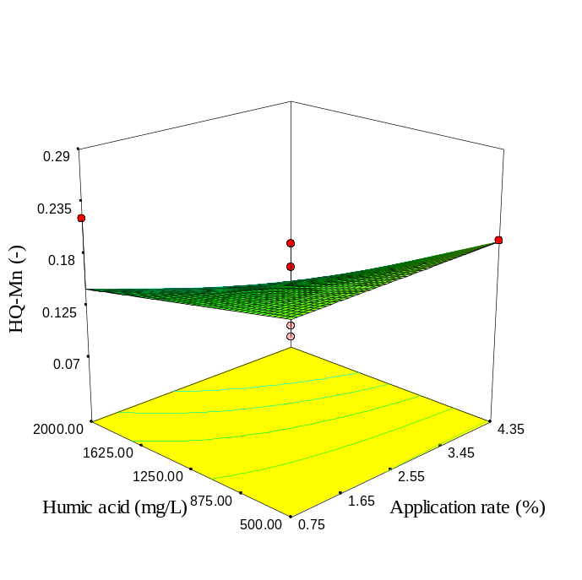 | 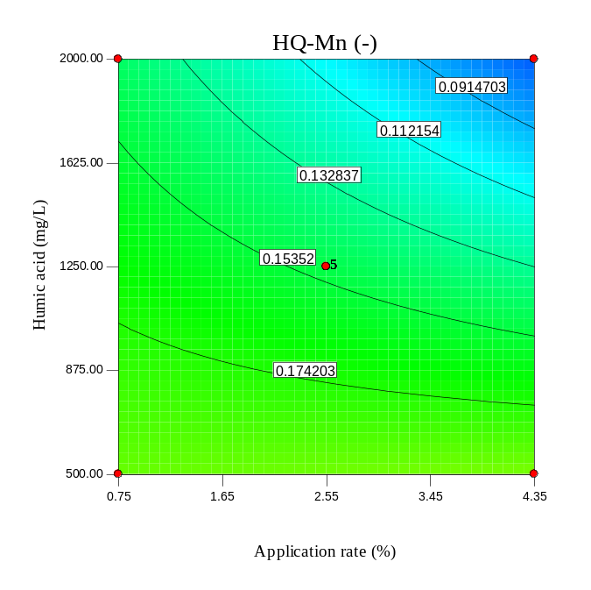
Fig. S74. As Fig S58, but for RH300.

(a) | (b)
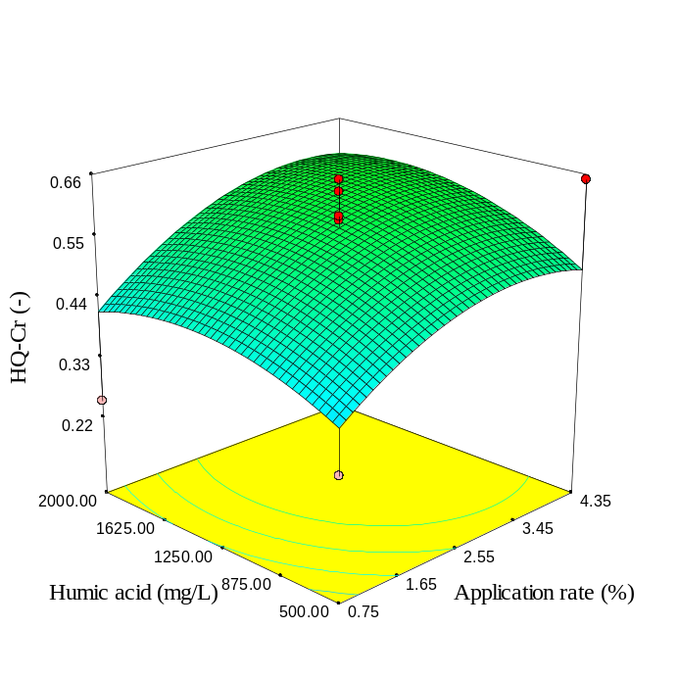 | 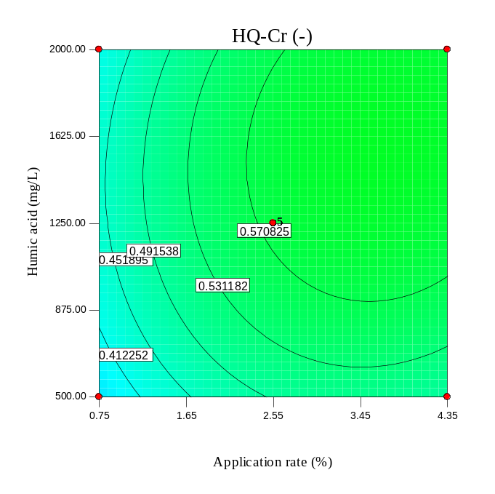
(c) | (d)
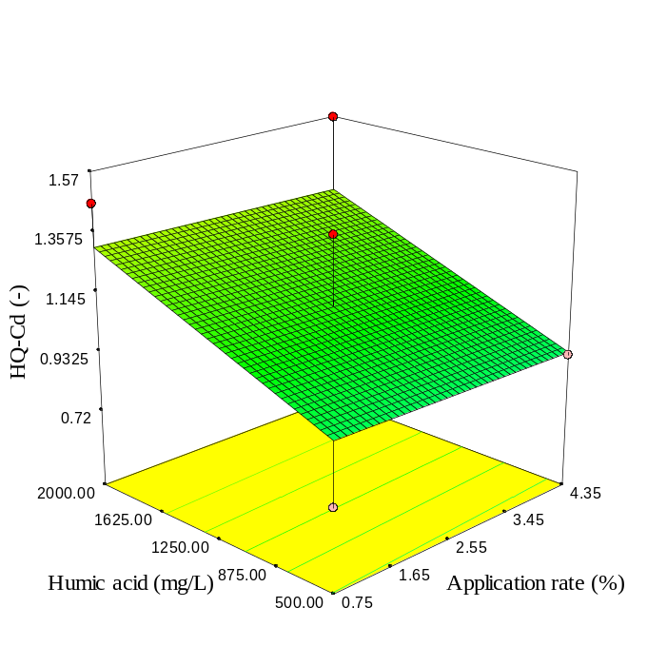 | 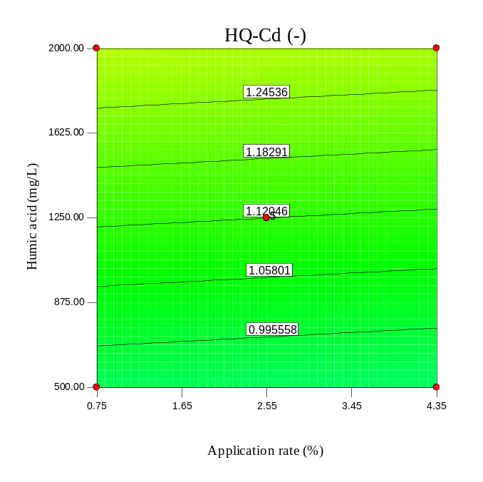
Fig. S74. As Fig S59, but for RH300.

(a) | (b)
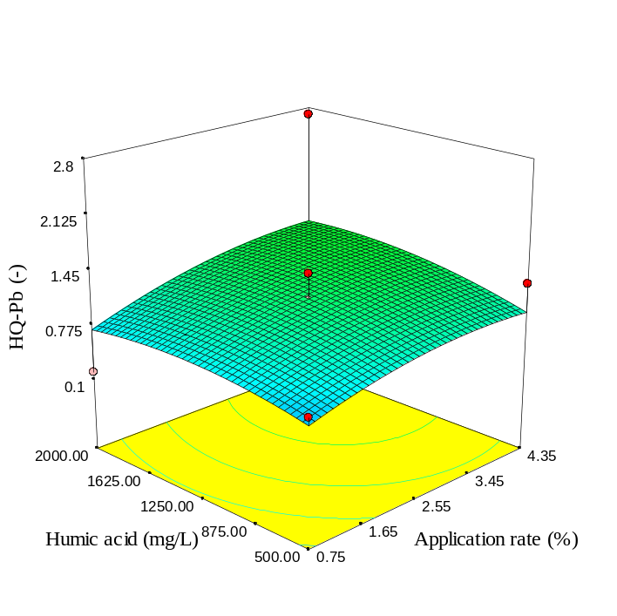 | 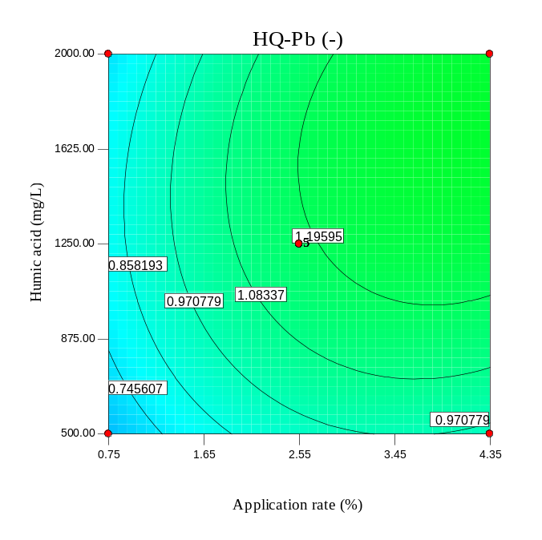
(c) | (d)
 | 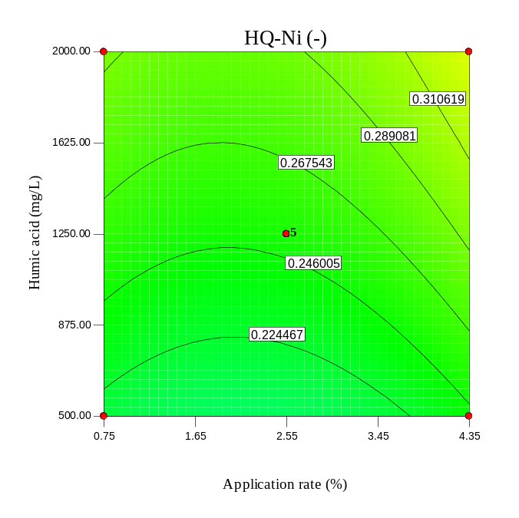
Fig. S75. As Fig S60, but for RH300.

(a) | (b)
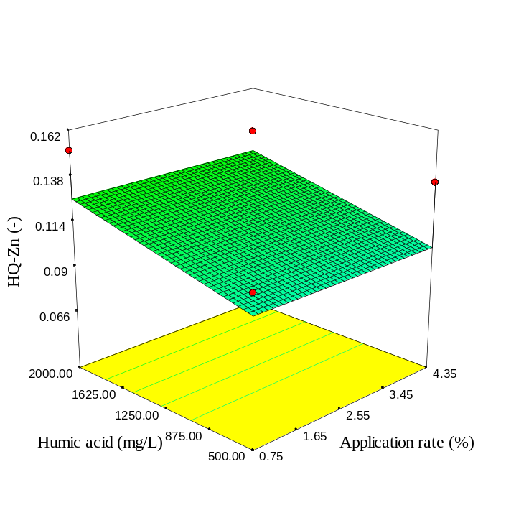 | 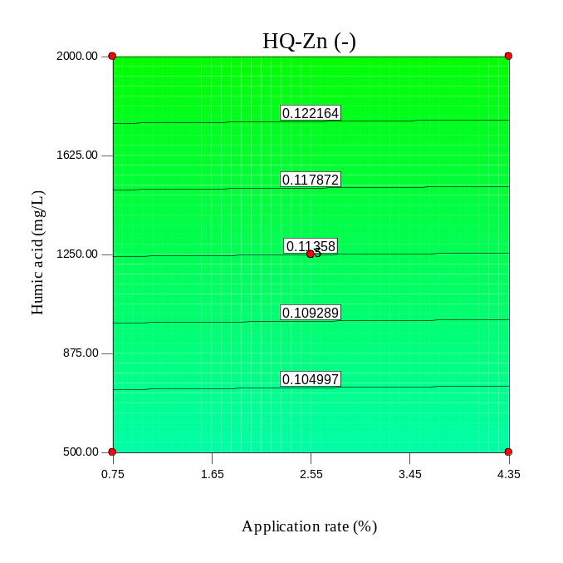
(c) | (d)
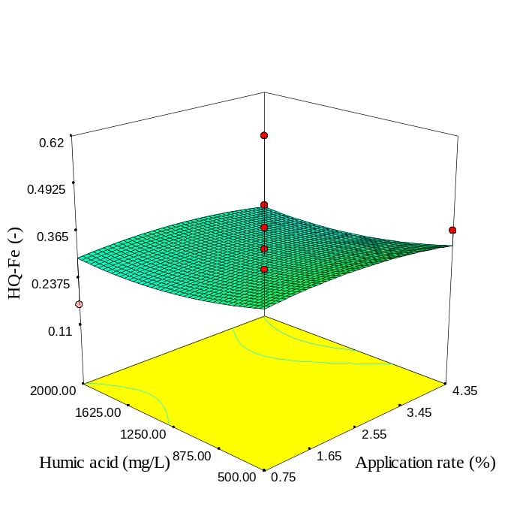 | 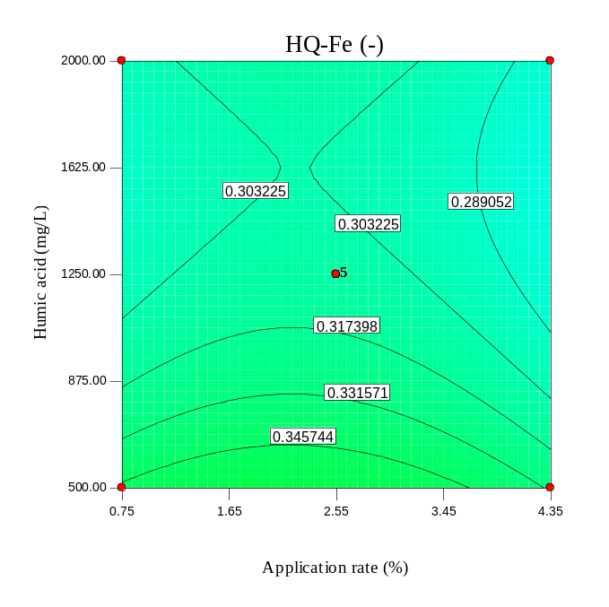
Fig. S80. As Fig S57, but for RH600.

(a) | (b)
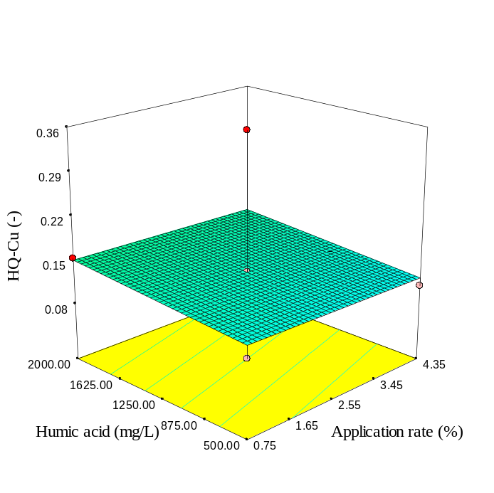 | 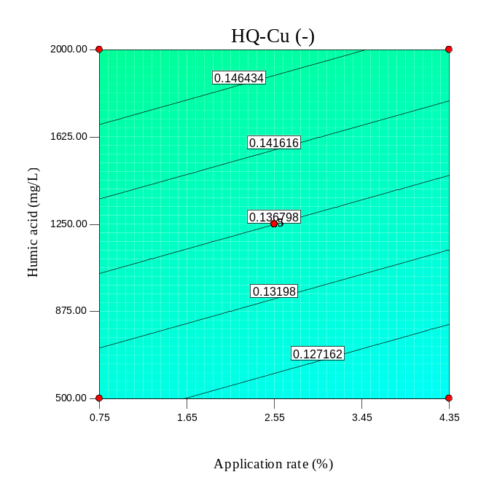
(c) | (d)
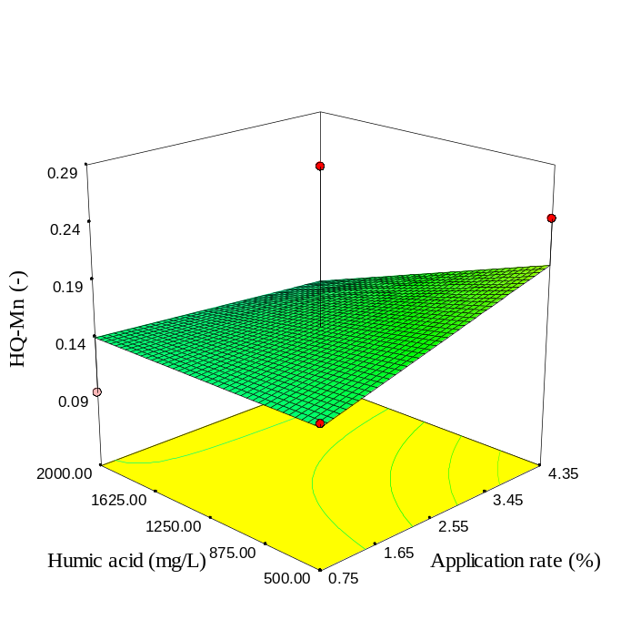 | 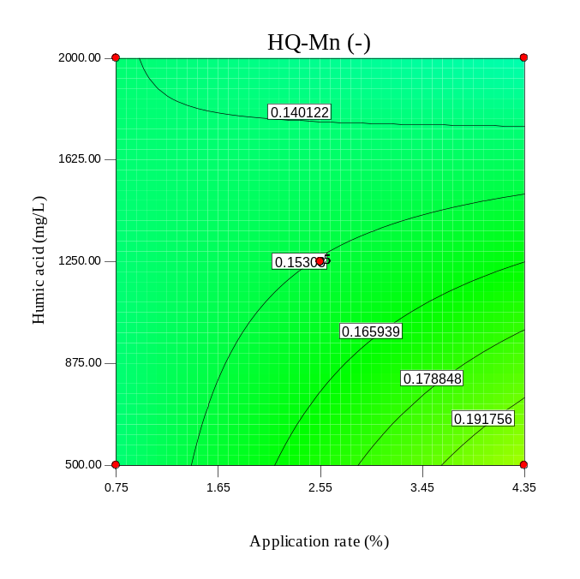
Fig. S81. As Fig S58, but for RH600.

(a) | (b)
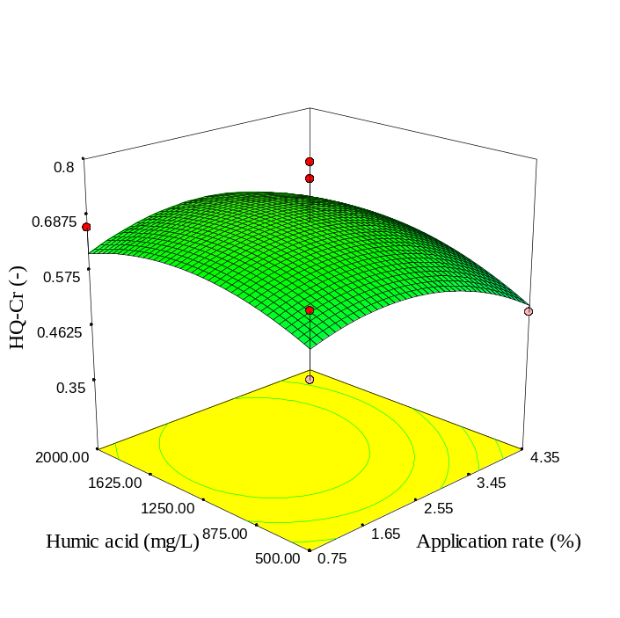 | 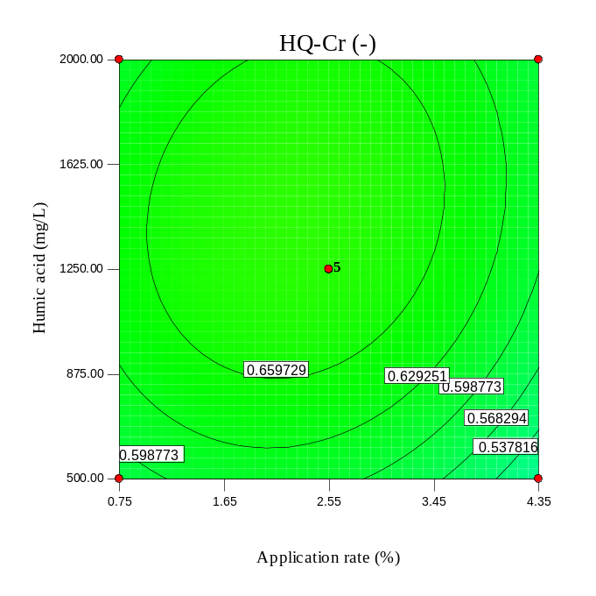
(c) | (d)
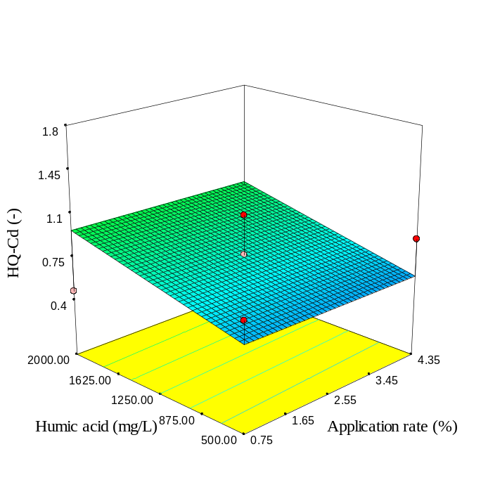 | 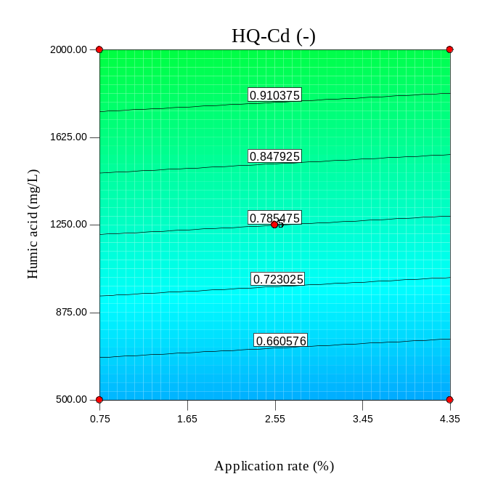
Fig. S82. As Fig S59, but for RH600.

(a) | (b)
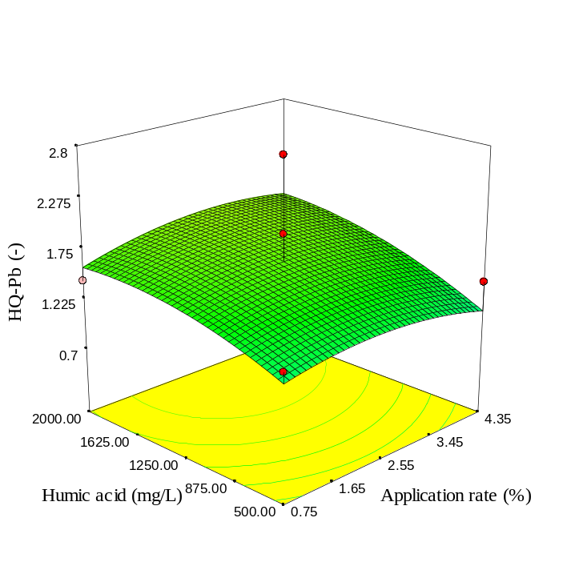 | 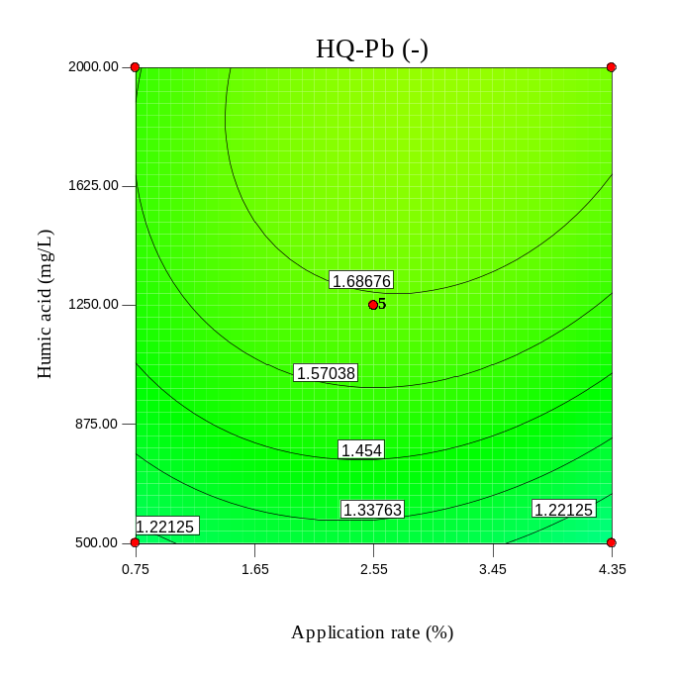
(c) | (d)
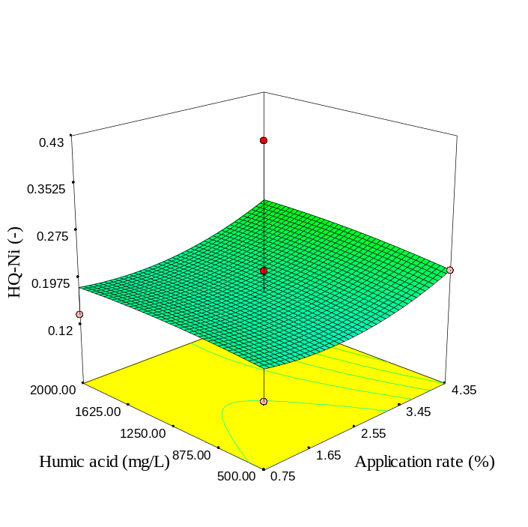 | 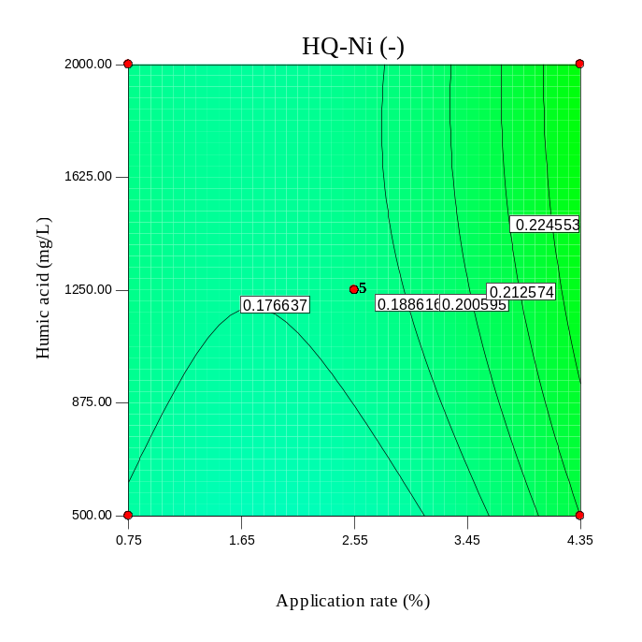
Fig. S83. As Fig S60, but for RH600.

(a) SBP | (b) SBP
(c) SBP300 | (d) SBP300
Fig. S84. 3D surface and contour plots of HI due to ingestion of spinach leaves affected by humic acid concentration and application rate.

(a) SBP600 | (b) SBP600
(c) SRH | (d) RH
Fig. S85. 3D surface and contour plots of HI due to ingestion of spinach leaves affected by humic acid concentration and application rate.

(a) RH300 | (b) RH300
(c) RH600 | (d) RH600
Fig. S86. 3D surface and contour plots of HI due to ingestion of spinach leaves affected by humic acid concentration and application rate.

(a) | (b)
(c) | (d)
Fig. S87. 3D surface and contour plots of CR-Cr and CR-Cd due to ingestion of spinach leaves affected by humic acid concentration and SBP application rate.

(a) | (b)
(c) | (d)
Fig. S88. 3D surface and contour plots of CR-Pb and CR-Ni due to ingestion of spinach leaves affected by humic acid concentration and SBP application rate.

(a) | (b)
(c) | (d)
Fig. S89. As Fig S87, but for SBP300.

(a) | (b)
(c) | (d)
Fig. S90. As Fig S88, but for SBP300.

(a) | (b)
(c) | (d)
 | 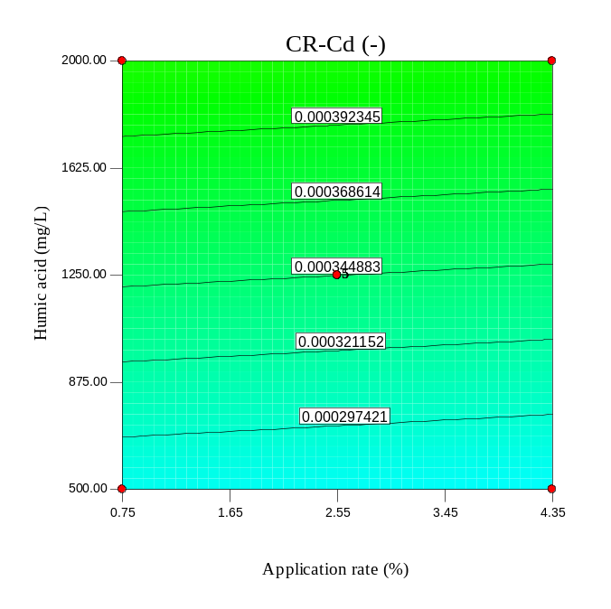
Fig. S91. As Fig S87, but for SBP600.

(a) | (b)
(c) | (d)
Fig. S92. As Fig S88, but for SBP600.

(a) | (b)
(c) | (d)
Fig. S93. As Fig S87, but for RH.

(a) | (b)
(c) | (d)
Fig. S94. As Fig S88, but for RH.

(a) | (b)
(c) | (d)
Fig. S95. As Fig S87, but for RH300.

(a) | (b)
(c) | (d)
Fig. S96. As Fig S88, but for RH300.

(a) | (b)
(c) | (d)
Fig. S97. As Fig S87, but for RH600.

(a) | (b)
(c) | (d)
Fig. S98. As Fig S88, but for RH600.

(a) SBP | (b) SBP
(c) SBP300 | (d) SBP300
Fig. S99. 3D surface and contour plots of TCR due to ingestion of spinach leaves affected by humic acid concentration and application rate.

(a) SBP600 | (b) SBP600
(c) RH | (d) RH
Fig. S100. 3D surface and contour plots of TCR due to ingestion of spinach leaves affected by humic acid concentration and application rate.

(a) RH300 | (b) RH300
(c) RH600 | (d) RH600
Fig. S101. 3D surface and contour plots of TCR due to ingestion of spinach leaves affected by humic acid concentration and application rate.

Corresponding author. Tel.: +98 8733620551; fax: +988733620550. P.O. Box: 416 E-mail addresses: f.ghorbanich@yahoo.com & f.ghorbani@uok.ac.ir.

