Supplementary data

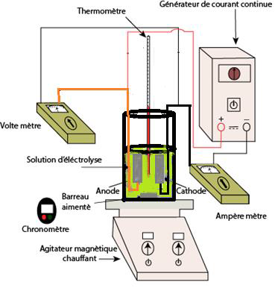
SM. 1 Detailed Schematic of the Experimental Setup

