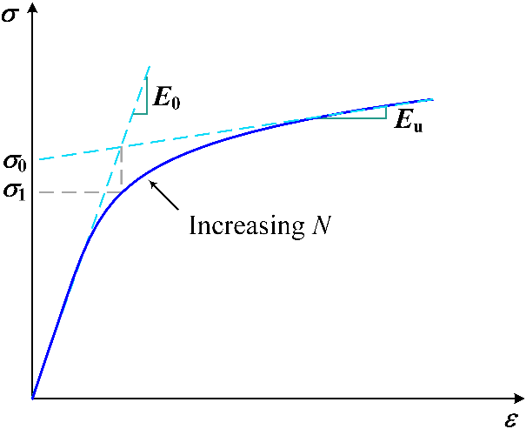
Fig. S1 The definition of parameters E₀, E_{u}, σ₀ and σ₁.

