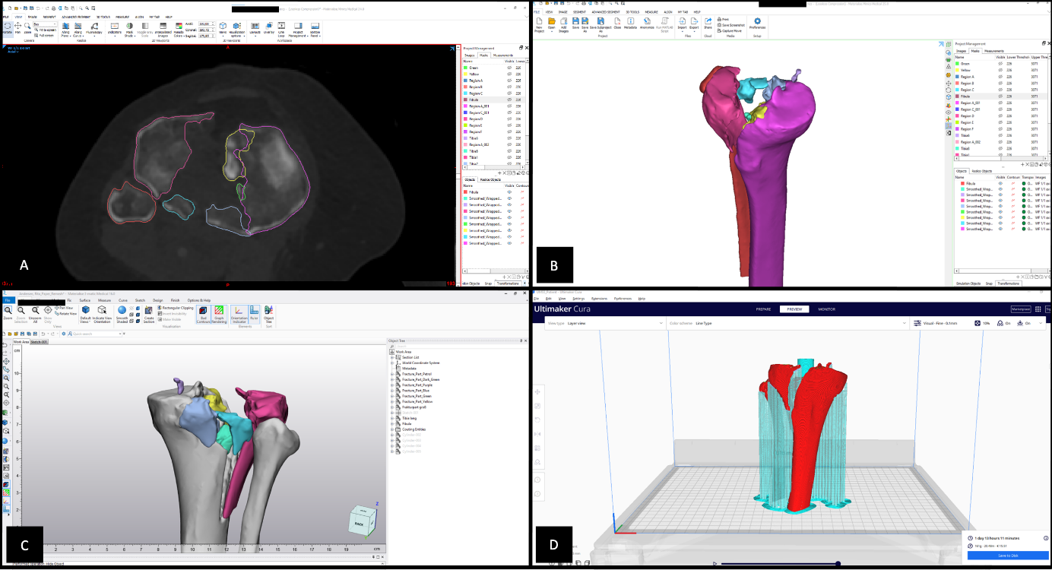
Supplement 1: threshold-based semi-automated segmentation using Materialise’s Interactive Medical Image Control System (Mimics Innovation Suite v24; Materialise, Leuven, Belgium) (A,B), post processing using Materialise 3-Matic (Materialise 3-Matic Medical v16; Materialise, Leuven, Belgium) (C), slicing process using Cura (Ultimaker Cura v4.10; Ultimaker, Utrecht, Netherlands) (D)

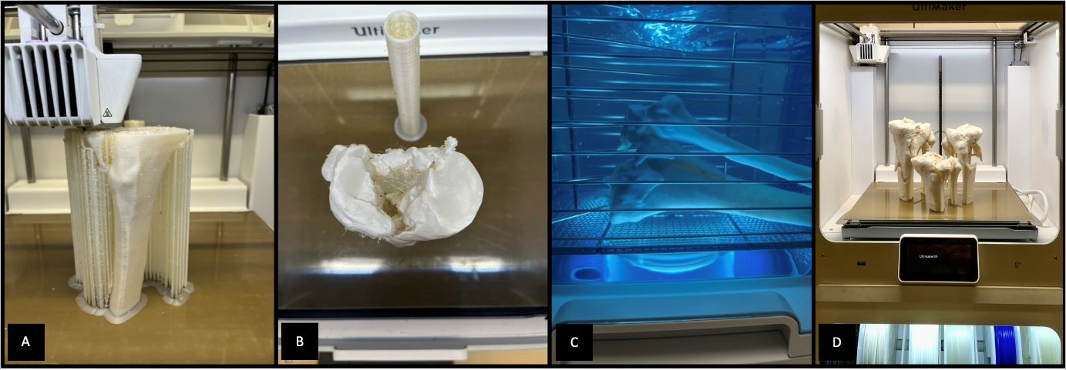
Supplement 2: 3D-printing station with a Ultimaker S5 FDM 3D printer (A, B, D) and a support dissolving station (C)

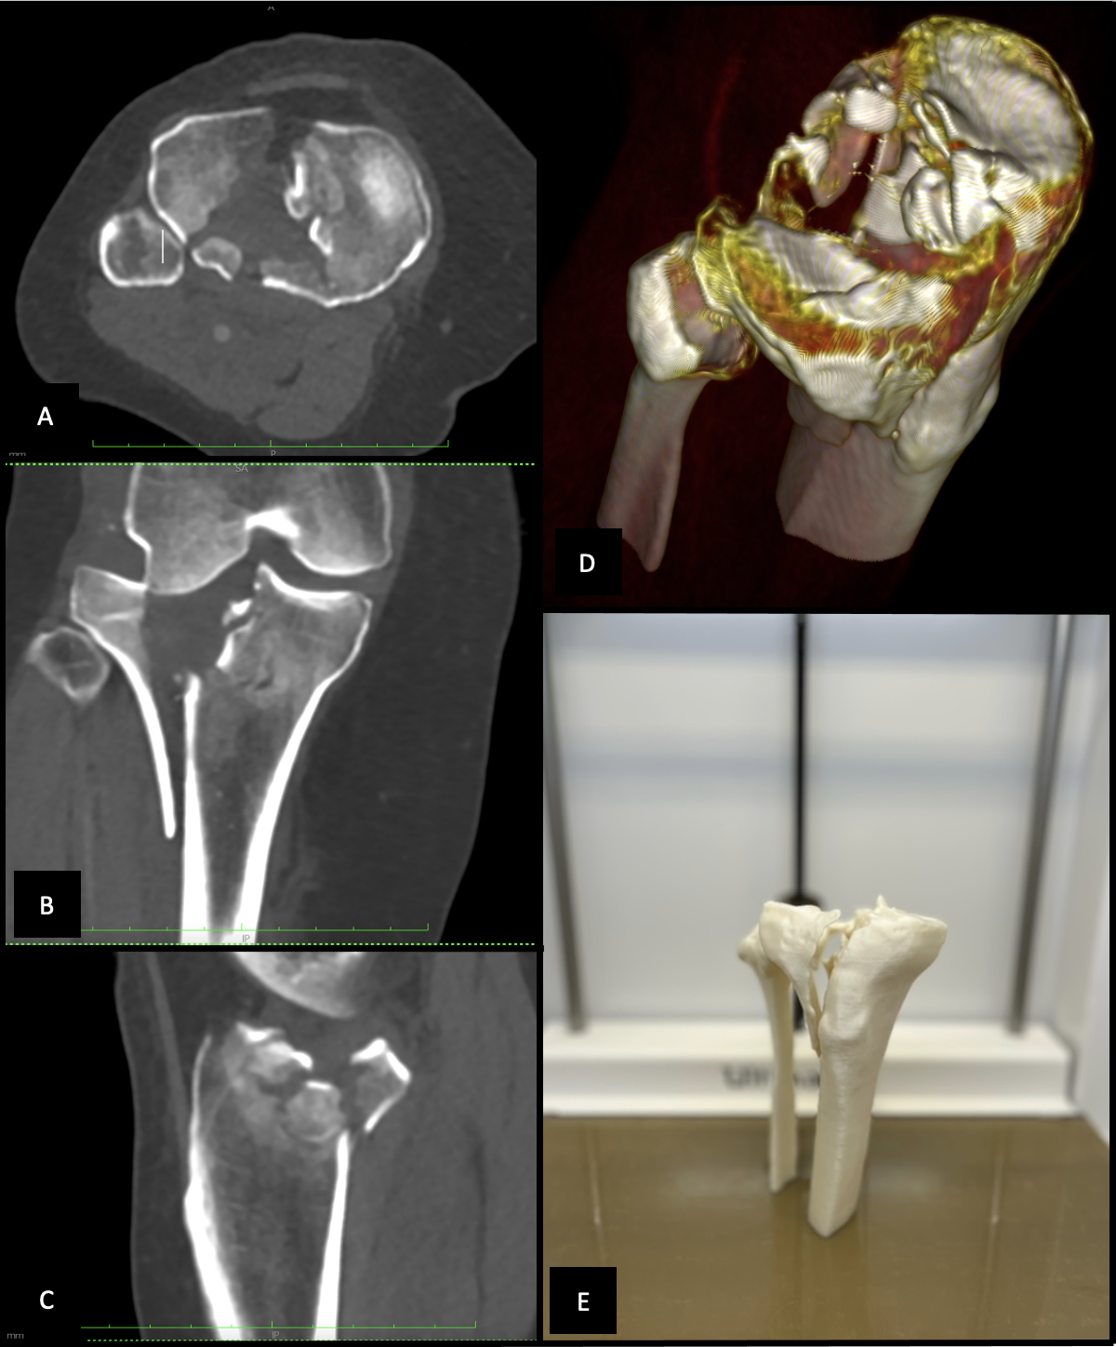
Supplement 3: multifragmentary lateral tibial plateau fracture shown as a CT-scan (A-C), a 3D volumetric reconstruction (D) and as a 3D-printed model (E)

surgical concept | options
Treatment concept | conservative  open surgical  (only) arthroscopy  fracturoscopy
Patient positioning | prone positioning  supine positioning  lateral positioning  floating positioning  supine positioning with intraoperative repositioning in prone position  supine positioning with intraoperative repositioning in lateral position  prone positioning with intraoperative repositioning in supine position  prone positioning with intraoperative repositioning in lateral position  lateral positioning with intraoperative repositioning in prone position  lateral positioning with intraoperative repositioning in supine position
Surgical approach | anterior-lateral approach  anterior-medial approach  posterior-medial approach  posterior-lateral approach  extended medial approach  extended lateral approach  posterior approach
choice of implants | 3.5 mm lateral proximal tibia  3.5 mm medial proximal tibia  3.5 mm posterolateral proximal tibia  3.5 mm posteromedial proximal tibia  Smith&Nephew, EVOS small fragment, proximal tibia steel plates

Supplement 4: the different aspects and their options to choose from of the surgical concept

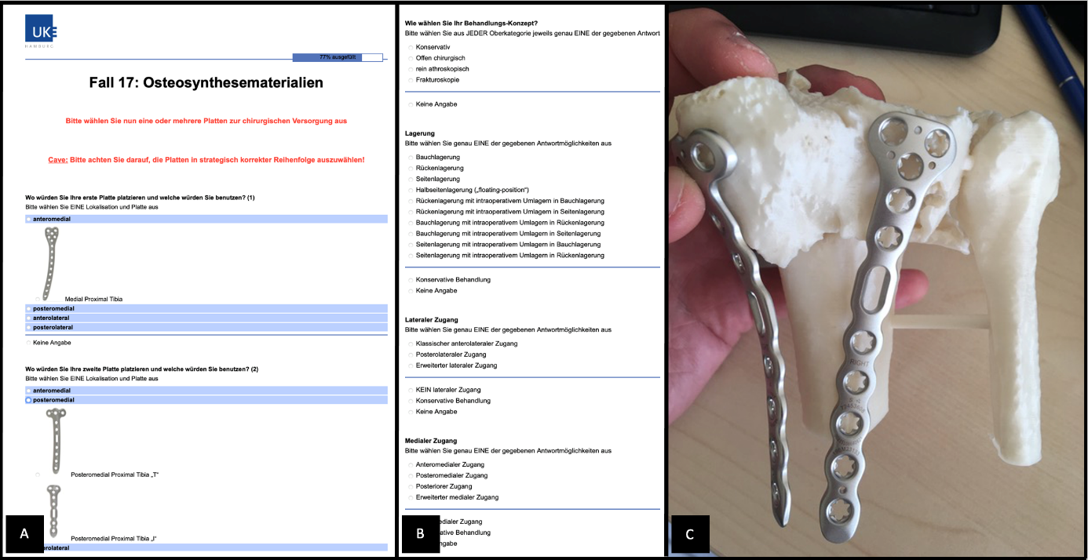
Supplement 5: online questionaire (A, B) and plate selection (B)

