Supplementary Figures
Davis et al., A Multivariate Genome-Wide Association Study Reveals Neural Correlates and Common Biological Mechanisms of Psychopathology Spectra

Supplementary Figures 3
Supplementary Figure 1. Genetic correlations between all 18 input GWAS in European ancestry individuals. 3
Supplementary Figure 2. Bifactor confirmatory factor model. 4
Supplementary Figure 3. General psychopathology confirmatory factor model. 5
Supplementary Figure 4. Manhattan plot of Q_{SNP} values for the externalizing factor. 6
Supplementary Figure 5. Manhattan plot of Q_{SNP} values for the internalizing factor. 7
Supplementary Figure 6. Manhattan plot of Q_{SNP} values for the second-order externalizing and internalizing factor. 8
Supplementary Figure 7. Results of gene-property analysis using BrainSpan developmental stages. 9
Supplementary Figure 8. Results of gene-tissue expression analyses using GTEx v8 tissue types. 10
Supplementary Figure 9. Results of cell-specific gene expression analyses for externalizing. 11
Supplementary Figure 10. Transcriptome wide association analysis using S-MultiXcan for externalizing (Panel A) and internalizing (Panel B). 12
Supplementary Figure 11. Transcriptome wide association analysis using PsychENCODE data for S-PrediXcan. 13
Supplementary Figure 12. MAGMA gene-property analyses performed on the subset of genes identified by both S-MultiXcan and S-PrediXcan for externalizing. 14
Supplementary Figure 13. MAGMA gene-property analyses performed on the subset of genes identified by both S-MultiXcan and S-PrediXcan for internalizing. 15
Supplementary Figure 14. MAGMA gene-property analyses performed on the subset of genes identified by both S-MultiXcan and S-PrediXcan for second-order EXT+internalizing. 16
Supplementary Figure 15. BrainXcan structural MRI association results for externalizing. 17
Supplementary Figure 16. BrainXcan diffusion MRI association results for externalizing. 18
Supplementary Figure 17. BrainXcan structural MRI association results for internalizing. 19
Supplementary Figure 18. BrainXcan diffusion MRI association results for internalizing. 20
Supplementary Figure 19. BrainXcan structural MRI association results for second order externalizing + internalizing. 21
Supplementary Figure 20. BrainXcan diffusion MRI association results for second order externalizing + internalizing. 22
Supplementary Figure 21. Results of bivariate causal mixture (MiXeR) models for externalizing and internalizing. 23
Supplementary Figure 22. Genetic correlations between the externalizing factor and publicly available phenotypes. 24
Supplementary Figure 23. Genetic correlations between the internalizing factor and publicly available phenotypes. 25
Supplementary Figure 24. Genetic correlations between the second-order externalizing and internalizing factor and publicly available phenotypes. 26

Supplementary Figures

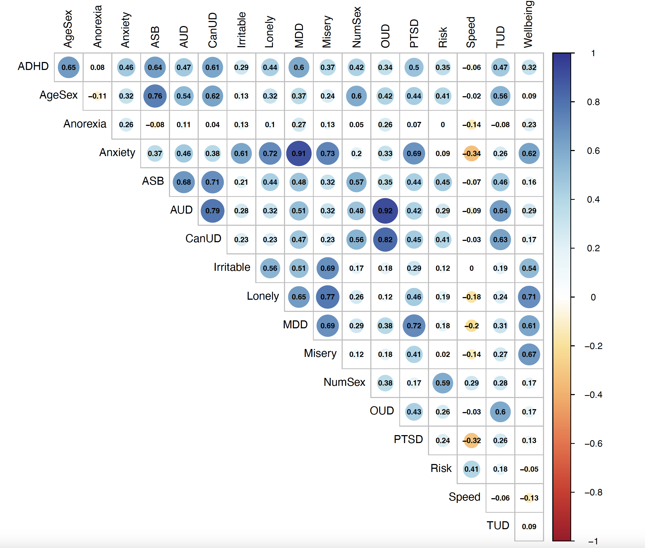

Supplementary Figure 1. Genetic correlations between all 18 input GWAS in European ancestry individuals.
ADHD = attention deficit hyperactivity disorder, AgeSex = age at first sexual intercourse, ASB = antisocial behavior, AUD = alcohol use disorder, CanUD = cannabis use disorder, MDD = major depressive disorder, NumSex = number of sexual partners, OUD = opioid use disorder, PTSD = posttraumatic stress disorder, Risk = general risk tolerance, Speeding = automobile speeding propensity, TUD = tobacco use disorder. Traits are ordered alphabetically. AgeSex and Wellbeing are reverse-coded.

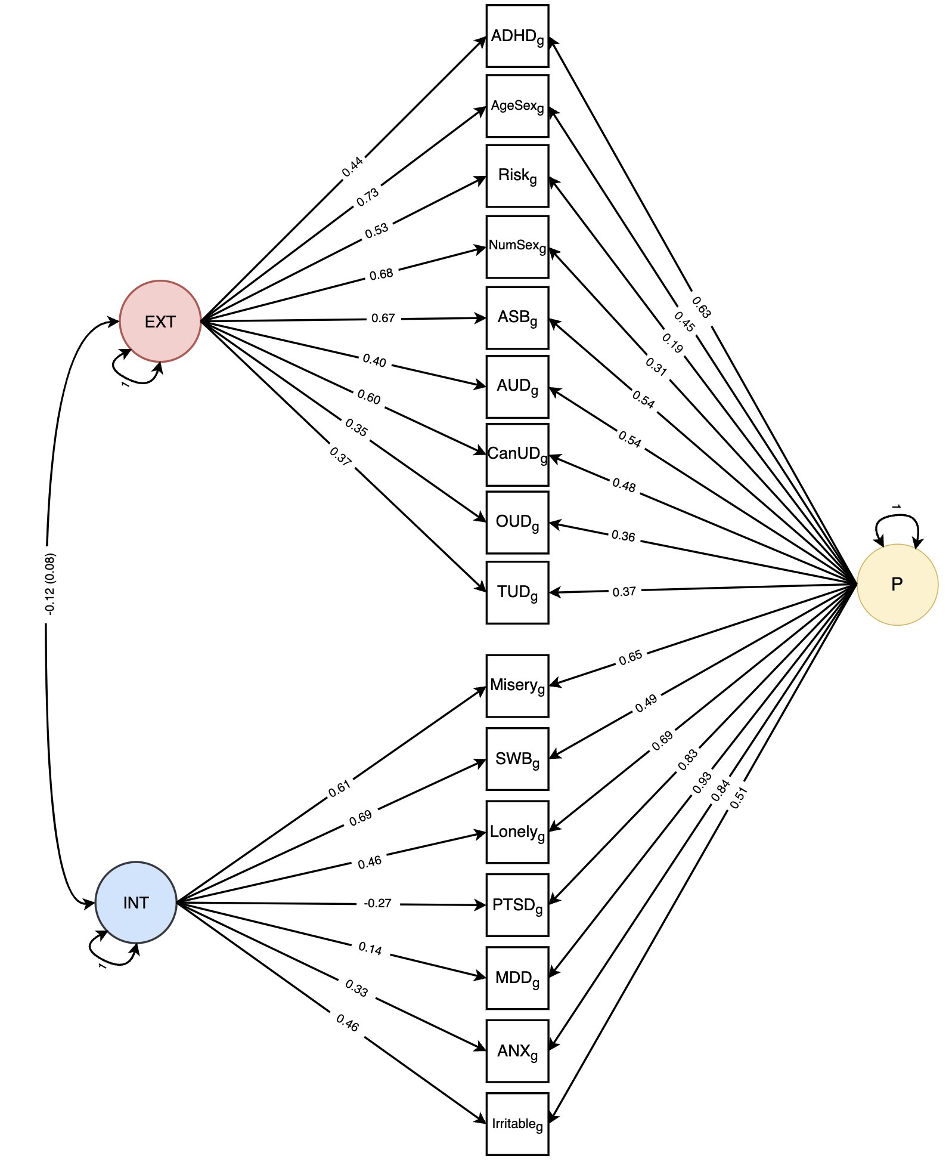

Supplementary Figure 2. Bifactor confirmatory factor model.
Model fit: 𝜒²(81) = 2527.19, p = 0, AIC = 2637.19, CFI = 0.94, SRMR = 0.05. EXT = externalizing, INT = internalizing, P = general psychopathology, ADHD = attention deficit hyperactivity disorder, AgeSex = age at first sexual intercourse (reverse-coded), NumSex = number of sexual partners, ASB = antisocial behavior, AUD = alcohol use disorder, CanUD = cannabis use disorder, OUD = opioid use disorder, TUD = tobacco use disorder, SWB = subjective wellbeing (reverse-coded), PTSD = posttraumatic stress disorder, MDD = major depressive disorder, ANX = anxiety. Residuals for the four substance use disorders were allowed to correlate.

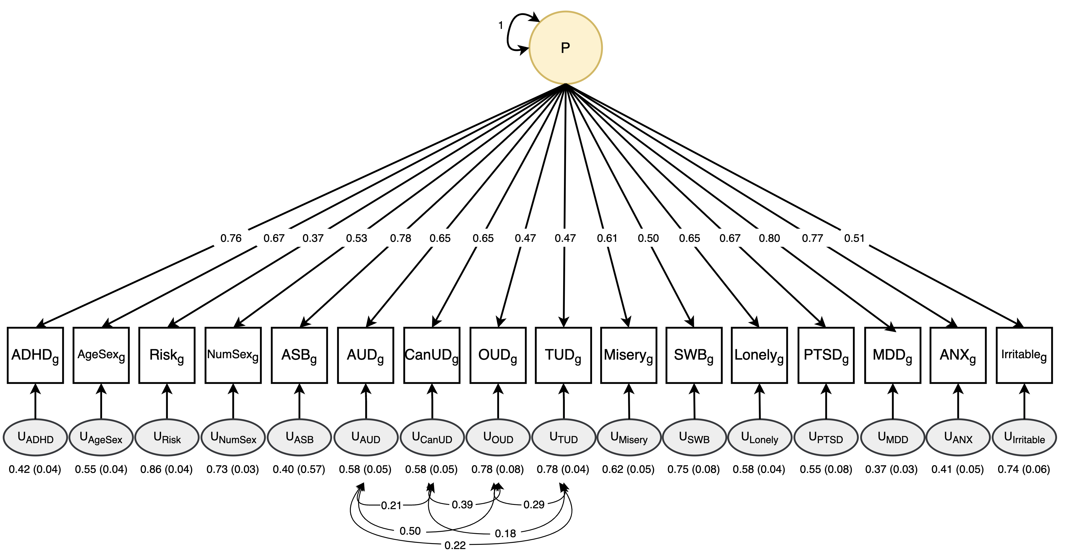

Supplementary Figure 3. General psychopathology confirmatory factor model.
Model fit: 𝜒²(98) = 8965.28, p = 0, AIC = 9041.28, CFI = 0.79, SRMR = 0.15. P = general psychopathology, ADHD = attention deficit hyperactivity disorder, AgeSex = age at first sexual intercourse (reverse-coded), NumSex = number of sexual partners, ASB = antisocial behavior, AUD = alcohol use disorder, CanUD = cannabis use disorder, OUD = opioid use disorder, TUD = tobacco use disorder, SWB = subjective wellbeing (reverse-coded), PTSD = posttraumatic stress disorder, MDD = major depressive disorder, ANX = anxiety.

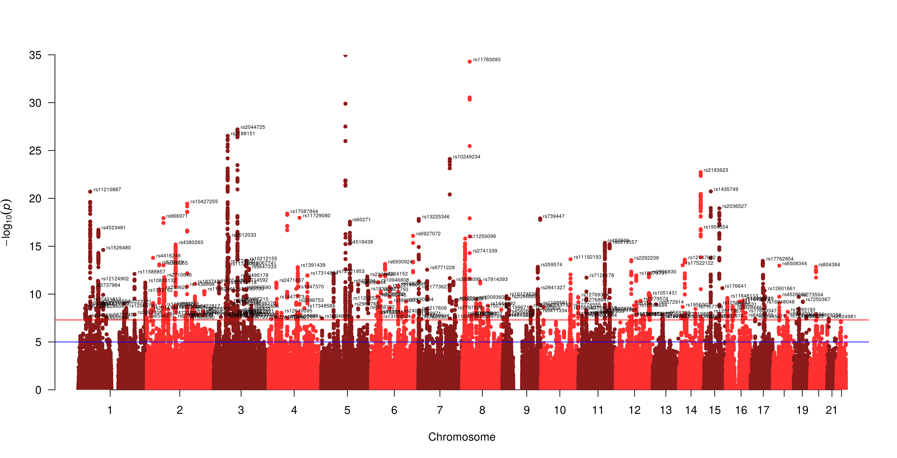

Supplementary Figure 4. Manhattan plot of Q_{SNP} values for the externalizing factor.
There were 228 independent SNPs that exhibited heterogeneous effects across the externalizing phenotypes. All SNPs with heterogenous effects (n = 3667) were filtered prior to conducting downstream analyses.

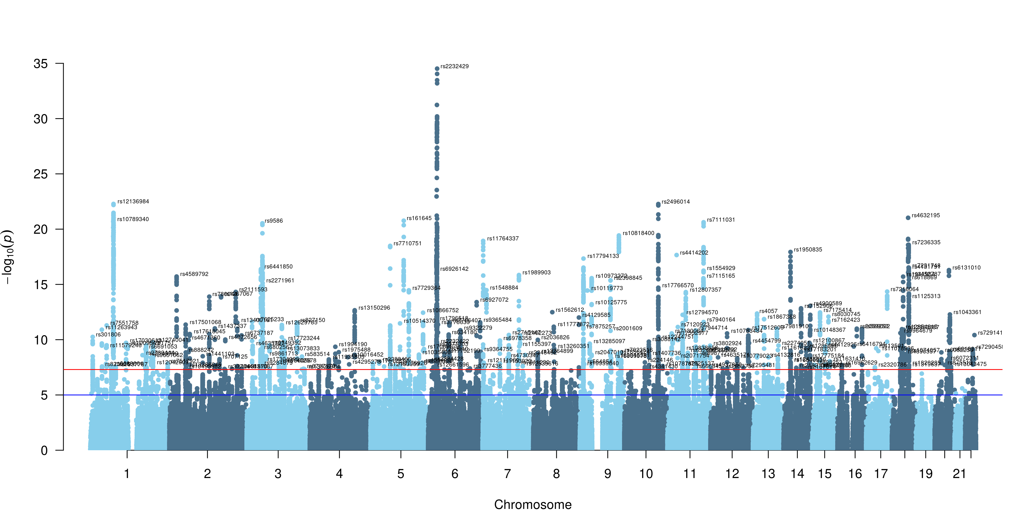

Supplementary Figure 5. Manhattan plot of Q_{SNP} values for the internalizing factor.
There were 222 independent SNPs that exhibited heterogeneous effects across the internalizing phenotypes. All SNPs with heterogenous effects (n = 3582) were filtered prior to conducting downstream analyses.

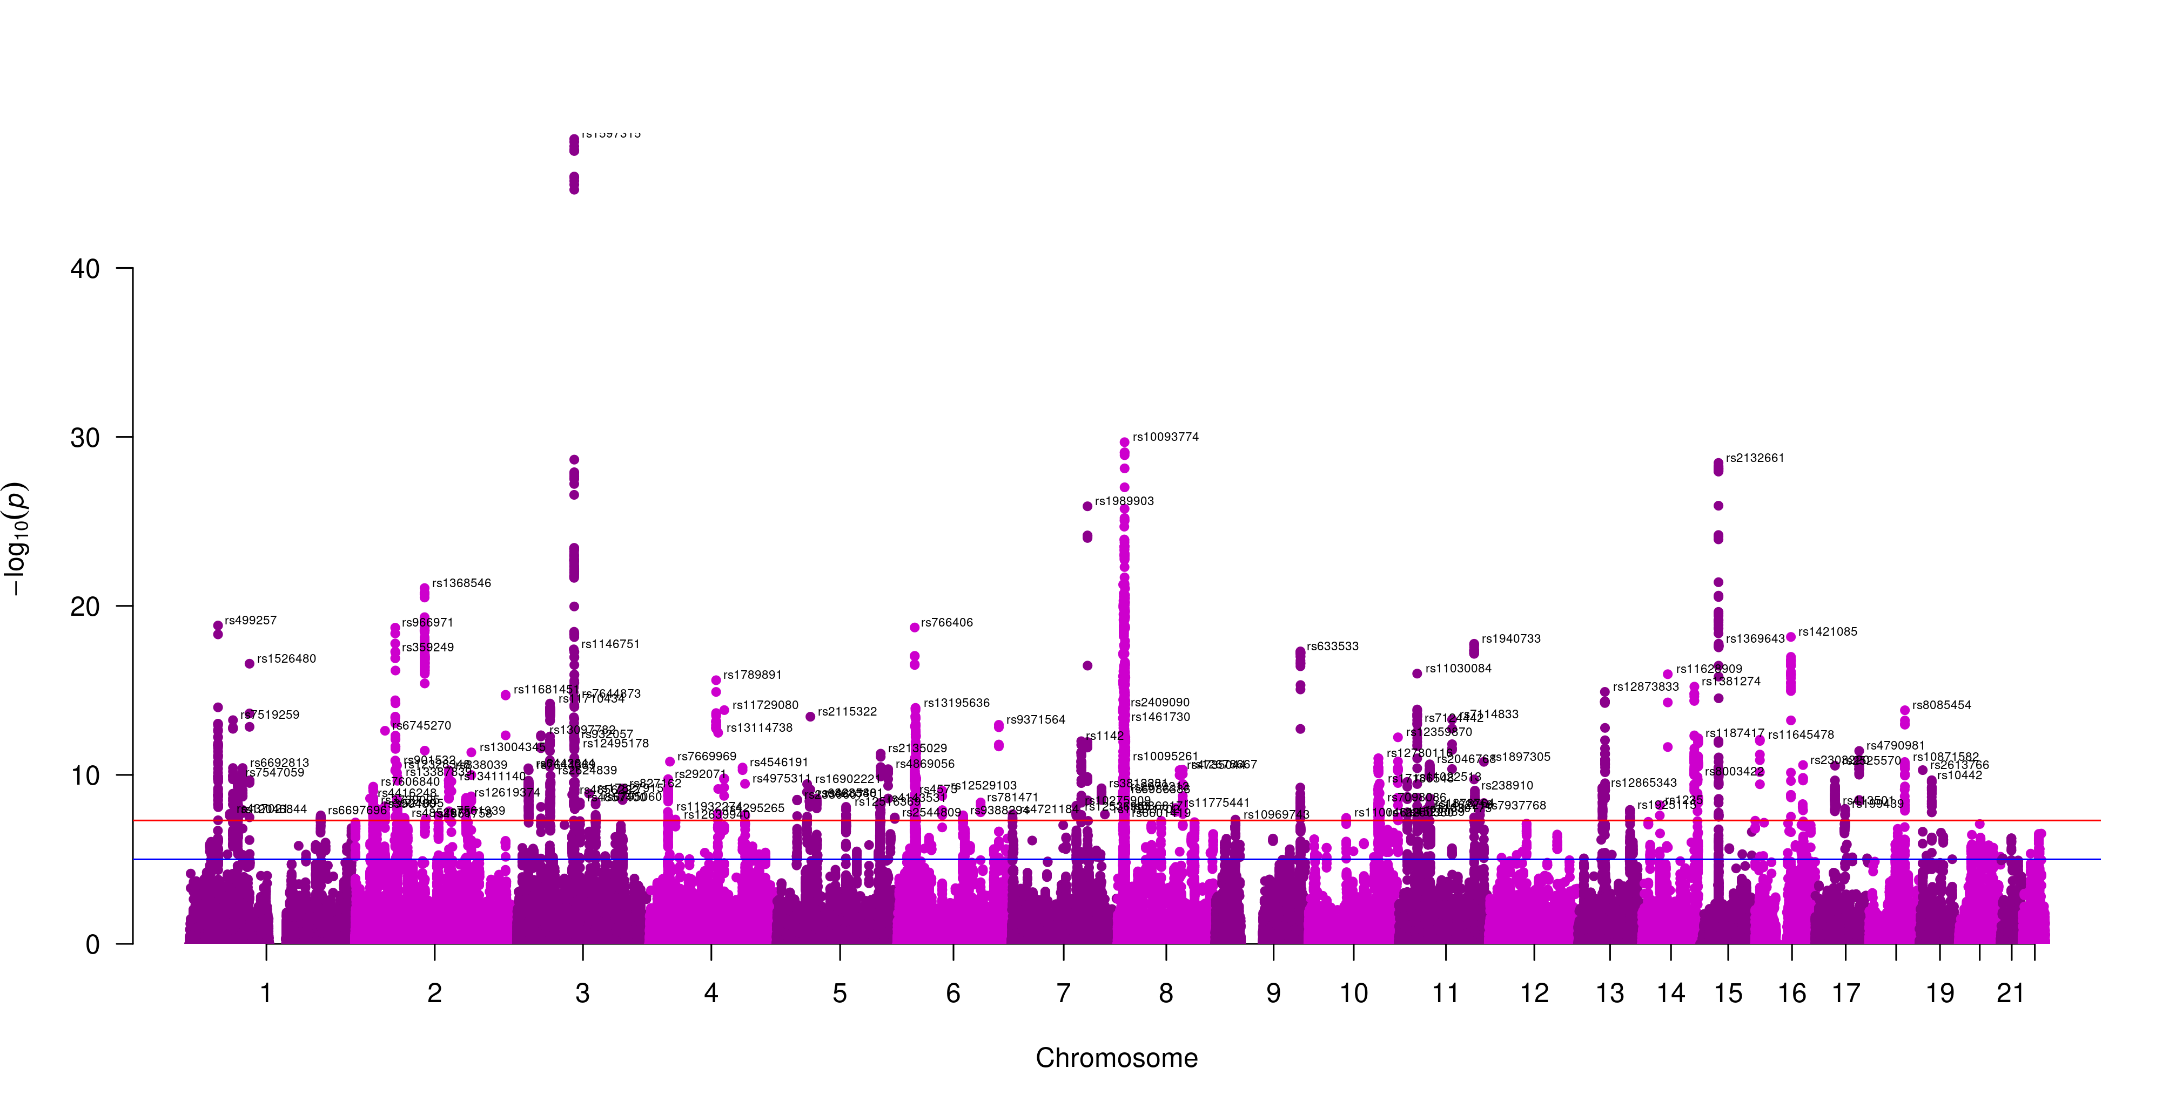

Supplementary Figure 6. Manhattan plot of Q_{SNP} values for the second-order externalizing and internalizing factor.
There were 130 independent SNPs that exhibited heterogeneous effects across internalizing and externalizing phenotypes. All SNPs with heterogenous effects (n = 2684) were filtered prior to conducting downstream analyses.

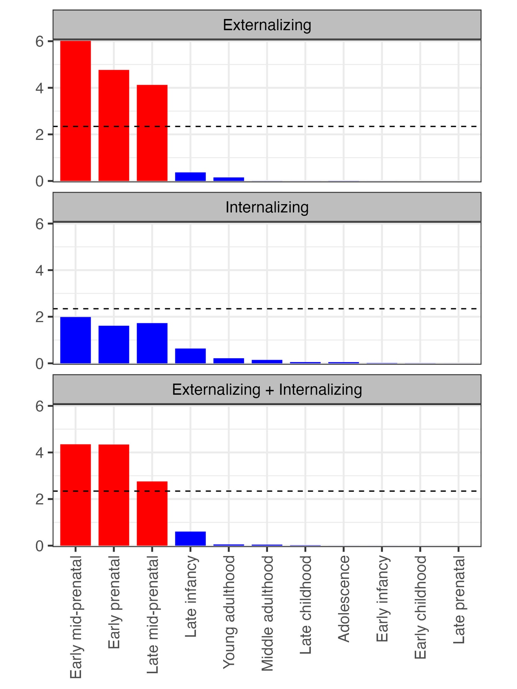

Supplementary Figure 7. Results of gene-property analysis using BrainSpan developmental stages.
Red indicates significance at a Bonferroni-adjusted p-value of 4.55e-03.
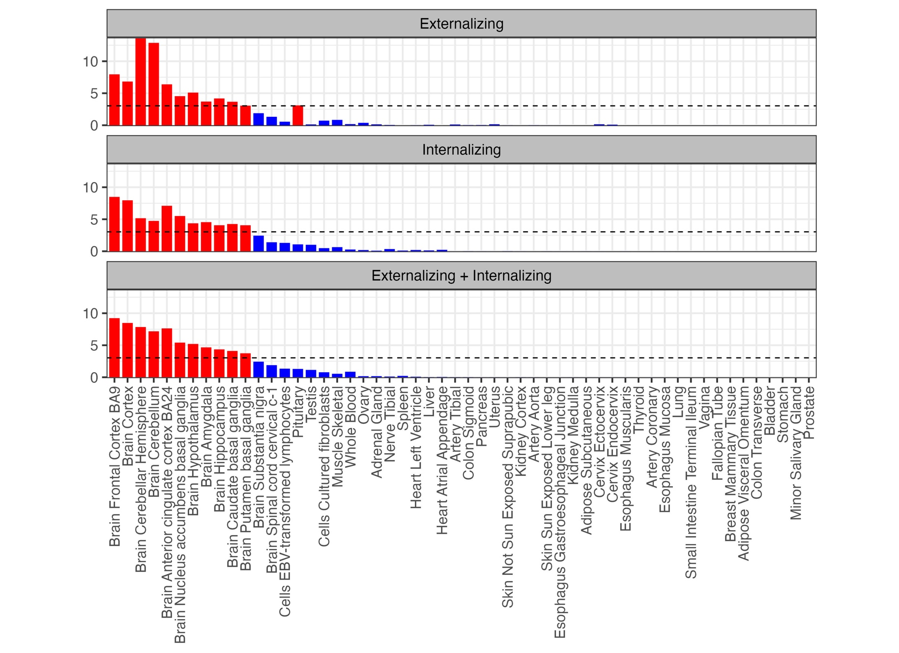

Supplementary Figure 8. Results of gene-tissue expression analyses using GTEx v8 tissue types.
Red indicates significance at a Bonferroni-adjusted p-value of 9.26e-04.

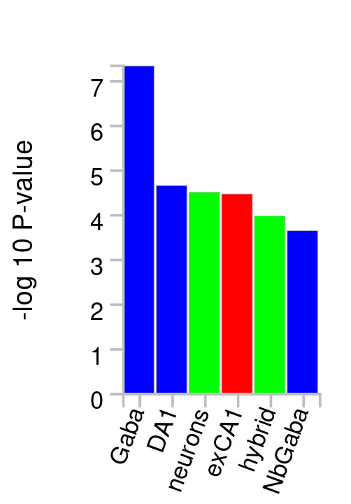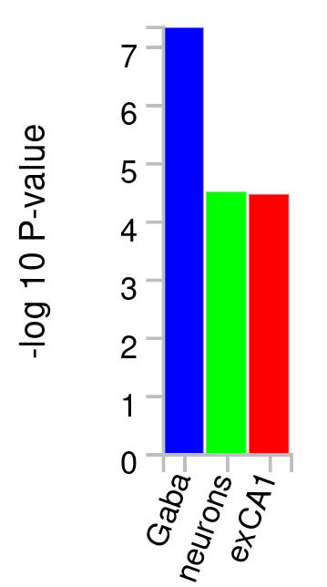
b)
a)

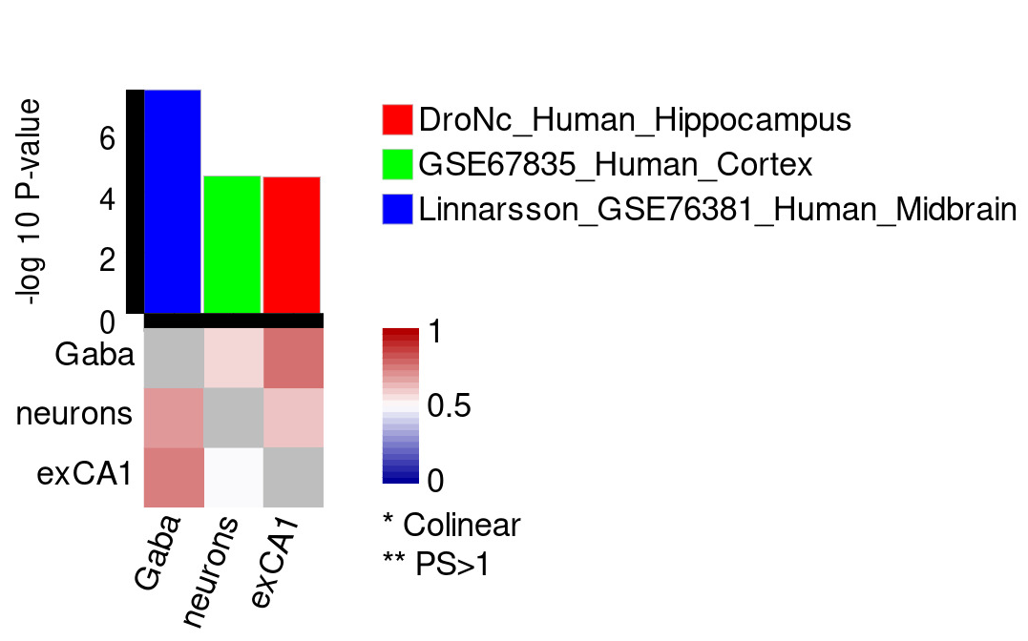
c)

Supplementary Figure 9. Results of cell-specific gene expression analyses for externalizing.
Analyses used single cell RNA sequencing (scRNA-seq) datasets from human brain cell expression profiles. Panel A shows results from step one across dataset analyses, panel B shows step 2 within-dataset conditional analyses, and panel C shows step 3 cross datasets conditional analyses. In panel C, the heatmap shows the cross-datasets proportional significance (PS) of cell type j (column) conditioning on cell type i (row). Each cell is colored by PS with upper limit 1, where PS>1 is represented by double stars. A star represents a pair of collinear cell types. Panel C bar plot presents marginal P-value of the cell type.

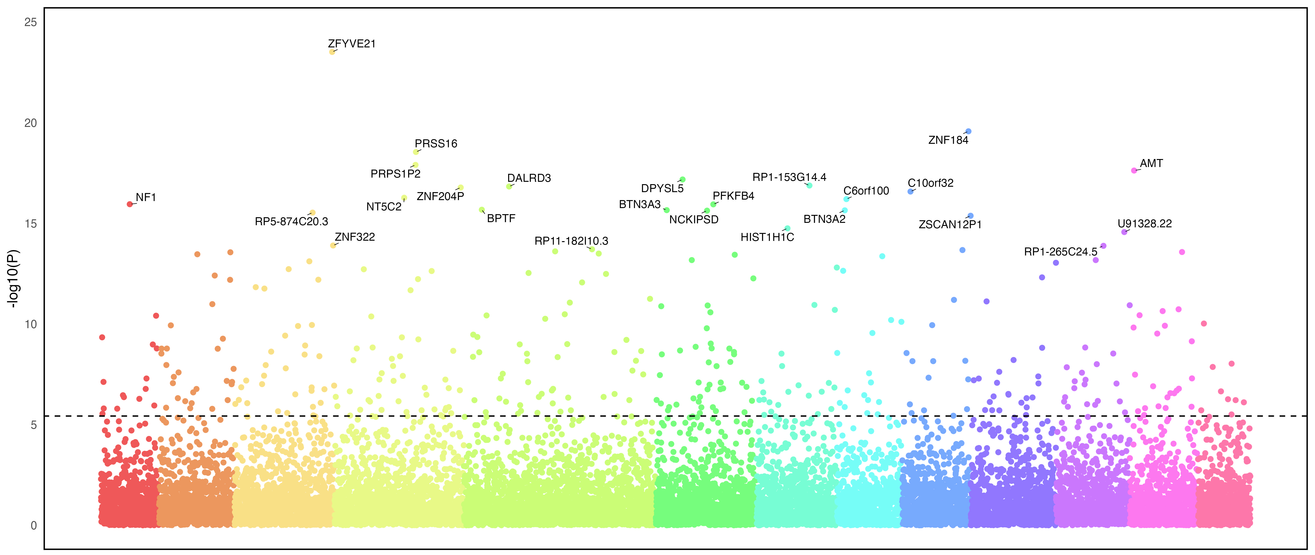
a)
b)
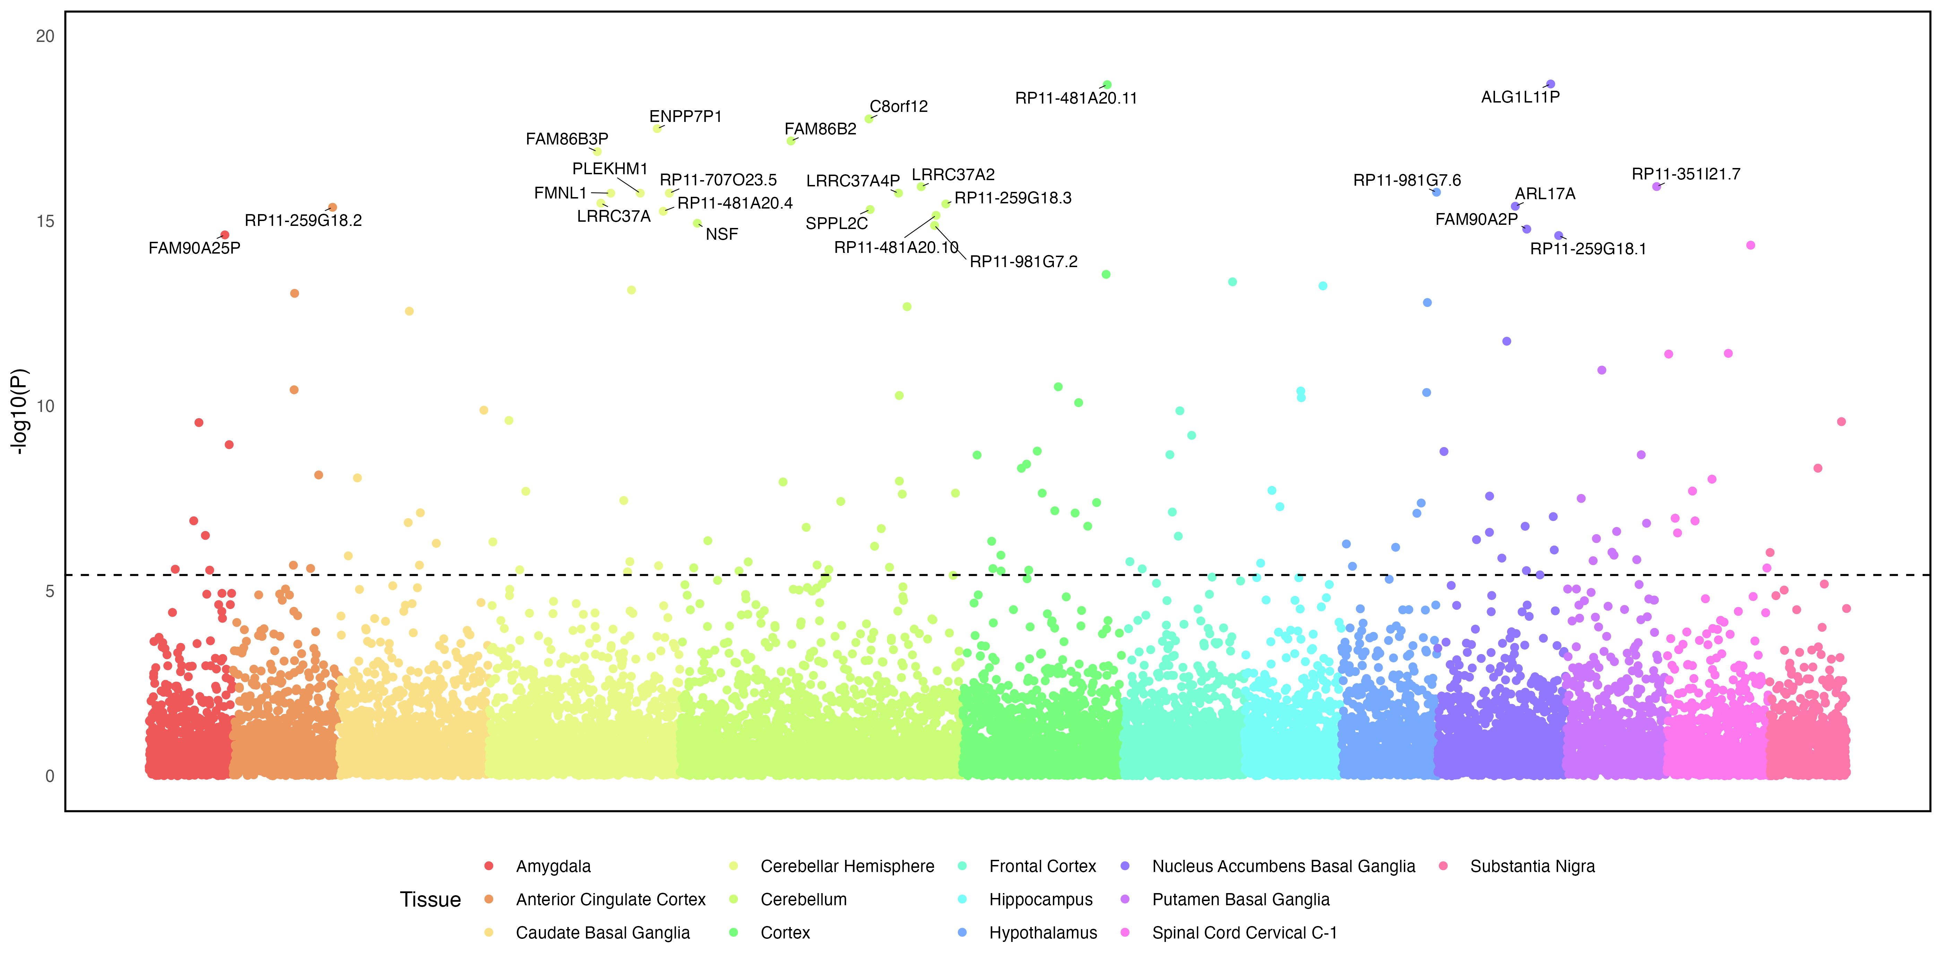

Supplementary Figure 10. Transcriptome wide association analysis using S-MultiXcan for externalizing (Panel A) and internalizing (Panel B).
Analyses examined the effects of SNP variation on gene expression across 13 types of brain tissue using S-MultiXcan. The top 25 associations are annotated for each factor. The best associated tissue type for each gene is indicated by color.
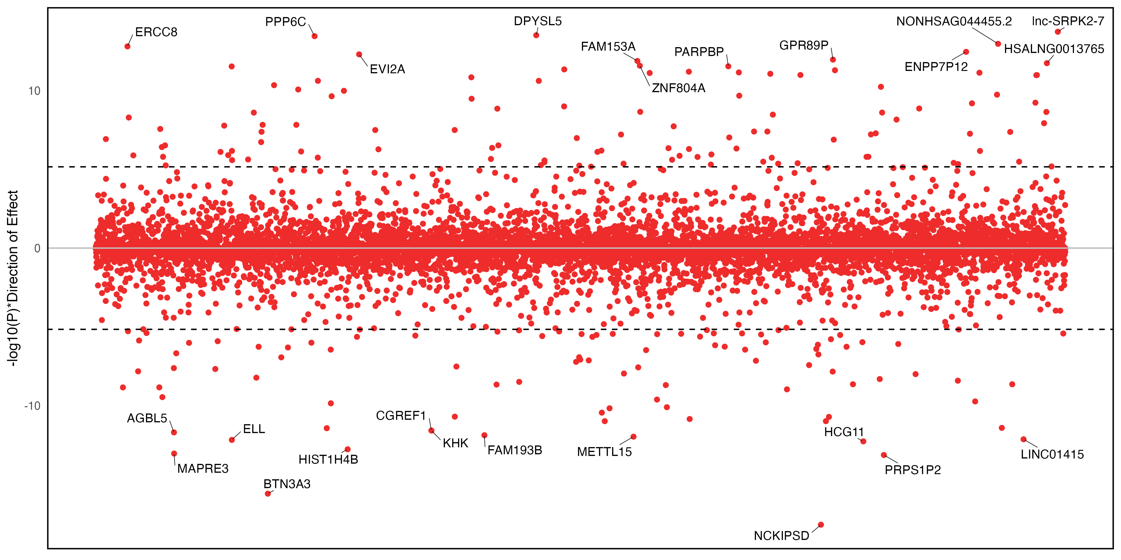
b)
a)
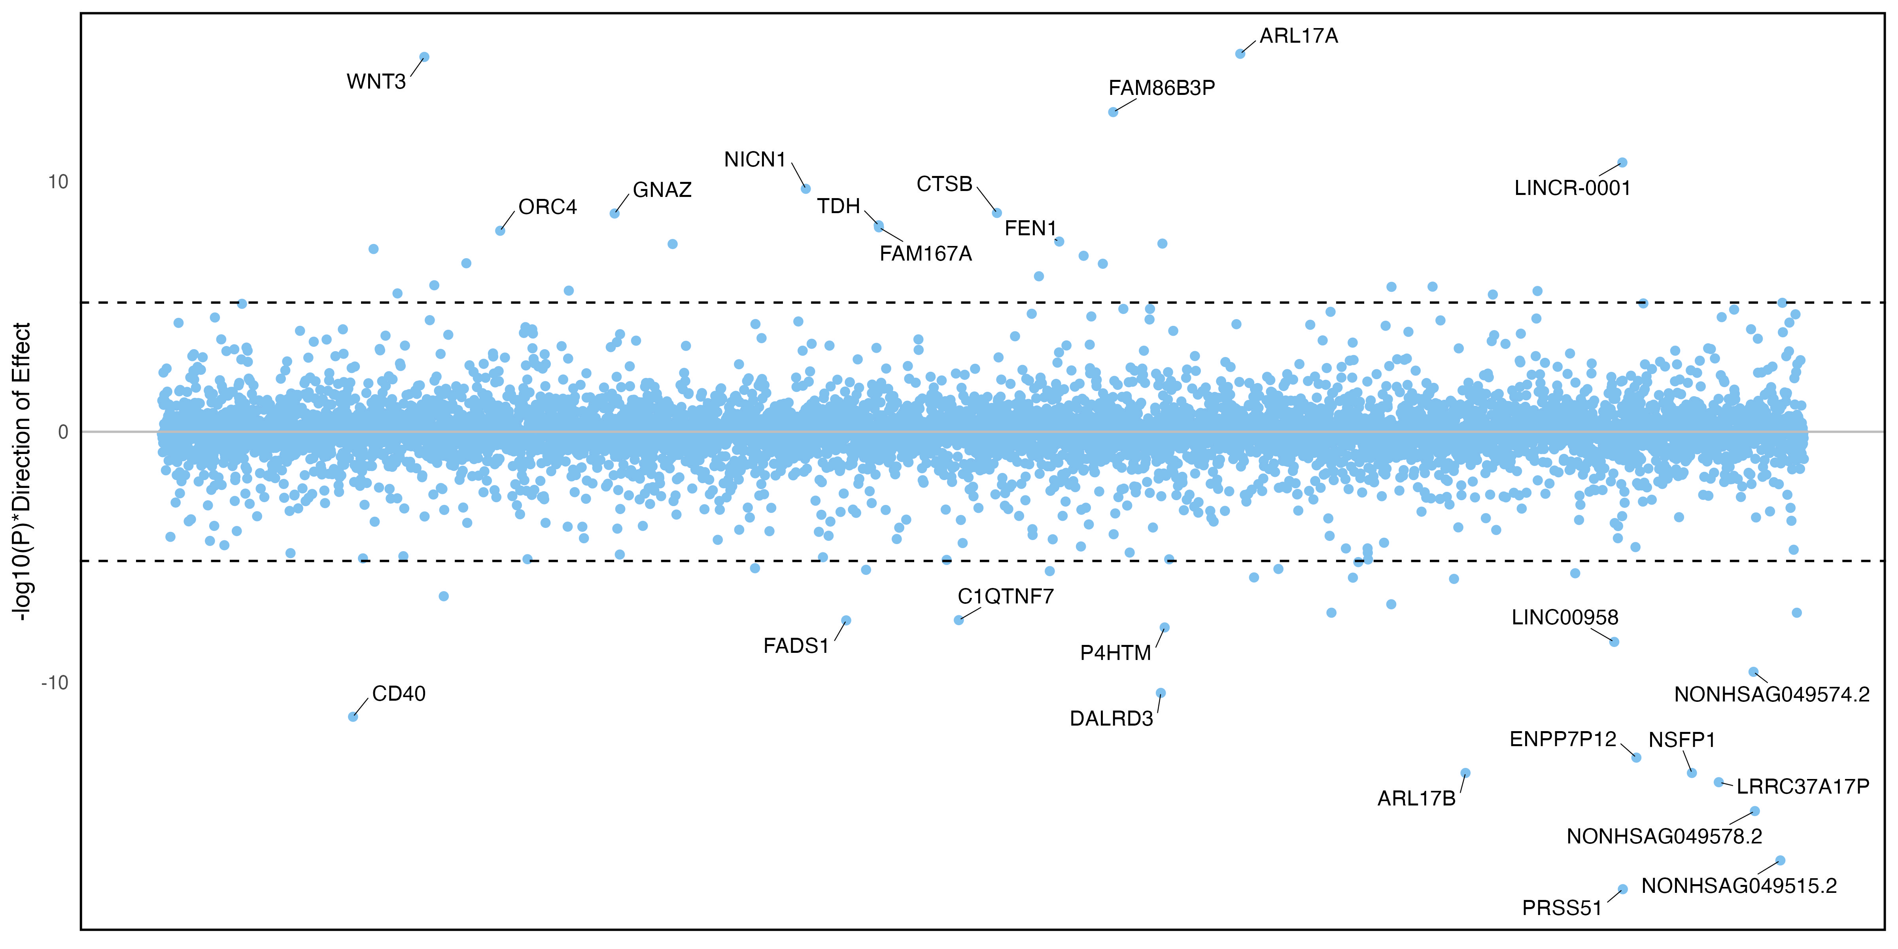
c)
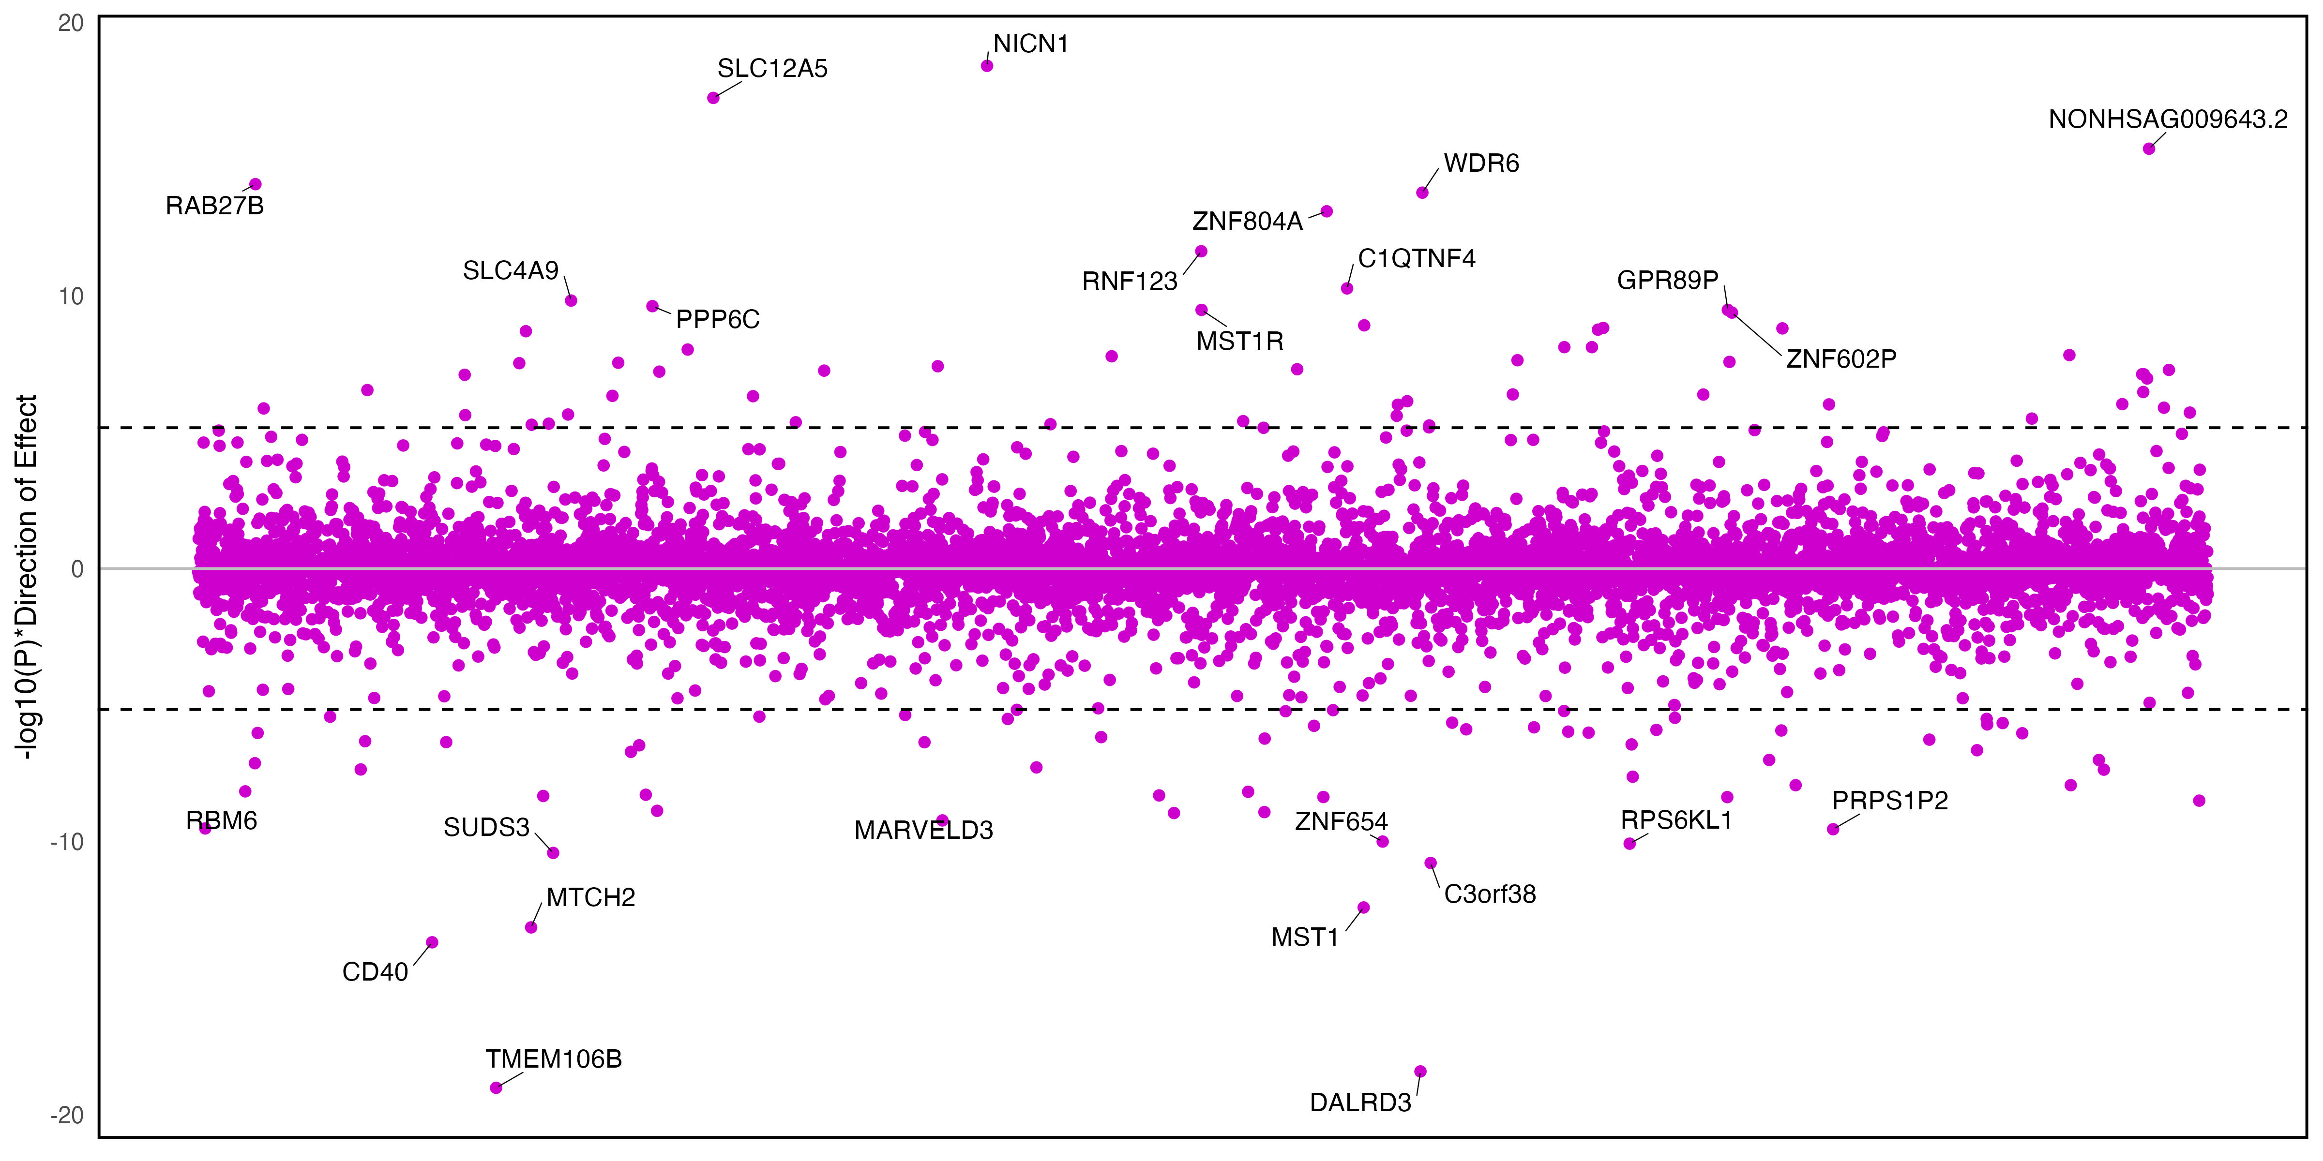

Supplementary Figure 11. Transcriptome wide association analysis using PsychENCODE data for S-PrediXcan.
Y-axis plots the p-value and whether genes were up- or down-regulated in brain tissue. The top 25 associations are annotated. Panel A is externalizing, B is internalizing, and C is EXT+INT.

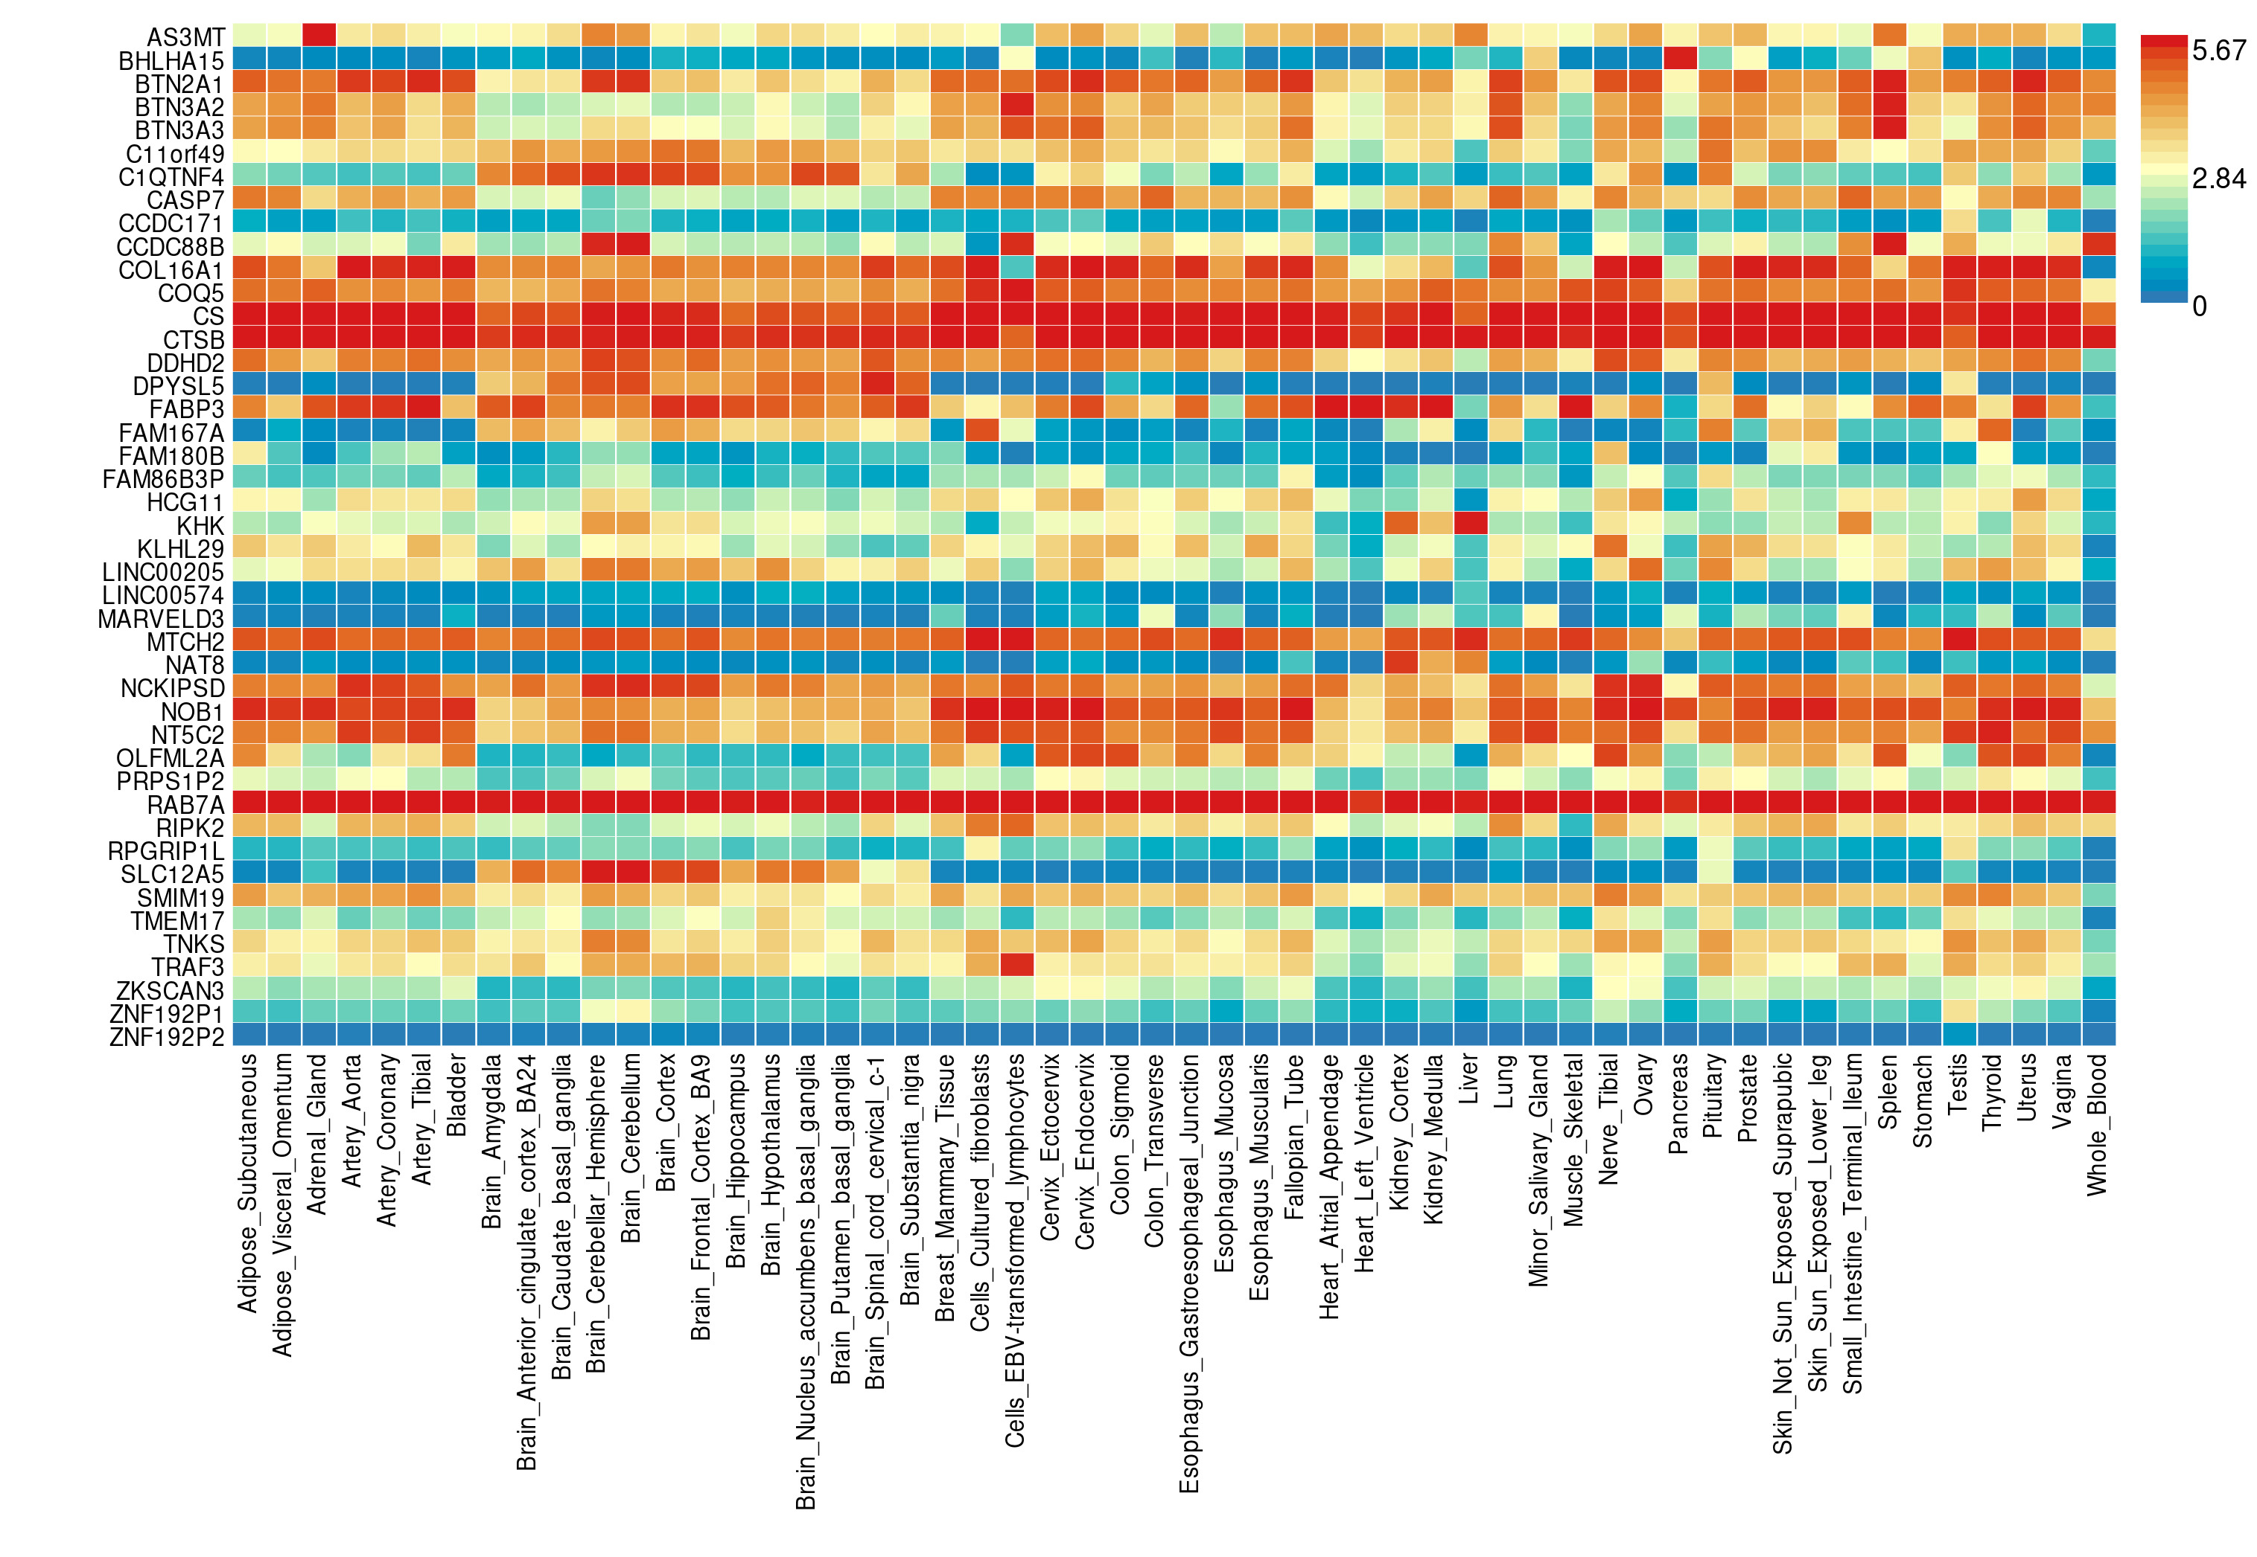

Supplementary Figure 12. MAGMA gene-property analyses performed on the subset of genes identified by both S-MultiXcan and S-PrediXcan for externalizing.
Heatmap presents average expression levels (log² transformed).
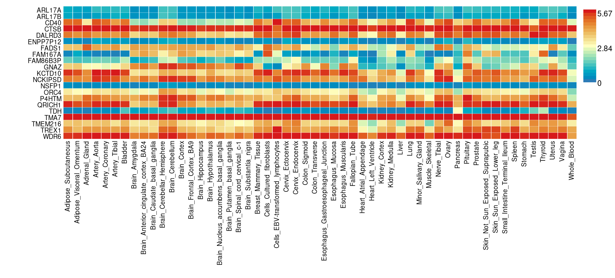

Supplementary Figure 13. MAGMA gene-property analyses performed on the subset of genes identified by both S-MultiXcan and S-PrediXcan for internalizing.
Heatmap presents average expression levels (log² transformed).
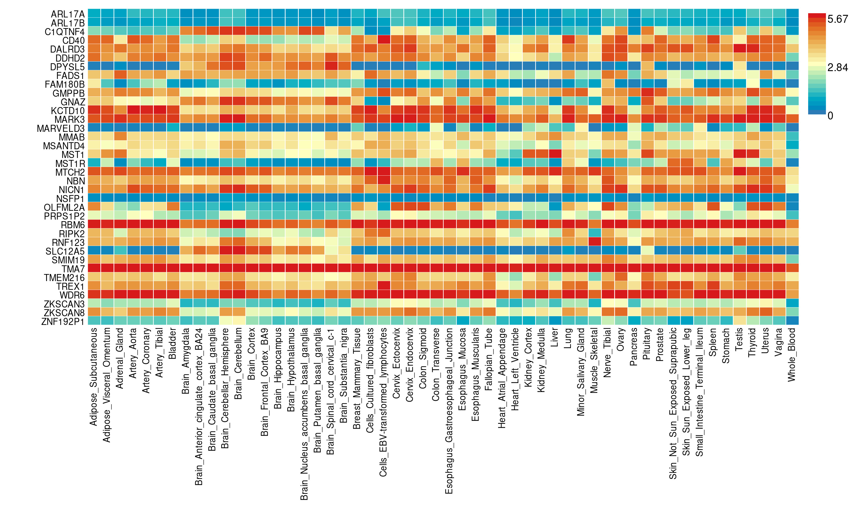

Supplementary Figure 14. MAGMA gene-property analyses performed on the subset of genes identified by both S-MultiXcan and S-PrediXcan for second-order EXT+internalizing.
Heatmap presents average expression levels (log² transformed).

Supplementary Figure 15. BrainXcan structural MRI association results for externalizing.
The direction and magnitude of the Z-scores of the association tests for each region are plotted by color. Interactive files showing the regions in the visualization are available here.

Supplementary Figure 16. BrainXcan diffusion MRI association results for externalizing.
The direction and magnitude of the Z-scores of the association tests for each region are plotted by color. Interactive files showing the regions in the visualization are available here.

Supplementary Figure 17. BrainXcan structural MRI association results for internalizing.
The direction and magnitude of the Z-scores of the association tests for each region are plotted by color. Interactive files showing the regions in the visualization are available here.

Supplementary Figure 18. BrainXcan diffusion MRI association results for internalizing.
The direction and magnitude of the Z-scores of the association tests for each region are plotted by color. Interactive files showing the regions in the visualization are available here.

Supplementary Figure 19. BrainXcan structural MRI association results for second order externalizing + internalizing.
The direction and magnitude of the Z-scores of the association tests for each region are plotted by color. Interactive files showing the regions in the visualization are available here.

Supplementary Figure 20. BrainXcan diffusion MRI association results for second order externalizing + internalizing.
The direction and magnitude of the Z-scores of the association tests for each region are plotted by color. Interactive files showing the regions in the visualization are available here.

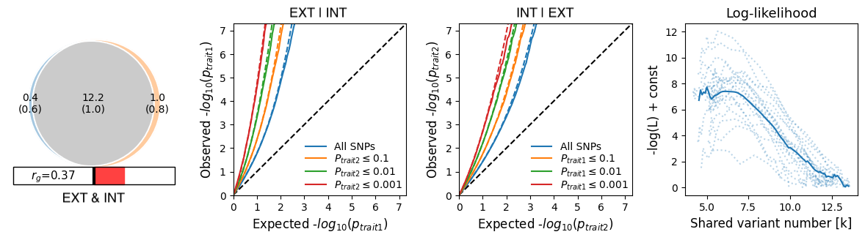

Supplementary Figure 21. Results of bivariate causal mixture (MiXeR) models for externalizing and internalizing.
The Venn diagram on the left shows the estimated overlap in causal variants for externalizing and internalizing. The next two panels show conditional Q-Q plots of the observed vs. expected -log₁₀ p-values in trait 1 as a function of the significance of the association with trait 2 (and vice versa) at the level of p$≤$ 0.1, p$≤$ 0.01, and p$≤$ 0.001. The final panel shows the negative log-likelihood as a function of polygenic overlap. The minimum model is represented by the point furthest to the left where the genetic overlap is estimated to be the minimum required to explain the genetic correlation between the two traits, the maximum model is represented as the point furthest on the right represents complete overlap where the least polygenic trait’s causal variants are a subset of the more polygenic trait, and the best model (i.e., the one selected by the MiXeR analysis) is the lowest point on the chart.

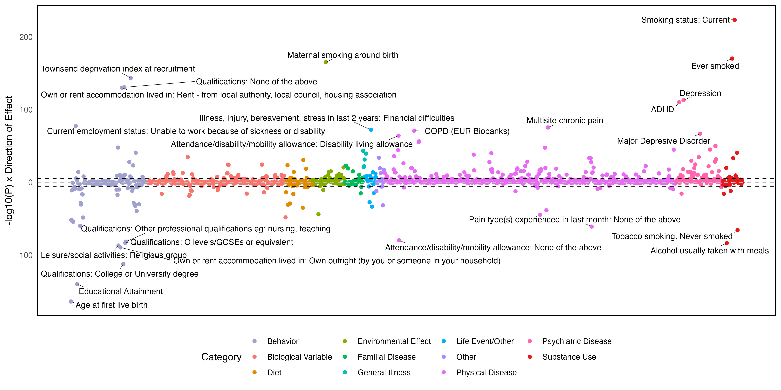

Supplementary Figure 22. Genetic correlations between the externalizing factor and publicly available phenotypes.
The top 25 associations are annotated.

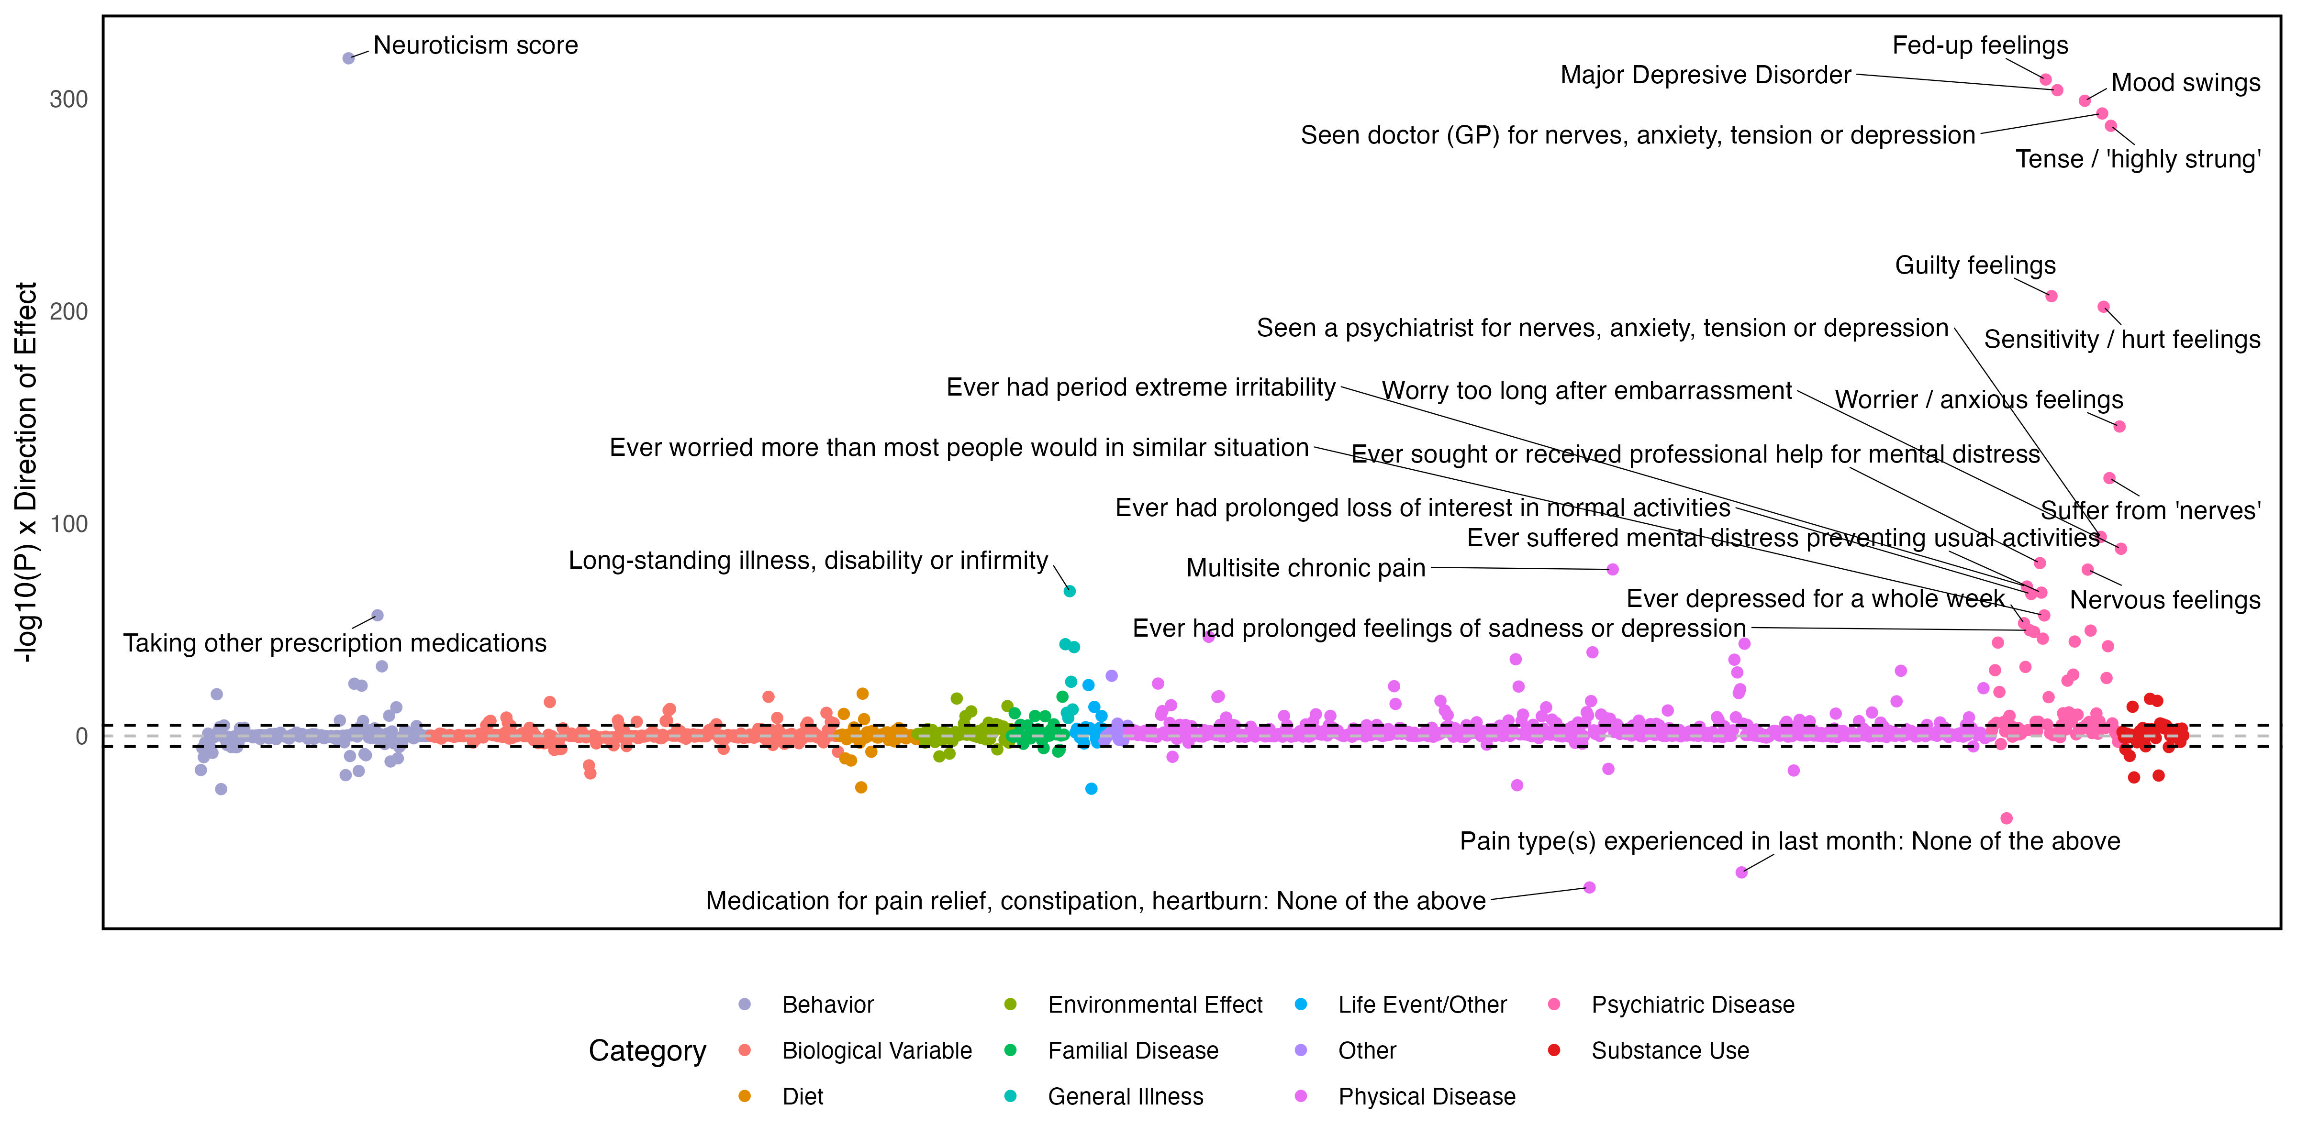

Supplementary Figure 23. Genetic correlations between the internalizing factor and publicly available phenotypes.
The top 25 associations are annotated.

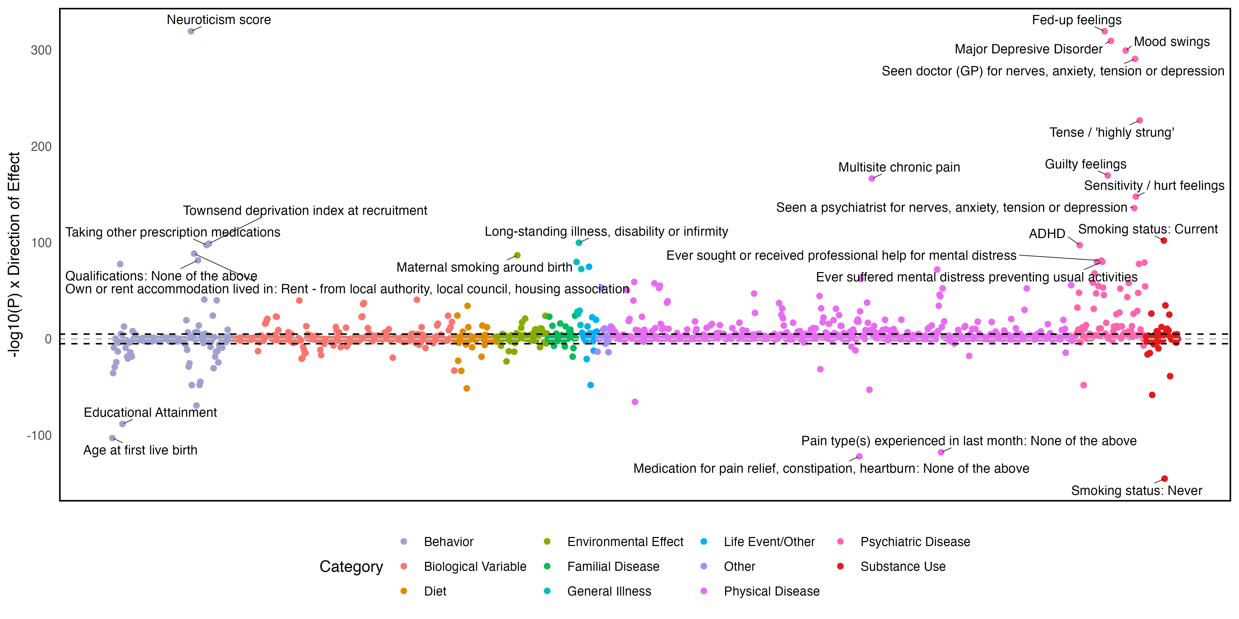

Supplementary Figure 24. Genetic correlations between the second-order externalizing and internalizing factor and publicly available phenotypes.
The top 25 associations are annotated.

