Supplementary Figures

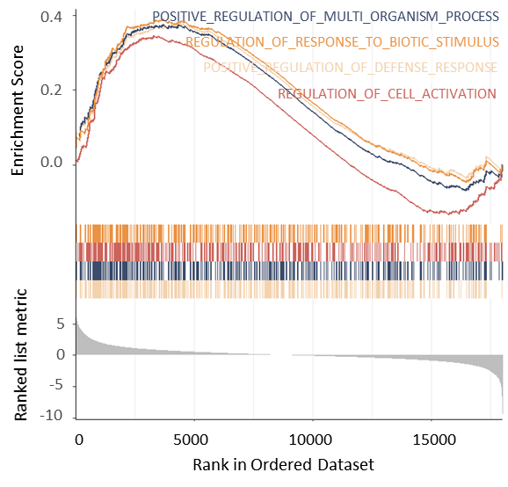
Figure S1. Functional analysis of the differentially expressed mRNAs using GSEA. Besides immunity, the enriched biological processes also include some common regulations in cells.

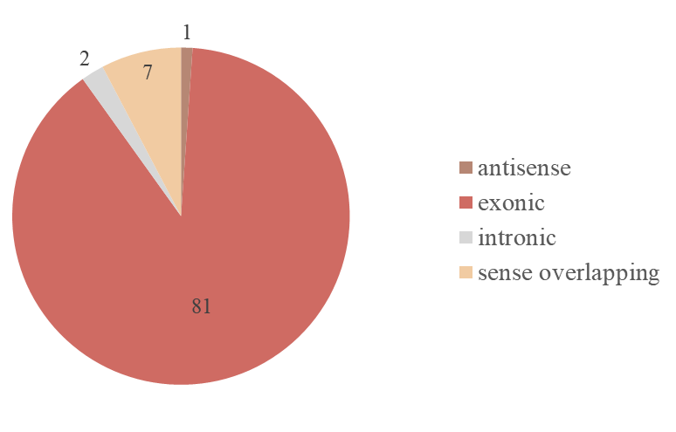
Figure S2. CircRNA types of the 91 immune-related circRNAs involved in the competing endogenous regulatory network.

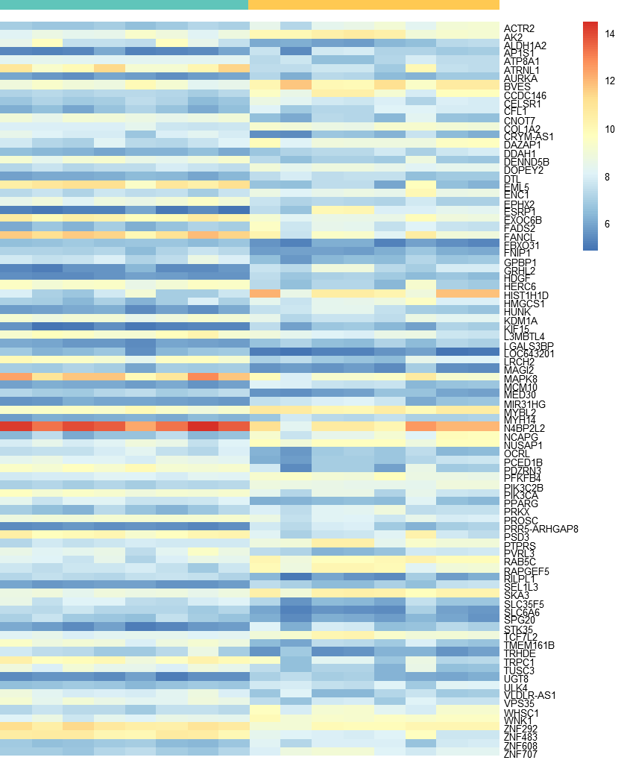
Figure S3. Heat map of the 91 immune-related circRNAs involved in the competing endogenous regulatory network. (green bar for normal; yellow bar for disease on the top)

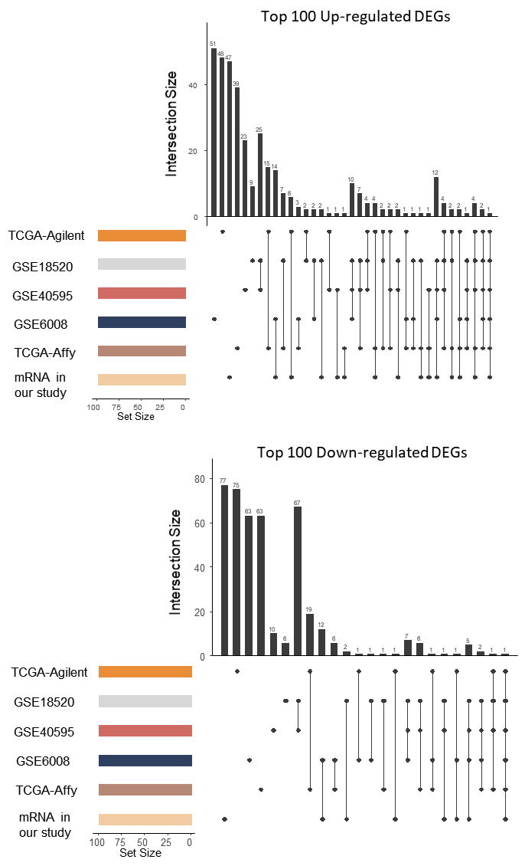
Figure S4. The intersection of up-regulated and down-regulated mRNAs among the six ovarian cancer cohorts.

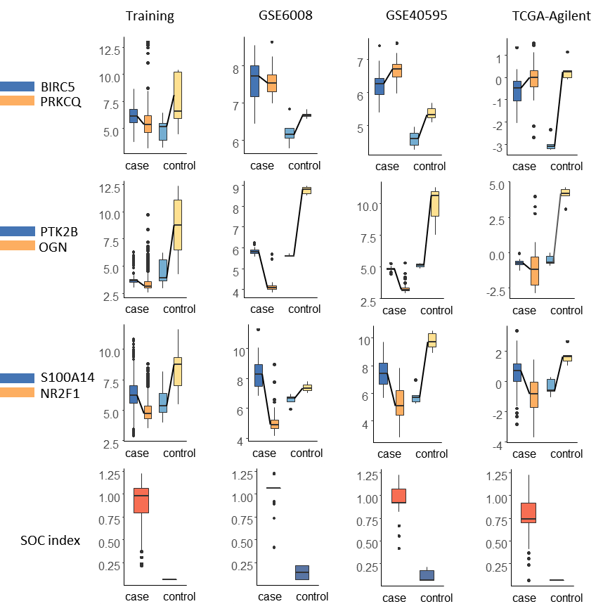
Figure S5. Boxplot of the three mRNA pairs and the SOC index in the training set and three validation cohorts.

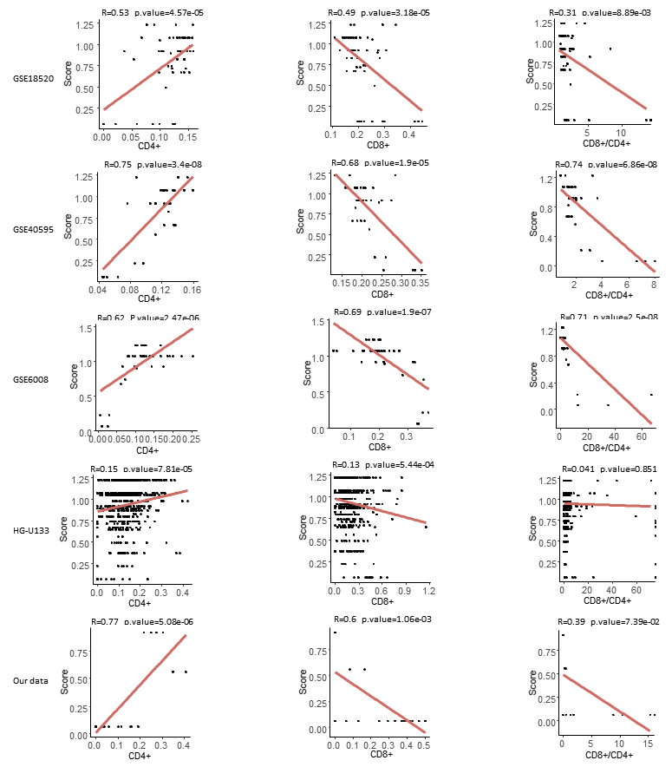
Figure S6. Correlation between the SOC index and CD4+ (left column), CD8+ (middle column), as well as CD8+/CD4+ (right column), in the five cohorts.

Table S1. The 91 immune-related circRNAs involved in the competing endogenous regulatory network.
probeID | circRNA | Alias | GeneSymbol | source | chrom | strand | txStart | txEnd | circRNA_type | best_transcript | Sequence
ASCRP3009059 | hsa_circRNA_406521 |  | UGT8 | 25070500 | chr4 | + | 115540578 | 115544858 | sense overlapping | NM_003360 | GCCCACTACCAGAATGAGAGTAACACATGCGCACTGTGGATTCCTTTGTGAATACATAAA
ASCRP3004771 | hsa_circRNA_104720 | hsa_circ_0006566 | ZNF707 | circBase | chr8 | + | 144771373 | 144772293 | exonic | NM_173831 | CATGGCCCAGTTGCTGAACCTGTTTGCATGAGTTGCTCCTGACGGCCCTTTAGGATACTT
ASCRP3006873 | hsa_circRNA_104651 | hsa_circ_0084927 | ESRP1 | circBase | chr8 | + | 95676924 | 95677424 | exonic | NM_017697 | CTTAAAATTGCTGGTGCAGCAAGATGGAACTTATTGATGATAACACCGTAGTCAGGGCAC
ASCRP3000367 | hsa_circRNA_404643 |  | PIK3C2B | 25070500 | chr1 | - | 204396775 | 204397348 | exonic | NM_002646 | AACAATAAACTCTTCATCATGGTGATGCATATTCGGGGCTTGTGTGATTTGGTGTACACC
ASCRP3011086 | hsa_circRNA_403102 |  | SEL1L3 | 25242744 | chr4 | - | 25848915 | 25849486 | exonic | NM_015187 | TATTTGGAACCTTCGGGCAAACAGGATTCCACAGTGTCCTCTGGAAAATGAATGTTGTAC
ASCRP3004649 | hsa_circRNA_406137 |  | HUNK | 25070500 | chr21 | + | 33331154 | 33347029 | exonic | NM_014586 | CATCTACTTCCTCTTAAACAAGAAACTGGAGCGCTATTTGTCAGGGAGGTGTGAACATGT
ASCRP3001445 | hsa_circRNA_406716 |  | LOC643201 | 25070500 | chr5 | - | 175581753 | 175586199 | exonic | NR_036494 | ACGAGATTCAGGAATGACATCAGTACTGGGAAAATGCAAGAAAGTATGTTCCGGTGAAGA
ASCRP3005396 | hsa_circRNA_004116 | hsa_circ_0004116 | MED30 | circBase | chr8 | + | 118540889 | 118543066 | exonic | NM_080651 | CCTCGTTTTGCTAGTGAAGAGAGGCGAGAAATTGCTGAAGTAAATAAACTGCCAAATGGT
ASCRP3001144 | hsa_circRNA_405028 |  | TRHDE | 25070500 | chr12 | + | 72955944 | 73015531 | exonic | NM_013381 | ACAGGCATCAACACTTATTTCAGATTGGATTTCCAGCAACAGGAACAGGATTATTTAACC
ASCRP3012936 | hsa_circRNA_103095 | hsa_circ_0008777 | AURKA | circBase | chr20 | - | 54956488 | 54961589 | exonic | NM_003600 | TTCAGAAACTTTCAAAGTTTGATGAGCAGAGAACTGCTACTGCTACAGCTCCAGTTGGAG
ASCRP3011117 | hsa_circRNA_406960 |  | CCDC146 | 25070500 | chr7 | + | 76922268 | 76924255 | sense overlapping | NM_020879 | TCAACCAGGCTTCCTTGTACCCACAGGTGAAAAATATGAATGGCTATCAAAGAAGGATCA
ASCRP3002066 | hsa_circRNA_104669 | hsa_circ_0085173 | GRHL2 | circBase | chr8 | + | 102570646 | 102571040 | exonic | NM_024915 | AGCCACAGAGAAACTGCCTTGGCACCAGTGAAGCCCAGAGTAATTTGAGTGGAGGAGAAA
ASCRP3003915 | hsa_circRNA_004226 | hsa_circ_0004226 | CDKN2B-AS1 | circBase | chr9 | + | 22046749 | 22066352 | exonic | NR_003529 | CACCATGCATGTGTCCCTTTTGATGAGAAGAATAAGCCTCATTCTGATTCAACAGCAGAG
ASCRP3003823 | hsa_circRNA_100684 | hsa_circ_0020048 | TCF7L2 | circBase | chr10 | + | 114724314 | 114799885 | exonic | NM_001146274 | CACACATTGTCCTCCATTTTCAGTCCGGCAGCACACATTACTCTGCGTACAAAACGATTG
ASCRP3007855 | hsa_circRNA_401801 |  | RAB5C | 25242744 | chr17 | - | 40278772 | 40282608 | exonic | NM_004583 | GACATCAGCAAAGACTGCAATGAACGTGAACGAAATCTTCATGGCAATAGTTGGAGGTCC
ASCRP3003034 | hsa_circRNA_101231 | hsa_circ_0000467 | SKA3 | circBase | chr13 | - | 21742126 | 21742538 | exonic | NM_145061 | ATGCGAGGAATAATAAAAGTACACGAGCAAGAAGCCATTAACTCTGACCCAGAGTTGTCT
ASCRP3003129 | hsa_circRNA_100833 | hsa_circ_0022383 | FADS2 | circBase | chr11 | + | 61605249 | 61615756 | exonic | NM_004265 | ATGTGAACATGCTGCACGTGTTTGTTCTGGGCGAATGGCAGCCCATCGAGGATGCCTTCC
ASCRP3003784 | hsa_circRNA_405964 |  | CCNT2-AS1 | 25070500 | chr2 | - | 135624111 | 135626611 | sense overlapping | NR_036549 | CAATTCTGGGACAACAAGGGATTCTGGAAGTGTCAGGAAAAGGCAATCACAGGAATATAT
ASCRP3012686 | hsa_circRNA_103486 | hsa_circ_0001345 | TRPC1 | circBase | chr3 | + | 142455220 | 142467302 | exonic | NM_003304 | TGTGTTCTGCAAAAAACAAAAAGGATAGCCTCCGGCATTCCAGGTGACTATTATATGGTT
ASCRP3013133 | hsa_circRNA_000328 | hsa_circ_0000328 | CFL1 | circBase | chr11 | - | 65622881 | 65623563 | intronic | ENST00000527752 | TTCTTTATAGGGATCAAGCATGAATTGCAAGCAAACTGCTACGAGGAGGGCAAGGAGATC
ASCRP3012255 | hsa_circRNA_003300 | hsa_circ_0003300 | LRCH2 | circBase | chrX | - | 114357089 | 114364762 | exonic | NM_020871 | TGCTTGTAAAAAGTTGGGTGTCTCACAGTATAAATCAATGAGGAAGAGTTCAAGTGGCAA
ASCRP3006089 | hsa_circRNA_402915 |  | PVRL3 | 25242744 | chr3 | + | 110830876 | 110866331 | exonic | NM_001243288 | CTCAGAAAGACCTATTTCAGGTGCCTTAGCTGGACCAATTATTGTGGAGCCACATGTCAC
ASCRP3005000 | hsa_circRNA_403883 |  | AP1S1 | 25242744 | chr7 | + | 100799874 | 100800766 | exonic | NM_001283 | CCACCGATACGTGGAGCTCTTAGACAAATACTTTGGCAGTATGCGGTTCATGCTATTATT
ASCRP3012950 | hsa_circRNA_005219 | hsa_circ_0005219 | STK35 | circBase | chr20 | + | 2097311 | 2098061 | exonic | NM_080836 | TTCAGGGCTAAGCATTTTGGGTGATTTTAAACTAGGAGAAAGGATCCTGGGTTATGCTGA
ASCRP3011716 | hsa_circRNA_104153 | hsa_circ_0004058 | ZNF292 | circBase | chr6 | + | 87925620 | 87928449 | exonic | NM_015021 | TCTTTCCCAGGAACCATTGGATAAGGATAAAGACACTCCTAGAATATGCAGAGAAATGGA
ASCRP3013216 | hsa_circRNA_039210 | hsa_circ_0039210 | VPS35 | circBase | chr16 | - | 46710494 | 46711310 | exonic | NM_018206 | TTGCTTTAATTGATAGATTGTTTTGACTGGCATATTGGAGCAAGTTGTAAACTGTAGGGA
ASCRP3004850 | hsa_circRNA_405719 |  | PTPRS | 25070500 | chr19 | - | 5214371 | 5220364 | exonic | NM_002850 | CATTCTGCGTCAGGACATTCTCTCTGCACAAGGAGCTATTTCATTGTGATGGTGCCACTG
ASCRP3000220 | hsa_circRNA_407327 |  | OCRL | 25070500 | chrX | + | 128691301 | 128692978 | exonic | NM_000276 | AAAGCGAGAGAAAGAATATGTCAACATTCAGACTTTCAGGTGGCTGCAAAATTCGGGTTC
ASCRP3007336 | hsa_circRNA_103066 | hsa_circ_0006332 | MYBL2 | circBase | chr20 | + | 42331129 | 42333998 | exonic | NM_002466 | GAAACATGCTGCGACCCTGATGCTTGGTGTGACCTGAGTAAATTTGACCTCCCTGAGGAA
ASCRP3002965 | hsa_circRNA_100295 | hsa_circ_0013451 | SORT1 | circBase | chr1 | - | 109910029 | 109912211 | exonic | NM_002959 | ATGACTTTTGGACAGTCCAAGCTATATCGAAGCATGTGTTTGATGATCTCAGAGGCTCAG
ASCRP3012126 | hsa_circRNA_402833 |  | ULK4 | 25242744 | chr3 | - | 41831152 | 41877463 | exonic | NM_017886 | TGCCATGTTGTCCTGTGGGATTCATCTTCAAAGACTAATCCAAGAAAAGGCAATTGTTCT
ASCRP3012956 | hsa_circRNA_402760 |  | PRR5-ARHGAP8 | 25242744 | chr22 | + | 45197956 | 45210638 | exonic | NM_181334 | TTCATCAAGGTCCTGTGGAACATCTTGAAGCCCCTCATCAGGGGATGACCGCTTTGGAAG
ASCRP3002325 | hsa_circRNA_101529 | hsa_circ_0035442 | ALDH1A2 | circBase | chr15 | - | 58284902 | 58287337 | exonic | NM_003888 | AGGGTCTACTGAGATGGAGACTATTTTACCTTTACAAGACATGAACCCATTGGAGTGTGT
ASCRP3010310 | hsa_circRNA_100157 | hsa_circ_0011462 | AK2 | circBase | chr1 | - | 33478807 | 33480195 | exonic | NM_013411 | GTGTTCGCAAGCATCCTAGCAGCCTTCTCCAAAGCCACATGCTGATTCACCCCAAGAGTG
ASCRP3007629 | hsa_circRNA_001589 | hsa_circ_0001589 | HIST1H1D | circBase | chr6 | - | 26234499 | 26234709 | sense overlapping | NM_005320 | GAAGGCAGCTCCGAAGAAAAACATCAAAAAGACTCCTAAGAAGGTAAAGAAGCCAGCAAC
ASCRP3002887 | hsa_circRNA_103335 | hsa_circ_0006084 | KIF15 | circBase | chr3 | + | 44826336 | 44835918 | exonic | NM_020242 | ATCTGAAAGGCAAAAAGATACCCATGCAGAAGGGATGAGATTGAAGGACCATCTGAATCT
ASCRP3007299 | hsa_circRNA_001387 | hsa_circ_0001387 | WHSC1 | circBase | chr4 | + | 1902352 | 1936989 | exonic | NM_007331 | GAAAAGACTCAGGACGGACAAGCACAGTCTTCGGAAGTGTTCTAAGAACGGAAGCATCTG
ASCRP3005613 | hsa_circRNA_102747 | hsa_circ_0008529 | ACTR2 | circBase | chr2 | + | 65473657 | 65492309 | exonic | NM_005722 | CGAGTTTTGAAGGGTGATGTGGAAAAACTTTCTGATCTTATGGTTGGTGATGAGGCAAGT
ASCRP3009211 | hsa_circRNA_100554 | hsa_circ_0002109 | MCM10 | circBase | chr10 | + | 13214375 | 13214765 | exonic | NM_018518 | GCTCGAACACCAAAGGCTTCACCTCCAGAGGAATTAAGGAATTTGCAAGAGCAAATGAAG
ASCRP3009776 | hsa_circRNA_404126 |  | VLDLR-AS1 | 25242744 | chr9 | - | 2536358 | 2539552 | exonic | NR_015375 | GGTCACAAACAAGAGGTCCCTGGATCTACAGGCTCCAAGCTTGATATAGAAGACTATCAT
ASCRP3003666 | hsa_circRNA_405649 |  | L3MBTL4 | 25070500 | chr18 | - | 6301901 | 6312055 | exonic | NM_173464 | CAAGGATAGCACAACCCCTTTGAGTCACGATTGCTATGCTATGCCTTGTATGACTAAGAC
ASCRP3000535 | hsa_circRNA_034693 | hsa_circ_0034693 | NUSAP1 | circBase | chr15 | + | 41648236 | 41650456 | exonic | NM_016359 | AAGAACACAATTCCATGAATGAACTGAAGGTAACAGAGATTCAAAGGTACCTTCAGAAGG
ASCRP3011829 | hsa_circRNA_103927 | hsa_circ_0001523 | ZNF608 | circBase | chr5 | - | 124036706 | 124036962 | exonic | NM_020747 | TGAATTTGGAAGGGATCGTGTGGCATGAAACAGAAGAAGGTTGACCCCCTGTTTACAGTG
ASCRP3009693 | hsa_circRNA_103124 | hsa_circ_0001187 | DOPEY2 | circBase | chr21 | + | 37619814 | 37620866 | exonic | NM_005128 | GGGATCCTCTTCCGTTTACTTTAAAACCACCAAACACAACCTCCAAGAGGGAAAACATTT
ASCRP3002185 | hsa_circRNA_014784 | hsa_circ_0014784 | HDGF | circBase | chr1 | - | 156711898 | 156713247 | exonic | NM_004494 | AGGAAAATAAAACCCGTTGATTACTATACCTGTAGCCACCAATGTTTCAAGAGGAGCCCC
ASCRP3009472 | hsa_circRNA_092549 | hsa_circ_0001486 | GPBP1 | circBase | chr5 | + | 56526672 | 56527148 | exonic | NM_022913 | GGAGGAAAGAAGACAAGAGAGAACGCAAACAGTTTGAAGCTGAGGATTTTTCGTCATTGA
ASCRP3009451 | hsa_circRNA_101245 | hsa_circ_0000471 | N4BP2L2 | circBase | chr13 | - | 33091993 | 33101669 | exonic | NM_033111 | GGAGACAGAGAATTCTGCTTGGTCAGAATCGTGATGGCATTGTGTTCAGCACTGATGACT
ASCRP3009745 | hsa_circRNA_004607 | hsa_circ_0004607 | DDAH1 | circBase | chr1 | - | 85816097 | 85824530 | exonic | NM_012137 | GGGTCTAGTGAATCTGCACAGAAGGCCCTTAAGGTTGACATGATGAAAGAAGCATTAGAA
ASCRP3011578 | hsa_circRNA_103936 | hsa_circ_0073859 | FNIP1 | circBase | chr5 | - | 131006155 | 131014868 | exonic | NM_133372 | TCTCATGCTGTGCAGAACAACAATTTGTAATCTTTACACGATGCCACGAATTGGAGAACC
ASCRP3009795 | hsa_circRNA_081069 | hsa_circ_0081069 | COL1A2 | circBase | chr7 | + | 94027693 | 94037203 | exonic | NM_000089 | GGTGAACCTGGTGCCCCTGGTGAAAATGGAACTCCAGGTCAAACAGAAACTGTAAGAAAG
ASCRP3009986 | hsa_circRNA_102402 | hsa_circ_0048232 | DAZAP1 | circBase | chr19 | + | 1417498 | 1422395 | exonic | NM_018959 | GTCACGGAGGTAGTCATGATCTATGACGCCGAGAAGCAGAGGCCCCGAGGAAGCTCTTCG
ASCRP3005237 | hsa_circRNA_405454 |  | CRYM-AS1 | 25070500 | chr16 | + | 21327227 | 21328447 | sense overlapping | NR_026675 | CCCTCAAATGAAAGAAGAATGGATTTCTCGGAGTCTGAAAAATTTATGGTTCTTCTCTGG
ASCRP3007271 | hsa_circRNA_005476 | hsa_circ_0005476 | TMEM161B | circBase | chr5 | - | 87516379 | 87541609 | sense overlapping | NM_153354 | CTTTTGCAATGTATATCTGTCAACAGTATCTCATCATGTTTGGTGATTTGGAGGAAGGGG
ASCRP3002759 | hsa_circRNA_405000 |  | PCED1B | 25070500 | chr12 | + | 47606379 | 47610472 | intronic | NM_001281429 | ATCACCAGTTACTTTAATGATCTATTCCTGCAGTGATGGTGTCATACCAGCCCATGGAAC
ASCRP3009420 | hsa_circRNA_100097 | hsa_circ_0009061 | KDM1A | circBase | chr1 | + | 23356961 | 23377013 | exonic | NM_015013 | GGACCACAACAGACCCAGAAGGTTTTTCTTTTCATTAGAAACCGCACAGTAGAGTACAGA
ASCRP3008327 | hsa_circRNA_101196 | hsa_circ_0007552 | RILPL1 | circBase | chr12 | - | 123983090 | 123984083 | exonic | NM_178314 | GAGGAGGAGCCTGAGGCATGTCAGAGCGGGAGCGACAGGTGATGAAGAAGCTGAAGGAGG
ASCRP3001027 | hsa_circRNA_102806 | hsa_circ_0008827 | SLC35F5 | circBase | chr2 | - | 114486977 | 114493435 | exonic | NM_025181 | ACAAGTTGGATATTCCAATGTTCTTTGTGGTTTTTGGCAAATTTGTCATATCAAGAAGCA
ASCRP3010478 | hsa_circRNA_100443 | hsa_circ_0000179 | DTL | circBase | chr1 | + | 212218001 | 212220759 | exonic | NM_016448 | GTTTGAGAAAGCTCCCAATATGGAACATGTACTAGCAGTTGCCAATGAAGAAGGCTTTGT
ASCRP3013132 | hsa_circRNA_089829 | hsa_circ_0089829 | PRKX | circBase | chrX | - | 3544459 | 3560012 | exonic | NM_005044 | TTCTTGCAGGCAAAATAGATTTCCCCAGACATTTGGATTTCCATGTAAAGACTTGGACCC
ASCRP3003409 | hsa_circRNA_104575 | hsa_circ_0083766 | EPHX2 | circBase | chr8 | + | 27382878 | 27394372 | exonic | NM_001979 | CAAAAGCCTCTTCAGAGCAAGCGATGAGGGCGGTGGCCAGTTTGAATACTCCCTTCATAC
ASCRP3005632 | hsa_circRNA_102761 | hsa_circ_0009043 | EXOC6B | circBase | chr2 | - | 72945231 | 72960247 | exonic | NM_015189 | CGCAAACATTCAGACAAAATTGGAGAGACTGCCATGAAGCAAAATCAAGTGACGGATACT
ASCRP3007816 | hsa_circRNA_102725 | hsa_circ_0004435 | FANCL | circBase | chr2 | - | 58425728 | 58459247 | exonic | NM_018062 | GACACCTCAGGGAAGAGACTTCCACCTTAGGATAGTGTTGCCTGAAGATTTACAACTGAA
ASCRP3002110 | hsa_circRNA_018315 | hsa_circ_0018315 | MAPK8 | circBase | chr10 | + | 49609654 | 49613024 | exonic | NM_002750 | AGCGGGCCTACAGAGAGCTAGTTCTTATGAAATGTGTTAATCACAAAAATCTTCTTGGTG
ASCRP3006570 | hsa_circRNA_006973 | hsa_circ_0006973 | PDZRN3 | circBase | chr3 | - | 73651504 | 73657835 | exonic | NM_015009 | CTGCAAATTCATGACAGGATTATTGAGGGCGAAGAAACCAAAAGTCTGACTCTTGTCCTG
ASCRP3001643 | hsa_circRNA_001788 | hsa_circ_0001788 | PROSC | circBase | chr8 | + | 37623043 | 37623873 | exonic | NM_007198 | ACTTCATTGGCCACCTACAGAAACAAAATGTCAACAAATTGATGGGATCTCCCAGCCATC
ASCRP3011212 | hsa_circRNA_001989 | hsa_circ_0001989 | SPG20 | circBase | chr13 | - | 36886281 | 36886614 | exonic | NM_015087 | TCAGATACAATTGATGGAGTTTGCACTGTAGCAAATTGCGTTGGAAAAGAACTAGCTCCA
ASCRP3010033 | hsa_circRNA_104166 | hsa_circ_0077527 | BVES | circBase | chr6 | - | 105563560 | 105573453 | exonic | NM_007073 | GTCCTCTCTTCGTAAAGATTGAAAAGGAACTCAGTGGCATGTACCGGCGATTGTTTGAAC
ASCRP3012188 | hsa_circRNA_001395 | hsa_circ_0001395 | NCAPG | circBase | chr4 | + | 17816475 | 17816981 | exonic | NM_022346 | TGCTCAGAGAGTAATGCTCCTTCAACAAGGTCTTAATGACAGATCAGCATATGCTACTTT
ASCRP3005694 | hsa_circRNA_101894 | hsa_circ_0040766 | FBXO31 | circBase | chr16 | - | 87376482 | 87380856 | exonic | NM_024735 | CGGGAGGCAGGAGTGCTTCACCGATATAGACACATTTTGGGATTGTGGCAGCCAGATATC
ASCRP3001894 | hsa_circRNA_403022 |  | PIK3CA | 25242744 | chr3 | + | 178921331 | 178922376 | exonic | NM_006218 | AGAGTACCTTGTTCCAATCCCAGTATATAAGAAGCTGTATAATGCTTGGGAGGATGCCCA
ASCRP3001831 | hsa_circRNA_001681 | hsa_circ_0001681 | RAPGEF5 | circBase | chr7 | - | 22330793 | 22357656 | exonic | NM_012294 | AGACTCCGAAGAAAGCAGTGATGAAATTCTTGTGCGTCTAACATCTGCGACTCTATCAAG
ASCRP3004746 | hsa_circRNA_102592 | hsa_circ_0052001 | MYH14 | circBase | chr19 | + | 50720871 | 50721028 | exonic | NM_024729 | CATGCTGCAGGACGTACTCCGGCCTTTTCTGTGTGGTCATCAACCCGTACAAGCAGCTTC
ASCRP3005100 | hsa_circRNA_406276 |  | PFKFB4 | 25070500 | chr3 | - | 48585964 | 48587667 | exonic | uc003ctw.3 | CCATCCACCGCTAAAAAGTGTCCATCATTCCAATATTCCTCAATAGTGTGCATGACCAAC
ASCRP3012746 | hsa_circRNA_103631 | hsa_circ_0069618 | ATP8A1 | circBase | chr4 | - | 42553214 | 42558057 | exonic | NM_006095 | TGTTTTCACTGGAAGAACACCCGACTCGGTGATTATAGATTCAGCAGAACTCACAGTTTG
ASCRP3000301 | hsa_circRNA_003251 | hsa_circ_0003251 | WNK1 | circBase | chr12 | + | 1003727 | 1006847 | exonic | NM_014823 | AAATCTAGTCGAAGCAGTTCCTTGGGGAATAAAAGCCCCCAGCTTTCAGTTTCTCAAGTC
ASCRP3005531 | hsa_circRNA_000810 | hsa_circ_0000810 | LGALS3BP | circBase | chr17 | - | 76967343 | 76968212 | sense overlapping | NM_005567 | CCTTGTCACTGGTCTGAGGTCATTAAAATTACATTGAGGATACCTACAAGCCCCGGATTT
ASCRP3013414 | hsa_circRNA_073009 | hsa_circ_0073009 | ENC1 | circBase | chr5 | - | 73923233 | 73925817 | exonic | ENST00000302351 | TTTCTCTTCACTCACTCCATCACTCGATGAGATAATATGAGATTTCTACTTCGGAGAGGC
ASCRP3010785 | hsa_circRNA_103830 | hsa_circ_0072389 | HMGCS1 | circBase | chr5 | - | 43294157 | 43299077 | exonic | NM_002130 | TACTCTCTTAAAGTCACACAAGATGCTACACCGGCTCTTTCACCATGCCTGGATCACTTC
ASCRP3011858 | hsa_circRNA_100686 | hsa_circ_0020093 | ATRNL1 | circBase | chr10 | + | 116879948 | 116889297 | exonic | NM_207303 | TGACCTGACTGGAGAAAAATTATGTGTCTGCAATGATAGTTGGCAAGGTTAACAGAACCT
ASCRP3001879 | hsa_circRNA_104559 | hsa_circ_0008752 | CNOT7 | circBase | chr8 | - | 17092224 | 17094882 | exonic | NM_013354 | AGAGCTGCAAAAATCTCAAAGGAGGACATGTATGCCCAGGACTCTATAGAGCTACTAACA
ASCRP3007790 | hsa_circRNA_101039 | hsa_circ_0025821 | DENND5B | circBase | chr12 | - | 31586088 | 31595859 | exonic | NM_144973 | GACAACGACTTGAGGGAGCCCAATCAATTGAGCAGAGACTGATGAAAATGGATCACACTG
ASCRP3003151 | hsa_circRNA_101424 | hsa_circ_0032883 | EML5 | circBase | chr14 | - | 89220855 | 89221015 | exonic | NM_183387 | ATGTTCATACACATGGTATAGCTTGCTTGGCGTTTGACTTAGATGGACAGCCTTGCATTG
ASCRP3005176 | hsa_circRNA_001304 | hsa_circ_0001425 | HERC6 | circBase | chr4 | - | 89340453 | 89341580 | antisense | NM_017912 | CCCAGTGACTTCTGGATACCACTGACTCTAGATTCATTTCACTACCAGGTCAAAGACACA
ASCRP3002230 | hsa_circRNA_403848 |  | MAGI2 | 25242744 | chr7 | - | 77885259 | 77885898 | exonic | NM_012301 | AGGACTGTCCCATTGGAAGTGAAACTTCTTTGATTATCCATCGAGGAGGTGATGTCATTG
ASCRP3009289 | hsa_circRNA_064335 | hsa_circ_0064335 | PPARG | circBase | chr3 | + | 12353878 | 12422990 | exonic | NM_138711 | GCTTCTGGATTTCACTATGGAGTTCATGCTTGTGAAGGATGCAAGATTTGAAAGAAGCCA
ASCRP3006806 | hsa_circRNA_104566 | hsa_circ_0004458 | PSD3 | circBase | chr8 | - | 18656804 | 18662408 | exonic | NM_015310 | CTGTGCAATAATGCTTCTTAATACCGATCTACATGGCCACCAATGCTGGGGTGAAAACAA
ASCRP3002512 | hsa_circRNA_103298 | hsa_circ_0004705 | SLC6A6 | circBase | chr3 | + | 14485131 | 14489324 | exonic | NM_003043 | AGTTCTGGGAAAAGCAAGGAGATGGCCACCAAGGAGAAGCTGCAGTGTCTGAAAGATTTC
ASCRP3011259 | hsa_circRNA_104557 | hsa_circ_0006410 | TUSC3 | circBase | chr8 | + | 15508205 | 15531345 | exonic | NM_006765 | TCATAAGAACCCACACAATGGACAAGTGGCAAGCTAATGAAGAATATCAAATACTGGCGA
ASCRP3012279 | hsa_circRNA_404246 |  | ZNF483 | 25242744 | chr9 | + | 114293154 | 114296633 | exonic | NM_133464 | TGGAAGAAGTCTCAAAAAGCTCCCGACTAGATCCAGTCTCTCAAGATTCTACTGTTTCCC
ASCRP3003382 | hsa_circRNA_008599 | hsa_circ_0008599 | MIR31HG | circBase | chr9 | - | 21476897 | 21477291 | exonic | NR_027054 | ATTTTGTGACTACACTGCAGGTTTCTGGTCCTCATACCGTGTGGTTGAGTGAAATCAAAA
ASCRP3004400 | hsa_circRNA_103258 | hsa_circ_0063822 | CELSR1 | circBase | chr22 | - | 46829289 | 46832186 | exonic | NM_014246 | CAGGTGCAGTACTACAACAAGGTTTGCCACTCAGGAAAGGAACGGCTTGCTTCTCTACAA

