Figuras suplementares

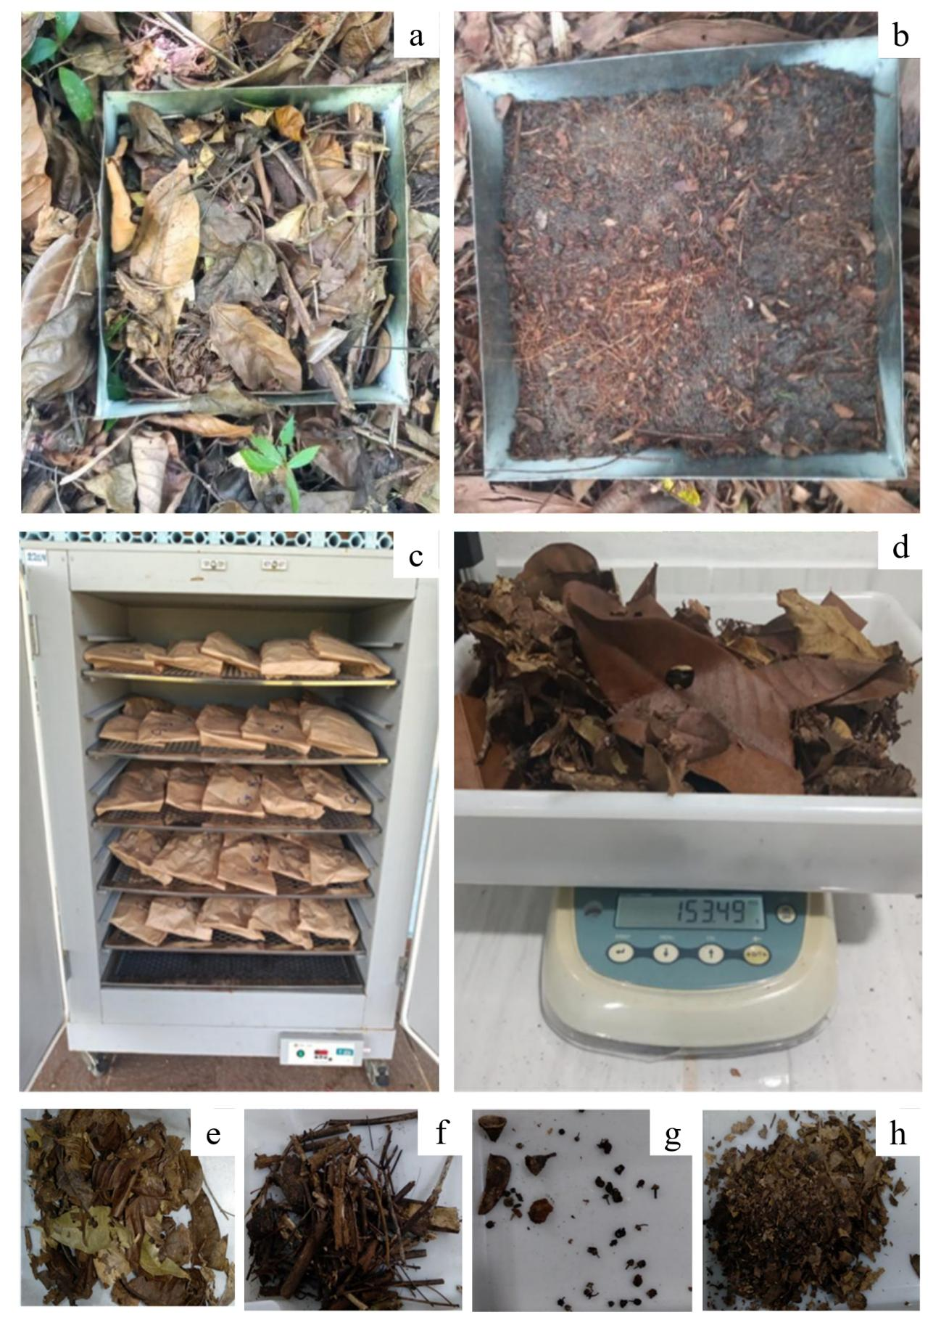
Supplementary Figure 1 Procedures for collection and processing of litter stock in Agroforestry Systems (AFS) of different ages and a Reference Forest (FLO) evaluated in the municipality of Irituia - Pará, Eastern Amazon
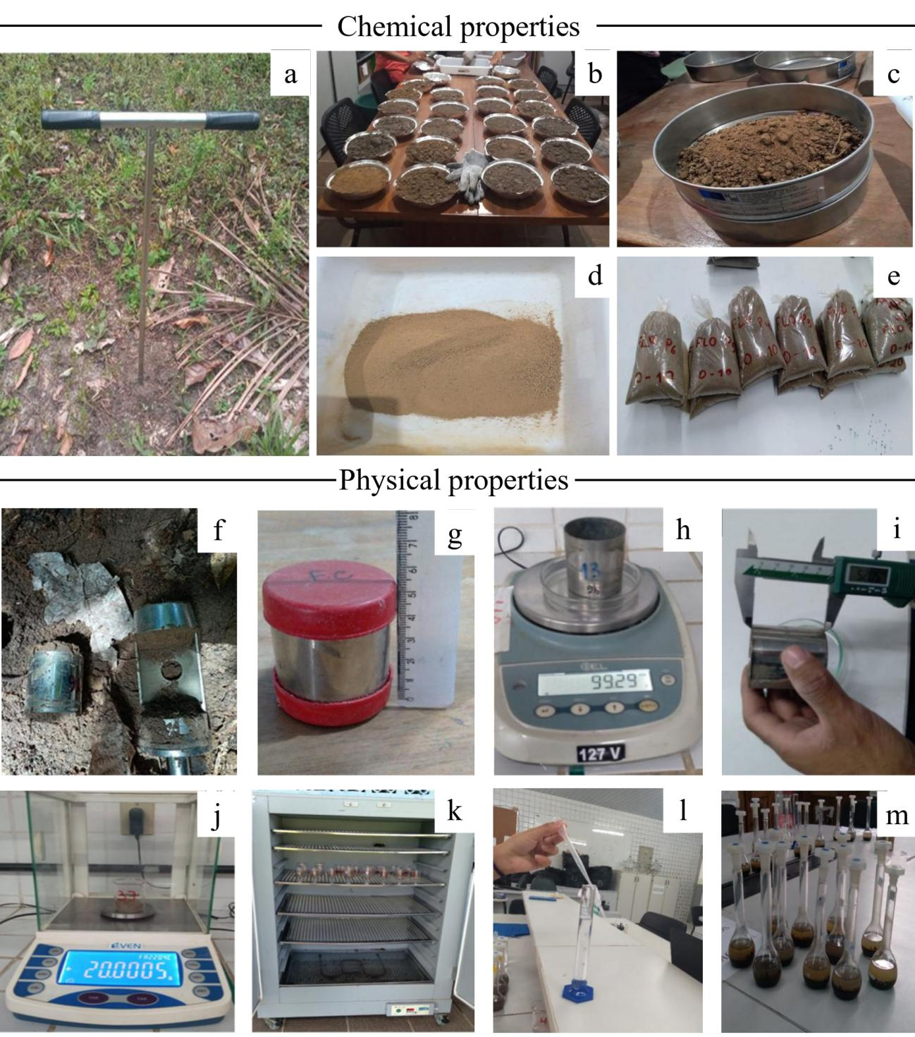
Supplementary Figure 2 Procedures for soil physical-chemical properties collection and analysis in Agroforestry Systems (AFS) of different ages and a Reference Forest (FLO) evaluated in the municipality of Irituia - Pará, Eastern Amazon

