7 Appendix
Table 6: Covariance of the error terms
ATRho | Coefficients | Std. Err. | Rho | Coefficients | Std. Err.
ATρ₁₂ | 1.169*** | 0.184 | ρ12 | 0.824*** | 0.059
ATρ₁₃ | 0.522∗ | 0.218 | ρ13 | 0.479* | 0.168
ATρ₁₄ | 1.197*** | 0.092 | ρ14 | 0.832*** | 0.028
ATρ₁₅ | 1.091*** | 0.208 | ρ15 | 0.797*** | 0.075
ATρ₂₃ | 0.577*** | 0.142 | ρ23 | 0.521*** | 0.103
ATρ₂₄ | 0.736*** | 0.127 | ρ24 | 0.627*** | 0.077
ATρ₂₅ | 1.216*** | 0.146 | ρ25 | 0.838*** | 0.043
ATρ₃₄ | 0.755*** | 0.083 | ρ34 | 0.638*** | 0.049
ATρ₃₅ | 0.668*** | 0.106 | ρ35 | 0.583*** | 0.069
ATρ₄₅ | 0.858*** | 0.113 | ρ45 | 0.695*** | 0.058
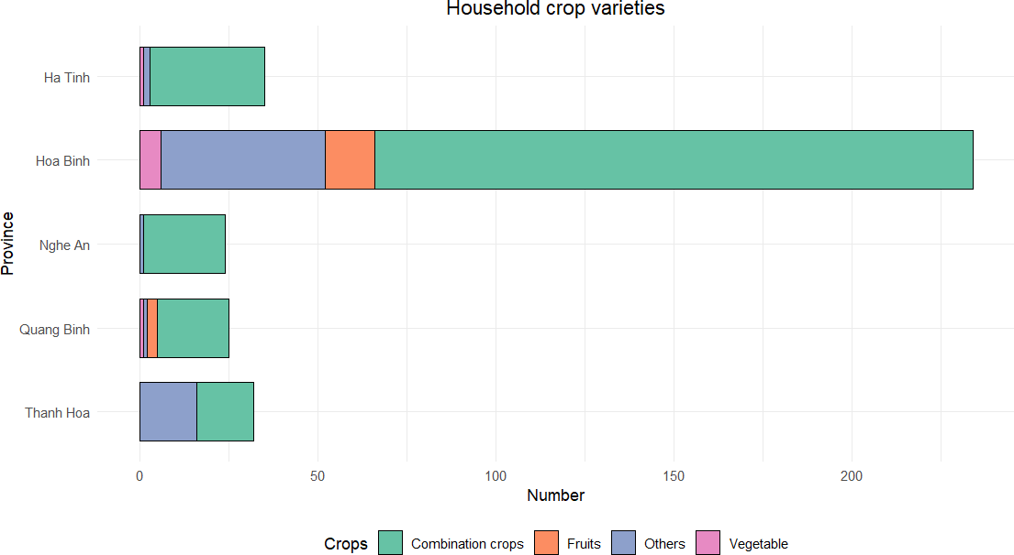
Significance levels: * : 10%; ** : 5%; *** : 1%.
Figure 8: Household crop varieties

