Supplemental Table 1a. Univariate analysis for OS
Factor |  | HR | 95% CI |  | P-value
 |  | HR | Lower | Upper | P-value
Age | <60 y/o | Ref. | − | − | −
Age | >60 y/o | 1.31 | 1.17 | 1.47 | <0.01*
Disease | Myeloid | Ref. | − | − | −
Disease | Others | 1.45 | 1.24 | 1.69 | <0.01*
Dx to HSCT | <1 year | Ref. | − | − | −
Dx to HSCT | >1 year | 0.89 | 0.79 | 1.01 | 0.07
Disease stage at HSCT | Early | Ref. | − | − | −
Disease stage at HSCT | Intermediate | 1.04 | 0.88 | 1.24 | 0.62
Disease stage at HSCT | Late | 2.31 | 2.03 | 2.62 | <0.01*
Cell source | BM | Ref. | − | − | −
Cell source | PB | 1.10 | 0.98 | 1.20 | 0.11
Donor type | MRD or MUD | Ref. | − | − | −
Donor type | Others | 1.24 | 1.11 | 1.39 | 0.97
F to M | No | Ref. | − | − | −
F to M | Yes | 1.13 | 0.99 | 1.29 | 0.08
Performance status | 0–1 | Ref. | − | − | −
Performance status | 2–4 | 3.00 | 2.55 | 3.52 | <0.01*
HCT-CI | 0–2 | Ref. | − | − | −
HCT-CI | ≥3 | 1.18 | 1.03 | 1.35 | 0.02*
CMV risk | None | Ref. | − | − | −
CMV risk | Yes | 1.00 | 0.80 | 1.26 | 0.95
Use of ATG/ALG | None | Ref. | − | − | −
Use of ATG/ALG | Yes | 0.95 | 0.80 | 1.12 | 0.52
Use of TBI | None | Ref. | − | − | −
Use of TBI | Yes | 1.07 | 0.95 | 1.20 | 0.27
Use of add. chem | None | Ref. | − | − | −
Use of add. chem | Yes | 1.08 | 0.93 | 1.25 | 0.32
HSCT year | Before 2013 | Ref. | − | − | −
HSCT year | 2013 or later | 0.93 | 0.82 | 1.05 | 0.22
Add. chem. drug, additional chemotherapeutic drug; ALG, anti-lymphocyte globulin; ATG, anti-thymocyte globulin; BM, bone marrow; CI, confidence interval; CMV, cytomegalovirus; comb., combination; Dx, diagnosis; F to M, HSCT from female donor to male recipient; HCT-CI, hematopoietic cell transplantation-specific comorbidity index; HR, hazard ratio; HSCT, hematopoietic stem cell transplantation; MRD, matched-related donor; MUD, matched-unrelated donor; OS, overall survival; PB, peripheral blood; Ref., reference; TBI, total body irradiation; y/o, years old; *, significant difference (p<0.05)

Supplemental Table 1b. Univariate analysis for NRM
Factor |  | HR | 95% CI |  | P-value
 |  | HR | Lower | Upper | P-value
Age | <60 y/o | Ref. | − | − | −
Age | ≥60 y/o | 1.40 | 1.19 | 1.65 | <0.01*
Disease | Myeloid | Ref. | − | − | −
Disease | Others | 1.28 | 1.02 | 1.60 | 0.03*
Dx to HSCT | ≤1 y | Ref. | − | − | −
Dx to HSCT | >1 y | 1.30 | 1.10 | 1.53 | <0.01*
Disease stage at HSCT | Early | Ref. | − | − | −
Disease stage at HSCT | Intermediate | 0.97 | 0.78 | 1.21 | 0.80
Disease stage at HSCT | Late | 1.07 | 0.89 | 1.28 | 0.46
Cell source | BM | Ref. | − | − | −
Cell source | PB | 0.89 | 0.75 | 1.06 | 0.18
Donor type | MRD or MUD | Ref. | − | − | −
Donor type | Others | 1.21 | 1.03 | 1.42 | 0.02*
F to M | No | Ref. | − | − | −
F to M | Yes | 1.08 | 0.89 | 1.31 | 0.44
PS | 0–1 | Ref. | − | − | −
PS | 2–4 | 1.50 | 1.17 | 1.94 | <0.01*
HCT-CI | 0–2 | Ref. | − | − | −
HCT-CI | ≥3 | 1.13 | 0.93 | 1.38 | 0.21
CMV risk | None | Ref. | − | − | −
CMV risk | Yes | 0.90 | 0.66 | 1.22 | 0.50
Use of ATG/ALG | None | Ref. | − | − | −
Use of ATG/ALG | Yes | 0.78 | 0.60 | 1.01 | 0.05
Use of TBI | None | Ref. | − | − | −
Use of TBI | Yes | 1.27 | 1.08 | 1.50 | <0.01*
Use of add. chem | None | Ref. | − | − | −
Use of add. chem | Yes | 1.07 | 0.86 | 1.32 | 0.54
HSCT year | Before 2013 | Ref. | − | − | −
HSCT year | 2013 or later | 0.90 | 0.77 | 1.07 | 0.23
Add. chem. drug, additional chemotherapeutic drug; ALG, anti-lymphocyte globulin; ATG, anti-thymocyte globulin; BM, bone marrow; CI, confidence interval; CMV, cytomegalovirus; comb., combination; Dx, diagnosis; F to M, HSCT from female donor to male recipient; HCT-CI, hematopoietic cell transplantation-specific comorbidity index; HR, hazard ratio; HSCT, hematopoietic stem cell transplantation; MRD, matched-related donor; MUD, matched-unrelated donor; NRM, non-relapse mortality; PB, peripheral blood; Ref., reference; TBI, total body irradiation; y/o, years old; *, significant difference (p<0.05)
Supplemental Table 1c. Univariate analysis for CIR
Factor |  | HR | 95% CI |  | P-value
 |  | HR | Lower | Upper | P-value
Age | <60 y/o | Ref. | − | − | −
Age | ≥60 y/o | 1.03 | 0.89 | 1.19 | 0.66
Disease | Myeloid | Ref. | − | − | −
Disease | Others | 1.35 | 1.11 | 1.65 | <0.01*
Dx to HSCT | <1 year | Ref. | − | − | −
Dx to HSCT | >1 year | 0.66 | 0.56 | 0.79 | <0.01*
Disease stage at HSCT | Early | Ref. | − | − | −
Disease stage at HSCT | Intermediate | 1.36 | 1.09 | 1.71 | 0.01*
Disease stage at HSCT | Late | 3.04 | 2.57 | 3.59 | <0.01*
Cell source | BM | Ref. | − | − | −
Cell source | PB | 1.28 | 1.11 | 1.49 | <0.01*
Donor type | MRD or MUD | Ref. | − | − | −
Donor type | Others | 1.05 | 0.91 | 1.22 | 0.49
F to M | No | Ref. | − | − | −
F to M | Yes | 1.09 | 0.91 | 1.29 | 0.35
PS | 0–1 | Ref. | − | − | −
PS | 2–4 | 2.18 | 1.79 | 2.66 | <0.01*
HCT-CI | 0–2 | Ref. | − | − | −
HCT-CI | ≥3 | 1.07 | 0.90 | 1.27 | 0.46
CMV risk | None | Ref. | − | − | −
CMV risk | Yes | 1.00 | 0.75 | 1.33 | 0.99
Use of ATG/ALG | None | Ref. | − | − | −
Use of ATG/ALG | Yes | 1.13 | 0.93 | 1.38 | 0.23
Use of TBI | None | Ref. | − | − | −
Use of TBI | Yes | 0.82 | 0.71 | 0.95 | 0.01*
Use of add. chem | None | Ref. | − | − | −
Use of add. chem | Yes | 1.00 | 0.83 | 1.21 | 0.99
HSCT year | Before 2013 | Ref. | − | − | −
HSCT year | 2013 or later | 0.90 | 0.78 | 1.05 | 0.19
Add. chem. drug, additional chemotherapeutic drug; ALG, anti-lymphocyte globulin; ATG, anti-thymocyte globulin; BM, bone marrow; CI, confidence interval; CIR, cumulative incidence of relapse; CMV, cytomegalovirus; comb., combination; Dx, diagnosis; F to M, HSCT from female donor to male recipient; HCT-CI, hematopoietic cell transplantation-specific comorbidity index; HR, hazard ratio; HSCT, hematopoietic stem cell transplantation; MRD, matched-related donor; MUD, matched-unrelated donor; PB, peripheral blood; Ref., reference; TBI, total body irradiation; y/o, years old; *, significant difference (p<0.05)
Supplemental Table 2a. Univariate analysis for OS in the older group
Factor |  | HR | 95% CI |  | P-value
 |  | HR | Lower | Upper | P-value
Disease | Myeloid | Ref. | − | − | −
Disease | Others | 1.21 | 0.92 | 1.58 | 0.17
Dx to HSCT | 1y or less | Ref. | − | − | −
Dx to HSCT | over 1y | 0.85 | 0.71 | 1.02 | 0.09
Disease stage at HSCT | Early | Ref. | − | − | −
Disease stage at HSCT | Intermediate | 1.00 | 0.78 | 1.27 | 0.99
Disease stage at HSCT | Late | 2.27 | 1.88 | 2.72 | <0.01*
Cell source | BM | Ref. | − | − | −
Cell source | PB | 1.19 | 0.99 | 1.42 | 0.07
Donor type | MRD or MUD | Ref. | − | − | −
Donor type | Others | 1.13 | 0.95 | 1.34 | 0.16
F to M | No | Ref. | − | − | −
F to M | Yes | 1.18 | 0.97 | 1.44 | 0.09
PS | 0–1 | Ref. | − | − | −
PS | 2–4 | 2.85 | 2.27 | 3.57 | <0.01*
HCT-CI | 0–2 | Ref. | − | − | −
HCT-CI | ≥3 | 1.14 | 0.93 | 1.39 | 0.20
CMV risk | None | Ref. | − | − | −
CMV risk | Yes | 0.99 | 0.71 | 1.39 | 0.97
Use of ATG/ALG | None | Ref. | − | − | −
Use of ATG/ALG | Yes | 0.93 | 0.72 | 1.20 | 0.55
Use of TBI | None | Ref. | − | − | −
Use of TBI | Yes | 1.11 | 0.94 | 1.30 | 0.24
Use of add. chem | None | Ref. | − | − | −
Use of add. chem | Yes | 1.68 | 1.33 | 2.11 | <0.01*
HSCT year | Before 2013 | Ref. | − | − | −
HSCT year | 2013 or later | 0.99 | 0.83 | 1.19 | 0.93
Add. chem. drug, additional chemotherapeutic drug; ALG, anti-lymphocyte globulin; ATG, anti-thymocyte globulin; BM, bone marrow; CI, confidence interval; CMV, cytomegalovirus; comb., combination; Dx, diagnosis; F to M, HSCT from female donor to male recipient; HCT-CI, hematopoietic cell transplantation-specific comorbidity index; HR, hazard ratio; HSCT, hematopoietic stem cell transplantation; MRD, matched-related donor; MUD, matched-unrelated donor; OS, overall survival; PB, peripheral blood; Ref., reference; TBI, total body irradiation; y/o, years old; *, significant difference (p<0.05)

Supplemental Table 2b. Univariate analysis for NRM in the older group
Factor |  | HR | 95% CI |  | P-value
 |  | HR | Lower | Upper | P-value
Disease | Myeloid | Ref. | − | − | −
Disease | Others | 1.48 | 1.04 | 2.09 | 0.03*
Dx to HSCT | <1 year | Ref. | − | − | −
Dx to HSCT | >1 year | 1.41 | 1.12 | 1.79 | <0.01*
Disease stage at HSCT | Early | Ref. | − | − | −
Disease stage at HSCT | Intermediate | 0.94 | 0.69 | 1.29 | 0.71
Disease stage at HSCT | Late | 1.29 | 1.00 | 1.66 | 0.05
Cell source | BM | Ref. | − | − | −
Cell source | PB | 1.01 | 0.78 | 1.30 | 0.93
Donor type | MRD or MUD | Ref. | − | − | −
Donor type | Others | 1.17 | 0.93 | 1.48 | 0.18
F to M | No | Ref. | − | − | −
F to M | Yes | 1.02 | 0.78 | 1.34 | 0.87
PS | 0–1 | Ref. | − | − | −
PS | 2–4 | 1.44 | 1.01 | 2.04 | 0.04*
HCT-CI | 0–2 | Ref. | − | − | −
HCT-CI | ≥3 | 1.02 | 0.77 | 1.36 | 0.87
CMV risk | None | Ref. | − | − | −
CMV risk | Yes | 0.91 | 0.58 | 1.43 | 0.68
Use of ATG/ALG | None | Ref. | − | − | −
Use of ATG/ALG | Yes | 0.85 | 0.60 | 1.22 | 0.38
Use of TBI | None | Ref. | − | − | −
Use of TBI | Yes | 1.39 | 1.11 | 1.75 | <0.01*
Use of add. chem | None | Ref. | − | − | −
Use of add. chem | Yes | 1.67 | 1.21 | 2.30 | <0.01*
HSCT year | Before 2013 | Ref. | − | − | −
HSCT year | 2013 or later | 0.99 | 0.78 | 1.26 | 0.95
Add. chem. drug, additional chemotherapeutic drug; ALG, anti-lymphocyte globulin; ATG, anti-thymocyte globulin; BM, bone marrow; CI, confidence interval; CMV, cytomegalovirus; comb., combination; Dx, diagnosis; F to M, HSCT from female donor to male recipient; HCT-CI, hematopoietic cell transplantation-specific comorbidity index; HR, hazard ratio; HSCT, hematopoietic stem cell transplantation; MRD, matched-related donor; MUD, matched-unrelated donor; NRM, non-relapse mortality; PB, peripheral blood; Ref., reference; TBI, total body irradiation; y/o, years old; *, significant difference (p<0.05)

Supplemental Figure 1. Overall survival, non-relapse mortality, and cumulative incidence of relapse according to three age groups (younger, 60–65 years, and >65 years)

Supplemental Figure 1.
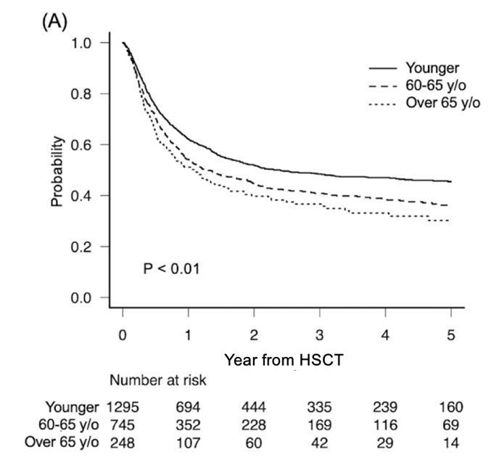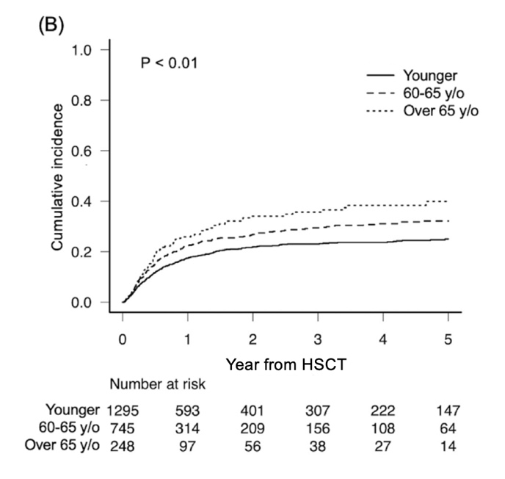
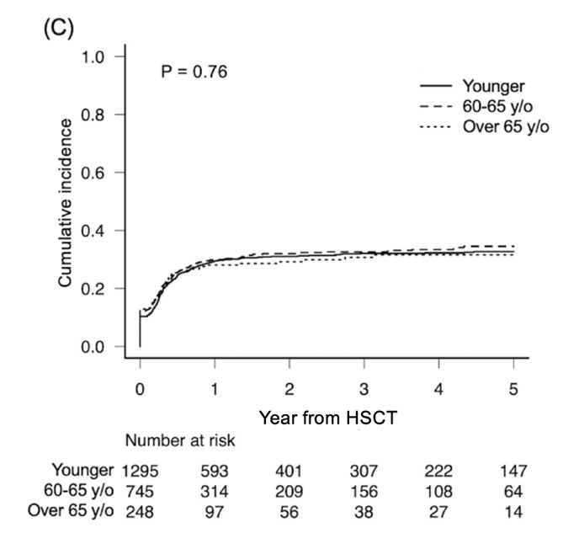
(a) Kaplan–Meier curves for overall survival after HSCT, (b) non-relapse mortality, (c) cumulative incidence of relapse, according to age groups (younger, <60 y/o; 60–65 y/o, and >65 y/o). HSCT, hematopoietic stem cell transplantation; y/o, years old; *, significant difference (p<0.05)

