Table S1. List of internal and recovery standards for the quantification of PAHs.
PAH | Internal standard | Recovery standard
Naphthalene, Acenaphthylene | Naphthalene-d8 | Acenaphthylene-d8
Acenaphthene | Acenaphthene-d10 | Anthracene-d10
Fluorene | Fluorene-d10 | Anthracene-d10
Dibenzothiophene | Dibenzothiophene-d8 | Anthracene-d10
Anthracene, phenanthrene | Phenanthrene-d10 | Anthracene-d10
Pyrene, fluoranthene | Pyrene-d10 | Fluoranthene-d10
Chrysene, benzo(a)anthracene | Chrysene-d12 | Benzo(a)anthracene-d12
Benzo(b)fluoranthene, benzo(k)fluoranthene, benzo(e)pyrene, benzo(a)pyrene, perylene | Benzo(k)fluoranthene-d12 | Benzo(a)pyrene-d12
Dibenzo(a,h)anthracene, Benzo(g,h,i)perylene, indeno(1,2,3-c,d)pyrene | Benzo(g,h,i)perylene-d12 | Indeno(1,2,3-c,d)pyrene-d12

Table S2. List of compounds, SICs and corresponding groups of GC-MS/SIM as described by Gallotta and Christensen (2012).
 | Group number
 | 1 | 2 | 3 | 4 | 5 | 6 | 7 | 8 | 9 | 10 | 11 | 12
nCx | 0 | 13 | 14 | 15 | 16 | 18 | 19 | 21 | 23 | 24 | 27 | 32 | n-alkane (RT of n-alkane to be used for group division)
SIC |  |  |  |  |  |  |  |  |  |  |  |  | Compound name
83 | x | x | x | x | x | x | x | x | x | x | x | x | n-Alkyl cyclo hexanes
85 | x | x | x | x | x | x | x | x | x | x | x | x | Alkanes
105 | x | x | x | x | x | x | x | x | x | x | x | x | Alkyl toluenes
123 | x | x | x | x | x | x |  |  |  |  |  |  | Sesquiterpanes
128 | x |  |  |  |  |  |  |  |  |  |  |  | Naphthalene
134 | x |  |  |  |  |  |  |  |  |  |  |  | Benzo(b)thiophene
136 | x |  |  |  |  |  |  |  |  |  |  |  | d8-Naphthalene
138 | x |  |  |  |  |  |  |  |  |  |  |  | Decalin
142 |  | x |  |  |  |  |  |  |  |  |  |  | C₁-Naphthalenes
148 | x | x |  |  |  |  |  |  |  |  |  |  | C₁-Benzo(b)thiophenes
152 | x | x | x |  |  |  |  |  |  |  |  |  | C₁-Decalins, Acenaphthylene
154 |  | x | x | x |  |  |  |  |  |  |  |  | Acenaphthene
156 |  |  | x |  |  |  |  |  |  |  |  |  | C₂-Naphthalenes
160 |  |  | x |  |  |  |  |  |  |  |  |  | d8-Acenaphthylene
162 |  | x | x |  |  |  |  |  |  |  |  |  | C₂-Benzo(b)thiophenes
164 |  |  | x | x |  |  |  |  |  |  |  |  | d10-Acenaphthene
166 | x | x |  |  | x |  |  |  |  |  |  |  | C₂-Decalins, Fluorene
168 |  | x | x | x |  |  |  |  |  |  |  |  | Dibenzofuran
170 |  |  |  | x | x |  |  |  |  |  |  |  | C₃-Naphthalenes
176 |  |  |  | x | x |  |  |  |  |  |  |  | C₃-Benzo(b)thiophenes, d10-Fluorene
178 |  |  |  |  |  | x |  |  |  |  |  |  | Phenanthrene, Anthracene
180 | x | x | x |  | x |  |  |  |  |  |  |  | C₃-Decalins, C₁-Fluorenes
182 |  |  |  | x | x | x |  |  |  |  |  |  | C₁-Dibenzofurans
184 |  |  |  | x | x | x |  |  |  |  |  |  | C₄-Naphthalenes, Dibenzothiophene
188 |  |  |  |  |  | x |  |  |  |  |  |  | d10-Phenanthrene, d10-Anthracene
190 |  |  |  | x | x |  |  |  |  |  |  |  | C₄-Benzo(b)thiophenes
191 |  |  |  |  |  |  |  |  | x | x | x | x | Tricyclic terpanes, Hopanes
192 |  |  |  |  | x | x | x |  |  |  |  |  | C₁-Phenanthrenes/anthracenes, d8-Dibenzothiophene
194 | x | x | x | x |  | x | x |  |  |  |  |  | C₄-Decalins, C₂-fluorenes
196 |  |  |  |  | x | x | x |  |  |  |  |  | C₂-Dibenzofurans
198 |  |  |  |  |  | x | x |  |  |  |  |  | C₁-Dibenzothiophenes
202 |  |  |  |  |  |  | x | x | x |  |  |  | Fluoranthene, Pyrene
206 |  |  |  |  |  |  | x | x | x |  |  |  | C₂-Phenanthrenes/anthracenes
208 |  |  |  |  |  | x | x |  |  |  |  |  | C₃-Fluorenes
212 |  |  |  |  |  |  | x | x |  |  |  |  | C₂-Dibenzothiophenes, d10-Fluoranthene, d10-Pyrene
216 |  |  |  |  |  |  |  | x | x |  |  |  | C₁-Fluoranthenes/pyrenes
217 |  |  |  |  |  |  |  | x | x | x | x | x | Steranes
218 |  |  |  |  |  |  |  |  |  | x | x | x | Steranes
220 |  |  |  |  |  |  | x | x | x |  |  |  | C₃-Phenanthrenes/anthracenes
226 |  |  |  |  |  |  | x | x | x |  |  |  | C₃-Dibenzothiophenes
228 |  |  |  |  |  |  |  |  |  | x |  |  | Benzo(a)anthracene, Chrysene
230 |  |  |  |  |  |  |  |  | x | x |  |  | C₂-Fluoranthenes/pyrenes
231 |  |  |  |  |  |  |  |  |  | x | x | x | Triaromatic steranes
234 |  |  |  |  |  |  |  | x | x | x |  |  | C₄-Phenanthrenes/anthracenes, Retene, Benzonaphtothiophene
240 |  |  |  |  |  |  |  | x | x | x |  |  | C₄-Dibenzothiophenes, d12-Benzo(a)anthracene, d12-Chrysene
242 |  |  |  |  |  |  |  |  |  | x | x |  | C₁-Chrysenes
244 |  |  |  |  |  |  |  | x |  |  |  |  | d14-p-Terphenyl
248 |  |  |  |  |  |  |  |  |  | x | x |  | C₁-Benzonaphtothiophenes
252 |  |  |  |  |  |  |  |  |  |  | x | x | 5 Rings PAHs
256 |  |  |  |  |  |  |  |  |  |  | x |  | C₂-Chrysenes
264 |  |  |  |  |  |  |  |  |  |  | x | x | d12-Benzo(k)fluoranthene, d12-Benzo(a)pyrene, d12-Perylene
270 |  |  |  |  |  |  |  |  |  |  | x | x | C₃-Chrysenes
276 |  |  |  |  |  |  |  |  |  |  |  | x | 6 Rings PAHs
278 |  |  |  |  |  |  |  |  |  |  |  | x | 6 Rings PAHs
288 |  |  |  |  |  |  |  |  |  |  |  | x | d12-Indeno(1,2,3-cd)pyrene, d12-Benzo(g,h,i)perylene
Total | 13 | 13 | 13 | 13 | 13 | 13 | 13 | 13 | 13 | 13 | 13 | 13

Table S3. Selected molecular ratios of PAHs used for source identification.
Ratios | Value range | Source | Reference
LMW/HMW | Low | Pyrogenic | Budzinski et al., 1997
 | High | Petrogenic
Phe/An | <10 | Pyrogenic | Baumard et al., 1998
 | >15 | Petrogenic
Chr/BaA | <1 | Pyrogenic | Soclo et al., 2000
 | >1 | Petrogenic
Flu/Pyr | >1 | Pyrogenic | Baumard et al., 1998
 | <1 | Petrogenic
BaA/Chr | > 0.4 | Pyrogenic | Gschwend and Hites, 1981
 | < 0.4 | Petrogenic
An/(An+Ph) | > 0.1 | Pyrogenic | Yunker et al., 2002
 | < 0.1 | Petrogenic
Flu/(Flu+Pyr) | < 0.4 | Petrogenic | Yunker et al., 2002
 | 0.4-0.5 | Fosil Fuel Combustion
 | > 0.5 | Grass,Wood, Coal Combustion
 | < 0.5 | Petrol Emissions | Ravindra et al., 2008
 | > 0.5 | Diesel Emissions
BaA/(BaA+Chr) | < 0.2 | Petrogenic | Akyuz and Cabuk, 2010
 | 0.2-0.35 | Coal Combustion | Yunker et al., 2002
 | >0.35 | Vehicular Emissions /Combustion
IP/(IP+Bghi) | < 0.2 | Petrogenic | Yunker et al., 2002
 | 0.2-0.5 | Petroleum Combustion
 | > 0.5 | Grass, Wood and Coal Combustion

A:
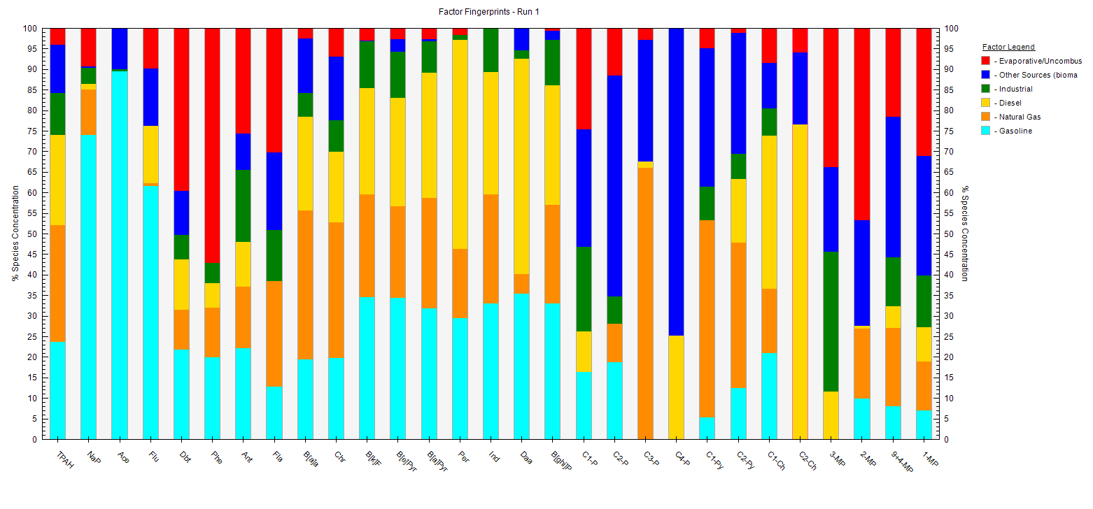
B:
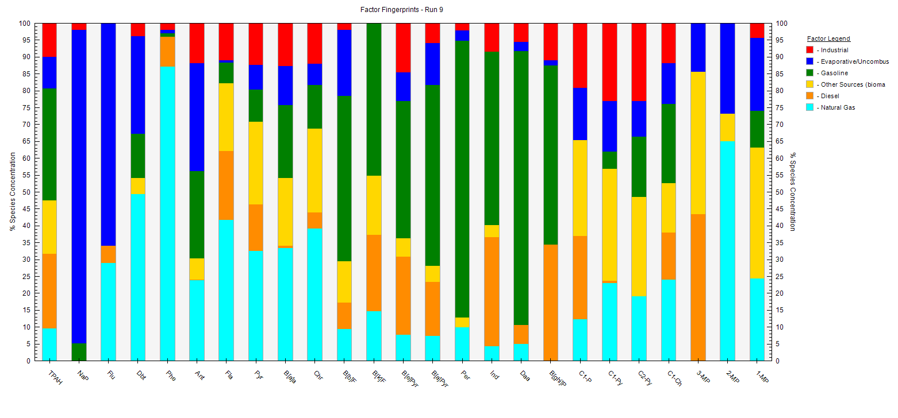

C:
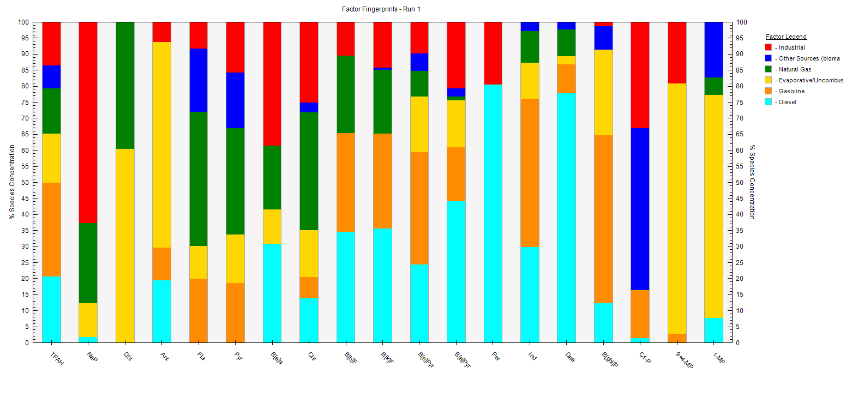

D:
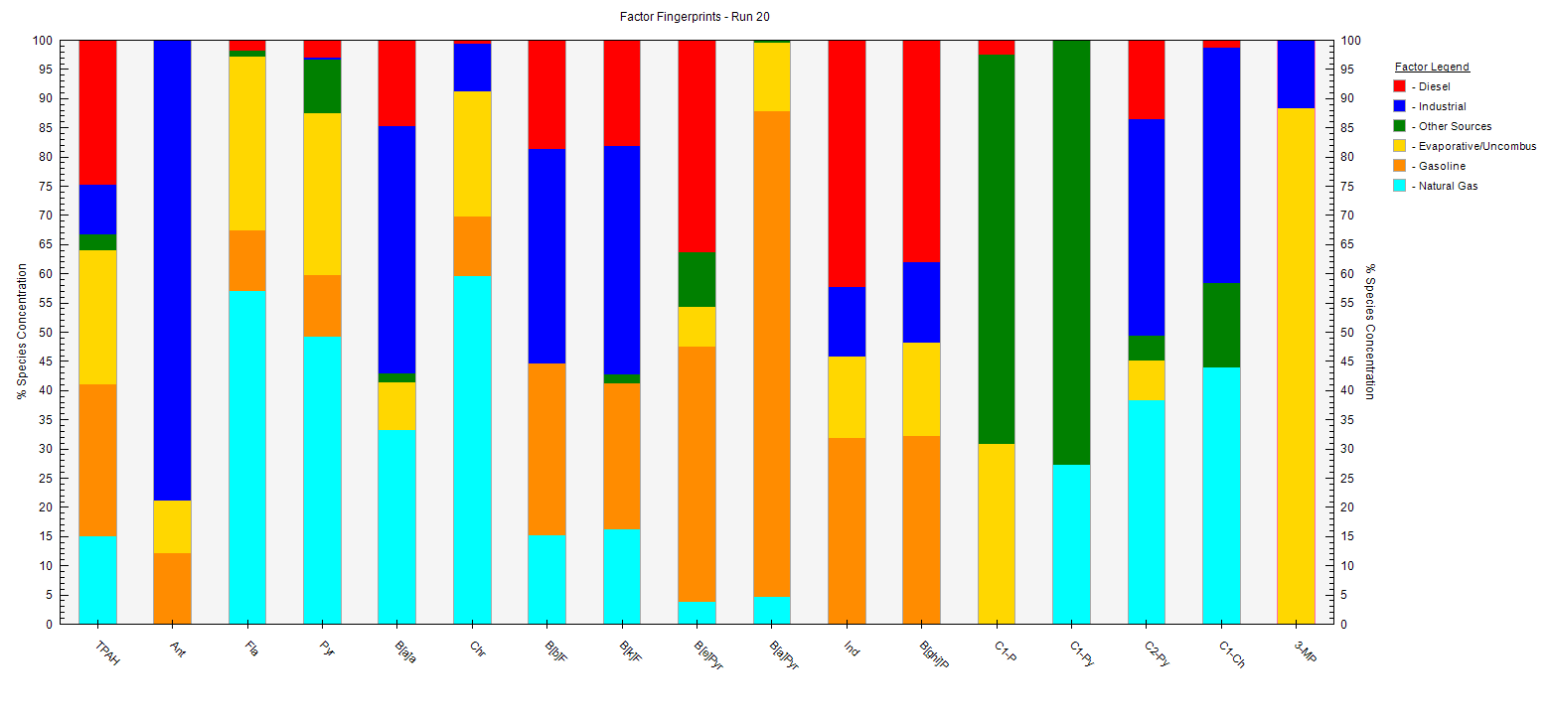
Fig. S1. Factor fingerprints of PAHs in PMF model in different seasons (A: Fall, B: Winter, C: Spring, D: Summer)

