Mechanisms controlling the dissolved load, chemical weathering and CO₂ consumption rates of Cauvery river, South India: Role of secondary soil minerals
B. Upendra^{1#}, M. Ciba¹, A. Aiswarya¹, V. Vinu Dev¹, G. Sreenivasulu¹, K. Anoop Krishnan¹
¹National Centre for Earth Science Studies (NCESS), Thiruvananthapuram-11, India.
#Corresponding author. Tel.: +91-0471-251-1700; E-mail address: upendra.ncess@gmail.com

Supplementary information – Figures
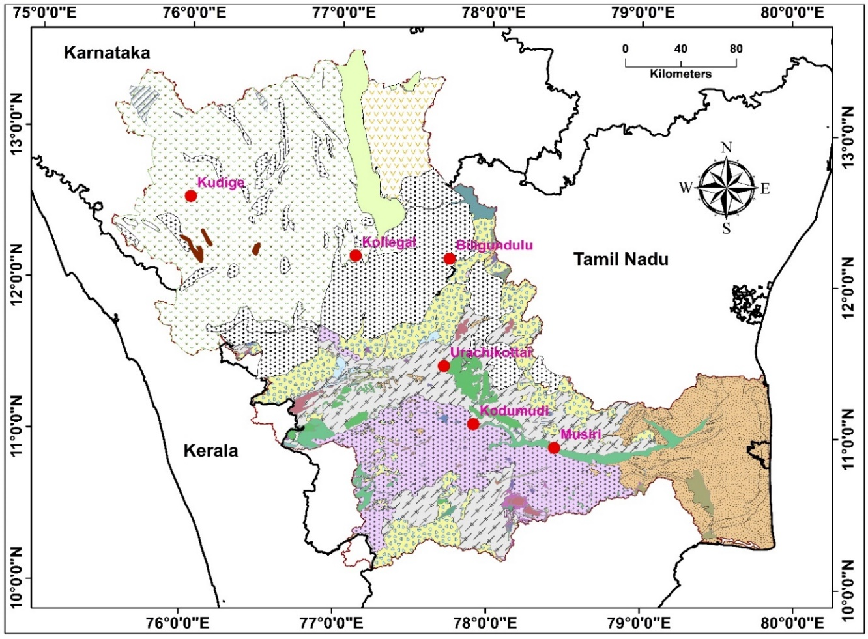

Figure S1. Geology of the Cauvery River Basin with hydrological observation (HO) stations
Source: The map is prepared by using geology data downloaded from Bhukosh (http://bhukosh.gsi.gov.in/Bhukosh/MapViewer.aspx)

Supplementary information – Tables

Location (Silent Valley, Nilgiri hills) | Na  (µM) | K  (µM) | Ca  (µM) | Mg  (µM) | Cl  (µM) | SO₄ (µM) | NO₃ (µM) | Reference
Rainfall water | 46 | 4 | 22 | 7 | 43 | 10 | 10 | Rao et al., 1995
Throughfall water | 81 | 51 | 45 | 18 | 81 | 11 | 34 | Rao et al., 1995

Table S1. Chemical composition of local rainfall and throughfall water from Nilgiri hills region (within CRB) used in this study for estimation of atmospheric contribution.

