Supplementary Materials for

A Core-shell Type Nanosystem Promotes Diabetic Wound Healing Through Photothermal-Responsive Release of Transforming Growth Factor β

Jinfei Hou^{1*†}, Junjin Jie^{2,3†}, Xinwei Wei^{4†}, Xiangqian Shen¹, Qingfang Zhao¹, Xupeng Chai⁵, Hao Pang¹, Zeren Shen¹, Jinqiang Wang⁴*, Linping Wu^{2*}, Jinghong Xu^{1*}

¹Departmant of Plastic Surgery, the First Affiliated Hospital, Zhejiang University School of Medicine, Hangzhou, 310003, Zhejiang, China
²Center for Chemical Biology and Drug Discovery, Guangzhou Institute of Biomedicine and Health, Chinese Academy of Sciences, Guangzhou, 510530, China
³Department of Plastic Surgery, Union Hospital, Tongji Medical College, Huazhong University of Science and Technology, Wuhan, 430022, China
⁴Key Laboratory of Advanced Drug Delivery Systems of Zhejiang Province, College of Pharmaceutical Sciences, Zhejiang University, Hangzhou 310058, China
⁵Department of Orthopedic Surgery, the Second Affiliated Hospital, Zhejiang University School of Medicine, Hangzhou City, Zhejiang Province, China

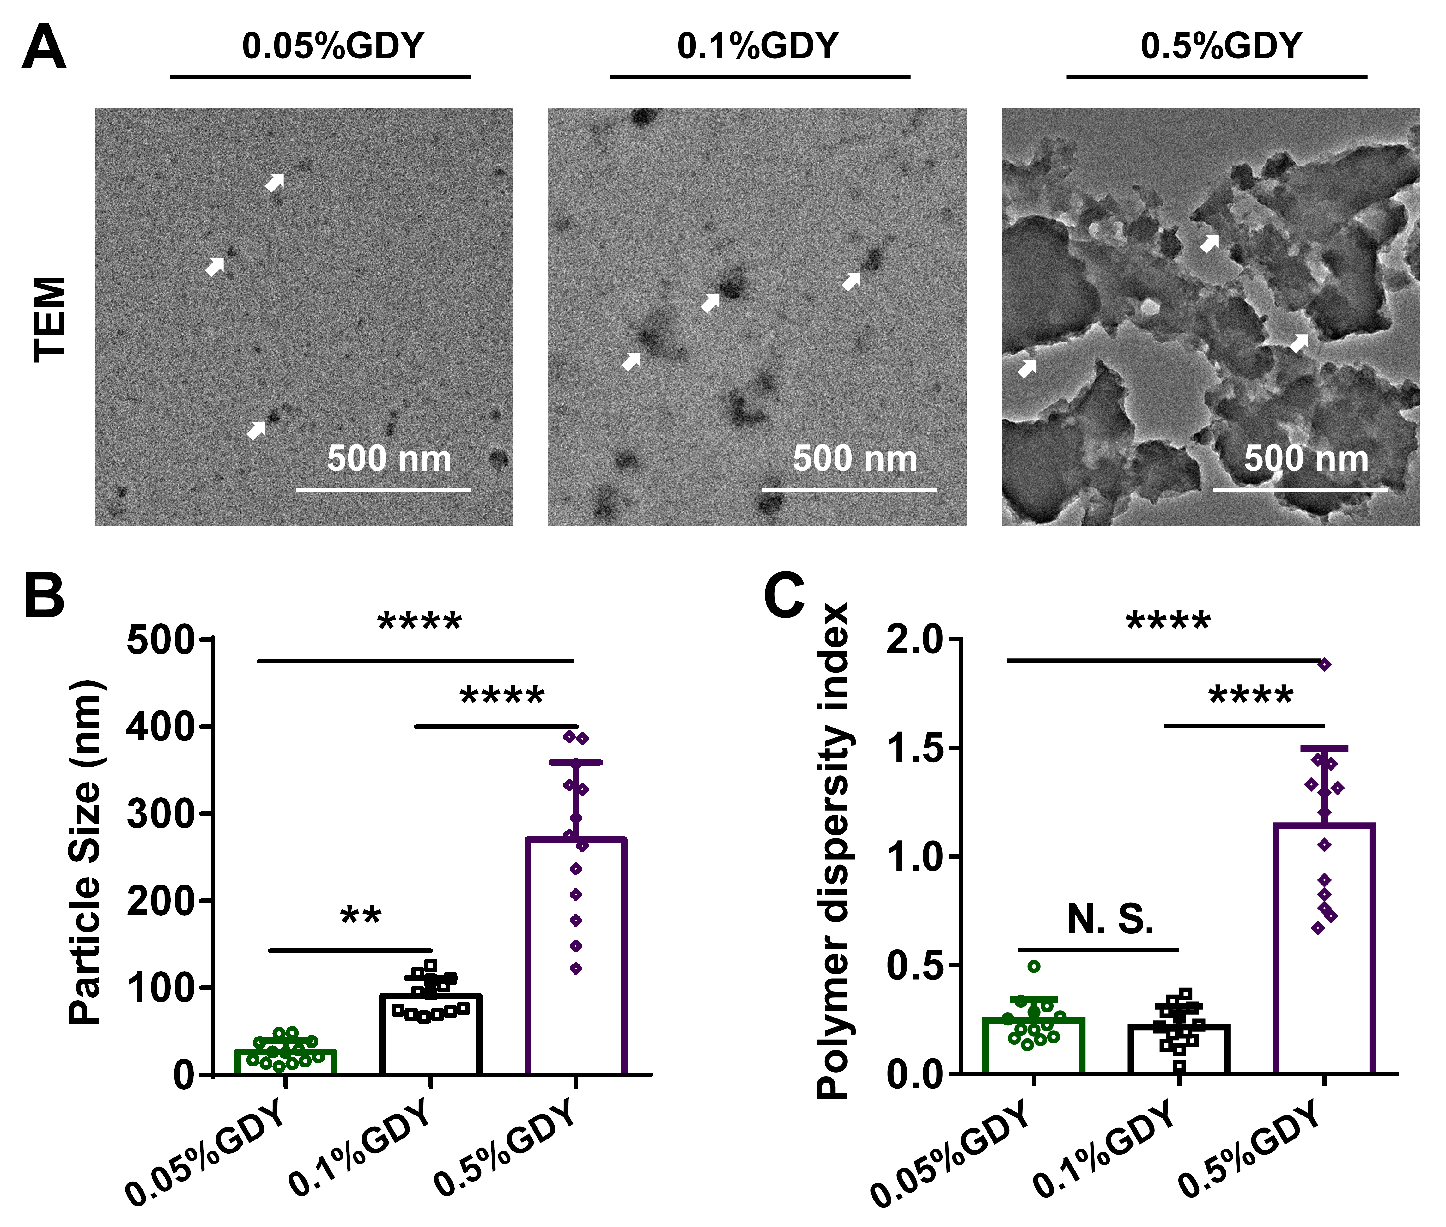
Fig. S1. Nanoparticles characterization of GDY NPs with different concentration. (A) TEM images, (B) particles size and (C) polymer dispersity index of GDY NPs with different concentration. White arrow: GDY particles. n = 13, ****p < 0.0001, **p < 0.01, by one-way ANOVA with Tukey correction.

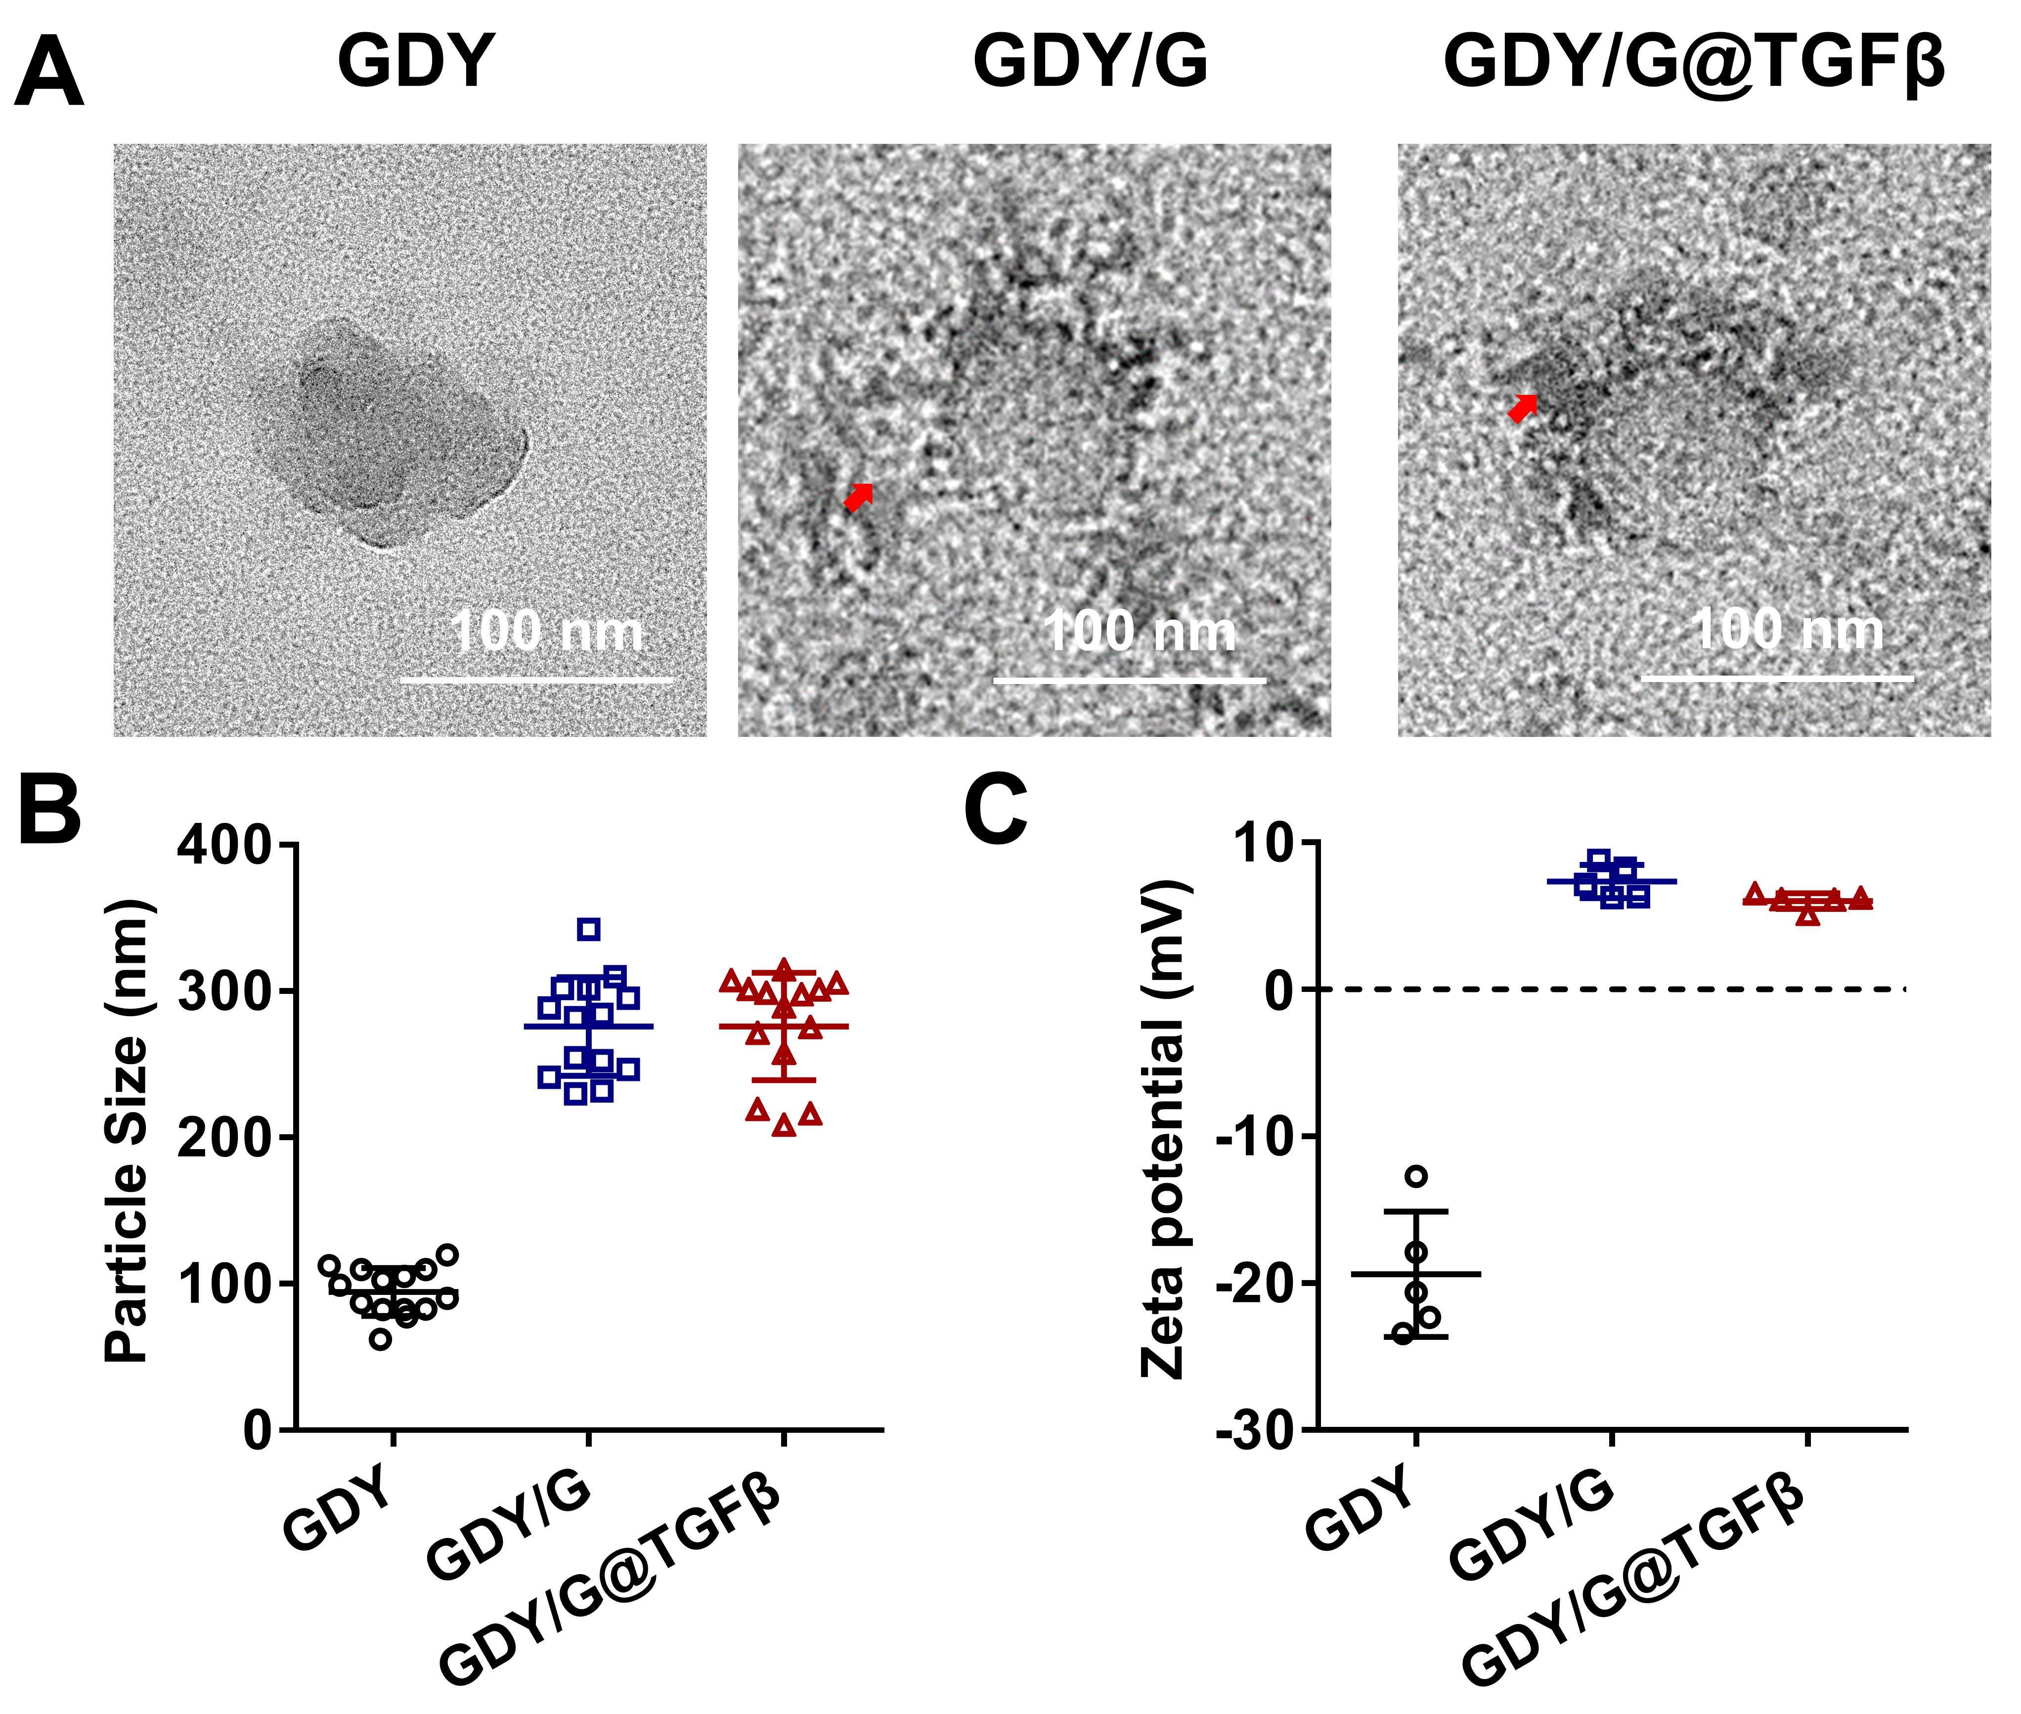
Fig. S2. (A) TEM images, (B) particle size and (C) zeta potential for different groups. Scale bar, 100 nm. Red arrow: gelatin coating. n = 14.

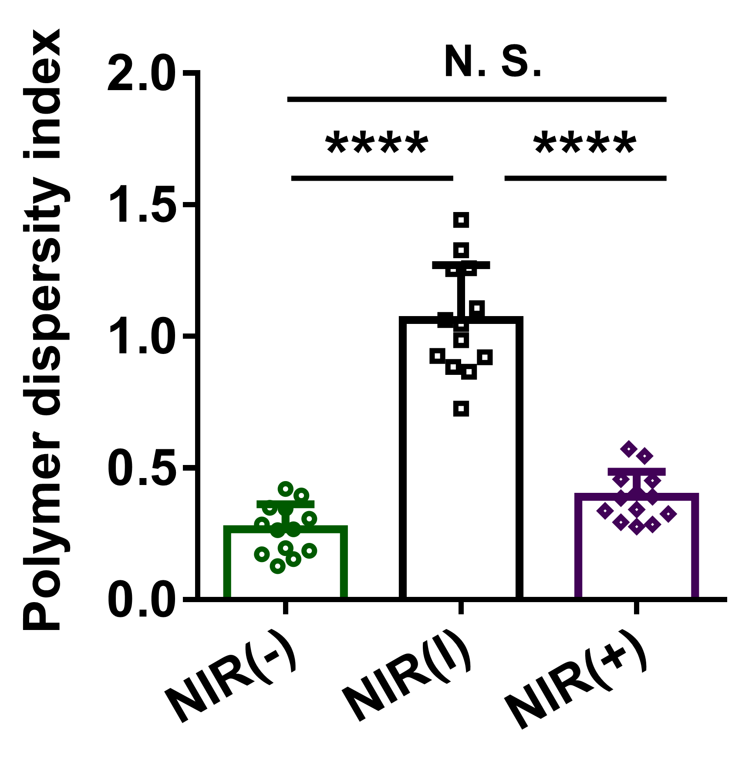
Fig. S3. Polymer dispersity index of PEGDA-GDY/G@TGFβ before and after NIR irradiation. NIR (-): without NIR-irradiation. NIR (|): with NIR-irradiation for 30s. NIR (+): with NIR-irradiation for 120s. n = 13, ****p < 0.0001, by one-way ANOVA with Tukey correction.

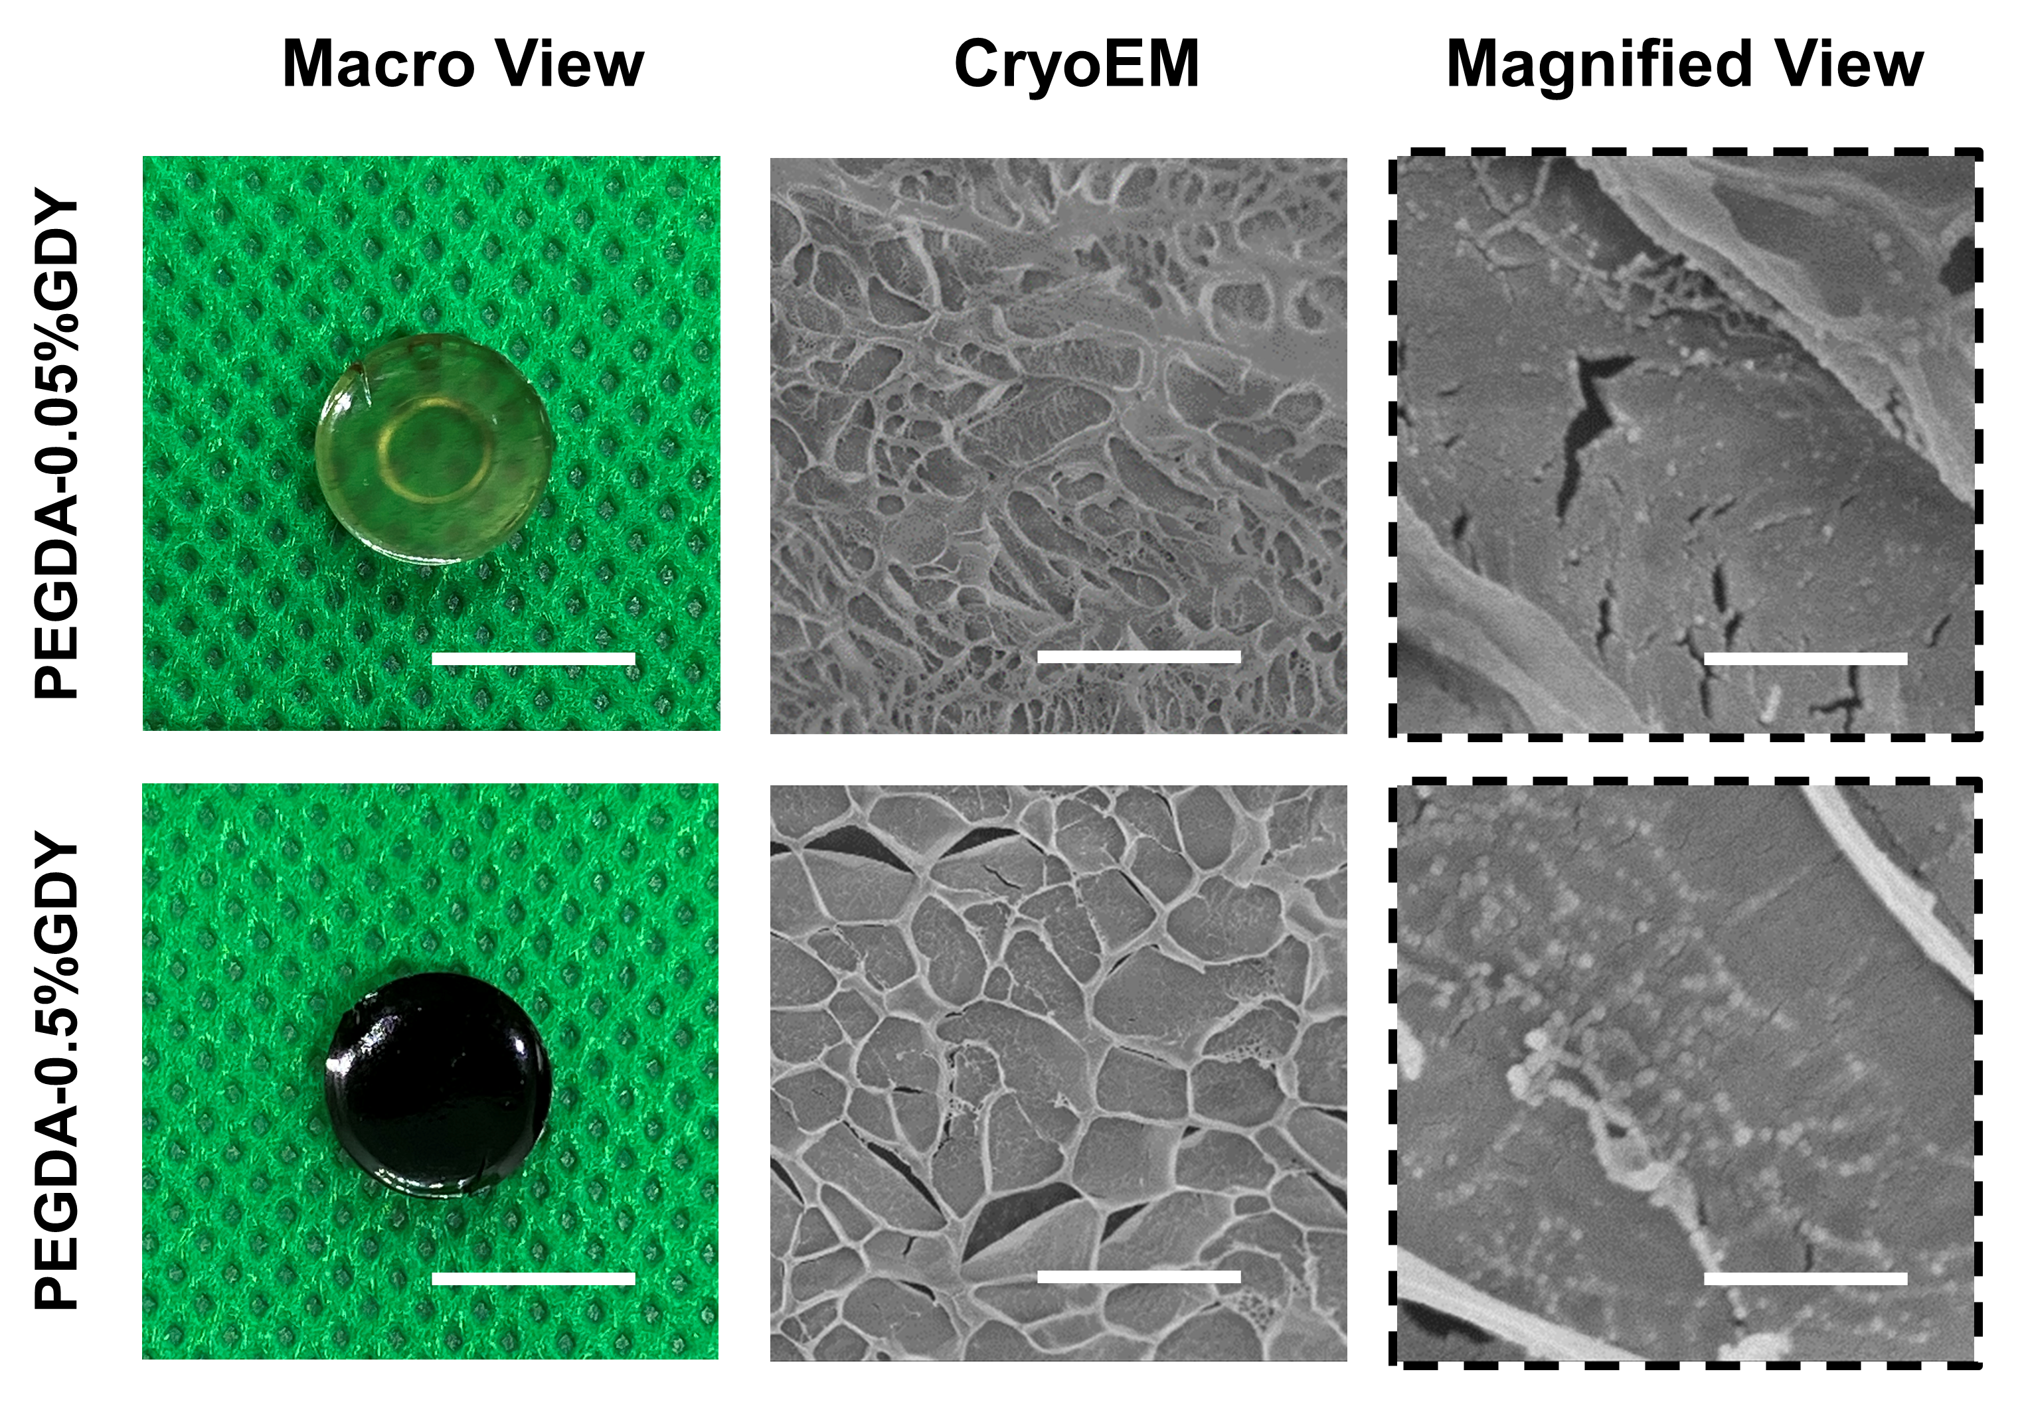
Fig. S4. Macro view and cryoEM view of different hydrogels. Scale bar: 1 μm for macro view. 50 μm for CryoEM view. 5 μm for magnified view.

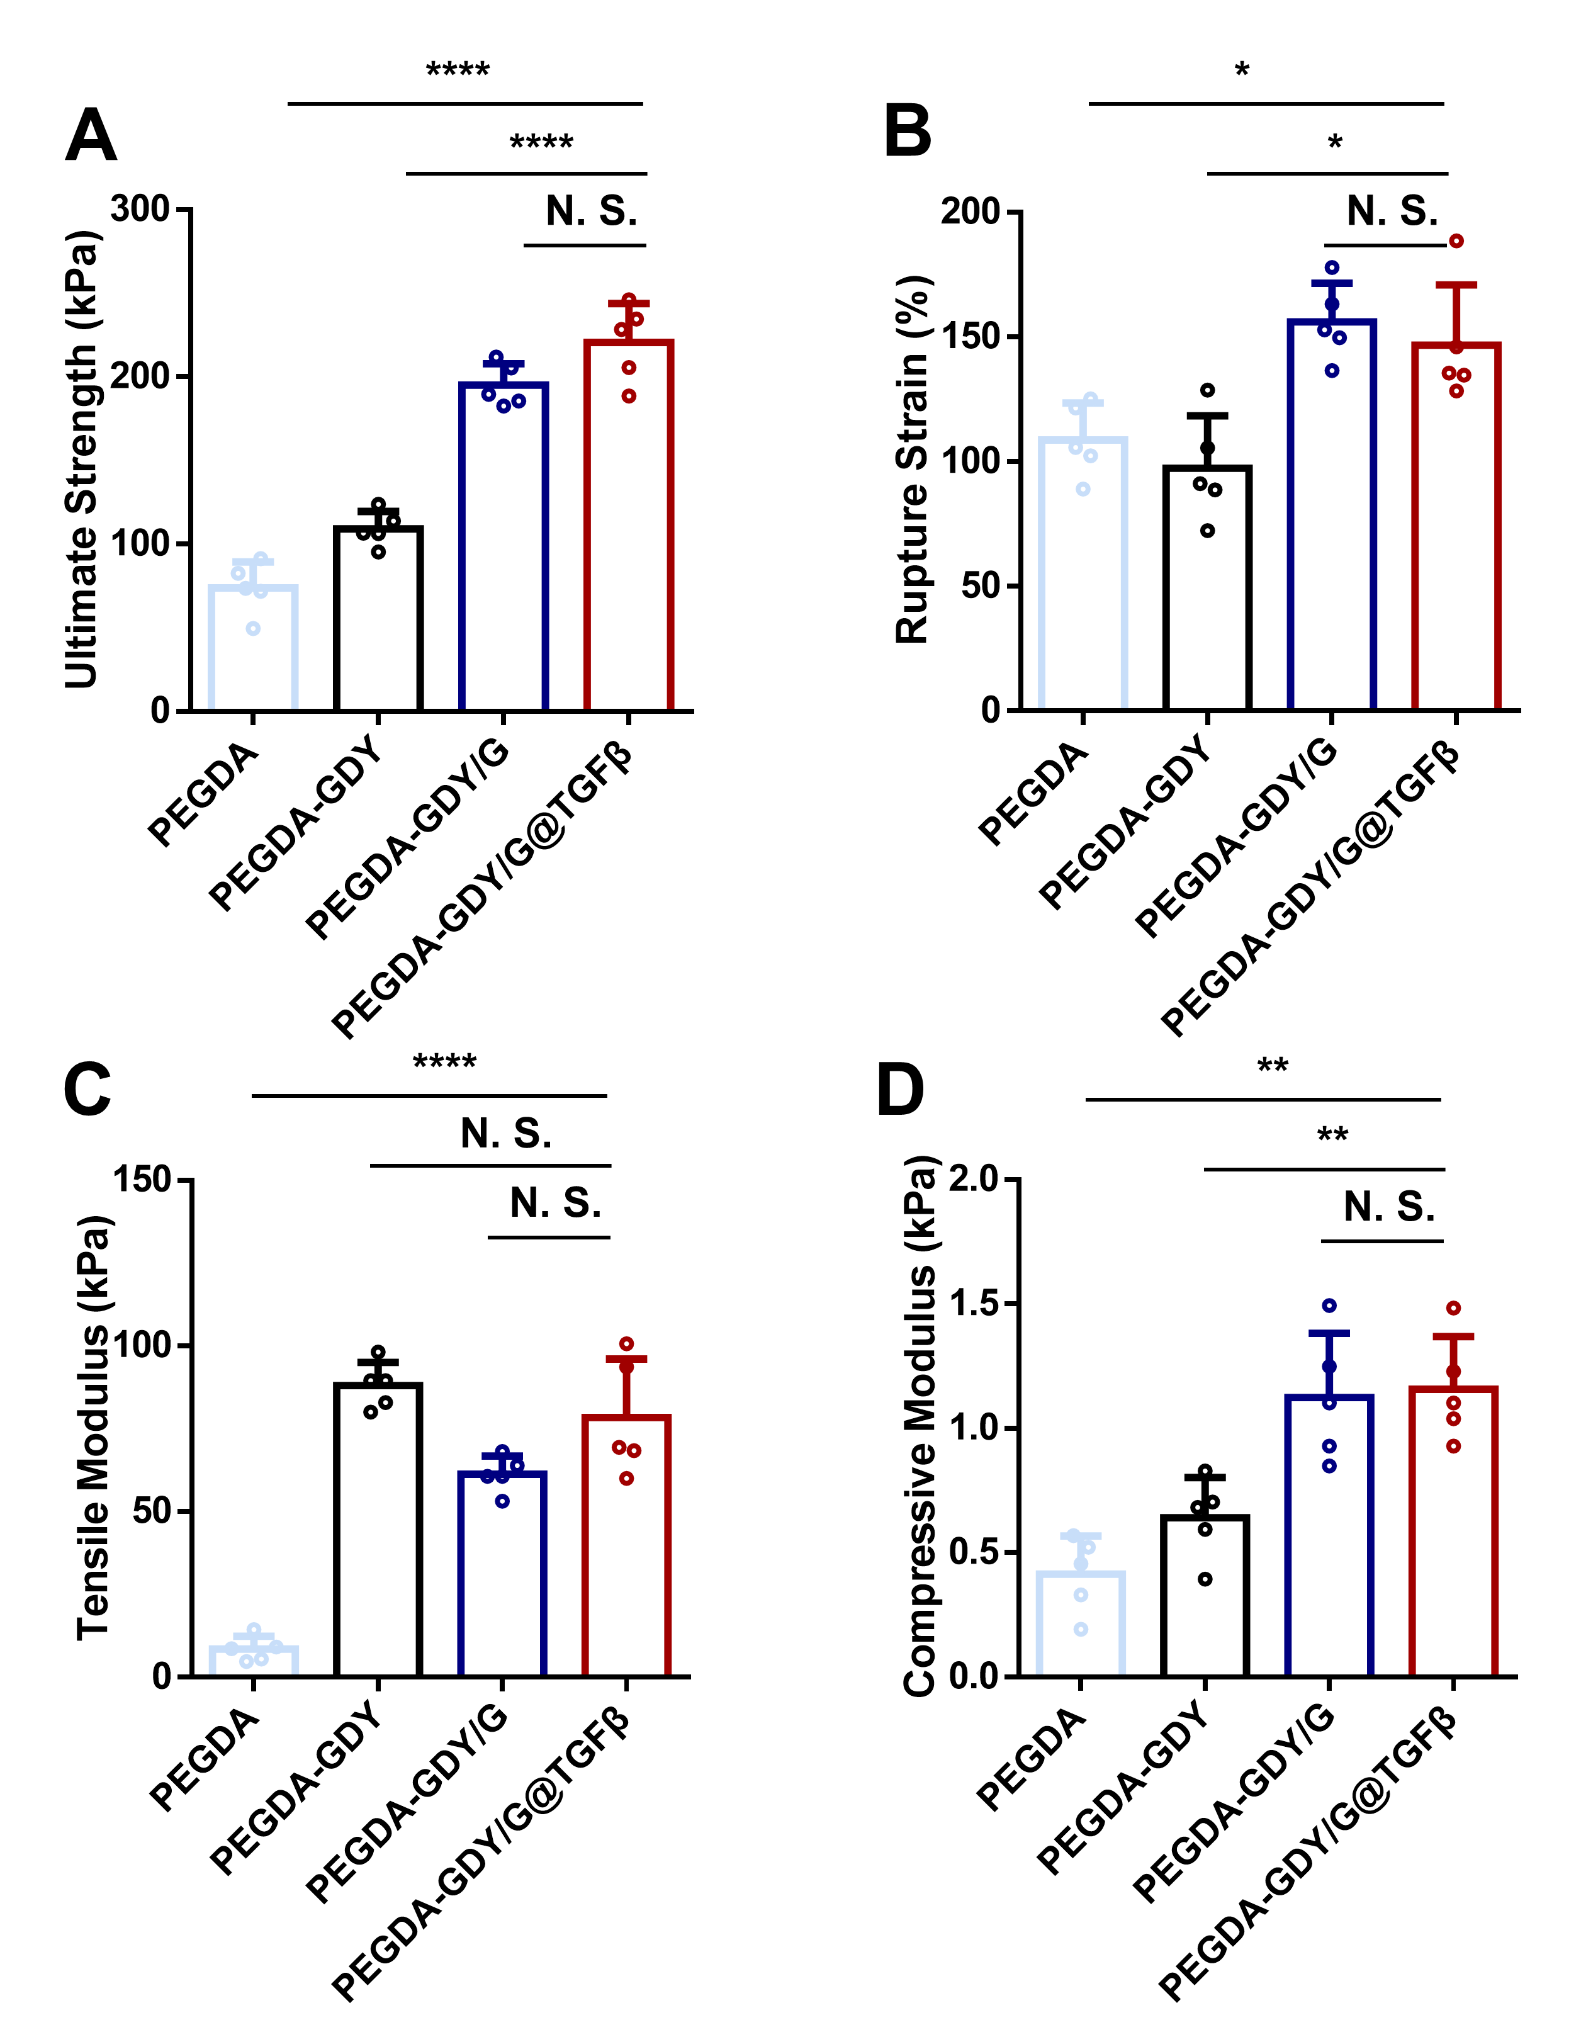
Fig. S5. Mechanical properties of different hydrogels. (A) The ultimate strength, (B) rupture strain, (C) tensile modulus, and (D) compressive modulus of different gels. n = 5, ****p < 0.000, **p < 0.01 and **p < 0.05, by one-way ANOVA with Tukey correction.

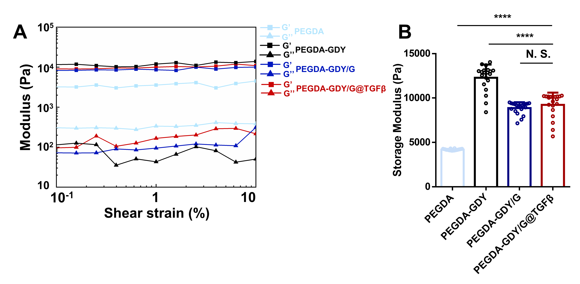
Fig. S6. Hydromechanical properties of the gels. (A) Frequency sweep and (B) storage modulus of different gels. n = 20, ****p < 0.0001, by one-way ANOVA with Tukey correction.

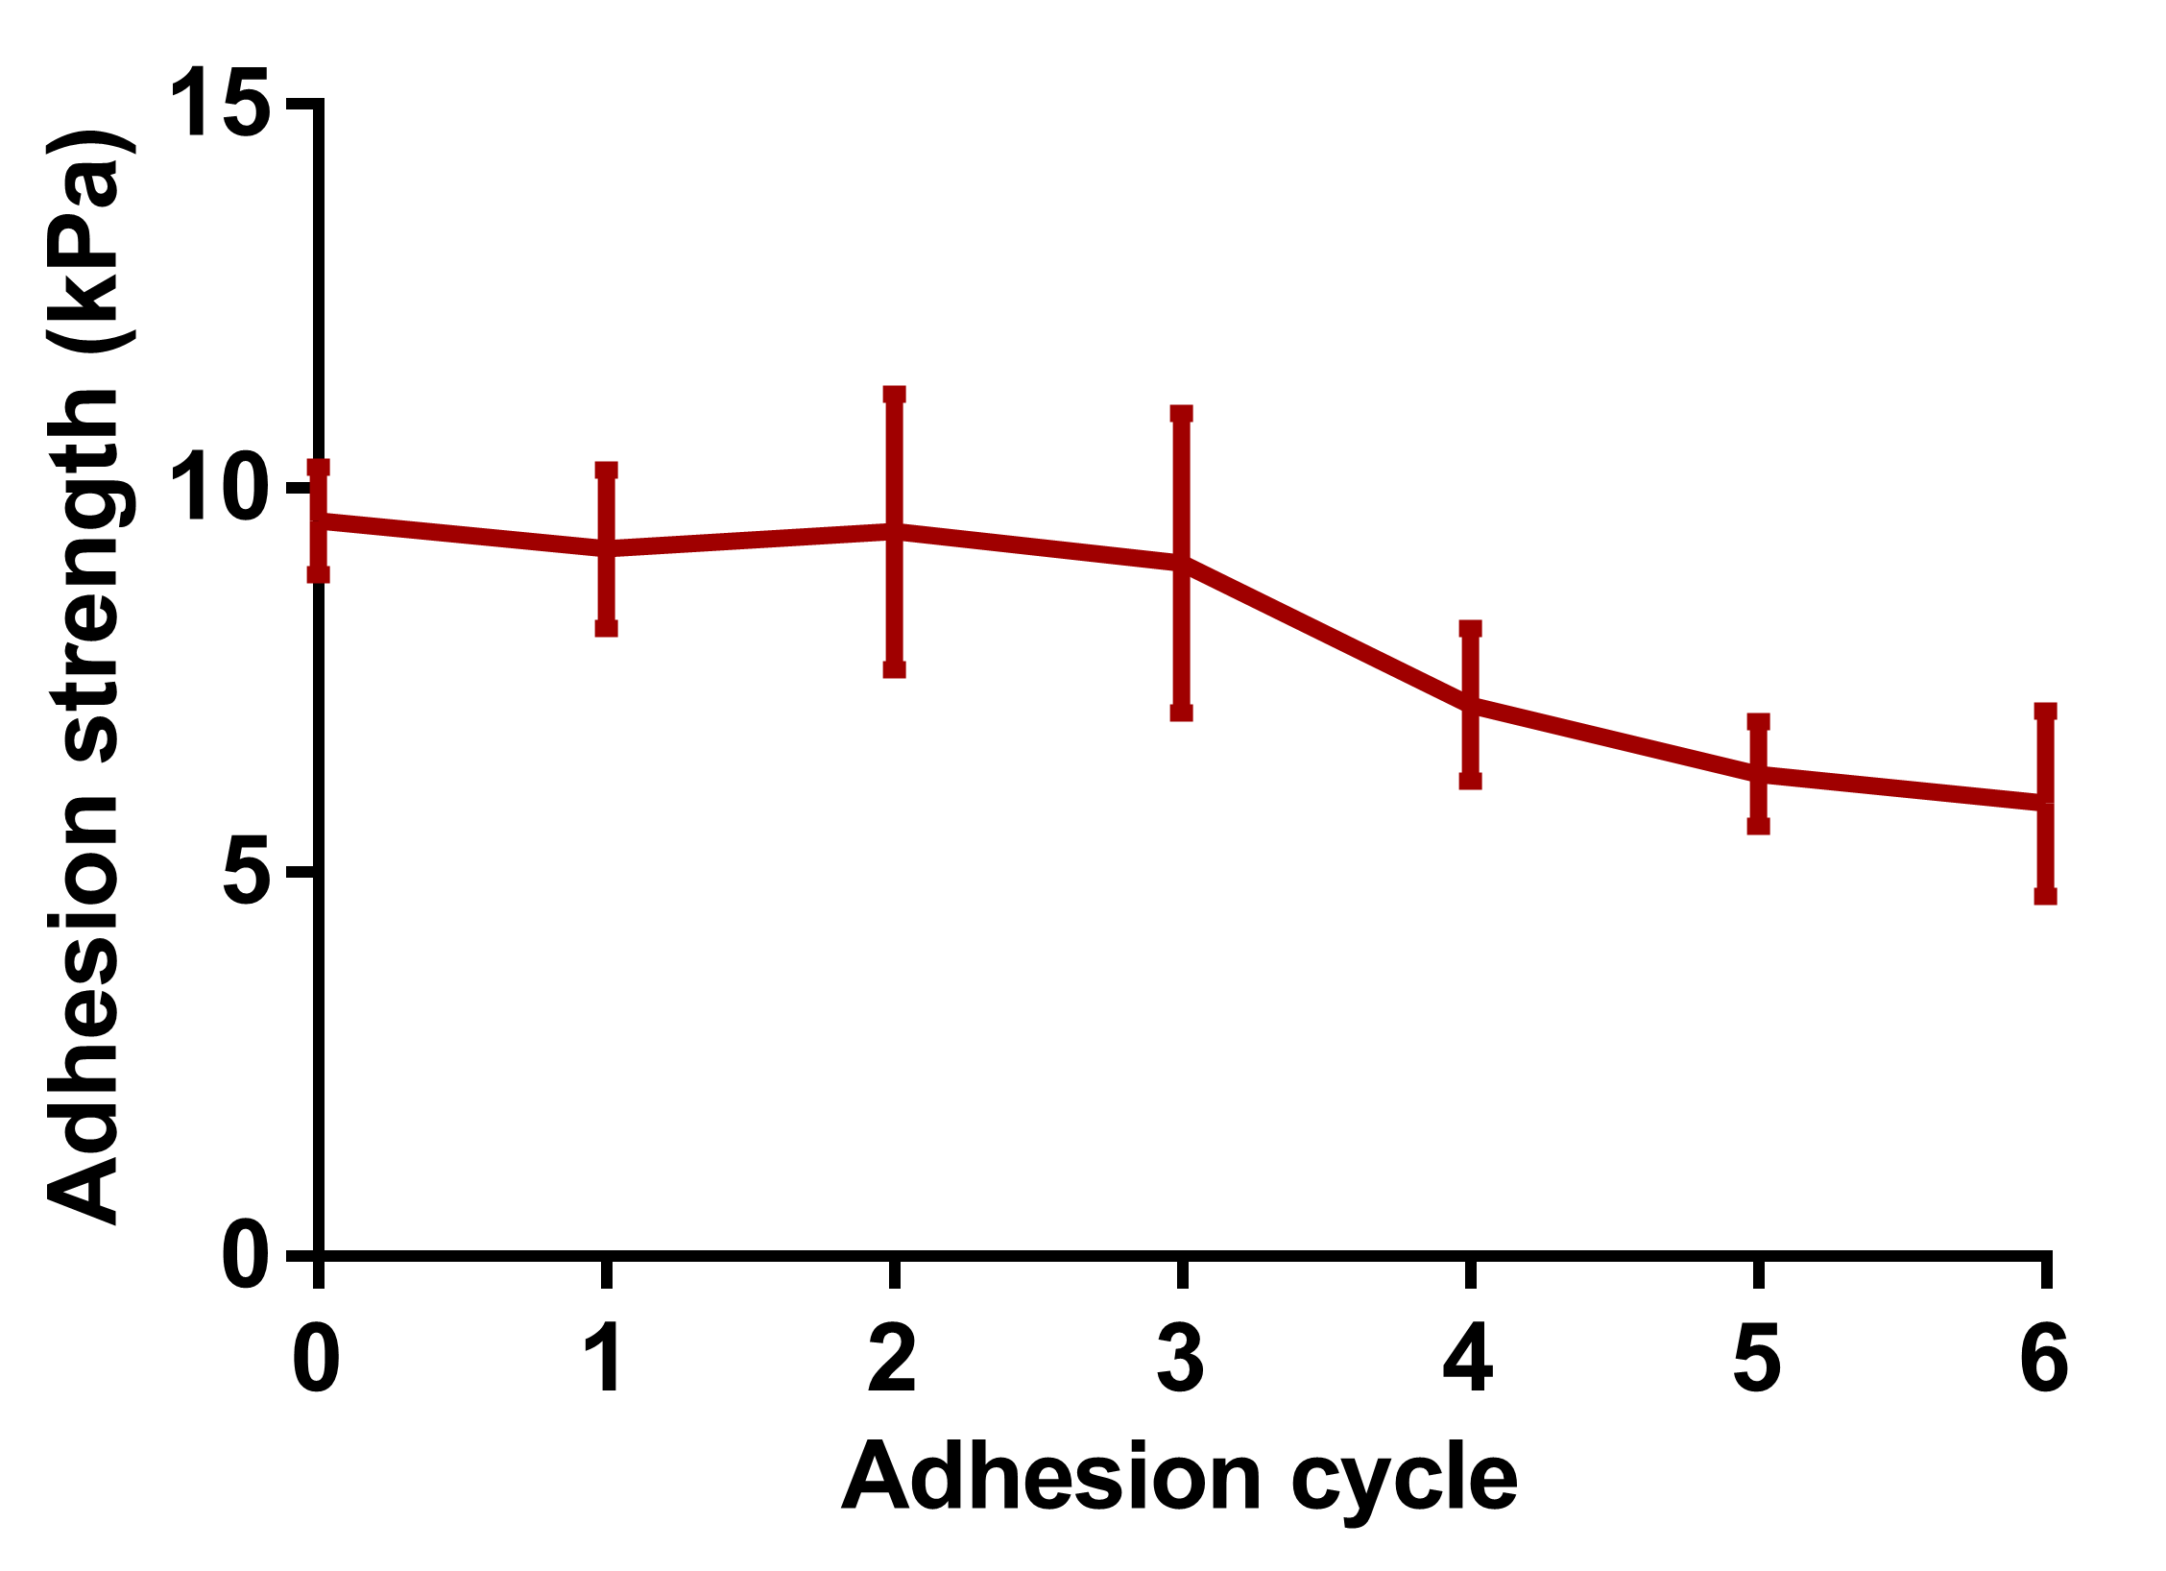
Fig. S7. Adhesion strength of PEGDA-GDY/G@TGFβ after adhesion cycles.

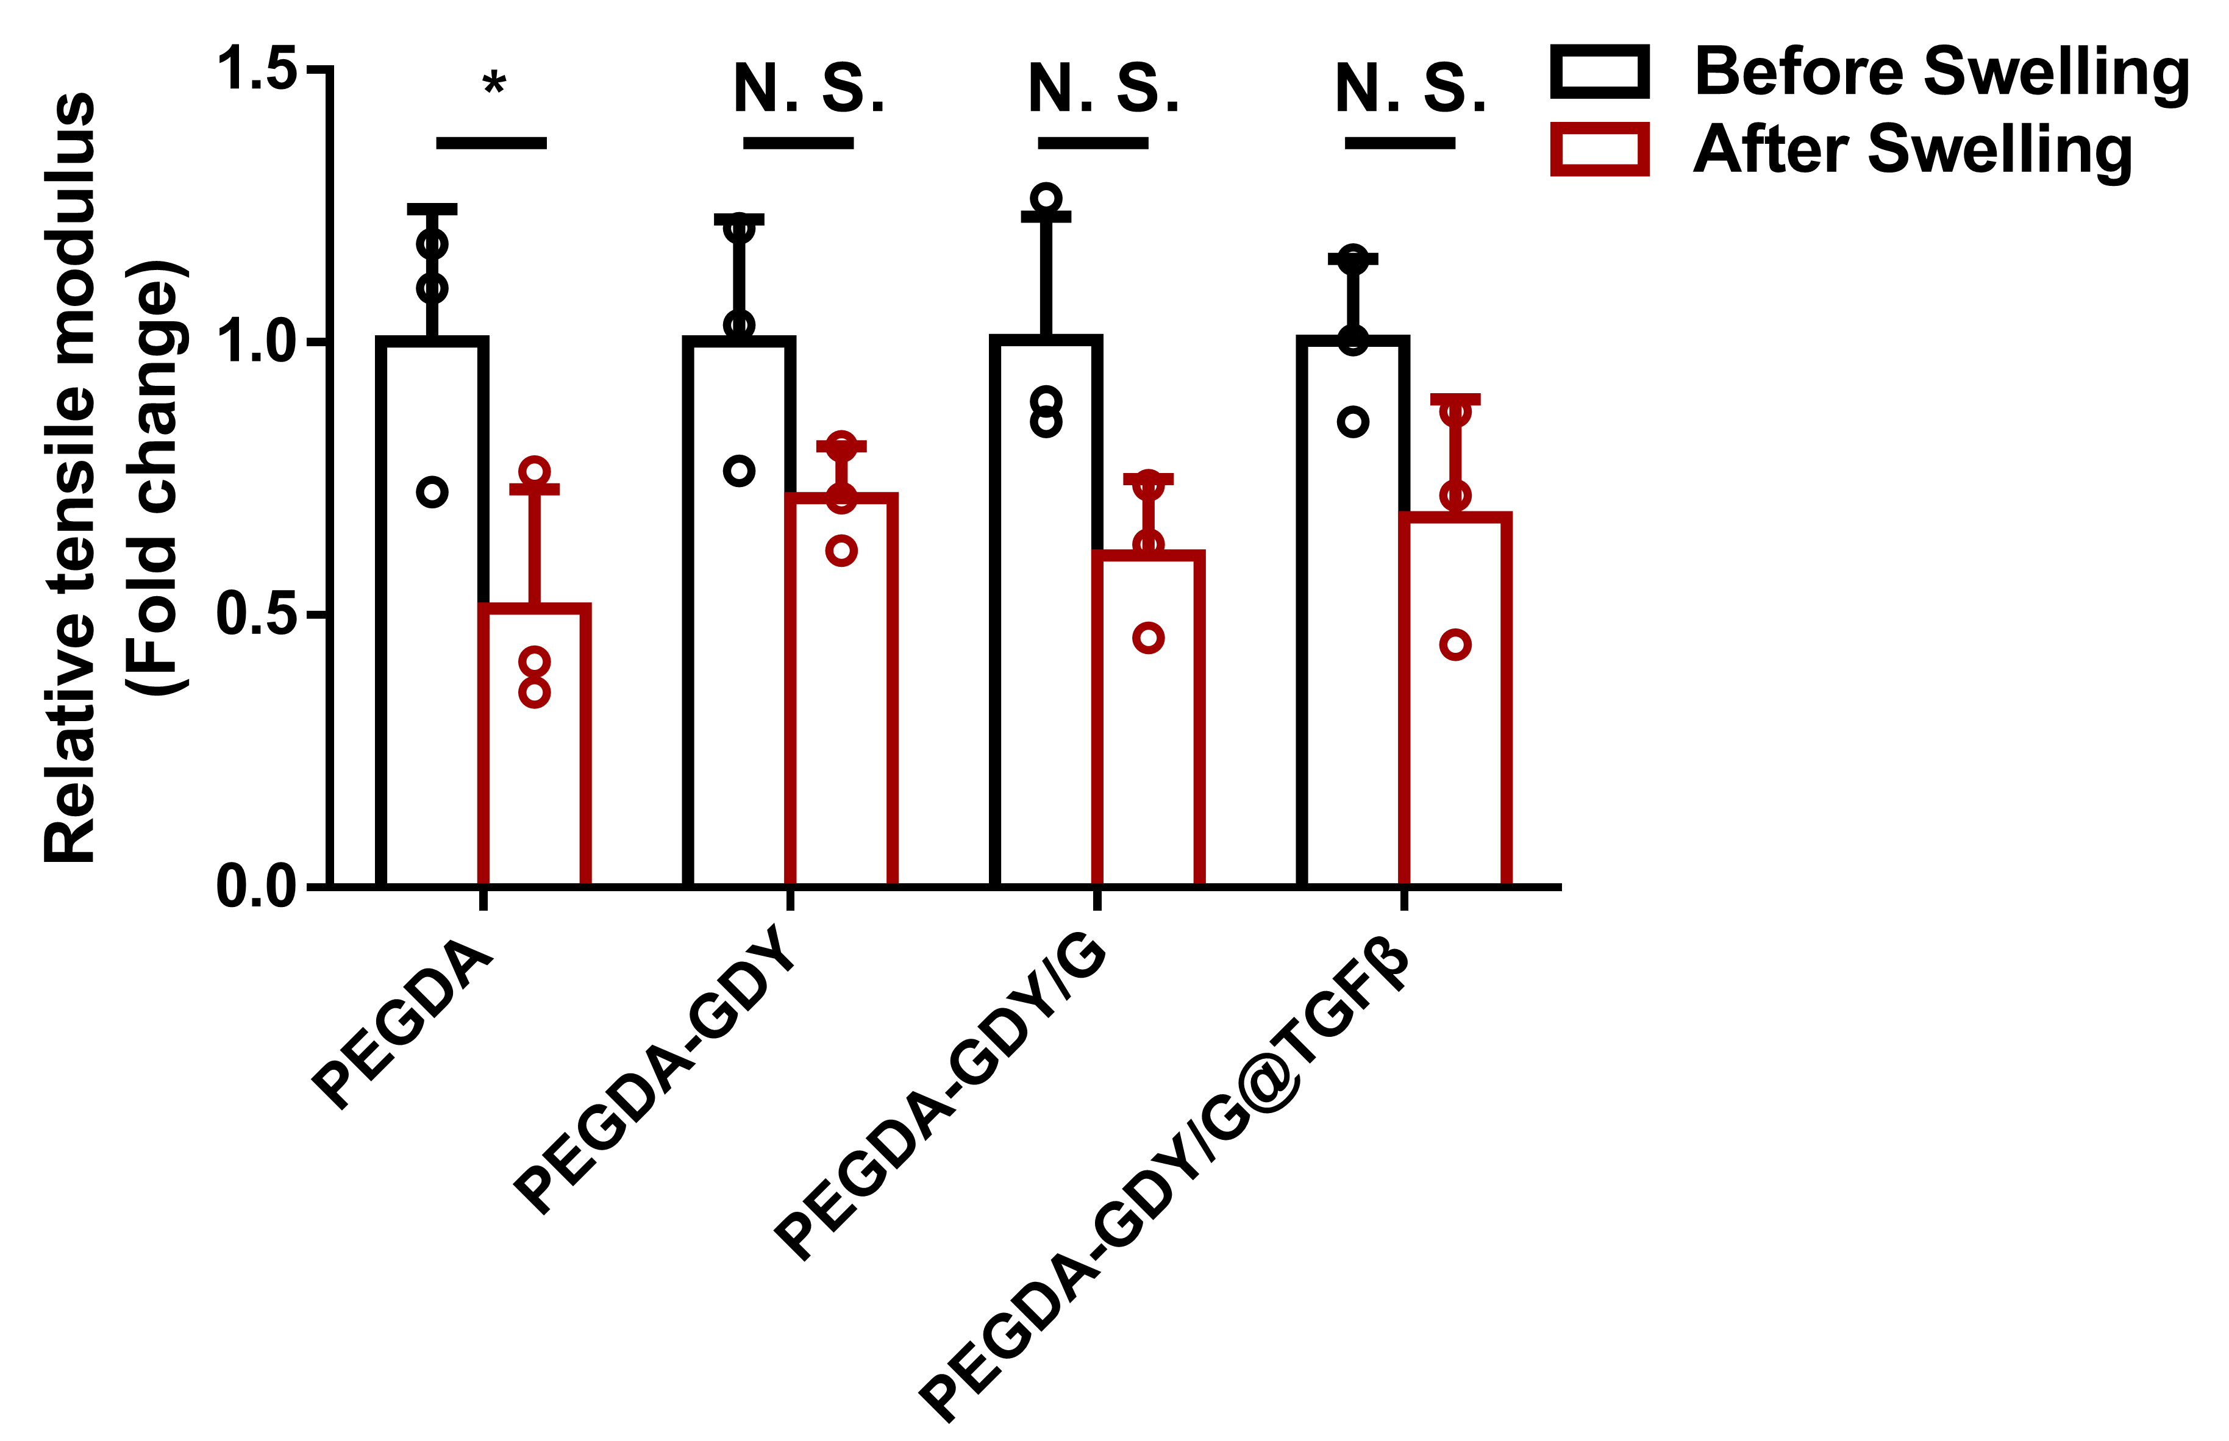
Fig. S8. Relative tensile modulus of different hydrogels before and after swelling. n = 5, by one-way ANOVA with Sidak correction.

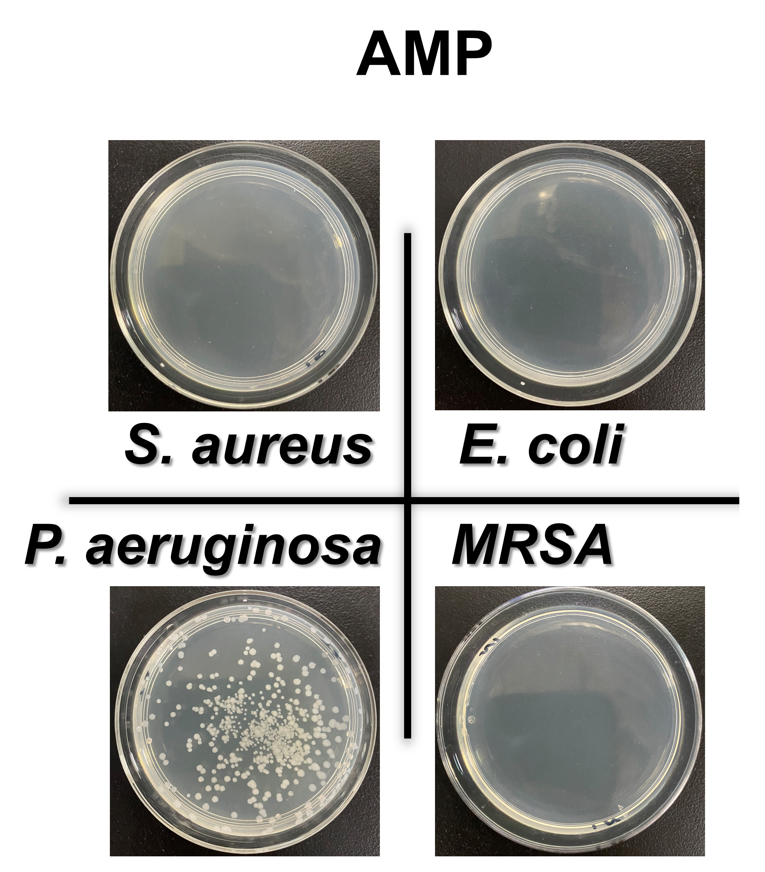
Fig. S9. The macro views of antibacterial experiments for AMP group.

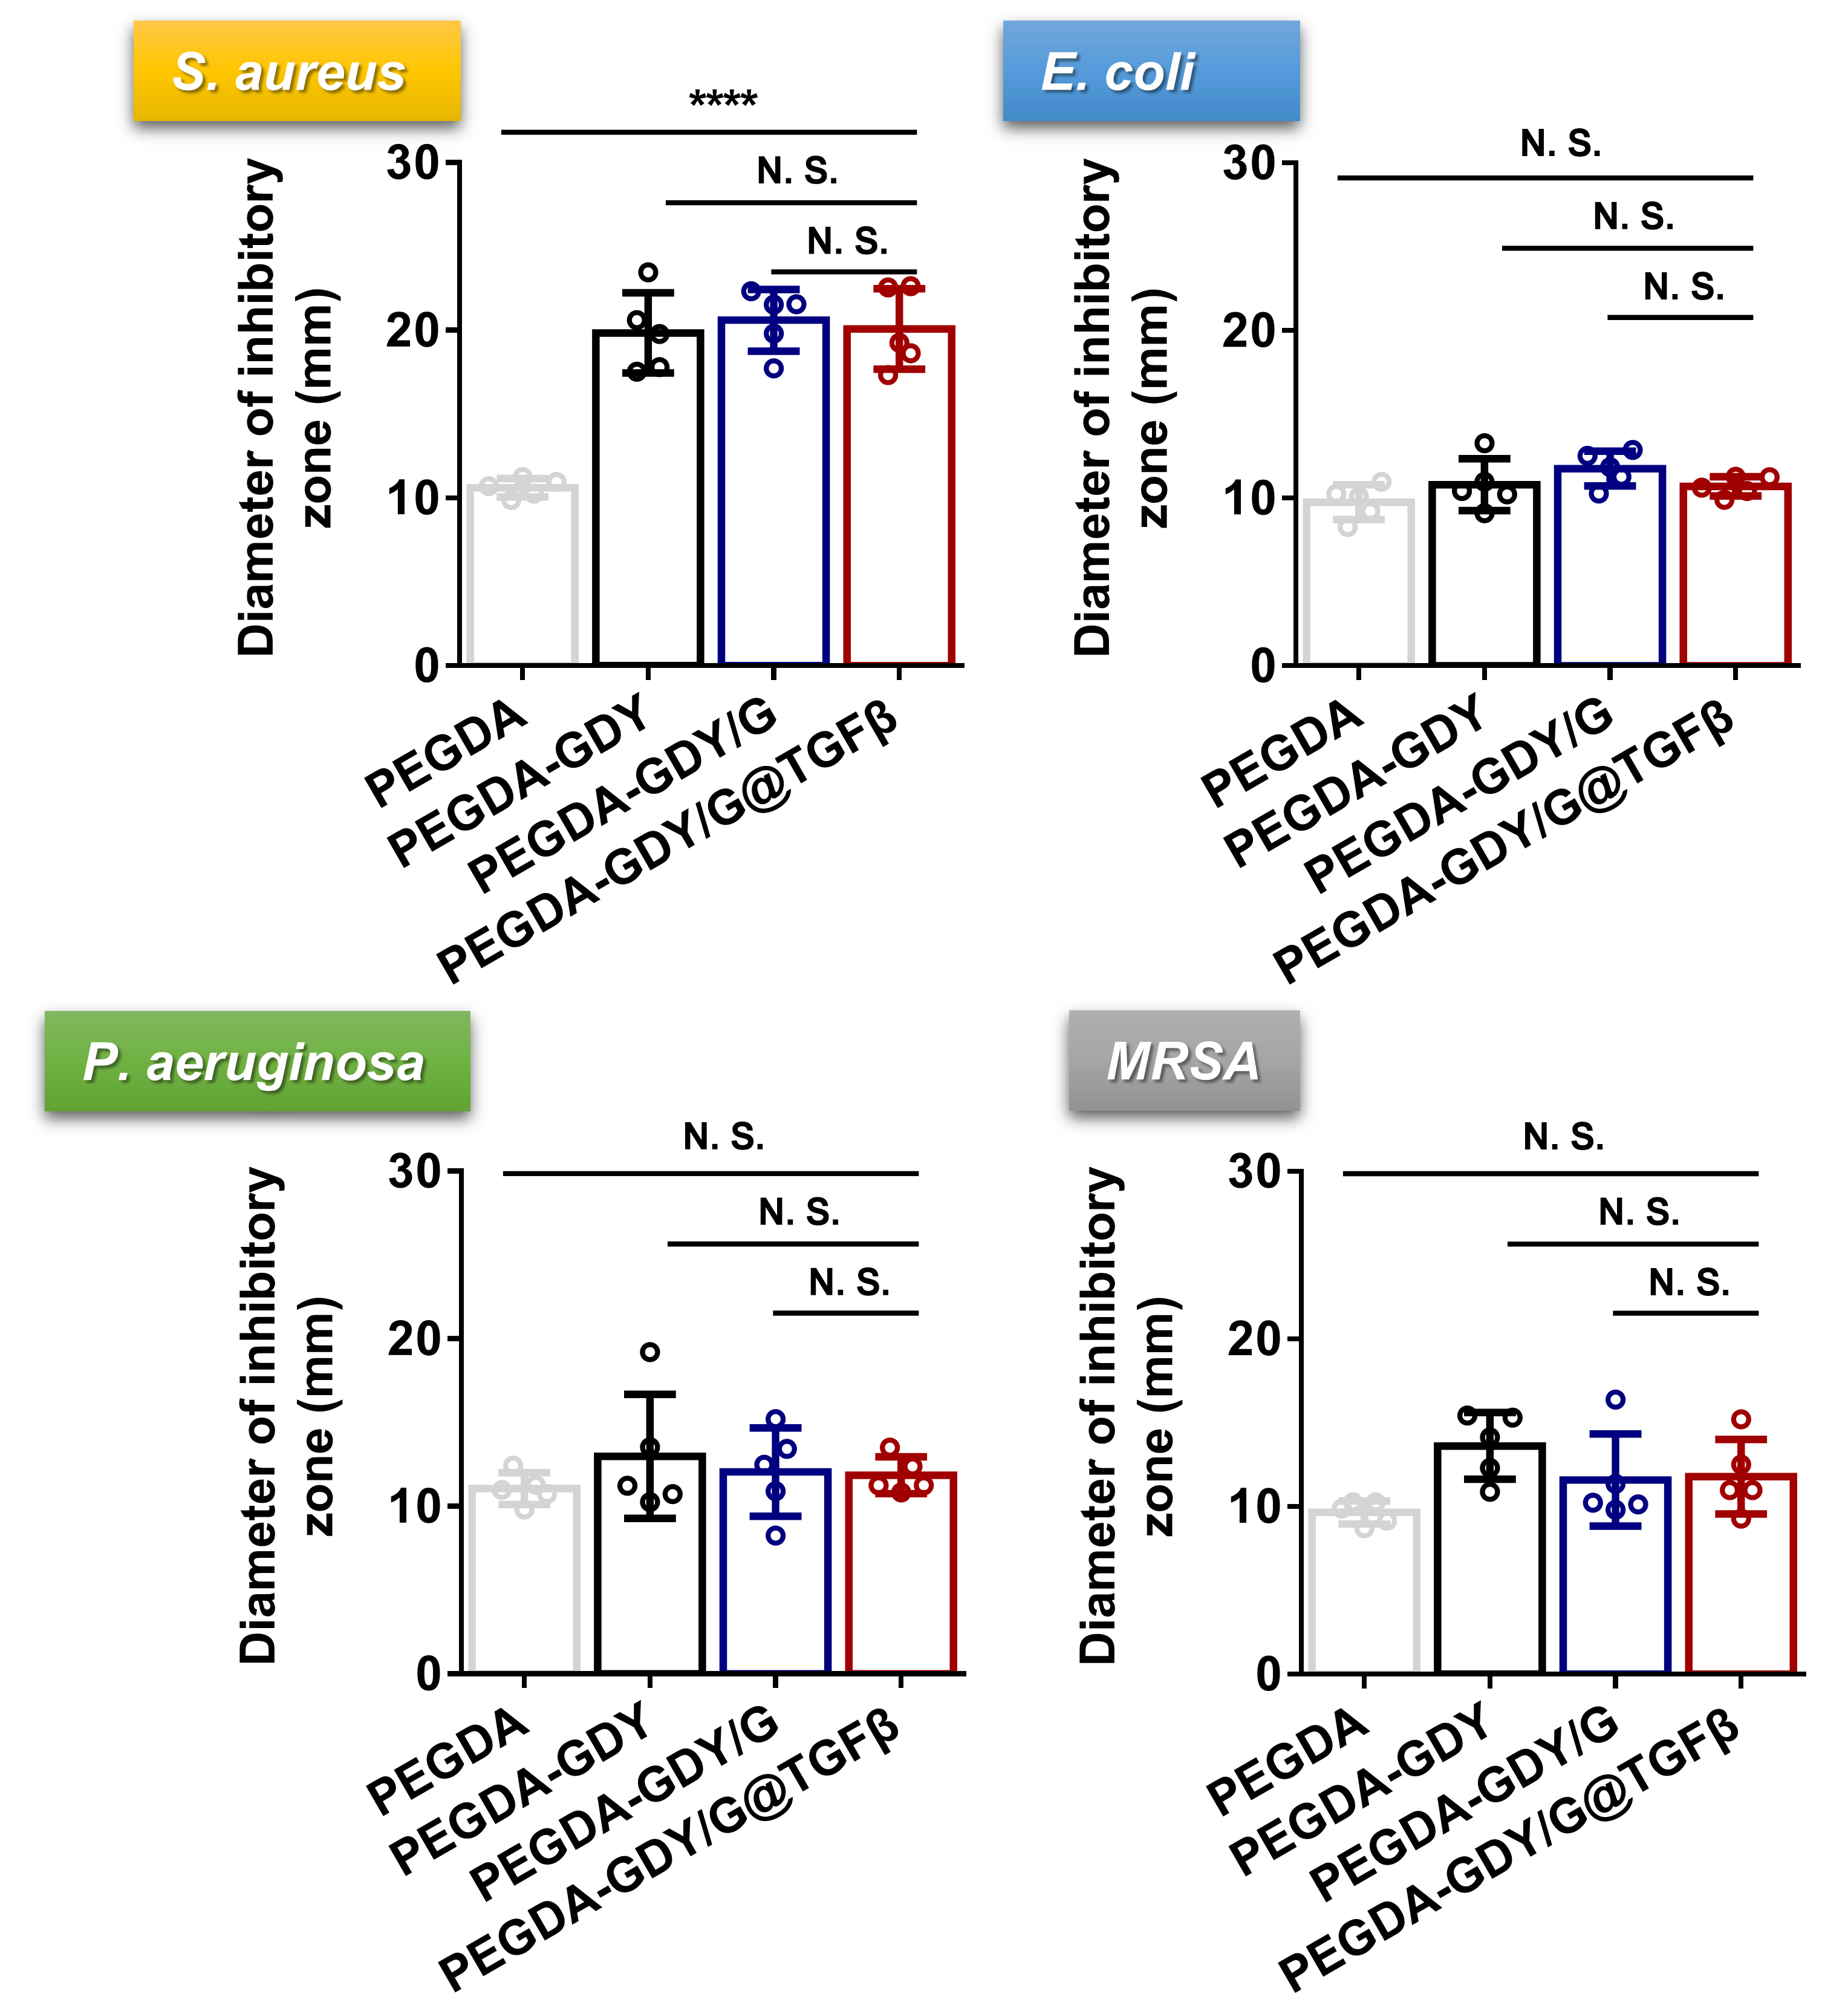
Fig. S10. The analysis of diameter of inhibitory zone for different bacteria in different hydrogels after NIR-irradiation.

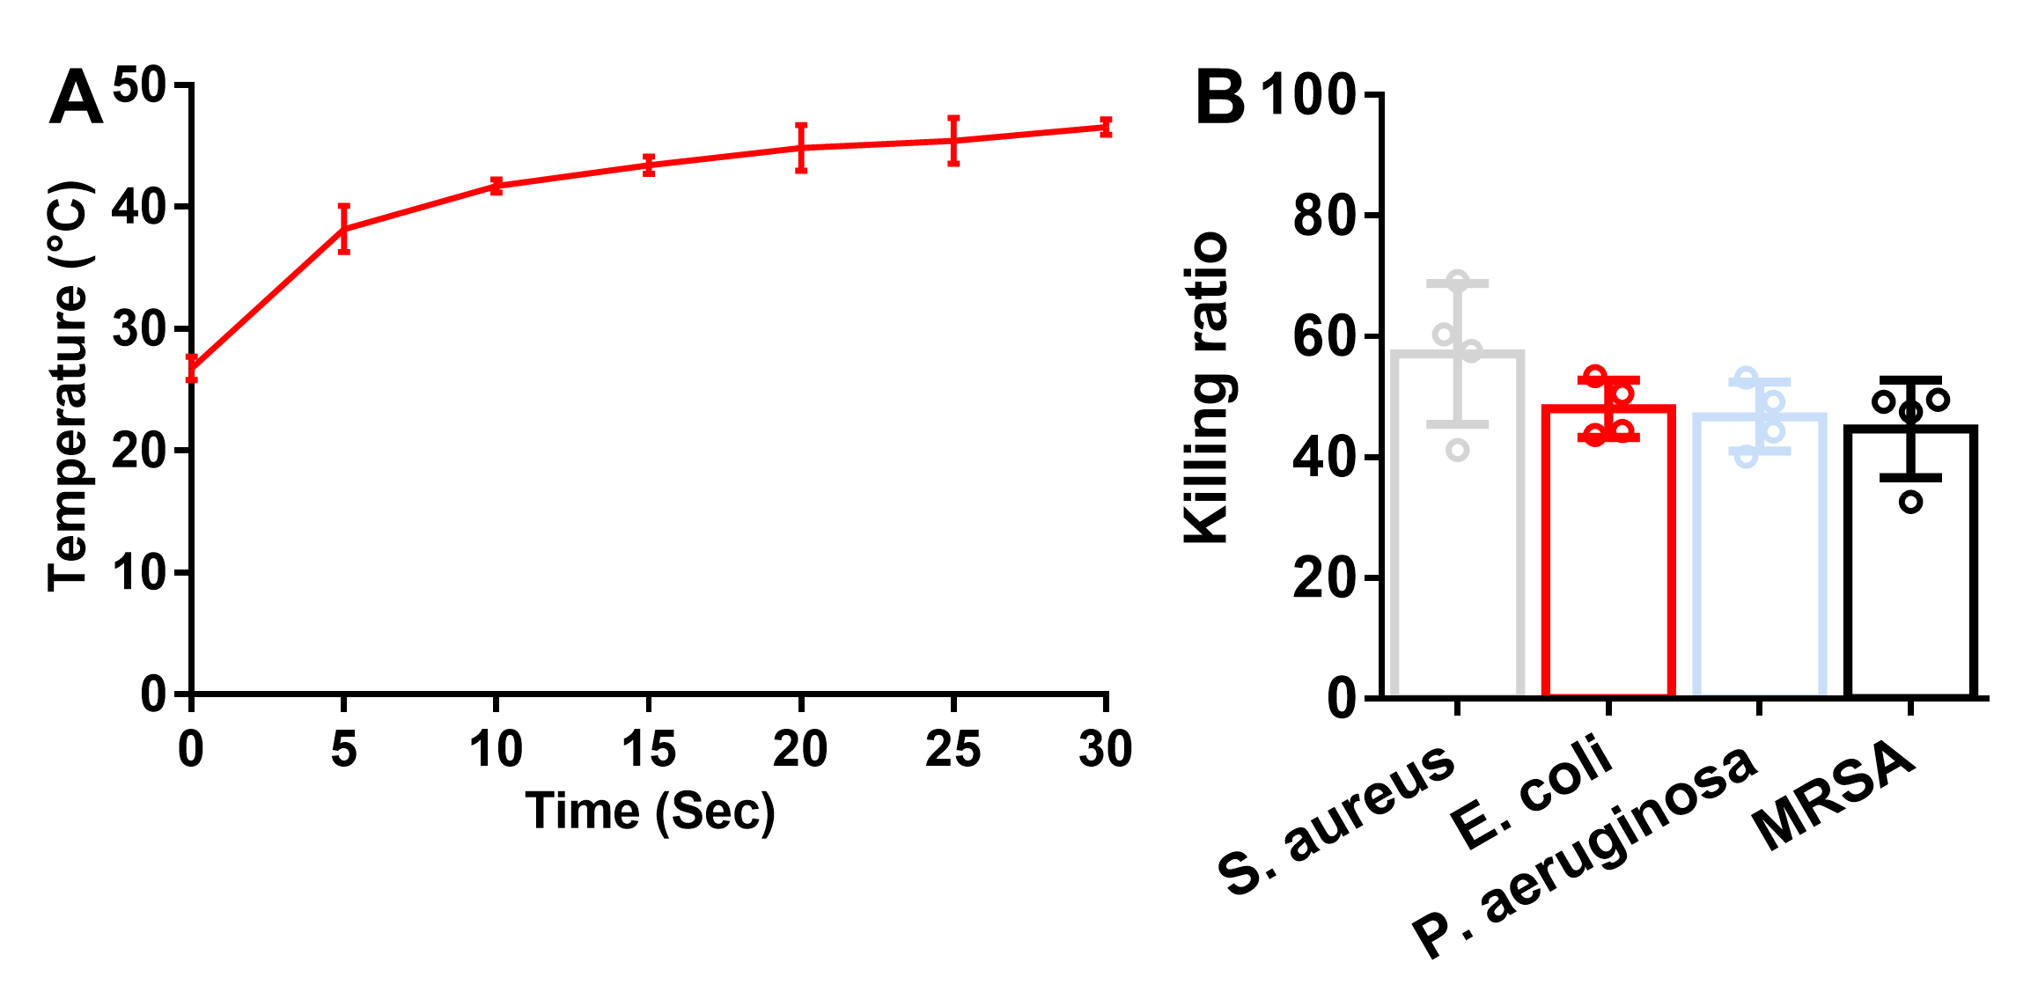
Fig. S11. (A) The time-temperature curve of heating. (B) The antibacterial effects to different bacteria. n = 4.

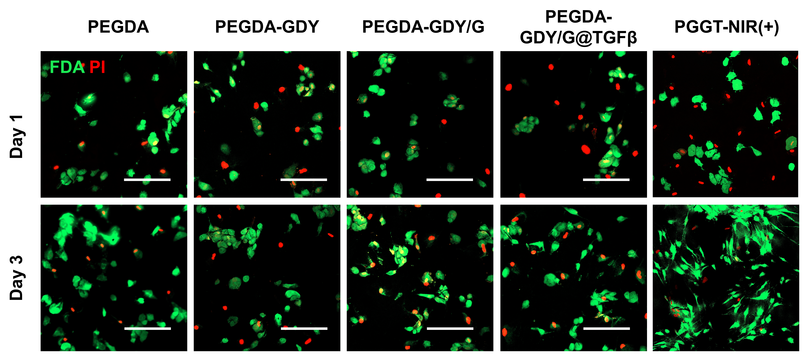
Fig. S12. FDA/PI staining of HDFs after implantation in hydrogels. Scale bar, 200 μm.

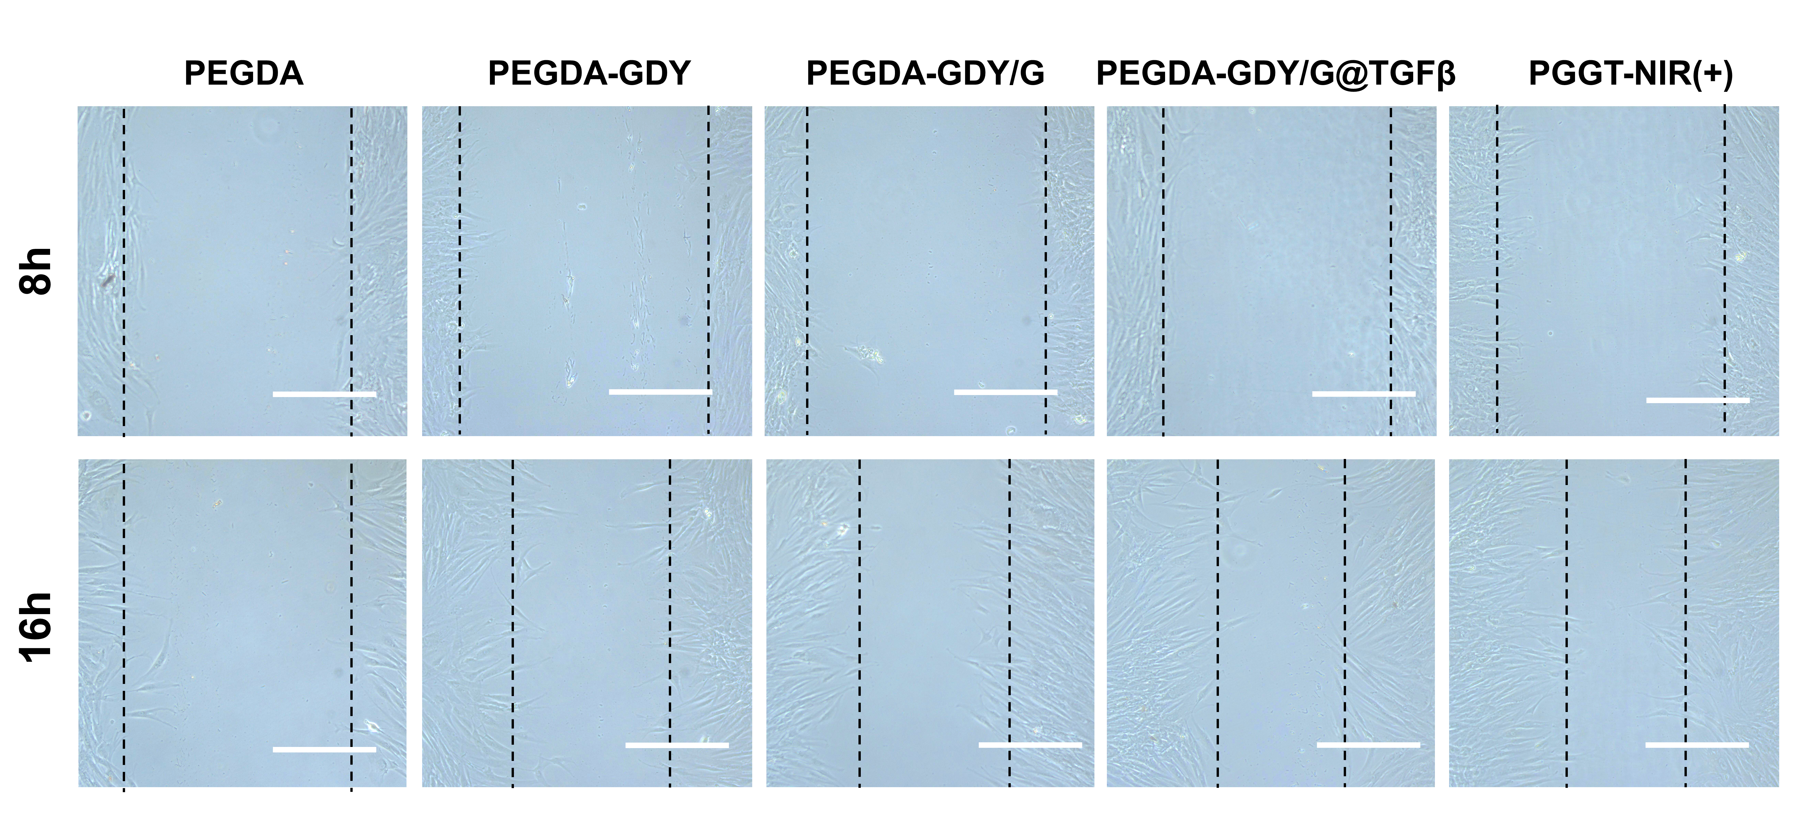
Fig. S13. The images of scratch assays. Scale bar, 200 μm. Black dash line: the edge of scratch.

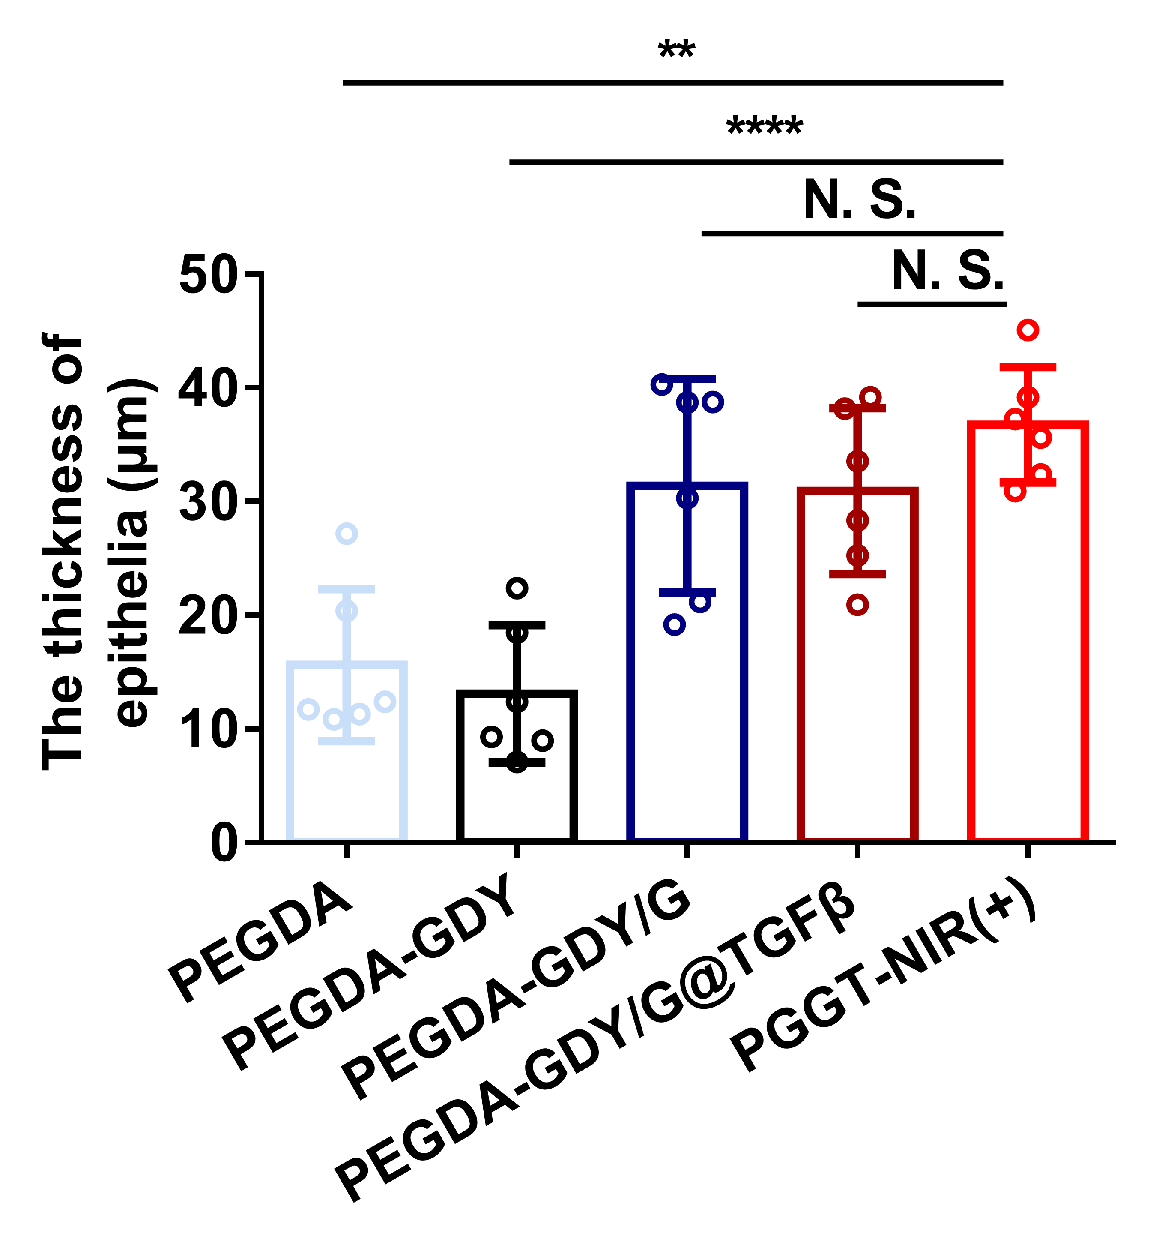
Fig. S14. The thickness of epithelia of wound in different groups. n = 6, ****p < 0.0001, **p < 0.01, by one-way ANOVA with Tukey correction.
Table S1. Blood routine examinations of mice post implantation in vivo
Liquid | WBC,10⁹/L | Lymphocyte,10⁹/L | Monocyte,10⁹/L | Neutrophil, 10⁹/L | RBC,10⁹/L
Sham | 21.6±6.2 | 5.2±3.6 | 1.5±0.2 | 10.2±1.4 | 9.2±0.5
PPGT | 22.5±3.4 | 5.7±6.2 | 2.2±0.4 | 11.5±0.2 | 10.1±0.8

 | Blood urea nitrogen, mg/dL | Creatinine, mg/dL | Aspartate aminotransferase, U/L | Alanine aminotransferase, U/L
Sham | 21.6±6.2 | 5.2±3.6 | 1.5±0.2 | 10.2±1.4
PPGT | 22.5±3.4 | 5.7±6.2 | 2.2±0.4 | 11.5±0.2
Table S2. Biochemical results of mice post implantation in vivo

Table S3 Antibodies used in immunohistofluorescence.

Primary | Catalog | Isotype | Company | Dilution | Secondary | Catalog | Company | Dilution
Collagen Ӏ | GB11022-3 | Rabbit | Servicebio | 1:500 | Goat polyclonal to Rabbit Cy3 | GB21303 | Servicebio | 1:300
CD206 | GB13438 | Rabbit | Servicebio | 1:500
iNOS | GB11119 | Rabbit | Servicebio | 1:500
CD31 | GB11063-2 | Rabbit | Servicebio | 1:1000
Collagen Ш | GB13023-3 | Rabbit | Servicebio | 1:200 | Goat polyclonal to Rabbit AF@488 | ab150081 | Abcam | 1:200

