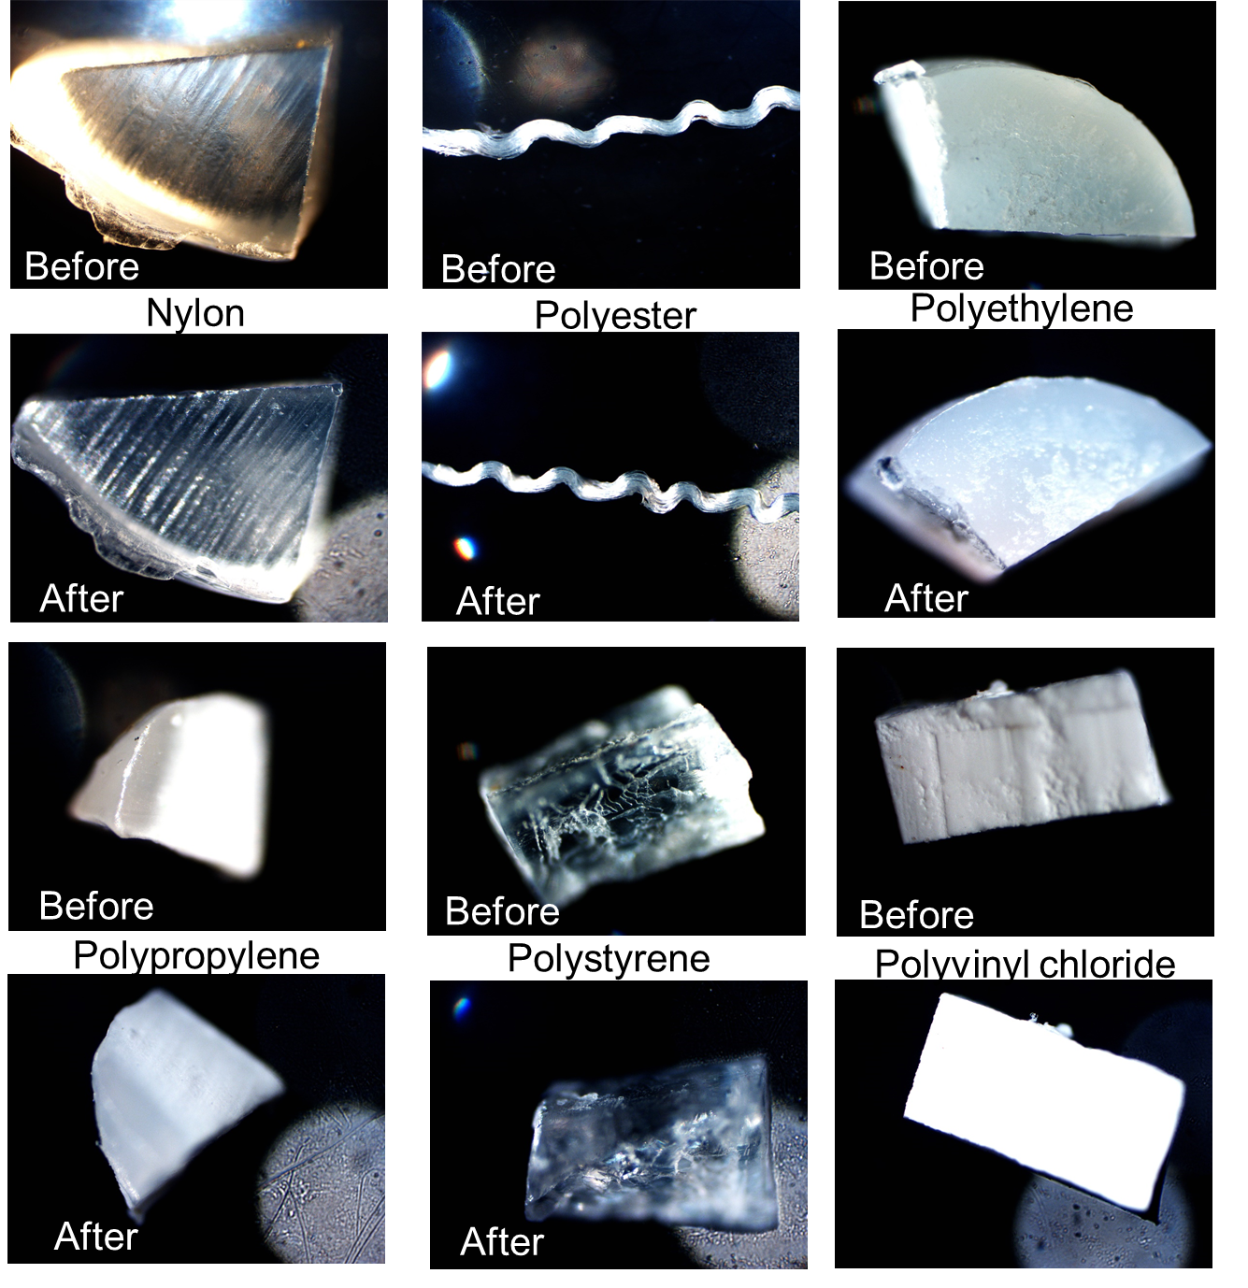

Figure S1: Before and after photos of polymers exposed to SPT for 24 hours at room temperature.

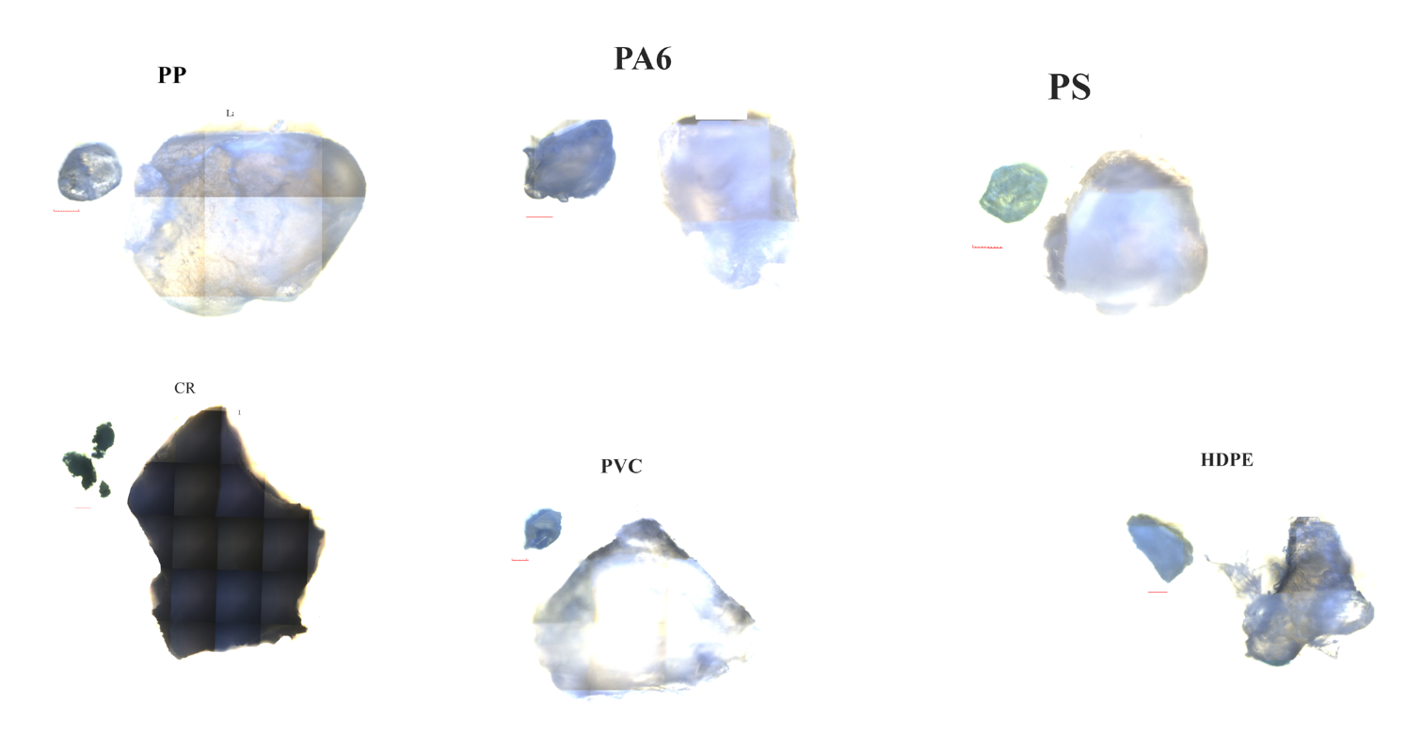
Figure S2: Images of the medium and large-sized microplastic particles of each material spiked into the sediment samples. Each red line is 100 μm for scale.

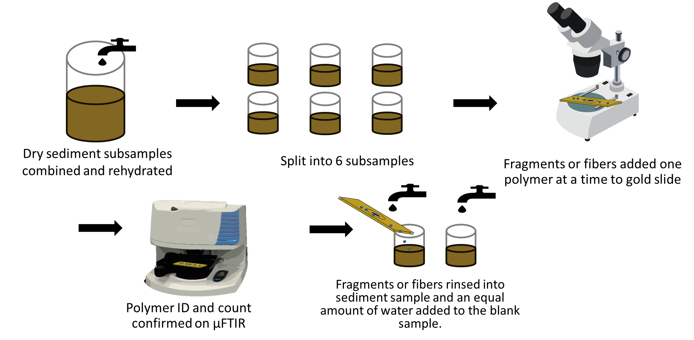

Figure S3: Diagram of the procedure of spiking sediments with microplastic particles and fibers.

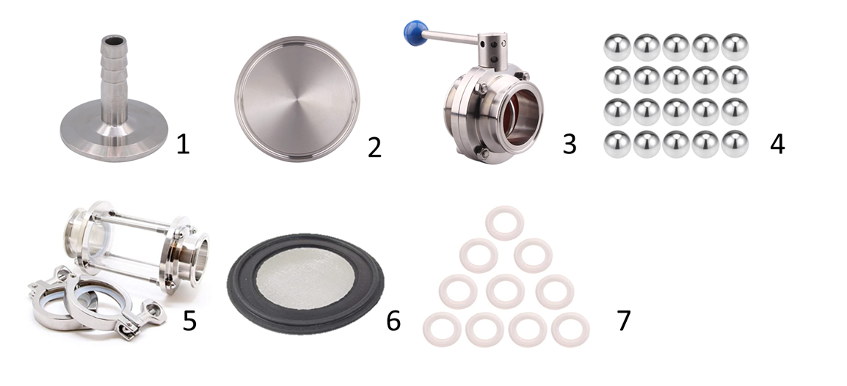
Figure S4: Parts needed to build a DSD. 1) vacuum attachment cap 2) Metal end cap 3) Ball valve 4) Meta balls (3 needed per DSD) 5) Sight glass and butterfly valve (2 needed per DSD) 6) 20 µm sieve 7) silicone O-rings (4 needed per DSD).

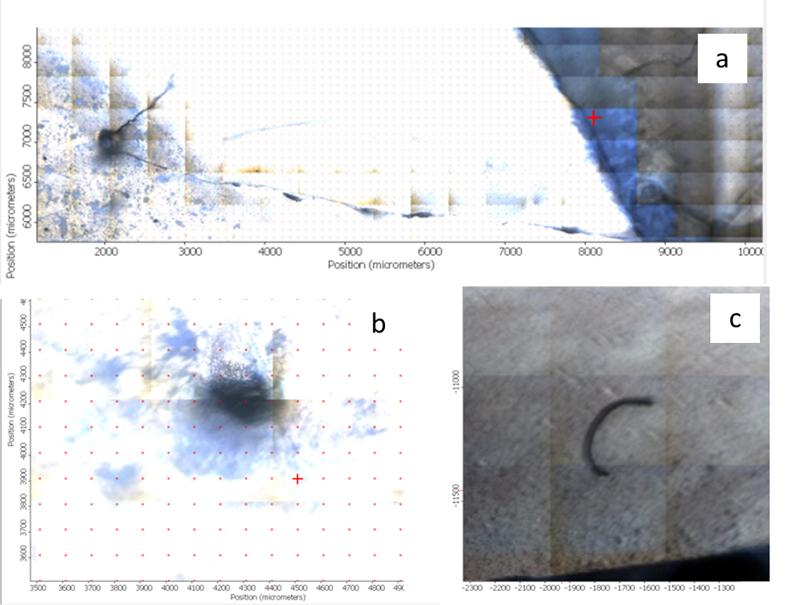
Figure S5: a) Polyethylene fiber and polycarbonate particle found in blank 1, b) polyethylene particle found in blank 1, c) polyester fiber in blank 2

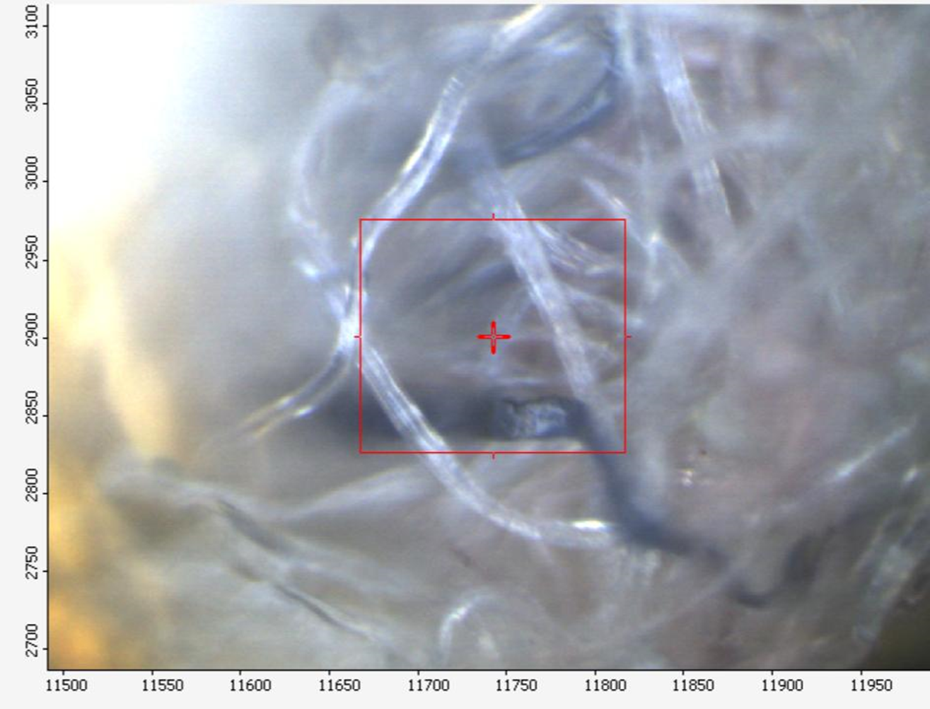 Figure S6: Tangled fibers on gold slide after sample was processed with the density separation device (DSD).

Sodium Polytungstate Information:

SPT (Sodium metatungstate monohydrate, Na6O39W1ٜ2·H20, CAS: 314075-43- 9) was obtained from Thermo Fisher Scientific.

SPT Stock Solution: 200 mL of high purity 18M Ω water filtered at 0.22 μm (hereafter referred to as high purity deionized water) was heated to 60 °C in a glass beaker on a hot plate and 500 g of dried SPT were slowly added, stirring between each scoop. The density of the solution was checked via gravimetric analysis by dividing the mass of a known amount of SPT over the volume weighed.

Density of SPT: A SPT solution more dense than the final density desired in the DSD is required because the SPT is mixed with water when initially added to the DSD. The required density is calculated using equation 1 (Skipp and Brownfield 1993).

Equation 1: (V_{d})(ρ_{m}-ρ_{d}) = (V_{l})(ρ_{l}-ρ_{m})

Where :
V_{d} = the volume of diluent
V_{l} = the volume of liquid SPT
ρ_{m} = the density mix (final density of solution)
ρ_{d} = the density of diluent
ρ_{l} = the density of liquid SPT

Therefore, because we used at most 80 mL to rinse the sediment into the DSD and pull the vacuum, that must be accounted for as the diluent in our final SPT density. So, if we diluted our 180 mL of SPT with 60 - 80 mL and want a final SPT density of at least 2.0 g/mL to float our most dense polymer (PVC ~ 1.38 g/mL -1.45 g/mL) then:

(80mL)(2.0 g/mL - 1.0 g/mL) = (180 mL)( ρ_{l}- 2.0)
(60mL)(2.0 g/mL - 1.0 g/mL) = (180 mL)( ρ_{l}- 2.0)
Where ρ_{l} = 2.33 - 2.44 g/mL

Recycling SPT post density separation: One of the benefits of sodium polytungstate is its ability to be recycled. The sodium polytungstate from these experiments was recycled with an efficiency of approximately 80%. After the sample had fully settled from the third mix in the DSD, the top chamber with the floating material and relatively clean SPT solution was closed off from the bottom chamber and carefully removed while held over a secondary container. This secondary container collects the SPT that was below the top chamber but still caught in the ball valve. The bottom chamber with the sediment and SPT was emptied into this container as well. This solution was then distributed into 15 mL centrifuge tubes and centrifuged at 30 RPM for 30 minutes. The centrifuge tubes were then checked to see if the pellet was solid and if it was, the SPT was poured off the top and filtered through a 20 μm polycarbonate filter paper. Similarly, after the SPT containing the microplastics (top chamber of DSD) was filtered to recover
the spiked microplastics, it was recycled in the same way as described above. Once filtered, the two batches of SPT were combined and heated to 60°C and additional SPT added as needed to increase the density to the desired 2.3 g/mL.

Additional information on the recycling of sodium polytungstate is available from http://www.sometu.de/howtouse.html

