Table S1 The distributions of variables with missing data and the multiple imputation data.
Variables | Number (%)  with missing date | Complete case | Multiple imputation
BMI | 62(1.20) | 29.15±7.07 | 29.16±7.08
Drinking status | 480(9.31)
No | 156(3.02) | 1317 (28.18) | 1473(28.58)
Yes | 324(6.29) | 3357 (71.82) | 3681(71.42)
Education level | 3(0.06)
Did not graduate from high school | 1(0.02) | 530 (10.29) | 531(10.30)
Graduated from high school | 0(0) | 1749 (33.95) | 1749(33.93)
College education or above | 2(0.04) | 2872 (55.76) | 2874(55.76)
Maritial | 442(8.58)
Married/Living with partner | 221(4.29) | 2615 (55.50) | 2836(55.03)
Widowed/divorced/separated | 48(0.93) | 1063 (22.56) | 1111(21.56)
Never married | 173(3.36) | 1034 (21.94) | 1207(23.42)
PIR | 454(8.81)
Low | 171(3.32) | 1556 (33.11) | 1727(33.51)
Medium | 164(3.18) | 1711 (36.40) | 1875(36.38)
High | 119(2.31) | 1433 (30.49) | 1552(30.11)
Serum cotinine(ng/ml) | 48(0.93) | 0.04(0.01,6.57) | 0.04(0.01,6.67)
Notes:data presented are mean±SD,median(Q1-Q3),or N(%).
Abbreviations:BMI,body mass index; PIR,ratio of family income to poverty.

Table S2 Association between serum Cu, Cu/Se-ratio and COPD in all participants based on original data.
Variables | Non-adjusted Model(n=5154) | Model 1(n=5154) | Model 2(n=3843)
Serum Cu(μmol/L) | 1.05 (1.03~1.07) | 1.06(1.04~1.09) | 1.06(1.03~1.09)
P-value | < 0.001 | < 0.001 | <0.001
Subgroups
Q1 | 1(Ref) | 1(Ref) | 1(Ref)
Q2 | 2.15(1.59~2.90) | 1.97(1.44~2.67) | 1.78(1.24~2.57)
Q3 | 2.80 (2.09~3.74) | 2.65(1.93~3.63) | 2.24(1.53~3.29)
Serum Cu/Se-ratio | 1.07 (1.04~1.10) | 1.08(1.05~1.12) | 1.08(1.04~1.12)
P-value | <0.001 | <0.001 | <0.001
Subgroups
Q1 | 1(Ref) | 1(Ref) | 1(Ref)
Q2 | 1.64 (1.23~2.17) | 1.52(1.14~2.04) | 1.37(0.97~1.93)
Q3 | 2.08(1.59~2.74) | 2.05(1.52~2.76) | 1.69(1.18~2.42)
Note:.Data presented are ORs and 95%Cls.
Model 1：Adjusted for age,gender.
Model 2：Adjusted for Model 1+race /ethnicity, marital status, education level, BMI, PIR, smoking status, drinking status, hypertension, diabetes, serum cotinine, hypercholesterolemia.

Table S3 Association between serum Cu, Cu/Se-ratio and COPD in smokers and non-smokers based on original data.
Variables | Smokers(n=1635) |  | Non-smokers(n=2208)
Variables | OR (95% CI) | P-value | OR (95% CI) | P-value
Serum Cu(μmol/L) | 1.09(1.05~1.13) | < 0.001 | 1.00(0.95~1.06) | 0.986
Subgroups
Q1 | 1(Ref) |  | 1(Ref)
Q2 | 1.71(1.09~2.67) | 0.019 | 1.78(0.94~3.37) | 0.078
Q3 | 2.46(1.55~3.93) | < 0.001 | 1.33(0.66~2.69) | 0.43
Serum Cu/Se-ratio | 1.11(1.06~1.17) | < 0.001 | 1.01(0.94~1.09) | 0.834
Subgroups
Q1 | 1(Ref) |  | 1(Ref)
Q2 | 1.43(0.94~2.19) | 0.099 | 1.50(0.81~2.78) | 0.202
Q3 | 1.87(1.20~2.92) | 0.006 | 1.44(0.74~2.80) | 0.287
Adjusted for age,gender,race /ethnicity, marital status, education level, BMI, PIR, drinking status, hypertension, diabetes, serum cotinine, hypercholesterolemia.

Table S4 The association between serum Cu, Cu/Se-ratio (excluding mean ± 3 SD), and COPD in smokers and nonsmokers.
Variable | Smokers(n=1635) |  | Non-smokers(n=2208)
Variable | OR (95% CI) | P-value | OR (95% CI) | P-value
Serum Cu(μmol/L) | 1.10(1.05~1.15) | < 0.001 | 1.01(0.94~1.08) | 0.789
Subgroups
Q1 | 1(Ref) |  | 1(Ref)
Q2 | 1.72(110~2.70) | 0.017 | 1.82(0.96~3.44) | 0.067
Q3 | 2.35(1.48~3.75) | < 0.001 | 1.35(0.67~2.75) | 0.402
Serum Cu/Se-ratio | 1.12(1.06~1.19) | < 0.001 | 1.02(0.94~1.12) | 0.608
Subgroups
Q1 | 1(Ref) |  | 1(Ref)
Q2 | 1.31(0.86~1.99) | 0.211 | 1.57(0.85~2.93) | 0.153
Q3 | 1.74(1.12~2.69) | 0.014 | 1.50(0.77~2.92) | 0.236
Adjusted for age,gender,race /ethnicity, marital status, education level, BMI, PIR, drinking status, hypertension, diabetes, serum cotinine, hypercholesterolemia.

Table S5 The levels of serum Cu, Cu/Se-ratio in smokers and nonsmokers.
Variables | Total  (n = 5154) | Non-smokers  (n = 2944) | smokers  (n = 2210) | P-value
Serum Cu(μmol/L),  Mean ± SD | 18.86± 4.83 | 18.91 ± 5.05 | 18.78 ± 4.53 | 0.350
Serum Cu/Se-ratio,  Mean ± SD | 11.69 ± 3.50 | 11.73 ± 3.61 | 11.65 ± 3.34 | 0.384
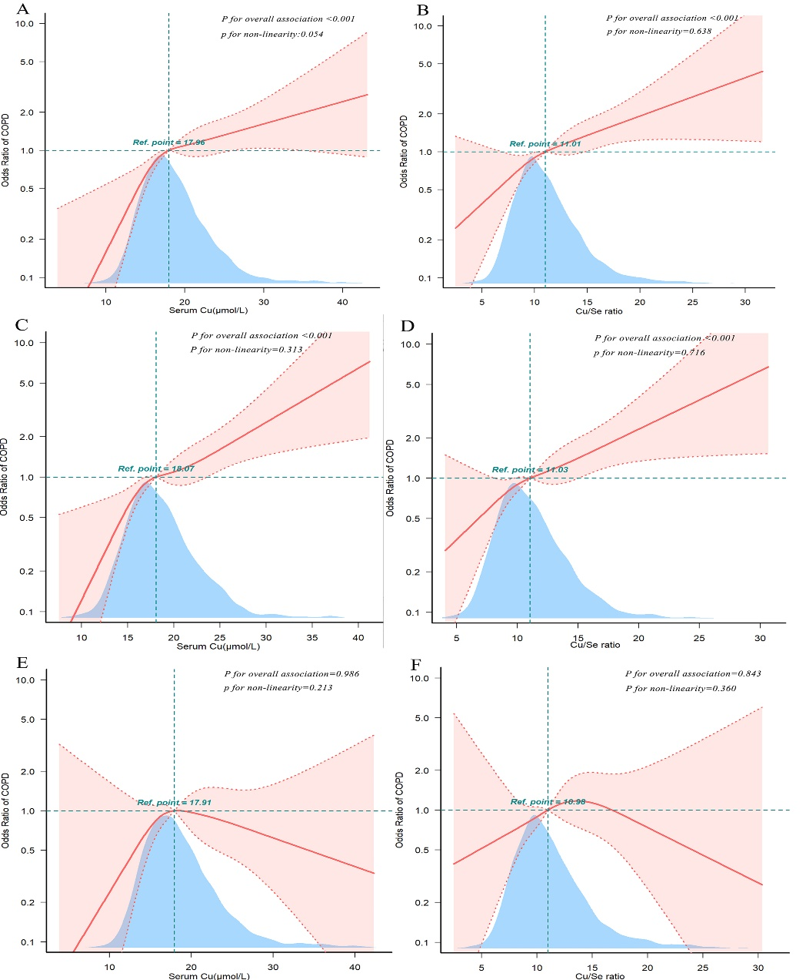
Figure S1. (A-F) Relationships between serum Cu, Cu/Se-ratio, and COPD were analyzed using restricted cubic spline modeling based on original data, (A,B) is the relationship between serum Cu, Cu/Se-ratio, and COPD in the whole population, and (C,D) is the relationship between serum Cu, Cu/Se-ratio, and COPD in smokers. (E,F) is the association between serum Cu, Cu/Se-ratio, and COPD in nonsmokers.The analyses were adjusted for sex, age, race, education, marriage, household income-to-poverty ratio, body mass index, drinking status, serum cotinine, hypertension and diabetes, and hypercholesterolemia. Showing 99.9% of the data.The solid lines indicate multivariate-adjusted odds ratios and the dashed lines indicate the 95%CIs derived from restricted cubic spline regression. The horizontal dotted lines represent the odds ratio of 1.0 (Reference point). The reference point was set at the median level of serum Cu, Cu/Se-ratio.

