Supplemental Results
MEG3 inhibits cell proliferation
The average width of scratches in hLCSCs transfected with pCMV6-A-GFP was 1.59±0.025 cm at 0 hours, and the average width of scratches in hLCSCs from pCMV6-A-GFP-MEG3 group was 1.58±0.125 cm. The difference was not significant between the two groups(1.59±0.025cm vs 1.58±0.125cm, P=0.4594>0.01). The average width of scratches in hLCSCs transfected with empty plasmid pGFP-V-RS was 1.62±0.16 cm, and the average width of scratches in hLCSCs of pGFP-V-RS-MEG3 group was 1.61±0.26 cm. The difference was not significant between the two groups( 1.62 ± 0.16 cm vs 1.61 ± 0.26 cm, P = 0.4885 > 0.05). After 24 hours of scratching, the damage repair ability of human liver cancer stem cells was significantly reduced in pCMV6-A-GFP-MEG3 group compared with the pCMV6-A-GFP group (0.22±0.03cm vs 0.72±0.07cm, P= 0.00269<0.01) and increased in pGFP-V-RS-MEG3 group compared to the pGFP-V-RS group (0.2±0.05 vs 0 cm, P=0.0099<0.01) (Fig. S8a&b).
The effect of MEG3 on the growth of liver cancer stem cells in vitro and in vivo is related to P53
To investigate whether the effect of MEG3 on hLCSCs is related to P53, the pCMV6-A-GFP-MEG3 and the P53 knockdown plasmid (pGFP-V-RS-P53) were transfected into hLCSCs respectively, and positive cells were screened and expanded (Fig. S9A). Compared to control, excessive transcription of MEG3 was produced in pCMV6-A-GFP-MEG3-hLCSCs and pCMV6-A-GFP-MEG3 plus pGFP-V-RS-P53-hLCSCs (Fig. S9B), and overexpression of P53 was generated in pCMV6-A-GFP-MEG3-hLCSCs and P53 was significantly reduced in pCMV6-A-GFP-MEG3 plus pGFP-V-RS-P53-hLCSCs (Fig. S9C). We determined the proliferation ability In vitro in the above three stable cell lines (pCMV6-A-GFP-hLCSCs, pCMV6-A-GFP-MEG3-hLCSCs, and pGFP-V-RS-MEG3 plus pGFP-V-RS-P53--hLCSCs ). Compared with the transfected empty plasmid pCMV6-A-GFP group , MEG3 overexpression decreased the OD450 value of hLCSCs (P<0.01) at 24 hours and 48 hours, however, the OD450 value of the pGFP-V-RS-MEG3 plus pGFP-V-RS-P53-hLCSCs group was not significantly changed at 24 hours and 48 hours. (Fig.S9D).The positive rate of BrdU in hLCSCs transfected with empty plasmid pCMV6-A-GFP was 37.59±4.96%, and the positive rate of BrdU in hLCSCs in pCMV6-A-GFP-MEG3 group was 9.78±1.71%, the latter was lower than the former, two The difference was extremely significant (37.59 ± 4.96% vs 9.78 ± 1.71%, P = 0.0044187 < 0.01). However, there was no significant difference in the BrdU-positive rate of hLCSCs between the pGFP-V-RS-MEG3 plus pGFP-V-RS-P53-hLCSCs group and pCMV6-A-GFP group(37.59±4.96). % vs 33.75 ± 6.9%, P = 0.3007 > 0.05) (Fig. S9E). The colony formation rate of hLCSCs transfected with pCMV6-A-GFP was 50.87±6.22%, and that of pCMV6-A-GFP-MEG3 was 22.85±4.47%. The latter was lower than the former. The difference between the two was extremely significant (50.87±6.22% vs 22.85±4.47%, P=0.0014<0.01). However, there was no significant difference in plate colony formation ability of hLCSCs between the pGFP-V-RS-MEG3 plus pGFP-V-RS-P53-hLCSCs group and pCMV6-A-GFP group (56.63± 10.17% vs 50.87 ± 6.22%, P = 0.146 > 0.05) (Fig.S9F). The sphere formation rate of hLCSCs transfected with pCMV6-A-GFP was 16.90±1.53%, and the sphere formation rate of hLCSCs in pCMV6-A-GFP-MEG3 group was 7.23±1.06%, which was lower than the former. The difference between the two was extremely significant (16.90±1.53% vs 7.23±1.06%, P=0.00834<0.01). However, there was no significant difference in microsphere formation ability of hLCSCs between the pGFP-V-RS-MEG3 plus pGFP-V-RS-P53-hLCSCs group and pCMV6-A-GFP group (18.56± 1.98% vs 16.90 ± 1.53%, P = 0.2277 > 0.05) (Fig. S9G).
Next. we performed tumor formation assays in vivo using in human liver cancer stem cell lines (hLCSCs). First, these three hLCSCs cells were inoculated into the subcutaneous skin of Balb/C nude mice with low immunity, including pCMV6-A-GFP-hLCSCs group, pCMV6-A-GFP-MEG3-hLCSCs group and pGFP-V-RS-MEG3 plus pGFP-V-RS-P53-hLCSCs group. After the mice were inoculated with the corresponding hLCSC cells, they were kept for 4 weeks for slaughter anatomy. The results form the pCMV6-A-GFP control group, the pCMV6-A-GFP-MEG3 group, the pCMV6-A-GFP-MEG3 plus pGFP-V-RS-P53 group were finally analyzed. Figure S10A shows a photograph of a transplanted tumor (xenograft).The average weight of transplanted tumors in pCMV6-A-GFP group was 1.098±0.173 g, and the average weight in pCMV6-A-GFP-MEG3 group in nude mice was 0.135±0.0187g, the latter is lower than the former, the difference between the two is extremely significant (1.098±0.226g vs 0.135±0.0187g, P=0.000015<0.01); however, There was no significant difference in the average weight of transplanted tumors between pCMV6-A-GFP group and pCMV6-A-GFP-MEG3 plus pGFP-V-RS-P53 group group (1.137 ± 0.226 g vs 1.098 ± 0.173 g, P = 0.395>0.05) (Fig. S10B).The average appearance time of transplanted tumors in nude mice in pCMV6-A-GFP group was 8.0±1.41 days, and the average appearance time of transplanted tumors in pCMV6-A-GFP-MEG3 group was 15.8±1.92 days, the latter was higher than the former, and the difference was extremely significant (8.0±1.41 days vs 15.8±1.92 days, P=0.01126<0.01); however, There was no significant difference of the average appearance time of transplanted tumors between pCMV6-A-GFP group and pCMV6-A-GFP-MEG3 plus pGFP-V-RS-P53 group group (8.0 ± 1.41 days vs 7.60 ± 1.14 days , P = 0.352>0.01) (Fig. S10C). Compred to pCMV6-A-GFP group, less poorly differentiated cancer cells and more moderately differentiated cancer cells were in pCMV6-A-GFP-MEG3 group. However, there was no significant difference in the pathological grade of transplanted tumors between pCMV6-A-GFP-MEG3 group and the pCMV6-A-GFP-MEG3 plus pGFP-V-RS-P53-hLCSCs group (Fig. S10D).The proliferating cell nuclear antigen (PCNA) positive rate of transplanted tumors was 38.94±5.20% in pCMV6-A-GFP group and was 16.31±2.39% in pCMV6-A-GFP-MEG3 group (38.94±5.20% vs 16.31±2.39%, P=0.0000181<0.01); however, there was no significant difference in the PCNA-positive rate of transplanted tumors between pCMV6-A-GFP-MEG3 group and the pCMV6-A-GFP-MEG3 plus pGFP-V-RS-P53-hLCSCs group (38.94±5.20% vs 42.43±7.47%, P =0.17449>0.05) (Fig. S10D&Ea).The Ki67 positive rate of transplanted tumors was 59.04±9.84% in pCMV6-A-GFP group and was 13.09±3.84% in pCMV6-A-GFP-MEG3 group(59.04±9.84% vs 13.09±3.84%, P=0.00001233<0.01); however, there was no significant difference in the Ki67 rate of transplanted tumors between pCMV6-A-GFP-MEG3 group and the pCMV6-A-GFP-MEG3 plus pGFP-V-RS-P53-hLCSCs group (59.04±9.84% vs 62.49±4.48%, P =0.093>0.05) (Fig. S10Eb) (Fig. S10D&Eb).These results suggest that MEG3 can significantly inhibit the hLCSCs growth ability in vitro and in vivo. However, the knockdown of P53 can abolish this function of MEG3.

MEG3 enhances the expression of P53 in human liver cancer stem cells
To investigate the effect of MEG3 on human hepatoma stem cell lines (hLCSCs), The four plasmids (pCMV6-A-GFP-MEG3,pCMV6-A-GF,pGFP-V-RS-MEG3 and pGFP-V-RS) were transfected into human hepatoma stem cell lines (hLCSCs), respectively, and positive cells were picked several times under fluorescent microscope and expanded. green fluorescent protein GFP was expressed in these four stable cell lines (Fig. S11A).Excessive MEG3 was produced in the MEG3 overexpression group compared to the control group transfected with the pCMV6-A-GFP plasmid. Furthermore, the MEG3 at the transcriptional level was significantly reduced in the MEG3 knockdown group compared to the control group transfected with the pGFP-V-RS plasmid (Fig. S11B). Dot blotting results also showed that excessive MEG3 was produced in the MEG3 overexpression group compared to the control group transfected with the pCMV6-A-GFP plasmid. Furthermore, the expression of MEG3 at the transcriptional level was significantly reduced in the MEG3 knockdown group compared to the control group transfected with the pGFP-V-RS plasmid (Fig. S11C). In addition, the results of back-to-back RT-PCR showed that excessive cyclic MEG3 was produced in the MEG3 overexpression group as compared with the control group transfected with the pCMV6-A-GFP plasmid. Furthermore, the transcription amount of the cyclic MEG3 in the MEG3 knockdown group was significantly reduced as compared with the control group transfected with the pGFP-V-RS plasmid (Fig.S11D).
MEG3 promotes methylation of histone H3 at the lysine 27th mediated by P53 in human liver cancer stem cells
To address whether MEG3 interacts with P53 in liver cancer stem cells and regulate the biological function of MEG3 through this mechanism, we have started some experiments. Firstly, we constructed related recombinant plasmids, including A1:pcDNA3.1-HA-P53, A2:pcDNA3.1-HA-P53 (N268D), A3:pcDNA3.1-HA-P53 (E285A), A4:pcDNA3. 1-HÁ-P53 (N340Q), A5: pcDNA3.1-HA-P53 (R175H), A6: pcDNA3.1-HA-P53 (P275S), A7: pcDNA3.1-HA-P53 (R175H/P275S), A8: pcDNA3.1-HA-P53 (R175H/L344P) (Figure S12A) and synthesized two sets of MEG3 biotin-labeled probes Biotin-MEG3 (I) and Biotin-MEG3 (II), and performed RNA pulldown, RIP and EMSA analysis using anti-HA. The results showed that MEG3(I) interacts with the P53-HA fusion protein including R175, P275, and L344. ,but not MEG3(II) (Fig. S12B-E). Although the interaction between P53 and MEG3 was enhanced in the stable hLCSCs transfected with pCMV6-A-GFP-MEG3 compared with the control stable hLCSCs transfected with pCMV6-A-GFP plasmid, the interaction of P53 with MEG3 was attenuated in the pCMV6-A-GFP -MEG3+ pGFP-V-RS-HP1α group (Fig. S13A-C).
MEG3 inhibits the expression of telomerase reverse transcriptase gene
There was no significant difference in the binding ability of RNA polII, H3K27me3 and to TERT promoter between pCMV6-A-GFP-MEG3+pGFP-V-RS-P53 group and pCMV6-AC-GFP group (Fig. S14A). The TERT promoter luciferase reporter gene activity was significantly increased in the pCMV6-A-GFP-MEG3 group compared to the pCMV6-A-GFP group(54161.67±8655.102 vs 3641.67±1511.45, p=0.00341 <0.01).However,there was no significant difference in TERT promoter luciferase reporter gene activity between pCMV6-A-GFP-MEG3+pGFP-V-RS-P53 group and pCMV6-AC-GFP group (54161.67 ± 8655.102 vs 60152.0 ± 18951.76, p = 0.2955 > 0.05) (Figure S14B).The transcriptional and translational capacity of TERT was decreased in in the pCMV6-A-GFP-MEG3 group compared to the pCMV6-A-GFP group. However, there was no significant diference in the transcriptional and translational capacity of TERT between pCMV6-A-GFP-MEG3+pGFP-V-RS-P53-hLCSCs group and pCMV6-AC-GFP group (Fig. S14C&D). Collectively, these results suggest that MEG3 significantly inhibits the expression of TERT in human liver cancer stem cells through P53-H3K27me3 pathway.

MEG3-dependent P53 inhibits telomerase activity in human liver cancer stem cells
Since MEG3 inhibits the expression of the telomerase reverse transcriptase gene TERT in human liver cancer stem cells through P53-H3K27me3, it is reasonable to believe that MEG3 can inhibit the telomerase activity in human liver cancer stem cells. Telomerase is composed of telomerase reverse transcriptase (TERT), telomerase RNA (TERC) and a pseudo-uracil synthetase (Fig. S15A). The transcription of telomerase RNA (TERC) was not significantly difference between pCMV6-A-GFP-MEG3 group and pCMV6-A-GFP group and between pGFP-V-RS-MEG3 group and pGFP-V-RS group(Fig. S15B&C).

MEG3 inhibits telomerase activity by promoting long noncoding RNA TERRA in human liver cancer stem cells
The telomere-associated repeat RNA sequence (TERRA) contains UUAGGG, a 100 bp to 9 kb lncRNA, specifically distributed in telomeres and dependent on RNA polymerase II for transcription. The activity of telomerase is inhibited by TERRA(Fig. S16A). The interaction between HP1α and DMNT3b or RNA PolII and TRF1 was significantly increased in pCMV6-A-GFP-MEG3 group compared to pCMV6-A-GFP group and significantly reduced in pGFP-V-RS-MEG3 group compared to pGFP-V-RS group (Fig.S16B). The binding ability of DNMT3b to TERRA promoter was significantly decreased in pCMV6-A-GFP-MEG3 group compared to pCMV6-A-GFP group and significantly increased in pGFP-V-RS-MEG3 group compared to pGFP-V-RS group. In contrast, the binding ability of RNApolII, P300 and TERRA promoter was significantly increased in pCMV6-A-GFP-MEG3 group compared to pCMV6-A-GFP group and significantly decreased in pGFP-V-RS-MEG3 group compared to pGFP-V-RS group (Fig.S16C).The pEZX-MT-TERRA-promoter-Luc luciferase reporter gene activity was significantly increased in pCMV6-A-GFP-MEG3 group compared to pCMV6-A-GFP group(14771.67±3499.41 vs 214782.33±18344.19, p=0.00185<0.01) and significantly decreased in pGFP-V-RS-MEG3 group compared to pGFP-V-RS group (18039.34±2472.08 vs 1634.35±230.97, p=0.0031 <0.01) (Fig. S16D). The above results suggest that MEG3 significantly promotes the transcriptional activity of TERRA.

MEG3 inhibits telomere stability in human liver cancer stem cells by promoting the interaction of P53 with long-chain non-coding RNA HULC
Given that studies have shown that POT1, Exo1, SNM1B, TRF2, and CST/AAF are important related proteins that maintain telomere length. We will analyze whether MEG3 has an effect on the effects of these proteins. To investigate the effects of HULC on the function of POT1, ExoI, TRF2, and SNM1B in hLCSCs, human liver cancer stem cell lines (hLCSCs) was transfected with pCMV6-A-GFP-HULC and pGFP-V-RS-HULC , respectively. HULC was significantly increased in pCMV6-A-GFP-HULC group compared to pCMV6-A-GFP group and significantly decreased in pGFP-V-RS-HULC group compared to pGFP-V-RS group (Fig. S17Aa&b).The binding ability of POT1, ExoI, TRF2, SNM1B to telomeric DNA was significantly increased in pCMV6-A-GFP-HULC group compared to pCMV6-A-GFP group and significantly decreased in pGFP-V-RS-HULC group compared to pGFP-V-RS group, and binding of CST /AAF to telomeric DNA was significantly decreased in pCMV6-A-GFP-HULC group compared to pCMV6-A-GFP group and significantly increased in pGFP-V-RS-HULC group compared to pGFP-V-RS group (Fig. S17B). Compared with the pCMV6-A-GFP group and the pCMV6-A-GFP-HULC group, the binding of P53 to HULC was significantly in pCMV6- In the A-GFP-HULC+pcDNA3-P53 group (Fig. S17C). The binding ability of POT1, ExoI, TRF2, SNM1B to telomeric DNA was significantly increased was significantly increased in pCMV6-A-GFP-HULC group compared to pCMV6-A-GFP group, and binding to telomeric DNA CST /AAF was significantly reduced in in pCMV6-A-GFP-HULC group compared to pCMV6-A-GFP group; however, binding ability of POT1, ExoI, TRF2, SNM1B , CST /AAF to telomeric DNA was significantly altered in the pCMV6-A-GFP-HULC+pcDNA3-P53 group (Fig. S17D). This result suggests that HULC can significantly promote the binding of POT1, ExoI, TRF2, SNM1B to telomeric DNA and reduce the binding of CST/AAF to bind to telomere DNA in liver cancer stem cells. But P53 can abolish this effect of HULC.

The Excessive of telomerase or TRF2abrogates the inhibitory effect of MEG3 on the growth of human liver cancer stem cells

Furthermore, in pGFP-V-RS-hLCSCs, pGFP-V-RS-MEG3-hLCSCs, pGFP-V-RS-MEG3+ rLV-TERT-hLCSCs, pGFP-V-RS-MEG3+pGFP- V-RS-TERT- hLCSCs, telomerase inhibitor-hLCSCs, pGFP-V-RS-MEG3+ telomerase inhibitor-hLCSCs, MEG3 was significantly decreased in pGFP-V-RS-MEG3 group, pGFP-V-RS-MEG3+rLV-TERT group , pGFP-V-RS-MEG3+ telomerase inhibitor group and dcreased in pGFP-V-RS-MEG3+pGFP-V-RS-TERT group compared to pGFP-V-RS group, and expression of TERT was significantly increased in pGFP-V-RS-MEG3 group, pGFP-V-RS-MEG3+rLV-TERT group , pGFP-V-RS-MEG3+telomerase inhibitor group and descreased in pGFP-V-RS-MEG3+pGFP-V-RS-TERT group compared to pGFP-V-RS group (Fig. S18A). Compared to pGFP-V-RS group, cell proliferation ability was significantly increased in pGFP-V-RS-MEG3 group, pGFP-V-RS-MEG3+rLV-TERT group and significantly decreased in telomerase inhibitor group. However, there was no significantly altered in the pGFP-V-RS-MEG3+pGFP-V-RS-TERT group and pGFP-V-RS-MEG3+telomerase inhibitor group compared with pGFP-V-RS group (Fig. S18B). Compared with the pGFP-V-RS group, the BrdU positive rate was significantly increased in the pGFP-V-RS-MEG3 group (56.65±6.64% vs 34.73±4.06%, P=0.000314<0.01), pGFP-V-RS-MEG3+rLV-TERT-hLCSCs group (75.755±8.48% vs 34.73±4.06%, P=0.00002525<0.01) and significantly decreased in telomerase inhibitor group(17.76±3.29% vs 34.73±4.06%, P=0.000982<0.01). However, there was significantly not altered in pGFP-V-RS-MEG3 +pGFP-V-RS-TERT group (37.54±7.52% vs 34.73±4.06%, P=0.1798>0.05) and pGFP-V-RS-MEG3+ telomerase inhibitor group (31.28±5.46% vs 34.73±4.06%, in P = 0.15111 < 0.01) (Fig. S18C).Compared to pGFP-V-RS group, the colony formation rate was significantly increased in the pGFP-V-RS-MEG3 group hLCSCs (60.34±1.99% vs 38.75±4.44%, P=0.00213<0.01), pGFP-V-RS-MEG3+rLV-TERT-hLCSCs group (78.64±3.007% vs 38.75±4.44%, P=0.000283<0.01) and significantly decreased telomerase inhibitor group (18.57±0.68% vs 38.75±4.44%, P=0.006315<0.01). However ,there was significantly altered in pGFP-V-RS-MEG3 +pGFP -V-RS-TERT group (42.26±8.85% vs 38.75±4.44%, P=0.314>0.05), pGFP-V-RS-MEG3+ telomerase inhibitor group (43.19±5, 505% vs 38.75±4.44%) , P = 0.1301 > 0.05) (Fig. S18D).Compared to pGFP-V-RS group, the sphere formation rate was significantly increased in pGFP-V-RS-MEG3 group (47.68±2.17% vs 24.96±4.96%, P=0.0064<0.01), pGFP-V-RS-MEG3+rLV-TERT group (62.188±3.13% vs 24.96±4.96%, P=0.0006984<0.01) and significantly decreased in telomerase inhibitor group(8.97±1.56% vs 24.96±4.96%, P=0.00973<0.01). However, there was significantly altered in pGFP-V-RS-MEG3 + pGFP-V-RS-TERT group (25.82±6.26% vs 24.96±4.96%, P=0.4378>0.05) and pGFP-V-RS-MEG3+ telomerase inhibitor group (23.48±7.90% vs 24.96±4.96%, P = 0.426 > 0.05).Compard to pGFP-V-RS group, the xenograft tumor was significantly increased in the pGFP-V-RS-MEG3 group (1.261±0.203 gram vs 0.634±0.031 gram, P=0.00019061<0.01), MEG3+rLV-TERT-hLCSCs group (1.762±0.164 g vs 0.634±0.031 g, P=0.0000062<0.01) and significantly decreased in in telomerase inhibitor group (0.28±0.0419g vs , 0.634±0.031g P=0.00000356<0.01).However, there was significantly not altered in pGFP-V-RS-MEG3 +pGFP-V-RS-TERT group (0.659±0.073g vs 0.634±0.031g P=0.23015>0.05) and pGFP-V-RS -MEG3+ telomerase inhibitor group (0.695±0.0895g vs 0.634) (Fig. S18Fa&b). Compared to pGFP-V-RS group, the xenografttumor appearance time was significantly decreased in the pGFP-V-RS-MEG3 group (6.33±1.03days vs 8.16±0.75days, P=0.00094<0.01), pGFP-V-RS-MEG3+rLV-TERT group (5.34±0.516 days vs 8.16±0.75days, P=0.00044<0.01) and significantly increased in telomerase inhibitor group (12.68±1.36days vs 8.16±0.75days, P=0.00014134<0.01).However, there was significantly not altered in pGFP-V-RS-MEG3 +pGFP-V-RS-TERT group (8.34 ± 0.186 days vs 8.16 ± 0.75 days, P = 0.3705 > 0.05) and pGFP-V-RS -MEG3 + telomerase inhibitor-hLCSCs group (7.83 ± 1.169 days vs 8.16±0.75days, P=0.288>0.05) (Fig. S18Fc). The xenograft tumors were then subjected to HE staining and proliferating cell nuclear antigen (PCNA) immunohistochemical staining(Fig. S18Ga). Compared to pGFP-V-RS group, the PCNA positive rate was significantly increased in pGFP-V-RS-MEG3 group (70.08±6.31% vs 52.42±4.16%, P=0.00096<0.01), pGFP-V-RS-MEG3+rLV-TERT group (87.23±4.28% vs 52.42±4.16%, P=0.0000000029<0.01) and decreased in telomerase inhibitor group (27.84±6.09% vs 52.42±4.16%, P=0.00000644<0.01).However,there was significantly not altered in pGFP-V-RS-MEG3+pGFP-V-RS-TERT group (50.02±5.36% vs 52.42±4.16%, P=0.2108>0.05) and pGFP-V-RS-MEG3+ telomerase inhibitor (49.17±11.07% vs 52.42±4.16%, P=0.2577>0.05) (Fig.S18Gb). Collectively, these observations suggest that MEG3 knockdown can significantly increase the growth in vitro and in vivo by increasing the expression of TERT.
Furthermore, in pGFP-V-RS-hLCSCs, pGFP-V-RS-MEG3-hLCSCs, pGFP-V-RS-MEG3 + pGFP-V-RS-TRF2-hLCSCs, MEG3 was significantly decreased in pGFP-V-RS-MEG3-hLCSCs, pGFP-V-RS-MEG3 + pGFP-V-RS- TRF2-hLCSCs compared to pGFP-V-RS group, and the expression of TRF2 was increased in pGFP-V-RS-MEG3 group and decreased in pGFP-V- RS-MEG3 + pGFP-V-RS -TRF2 group (Fig. S19A). Compared to pGFP-V-RS group,cell growth ability was significantly decreased in pGFP-V-RS-MEG3 group.However,there was no significant significance between pGFP-V-RS group and pGFP-V-RSP-MEG3 + pGFP-V-RS-TRF2 group (Figure S19B). Compared to pGFP-V-RS group, Brdu positive rate was significantly decreased in pGFP-V-RS-MEG3 group(67.22±2.91% vs 46.68±2.41%, P=0.00664<0.01).However,there was no significant significance between pGFP-V-RS group and pGFP-V-RSP-MEG3+pGFP-V-RS-TRF2 group(49.232±10.68% vs 46.68±2.41%, P=0.34345>0.05) (Fig. S19C). Compared to pGFP-V-RS group, colony formation rate was significantly decreased in pGFP-V-RS-MEG3 group (74.53±4.84% vs 37.89±4.04%, P=0.009214<0.01). However, there was no significant difference between pGFP-V-RS group and pGFP-V-RSP-MEG3 + pGFP-V-RS-TRF2 group (41.51± 7.78% vs 37.89 ± 4.04%, P = 0.2387 > 0.05) (Figure S19D). Compared to pGFP-V-RS group, sphere formation rate was significantly decreased in pGFP-V-RS-MEG3 group (47.49±4.59% vs 22.45±2.59%, P=0.00975<0.01). However, there was no significant difference between pGFP-V-RS group and pGFP-V-RSP-MEG3 + pGFP-V-RS-TRF2 group (24.74± 7.02% vs 22.45±2.59%, P=0.23474>0.05) (Fig. S19E).Compared to pGFP-V-RS group, the average weight of xenograft tumor was significantly increased in pGFP-V-RS-MEG3 group(0.79±0.077 g vs 1.46±0.169 g, P=0.0004538<0.01).However, there was no significant difference between pGFP-V-RS group and pGFP-V-RSP-MEG3 + pGFP-V-RS-TRF2 group (0.75 ± 0.032 g vs 0.79 ± 0.077 g, P = 0.0914 > 0.05) (Fig. S19Fa&b).Compared to pGFP-V-RS group, the appearance time of xenograft tumor was significantly decreased in pGFP-V-RS-MEG3 group (5.33±0.516 days vs 8.33±0.816 days, P=0.0002174<0.01). However, there was no significant difference between pGFP-V-RS group and pGFP-V-RSP-MEG3 + pGFP-V-RS-TRF2 group ( 8.84 ± 1.137 g vs 8.33 ± 0.816 days, P = 0.2902 > 0.05) (Fig. S19Fc).The transplanted tumor was subjected to HE staining and proliferating cell nuclear antigen (PCNA) immunohistochemical staining(Fig. S19Ga). Compared to pGFP-V-RS group, the PCNA positive rate was significantly decreased in pGFP-V-RS-MEG3 group (51.09±10.91% vs 31.67±4.91%, P=0.00824<0.01).however, However, there was no significant difference between pGFP-V-RS group and pGFP-V-RSP-MEG3 + pGFP-V-RS-TRF2 group (33.95±8.53 % vs 31.67±4.91) %, P = 0.3166 > 0.05) (Fig. S19 Ga & b).Collectively,these results suggest that that knockdown of MEG3 can significantly increase the growth ability of liver cancer stem cells dependent on TRF2.

Table S1 The expression of MEG3 in various patients with liver cancer
group | Liver cancer cases(n) | MEG3 downregulation（%）
Gender

male | 78 | 100
female | 20 | 100
alpha-fetoprotein(AFP)

≤20ng/mL | 88 | 100
＞20ng/mL | 10 | 100
hepatitis B virus (HBV)
+ | 75 | 100
- | 23 | 100
tumor size
≤5cm | 28 | 100
5—10cm | 50 | 100
>10cm | 20 | 100
capsule integrity

yes | 64 | 100
no | 34 | 100
Intra-liver metastasis

yes | 32 | 100
no | 66 | 100
Portal vein thrombus
yes | 30 | 100
no | 68 | 100
Edmondson's pathological grade

Ⅰ | 22 | 100
II | 62 | 100
III-IV | 14 | 100
Child-Pugh pathological grade

A | 21 | 100
B | 65 | 100
C | 12 | 100
TNM clinical stage

I | 24 | 100
II | 59 | 100
III | 15 | 100
Survival time
<1year | 26 | 100
1-5yeras | 64 | 100
>5years | 8 | 100
cirrhosis
≤0.5cm | 43 | 100
＞0.5cm | 55 | 100
PCNA
0－50％ | 15 | 100
51－100％ | 83 | 100
Recurrence
+ | 78 | 100
- | 20 | 100
Table S2 The Correlation between abnormal expression of MEG3 and clinicopathological features of patients with liver cancer (*,P<0.05;**,P<0.01)
Group | MEG3 LI（ISH,n=62） | MEG3 EI（RT-PCR, n=36）
Gender

male | 0.34±0.08*(n=48) | 0.014±0.002*(n=30)
female | 0.86±0.03(n=14) | 0.045±0.012(n=6)
alpha-fetoprotein(AFP)

≤20ng/mL | 0.65±0.04**(n=6) | 0.067±0.011*** (n=4)
＞20ng/mL | 0.12±0.03(n=56) | 0.023±0.004 (n=32)
hepatitis B virus (HBV)
+ | 0.05±0.01**(n=51) | 0.005±0.001**(n=24)
- | 0.25±0.05(n=11) | 0.0168±0.003 (n=12)
tumor size
≤5cm | 0.89±015**(n=20) | 0.09±0.023**(n=8)
5—10cm | 0.65±0.12*(n=30) | 0.04±0.011** (n=20)
>10cm | 0.07±0.01(n=12) | 0.007±0.002(n=8)
capsule integrity

yes | 0.68±0.17**(n=41) | 0.014±0.002**(n=23)
no | 0.08±0.02(n=21) | 0.005±0.01(n=13)
Intra-liver metastasis

yes | 0.008±0.002**(n=22) | 0.00002±0.000004**(n=10)
no | 0.034±0.006 (n=40) | 0.0006±0.0001 (n=26)
Portal vein thrombus
yes | 0.06±0.015**(n=10) | 0.0097±0.003**(n=20)
no | 0.12±0.03 (n=52) | 0.0426±0.0124 (n=16)
Edmondson's pathological grade

Ⅰ | 0.87±0.18**(n=14) | 0.0085±0.0022**(n=8)
II | 0.51±0.11*(n=40) | 0.0021±0.0005 ** (n=22)
III-IV | 0.06±0.01 (n=8) | 0.0003±0.00006 (n=6)
Child-Pugh pathological grade

A | 0.78±0.13**(n=11) | 0.0232±0.005**(n=10)
B | 0.11±0.02**(n=44) | 0.0072±0.0011 ** (n=21)
C | 0.02±0.004(n=7) | 0.0002±0.00005(n=5)
TNM clinical stage

I | 0.452±0.11*(n=13) | 0.0455±0.013*(n=11)
II | 0.056±0.014*(n=42) | 0.0087±0.002* (n=17)
III | 0.008±0.002(n=7) | 0.0001±0.00002 (n=8)
Survival time
<1year | 0.005±0.001**(n=14) | 0.0009±0.0001**(n=12)
1-5yeras | 0.102±0.018**(n=44) | 0.012±0.003** (n=20)
>5years | 0.563±0.123 (n=4) | 0.065±0.011 (n=4)
cirrhosis
≤0.5cm | 0.045±0.011**(n=23) | 0.0114±0.0023**(n=20)
＞0.5cm | 0.001±0.0002(n=39) | 0.006±0.0001 (n=16)
PCNA
0－50％ | 0.198±0.02**(n=10) | 0.00564±0.0012**(n=5)
51－100％ | 0.006±0.0012(n=52) | 0.0006±0.00011 (n=31)
Recurrence
+ | 0.034±0.007**(n=45) | 0.045±0.013*(n=33)
- | 0.098±0.022(n=17) | 0.114±0.025(n=3)
- | 0.098±0.022(n=17) | 0.114±0.025(n=3)
Table S1 The expression of MEG3 in various patients with liver cancer
Table S2 The Correlation between abnormal expression of MEG3 and clinicopathological features of patients with liver cancer

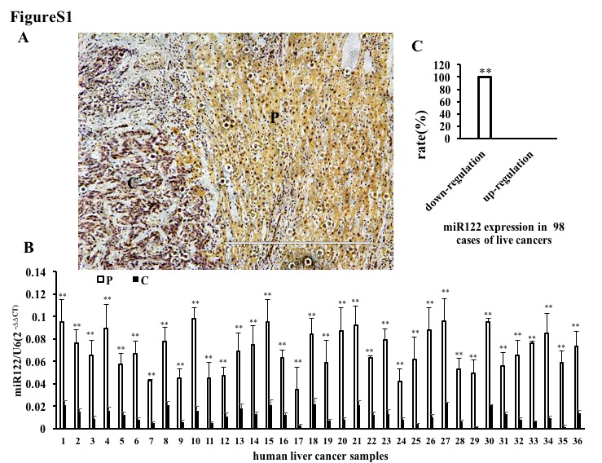
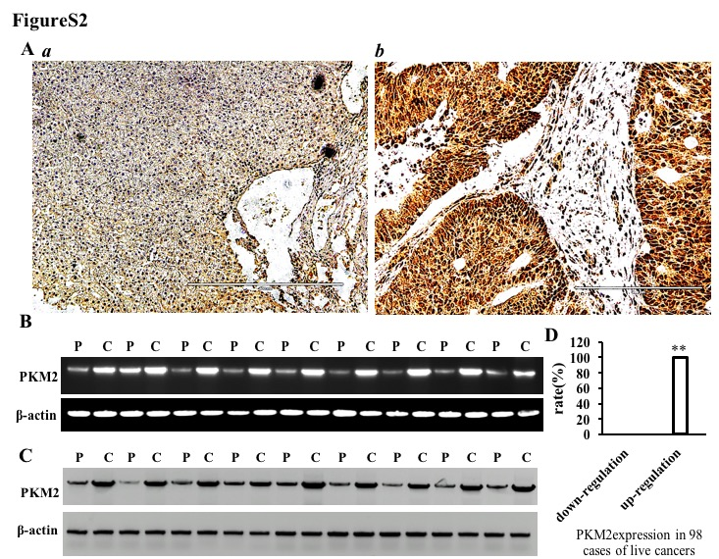
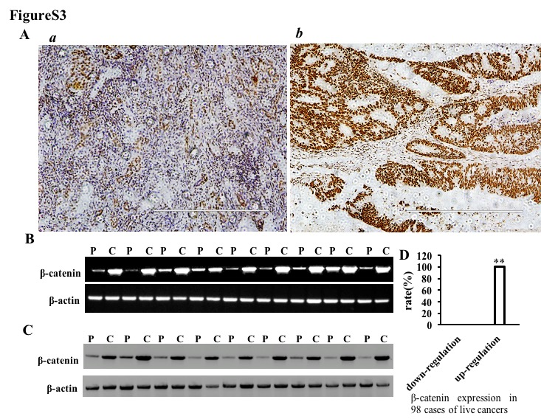
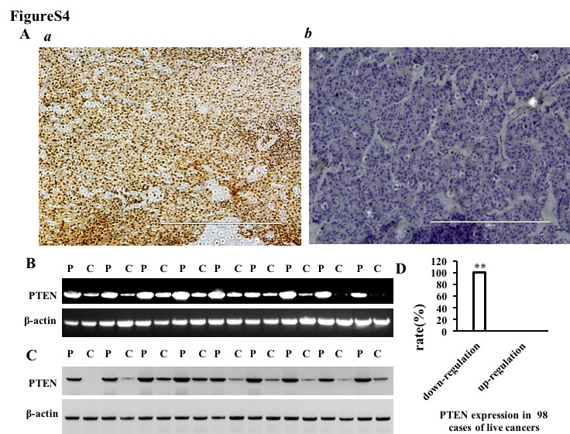
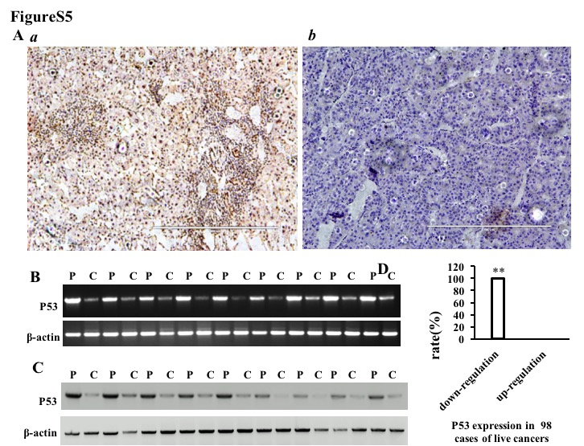
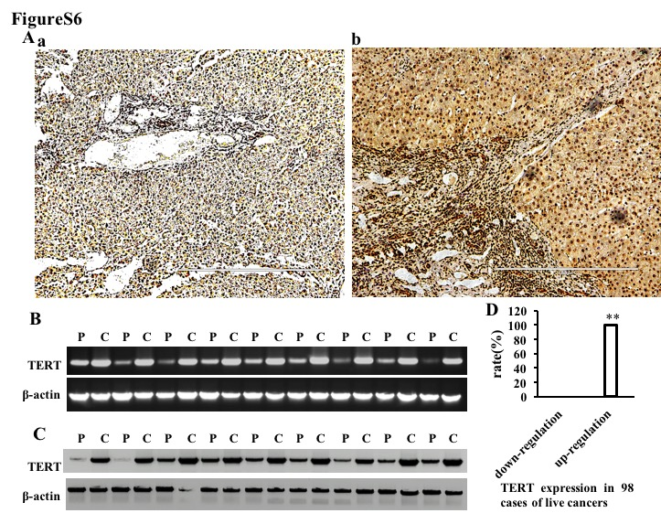
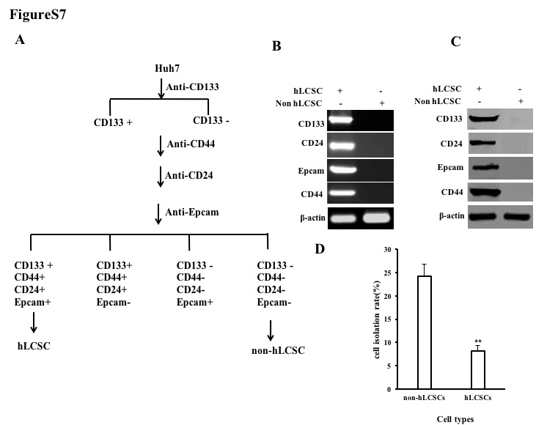

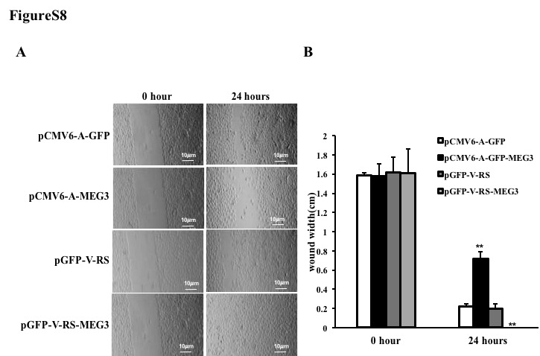
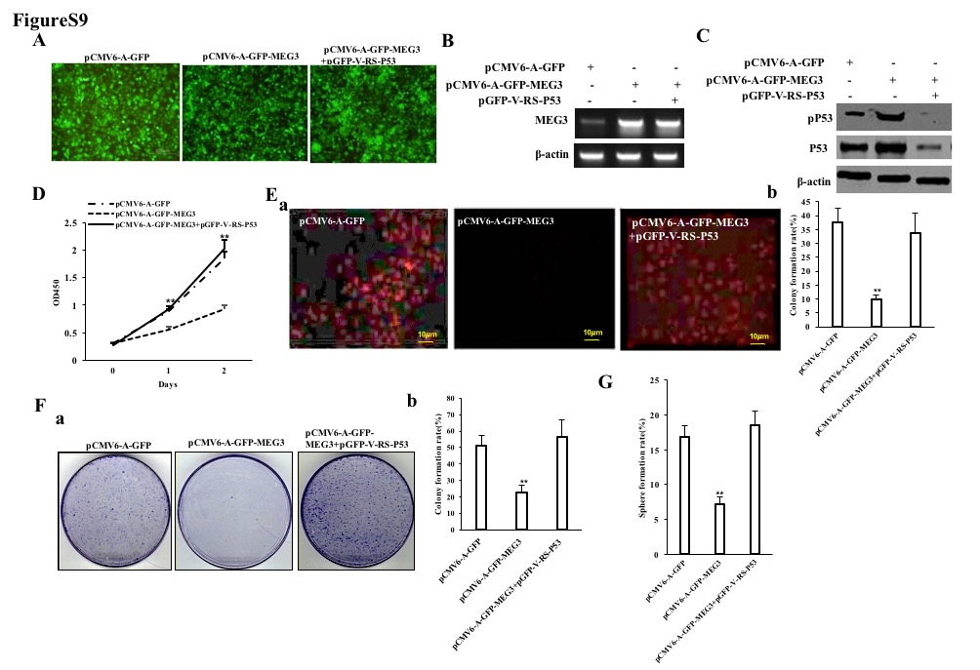
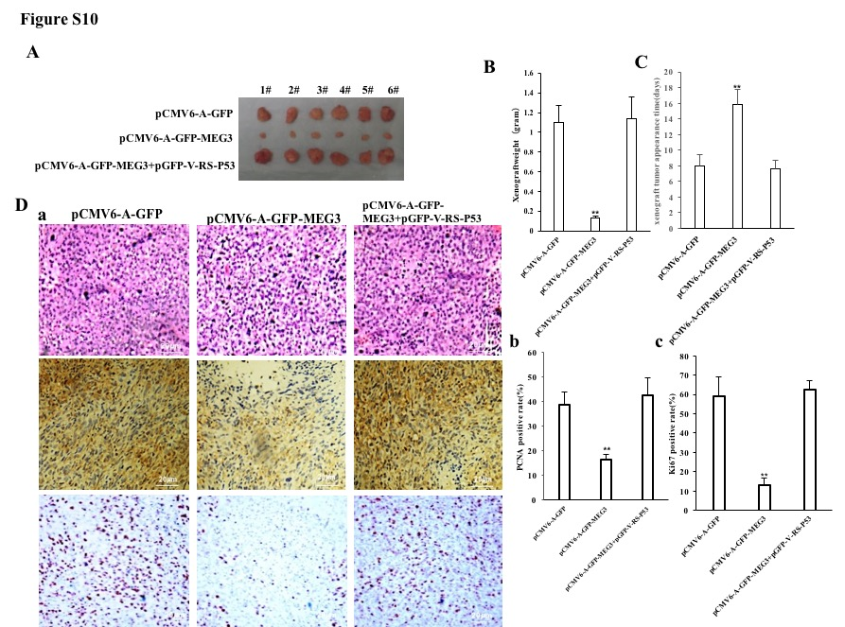

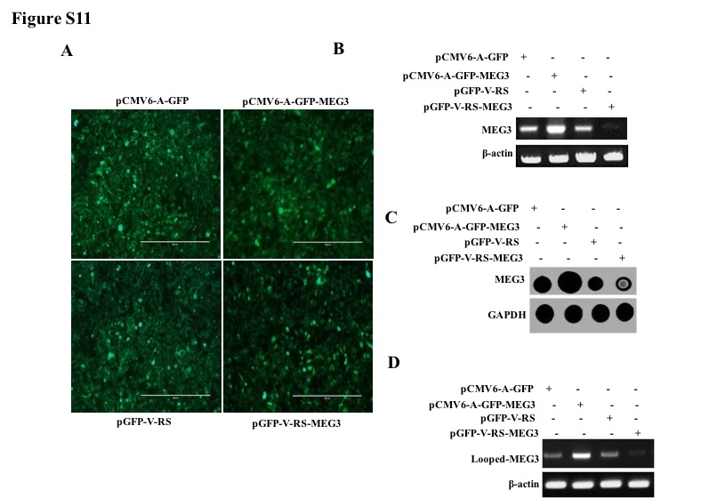

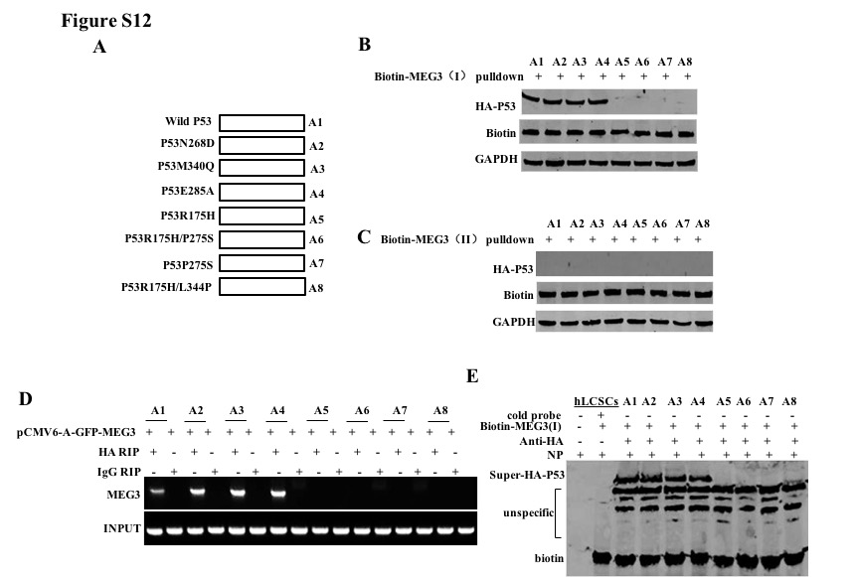

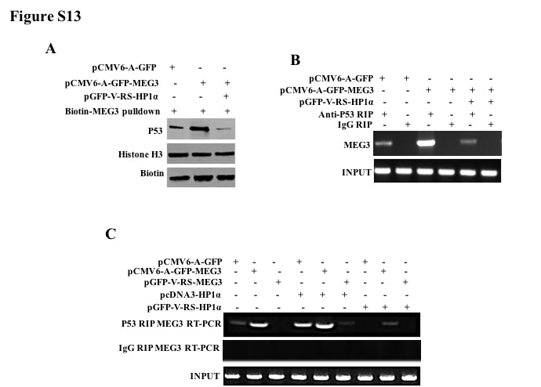

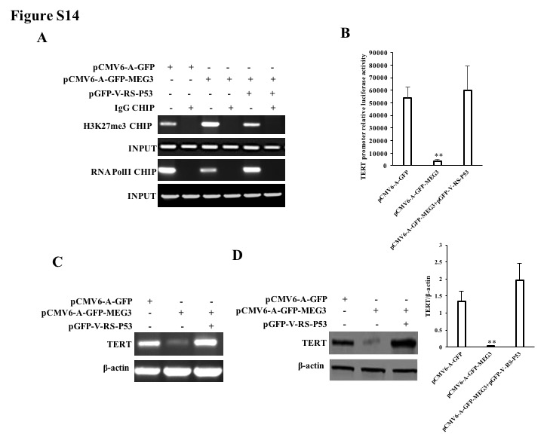
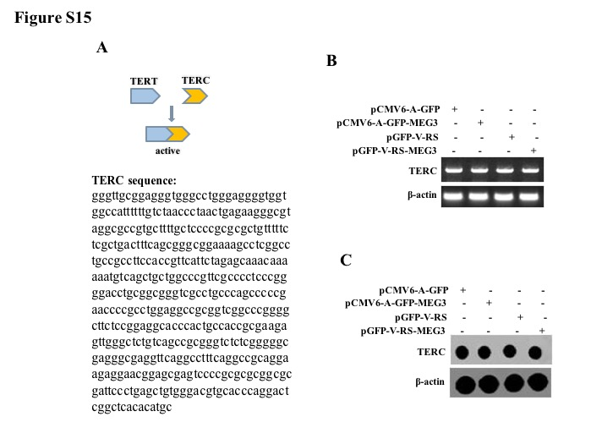
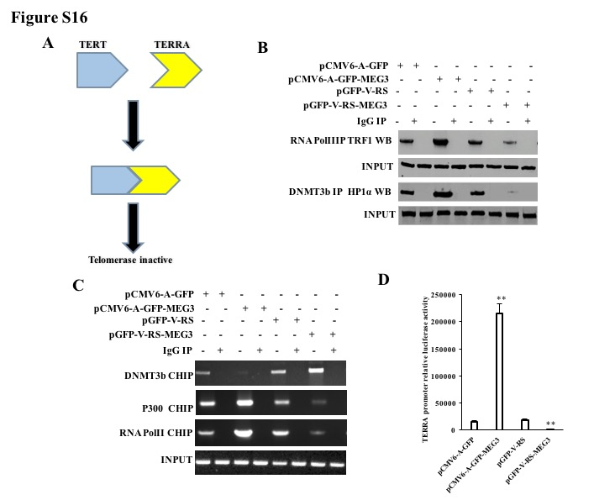
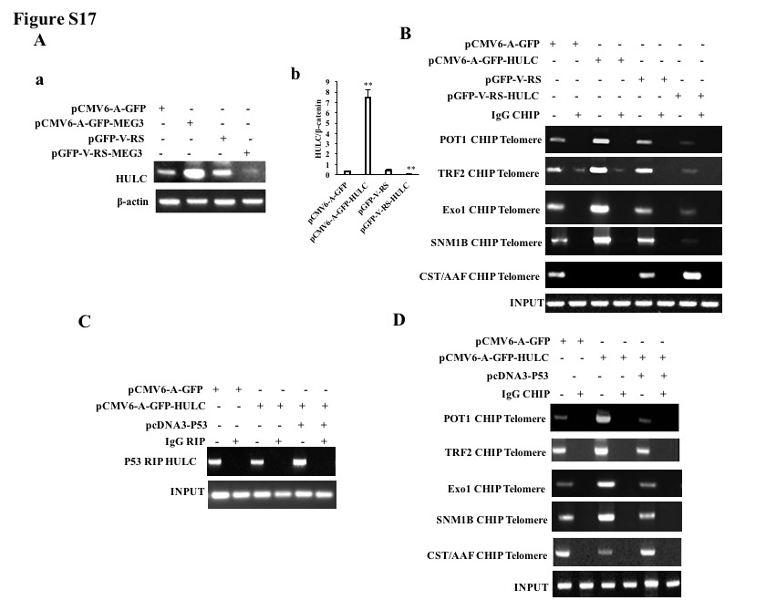
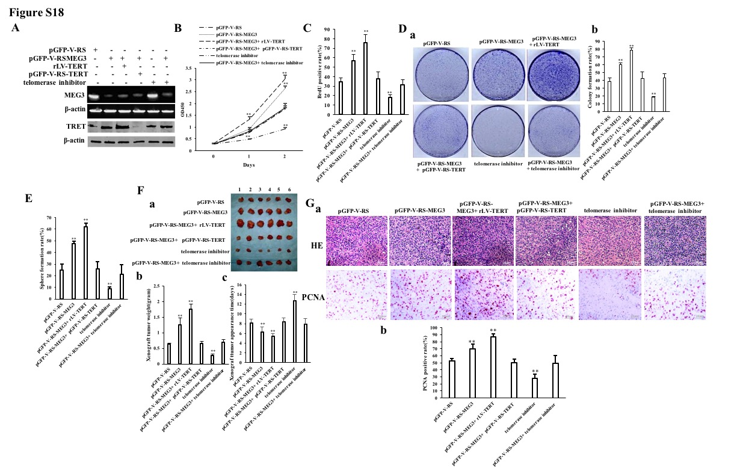
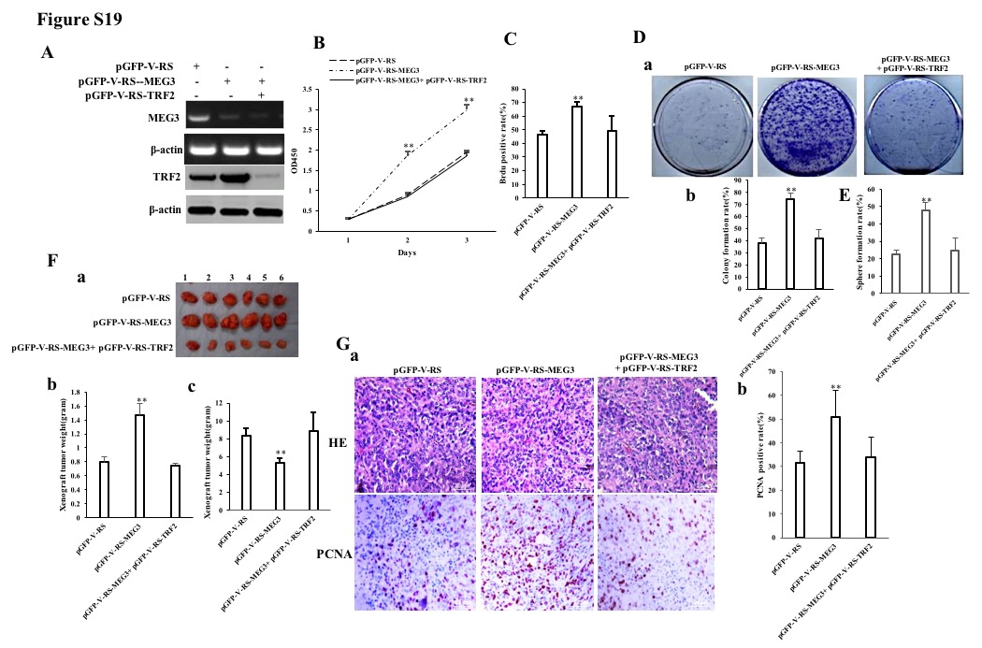

Supplemental Figure legends

FigureS1-S6: The analysis of the expression of miR122(FigureS1), PKM2 (FigureS2), β-catenin (FigureS3) , PTEN (FigureS4), P53 (FigureS5), TERT (FigureS6) in the 98 cases of liver cancer patients.
Figure S7 The isolation of human liver cancer stem cell isolation .A. Screening of human hepatoma stem cells from Huh7 cells by CD133/CD44/CD24/EpCAM beads B. Analysis of transcriptional abilities of CD133, CD44, CD24 and Epcam by RT-PCR in human hepatoma stem cells and non-hepatoma stem cells, respectively , β-actin as an internal reference gene. C. Western blotting analysis using anti-CD133, anti-CD44, anti-CD24, anti-EpCAM, and β-actin as internal reference genes in human hepatoma stem cells and non-hepatoma stem cells, respectively. D. Comparison of human liver cancer stem cells isolated from human liver cancer cell Huh7 with non-hepatoma stem cells. Each group of values ​​is expressed as mean ± standard deviation (mean ± SEM, n = 3), **, P < 0.01, *, P < 0.05.
Figure S8 Wound test : MEG3 affects the average width of human liver cancer stem cell scratches. Each group of values ​​is expressed as mean ± standard deviation (mean ± SEM, n = 3), **, P < 0.01, *, P < 0.05.
Figure S9 Tumorigenicity in vitro of human liver cancer stem cells. A. Green fluorescent photograph form four hLCSCs stable cell lines transfected pCMV6-A-GFP-MEG3 , pCMV6-A-GFP and pCMV6-A-GFP-MEG3 plus pGFP-V-RS-P53 plasmids ,respectively.B. The expression of MEG3 in these four stable cell lines was detected by reverse transcription polymerase chain reaction (RT-PCR), and β-actin was used as an internal reference gene.C. Western blotting was used to detect the expression of P53 in these three stable cell lines, and β-actin was used as an internal reference gene.D. The cell proliferation ability of these stably transfected cell lines was determined by the CCK8 method. Three replicate wells were set for each sample, and the OD450 value was measured by a microplate reader for 3 days. Each group of values ​​was expressed as mean ± standard deviation (mean ± SEM, n = 3), **, P < 0.01 indicates statistically significant difference, *, P < 0.05 indicates statistically significant difference, and statistically significant .E. The percentage of cellular S phase of these stably transfected cell lines was determined by the BrdU method. Three replicate wells were set for each sample, and each group of values ​​was expressed as mean ± standard deviation (bar ± SEM, n = 3), **, P < 0.01 indicates that the statistical difference was extremely significant, *, P < 0.05 indicates statistical The difference is significant and statistically significant.F. Determination of cell colony forming ability a. Photograph of colonies (groups are shown on the left side of the image); b. Determination of cell colony formation rate. Each group of values ​​is expressed as mean ± standard deviation (bar ± SEM, n = 3 ), **, P < 0.01 indicates that the statistical difference is extremely significant, *, P < 0.05 indicates statistically significant difference, and is statistically significant. G. Determination of cell sphere formation ability. Each group of values ​​was expressed as mean ± standard deviation (bar ± SEM, n = 3), **, P < 0.01 indicates that the statistical difference was extremely significant, *, P < 0.05 indicates statistically significant difference, and was statistically significant.

Figure S10 Tumorigenicity test In vivo of human liver cancer stem cells. A. hLCSCs cells stably transfected with pCMV6-A-GFP ,pCMV6-A-GFP-MEG3 and and pCMV6-A-GFP-MEG3 plus pGFP-V-RS-P53 were inoculated into Balb/C. A photograph of a transplanted tumor (xenograft) .B. Comparison of the size (g) of transplanted tumors in nude mice. Each group of values ​​was expressed as mean ± standard deviation (mean ± SEM, n = 6), **, P < 0.01 indicates that the statistical difference was extremely significant, *, P < 0.05 indicates statistically significant difference, and was statistically significant. C. Comparison of appearance time (days) of transplanted tumors in nude mice. Each group of values ​​was expressed as mean ± standard deviation (mean ± SEM, n = 6), **, P < 0.01 indicates that the statistical difference was extremely significant, *, P < 0.05 indicates statistically significant difference, and was statistically significant. D. 4% formaldehyde-fixed, paraffin-embedded nude mouse transplanted tumor tissue sections (4 μm) were subjected to hematoxylin-eosin (HE), anti-PCNA immunohistochemical staining and anti-Ki67 Immunohistochemical staining (original magnification × 100).E.a. Comparison of PCNA positive rates in transplanted tumors in nude mice. Each group of values ​​was expressed as mean ± standard deviation (mean ± SEM, n = 6), **, P < 0.01 indicates that the statistical difference was extremely significant, *, P < 0.05 indicates statistically significant difference, and was statistically significant. b. Comparison of Ki67 positive rates in transplanted tumors in nude mice. Each group of values ​​was expressed as mean ± standard deviation (mean ± SEM, n = 6), **, P < 0.01 indicates that the statistical difference was extremely significant, *, P < 0.05 indicates statistically significant difference, and was statistically significant.

Figure S11 Construction and identification of MEG3 overexpressing or knocking down liver cancer stem cell lines. A. Four stable cell lines were picked up under fluorescence microscopy (including pCMV6-A-GFP-hLCSCs, pCMV6-A-GFP-MEG3-hLCSCs, pGFP-V-RS-hLCSCs, and pGFP-V-RS-MEG3). Positive hLCSCs cells expressing green fluorescent protein were expanded and cultured, and images were taken using a fluorescence microscope. B. The expression of MEG3 was detected by RT-PCR in four stable cell lines, and β-actin was used as an internal reference gene. C. Dot blotting was used to detect the expression of MEG3 in four stable cell lines, and β-actin was used as an internal reference gene. D. The expression of circular MEG3 was detected by back-to-back RT-PCR in four stable cell lines, and β-actin was used as an internal reference gene.

Figure S12 Interaction analysis between MEG3 and P53-HA fusion proteins .A.Construction of recombinant plasmids, including A1:pcDNA3.1-HA-P53, A2:pcDNA3.1-HA-P53 (N268D), A3:pcDNA3.1-HA-P53 (E285A), A4:pcDNA3.1-HÁ -P53 (N340Q), A5: pcDNA3.1-HA-P53 (R175H), A6: pcDNA3.1-HA-P53 (P275S), A7: pcDNA3.1-HA-P53 (R175H/P275S), A8: pcDNA3 .1-HA-P53 (R175H/L344P). B. RNA pulldown analysis was performed using biotin-labeled probes Biotin-MEG3(I) and anti-HA of MEG3. Hisone H3 As INPUT, Biotin is used as an internal reference.C. RNA pulldown analysis using biotin-labeled probe Biotin-MEG3 (II) and anti-HA of MEG3. Hisone H3 As INPUT, Biotin is used as an internal reference. D. RNA immunoprecipitation (RIP) using anti-HA. MEG3 primer was used for RT-PCR amplification of MEG3. IgG RIP was used as a negative control.E. Super-RNA-Protein complex gel migration assay (Super-EMSA) using Biotin-MEG3 and anti-HA . IgG super-EMSA as a negative control, nucleoprotein-free EMSA and EMSA with excess cold probe as a system reference, Biotin band as INPUT.

Figure S13 Interaction analysis between MEG3 and P53 in hLCSCs.A. RNA pulldown analysis was performed using MEG3 biotinylated probes Biotin-MEG3 (I) and anti-HA. Hisone H3 is used as INPUT and Biotin is used as an internal reference. B. RNA immunoprecipitation (RIP) was performed. IgG RNA co-immunoprecipitation was used as a negative control, and MEG3 was separately amplified as an internal reference (INPUT) using RNA retained before RIP as INPUT.
C. RNA immunoprecipitation (RIP).IgG RNA co-immunoprecipitation was used as a negative control, and MEG3 was separately amplified as an internal reference (INPUT) using RNA retained before RIP as a template.

Figure S14 MEG3 inhibits the expression of TERT in human liver cancer stem cells dependent on P53-H3K27me3.A. Chromatin Immunoprecipitation (CHIP) with anti-RNApolII and anti-H3K27me3. IgG chromatin immunoprecipitation was used as a negative control; the promoter of TERT (using the same primer as above) was amplified as a reference (INPUT) using the DNA retained before chromatin immunoprecipitation as a template.B. The assay of pEZX-MT-TERT promoter-Luc dual luciferase activity .Each experiment was repeated three times. Each group of values ​​is expressed as mean ± standard deviation (mean ± SEM, n = 3), **, P < 0.01, *, P < 0.05.C.Reverse transcription Polymerase chain reaction (RT-PCR) was used to detect the transcriptional capacity of TERT . β-actin was used as an internal reference gene.D.a Total cellular proteins were extracted, and the translation ability of TERT was detected by Western blotting.β-actin was used as an internal reference gene. b. Semi-quantitative analysis of grayscale scanning of positive bands. Each experiment was repeated three times. Each group of values ​​is expressed as mean ± standard deviation (mean ± SEM, n = 3), **, P < 0.01, *, P < 0.05.

Figure S15 Analysis of the effect of MEG3 on the transcriptional capacity of TERC in human liver cancer stem cells.A. Schematic diagram of the interaction of telomerase reverse transcriptase (TERT) with telomerase RNA (TERC).B. The transcriptional capacity of TERC was detected Reverse transcription polymerase chain reaction (RT-PCR) to detect in these four stable cell lines, β-actin as an internal reference gene. C. The transcriptional ability of TERC was detected by Dot-blot in these four stable cell lines t, and GAPDH was used as an internal reference gene.

Figure S16 MEG3 affects transcriptional activity long non-coding RNA TERRA .A. Schematic diagram of inhibition of telomerase activity by TERRA.B. The Co-Immunoprecipitation with anti-DMNT3b or anti-RNA PolII, anti-HP1α or anti-TRF1. IgG co-immunoprecipitation was used as a negative control, and anti-HP1α or anti-TRF1 in the sample before co-precipitation was detected by Western blotting as INPUT.C. After cross-linking formaldehyde, the chromatin immunoprecipitation (CHIP) with anti-DNMT 3b, anti-RNA polII, anti-P300. The isolated and purified DNA is used as a template, and a polymerase chain reaction (PCR) amplification is carried out using primers designed to bind to the promoter region of TERRA. IgG chromatin immunoprecipitation was used as a negative control; the TERRA promoter (using the same primers as above) was used as an internal reference (INPUT) by using the DNA retained before chromatin immunoprecipitation as a template.D. The pEZX-MT-TERRA promoter-Luc dual luciferase activity was measured. The measured results were plotted with the internal parameters of the Promega system. Each experiment was repeated three times. Each group of values ​​is expressed as mean ± standard deviation (mean ± SEM, n = 3), **, P < 0.01, *, P < 0.05.

Figure S17 Long non-coding RNA HULC mediates the binding of POT1, ExoI, TRF2, SNM1B, CST/AAF to telomeric DNA in human liver cancer stem cells. A. a. The expression of HULC in these four stable cell lines was detected by reverse transcription polymerase chain reaction (RT-PCR), and β-actin was used as internal Reference gene.b. Quantitative reverse transcription polymerase chain reaction (RT-PCR) was used to detect the expression of HULC in these four stable cell lines, and β-actin was used as an internal reference gene.B. Chromatin immunoprecipitation (CHIP) using anti-POT1, anti-ExoI, anti-TRF2, anti-SNM1B and anti-CST/AAF. Polymerase chain reaction (PCR) amplification was carried out using a primer designed according to the telomeric DNA. IgG chromatin immunoprecipitation was used as a negative control; telomeres (using the same primers as above) were used as an internal reference (INPUT) by using the DNA retained before chromatin immunoprecipitation as a template. C. T RNA immunoprecipitation (RIP) with anti-P53. The RNA isolated from the RIP was used as a template, and the HULC primer was used for reverse transcription polymerase chain reaction (RT-PCR) to amplify HULC. IgG RNA immunoprecipitation was used as a negative control; retained by RNA co-precipitation The RNA was subjected to a reverse transcription polymerase chain reaction as an internal reference (INPUT).D. Chromatin immunoprecipitation (CHIP) with anti-POT1, anti-ExoI, anti-TRF2, anti-SNM1B and anti-CST/AAF . Polymerase chain reaction (PCR) amplification was performed using primers designed to bind to the above-mentioned proteins, IgG chromatin immunoprecipitation was used as a negative control; telomere was amplified by using DNA retained before chromatin immunoprecipitation as a templateas an internal reference (INPUT).

Figure S18 Rescued-test based on telomerase reverse transcriptase gene and telomerase inhibitor.A. In pGFP-V-RS-hLCSCs, pGFP-V-RS-MEG3-hLCSCs, pGFP-V-RS-MEG3+rLV-TERT-hLCSCs, pGFP-V-RS-MEG3 +pGFP -V-RS-TERT-hLCSCs, telomerase inhibitor-hLCSCs, pGFP-V-RS -MEG3+ telomerase inhibitor-hLCSCs, MEG3 was detected reverse polymerase chain reaction (RT-PCR), β-actin as an internal reference gene. Total protein was extracted and the expression of TERT s was detected by Western blotting, and β-actin was used as an internal reference gene.B. Cell proliferation capacity assay by CCK8 assay . C. Determination of cell S phase by BrdU method percentage.D. a. Photograph of plate colonies (groups are shown on the left side of the image); b. Determination of cell plate colony formation rate. Each group of values ​​is expressed as mean ± standard deviation (bar ± SEM, n = 3), **, P < 0.01 indicates that the statistical difference is extremely significant, *, P < 0.05 The statistical difference was significant and statistically significant.E. The formation of spheres was measured. Each group of values ​​was expressed as mean ± standard deviation (bar ± SEM, n = 3), **, P < 0.01 indicates that the statistical difference was extremely significant, *, P < 0.05 indicates statistically significant difference, and was statistically significant.F. a. Photographs of transplanted tumors (xenograft) .b. Comparison of the size (g) of transplanted tumors in nude mice.c. Comparison of time (days) of transplanted tumors in nude mice. G.a. 4% formaldehyde-fixed, paraffin-embedded nude mouse transplanted tumor tissue sections (4 μm) were subjected to HE staining and anti-PCNA immunohistochemical staining, respectively. b. Comparison of PCNA positive rates of transplanted tumors in nude mice.

Figure S19 rescued- test based on telomere-stabilized protein TRF2 gene.A. MEG3 was detected by reverse transcription polymerase chain reaction (RT-PCR), and β-actin was used as an internal reference gene. Total cellular proteins were extracted, and the expression of TRF2 was detected by Western blotting, and β-actin was used as an internal reference gene.B. The cell proliferation ability was determined by CCK8 method. C. The percentage of cell S phase was determined by BrdU method. D. a. Photograph of plate colonies; b. Determination of cell plate colony formation rate Analysis. E. The assay for the formation of spheres. Each group of values ​​was expressed as mean ± standard deviation (bar ± SEM, n = 3), **, P < 0.01 indicates that the statistical difference was extremely significant, *, P < 0.05 indicates statistically significant difference, and was statistically significant.F. In vivo tumor formation test of liver cancer stem cells.a. A photograph of a transplanted tumor (xenograft) .b. The size (g) of the transplanted tumor was compared.c. The comparison of the formation time (days)of transplanted tumors. Each group of values ​​was expressed as mean ± standard deviation (mean ± SEM, n = 6), **, P < 0.01 indicates that the statistical difference was extremely significant, *, P < 0.05 indicates statistically significant difference, and was statistically significant.G.a. HE staining and anti-PCNA immunohistochemical staining were performed on 4% formaldehyde-fixed, paraffin-embedded nude mice transplanted tumor tissue sections (4 μm). b. Comparison of PCNA positive rates of transplanted tumors in nude mice.

