Supplementary Information – Additional File 2

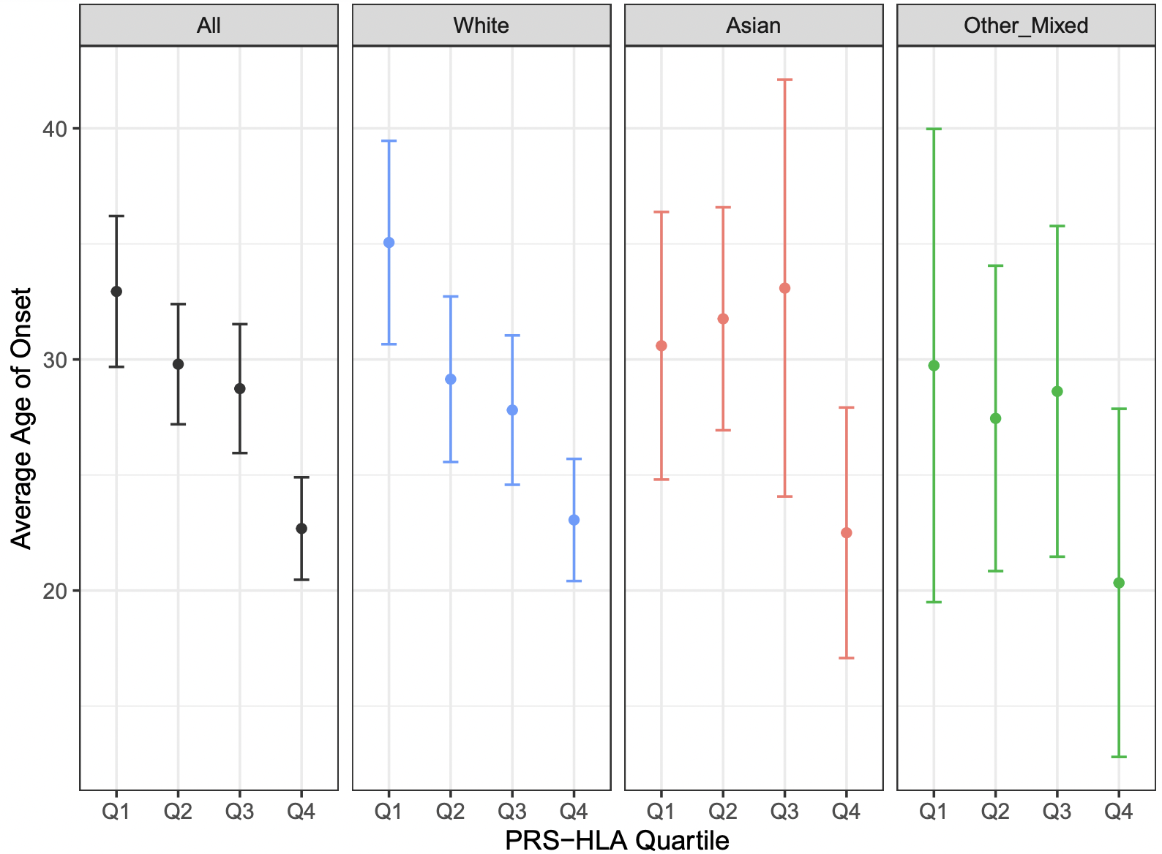

Figure S1. Age of psoriasis onset according to PRS-HLA quartiles. Each point represents the mean age of onset for each race: all races combined (black), White (blue), Asian (red), other/mixed (green). Error bars show upper and lower confidence intervals.

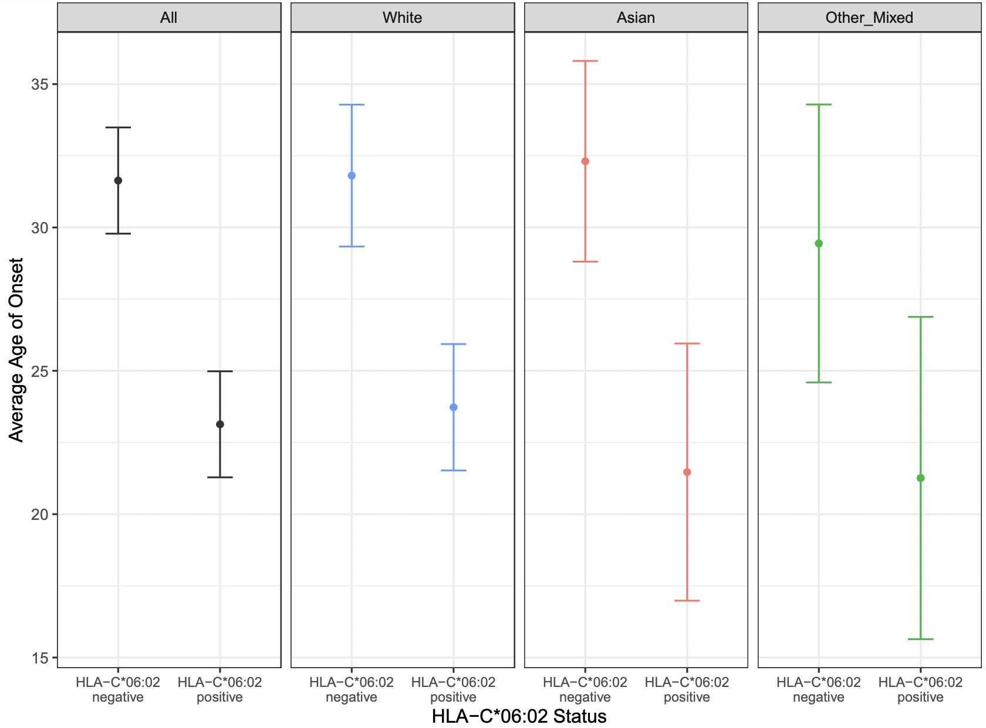

Figure S2. Age of psoriasis onset according to HLA-C*06:02 status. Each point represents the mean age of onset for each race: all races combined (black), White (blue), Asian (red), other/mixed (green). Error bars show upper and lower confidence intervals.

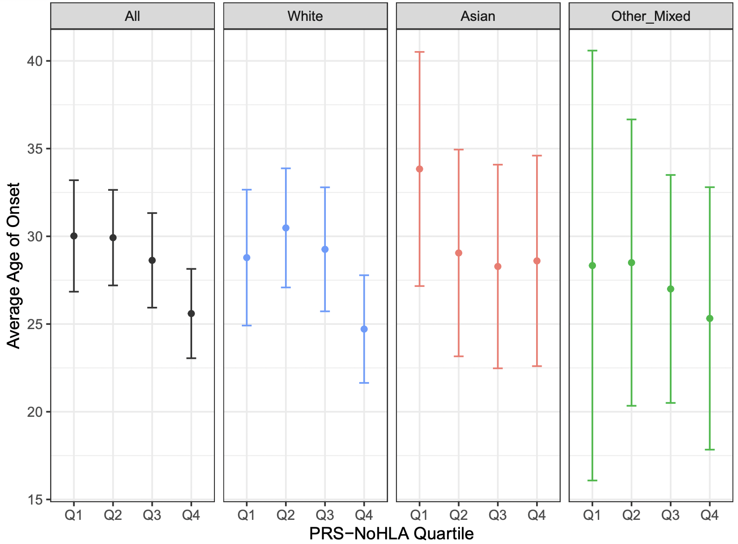

Figure S3. Age of psoriasis onset according to PRS-NoHLA quartiles. Each point represents the mean age of onset for each race: all races combined (black), White (blue), Asian (red), other/mixed (green). Error bars show upper and lower confidence intervals.

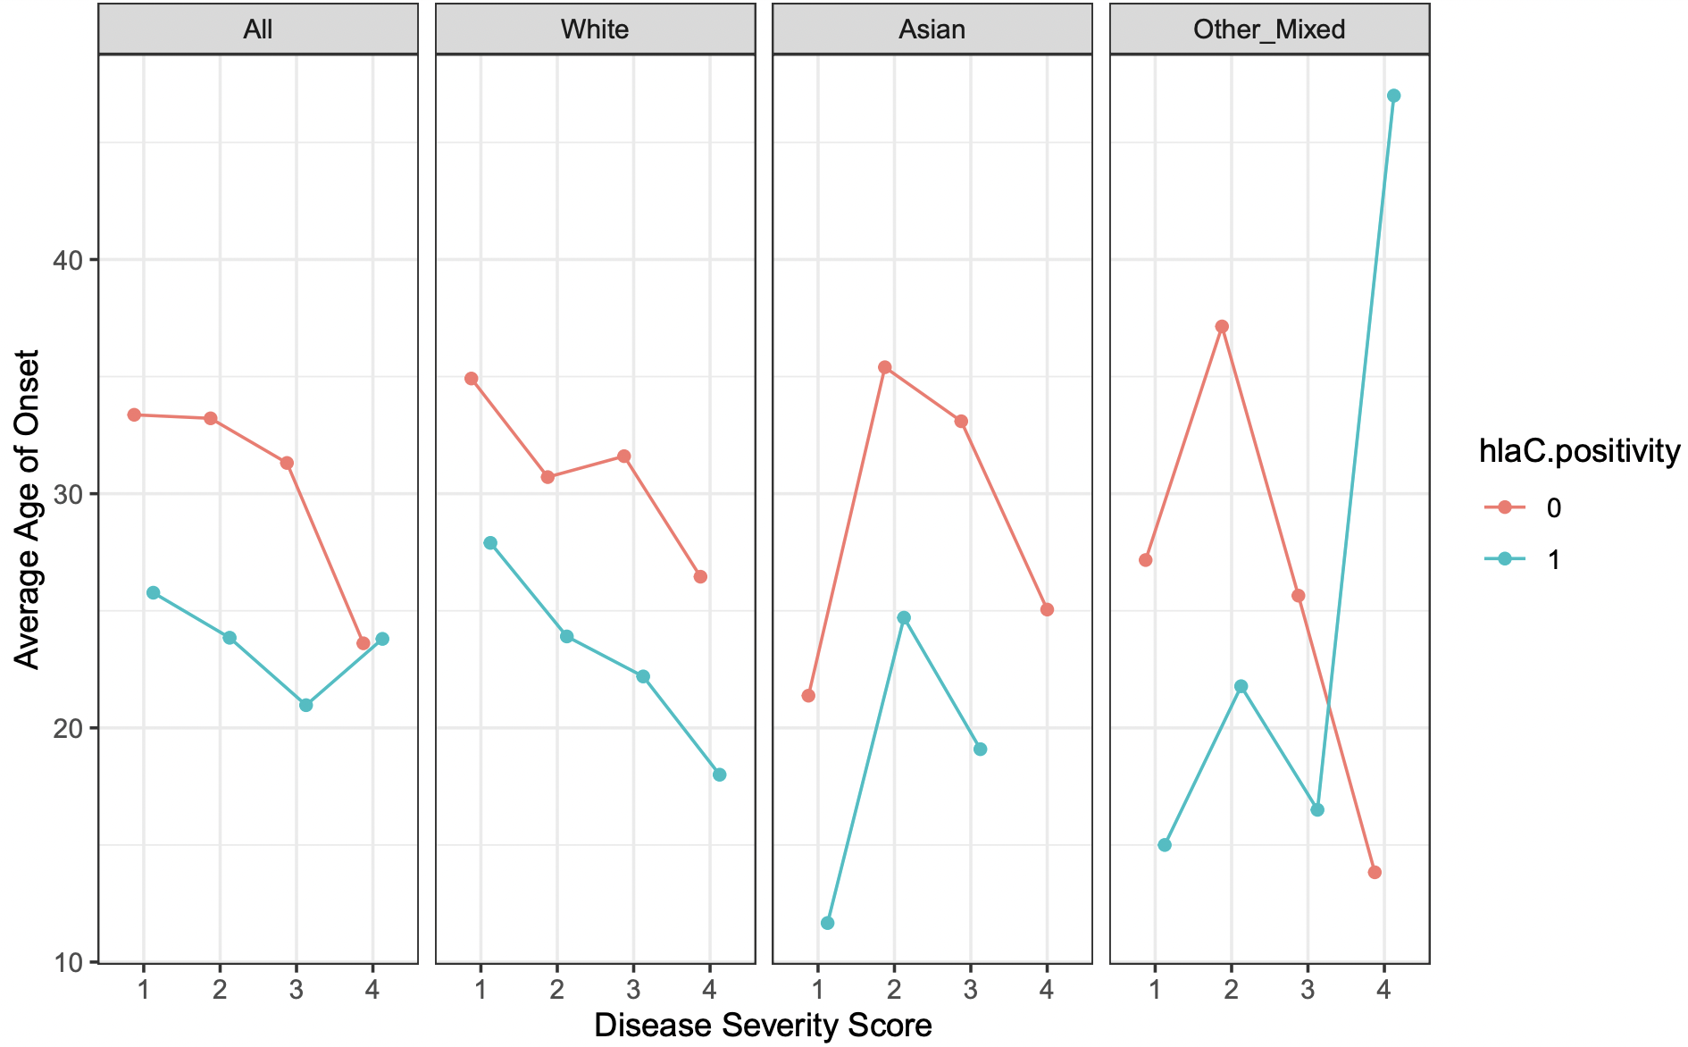

Figure S4. Average age of psoriasis onset according to disease severity. Each point represents the mean age of onset according to severity levels for each race. Severity levels were scored according to the following: 1 (mild), 2 (moderate), 3 (severe), 4 (very severe). Mean age of onset values were calculated for each HLA-C*06:02 status: HLA-C*06:02-negative (pink),
HLA-C*06:02- positive (blue).

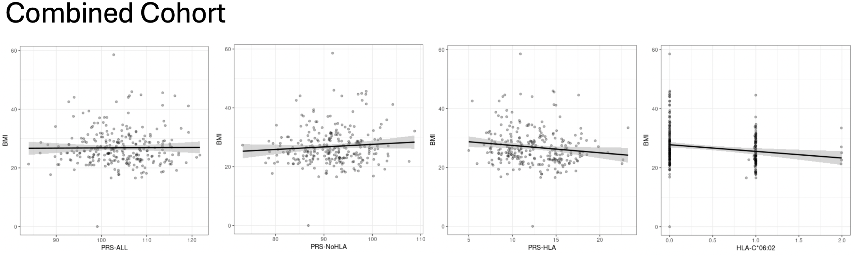
PRS-ALL | PRS-NoHLA | PRS-HLA | HLA-C*06:02
Adjusted R²: -0.003686 | Adjusted R²: 0.003343 | Adjusted R²: 0.01425 | Adjusted R²: 0.03237
p-value: 0.8895 | p-value: 0.1697 | p-value: 0.02836 | p-value: 0.00181

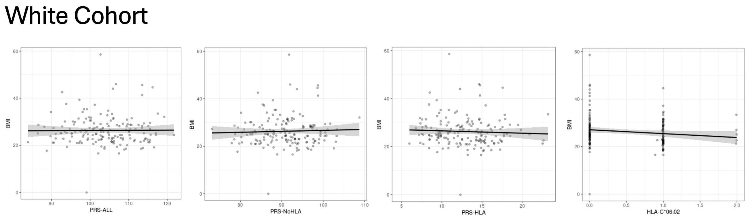
PRS-ALL | PRS-NoHLA | PRS-HLA | HLA-C*06:02
Adjusted R²: -0.005833 | Adjusted R²: -0.004283 | Adjusted R²: -0.003034 | Adjusted R²: 0.01458
p-value: 0.9057 | p-value: 0.6007 | p-value: 0.4868 | p-value: 0.06252

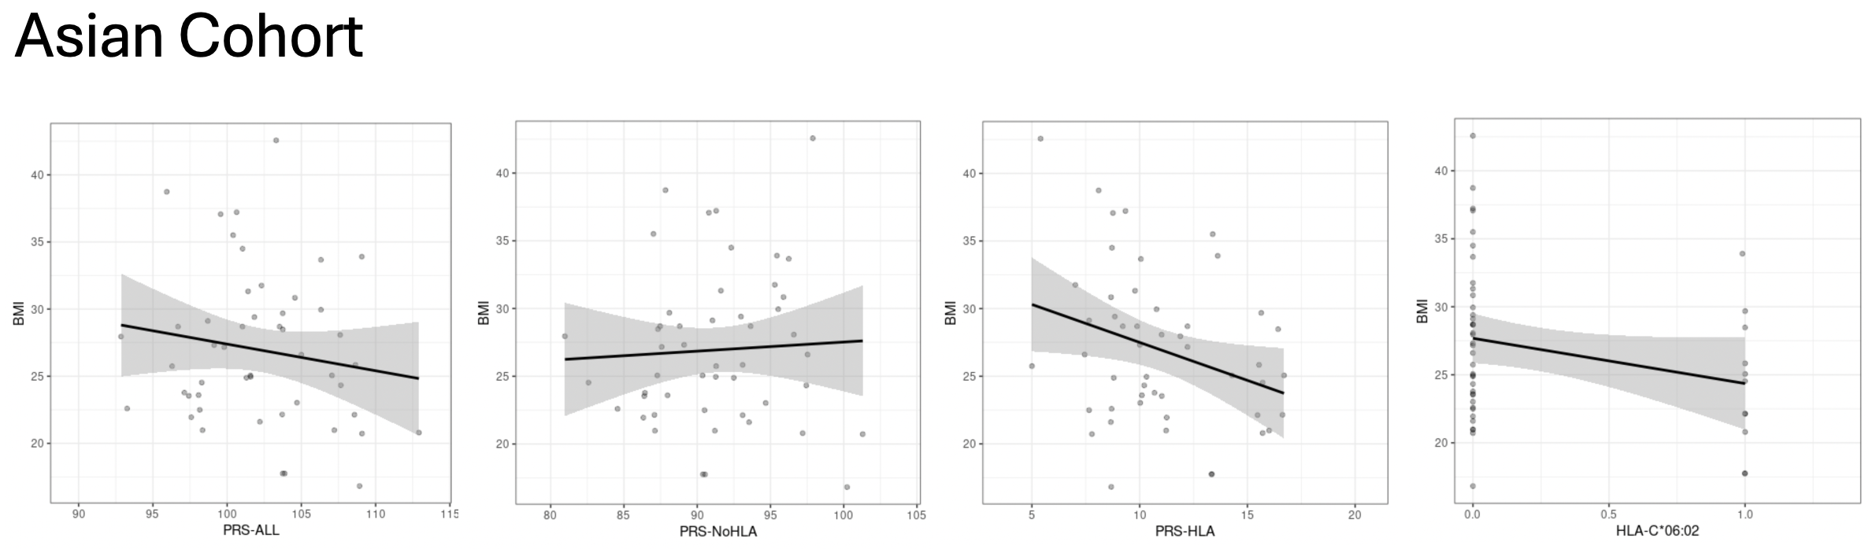
PRS-ALL | PRS-NoHLA | PRS-HLA | HLA-C*06:02
Adjusted R²: 0.003751 | Adjusted R²: -0.01843 | Adjusted R²: 0.07324 | Adjusted R²: 0.04072
p-value: 0.2828 | p-value: 0.7186 | p-value: 0.03357 | p-value: 0.0879

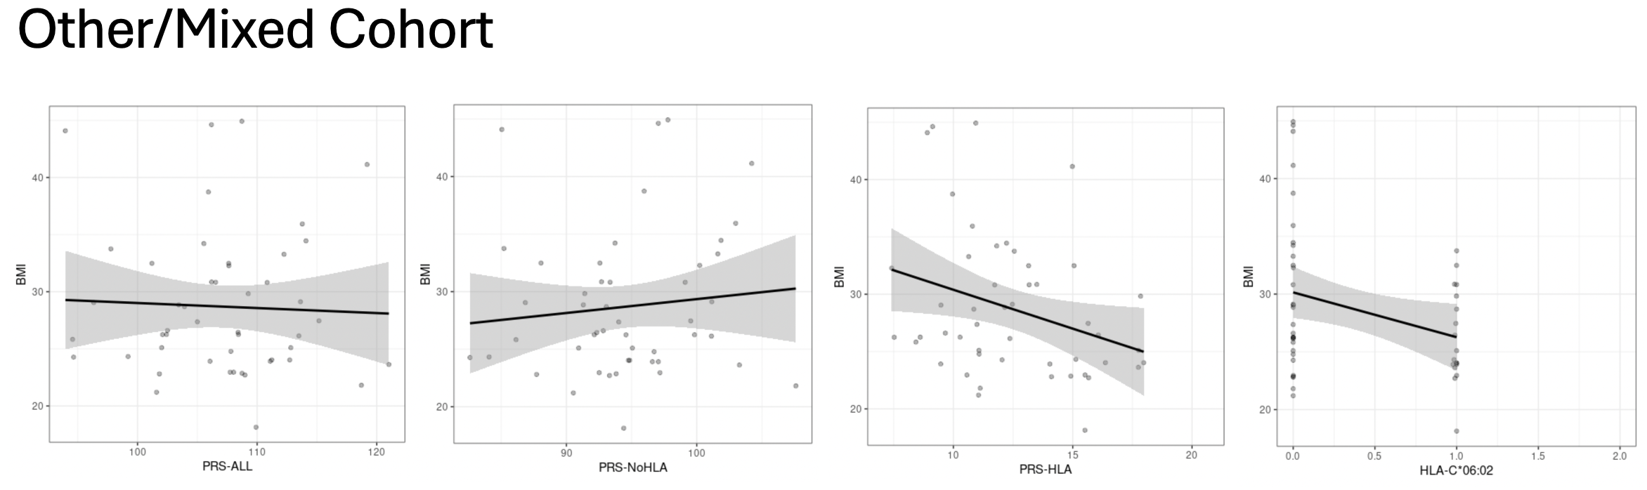
PRS-ALL | PRS-NoHLA | PRS-HLA | HLA-C*06:02
Adjusted R²: -0.01976 | Adjusted R²: -0.009877 | Adjusted R²: 0.07535 | Adjusted R²: 0.07062
p-value: 0.7666 | p-value: 0.466 | p-value: 0.03304 | p-value: 0.03786

Figure S5. Linear regression correlations between BMI and PRS. Linear regression for each cohort was run using BMI is the outcome variable and PRS as the predictor variable. Adjusted R² and p-value results shown under their respective plots. Significant p-values (<0.05) are bolded.

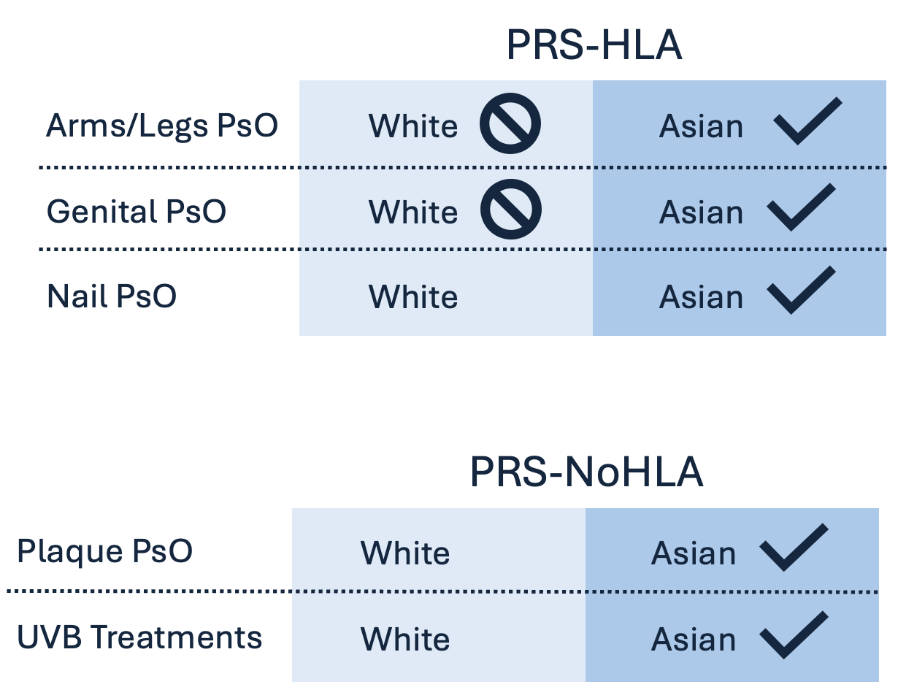

Figure S6. Racial differences between certain PRS associations. Clinical features are specified on the left, with resulting comparisons between the White and Asian cohorts in the right blue boxes. A cross sign indicates a significant protective effect for that cohort, while a check indicates a significant driving effect, and no sign indicates no statistically significant finding for that cohort.

