SUPPLEMENTARY MATERIAL

The role of Mediterranean diet in cancer incidence and survival in the older adults: a systematic review and meta-analysis.

Authors:
Giulia Giordano, Luca Mastrantoni, Roberta Terranova, Giuseppe Ferdinando Colloca, Giuseppe Zuccalà, Francesco Landi.

Summary.
Table S1. Full search strategy. 2
Table S2. Studies excluded by full text 3
Fig. S1. Pooled results from medium and high adherence. 9
Fig. S2. Sensitivity analysis excluding studies comparing MD to other dietary patterns 11
Fig. S3. Sensitivity analysis for OPI 12
Fig. S4. Sensitivity analysis for adherence 14
Fig. S5. Cancer type 15
Fig. S6. Risk Of Bias 19
Table S3. GRADE Assessment 22
Table S4. PRISMA checklist. 23

Table S1. Full search strategy.

Database | Research String | Records
PubMed | ("Diet, Mediterranean"[MeSH Terms] OR "mediterranean diet"[All Fields]) AND ("Neoplasms"[MeSH Terms] OR "cancer"[All Fields]) AND ("Aged"[MeSH Terms] OR "elderly"[All Fields] OR "geriatric"[All Fields] OR “older”[All Fields]) AND "humans"[MeSH Terms] | 424
Embase | ('Diet, Mediterranean'/exp OR 'mediterranean diet') AND (Neoplasms/exp OR cancer) AND (Aged/exp OR elderly OR geriatric) AND humans/exp | 617
CENTRAL | ("Mediterranean diet") AND ("cancer" OR "neoplasms") AND ("aged" OR "elderly" OR "geriatric" OR "older") AND ("humans") | 128
TOTAL |  | 1169

Legend. CENTRAL= Cochrane Central Register of Controlled Trials.

Table S2. Studies excluded by full text

Title | Author, year | Reason
Adherence to mediterranean diet, physical activity and survival after prostate cancer diagnosis | Di Maso, M. - 2021 | No subgroup analysis older adults
Mediterranean dietary pattern and cancer risk in the EPIC cohort | Couto, E. - 2011 | No subgroup analysis older adults
Consumption of animal products, olive oil and dietary fat and results from the Belgian case-control study on bladder cancer risk | Brinkman, M.T. - 2011 | No subgroup analysis older adults
Diet and cancer prevention: Contributions from the European Prospective Investigation into Cancer and Nutrition (EPIC) study | Gonzalez, C.A. - 2010 | No subgroup analysis older adults
Adherence to a Mediterranean diet and risk of gastric adenocarcinoma within the European Prospective Investigation into Cancer and Nutrition (EPIC) cohort study | Buckland, G. - 2010 | No subgroup analysis older adults
A combined healthy lifestyle score and risk of pancreatic cancer in a large cohort Study | Jiao, L. - 2009 | No subgroup analysis older adults
Dietary patterns and breast cancer risk in Asian American women | Wu, A.H. - 2009 | No subgroup analysis older adults
A protective effect of the Mediterranean diet for cutaneous melanoma | Fortes, C. - 2008 | No subgroup analysis older adults
Conformity to traditional Mediterranean diet and cancer incidence: The Greek EPIC cohort | Benetou, V. - 2008 | No subgroup analysis older adults
Mediterranean dietary pattern and prediction of all-cause mortality in a US population: Results from the NIH-AARP diet and health study | Mitrou, P.N. - 2007 | No subgroup analysis older adults
Dietary patterns, Mediterranean diet, and endometrial cancer risk | Dalvi, T.B. - 2007 | No subgroup analysis older adults
Diet quality and BRCA-associated breast cancer risk | Nkondjock, A. - 2007 | No subgroup analysis older adults
Dietary patterns and the risk of colorectal adenoma recurrence in a European intervention trial | Cottet, V. - 2005 | No subgroup analysis older adults
Adherence to the Mediterranean diet is associated with total antioxidant capacity in healthy adults: The ATTICA study | Pitsavos, C. - 2005 | No subgroup analysis older adults
Association between overall diet quality and postmenopausal breast cancer risk in five Finnish cohort studies | Männistö, S. - 2021 | No subgroup analysis older adults
Indices of Diet Quality and Risk of Lung Cancer in the Women's Health Initiative Observational Study | Myneni, A.A. - 2021 | No subgroup analysis older adults
Low adherence to the western and high adherence to the mediterranean dietary patterns could prevent colorectal cancer | Castelló, A. - 2019 | No subgroup analysis older adults
Dietary index scores and invasive breast cancer risk among women with a family history of breast cancer | Petimar, J. - 2019 | No subgroup analysis older adults
Adherence to Mediterranean diet and risk of prostate cancer | Urquiza-Salvat, N. - 2019 | No subgroup analysis older adults
Dairy product consumption and risk of colorectal cancer in an older mediterranean population at high cardiovascular risk | Barrubés, L. - 2018 | No subgroup analysis older adults
Diet-quality indexes are associated with a lower risk of cardiovascular, respiratory, and all-cause mortality among Chinese adults | Neelakantan, N. - 2018 | No subgroup analysis older adults
Mediterranean Dietary Pattern is Associated with Low Risk of Aggressive Prostate Cancer: MCC-Spain Study | Castelló, A. - 2018 | No subgroup analysis older adults
Biomarker-calibrated nutrient intake and healthy diet index associations with mortality risks among older and frail women from the Women's Health Initiative | Zaslavsky, O. - 2017 | No subgroup analysis older adults
Association between selected dietary scores and the risk of urothelial cell carcinoma: A prospective cohort study | Dugué, P.-A. - 2016 | No subgroup analysis older adults
Meat consumption and breast cancer: a case-control study in women | Mourouti, N. - 2015 | No subgroup analysis older adults
Factors associated with colorectal cancer in the context of the mediterranean diet: A case-control study | Grosso, G. - 2014 | No subgroup analysis older adults
Mediterranean diet and prostate cancer risk and mortality in the health professionals follow-up study | Kenfield, S.A. - 2014 | No subgroup analysis older adults
Index-based dietary patterns and risk of head and neck cancer in a large prospective study | Li, W.-Q., - 2014 | No subgroup analysis older adults
Mediterranean diet and hepatocellular carcinoma | Turati, F. - 2014 | No subgroup analysis older adults
Red meat, mediterranean diet and lung cancer risk among heavy smokers in the cosmos screening study | Gnagnarella, P. - 2013 | No subgroup analysis older adults
Mediterranean diet and colorectal cancer risk: Results from a European cohort | Bamia, C. - 2013 | No subgroup analysis older adults
The mediating effect of Mediterranean diet on the relation between smoking and colorectal cancer: a case-control study. | Kontou, N. - 2013 | No subgroup analysis older adults
Adherence to mediterranean-style dietary pattern and risk of esophageal squamous cell carcinoma: A case-control study in Iran | Jessri, M. - 2012 | No subgroup analysis older adults
Impact of mediterranean diet on chronic non-communicable diseases and longevity | Dominguez, L.J. - 2021 | No subgroup analysis older adults
Adherence to the MIND Diet and Risk of Breast Cancer: A Case-control Study | Aghamohammadi, V. - 2021 | No subgroup analysis older adults
Diet quality and risk of lung cancer in the multiethnic cohort study | Park, S.-Y. - 2021 | No subgroup analysis older adults
Diet Quality and Breast Cancer Recurrence and Survival: The Pathways Study | Ergas, I.J. – 2021 | No subgroup analysis older adults
Adherence to prudent and mediterranean dietary patterns is inversely associated with lung cancer in moderate but not heavy male Polish smokers: A case‐control study | Hawrysz, I. - 2020 | No subgroup analysis older adults
Association of Diet Quality with Survival among People with Metastatic Colorectal Cancer in the Cancer and Leukemia B and Southwest Oncology Group 80405 Trial | Van Blarigan, E.L. - 2020 | No subgroup analysis older adults
Dietary patterns based on the Mediterranean diet and DASH diet are inversely associated with high aggressive prostate cancer in PCaP | Schneider, L. - 2019 | No subgroup analysis older adults
Impact of nutritional status on gastroenteropancreatic neuroendocrine tumors (GEP-NET) aggressiveness | Barrea, L. - 2018 | No subgroup analysis older adults
Associations of mediterranean diet and a posteriori derived dietary patterns with breast and lung cancer risk: A case-control study | Krusinska, B. - 2018 | No subgroup analysis older adults
Diet and endometrial cancer: A focus on the role of fruit and vegetable intake, Mediterranean diet and dietary inflammatory index in the endometrial cancer risk | Ricceri, F. - 2017 | No subgroup analysis older adults
The association of dietary quality with colorectal cancer among normal weight, overweight and obese men and women: A prospective longitudinal study in the USA | Torres Stone - 2017 | No subgroup analysis older adults
A prospective cohort study of dietary indices and incidence of epithelial ovarian cancer | Xie, J. - 2014 | No subgroup analysis older adults
The role of number of meals, coffee intake, salt and type of cookware on colorectal cancer development in the context of the Mediterranean diet. | Kontou, N. - 2013 | No subgroup analysis older adults
Influence of the Mediterranean Diet on the Risk of Cancers of the Upper Aerodigestive Tract | Bosetti, C. - 2003 | No subgroup analysis older adults
Adherence to a Mediterranean diet and survival in a Greek population | Trichopoulou, A. - 2003 | No subgroup analysis older adults
Population-attributable risk of modifiable lifestyle factors to hepatocellular carcinoma: The multi-ethnic cohort | Zhou, K. - 2023 | No subgroup analysis older adults
Adherence to Mediterranean Diet and Nutritional Status in Women with Breast Cancer: What Is Their Impact on Disease Progression and Recurrence-Free Patients’ Survival? | Mantzorou, M. - 2022 | No subgroup analysis older adults
Quality diet index and risk of pancreatic cancer: Findings from the Singapore Chinese health study | Luu, H.N. - 2021 | No subgroup analysis older adults
Quality diet indexes and risk of hepatocellular carcinoma: Findings from the Singapore Chinese Health Study | Luu, H.N. - 2021 | No subgroup analysis older adults
Adherence to the Mediterranean Diet and Overall Cancer Incidence: The Netherlands Cohort Study | Schulpen, M. - 2021 | No subgroup analysis older adults
Adherence to the Mediterranean dietary pattern in relation to glioma: A case–control study | Mousavi, S.M. - 2021 | No subgroup analysis older adults
The association between diet quality and cancer incidence of the head and neck | Saraiya, V. – 2020 | No subgroup analysis older adults
An inverse association between the Mediterranean diet and bladder cancer risk: a pooled analysis of 13 cohort studies | Witlox, W.J.A. - 2020 | No subgroup analysis older adults
Mediterranean diet adherence and risk of colorectal cancer: the prospective Netherlands Cohort Study | Schulpen, M. - 2020 | No subgroup analysis older adults
Adherence to the mediterranean diet and risks of prostate and bladder cancer in the Netherlands cohort study | Schulpen, M. - 2019 | No subgroup analysis older adults
Mediterranean diet adherence and risk of esophageal and gastric cancer subtypes in the Netherlands Cohort Study | Schulpen, M. - 2019 | No subgroup analysis older adults
Adherence to Mediterranean diet and prostate cancer risk in Sicily: population-based case–control study | Russo, G.I. - 2019 | No subgroup analysis older adults
Effects of dietary habits and sedentary lifestyle on breast cancer among women attending the oncology day treatment center at a state university in Turkey | Toklu, H. - 2018 | No subgroup analysis older adults
Diet Quality Scores Inversely Associated with Postmenopausal Breast Cancer Risk Are Not Associated with Premenopausal Breast Cancer Risk in the California Teachers Study | Haridass, V. - 2018 | No subgroup analysis older adults
Western Dietary Pattern, But not Mediterranean Dietary Pattern, Increases the Risk of Prostate Cancer | Jalilpiran, Y. - 2018 | No subgroup analysis older adults
Adherence to the Mediterranean diet and nasopharyngeal cancer risk in Italy | Turati, F. - 2017 | No subgroup analysis older adults
Healthy dietary patterns and incidence of biliary tract and gallbladder cancer in a prospective study of women and men | Larsson, S.C. - 2017 | No subgroup analysis older adults
Mediterranean diet and colorectal cancer risk: A pooled analysis of three Italian case-control studies | Rosato, V. - 2016 | No subgroup analysis older adults
Diet Quality and Colorectal Cancer Risk in the Women's Health Initiative Observational Study | Vargas, A.J. - 2016 | No subgroup analysis older adults
Among 4 diet quality indexes, only the alternate mediterranean diet score is associated with better colorectal cancer survival and only in African American women in the multiethnic Cohort | Jacobs, S. - 2016 | No subgroup analysis older adults
Paleolithic and mediterranean diet pattern scores and risk of incident, sporadic colorectal adenomas | Whalen, K.A. - 2014 | No subgroup analysis older adults
Conformity to traditional mediterranean diet and breast cancer risk in the greek EPIC (European Prospective Investigation into Cancer and nutrition) cohort | Trichopoulou - 2010 | No subgroup analysis older adults
Mediterranean dietary pattern in a randomized trial: Prolonged survival and possible reduced cancer rate | De Lorgeril, M. - 1998 | No subgroup analysis older adults
Tobacco and diet as determinants of survival in male laryngeal cancer patients | Crosignani, P. - 1996 | No subgroup analysis older adults
High adherence to Western dietary pattern and prostate cancer risk: findings from the EPIC-Spain cohort | Castelló, A. - 2023 | No subgroup analysis older adults
Association between the Mediterranean Diet and Vitamin C and the Risk of Head and Neck Cancer | Saka-Herrán, C. 2023 | No subgroup analysis older adults
The association of a combined healthy lifestyle with the risk of postmenopausal breast cancer subtypes in the Netherlands Cohort Study | van den Brandt, P.A. - 2023 | No subgroup analysis older adults
Association of a Mediterranean Diet with Outcomes for Patients Treated with Immune Checkpoint Blockade for Advanced Melanoma | Bolte, L.A. - 2023 | No subgroup analysis older adults
Dietary Inflammatory Index, Alternative Healthy Eating Index-2010, Mediterranean Diet Score and the risk of pancreatic cancer | Afshar, N. - 2023 | No subgroup analysis older adults
Adherence to Mediterranean-Style Dietary Pattern and Risk of Bladder Cancer: A Case-Control Study in Iran | Hajjar, M. - 2023 | No subgroup analysis older adults
Adherence to the Western, Prudent and Mediterranean Dietary Patterns and Colorectal Cancer Risk: Findings from the Spanish Cohort of the European Prospective Investigation into Cancer and Nutrition (EPIC-Spain) | Castelló, A. - 2022 | No subgroup analysis older adults
Dietary Patterns and Prostate Cancer: CAPLIFE Study | Lozano-Lorca, M. - 2022 | No subgroup analysis older adults
A Case–Control Study Examining the Association of Fiber, Fruit, and Vegetable Intake and the Risk of Colorectal Cancer in a Palestinian Population | Taha, H.M. - 2022 | No subgroup analysis older adults
Diet quality and pancreatic cancer incidence in the Multiethnic Cohort | Steel, H. - 2022 | No subgroup analysis older adults
Diet quality and risk of gastric adenocarcinoma: The Multiethnic Cohort | Acuna, N., Park. - 2022 | No subgroup analysis older adults
Dietary Fat Intake: Associations with Dietary Patterns and Postmenopausal Breast Cancer. A Case‐Control Study | Stasiewicz, B. - 2022 | No subgroup analysis older adults
Randomised controlled trial testing the feasibility of an exercise and nutrition intervention for patients with ovarian cancer during and after first-line chemotherapy (BENITA-study) | Maurer, T., Belau. - 2022 | No subgroup analysis older adults
Different levels of adherence to the Mediterranean diet that do not change the risk of breast cancer in western women | Caldas, D.R.C. - 2022 | No subgroup analysis older adults
The role of diet, alcohol, bmi, and physical activity in cancer mortality: Summary findings of the epic study | Molina-Montes, E. - 2021 | No subgroup analysis older adults
Relationship between the risk of gastric cancer and adherence to the mediterranean diet according to different estimators. Mcc—spain study | Álvarez-álvarez, L. - 2021 | No subgroup analysis older adults
Pretreatment adherence to a priori-defined dietary patterns is associated with decreased nutrition impact symptom burden in head and neck cancer survivors | Vieytes, C.A.M. - 2021 | No subgroup analysis older adults
Dietary quality indexes and risk of pancreatic cancer: Findings from a prospective cohort study | Luu, H.N. - 2021 | No subgroup analysis older adults
Total nut, tree nut, and peanut consumption and metabolic status in southern Italian adults | Micek, A. - 2021 | No subgroup analysis older adults
A mediterranean dietary intervention in female carriers of brca mutations: Results from an italian prospective randomized controlled trial | Bruno, E. - 2020 | No subgroup analysis older adults
Healthy Eating Index-2010 and Mediterranean-Style Dietary Pattern Score and the risk of colorectal cancer and adenoma: a case–control study | Jafari Nasab, S. - 2020 | No subgroup analysis older adults
Lifestyle-Related Factors and Total Mortality in a Mediterranean Prospective Cohort | Ruiz-Estigarribia, L. - 2020 | No subgroup analysis older adults
Composite score of healthy lifestyle factors and risk of hepatocellular carcinoma: Findings from a prospective cohort study | Luu, H.N. - 2020 | No subgroup analysis older adults
Diet quality indexes and risk of hepatocellular carcinoma: Findings from the Singapore chinese health study | Luu, H.N. - 2020 | No subgroup analysis older adults
Association between nutrient-based dietary patterns and bladder cancer in Italy | Edefonti, V. - 2020 | No subgroup analysis older adults
Dietary Pattern and Risk of Multiple Myeloma in Two Large Prospective US Cohort Studies | Lee, D.H. - 2019 | No subgroup analysis older adults
High-Quality Diets Are Associated With Reduced Risk of Hepatocellular Carcinoma and Chronic Liver Disease: The Multiethnic Cohort | Bogumil, D. - 2019 | No subgroup analysis older adults
Indices of diet quality and risk of lung cancer incidence and mortality in the Women's Health Initiative Observational Study | Myneni, A.A. - 2018 | No subgroup analysis older adults
The influence of nutritional factors on prostate cancer incidence and aggressiveness | Pascual-Geler, M. - 2018 | No subgroup analysis older adults
Mediterranean diet, physical activity and their combined effect on all-cause mortality: The Seguimiento Universidad de Navarra (SUN) cohort | Alvarez-Alvarez. - 2018 | No subgroup analysis older adults
High-quality diets are associated with reduced risk of hepatocellular carcinoma: Diet quality index analyses in the multiethnic cohort | Setiawan, V.W. - 2017 | No subgroup analysis older adults
Higher adherence to the traditional Mediterranean diet is associated with lower cardiovascular risk and all-cause mortality in the elderly: Prospective findings from the Moli-sani study | Bonaccio, M. - 2017 | No subgroup analysis older adults
Dietary patterns and risk of pancreatic cancer: A systematic review | Zheng, J. - 2017 | No subgroup analysis older adults
Higher adherence to Mediterranean diet is associated with lower risk of overall mortality in subjects with cardiovascular disease: Prospective results from the MOLI-SANI study | Bonaccio, M. - 2016 | No subgroup analysis older adults
Diet quality scores and prediction of all-cause, cardiovascular and cancer mortality in a pan-european cohort study | Lassale, C. - 2016 | No subgroup analysis older adults
Adherence to mediterranean-style dietary pattern and risk of prostate cancer: A case-control study in Iran | Askari, F. - 2016 | No subgroup analysis older adults
Mediterranean diet and other lifestyle factors in relation to 20-year all-cause mortality: A cohort study in an Italian population | Prinelli, F. - 2015 | No subgroup analysis older adults
A pilot study to investigate if New Zealand men with prostate cancer benefit from a Mediterranean-style diet | Erdrich, S. - 2015 | No subgroup analysis older adults
Adherence to the mediterranean diet and risk of breast cancer in the European prospective investigation into cancer and nutrition cohort study | Buckland, G. - 2013 | No subgroup analysis older adults
Mediterranean Diet Score and prostate cancer risk in a Swedish population-based case-control study | Möller, E. - 2013 | No subgroup analysis older adults
Fruit and vegetables consumption and breast cancer risk: The EPIC italy study | Masala, G. - 2012 | No subgroup analysis older adults
Association between the Mediterranean diet and cancer risk: a review of observational studies | Verberne L. - 2010 | No subgroup analysis older adults
Dietary patterns and the risk of colorectal cancer and adenomas. | Randi G. - 2010 | No subgroup analysis older adults
Mediterranean diet adherence and risk of pancreatic cancer: A pooled analysis of two Dutch cohorts. | Schulpen M. - 2019 | No subgroup analysis older adults
Legume consumption and risk of all-cause, cardiovascular, and cancer mortality in the PREDIMED study. | Papandreou C. - 2019 | No subgroup analysis older adults
Mediterranean dietary pattern and skin cancer risk: A prospective cohort study in French women. | Mahamat-Saleh Y. - 2019 | No subgroup analysis older adults
Mediterranean diet and mortality in Switzerland: an alpine paradox? | Vormund K. - 2015 | No subgroup analysis older adults
Adherence to a Mediterranean-Style Dietary Pattern and Cancer Risk in a Prospective Cohort Study. | Yiannakou I. - 2021 | No subgroup analysis older adults
Metabolic syndrome and colorectal cancer: the protective role of Mediterranean diet--a case-control study. | Kontou N. - 2017 | No subgroup analysis older adults
Which Diets Are Effective in Reducing Cardiovascular and Cancer Risk in Women with Obesity? An Integrative Review. | Silveira EA. - 2021 | No subgroup analysis older adults
Adherence to Mediterranean diet: A comparison of patients with head and neck cancer and healthy population. | Salvatore Benito A. - 2018 | No subgroup analysis older adults
Non-adherence to Mediterranean diet and synergy with lifestyle habits in the occurrence of breast cancer: a case-control study in Italy. | La Torre G. - 2017 | No subgroup analysis older adults
The mediterranean dietary pattern and breast cancer risk in Greek-Cypriot women: a case-control study. | Demetriou CA. – 2012 | No subgroup analysis older adults
Adherence to the Western, Prudent and Mediterranean dietary patterns and breast cancer risk: MCC-Spain study. | Castelló A. - 2017 | No subgroup analysis older adults
Adherence to the Mediterranean diet is associated with lower likelihood of breast cancer: a case-control study. | Mourouti N. - 2014 | No subgroup analysis older adults
Risk of lymphoma subtypes and dietary habits in a Mediterranean area. | Campagna M. - 2015 | No subgroup analysis older adults
The protective effect of the Mediterranean diet on lung cancer. | Fortes C. - 2003 | No subgroup analysis older adults
Hypothesis and data-driven dietary patterns and colorectal Cancer survival: findings from Newfoundland and Labrador colorectal Cancer cohort. | Sharma I. - 2018 | No subgroup analysis older adults
A prospective analysis of diet quality and endometrial cancer among 84,415 postmenopausal women in the Women's Health Initiative. | George SM. - 2015 | No subgroup analysis older adults
Recommendation-based dietary indexes and risk of colorectal cancer in the Nurses' Health Study and Health Professionals Follow-up Study. | Petimar J. - 2018 | No subgroup analysis older adults
Index-based dietary patterns and the risk of prostate cancer in the NIH-AARP diet and health study. | Bosire C. – 2013 | No subgroup analysis older adults
Higher diet quality is associated with decreased risk of all-cause, cardiovascular disease, and cancer mortality among older adults. | Reedy J. - 2014 | No subgroup analysis older adults
A comparison between two healthy diet scores, the modified Mediterranean diet score and the Healthy Nordic Food Index, in relation to all-cause and cause-specific mortality. | Warensjö Lemming E. - 2018 | No subgroup analysis older adults
Greater adherence to a Mediterranean diet is associated with lower prevalence of colorectal adenomas in men of all races. | Haslam A. – 2017 | No subgroup analysis older adults
Index-based dietary patterns and risk of colorectal cancer: the NIH-AARP Diet and Health Study | Reedy J. - 2008 | No subgroup analysis older adults
Does the Mediterranean dietary pattern or the Healthy Diet Index influence the risk of breast cancer in a large British cohort of women? | Cade JE. - 2011 | No subgroup analysis older adults
Dietary quality using four dietary indices and lung cancer risk: the Golestan Cohort Study (GCS). | Wang Q. - 2021 | No subgroup analysis older adults
Whole Grain Consumption and Breast Cancer: A Case-Control Study in Women. | Mourouti N. - 2016 | No subgroup analysis older adults
Prediagnosis dietary pattern and survival in patients with multiple myeloma. | Lee DH. - 2020 | No subgroup analysis older adults
The application of six dietary scores to a Middle Eastern population: a comparative analysis of mortality in a prospective study. | Hashemian M- 2019 | No subgroup analysis older adults
Nut consumption is inversely associated with both cancer and total mortality in a Mediterranean population: prospective results from the Moli-sani study | Bonaccio M - 2015 | No subgroup analysis older adults
Dietary habits and cancer: the experience of EPIC-Italy | Sieri S - 2015 | No subgroup analysis older adults
Index-based dietary patterns and risk of incident hepatocellular carcinoma and mortality from chronic liver disease in a prospective study. | Li WQ. - 2014 | No subgroup analysis older adults
Adherence to the USDA Food Guide, DASH Eating Plan, and Mediterranean dietary pattern reduces risk of colorectal adenoma. | Dixon LB. - 2007 | No subgroup analysis older adults
Association between diet quality and ovarian cancer risk and survival | Anlan Cao - 2024 | No subgroup analysis older adults
Combined associations of a healthy lifestyle and body mass index with colorectal cancer recurrence and survival: a cohort study. | Barot, S. - 2024 | No subgroup analysis older adults
The association between the Mediterranean Diet Score and death from cancer of the head and neck | Saraiya, V. - 2024 | No subgroup analysis older adults
Association of Mediterranean Diet Adherence with Disease Progression Characteristics, Lifestyle Factors and Overall Survival in Gastric Cancer Patients | Pavlidou E. - 2023 | No subgroup analysis older adults
The Mediterranean diet is associated with a reduction in premature mortality among middle-aged adults. | Martínez-González MA. - 2012 | No subgroup analysis older adults
Mediterranean diet. Characteristics and health benefits | Serra Majem, L.- 2004 | Wrong study design
Tomatoes and risk of digestive-tract cancers | Franceschi, S.- 1994 | Wrong study design
Impact of Mediterranean diet on metabolic syndrome, cancer and longevity | Di Daniele, N.D.- 2017 | Wrong study design
The role of Mediterranean type of diet on the development of cancer and cardiovascular disease, in the elderly: A systematic review | Tyrovolas, S.- 2010 | Wrong study design
Mediterranean diet and mortality in the elderly: A prospective cohort study and a meta-analysis | Bonaccio, M.- 2018 | Wrong study design
Adherence to the Mediterranean Diet and Risk of Gastric Cancer: A Systematic Review and Meta-Analysis | Bai, X.- 2023 | Wrong study design
The Role of the Mediterranean Diet in Breast Cancer Survivorship: A Systematic Review and Meta-Analysis of Observational Studies and Randomised Controlled Trials | Chen, G.- 2023 | Wrong study design
The Role of Diet in Prognosis among Cancer Survivors: A Systematic Review and Meta-Analysis of Dietary Patterns and Diet Interventions | Castro-Espin, C.- 2022 | Wrong study design
An updated systematic review and meta-analysis on adherence to mediterranean diet and risk of cancer | Morze, J.- 2021 | Wrong study design
Impact of dietary and lifestyle interventions in elderly or people diagnosed with diabetes, metabolic disorders, cardiovascular disease, cancer and micronutrient deficiency on micronuclei frequency – A systematic review and meta-analysis | Wagner, K.-H.- 2021 | Wrong study design
Mediterranean dietary pattern and chronic diseases | Panico, S.- 2014 | Wrong study design
Adherence to Mediterranean Diet and Risk of Cancer: An Updated Systematic Review and Meta-Analysis | Schwingshackl L- 2017 | Wrong study design
The Impact of Plant-Based Dietary Patterns on Cancer-Related Outcomes: A Rapid Review and Meta-Analysis | Molina-Montes E- 2020 | Wrong study design
Mediterranean diet for cancer prevention and survivorship | Monllor-Tormos A- 2023 | Wrong study design
Association between Mediterranean diet adherence and colorectal cancer: a dose-response meta-analysis | Zhong Y- 2020 | Wrong study design
Diet Quality and Upper Gastrointestinal Cancers Risk: A Meta-Analysis and Critical Assessment of Evidence Quality | Moazzen S- 2020 | Wrong study design
Effectiveness of interventions applicable to primary health care settings to promote Mediterranean diet or healthy eating adherence in adults: A systematic review | Maderuelo-Fernandez JA- 2015 | Wrong study design
Adherence to a healthy diet according to the World Health Organization guidelines and all-cause mortality in elderly adults from Europe and the United States | Jankovic N- 2014 | Wrong study design
Frequency of nut consumption and mortality risk in the PREDIMED nutrition intervention trial | Guasch-Ferré, M.- 2013 | Wrong outcome
A prospective study of tomato products, lycopene, and prostate cancer risk | Giovannucci, E.- 2002 | Wrong outcome
Nut and peanut butter consumption and the risk of esophageal and gastric cancer subtypes | Hashemian, M.- 2017 | Wrong outcome
Associations of bread and pasta with the risk of cancer of the breast and colorectum | Augustin, L.- 2013 | Wrong outcome
Olive oil, other seasoning fats, and the risk of colorectal carcinoma | Braga, C.- 1998 | Wrong outcome
Mediterranean-style dietary pattern improves cancer-related fatigue and quality of life in men with prostate cancer treated with androgen deprivation therapy: A pilot randomised control trial | Baguley, B.J.- 2021 | Wrong outcome
How efficient is resveratrol as an antioxidant of the Mediterranean diet, towards alterations during the aging process? | Silva, P.- 2019 | Wrong outcome
Effects of polyphenols and their metabolites on age-related diseases | Zhor, C.- 2023 | Wrong outcome
Mediterranean diet adherence in an Extremadura population cohort. HERMEX study | Yeguas Rosa, L.- 2020 | Wrong outcome
Logistic lasso regression for dietary intakes and breast cancer | McEligot, A.J.- 2020 | Wrong outcome
Lifestyles and risk factors associated with baseline adherence to the mediterranean diet in the predimed trial | Hu, E.- 2013 | Wrong outcome
Identification of Dietary Patterns Using Two Statistical Approaches and Their Association With Breast Cancer Risk: A Case-Control Study in Southern France | Bessaoud, F.- 2012 | Wrong outcome
Adherence to the Mediterranean Diet and Prostate Cancer Severity | Sciacca, Salvatore - 2023 | Wrong outcome
Index-based dietary patterns and risk of pancreatic ductal adenocarcinoma: Results from the NIH-AARP Diet and Health Study | Julián-Serrano, S.- 2021 | Wrong publication type
More evidence that a healthy lifestyle matters: Converting epidemiology to policy | Brunner, E.- 2005 | Wrong publication type
Healthy lifestyle and mediterranean diet decreases mortality in the elderly | Knoops, K.T.- 2004 | Wrong publication type
The Mediterranean diet from past to future: Key concepts from the second “Ancel Keys” International Seminar | Russo, G.L.- 2021 | Wrong publication type
Mediterranean diet and age with respect to overall survival in institutionalized, nonsmoking elderly people | Lasheras, C.- 2000 | No cancer data
Modified Mediterranean diet and survival: EPIC-elderly prospective cohort study | Trichopoulou, A.- 2005 | No cancer data
Anatomy of the Mediterranean Diet and Mortality Among Older Women with Frailty | Zaslavsky, O.- 2018 | No cancer data
Dietary patterns and survival of older Europeans: The EPIC-Elderly Study (European Prospective Investigation into Cancer and Nutrition) | Bamia, C.- 2007 | No MD
The Southern European Atlantic diet and all-cause and cause-specific mortality: a European multicohort study. European journal of preventive cardiology | Carballo-Casla, A - 2024 | No MD

Fig. S1. Pooled results from medium and high adherence.

[A] Hazard Ratios for cancer incidence
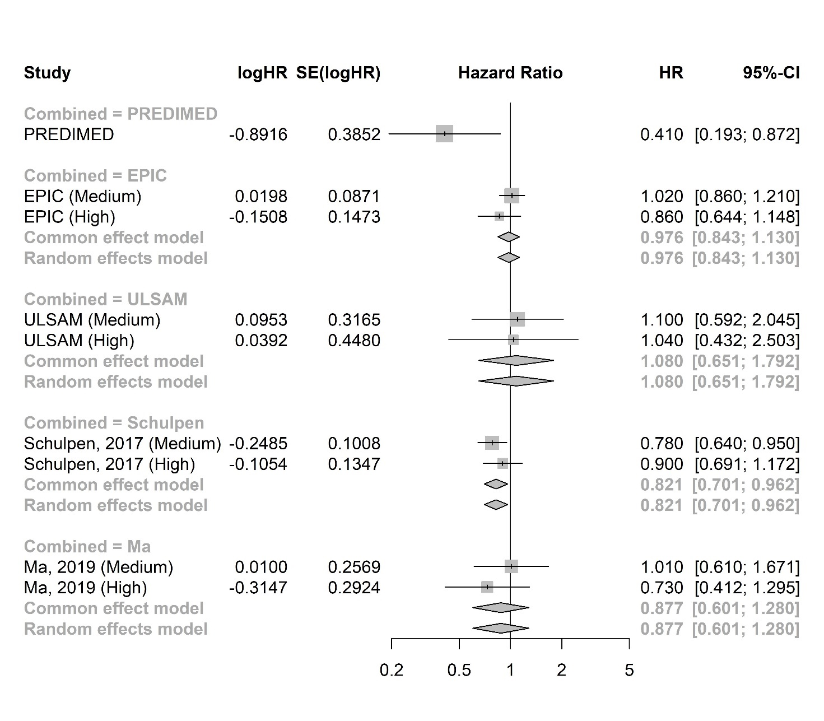

[B] Hazard Ratios for cancer mortality
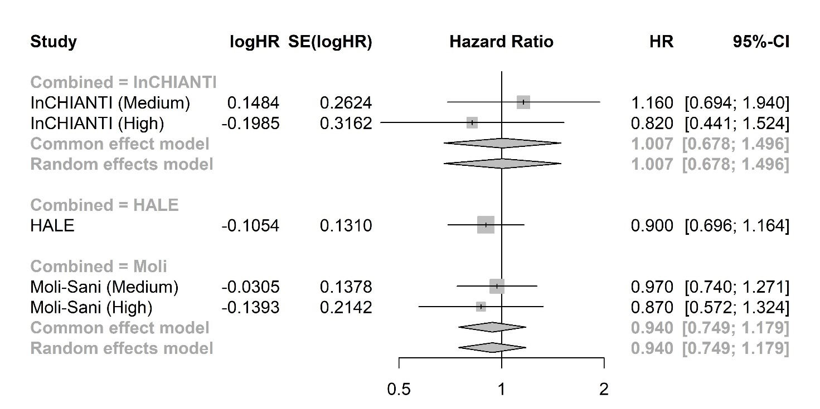

[C] Odds Ratios for cancer incidence
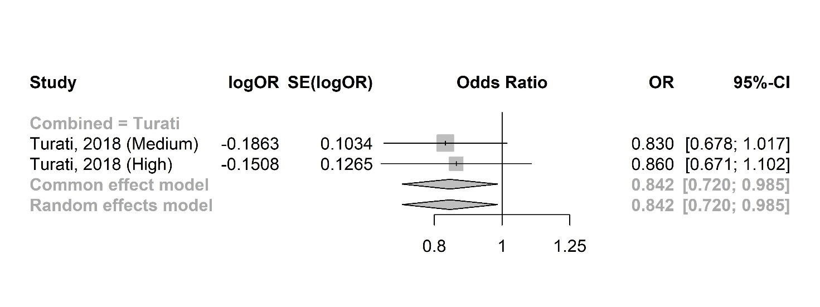

Fig. S1 Legend. [A] Hazard ratios for cancer incidence. [B] Hazard ratios for cancer mortality. [C] Odd ratios for cancer incidence. Results from the fixed effect model were considered. SE=standard error. HR=hazard ratio. OR=odds ratio. CI=confidence interval.

Fig. S2. Sensitivity analysis excluding studies comparing MD to other dietary patterns

[A] Cancer Incidence
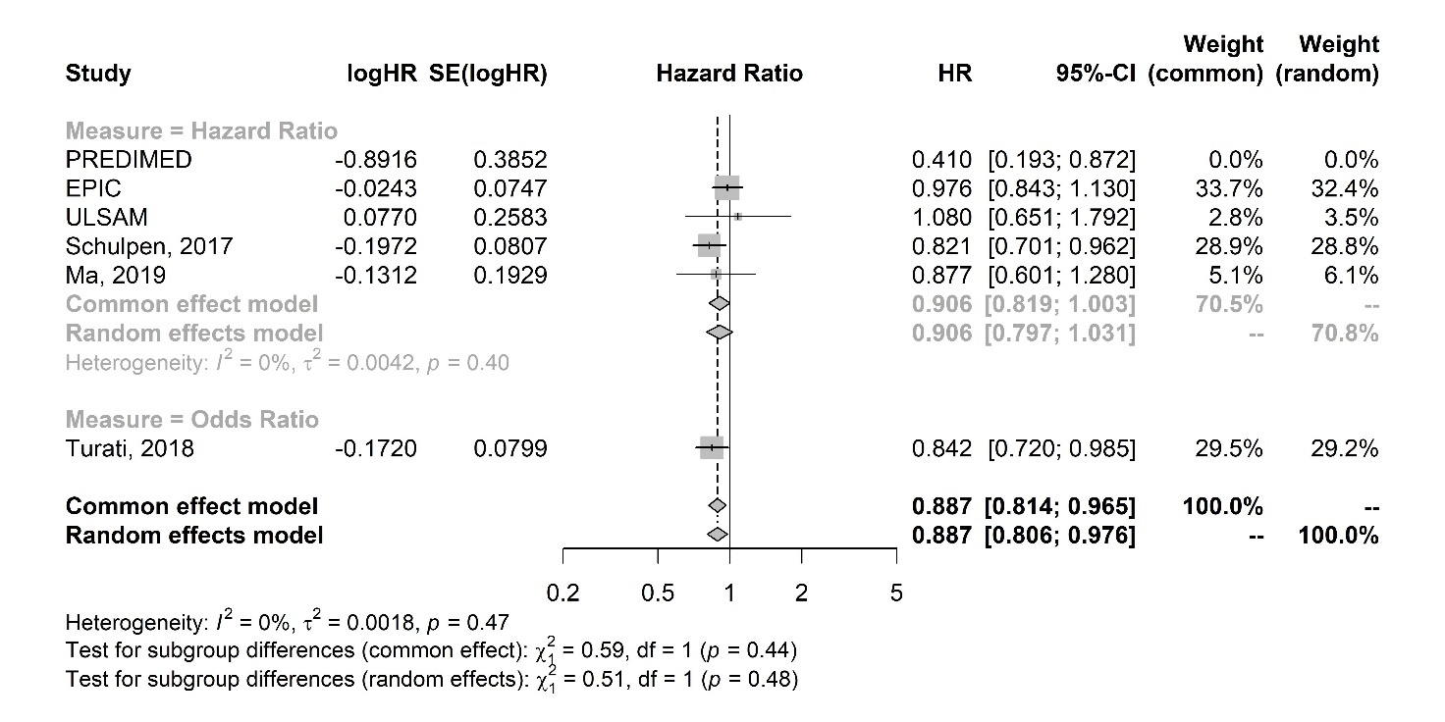
logES SE(logES) Effect Size ES

[B] Cancer Mortality
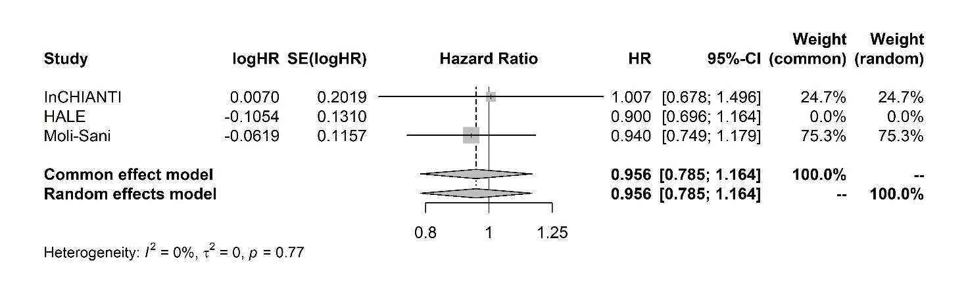

Fig. S2 Legend. [A] Sensitivity analysis for cancer incidence including studies evaluating MD only. [B] Sensitivity analysis for cancer mortality including studies evaluating MD only. The PREDIMED and HALE studies were reported in forest plots but were not included in this analysis. ES=effect size. SE=standard error. HR=hazard ratio. OR=odds ratio. CI=confidence interval.

Fig. S3. Sensitivity analysis for OPI

[A] Subgroup analysis according to score
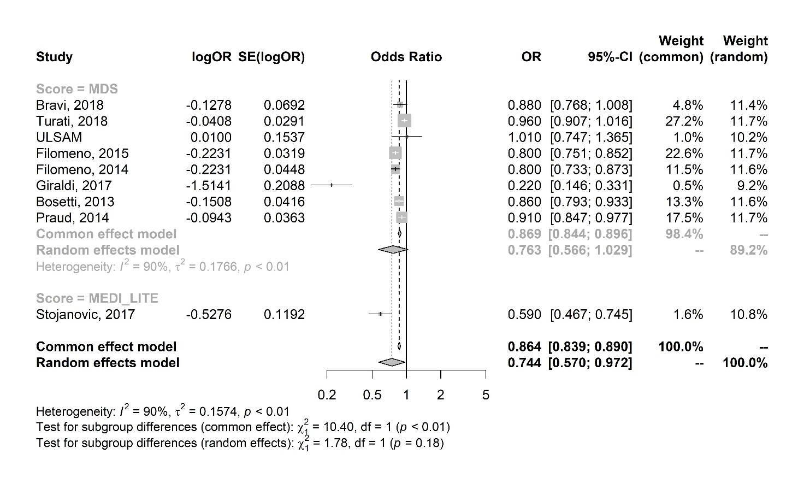
[B] Excluding outlier
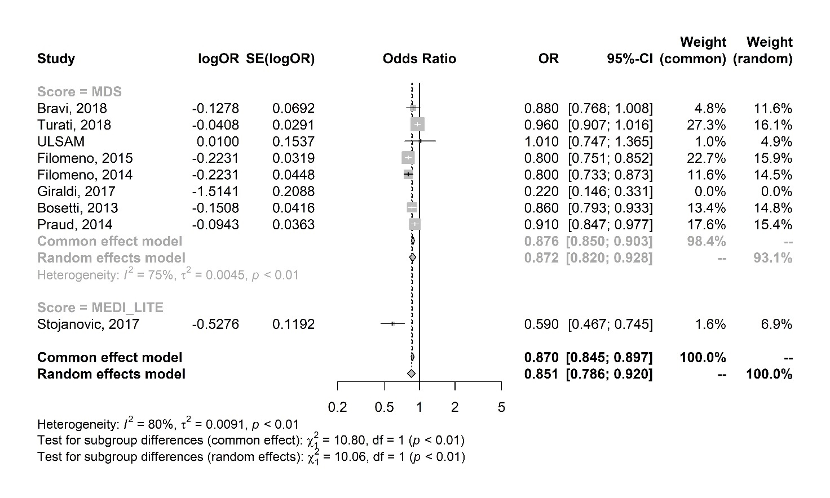

[C] Case Control and Cohort
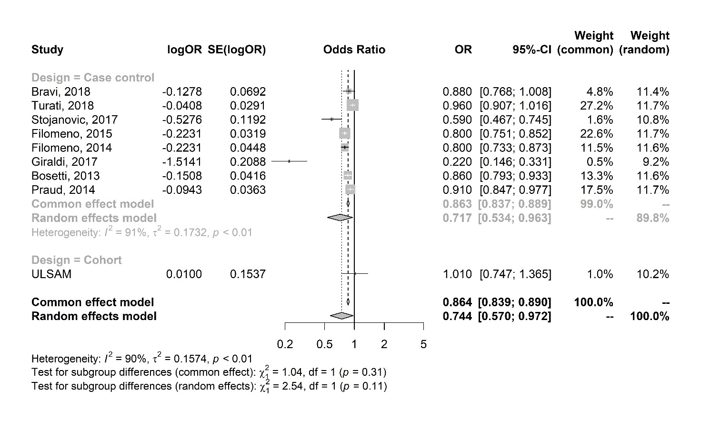
Fig. S3 Legend. [A] Subgroup analysis according to score. [B] Subgroup analysis excluding outlier. [C] Sensitivity analysis for case-control and cohort studies with one-point increase. In panel B, study from Giraldi et colleagues was considered an outlier due to the effect size. Results from the studies evaluating MDs were consistent with the primary analysis, In panel C, even if the interaction test is formally non-significant, it should be considered that only one trial (ULSAM) was a cohort study and reported a non-significant effect. OPI=one-point increase. MDS=Mediterranean diet score. OR=odds ratio. SE=standard error. CI=confidence interval.

Fig. S4. Sensitivity analysis for adherence

[A] Adherence only in HR
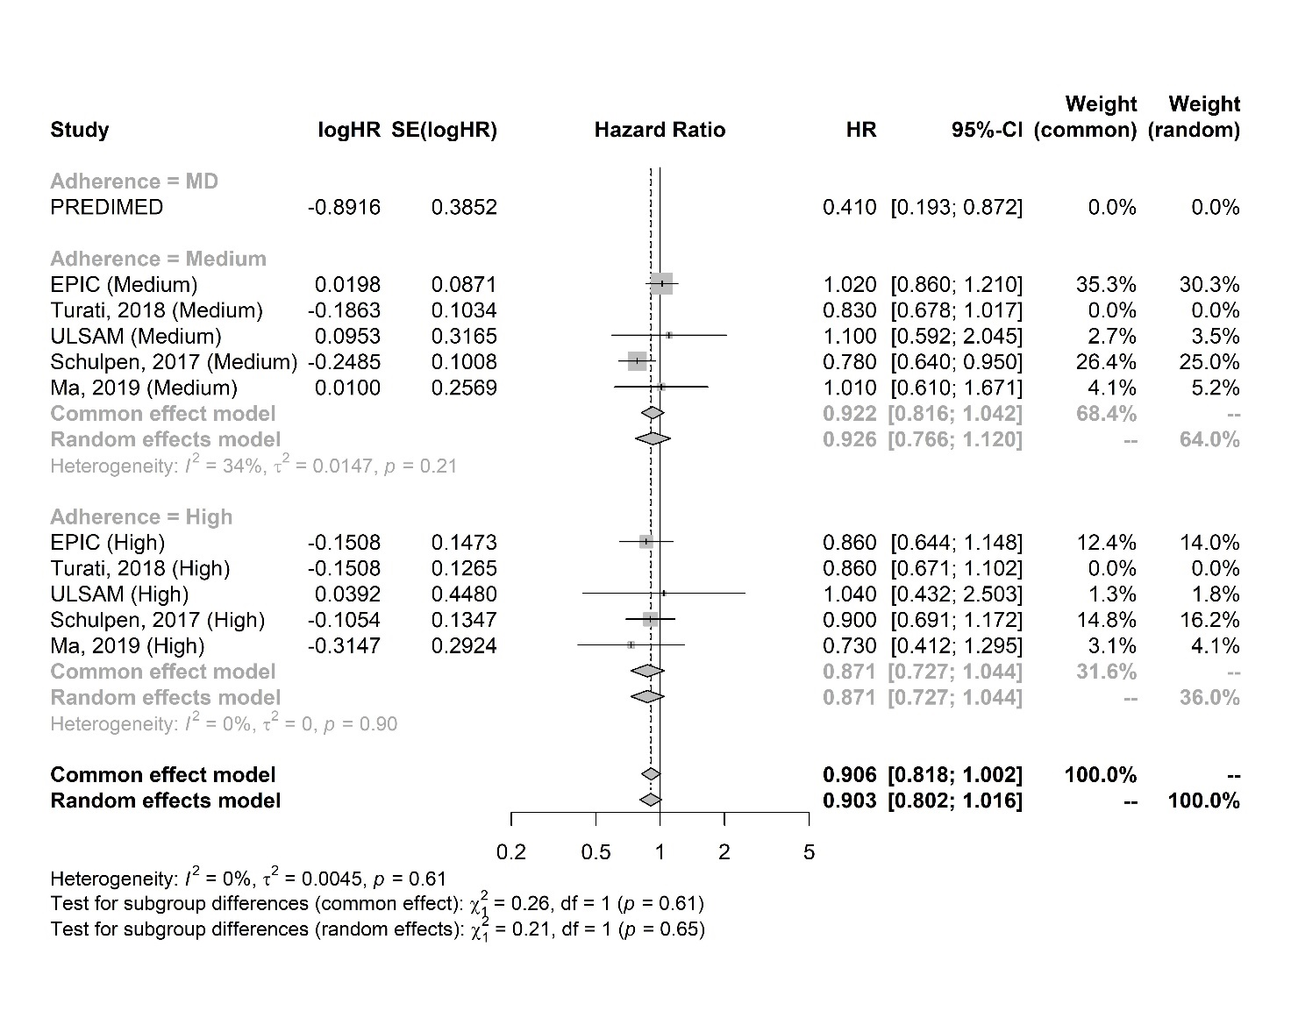
Fig. S4 Legend. [A] Sensitivity analysis evaluating adherence only in HR. The study from Turati and colleagues is reported in the forest plot but was excluded from this analysis since the outcome reported was odds ratio. MD=Mediterranean diet. HR=hazard ratio. SE=standard error. CI=confidence interval.

Fig. S5. Cancer type

[A] Cancer incidence only in studies evaluating HR
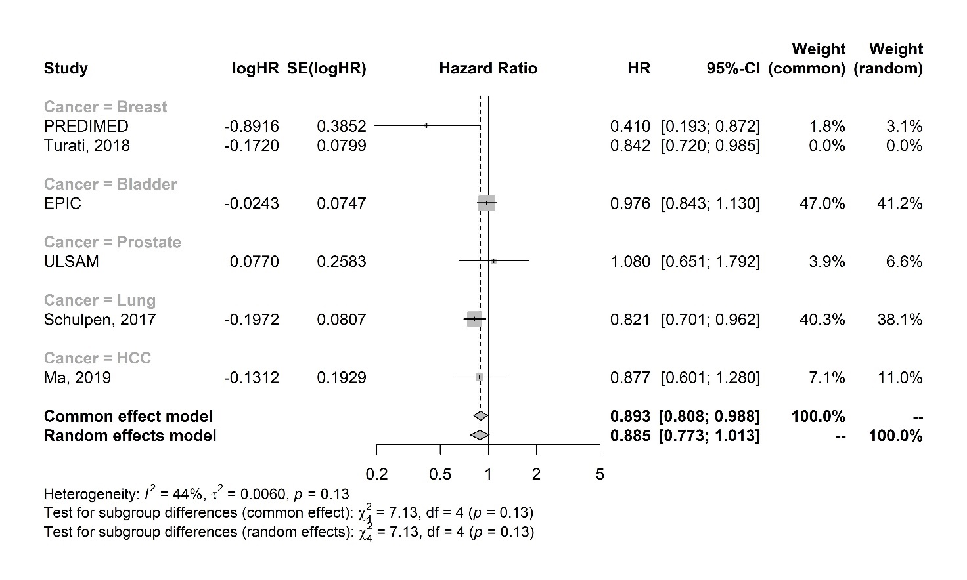

[B] Cancer incidence in studies evaluating MD as OPI
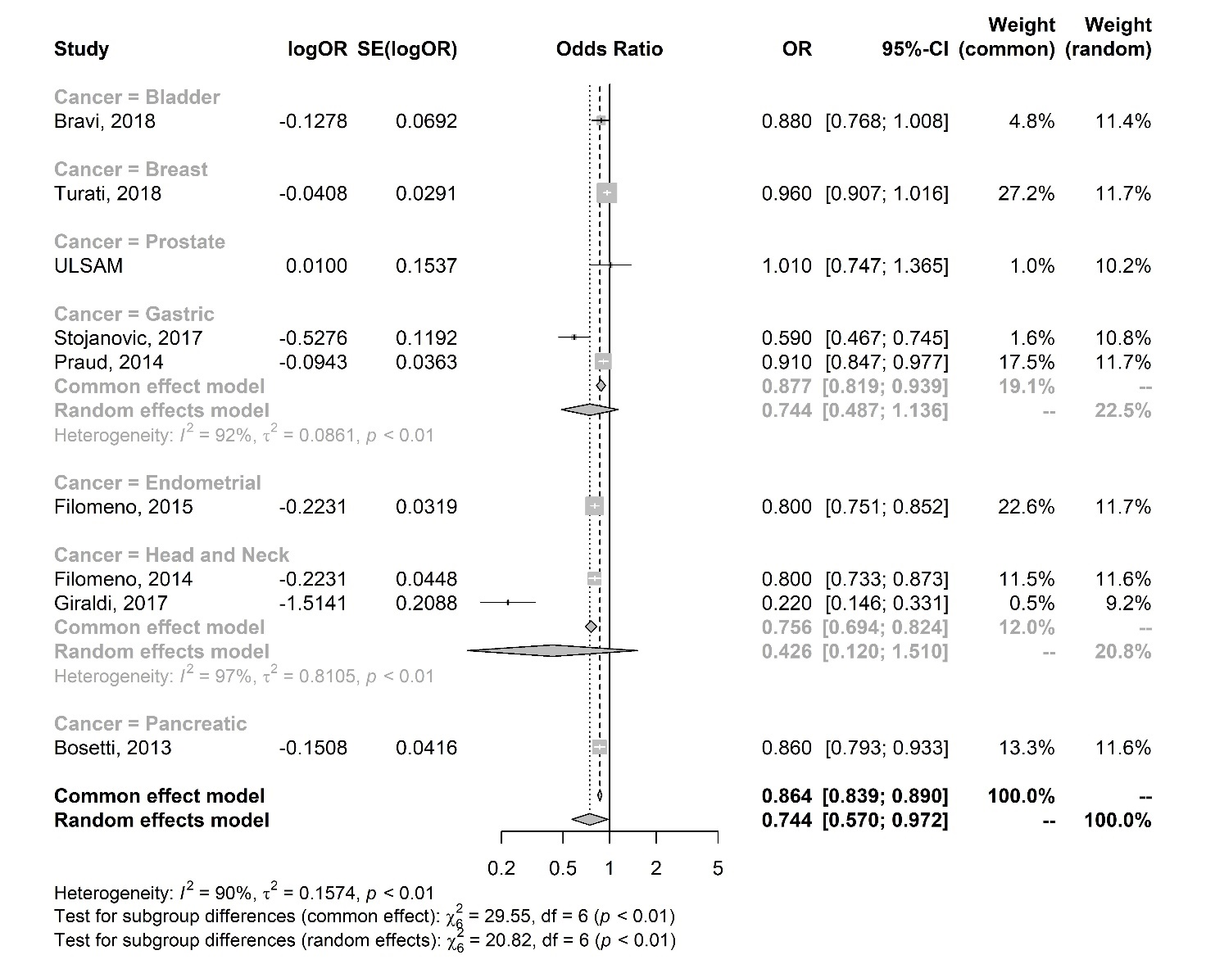

[C] Cancer incidence in studies evaluating MD as OPI using MDS
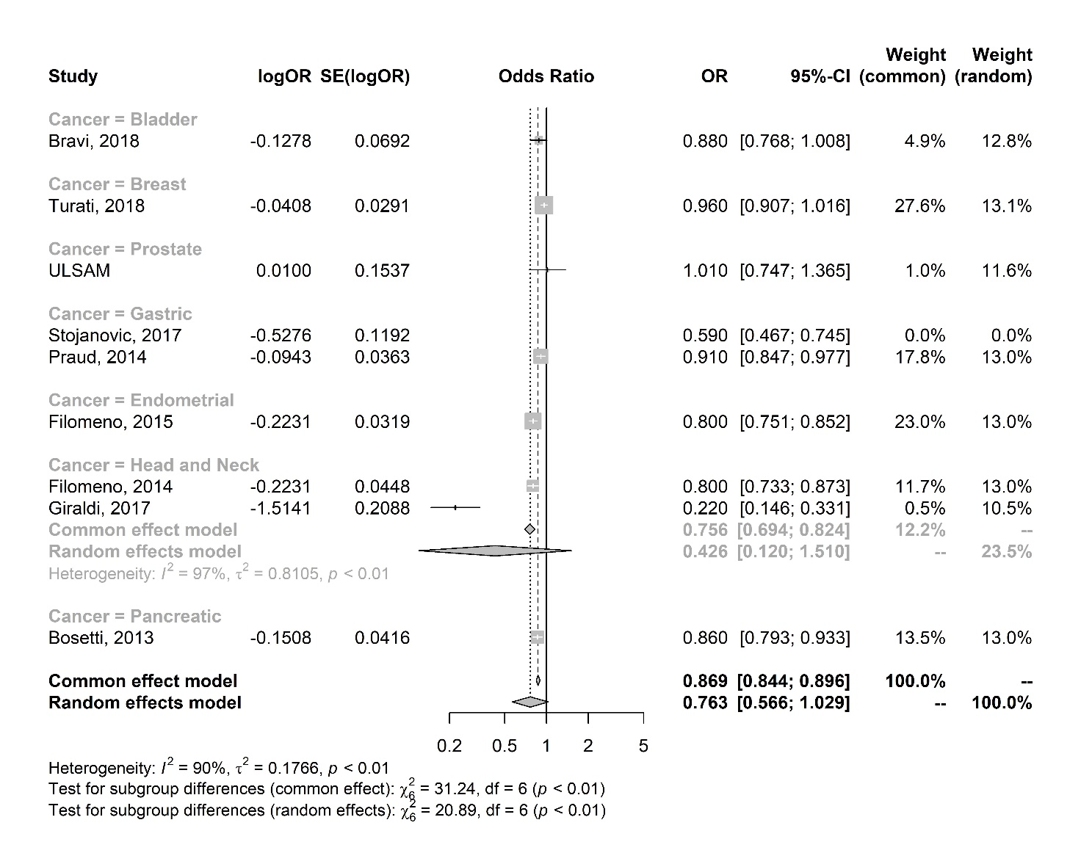

[D] Cancer incidence in OPI sensitivity analysis
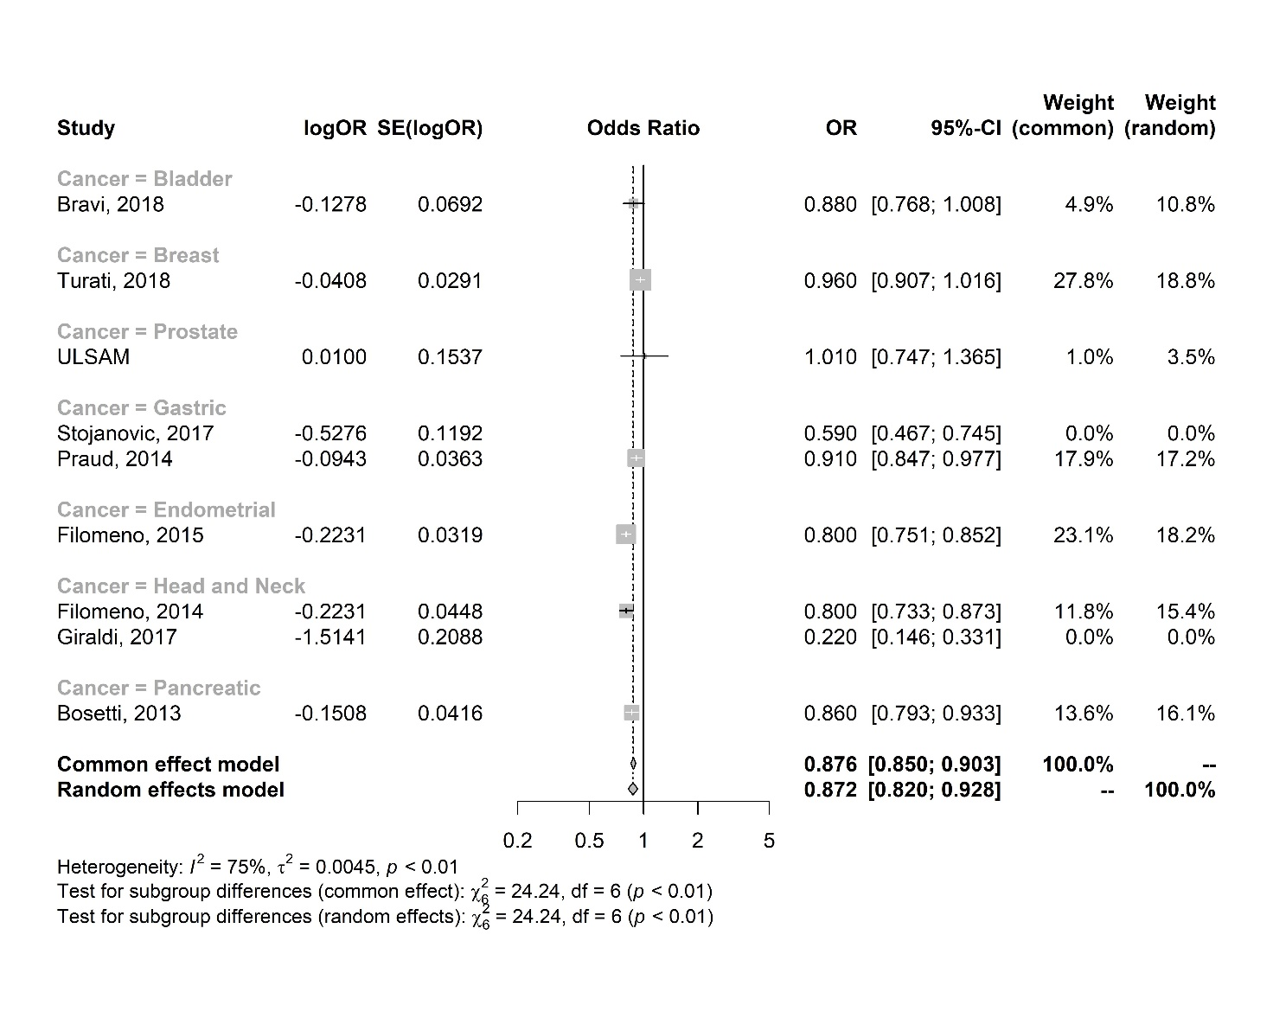

Fig. S5 Legend. [A] Cancer incidence only in studies evaluating HR. [B] Cancer incidence in studies evaluating MD as OPI. [C] Cancer incidence in studies evaluating MD as OPI using MDS. [D] Cancer incidence in OPI sensitivity analysis. In panel D, the study from Giraldi and colleagues was excluded due to effect size and Stojanovic and colleagues due to the use of MEDILITE. OPI=one-point increase. MDS=Mediterranean diet score. OR=odds ratio. HR=hazard ratio. SE=standard error. CI=confidence interval.

Fig. S6. Risk Of Bias

[A] Newcastle Ottawa scale – Cohort studies
 | Selection |  |  |  | Comparability | Outcome
Author, year | Representativeness of the exposed cohort | Selection of the non exposed cohort | Ascertainment of exposure | Demonstration that outcome of interest was not present at start of study | Comparability of cohorts on the basis of the design or analysis | Assessment of outcome | Was follow-up long enough for outcomes to occur | Adequacy of follow up of cohort
Hidalgo-Liberona 2021 | * | * | * |  | ** | * | * | *
Knoops 2004 | * | * | * | * | ** | * | * | *
Bonaccio 2018 | * | * | * |  | ** | * | *
Buckland 2013 | * | * | * |  | * | * | *
Ax 2015 | * | * |  |  | * | * | *
Schulpen 2017 | * | * |  | * | ** | * | *
Yanan Ma 2019 |  | * |  |  | ** | ** | *

[B] Newcastle Ottawa scale – Case-control studies
 | Selection |  |  |  | Comparability | Outcome
Author, year | Is the case definition adequate? | Representativeness of the cases | Selection of Controls | Definition of Controls | Comparability of cases and controls on the basis of the design or analysis | Ascertainment of exposure | Same method of ascertainment for cases and controls | Non-Response rate
Giraldi 2017 |  | * | * |  | ** |  | *
Stojanovic 2017 |  | * | * | * | ** |  | *
Bosetti 2013 |  | * |  |  | ** |  | *
Filomeno 2014 | * | * |  | * | ** |  | *
Filomeno 2015 | * | * |  |  | ** |  | *
Praud 2013 |  | * |  |  | ** |  | *
Turati 2018 | * | * |  | * | ** |  | *
Bravi 2018 | * | * |  |  | ** |  | *
Reference.
- Wells GA, Shea B, O’Connell D, Peterson J, Welch V, Losos M, et al. The Newcastle-Ottawa Scale (NOS) for assessing the quality if nonrandomized studies in meta-analyses. Available from: URL: http://www.ohri.ca/programs/clinical_epidemiology/oxford.htm.

[C] Risk of bias assessed with ROB 2
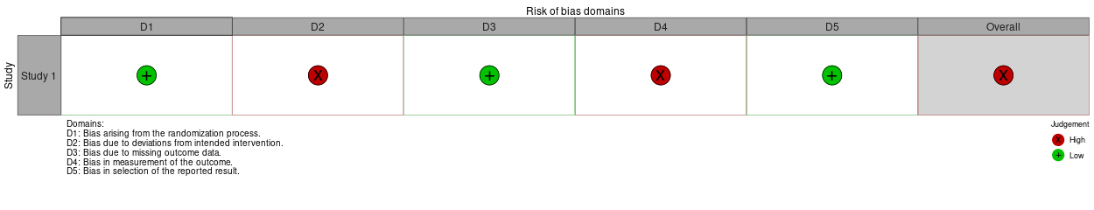 Reference.
- McGuinness, LA, Higgins, JPT. Risk-of-bias VISualization (robvis): An R package and Shiny web app for visualizing risk-of-bias assessments. Res Syn Meth. 2020- 1- 7. https://doi.org/10.1002/jrsm.1411

Table S3. GRADE Assessment

Question: Does mediterranean diet reduce cancer incidence in older population?

Certainty assessment |  |  |  |  |  |  | Effect |  | Certainty
Comparison | Study Design | Risk of Bias | Inconsistency | Indirectness | Imprecision | Other considerations | Outcome | Relative Effect  (95% CrI) | Grade
Mediterranean diet (Medium-High adherence or MD)  Vs  No Mediterranean diet (Low adherence or other dietary patterns) | 1 RCT  (Phase III)  4 nRCTs  (4 cohort) | Serious | Not Serious | Not serious | Serious | None | HR (Categories) | 0.885 (0.773-1.013) | Low
 | 1 NRCTs  (case control) | Serious | Not serious | Not serious | Not serious | None | OR (Categories) | 0.842 (0.720-0.985) | Low
 | 1 RCT  (Phase III)  5 NRCTs  (4 cohort and 1 case control) | Serious | Not serious | Serious | Not serious | None | Pooled HR and OR (Categories) | 0.876 (0.794-0.966) | Low
 | 9 NRCTs  (9 case control) | Serious | Serious | Not serious | Serious | None | OR  (One point increase) | 0.744 (0.570-0.972) | Low

Question: Does mediterranean diet reduce cancer mortality in older population?

Certainty assessment |  |  |  |  |  |  | Effect |  | Certainty
Comparison | Study Design | Risk of Bias | Inconsistency | Indirectness | Imprecision | Other considerations | Outcome | Relative Effect  (95% CrI) | Grade
Mediterranean diet (Medium-High adherence or MD)  Vs  No Mediterranean diet (Low adherence or other dietary patterns) | 3 nRCTs  (3 cohort) | Serious | Not Serious | Serious | Serious | None | HR (Categories) | 0.935 (0.800-1.093) | Low

Table S4. PRISMA checklist.

Section and Topic | Item # | Checklist item | Location where item is reported
TITLE
Title | 1 | Identify the report as a systematic review. | 1
ABSTRACT
Abstract | 2 | See the PRISMA 2020 for Abstracts checklist. | 2
INTRODUCTION
Rationale | 3 | Describe the rationale for the review in the context of existing knowledge. | 4
Objectives | 4 | Provide an explicit statement of the objective(s) or question(s) the review addresses. | 4
METHODS
Eligibility criteria | 5 | Specify the inclusion and exclusion criteria for the review and how studies were grouped for the syntheses. | 5
Information sources | 6 | Specify all databases, registers, websites, organisations, reference lists and other sources searched or consulted to identify studies. Specify the date when each source was last searched or consulted. | 5
Search strategy | 7 | Present the full search strategies for all databases, registers and websites, including any filters and limits used. | Table S1
Selection process | 8 | Specify the methods used to decide whether a study met the inclusion criteria of the review, including how many reviewers screened each record and each report retrieved, whether they worked independently, and if applicable, details of automation tools used in the process. | 5
Data collection process | 9 | Specify the methods used to collect data from reports, including how many reviewers collected data from each report, whether they worked independently, any processes for obtaining or confirming data from study investigators, and if applicable, details of automation tools used in the process. | 5
Data items | 10a | List and define all outcomes for which data were sought. Specify whether all results that were compatible with each outcome domain in each study were sought (e.g. for all measures, time points, analyses), and if not, the methods used to decide which results to collect. | 5-6
Data items | 10b | List and define all other variables for which data were sought (e.g. participant and intervention characteristics, funding sources). Describe any assumptions made about any missing or unclear information. | 5-6
Study risk of bias assessment | 11 | Specify the methods used to assess risk of bias in the included studies, including details of the tool(s) used, how many reviewers assessed each study and whether they worked independently, and if applicable, details of automation tools used in the process. | 6
Effect measures | 12 | Specify for each outcome the effect measure(s) (e.g. risk ratio, mean difference) used in the synthesis or presentation of results. | 5-6
Synthesis methods | 13a | Describe the processes used to decide which studies were eligible for each synthesis (e.g. tabulating the study intervention characteristics and comparing against the planned groups for each synthesis (item #5)). | 5-6
Synthesis methods | 13b | Describe any methods required to prepare the data for presentation or synthesis, such as handling of missing summary statistics, or data conversions. | 5-6
Synthesis methods | 13c | Describe any methods used to tabulate or visually display results of individual studies and syntheses. | 5-6
Synthesis methods | 13d | Describe any methods used to synthesize results and provide a rationale for the choice(s). If meta-analysis was performed, describe the model(s), method(s) to identify the presence and extent of statistical heterogeneity, and software package(s) used. | 5-6
Synthesis methods | 13e | Describe any methods used to explore possible causes of heterogeneity among study results (e.g. subgroup analysis, meta-regression). | 5-6
Synthesis methods | 13f | Describe any sensitivity analyses conducted to assess robustness of the synthesized results. | 6
Reporting bias assessment | 14 | Describe any methods used to assess risk of bias due to missing results in a synthesis (arising from reporting biases). | 6
Certainty assessment | 15 | Describe any methods used to assess certainty (or confidence) in the body of evidence for an outcome. | 6
RESULTS
Study selection | 16a | Describe the results of the search and selection process, from the number of records identified in the search to the number of studies included in the review, ideally using a flow diagram. | 7- Fig. 1
Study selection | 16b | Cite studies that might appear to meet the inclusion criteria, but which were excluded, and explain why they were excluded. | Table S2
Study characteristics | 17 | Cite each included study and present its characteristics. | Table 1
Risk of bias in studies | 18 | Present assessments of risk of bias for each included study. | Fig. S6
Results of individual studies | 19 | For all outcomes, present, for each study: (a) summary statistics for each group (where appropriate) and (b) an effect estimate and its precision (e.g. confidence/credible interval), ideally using structured tables or plots. | Table 1
Results of syntheses | 20a | For each synthesis, briefly summarise the characteristics and risk of bias among contributing studies. | 8-Fig. S6
Results of syntheses | 20b | Present results of all statistical syntheses conducted. If meta-analysis was done, present for each the summary estimate and its precision (e.g. confidence/credible interval) and measures of statistical heterogeneity. If comparing groups, describe the direction of the effect. | 7-8
Results of syntheses | 20c | Present results of all investigations of possible causes of heterogeneity among study results. | 7-8
Results of syntheses | 20d | Present results of all sensitivity analyses conducted to assess the robustness of the synthesized results. | 7-8-Supplementary
Reporting biases | 21 | Present assessments of risk of bias due to missing results (arising from reporting biases) for each synthesis assessed. | Fig.S6
Certainty of evidence | 22 | Present assessments of certainty (or confidence) in the body of evidence for each outcome assessed. | Table S3
DISCUSSION
Discussion | 23a | Provide a general interpretation of the results in the context of other evidence. | 9-10-11
Discussion | 23b | Discuss any limitations of the evidence included in the review. | 10-11
Discussion | 23c | Discuss any limitations of the review processes used. | 10-11
Discussion | 23d | Discuss implications of the results for practice, policy, and future research. | 10-11
OTHER INFORMATION
Registration and protocol | 24a | Provide registration information for the review, including register name and registration number, or state that the review was not registered. | 5
Registration and protocol | 24b | Indicate where the review protocol can be accessed, or state that a protocol was not prepared. | 5
Registration and protocol | 24c | Describe and explain any amendments to information provided at registration or in the protocol. | N.A.
Support | 25 | Describe sources of financial or non-financial support for the review, and the role of the funders or sponsors in the review. | 6-12
Competing interests | 26 | Declare any competing interests of review authors. | 12
Availability of data, code and other materials | 27 | Report which of the following are publicly available and where they can be found: template data collection forms; data extracted from included studies; data used for all analyses; analytic code; any other materials used in the review. | 12
Legend. NA, not assessed.

