Title
Frequency and severity of hyponatremia in healthy children with acute illnesses

Journal name
Pediatric Nephrology

Authors
Shoichiro Shirane, Riku Hamada, Yoshihiko Morikawa, Ryoko Harada, Yuko Hamasaki, Kenji Ishikura, Masataka Honda, Hiroshi Hataya

Corresponding author
Riku Hamada, M.D.
Department of Nephrology and Rheumatology, Tokyo Metropolitan Children’s Medical Center
2-8-29 Musashidai, Fuchu, Tokyo 183-8561, Japan
E-mail: riku_hamada@tmhp.jp

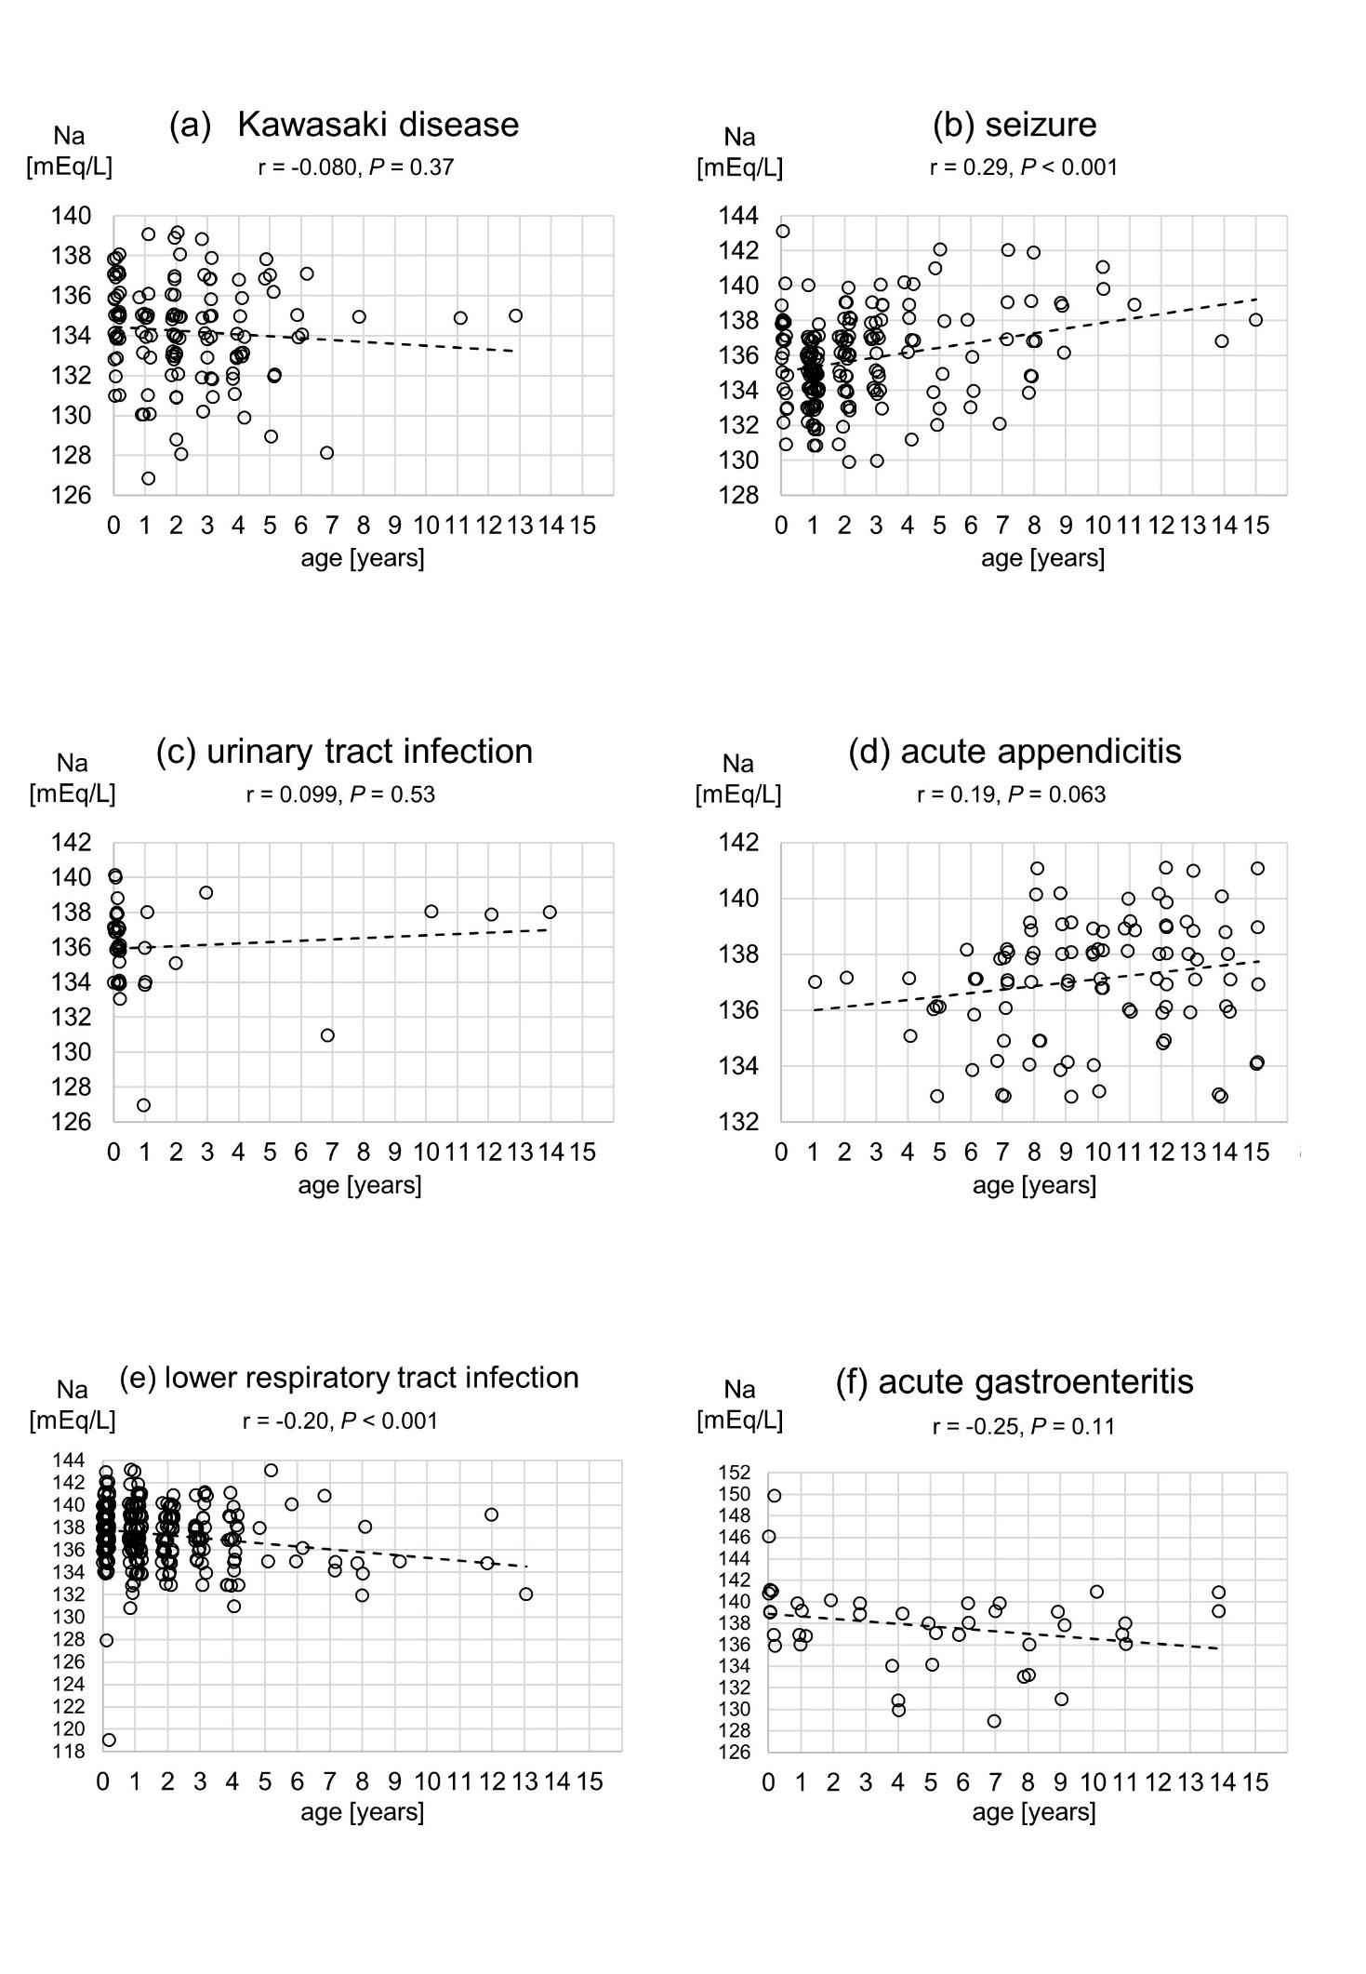

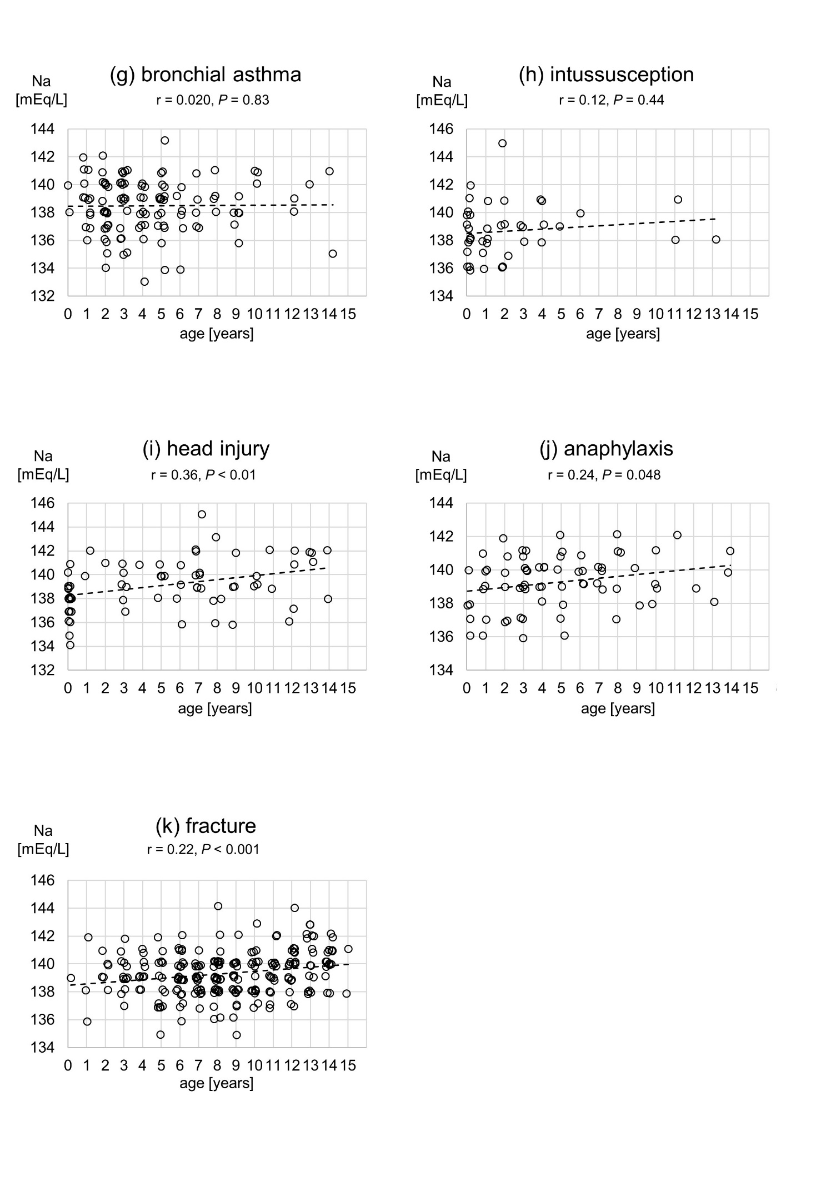
Supplementary Fig. 1a–k Jitter plots (small circles) and broken lines showing approximate best fit for diseases with more than 30 cases. CI, confidence interval; Na, serum sodium; r, correlation coefficient

