Supplementary Material
1. Supplementary Fig

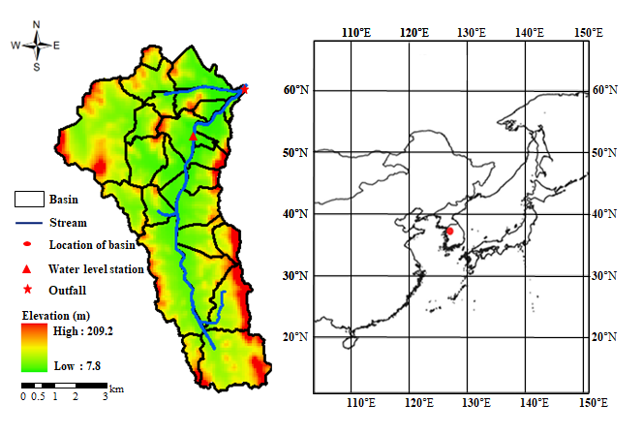
Fig. S1 Study area

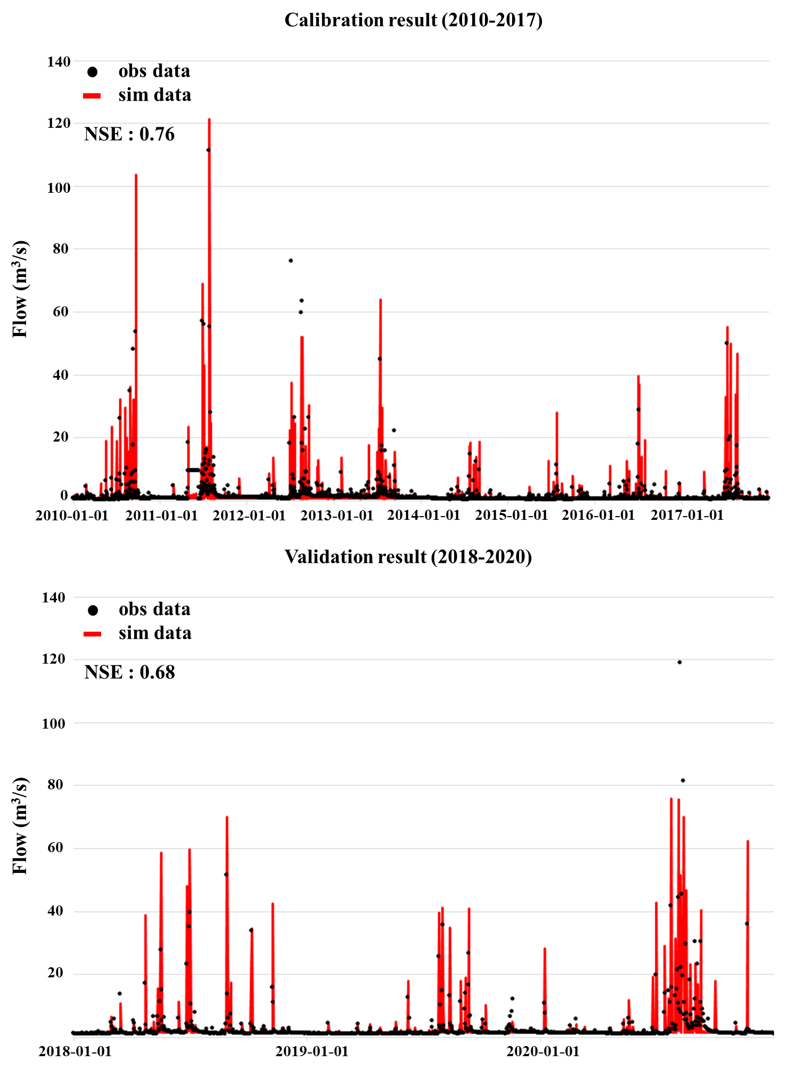
Fig. S2 Calibration and validation of the SWMM model

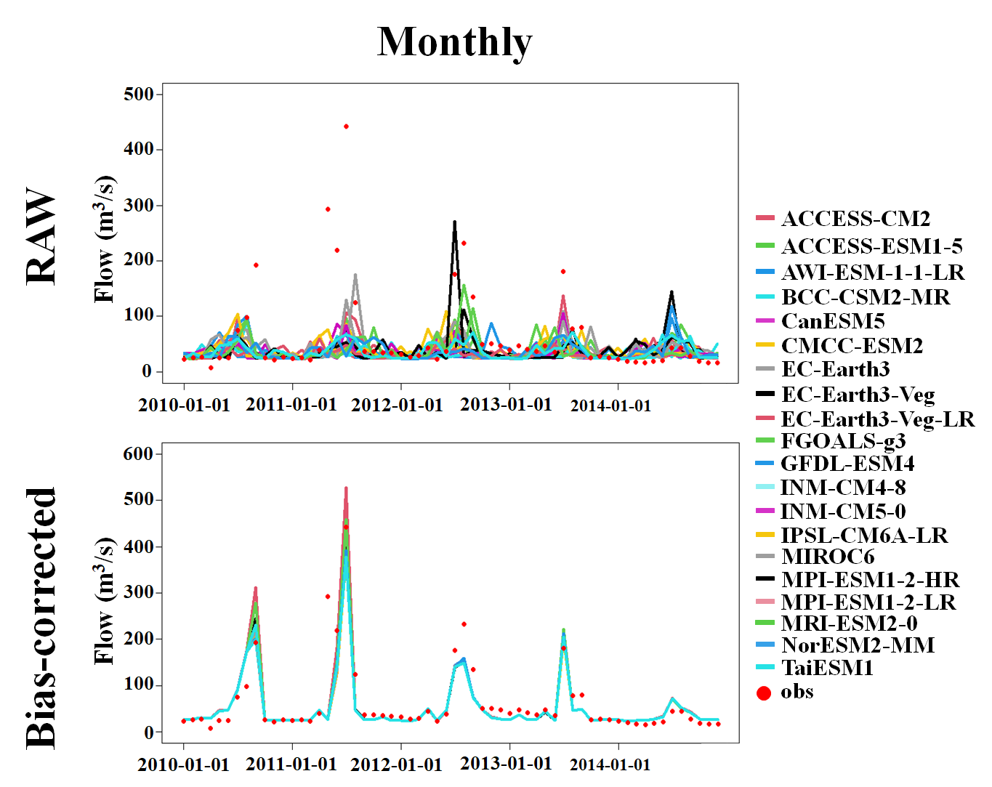
Fig. S3 Monthly simulated runoff using GCM raw and bias-corrected climate variables

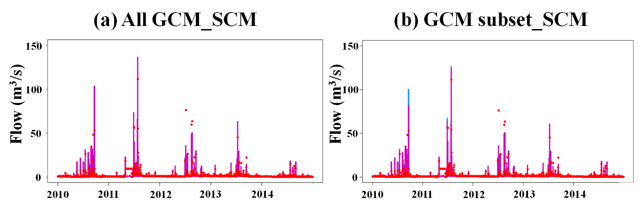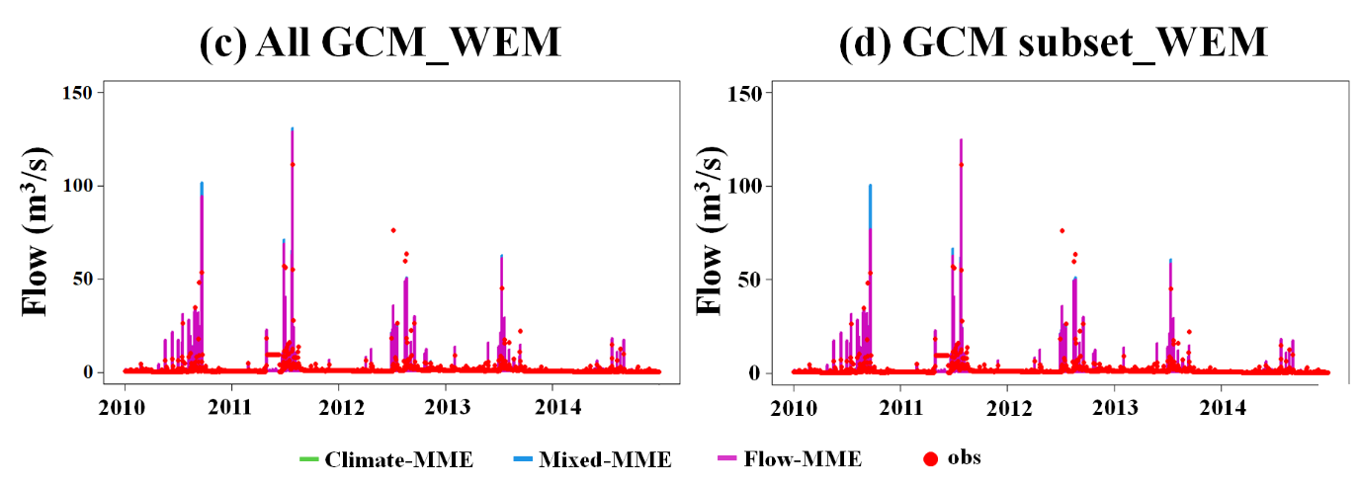
Fig. S4 Daily simulated runoff from different MME approaches

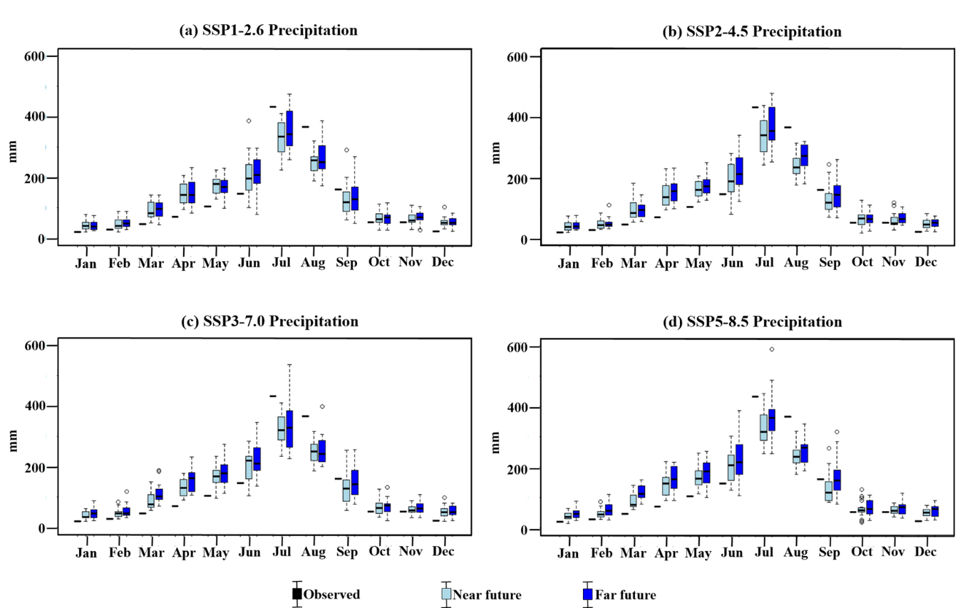
Fig. S5 The projected monthly precipitation for different SSPs in the near (2021-2050) and far future (2070-2099) compared to the observed monthly precipitation for the historical period (1985-2014)

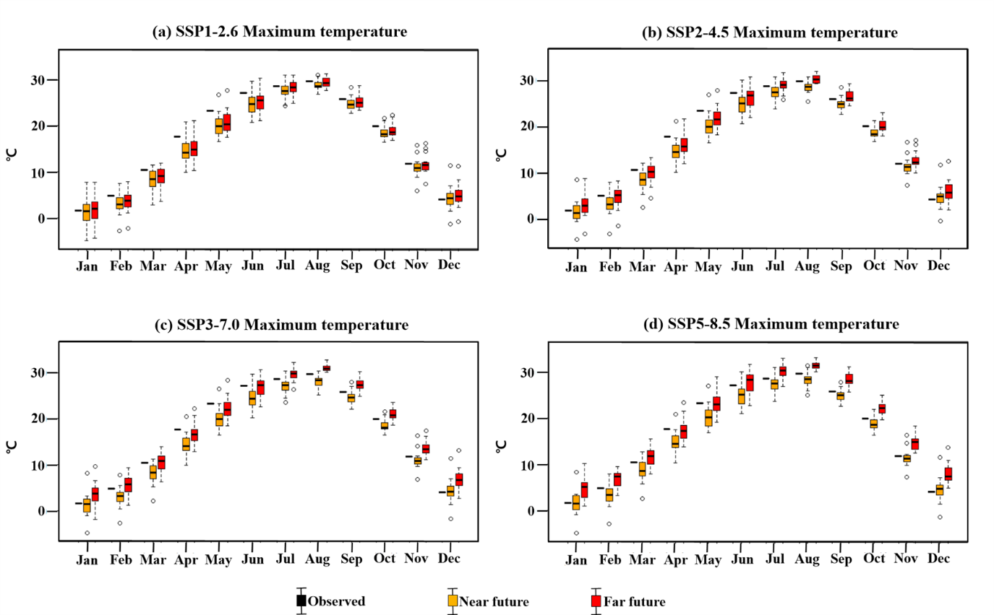
Fig. S6 The projected monthly maximum temperature for different SSPs in the near (2021-2050) and far future (2070-2099) compared to the observed monthly maximum temperature for the historical period (1985-2014)

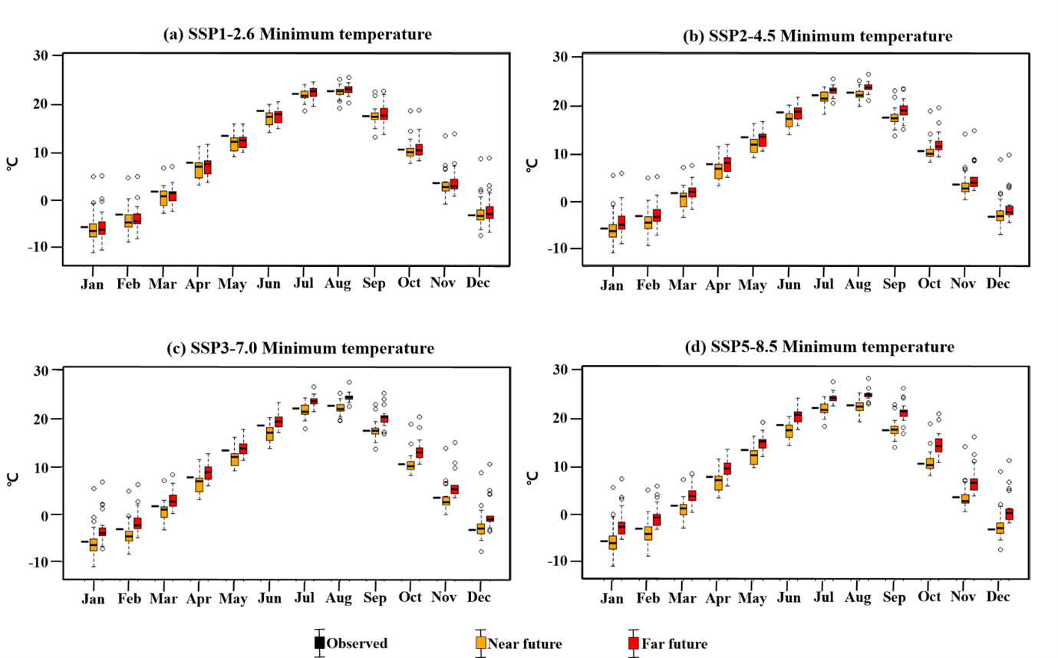
Fig. S7 The projected monthly minimum temperature for different SSPs in the near (2021-2050) and far future (2070-2099) compared to the observed monthly minimum temperature for the historical period (1985-2014)

2. Supplementary Table

Table S1 Information on the observed values used in this study
Objective | Station | Value | Period
Evaluation of GCM climate simulation performance | Seoul weather station | Daily precipitation, maximum temperature, minimum temperature | 1985-2014
Runoff simulation performance Evaluation of MME approaches | Neobudae Bridge water level station | Runoff | 2010-2014
Calibration and validation of the hydrological model | Seoul weather station, Neobudae Bridge water level station | Daily precipitation, runoff, PET | 2010-2020

Table S2 Information on CMIP6 GCMs used in this study
No | Institution | Model | Resolution  (lon × lat)
1 | Commonwealth Scientific and Industrial Research Organisation, Australia | ACCESS-CM2 | 1.2° × 1.8°
2 |  | ACCESS-ESM1-5 | 1.2° × 1.8°
3 | Alfred Wegener Institute, Germany | AWI-CM-1-1-MR | 0.9° × 0.9°
4 | Beijing Climate Centre, China | BCC-CSM2-MR | 1.1° × 1.1°
5 | Canadian Centre for Climate Modelling and Analysis, Canada | CanESM5 | 2.8° × 2.8°
6 | Euro-Mediterranean Centre on Climate Change, Italy | CMCC-ESM2 | 1.2° × 0.9°
7 | EC-EARTH consortium, Netherlands/Ireland | EC-Earth3 | 0.7° × 0.7°
8 | EC-EARTH consortium, Netherlands/Ireland | EC-Earth3-Veg | 0.7° × 0.7°
9 | EC-EARTH consortium, Netherlands/Ireland | EC-Earth3-Veg-LR | 0.7° × 0.7°
10 | Chinese Academy of Sciences, China | FGOALS-g3 | 2.3° × 2.0°
11 | NOAA Geophysical Fluid Dynamics Laboratory, USA | GFDL-ESM4 | 1.0° × 1.3°
12 | Institute for Numerical Mathematics, Russia | INM-CM4-8 | 1.5° × 2.0°
13 | Institute for Numerical Mathematics, Russia | INM-CM5-0 | 1.5° × 2.0°
14 | Institut Pierre-Simon Laplace, France | IPSL-CM6A-LR | 1.3° × 2.5°
15 | Japan Agency for Marine-Earth Science and Technology, Atmosphere and Ocean Research Institute for Environmental Studies, Japan | MIROC6 | 1.4° × 1.4°
16 | Max Planck Institute for Meteorology, Germany | MPI-ESM1-2-HR | 0.9° × 0.9°
17 | Max Planck Institute for Meteorology, Germany | MPI-ESM1-2-LR | 1.9° × 1.9°
18 | Meteorological Research Institute, Japan | MRI-ESM2-0 | 1.1° × 1.1°
19 | Norwegian Climate Centre, Norway | NorESM2-MM | 0.9° × 0.9°
20 | Research Center for Environmental Changes, Taiwan | TaiESM1 | 0.9° × 0.9°

Table S3 TOPSIS-based GCM performance rankings and weighting values for climate variables
GCM | Precipitation |  |  | Maximum temperature |  |  | Minimum temperature |  |  | Integrated
GCM | C* | Rank | Weight | C* | Rank | Weight | C* | Rank | Weight | C* | Rank | Weight
ACCESS-CM2 | 0.00 | 20 | 0.01 | 0.61 | 13 | 0.04 | 0.68 | 8 | 0.06 | 0.43 | 20 | 0.01
ACCESS-ESM1-5 | 0.91 | 12 | 0.04 | 0.66 | 11 | 0.05 | 0.58 | 12 | 0.04 | 0.69 | 10 | 0.05
AWI-ESM-1-1-LR | 0.97 | 2 | 0.09 | 0.76 | 7 | 0.07 | 0.83 | 6 | 0.07 | 0.84 | 3 | 0.09
BCC-CSM2-MR | 0.86 | 16 | 0.02 | 0.85 | 5 | 0.07 | 0.00 | 20 | 0.01 | 0.55 | 17 | 0.02
CanESM5 | 0.90 | 13 | 0.03 | 0.46 | 17 | 0.02 | 0.67 | 9 | 0.06 | 0.60 | 15 | 0.03
CMCC-ESM2 | 0.85 | 17 | 0.02 | 0.70 | 8 | 0.06 | 0.58 | 12 | 0.04 | 0.70 | 8 | 0.06
EC-Earth3 | 0.93 | 9 | 0.06 | 0.63 | 12 | 0.04 | 0.50 | 18 | 0.01 | 0.65 | 14 | 0.03
EC-Earth3-Veg | 0.91 | 11 | 0.05 | 0.61 | 13 | 0.04 | 0.57 | 16 | 0.02 | 0.66 | 13 | 0.04
EC-Earth3-Veg-LR | 0.97 | 4 | 0.08 | 0.26 | 20 | 0.01 | 0.85 | 4 | 0.08 | 0.56 | 16 | 0.02
FGOALS-g3 | 0.95 | 6 | 0.07 | 0.69 | 9 | 0.06 | 0.57 | 15 | 0.03 | 0.71 | 7 | 0.07
GFDL-ESM4 | 0.78 | 18 | 0.01 | 0.37 | 18 | 0.01 | 0.65 | 10 | 0.05 | 0.53 | 18 | 0.01
INM-CM4-8 | 0.86 | 15 | 0.03 | 0.31 | 19 | 0.01 | 0.64 | 11 | 0.05 | 0.52 | 19 | 0.01
INM-CM5-0 | 0.93 | 7 | 0.07 | 0.89 | 3 | 0.08 | 0.52 | 17 | 0.02 | 0.75 | 5 | 0.08
IPSL-CM6A-LR | 0.93 | 10 | 0.05 | 0.90 | 2 | 0.09 | 1.00 | 1 | 0.09 | 0.96 | 2 | 0.09
MIROC6 | 0.95 | 5 | 0.08 | 0.89 | 3 | 0.08 | 0.36 | 19 | 0.01 | 0.69 | 9 | 0.06
MPI-ESM1-2-HR | 0.88 | 14 | 0.03 | 0.61 | 13 | 0.04 | 0.58 | 12 | 0.04 | 0.66 | 12 | 0.04
MPI-ESM1-2-LR | 0.97 | 3 | 0.09 | 0.83 | 6 | 0.07 | 0.74 | 7 | 0.07 | 0.84 | 4 | 0.08
MRI-ESM2-0 | 0.51 | 19 | 0.01 | 0.69 | 9 | 0.06 | 0.88 | 3 | 0.08 | 0.67 | 11 | 0.05
NorESM2-MM | 0.93 | 8 | 0.06 | 0.56 | 16 | 0.02 | 0.85 | 4 | 0.08 | 0.71 | 6 | 0.07
TaiESM1 | 0.99 | 1 | 0.10 | 0.91 | 1 | 0.09 | 0.97 | 2 | 0.09 | 0.98 | 1 | 0.10

Table S4 TOPSIS-based GCM performance rankings and weighting values for flow
GCM | C* | Rank | Weight
ACCESS-CM2 | 0.00 | 20 | 0.01
ACCESS-ESM1-5 | 0.84 | 11 | 0.05
AWI-ESM-1-1-LR | 0.91 | 5 | 0.08
BCC-CSM2-MR | 0.83 | 15 | 0.03
CanESM5 | 0.79 | 17 | 0.02
CMCC-ESM2 | 0.95 | 3 | 0.09
EC-Earth3 | 0.89 | 9 | 0.06
EC-Earth3-Veg | 0.92 | 4 | 0.08
EC-Earth3-Veg-LR | 0.83 | 14 | 0.03
FGOALS-g3 | 0.84 | 12 | 0.04
GFDL-ESM4 | 0.96 | 2 | 0.09
INM-CM4-8 | 1.00 | 1 | 0.10
INM-CM5-0 | 0.83 | 16 | 0.02
IPSL-CM6A-LR | 0.90 | 7 | 0.07
MIROC6 | 0.90 | 6 | 0.07
MPI-ESM1-2-HR | 0.74 | 18 | 0.01
MPI-ESM1-2-LR | 0.86 | 10 | 0.05
MRI-ESM2-0 | 0.43 | 19 | 0.01
NorESM2-MM | 0.83 | 13 | 0.04
TaiESM1 | 0.89 | 8 | 0.06

